SKYN
All page texts
Copywriting working document
28 July 2026
This document collects every visible text from the SKYN website and app, page by page. Each page includes a screenshot as a visual reference so you can see exactly where a text belongs. The tables have three columns:
- Element — where the text appears (section, button, field).
- Current text — the text that is there now.
- New text — blank, for writing your new or revised copy.
Note: some texts are baked into the design images (e.g. the testimonials and labels on the homepage). These are marked below with “(in render image)” — they live in the image, not in editable text.

1 · Home (landing page)
File: index.html — the public landing page. Four sections: hero, FAQ + pricing, about, footer.

1.1 · Hero
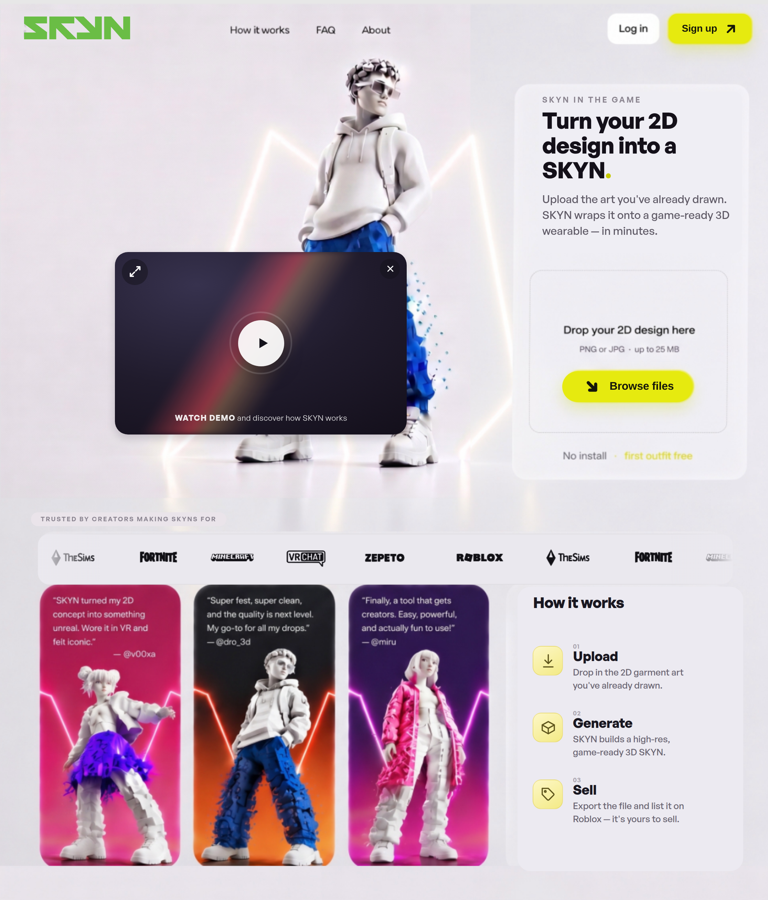
Element | Current text | New text
Navigation | How it works · FAQ · About · Log in · Sign up
Eyebrow | SKYN in the game
Title (H1) | Turn your 2D design into a SKYN.
Intro text | Upload the art you've already drawn. SKYN wraps it onto a game-ready 3D wearable — in minutes.
Upload card | Drop your 2D design here  PNG or JPG · up to 25 MB  Browse files
Below upload (in render image) | No install · first outfit free
Video button | Watch demo and discover how SKYN works
Trusted-by label | Trusted by creators making SKYNs for
Brand logos (ticker) | Roblox · The Sims · Fortnite · Minecraft · VRChat · Zepeto
How it works — title | How it works
Step 01 | Upload  Drop in the 2D garment art you've already drawn.
Step 02 | Generate  SKYN builds a high-res, game-ready 3D SKYN.
Step 03 | Sell  Export the file and list it on Roblox — it's yours to sell.
Testimonials (in render image) | “…concept into something unreal. Wore it in VR and felt iconic.” — @v00xa  “…and the quality is next level. My go-to for all my drops.” — @dro_3d  “…creators. Easy, powerful, and actually fun to use!” — @miru

1.2 · FAQ + Pricing
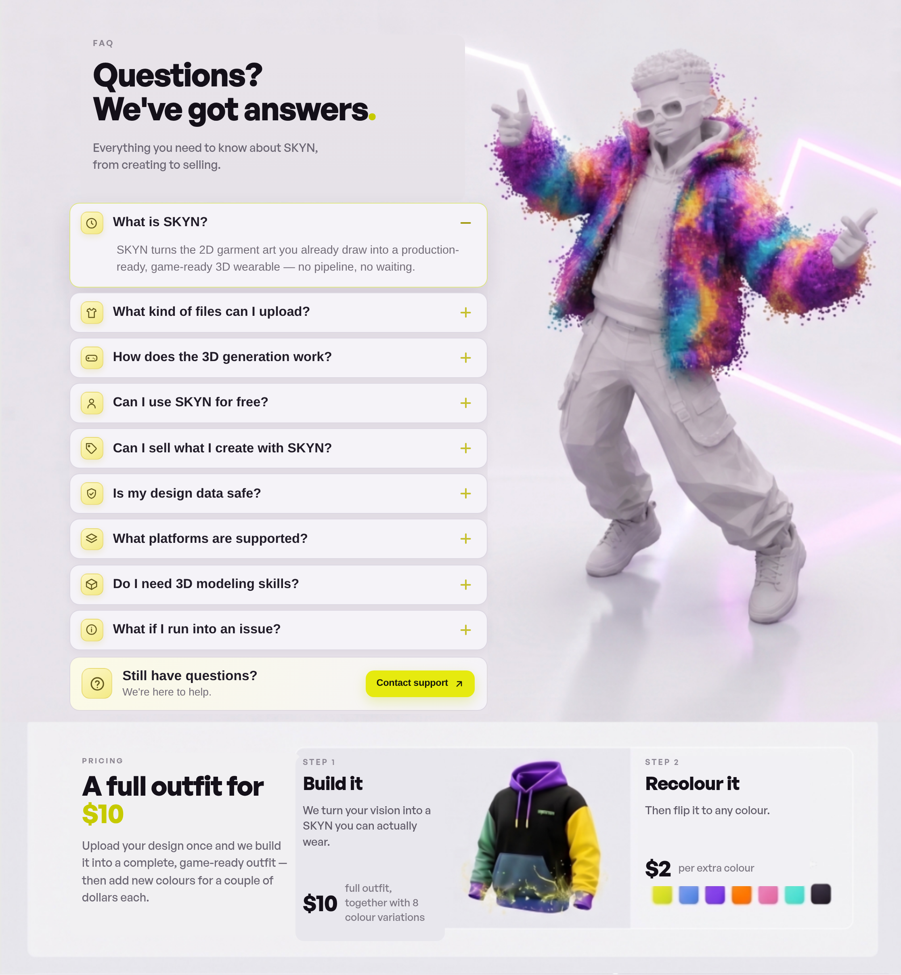

FAQ
Element | Current text | New text
Eyebrow | FAQ
Title (H2) | Questions? We've got answers.
Intro text | Everything you need to know about SKYN, from creating to selling.
Question 1 | What is SKYN?  SKYN turns the 2D garment art you already draw into a production-ready, game-ready 3D wearable — no pipeline, no waiting.
Question 2 | What kind of files can I upload?  PNG or JPG artwork up to 25 MB. Clean, high-contrast designs give the sharpest results.
Question 3 | How does the 3D generation work?  We map your artwork onto a game-ready garment base, then refine geometry and materials for real-time engines.
Question 4 | Can I use SKYN for free?  Your first outfit is free — no install required. After that a full outfit is a flat $10.
Question 5 | Can I sell what I create with SKYN?  Yes. You own the exported file and can list it on platforms like Roblox and keep the revenue.
Question 6 | Is my design data safe?  Your uploads stay private and are used only to generate your SKYN. You keep full ownership.
Question 7 | What platforms are supported?  Roblox, The Sims, Fortnite, Minecraft, VRChat, Zepeto and any engine that accepts standard 3D formats.
Question 8 | Do I need 3D modeling skills?  None at all. If you can draw or design in 2D, SKYN handles the entire 3D pipeline for you.
Question 9 | What if I run into an issue?  Our support team is one click away and happy to help you get your SKYN game-ready.
CTA | Still have questions?  We're here to help.  Contact support

Pricing
Element | Current text | New text
Eyebrow | Pricing
Title (H2) | A full outfit for $10
Intro text | Upload your design once and we build it into a complete, game-ready outfit — then add new colours for a couple of dollars each.
Step 1 | Step 1 — Build it  We turn your vision into a SKYN you can actually wear.  $10 — full outfit, together with 8 colour variations
Step 2 | Step 2 — Recolour it  Then flip it to any colour.  $2 — per extra colour

1.3 · About
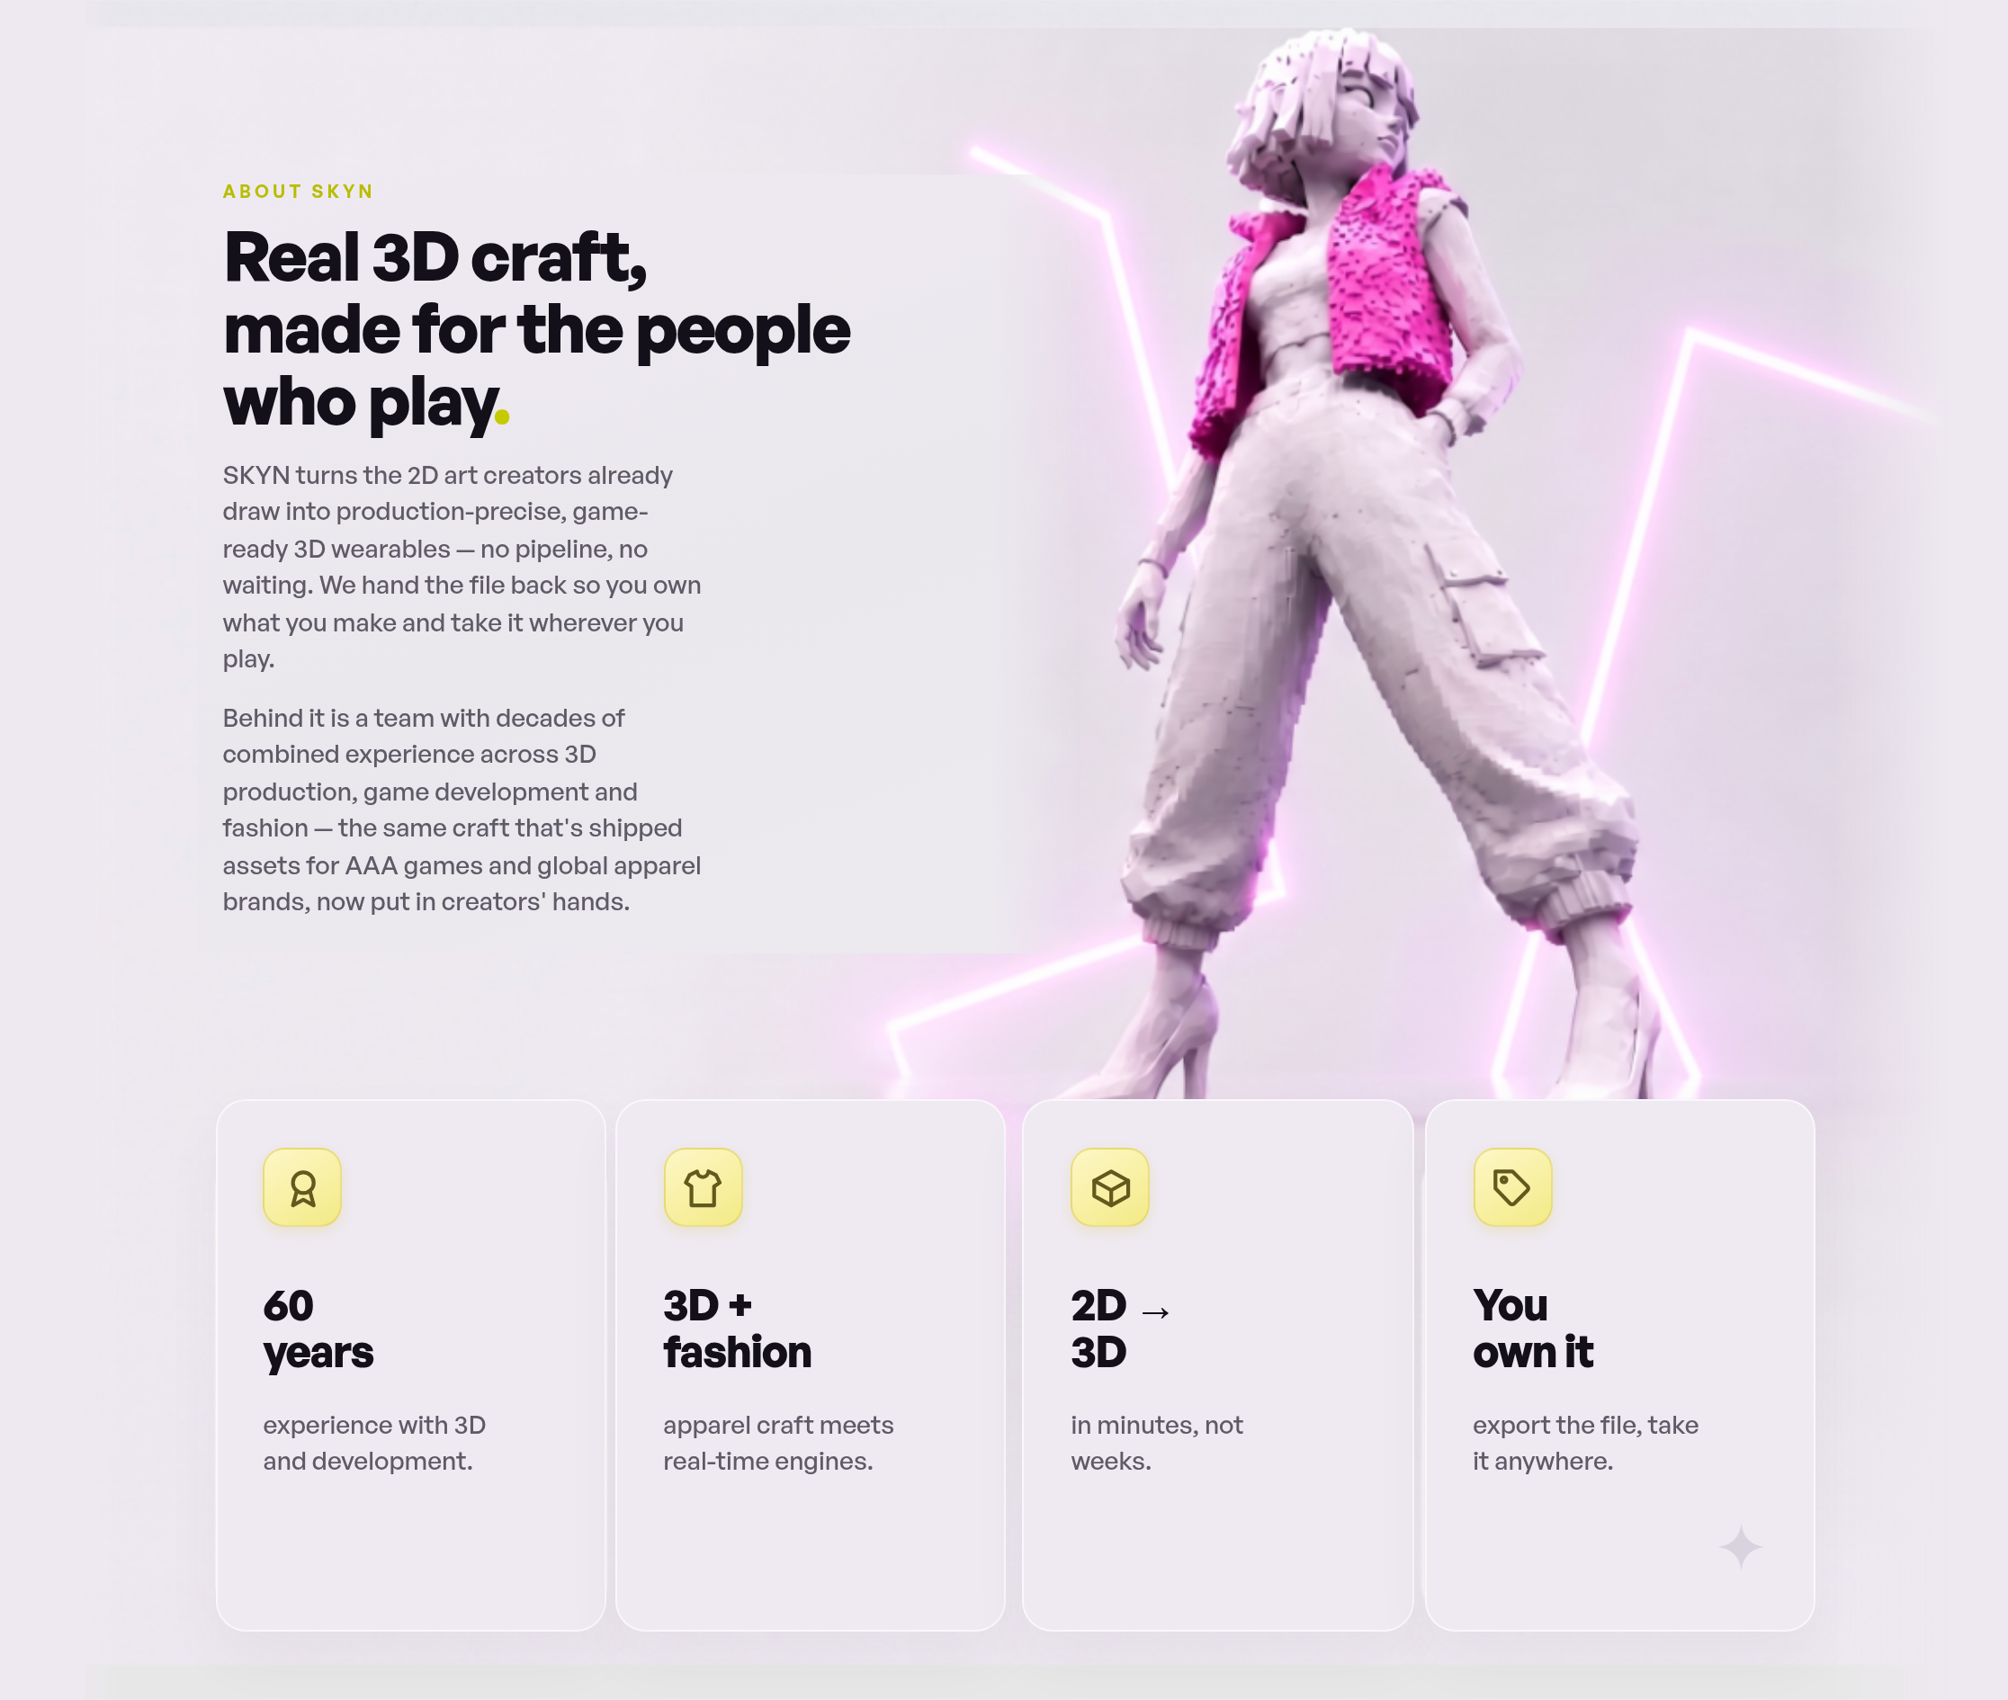
Element | Current text | New text
Eyebrow | About SKYN
Title (H2) | Real 3D craft, made for the people who play.
Text 1 | SKYN turns the 2D art creators already draw into production-precise, game-ready 3D wearables — no pipeline, no waiting. We hand the file back so you own what you make and take it wherever you play.
Text 2 | Behind it is a team with decades of combined experience across 3D production, game development and fashion — the same craft that's shipped assets for AAA games and global apparel brands, now put in creators' hands.
Stat card 1 | 60 years  experience with 3D and development.
Stat card 2 | 3D + fashion  apparel craft meets real-time engines.
Stat card 3 | 2D → 3D  in minutes, not weeks.
Stat card 4 | You own it  export the file, take it anywhere.

1.4 · Footer + cookie notice (shared across all pages)
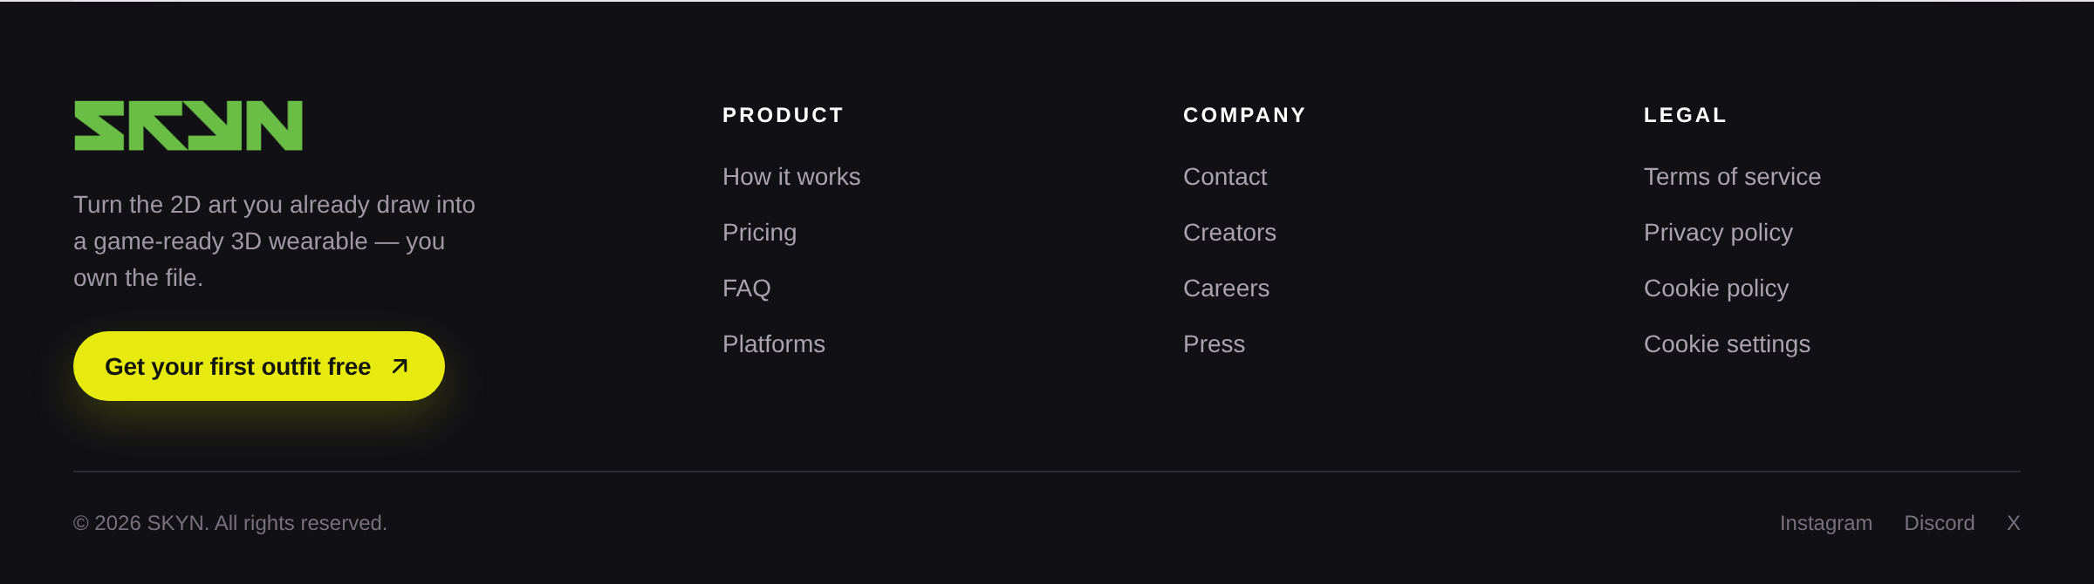
Element | Current text | New text
Brand tagline | Turn the 2D art you already draw into a game-ready 3D wearable — you own the file.
Footer CTA | Get your first outfit free
Column — Product | How it works · Pricing · FAQ · Platforms
Column — Company | Contact · Creators · Careers · Press
Column — Legal | Terms of service · Privacy policy · Cookie policy · Cookie settings
Bottom line | © 2026 SKYN. All rights reserved.
Social | Instagram · Discord · X
Cookie notice | Your privacy matters.  We use essential cookies and optional analytics to improve SKYN.  Reject optional · Accept all

2 · Welcome (returning user)
File: homepage_recognised.html — greeting screen for a signed-in user.
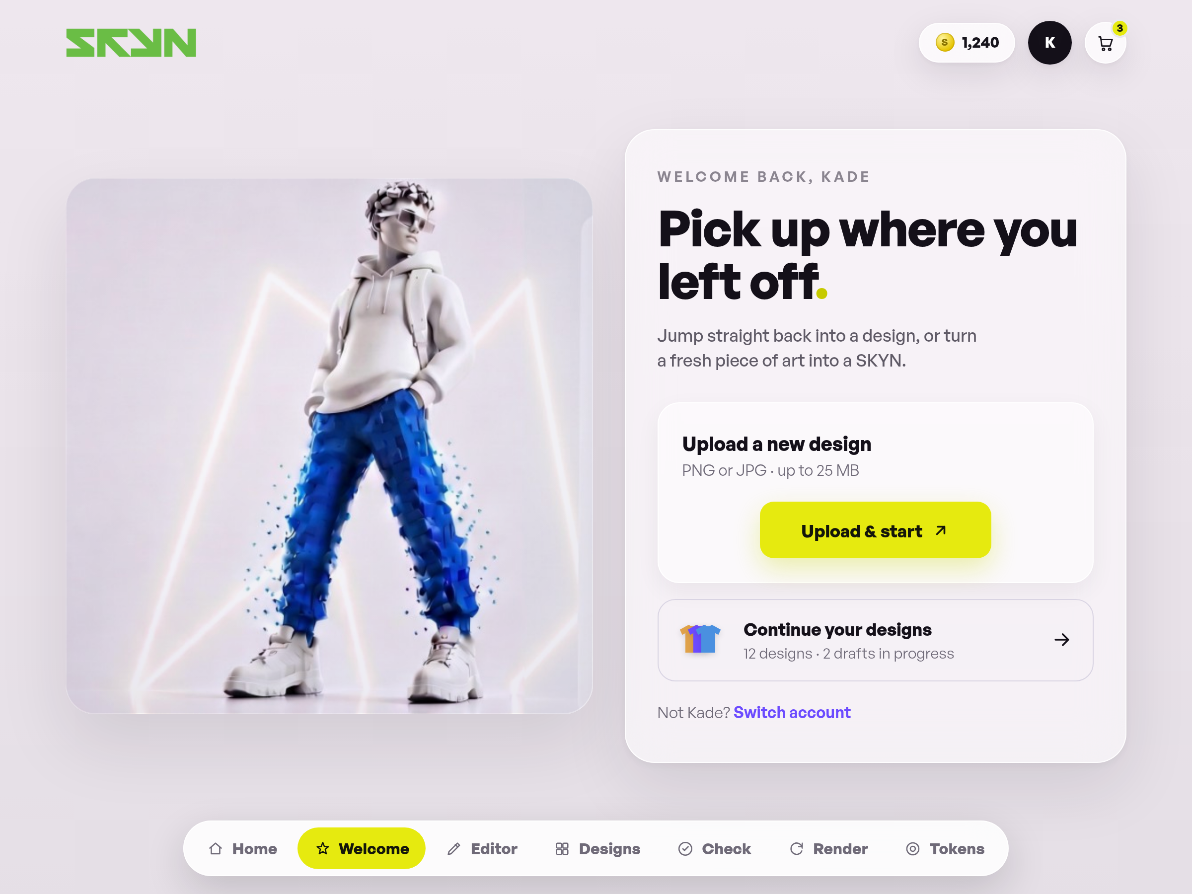
Element | Current text | New text
Eyebrow | Welcome back, Kade
Title (H1) | Pick up where you left off.
Lead | Jump straight back into a design, or turn a fresh piece of art into a SKYN.
Upload block | Upload a new design  PNG or JPG · up to 25 MB  Upload & start
Continue working | Continue your designs  12 designs · 2 drafts in progress
Fine print | Not Kade? Switch account
Bottom page bar | Home · Welcome · Editor · Designs · Check · Render · Tokens

3 · Editor
File: page2.html — 3D editor for viewing the SKYN and picking colour variants.
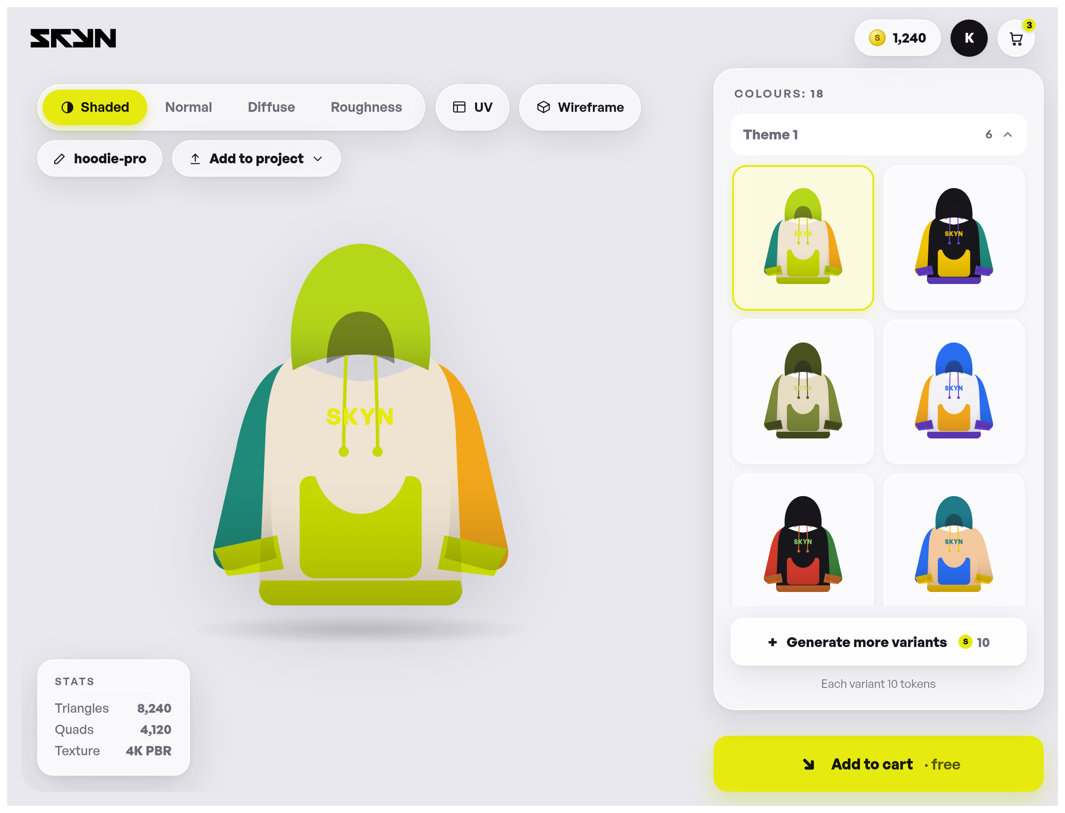
Element | Current text | New text
Header | Token counter: 1,240 · cart badge: 3
View modes | Shaded · Normal · Diffuse · Roughness
Extra tools | UV · Wireframe
Project name (editable) | hoodie-pro
Button | Add to project
Stats block | STATS  Triangles — 8,240  Quads — 4,120  Texture — 4K PBR
Sidebar colours | Colours: 18
Theme groups | Theme 1 · Theme 2 · Theme 3
Variants button | Generate more variants  S 10  Each variant 10 tokens
Primary button | Add to cart · free
Colours panel (title) | Add colours  15 palettes · pick a full palette
Panel button / line | Select a palette to render  Tap a palette to add all its colours
Palette names (sample data) | Berry · Candy · Cobalt · Coral · Crimson · Earth · Ember · Escape · Forest · Frost · Grape · Grape Soda · Ice · Jewel · Lilac · Midnight · Mint · Mono Warm · Monochrome · Neon · Ocean · Olive · Pastel · Peach · Racing · Retro · Sand · Sky · Slate · Sunrise · Sunset · Vibrant
Notifications (toasts) | Added [palette] · Render [palette]

4 · Designs
File: page3.html — overview of saved designs. Sidebar navigation + search/filter + card grid.
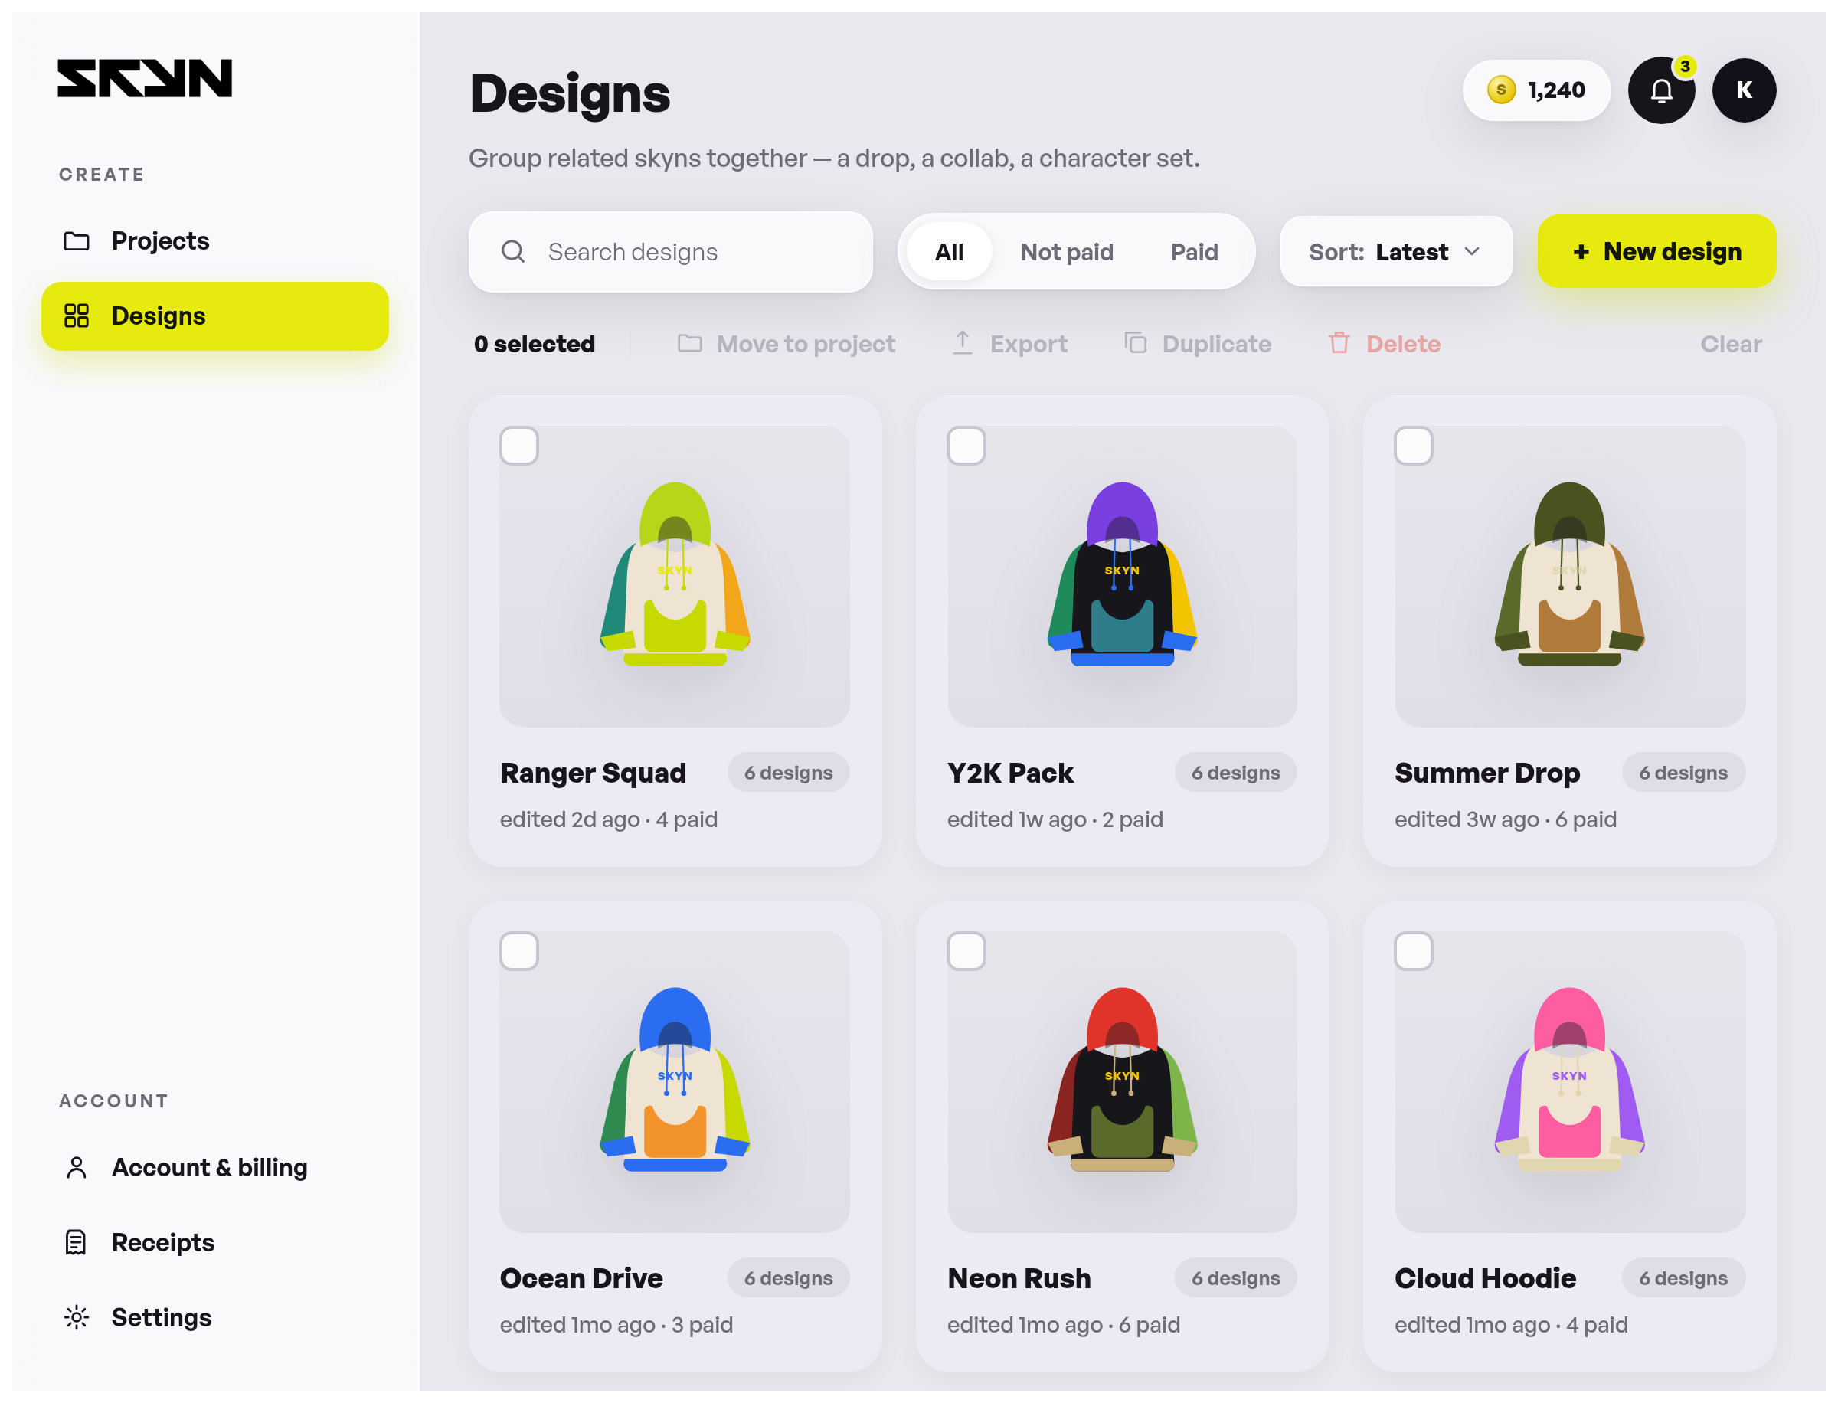
Element | Current text | New text
Sidebar — Create | Projects · Designs
Sidebar — Account | Account & billing · Receipts · Settings
Title (H1) | Designs
Subtitle | Group related skyns together — a drop, a collab, a character set.
Search field (placeholder) | Search designs
Filters | All · Not paid · Paid
Sort / button | Sort: Latest · + New design
Bulk bar | 0 selected · Move to project · Export · Duplicate · Delete · Clear
Design cards (sample data) | Ranger Squad — 6 colours · edited 2d ago  Y2K Pack — 6 colours · edited 1w ago  Summer Drop — 6 colours · edited 3w ago  Ocean Drive — 6 colours · edited 1mo ago  Neon Rush — 6 colours · edited 1mo ago  Cloud Hoodie — 6 colours · edited 1mo ago  Studio Line — 4 colours · edited 2mo ago  Retro Wave — 5 colours · edited 2mo ago  Court Kit — 6 colours · edited 3mo ago
Notifications (toasts) | New design — opening the editor… · Opening “…” in the editor… · Moved · Exported · Duplicated · Deleted · Select …
Footer | Shared footer — see 1.4

5 · Quality check
File: page5.html — checking the uploaded file before rendering.
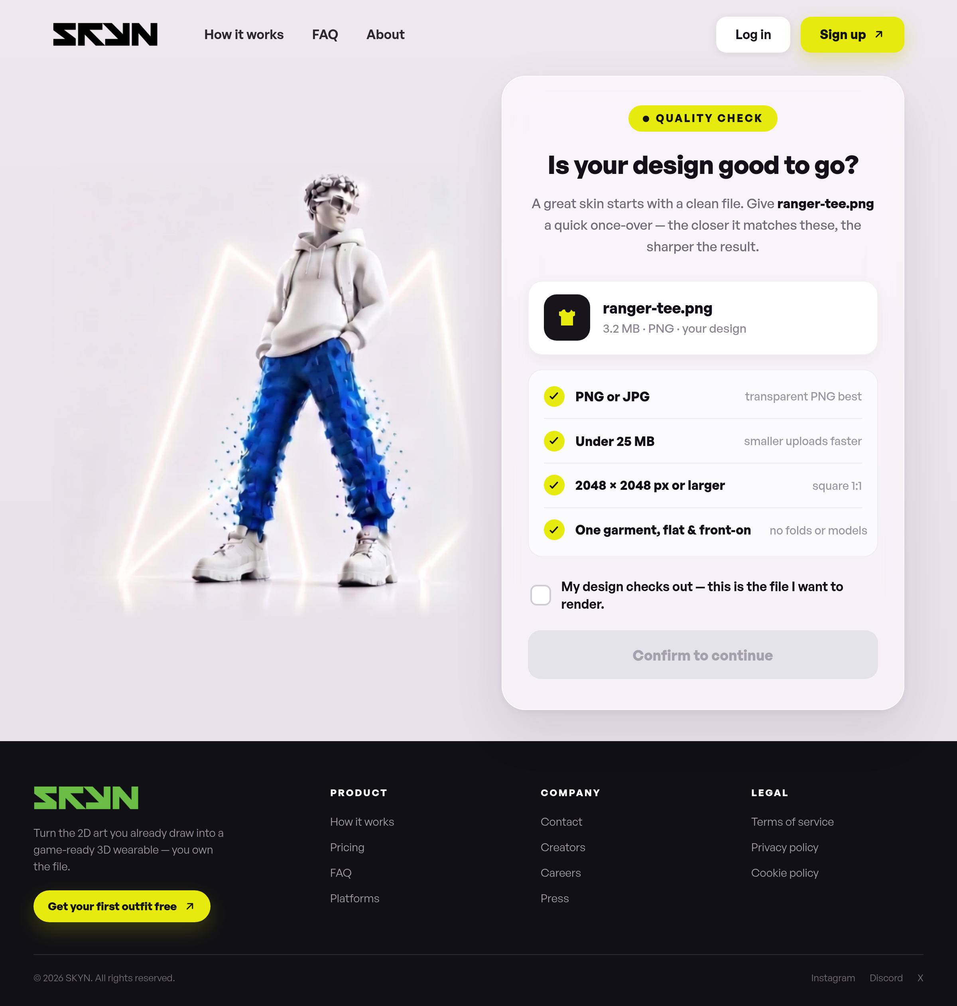
Element | Current text | New text
Navigation | How it works · FAQ · About · Log in · Sign up
Badge | Quality check
Title | Is your design good to go?
Subtext | A great skin starts with a clean file. Give ranger-tee.png a quick once-over — the closer it matches these, the sharper the result.
File chip | ranger-tee.png  3.2 MB · PNG · your design
Check 1 | PNG or JPG  transparent PNG best
Check 2 | Under 25 MB  smaller uploads faster
Check 3 | 2048 × 2048 px or larger  square 1:1
Check 4 | One garment, flat & front-on  no folds or models
Confirmation | My design checks out — this is the file I want to render.
Button | Confirm to continue
Footer | Shared footer — see 1.4

6 · Render (building)
File: page4.html — waiting screen while the 3D SKYN is generated.
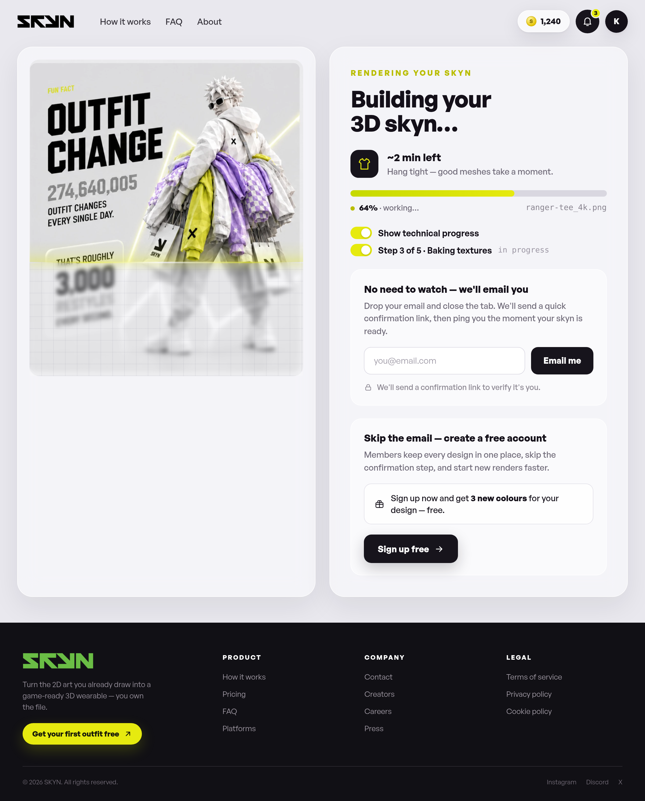
Element | Current text | New text
Navigation | How it works · FAQ · About
Fun fact (in image) | Fun fact — 274,640,005 outfit changes every single day, roughly 3,000 restyles every second
Eyebrow | Rendering your skyn
Title | Building your 3D skyn…
ETA | ~2 min left  Hang tight — good meshes take a moment.
Progress | 58% · working… · file: ranger-tee.png
Toggles | Show technical progress  Step 1 of 5 · Generating mesh — in progress
Step names (JS) | Generating mesh · UV unwrap · Baking textures · Final polish (Step X of 5)
Card 1 | No need to watch — we'll email you  Drop your email and close the tab. We'll send a quick confirmation link, then ping you the moment your skyn is ready.  Placeholder: you@email.com · Button: Email me  We'll send a confirmation link to verify it's you.
Card 2 | Skip the email — create a free account  Members keep every design in one place, skip the confirmation step, and start new renders faster.  Sign up now and get 3 new colours for your design — free.  Button: Sign up free
Notifications (toasts) | Enter a valid email address.  Done — we'll email you when your skyn is ready.  Creating your free account…  Your first outfit is free — let's go.
Footer | Shared footer — see 1.4

7 · Tokens (top up)
File: page6.html — buy token packs.
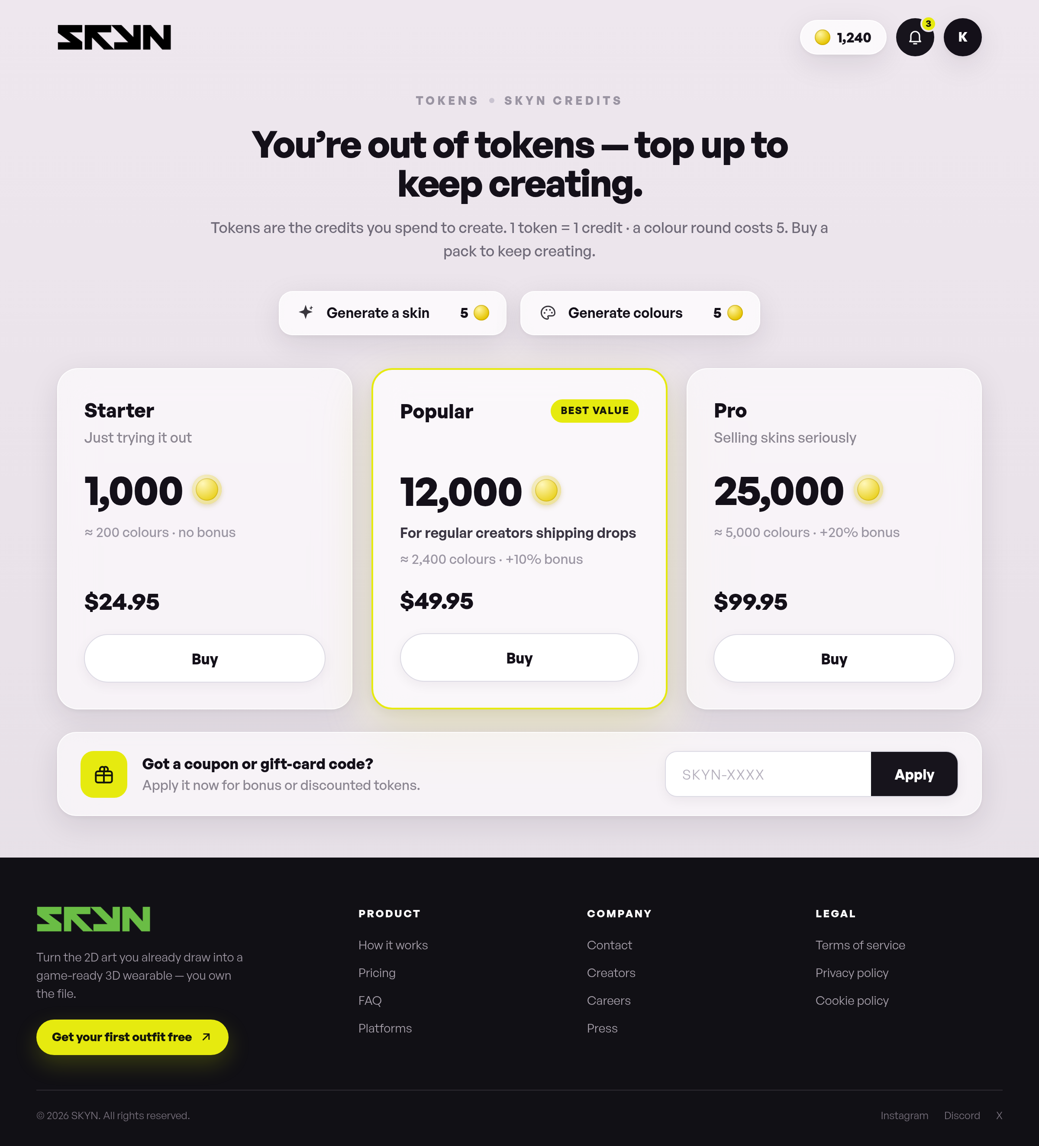
Element | Current text | New text
Eyebrow | Tokens · SKYN credits
Title | You’re out of tokens — top up to keep creating.
Subtext | Tokens are the credits you spend to create. 1 token = 1 credit · a colour round costs 5. Buy a pack to keep creating.
Cost chips | Generate a skin — 5  Generate colours — 5
Starter pack | Starter  Just trying it out  1,000 tokens · ≈ 200 colours · no bonus  $24.95 · Buy
Popular pack | Popular — Best value  For regular creators shipping drops  12,000 tokens · ≈ 2,400 colours · +10% bonus  $49.95 · Buy
Pro pack | Pro  Selling skins seriously  25,000 tokens · ≈ 5,000 colours · +20% bonus  $99.95 · Buy
Coupon block | Got a coupon or gift-card code?  Apply it now for bonus or discounted tokens.  Placeholder: SKYN-XXXX · Button: Apply
Footer | Shared footer — see 1.4

8 · Legal center
File: page7.html — legal documents. Full running text below.
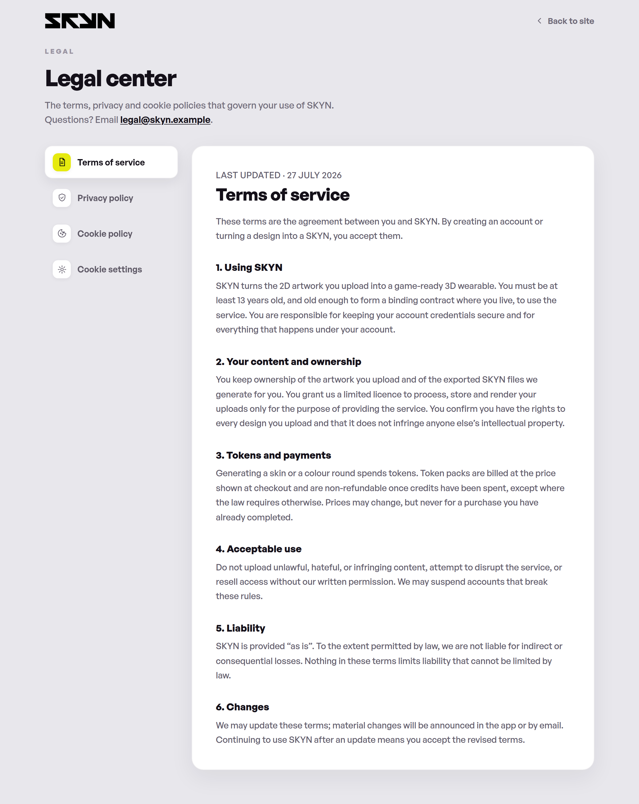
Element | Current text | New text
Top bar | Back to site
Eyebrow | Legal
Title (H1) | Legal center
Subtext | The terms, privacy and cookie policies that govern your use of SKYN. Questions? Email legal@skyn.example.
Side navigation | Terms of service · Privacy policy · Cookie policy · Cookie settings

8.1 · Terms of service
Last updated · 27 July 2026
These terms are the agreement between you and SKYN. By creating an account or turning a design into a SKYN, you accept them.

1. Using SKYN
SKYN turns the 2D artwork you upload into a game-ready 3D wearable. You must be at least 13 years old, and old enough to form a binding contract where you live, to use the service. You are responsible for keeping your account credentials secure and for everything that happens under your account.

2. Your content and ownership
You keep ownership of the artwork you upload and of the exported SKYN files we generate for you. You grant us a limited licence to process, store and render your uploads only for the purpose of providing the service. You confirm you have the rights to every design you upload and that it does not infringe anyone else’s intellectual property.

3. Tokens and payments
Generating a skin or a colour round spends tokens. Token packs are billed at the price shown at checkout and are non-refundable once credits have been spent, except where the law requires otherwise. Prices may change, but never for a purchase you have already completed.

4. Acceptable use
Do not upload unlawful, hateful, or infringing content, attempt to disrupt the service, or resell access without our written permission. We may suspend accounts that break these rules.

5. Liability
SKYN is provided “as is”. To the extent permitted by law, we are not liable for indirect or consequential losses. Nothing in these terms limits liability that cannot be limited by law.

6. Changes
We may update these terms; material changes will be announced in the app or by email. Continuing to use SKYN after an update means you accept the revised terms.

8.2 · Privacy policy
Last updated · 27 July 2026
This policy explains what we collect, why, and the choices you have. We collect as little as possible to run SKYN well.

1. What we collect
Account details you give us (name, email), the designs you upload and the SKYNs we generate, billing metadata from our payment processor, and basic usage and device data needed to keep the service reliable.

2. How we use it
To generate your SKYNs, run your account and billing, provide support, keep the service secure, and — only with your consent — to understand product usage through analytics.

3. Sharing
We do not sell your personal data. We share it only with processors that help us run SKYN (hosting, payments, email) under contracts that require them to protect it, or where the law requires disclosure.

4. Retention
We keep your uploads and generated files while your account is active. Delete a design and we remove it from active systems promptly; backups age out on a rolling schedule.

5. Your rights
You can access, correct, export or delete your personal data, and object to certain processing. Email privacy@skyn.example and we’ll respond within the timeframes the law sets.

8.3 · Cookie policy
Last updated · 27 July 2026
Cookies are small files stored on your device. We use a small set of them, and you stay in control of the optional ones.

1. Essential
Required to sign you in, keep your session secure and remember your basic preferences. The service cannot work without these, so they are always on.

2. Analytics
Help us understand which features are used so we can improve them. These load only if you allow them in cookie settings.

3. Personalization
Remember choices like recently used palettes to tailor your experience. Optional, and off until you opt in.

4. Managing cookies
Change your choices any time in cookie settings, or clear cookies in your browser. Blocking essential cookies may stop parts of SKYN from working.

8.4 · Cookie settings
Choose which optional cookies SKYN may use. Your choice is saved on this device and you can change it whenever you like.
Element | Current text | New text
Essential cookies | Sign-in, security and core preferences. Always active.
Analytics cookies | Anonymous usage stats that help us improve features.
Personalization cookies | Remember palettes and choices to tailor your experience.
Buttons | Reject optional · Save preferences

