SKYN
Alle teksten per pagina
Werkdocument voor copywriting
28 juli 2026
Dit document verzamelt alle zichtbare teksten van de SKYN-website en -app, pagina voor pagina. Bij elke pagina staat een screenshot als visuele referentie, zodat je precies ziet wáár een tekst hoort. De tabellen hebben drie kolommen:
- Onderdeel — waar de tekst staat (sectie, knop, veld).
- Huidige tekst — de tekst die er nu staat (Engels).
- Nieuwe tekst — leeg, om je nieuwe/vertaalde tekst in te schrijven.
Let op: sommige teksten zijn in de ontwerp-afbeeldingen "gebakken" (bv. testimonials en labels op de homepage). Die staan hieronder gemarkeerd met “(in render-afbeelding)” — ze zitten in het beeld, niet in bewerkbare tekst.

1 · Home (landingspagina)
Bestand: index.html — de publieke landingspagina. Vier secties: hero, FAQ + pricing, about, footer.

1.1 · Hero
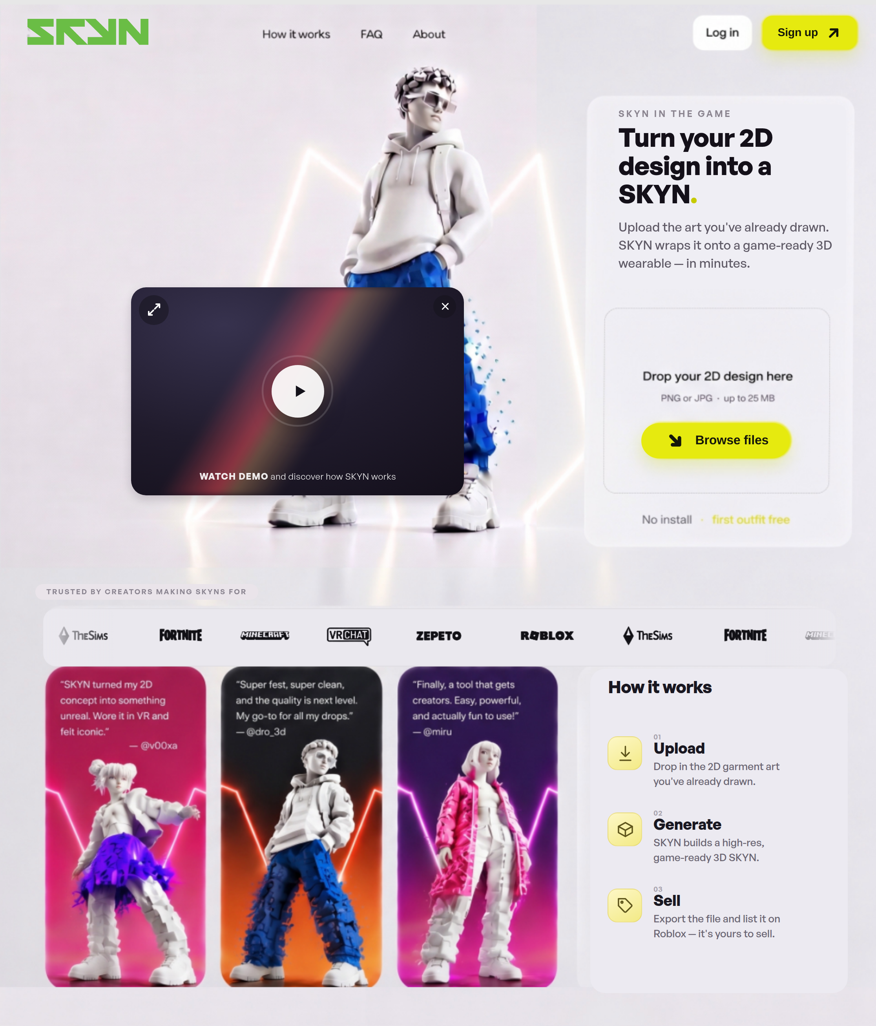
Onderdeel | Huidige tekst | Nieuwe tekst
Navigatie | How it works · FAQ · About · Log in · Sign up
Eyebrow | SKYN in the game
Titel (H1) | Turn your 2D design into a SKYN.
Introtekst | Upload the art you've already drawn. SKYN wraps it onto a game-ready 3D wearable — in minutes.
Upload-kaart | Drop your 2D design here  PNG or JPG · up to 25 MB  Browse files
Onder upload (in render-afbeelding) | No install · first outfit free
Video-knop | Watch demo and discover how SKYN works
Trusted-by label | Trusted by creators making SKYNs for
Merklogo’s (ticker) | Roblox · The Sims · Fortnite · Minecraft · VRChat · Zepeto
How it works — titel | How it works
Stap 01 | Upload  Drop in the 2D garment art you've already drawn.
Stap 02 | Generate  SKYN builds a high-res, game-ready 3D SKYN.
Stap 03 | Sell  Export the file and list it on Roblox — it's yours to sell.
Testimonials (in render-afbeelding) | “…concept into something unreal. Wore it in VR and felt iconic.” — @v00xa  “…and the quality is next level. My go-to for all my drops.” — @dro_3d  “…creators. Easy, powerful, and actually fun to use!” — @miru

1.2 · FAQ + Pricing
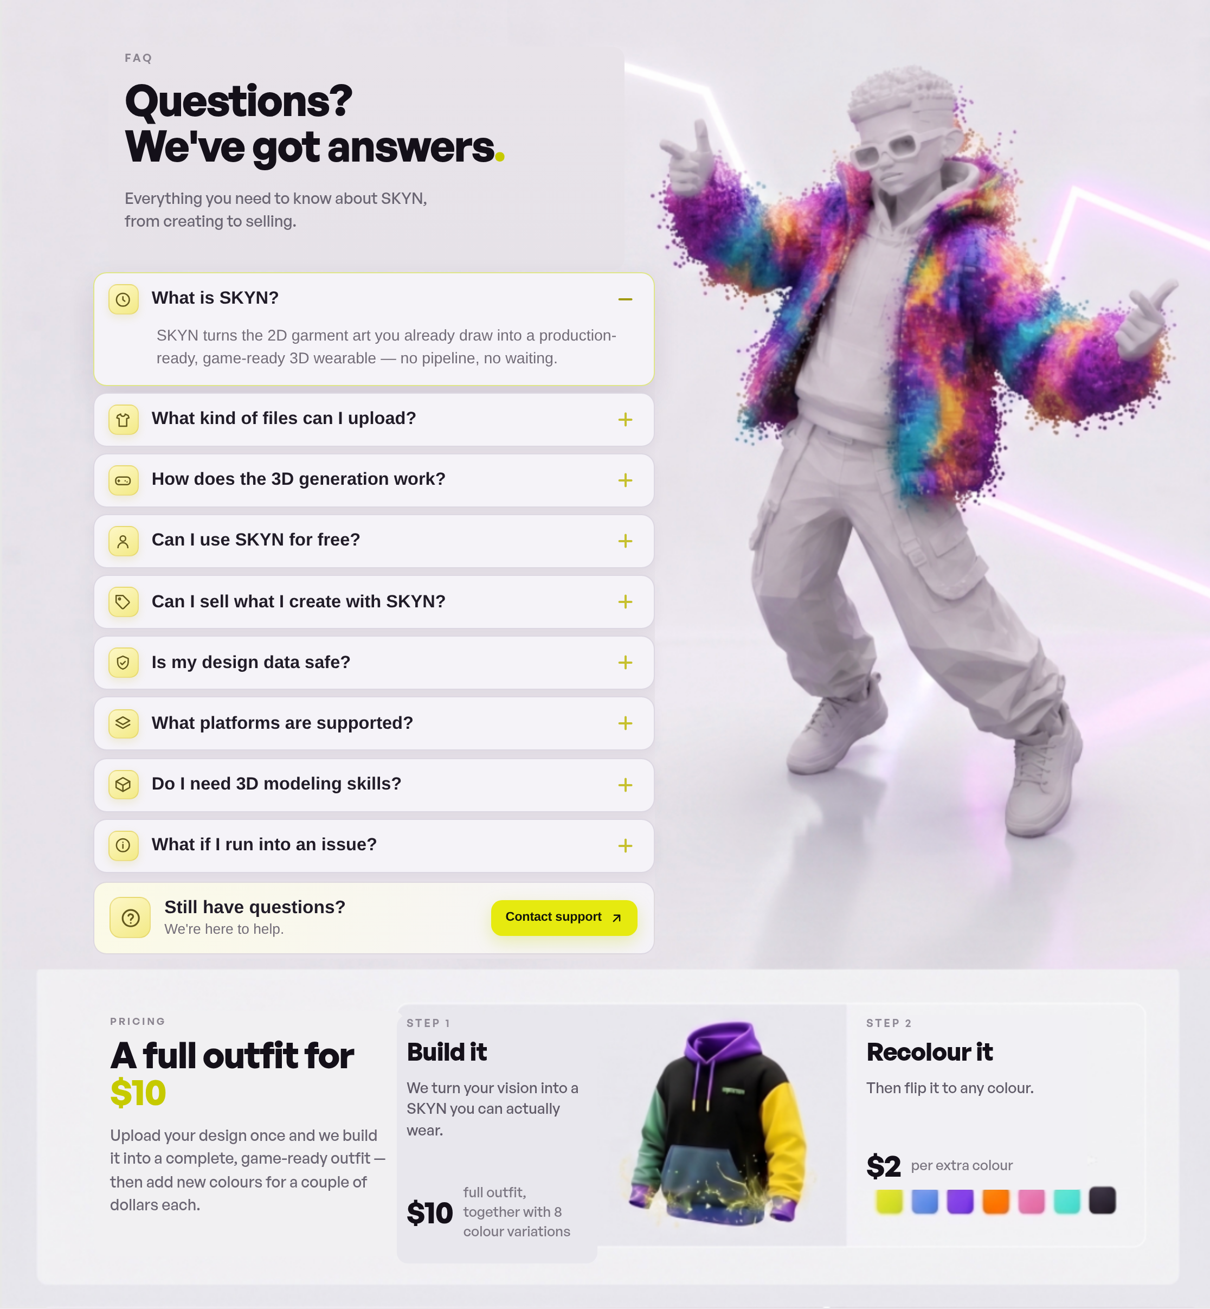

FAQ
Onderdeel | Huidige tekst | Nieuwe tekst
Eyebrow | FAQ
Titel (H2) | Questions? We've got answers.
Introtekst | Everything you need to know about SKYN, from creating to selling.
Vraag 1 | What is SKYN?  SKYN turns the 2D garment art you already draw into a production-ready, game-ready 3D wearable — no pipeline, no waiting.
Vraag 2 | What kind of files can I upload?  PNG or JPG artwork up to 25 MB. Clean, high-contrast designs give the sharpest results.
Vraag 3 | How does the 3D generation work?  We map your artwork onto a game-ready garment base, then refine geometry and materials for real-time engines.
Vraag 4 | Can I use SKYN for free?  Your first outfit is free — no install required. After that a full outfit is a flat $10.
Vraag 5 | Can I sell what I create with SKYN?  Yes. You own the exported file and can list it on platforms like Roblox and keep the revenue.
Vraag 6 | Is my design data safe?  Your uploads stay private and are used only to generate your SKYN. You keep full ownership.
Vraag 7 | What platforms are supported?  Roblox, The Sims, Fortnite, Minecraft, VRChat, Zepeto and any engine that accepts standard 3D formats.
Vraag 8 | Do I need 3D modeling skills?  None at all. If you can draw or design in 2D, SKYN handles the entire 3D pipeline for you.
Vraag 9 | What if I run into an issue?  Our support team is one click away and happy to help you get your SKYN game-ready.
CTA | Still have questions?  We're here to help.  Contact support

Pricing
Onderdeel | Huidige tekst | Nieuwe tekst
Eyebrow | Pricing
Titel (H2) | A full outfit for $10
Introtekst | Upload your design once and we build it into a complete, game-ready outfit — then add new colours for a couple of dollars each.
Stap 1 | Step 1 — Build it  We turn your vision into a SKYN you can actually wear.  $10 — full outfit, together with 8 colour variations
Stap 2 | Step 2 — Recolour it  Then flip it to any colour.  $2 — per extra colour

1.3 · About
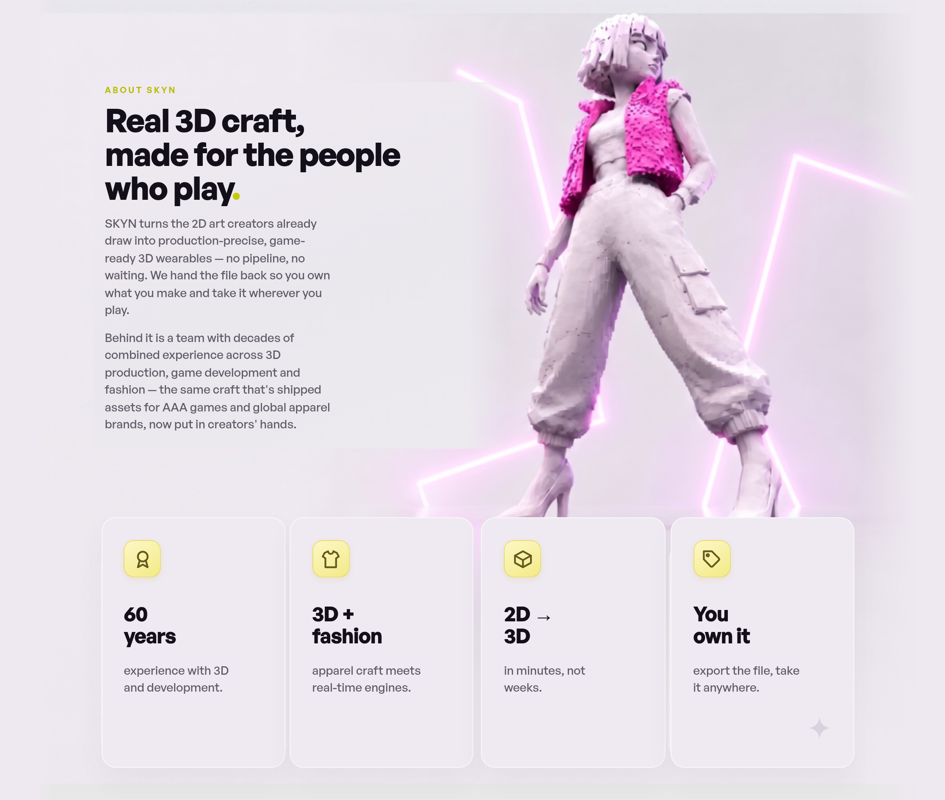
Onderdeel | Huidige tekst | Nieuwe tekst
Eyebrow | About SKYN
Titel (H2) | Real 3D craft, made for the people who play.
Tekst 1 | SKYN turns the 2D art creators already draw into production-precise, game-ready 3D wearables — no pipeline, no waiting. We hand the file back so you own what you make and take it wherever you play.
Tekst 2 | Behind it is a team with decades of combined experience across 3D production, game development and fashion — the same craft that's shipped assets for AAA games and global apparel brands, now put in creators' hands.
Statkaart 1 | 60 years  experience with 3D and development.
Statkaart 2 | 3D + fashion  apparel craft meets real-time engines.
Statkaart 3 | 2D → 3D  in minutes, not weeks.
Statkaart 4 | You own it  export the file, take it anywhere.

1.4 · Footer + cookie-melding (gedeeld op alle pagina’s)
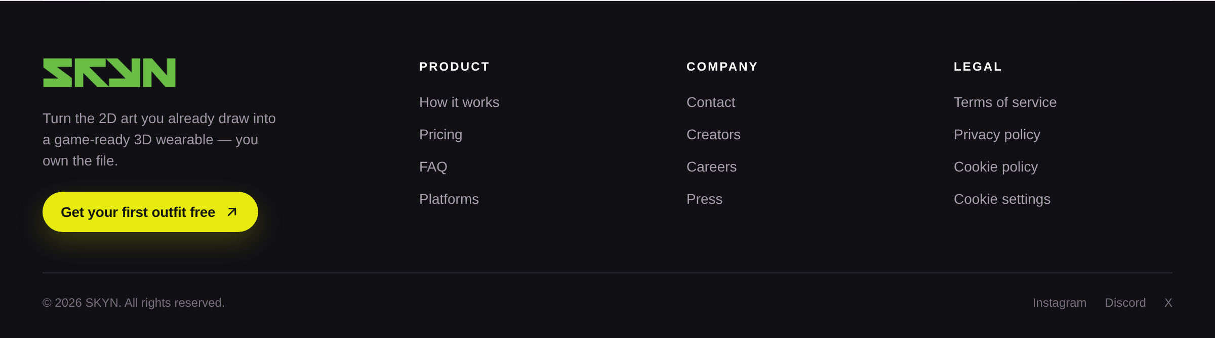
Onderdeel | Huidige tekst | Nieuwe tekst
Merk-tagline | Turn the 2D art you already draw into a game-ready 3D wearable — you own the file.
Footer-CTA | Get your first outfit free
Kolom Product | How it works · Pricing · FAQ · Platforms
Kolom Company | Contact · Creators · Careers · Press
Kolom Legal | Terms of service · Privacy policy · Cookie policy · Cookie settings
Onderregel | © 2026 SKYN. All rights reserved.
Social | Instagram · Discord · X
Cookie-melding | Your privacy matters.  We use essential cookies and optional analytics to improve SKYN.  Reject optional · Accept all

2 · Welcome (terugkerende gebruiker)
Bestand: homepage_recognised.html — begroetingsscherm voor een ingelogde gebruiker.
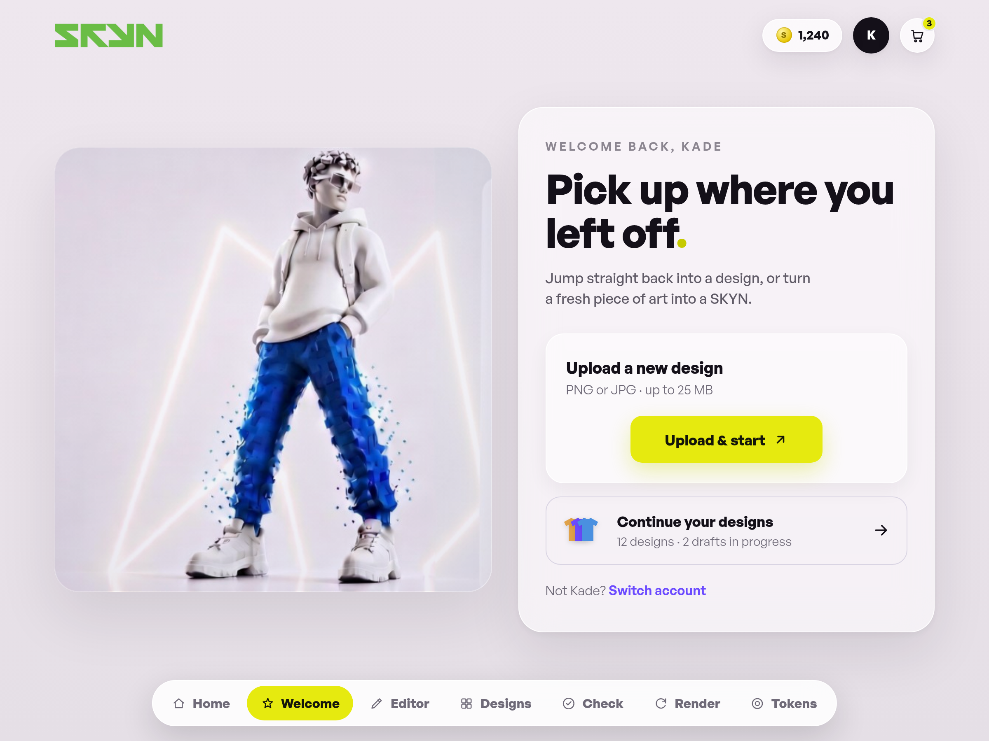
Onderdeel | Huidige tekst | Nieuwe tekst
Eyebrow | Welcome back, Kade
Titel (H1) | Pick up where you left off.
Lead | Jump straight back into a design, or turn a fresh piece of art into a SKYN.
Upload-blok | Upload a new design  PNG or JPG · up to 25 MB  Upload & start
Verder werken | Continue your designs  12 designs · 2 drafts in progress
Kleine regel | Not Kade? Switch account
Paginabalk onderaan | Home · Welcome · Editor · Designs · Check · Render · Tokens

3 · Editor
Bestand: page2.html — 3D-editor waarin de SKYN wordt bekeken en kleurvarianten worden gekozen.
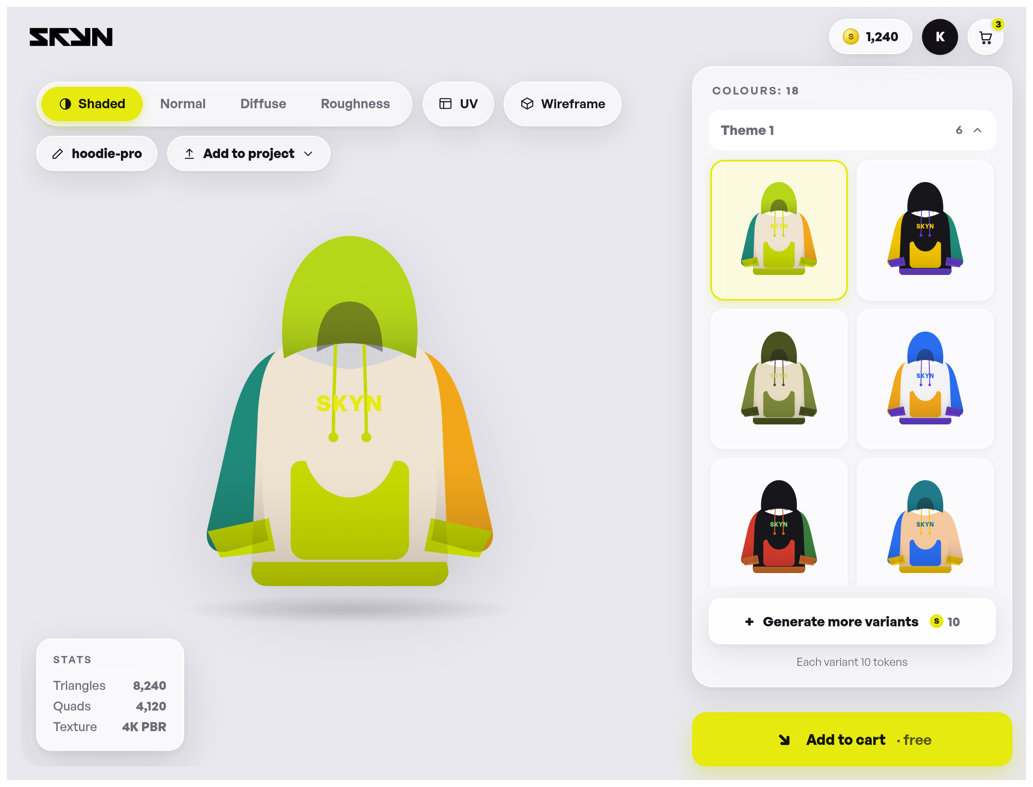
Onderdeel | Huidige tekst | Nieuwe tekst
Header | Token-teller: 1,240 · winkelmand-badge: 3
Weergavemodi | Shaded · Normal · Diffuse · Roughness
Extra tools | UV · Wireframe
Projectnaam (bewerkbaar) | hoodie-pro
Knop | Add to project
Stats-blok | STATS  Triangles — 8,240  Quads — 4,120  Texture — 4K PBR
Zijbalk kleuren | Colours: 18
Thema-groepen | Theme 1 · Theme 2 · Theme 3
Knop varianten | Generate more variants  S 10  Each variant 10 tokens
Hoofdknop | Add to cart · free
Kleuren-paneel (titel) | Add colours  15 palettes · pick a full palette
Paneel-knop / -regel | Select a palette to render  Tap a palette to add all its colours
Palet-namen (voorbeelddata) | Berry · Candy · Cobalt · Coral · Crimson · Earth · Ember · Escape · Forest · Frost · Grape · Grape Soda · Ice · Jewel · Lilac · Midnight · Mint · Mono Warm · Monochrome · Neon · Ocean · Olive · Pastel · Peach · Racing · Retro · Sand · Sky · Slate · Sunrise · Sunset · Vibrant
Meldingen (toasts) | Added [palet] · Render [palet]

4 · Designs
Bestand: page3.html — overzicht van opgeslagen designs. Zijbalk-navigatie + zoek/filter + kaartenraster.
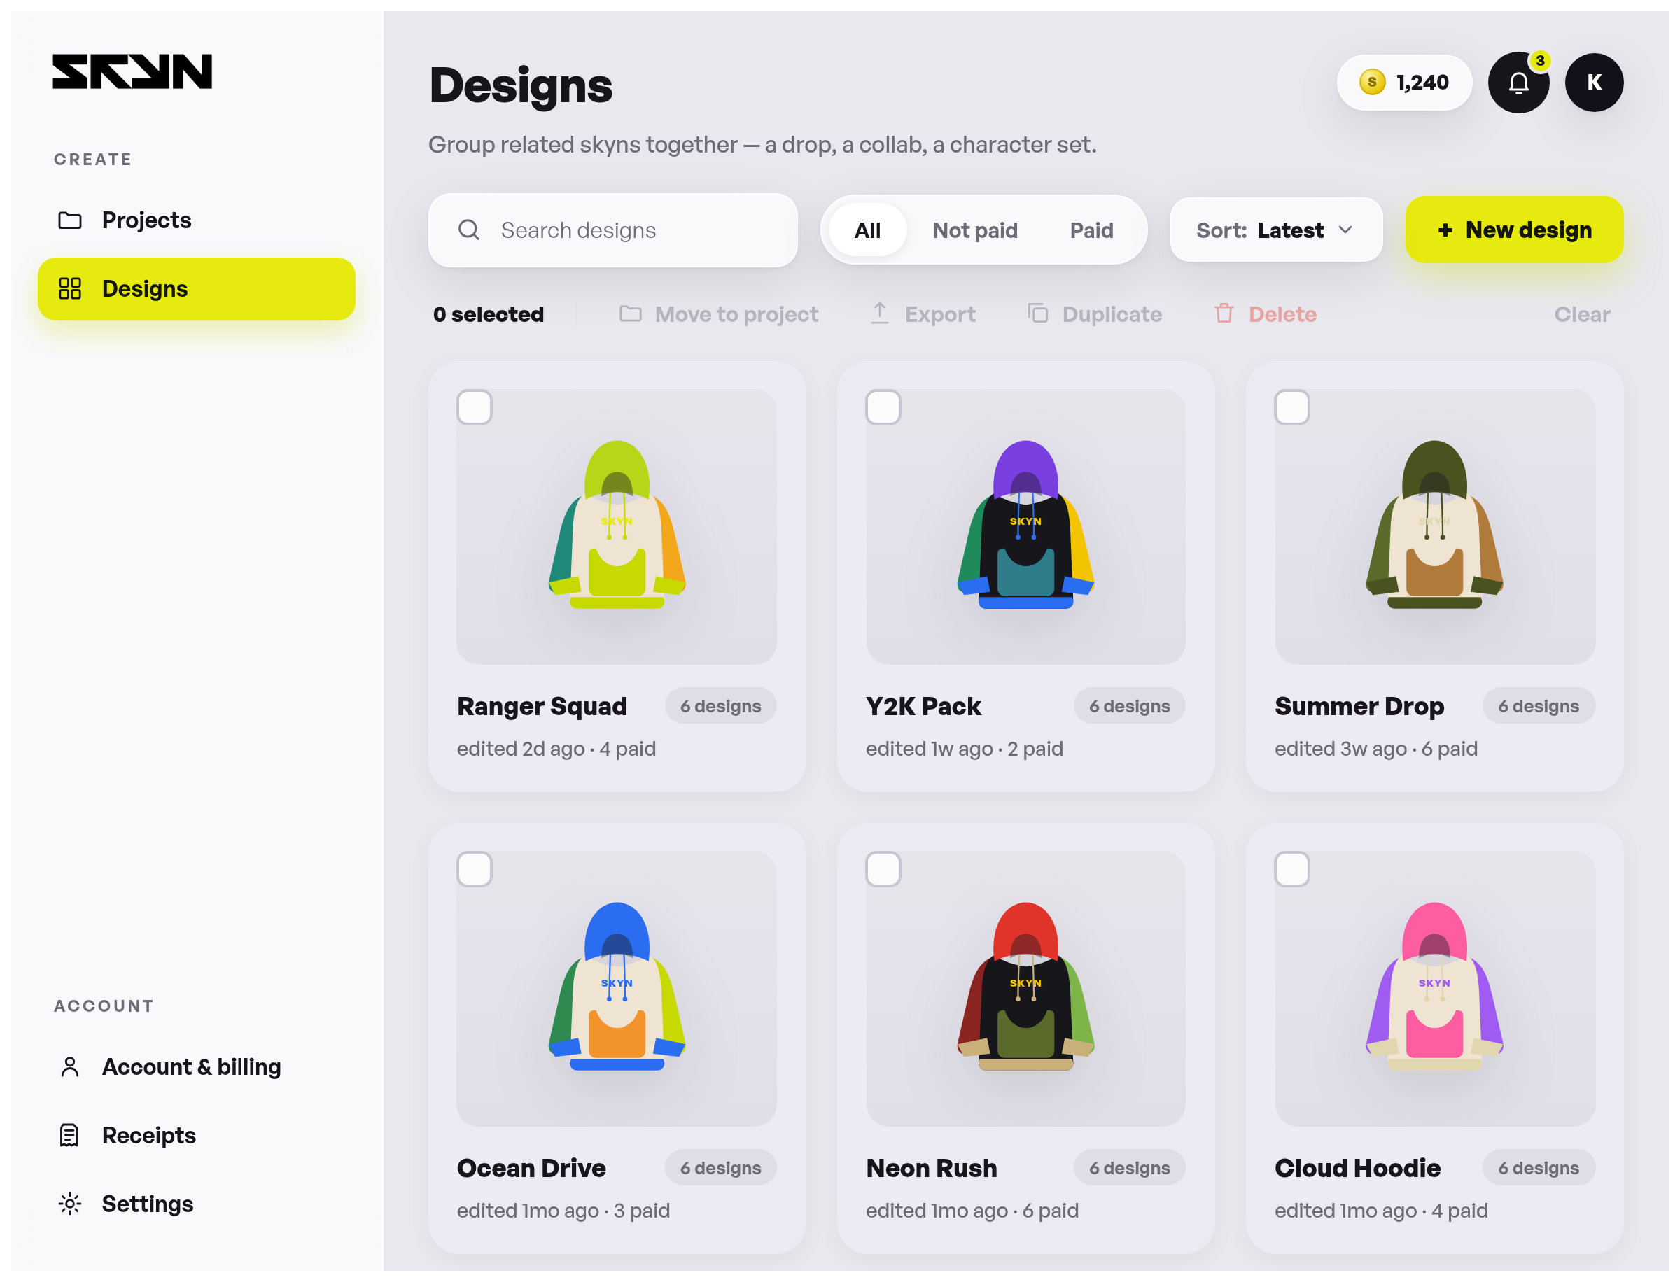
Onderdeel | Huidige tekst | Nieuwe tekst
Zijbalk — Create | Projects · Designs
Zijbalk — Account | Account & billing · Receipts · Settings
Titel (H1) | Designs
Subtitel | Group related skyns together — a drop, a collab, a character set.
Zoekveld (placeholder) | Search designs
Filters | All · Not paid · Paid
Sorteren / knop | Sort: Latest · + New design
Bulk-balk | 0 selected · Move to project · Export · Duplicate · Delete · Clear
Design-kaarten (voorbeelddata) | Ranger Squad — 6 colours · edited 2d ago  Y2K Pack — 6 colours · edited 1w ago  Summer Drop — 6 colours · edited 3w ago  Ocean Drive — 6 colours · edited 1mo ago  Neon Rush — 6 colours · edited 1mo ago  Cloud Hoodie — 6 colours · edited 1mo ago  Studio Line — 4 colours · edited 2mo ago  Retro Wave — 5 colours · edited 2mo ago  Court Kit — 6 colours · edited 3mo ago
Meldingen (toasts) | New design — opening the editor… · Opening “…” in the editor… · Moved · Exported · Duplicated · Deleted · Select …
Footer | Gedeelde footer — zie 1.4

5 · Quality check
Bestand: page5.html — controle van het geüploade bestand vóór het renderen.
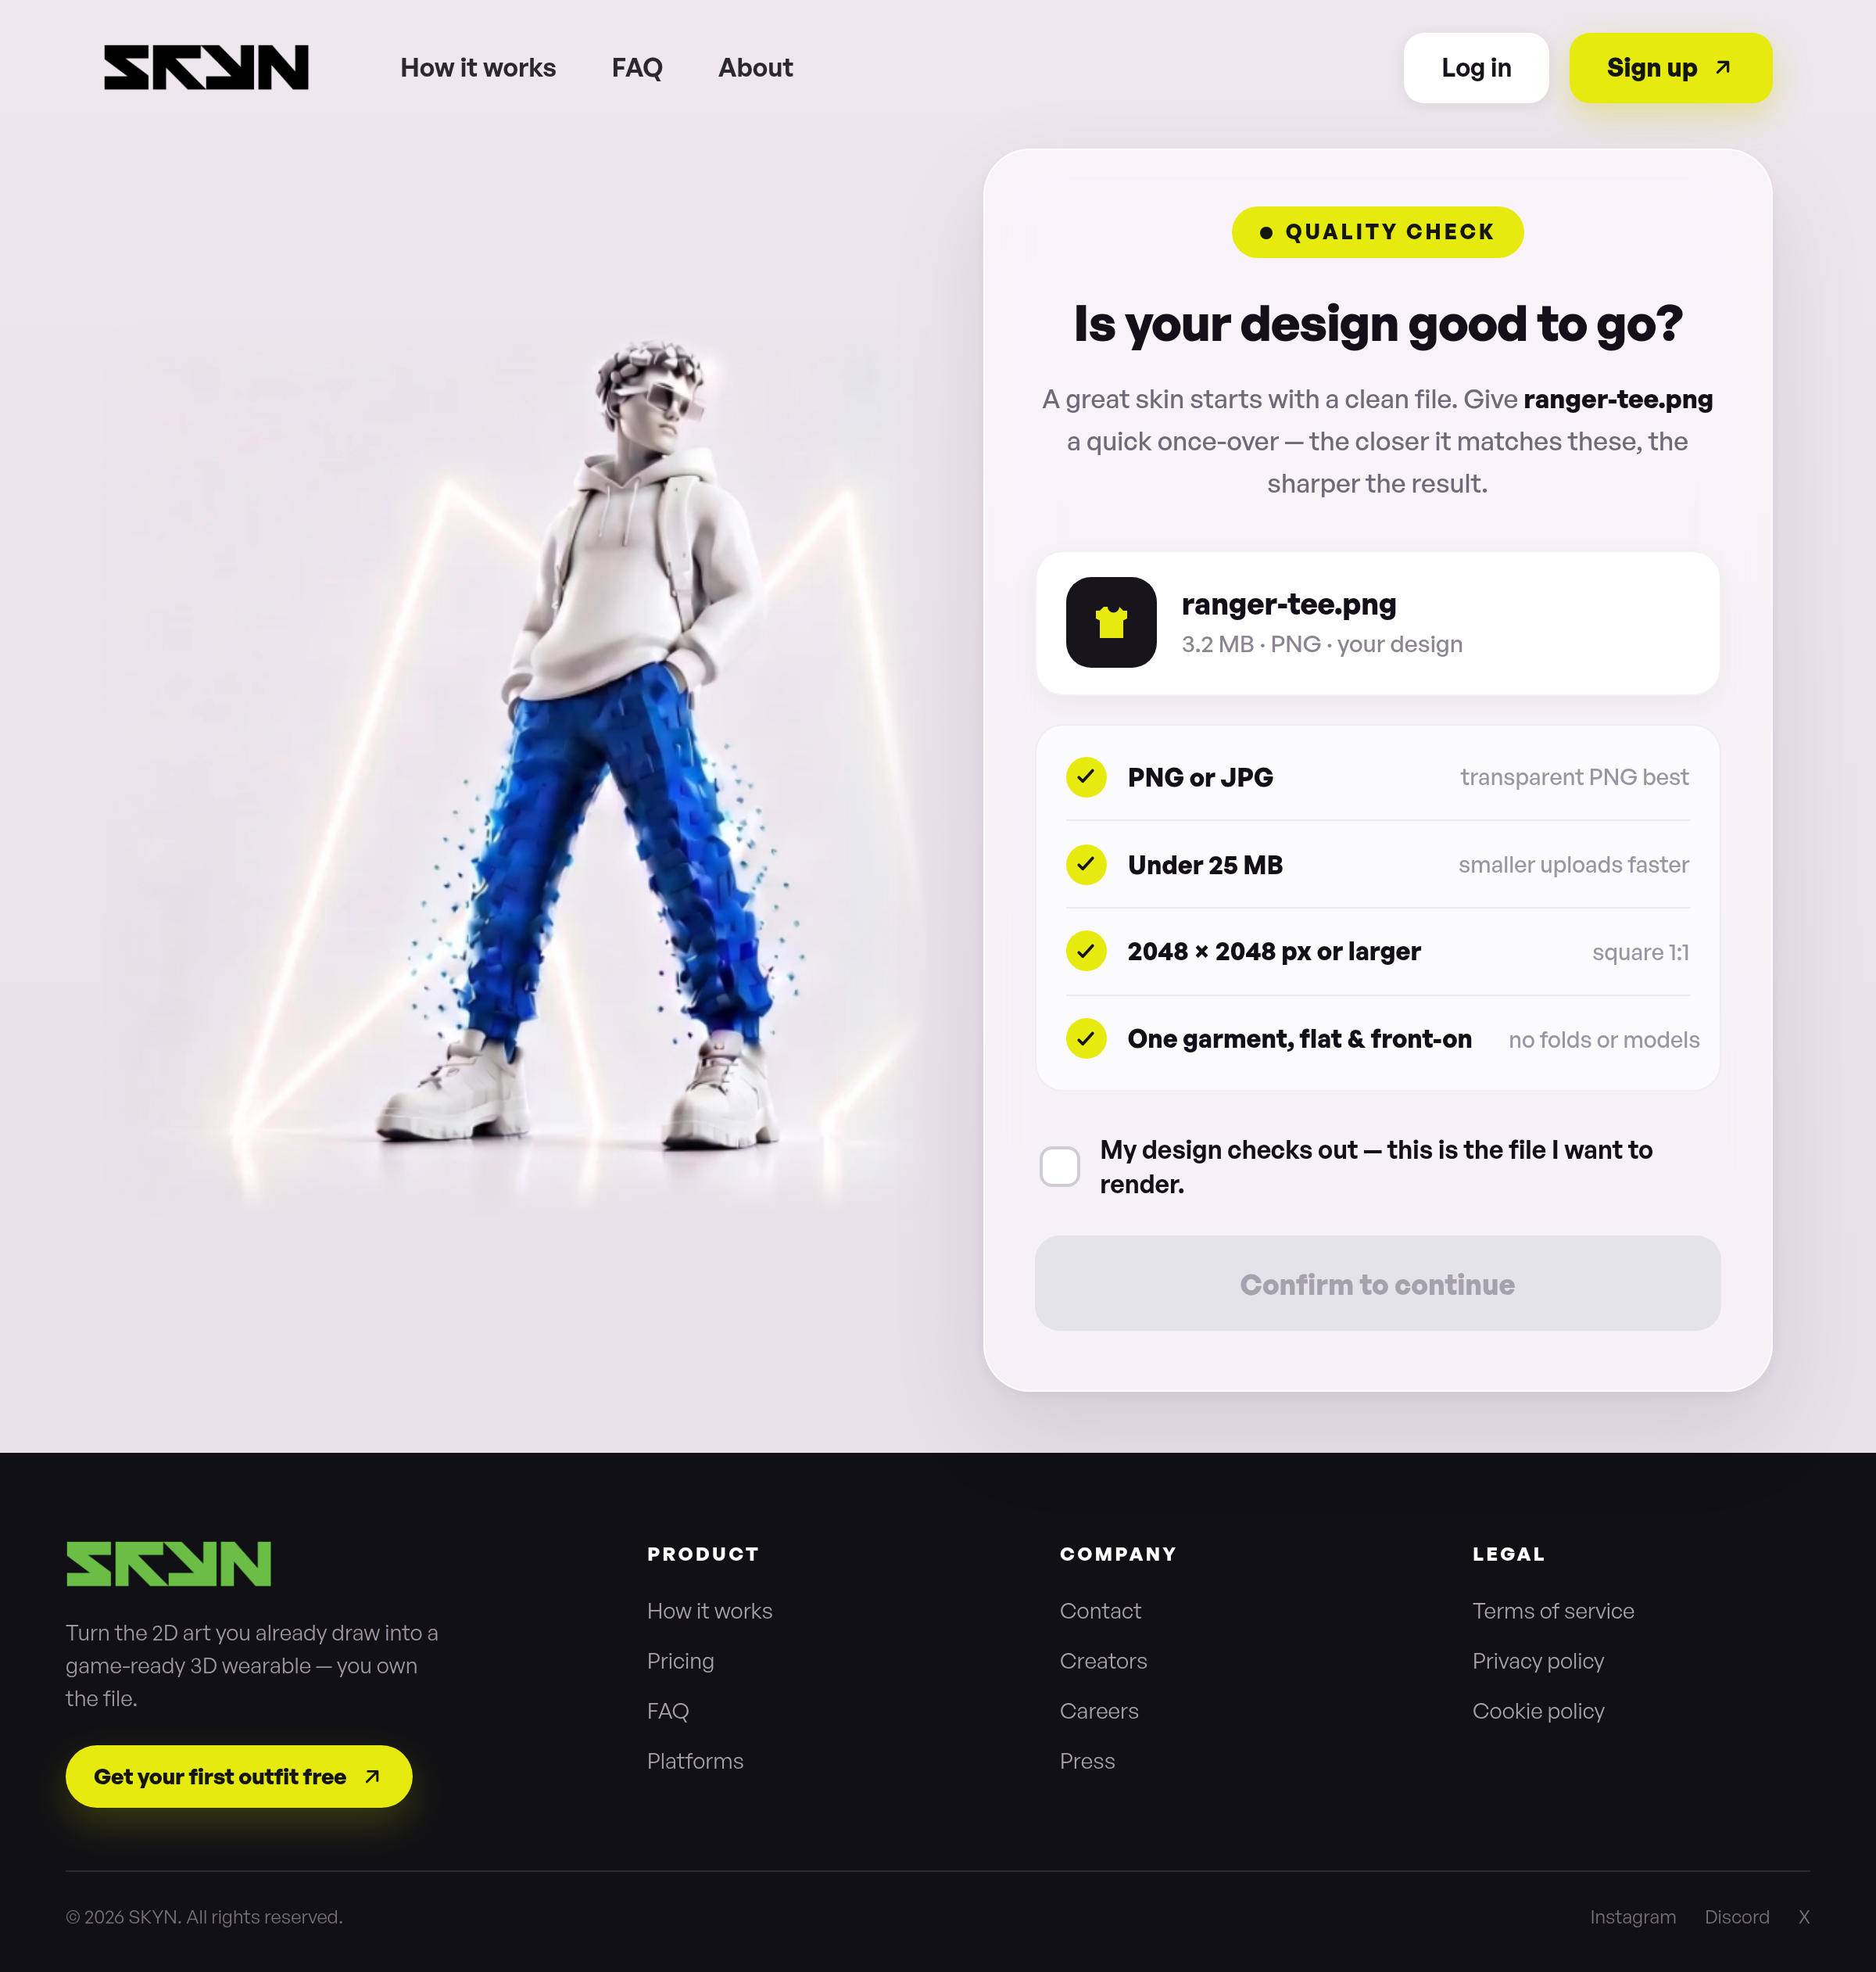
Onderdeel | Huidige tekst | Nieuwe tekst
Navigatie | How it works · FAQ · About · Log in · Sign up
Badge | Quality check
Titel | Is your design good to go?
Subtekst | A great skin starts with a clean file. Give ranger-tee.png a quick once-over — the closer it matches these, the sharper the result.
Bestand-chip | ranger-tee.png  3.2 MB · PNG · your design
Check 1 | PNG or JPG  transparent PNG best
Check 2 | Under 25 MB  smaller uploads faster
Check 3 | 2048 × 2048 px or larger  square 1:1
Check 4 | One garment, flat & front-on  no folds or models
Bevestiging | My design checks out — this is the file I want to render.
Knop | Confirm to continue
Footer | Gedeelde footer — zie 1.4

6 · Render (bezig met bouwen)
Bestand: page4.html — wachtscherm terwijl de 3D-SKYN wordt gegenereerd.
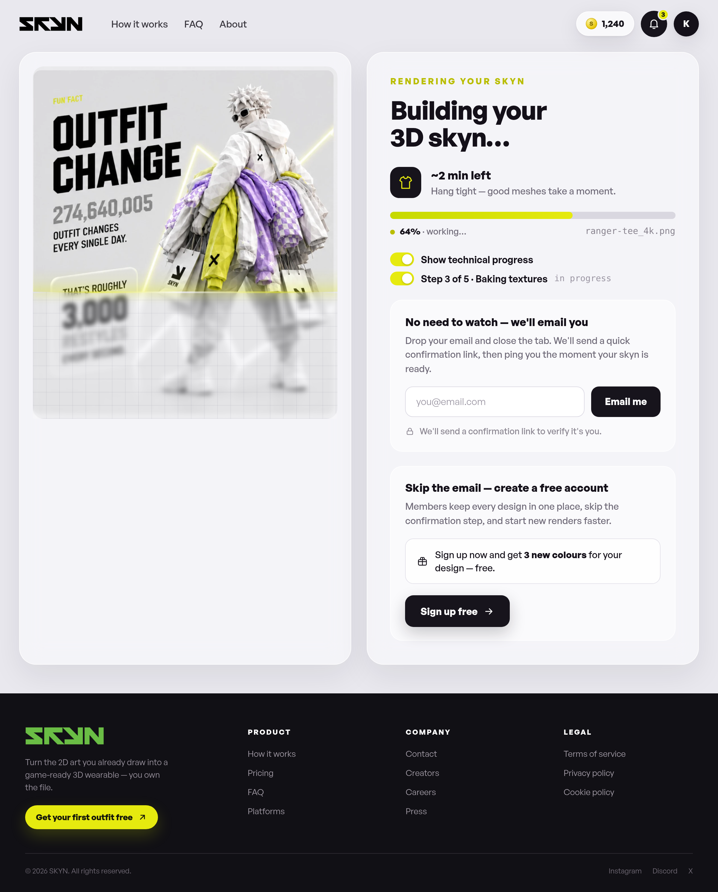
Onderdeel | Huidige tekst | Nieuwe tekst
Navigatie | How it works · FAQ · About
Fun-fact (in afbeelding) | Fun fact — 274,640,005 outfit changes every single day, roughly 3,000 restyles every second
Eyebrow | Rendering your skyn
Titel | Building your 3D skyn…
ETA | ~2 min left  Hang tight — good meshes take a moment.
Voortgang | 58% · working… · bestand: ranger-tee.png
Toggles | Show technical progress  Step 1 of 5 · Generating mesh — in progress
Stap-namen (JS) | Generating mesh · UV unwrap · Baking textures · Final polish (Step X of 5)
Kaart 1 | No need to watch — we'll email you  Drop your email and close the tab. We'll send a quick confirmation link, then ping you the moment your skyn is ready.  Placeholder: you@email.com · Knop: Email me  We'll send a confirmation link to verify it's you.
Kaart 2 | Skip the email — create a free account  Members keep every design in one place, skip the confirmation step, and start new renders faster.  Sign up now and get 3 new colours for your design — free.  Knop: Sign up free
Meldingen (toasts) | Enter a valid email address.  Done — we'll email you when your skyn is ready.  Creating your free account…  Your first outfit is free — let's go.
Footer | Gedeelde footer — zie 1.4

7 · Tokens (bijkopen)
Bestand: page6.html — token-pakketten kopen.
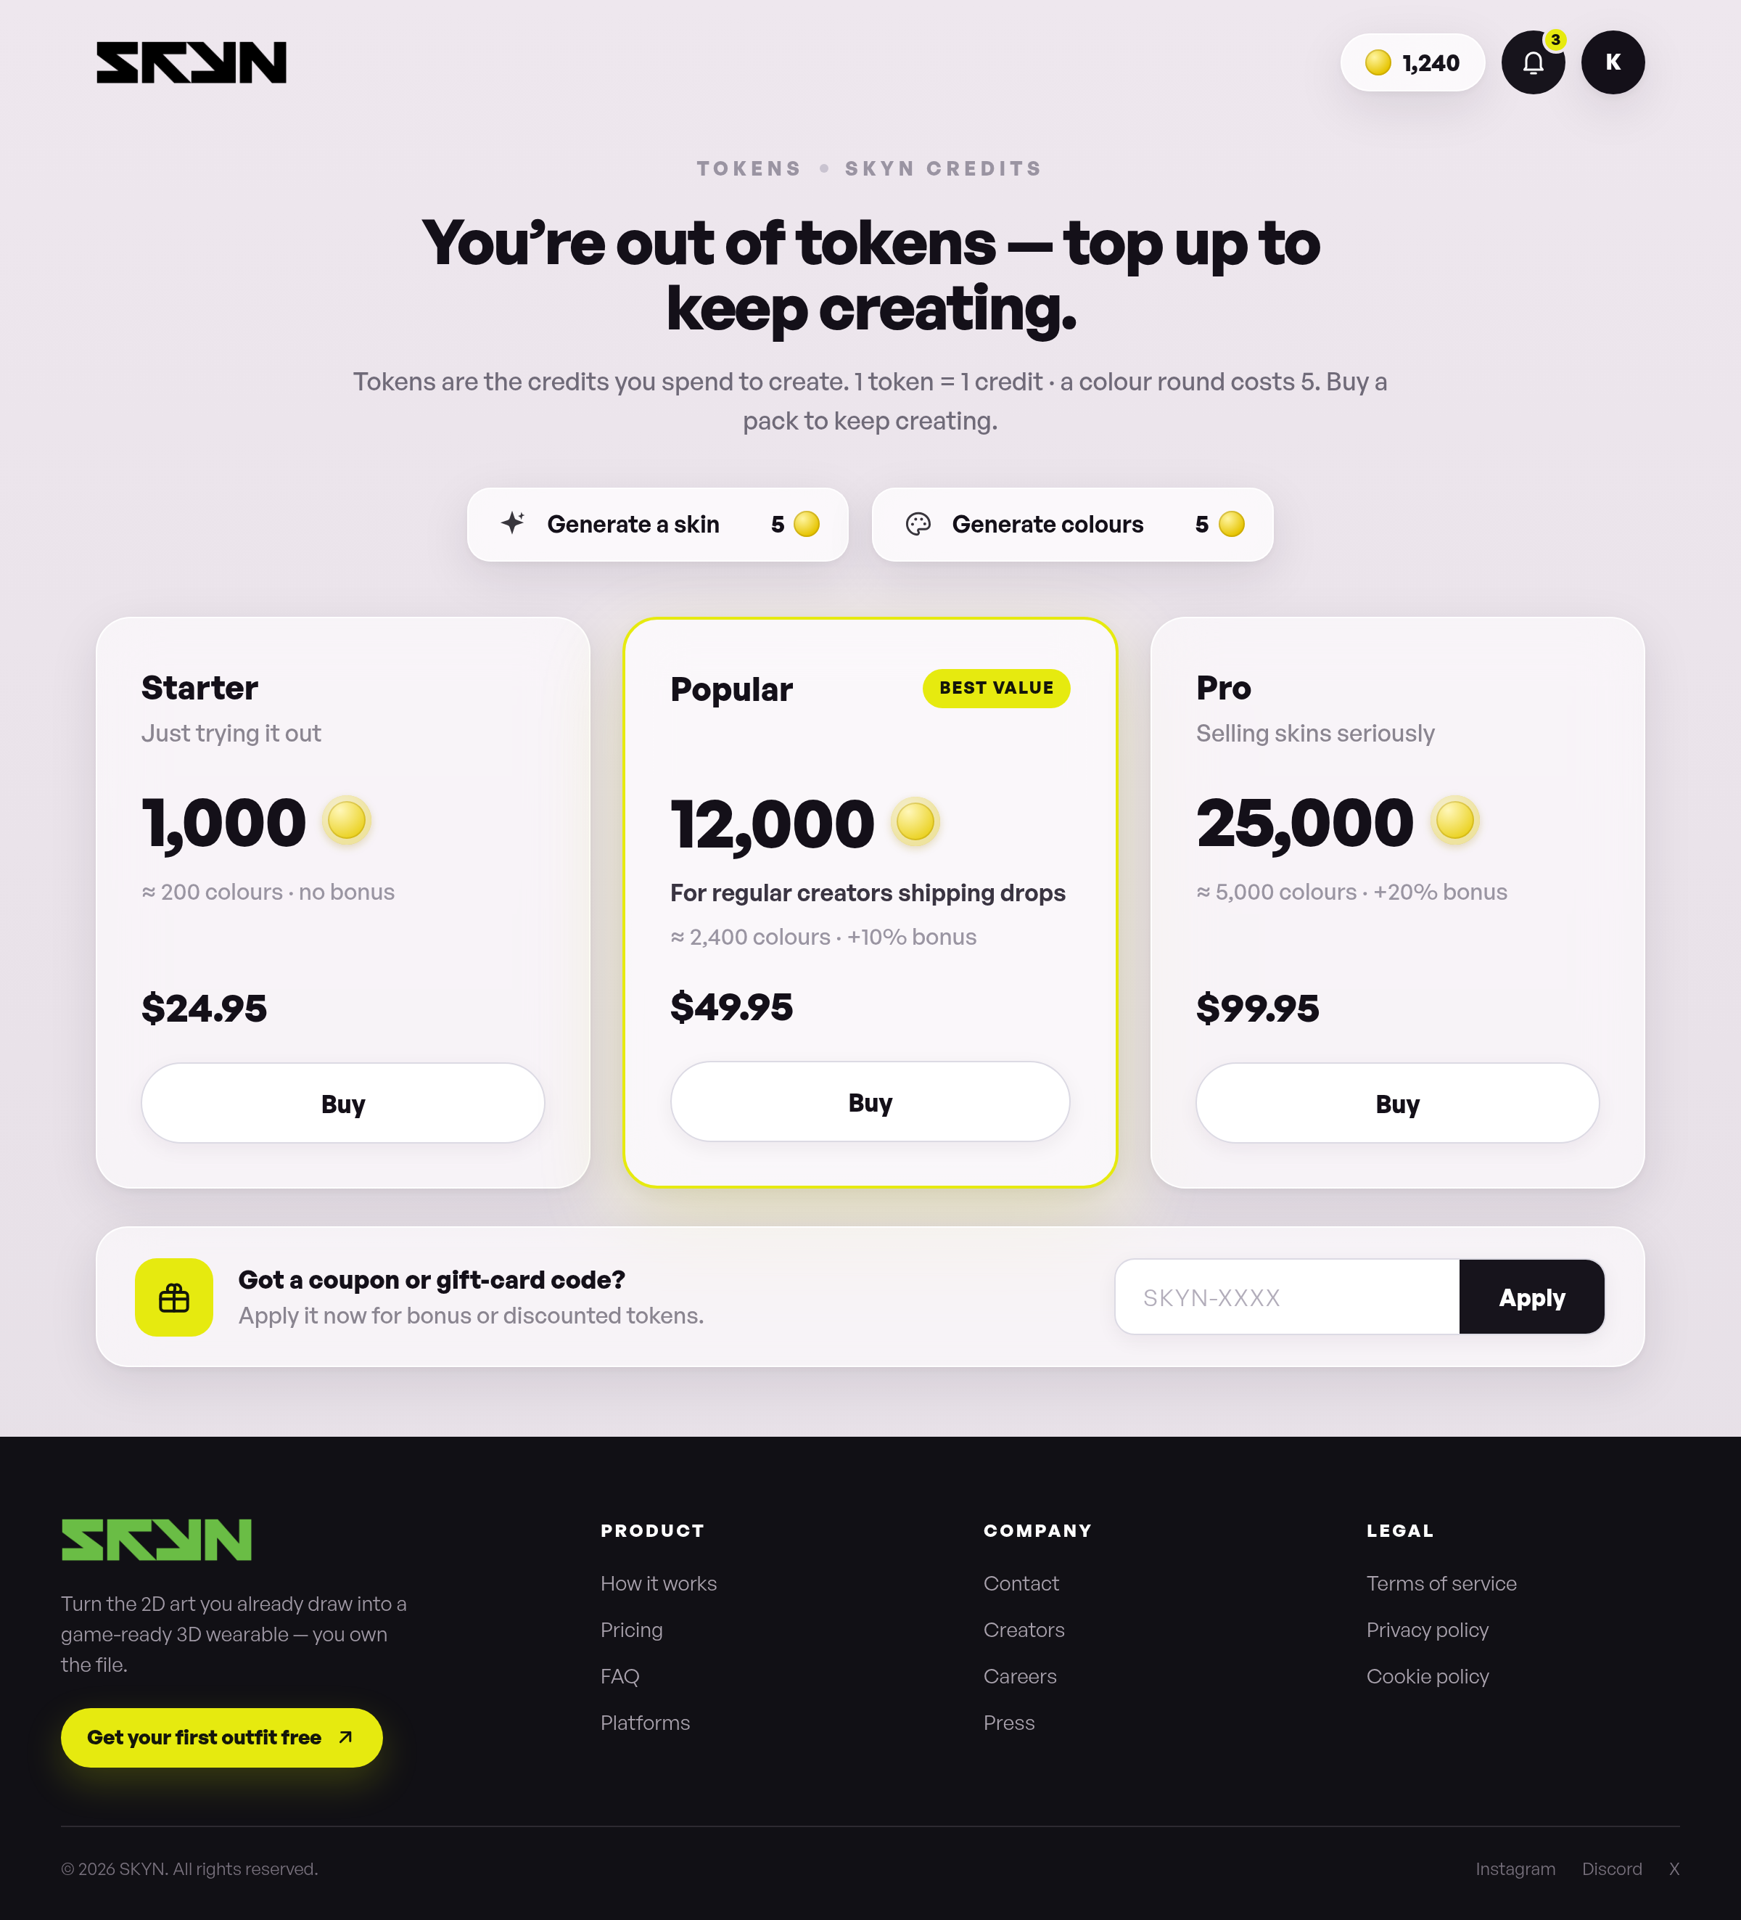
Onderdeel | Huidige tekst | Nieuwe tekst
Eyebrow | Tokens · SKYN credits
Titel | You’re out of tokens — top up to keep creating.
Subtekst | Tokens are the credits you spend to create. 1 token = 1 credit · a colour round costs 5. Buy a pack to keep creating.
Kosten-chips | Generate a skin — 5  Generate colours — 5
Pakket Starter | Starter  Just trying it out  1,000 tokens · ≈ 200 colours · no bonus  $24.95 · Buy
Pakket Popular | Popular — Best value  For regular creators shipping drops  12,000 tokens · ≈ 2,400 colours · +10% bonus  $49.95 · Buy
Pakket Pro | Pro  Selling skins seriously  25,000 tokens · ≈ 5,000 colours · +20% bonus  $99.95 · Buy
Coupon-blok | Got a coupon or gift-card code?  Apply it now for bonus or discounted tokens.  Placeholder: SKYN-XXXX · Knop: Apply
Footer | Gedeelde footer — zie 1.4

8 · Legal center
Bestand: page7.html — juridische documenten. Volledige lopende tekst hieronder.
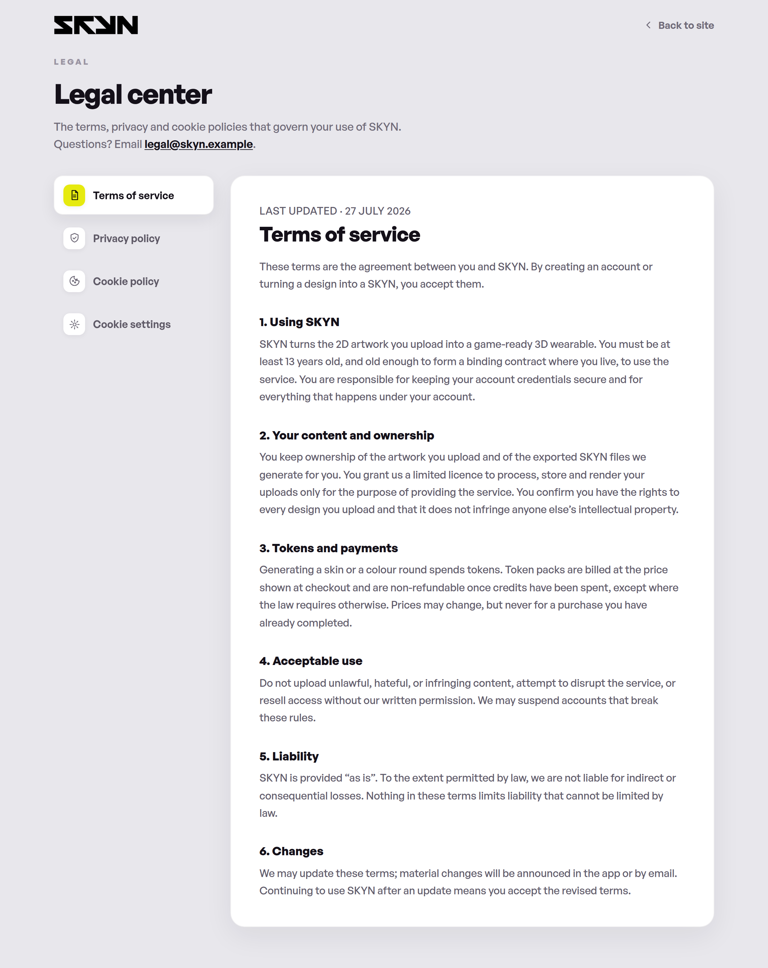
Onderdeel | Huidige tekst | Nieuwe tekst
Bovenbalk | Back to site
Eyebrow | Legal
Titel (H1) | Legal center
Subtekst | The terms, privacy and cookie policies that govern your use of SKYN. Questions? Email legal@skyn.example.
Zij-navigatie | Terms of service · Privacy policy · Cookie policy · Cookie settings

8.1 · Terms of service
Last updated · 27 July 2026
These terms are the agreement between you and SKYN. By creating an account or turning a design into a SKYN, you accept them.

1. Using SKYN
SKYN turns the 2D artwork you upload into a game-ready 3D wearable. You must be at least 13 years old, and old enough to form a binding contract where you live, to use the service. You are responsible for keeping your account credentials secure and for everything that happens under your account.

2. Your content and ownership
You keep ownership of the artwork you upload and of the exported SKYN files we generate for you. You grant us a limited licence to process, store and render your uploads only for the purpose of providing the service. You confirm you have the rights to every design you upload and that it does not infringe anyone else’s intellectual property.

3. Tokens and payments
Generating a skin or a colour round spends tokens. Token packs are billed at the price shown at checkout and are non-refundable once credits have been spent, except where the law requires otherwise. Prices may change, but never for a purchase you have already completed.

4. Acceptable use
Do not upload unlawful, hateful, or infringing content, attempt to disrupt the service, or resell access without our written permission. We may suspend accounts that break these rules.

5. Liability
SKYN is provided “as is”. To the extent permitted by law, we are not liable for indirect or consequential losses. Nothing in these terms limits liability that cannot be limited by law.

6. Changes
We may update these terms; material changes will be announced in the app or by email. Continuing to use SKYN after an update means you accept the revised terms.

8.2 · Privacy policy
Last updated · 27 July 2026
This policy explains what we collect, why, and the choices you have. We collect as little as possible to run SKYN well.

1. What we collect
Account details you give us (name, email), the designs you upload and the SKYNs we generate, billing metadata from our payment processor, and basic usage and device data needed to keep the service reliable.

2. How we use it
To generate your SKYNs, run your account and billing, provide support, keep the service secure, and — only with your consent — to understand product usage through analytics.

3. Sharing
We do not sell your personal data. We share it only with processors that help us run SKYN (hosting, payments, email) under contracts that require them to protect it, or where the law requires disclosure.

4. Retention
We keep your uploads and generated files while your account is active. Delete a design and we remove it from active systems promptly; backups age out on a rolling schedule.

5. Your rights
You can access, correct, export or delete your personal data, and object to certain processing. Email privacy@skyn.example and we’ll respond within the timeframes the law sets.

8.3 · Cookie policy
Last updated · 27 July 2026
Cookies are small files stored on your device. We use a small set of them, and you stay in control of the optional ones.

1. Essential
Required to sign you in, keep your session secure and remember your basic preferences. The service cannot work without these, so they are always on.

2. Analytics
Help us understand which features are used so we can improve them. These load only if you allow them in cookie settings.

3. Personalization
Remember choices like recently used palettes to tailor your experience. Optional, and off until you opt in.

4. Managing cookies
Change your choices any time in cookie settings, or clear cookies in your browser. Blocking essential cookies may stop parts of SKYN from working.

8.4 · Cookie settings
Choose which optional cookies SKYN may use. Your choice is saved on this device and you can change it whenever you like.
Onderdeel | Huidige tekst | Nieuwe tekst
Essential cookies | Sign-in, security and core preferences. Always active.
Analytics cookies | Anonymous usage stats that help us improve features.
Personalization cookies | Remember palettes and choices to tailor your experience.
Knoppen | Reject optional · Save preferences

