Introduction to C++: Assessment 1 - Week 5, 2019
Instructions for using each file can be found in README.md which is found in the same directory as this. The specific data used in generating this report can be found in the raw_data subdirectory.

Question 1: Using Random Numbers
This program (random.cpp) takes in an integer input (or asks for one in the absence of an input), generates that many random floating point numbers between 0 and 1, stores them in a vector and then uses them to calculate the mean and variance of the generated numbers.
To calculate the mean, the vector storing them is iterated through and summed into a variable, which is then divided by the original input to obtain the mean.
For the variance, the vector is again iterated through, this time calculating the squared difference from the mean and storing in a variable, which again is divided by the original input to obtain the variance.
The program then outputs the original input, the variance and the mean to stdout as comma separated values.
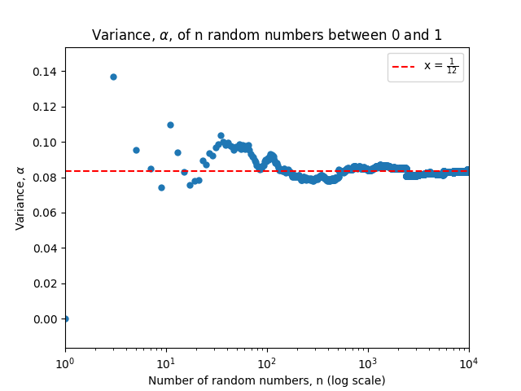
Figure 1. Empirical calculation of the variance
Raw data used in this graph can be found in random_used.csv
To empirically calculate the limit of the variance as the number of simulated numbers grows, this program was run with inputs of every odd number below 10000, piped into a .csv file and plotted using python, which resulted in Figure 1 above; the data in this graph clearly points to a convergence value of as the input value tends to infinity.

Question 2: Simulating Dice Throws
This program (dice.cpp) takes an integer input and returns the aggregated results of that many throws of a pair of computed six-sided dice.
To accomplish this it first checks to ensure the input is an integer and initialising a vector big enough to count all possible results. After this a random floating point number between 0 and 1 is generated, and then mapped this to an integer between 1 and 6 inclusive, before repeating this process and summing the two values; this sum is then stored in the aforementioned vector. This process is repeated N times, where N is the initial integer input.
A string for the filename is then created according to the specification supplied by the problem sheet, and stdout is then redirected to this file. Finally the vector is iterated through and the results (each sum and the number of times that sum was generated) are then outputted to stdout in the format specified.
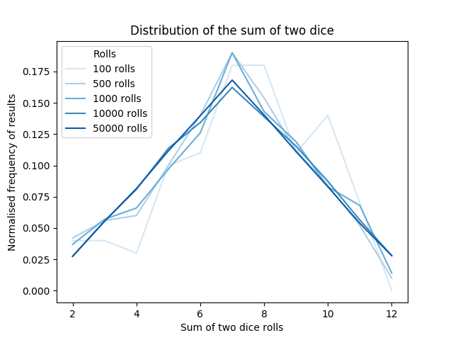
Figure 2. Normalised distribution of the sum of a pair of dice rolls with varying numbers of trials.
Raw data used to create this graph can be found in dice_N_used.dat
Results were then obtained for the specified number of trials, and plotted as seen in Figure 2 above. This figure shows that as the number of trials increases towards infinity, the distribution of results converges towards a triangular distribution centred around the most common result, 7. This raw data is now below in Figure 3.
Sum | 2 | 3 | 4 | 5 | 6 | 7 | 8 | 9 | 10 | 11 | 12
No. Trials
100 | 4 | 4 | 3 | 10 | 11 | 18 | 18 | 11 | 14 | 7 | 0
500 | 21 | 28 | 30 | 50 | 70 | 95 | 77 | 56 | 42 | 26 | 5
1000 | 37 | 57 | 66 | 97 | 126 | 190 | 143 | 119 | 83 | 68 | 14
10000 | 275 | 555 | 809 | 1136 | 1342 | 1623 | 1389 | 1154 | 873 | 564 | 280
50000 | 1370 | 2769 | 4077 | 5580 | 6982 | 8407 | 7016 | 5561 | 4149 | 2691 | 1398
Figure 3. Table of results for dice.cpp, the sum total of two simulated dice and the frequency of that score given a certain number of trials
Raw data used to create this table can be found in dice_N_used.dat

Question 3: The Game of Craps
This program (craps.cpp) takes an integer input, n, and simulates that many games of craps, storing the result (win/loss) as well as how many pairs of dice throws it took to achieve that result. This is outputted to stdout as comma separated variables with: count of games reaching this result with that many rolls, number of rolls of the game, result of the game (Win/Loss) on each line.
To do that, the input is checked to be a positive integer and two vectors are initialised: one to store losses and the other to store wins. The program then enters a for-loop over the number of games requested by the input; first initialising/resetting variables used to simulate the game, before entering a while-loop to simulate the game. Within this while-loop, the rolling of two dice is simulated as above, and the value is assigned to a variable while the roll counter is incremented. This value is then checked using the first roll specific conditions to see if it wins or loses craps; if it does, the while-loop is exited; if it doesn’t, it saves the value to another variable initialised earlier, then the while-loop iterates and dice are rolled again, roll counter is incremented and the new value is checked against the non-first roll conditions, and this repeats until a victory or loss is achieved.
When a result has been found, the vector corresponding to that result is checked to have enough elements (if not, the vector has new elements added until it is), and the value at the element corresponding to the number of rolls the game took is incremented (i.e. if the game took 7 rolls, the value at the 7th element in the vector is incremented by 1).
If there are more games due to be simulated, the for-loop is iterated and variables are then re-initialised and another game is “played”; if not, the results are outputted to stdout by iterating through each vector.
This program was then run for 10,000 games of craps as specified, and the results were piped and saved to a .csv file. This was then analysed and plotted using python, resulting in the figures below.
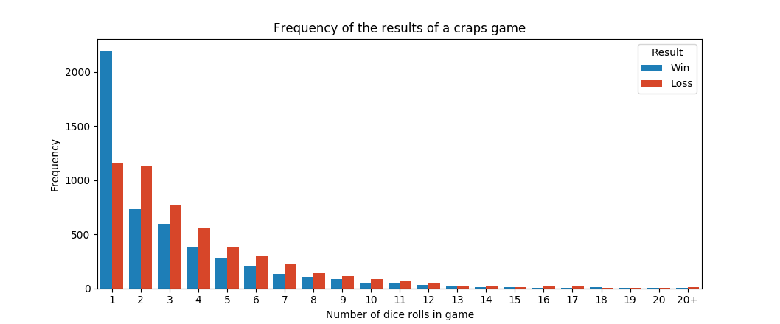
Figure 4. Graphical representation of the spread of the length and result of 10,000 simulated craps games
Raw data used to create this graph can be found in craps_used.csv
Both Figures 4, above, and 5, below, show the relationship between length of the simulated game of craps and it’s result. Games after 20 rolls are grouped due to their scarcity.
Rolls | 1 | 2 | 3 | 4 | 5 | 6 | 7 | 8 | 9 | 10 | 11 | 12 | 13 | 14 | 15 | 16 | 17 | 18 | 19 | 20 | 20+
Wins | 2196 | 735 | 599 | 387 | 273 | 211 | 135 | 108 | 83 | 46 | 50 | 30 | 17 | 13 | 8 | 7 | 5 | 8 | 4 | 1 | 3
Losses | 1159 | 1134 | 767 | 564 | 376 | 295 | 221 | 143 | 113 | 88 | 64 | 48 | 26 | 20 | 9 | 17 | 16 | 6 | 3 | 4 | 8
Figure 5. Table of results for 10,000 games of craps
Raw data used to create this graph can be found in craps_used.csv

From this data, the mean length of a craps game was calculated to be 3.382 +/- 0.030 rolls, quoted here with the standard error, while the median and mode lengths of a craps game in this sample were 2 and 1 respectively.
The overall chance of winning a game was calculated to be 0.492 +/- 0.005, again quoted with the standard error.

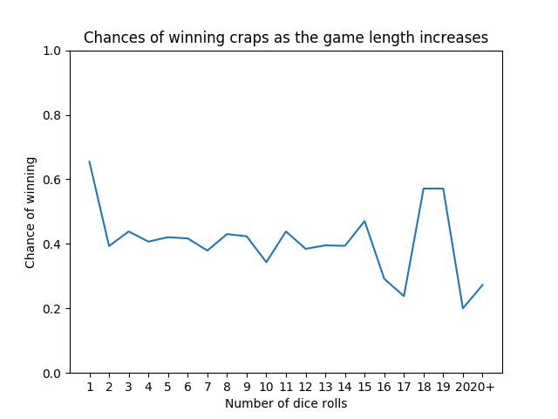
Figure 6. Graph depicting the change in chance of winning a game of craps vs length of the game
Raw data used to create this graph can be found in craps_used.csv

From Figure 6 there is clearly a sharp decrease in winning percentage after the first roll, after which it’s fairly stable somewhere around 0.4, however after about 14 rolls, it becomes somewhat noisier due to the low frequency with which it gets to that point.

