

VRAJBHOOMI INTERNATIONAL SCHOOL MOGAR ANAND

PATEL CONTROL PANEL
FOR
AISSCE 2024-25 EXAMINATION
[AS A PART OF THE INFORMATICS PRACTICES COURSE (065)]

SUBMITTED BY
NAME:_________________
ROLL NO: ___________

UNDER THE GUIDANCE OF MR. PIKUN SEN

Certificate

This is to certify that this IP Project on the topic PATEL CONTROL PANEL has been successfully completed by Master/Miss …………………….. of class XII Session under the guidance of Mr. Pikun Sen in particular fulfillment of the curriculum of Central Board of Secondary Education (CBSE) leading to the award of annual examination of the year 2024-2025. It has been carried out under my direct/indirect supervision and guidance. This report or similar report on the topic has not been submitted for any other examination and does not form a part of any other course undergone by the candidate.

……………………… ……………………………
Signature of Student Signature of Teacher/Guide
Name: ______ Name: MR. PIKUN SEN
Roll No.: ________ Designation: PGT (Compt. Sc.)

………………………………… …….…………………………………
Signature of Principal Signature of External Examination
Name: Ms.

ACKNOWLEDGEMENT

I would like to express my sincere regards to the Principal Ms. BINDU BHATT who gave me the opportunity to work on this project.
I would also like to express my profound gratitude to my teacher Mr. PIKUN SEN who encouraged and guided me as and when required.
Lastly, I would like to thank my parents and friends for their moral support and helping me through the project.
SIDDHI PATEL
XII SCIENCE

TABLE OF CONTENT INDEX
PROJECT
- Introduction
- System Requirements
- Used Packages, Installation and Description
- Application Module Description
- Data Structure
- Coding
- Coding for MySQL - Python Interface
- Coding for Python Tkinter
- Result / Output
RECORDS
- Python Based Programs
- SQL Questions

INTRODUCTION

The "Patel Control Panel" is a software system designed to help store owners and employees manage store activities like product management, customer orders, and billing. It's a simple tool built with Python and uses Tkinter for the user interface and MySQL to store product and transaction data.

Purpose of the Project:
The "Patel Control Panel" is created to make store management easier. It helps store owners keep track of products, process customer orders, and generate bills, all in one place. The goal is to save time, reduce errors, and make store operations more organized.
SYSTEM REQUIREMENTS

HARDWARE:-
1)LAPTOP /COMPUTER

SOFTWARE:-
1)TKINTER
2)PYTHON
3)MYSQL
4)DOCX

PYTHON PACKAGES

Python GUI package
from tkinter import *
from tkinter import ttk
(To represent info, error, and other Graphically dialogue box.)
import tkinter.messagebox as mb
(To display popup message to user )

Python MySQL Interface and other Package
import mysql.connector as msql
(To install package: pip install mysql-connector-python)

Python Docx
From docx import document
(To install package : pip install python-docx)

APPLICATION MODULE DESCRIPTION

- get_db_connection()
Purpose: Establishes a connection to the MySQL database (storemag) to interact with the data.
- get_products_by_category(category="")
Purpose: Fetches products from the database, optionally filtering them by category. If no category is provided, it fetches all products.
- show_store_panel()
Purpose: Displays the store panel, allowing the user to enter a category and search for products. It sets up the UI components for category search and display of products.
- display_products(category)
Purpose: Displays the products based on the category entered by the user. It also sets up functionality for adding and removing products from the shopping cart.

- update_cart_display()
Purpose: Updates the display of the shopping cart. It shows the items and their quantities that the user has added to the cart.
- add_to_cart(product_id,name,price,available_qty)
Purpose: Adds a product to the shopping cart. It ensures the product quantity doesn’t exceed the available stock and displays a warning if the stock is insufficient.
- remove_from_cart(product_id, name)
Purpose: Removes a product from the shopping cart. It updates the cart display accordingly.
- show_bill_panel(cart_items)
Purpose: Displays the bill generation panel where the user can enter customer details (name, phone, payment method) and view the selected items in the cart.
- save_bill()
Purpose: Saves the bill by updating the stock in the database and creating a Word document (.docx)

- add_product()
Purpose: Adds a new product to the database with the provided details (category, product name, quantity, price).
- remove_product()
Purpose: Removes a product from the database based on the provided product name.
- modify_product()
Purpose: Modifies an existing product in the database, allowing updates to the quantity and price.
- show_admin_panel()
Purpose: Displays the admin panel, allowing the admin to add, remove, or modify products in the database.
- clear_entries()
Purpose: Clears all input fields (product category, name, quantity, and price) in the admin panel to reset the form after an action is completed.

- clear_screen()
Purpose: Clears all widgets and components from the screen to prepare for displaying a new panel (e.g., switching between store, admin, and bill panels).
- show_main_panel()
Purpose: Displays the main panel with buttons for navigating to the Admin, Store, or Bill panels. This is the default view when the app starts.
DATA STRUCTURE

Table: Product
Field_Name | DataType | Constraint
Prod_id | int(6) | PRIMARYKEY, AUTO_INCREMENT, NOT NULL
Category | varchar(225)
Prodnm | varchar(225)
Qty | int
Mrp | decimal(10,2)

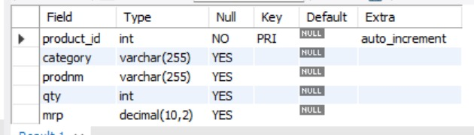
CODING

import tkinter as tk
from tkinter import messagebox
import mysql.connector
from docx import Document

# MySQL Database connection
def get_db_connection():
return mysql.connector.connect(
host="localhost", # Change to your host if different
user="root", # MySQL username
password="root", # MySQL password
database="storemag"
)

# Function to fetch products from the database
def get_products_by_category(category=""):
connection = get_db_connection()
cursor = connection.cursor()
query = "SELECT * FROM product WHERE category LIKE %s" if category else "SELECT * FROM product"
cursor.execute(query, ('%' + category + '%',) if category else ())
products = cursor.fetchall()
connection.close()
return products

# Store Panel to show products category-wise
def show_store_panel():
clear_screen()
label_info = tk.Label(window, text="Store Management", font=("Arial", 12))
label_info.pack(pady=20)

# Category selection
label_category = tk.Label(window, text="Enter Category (optional):")
label_category.pack(pady=5)

entry_category = tk.Entry(window)
entry_category.pack(pady=5)

# Search button to filter products by category
button_search = tk.Button(window, text="Search", command=lambda: display_products(entry_category.get()))
button_search.pack(pady=5)

def display_products(category):
clear_screen()
label_category = tk.Label(window, text="Store Management", font=("Arial", 12))
label_category.pack(pady=20)

products = get_products_by_category(category)

cart_items = {}

def update_cart_display():
cart_display.delete(0, tk.END)
for name, qty in cart_items.items():
cart_display.insert(tk.END, f"{name} - Qty: {qty}")

def add_to_cart(product_id, name, price, available_qty):
if name in cart_items:
if cart_items[name] < available_qty:
cart_items[name] += 1
else:
messagebox.showwarning("Stock Limit", f"Cannot add more than available quantity ({available_qty}) for {name}.")
else:
if available_qty > 0:
cart_items[name] = 1
else:
messagebox.showwarning("Out of Stock", f"{name} is out of stock.")
update_cart_display()

def remove_from_cart(product_id, name):
if name in cart_items and cart_items[name] > 0:
cart_items[name] -= 1
if cart_items[name] == 0:
del cart_items[name]
update_cart_display()

# Display products with + and - buttons
for product in products:
product_id, category, name, qty, mrp = product

# Create a horizontal frame for each product
product_frame = tk.Frame(window)
product_frame.pack(fill=tk.X, padx=10, pady=5)

# Product information
product_label = tk.Label(product_frame, text=f"{name} - ${mrp} (Available: {qty})", width=50, anchor="w")
product_label.pack(side=tk.LEFT, padx=5)

# Add (+) button
button_add = tk.Button(product_frame, text="+", command=lambda pid=product_id, pname=name, pprice=mrp, pqty=qty: add_to_cart(pid, pname, pprice, pqty))
button_add.pack(side=tk.LEFT, padx=5)

# Remove (-) button
button_remove = tk.Button(product_frame, text="-", command=lambda pid=product_id, pname=name: remove_from_cart(pid, pname))
button_remove.pack(side=tk.LEFT, padx=5)

# Cart display
cart_display = tk.Listbox(window, width=50, height=10)
cart_display.pack(pady=20)

# Proceed to bill button
button_proceed_to_bill = tk.Button(window, text="Proceed to Bill", command=lambda: show_bill_panel(cart_items))
button_proceed_to_bill.pack(pady=10)

# Bill Panel for customer details and bill generation
def show_bill_panel(cart_items):
clear_screen()

label_info = tk.Label(window, text="Bill Generation", font=("Arial", 14))
label_info.pack(pady=20)

total_price = 0
bill_details = "\n".join([f"{item} - Qty: {qty}" for item, qty in cart_items.items()])
for item, qty in cart_items.items():
total_price += qty * 100 # Assuming price is 100 for simplicity. Replace with actual price.

# Display selected items in the bill panel
label_items = tk.Label(window, text="Selected Items:\n" + bill_details)
label_items.pack()

label_total = tk.Label(window, text=f"Total: ${total_price}")
label_total.pack()

# Customer details entry fields
label_name = tk.Label(window, text="Name:")
label_name.pack()
entry_name = tk.Entry(window)
entry_name.pack(pady=5)

label_phone = tk.Label(window, text="Phone Number:")
label_phone.pack()
entry_phone = tk.Entry(window)
entry_phone.pack(pady=5)

label_payment = tk.Label(window, text="Mode of Payment:")
label_payment.pack()
entry_payment = tk.Entry(window)
entry_payment.pack(pady=5)

def save_bill():
name = entry_name.get()
phone = entry_phone.get()
payment_mode = entry_payment.get()

if not name or not phone or not payment_mode:
messagebox.showerror("Input Error", "Please fill all the customer details.")
return

try:
conn = get_db_connection()
cursor = conn.cursor()

# Update the stock in the database
for item_name, qty in cart_items.items():
cursor.execute("UPDATE product SET qty = qty - %s WHERE prodnm = %s AND qty >= %s", (qty, item_name, qty))
if cursor.rowcount == 0:
messagebox.showwarning("Stock Warning", f"Insufficient stock for {item_name}. Stock not updated.")

conn.commit()
conn.close()

# Create the Word file
doc = Document()
doc.add_heading('Store Bill', 0)
doc.add_paragraph(f"Customer Name: {name}")
doc.add_paragraph(f"Phone No: {phone}")
doc.add_paragraph(f"Mode of Payment: {payment_mode}")
doc.add_paragraph(f"\nSelected Products:\n{bill_details}")
doc.add_paragraph(f"\nTotal Price: ${total_price}")

# Save the document
doc.save(f"{name}_bill.docx")
messagebox.showinfo("Success", "Bill saved successfully. Stock updated.")

# Redirect to main panel after saving bill
show_main_panel()

except Exception as e:
messagebox.showerror("Error", f"An error occurred: {e}")

button_save = tk.Button(window, text="Save Bill", command=save_bill)
button_save.pack(pady=5)
# Function to add a product to the database
def add_product():
category = entry_category.get()
prodnm = entry_prodnm.get()
qty = entry_qty.get()
mrp = entry_mrp.get()

if not category or not prodnm or not qty or not mrp:
messagebox.showerror("Input Error", "Please fill all fields.")
return

try:
conn = get_db_connection()
cursor = conn.cursor()
cursor.execute("INSERT INTO product (category, prodnm, qty, mrp) VALUES (%s, %s, %s, %s)",
(category, prodnm, qty, mrp))
conn.commit()
conn.close()
messagebox.showinfo("Success", "Product added successfully.")
clear_entries()
except Exception as e:
messagebox.showerror("Database Error", str(e))

# Function to remove a product from the database
def remove_product():
prodnm = entry_prodnm.get()
if not prodnm:
messagebox.showerror("Input Error", "Please provide a product name.")
return

try:
conn = get_db_connection()
cursor = conn.cursor()
cursor.execute("DELETE FROM product WHERE prodnm = %s", (prodnm,))
conn.commit()
conn.close()
messagebox.showinfo("Success", "Product removed successfully.")
clear_entries()
except Exception as e:
messagebox.showerror("Database Error", str(e))

# Function to modify a product in the database
def modify_product():
prodnm = entry_prodnm.get()
qty = entry_qty.get()
mrp = entry_mrp.get()

if not prodnm or not qty or not mrp:
messagebox.showerror("Input Error", "Please provide all the required details.")
return

try:
conn = get_db_connection()
cursor = conn.cursor()
cursor.execute("UPDATE product SET qty = %s, mrp = %s WHERE prodnm = %s",
(qty, mrp, prodnm))
conn.commit()
conn.close()
messagebox.showinfo("Success", "Product updated successfully.")
clear_entries()
except Exception as e:
messagebox.showerror("Database Error", str(e))

# Function to display the Admin panel
def show_admin_panel():
clear_screen()
global label_category,label_prodnm,label_qty,label_mrp,entry_category,entry_prodnm,entry_prodnm,entry_prodnm,button_remove,button_add,button_modify

label_category.pack()
entry_category.pack()
label_prodnm.pack()
entry_prodnm.pack()
label_qty.pack()
entry_qty.pack()
label_mrp.pack()
entry_mrp.pack()

button_add.pack()
button_remove.pack()
button_modify.pack()

# Function to clear the entry fields
def clear_entries():
entry_category.delete(0, tk.END)
entry_prodnm.delete(0, tk.END)
entry_qty.delete(0, tk.END)
entry_mrp.delete(0, tk.END)

# Function to clear the screen
def clear_screen():
for widget in window.winfo_children():
widget.pack_forget()

# Main Panel
def show_main_panel():
clear_screen()
button_admin.pack(pady=10)
button_store.pack(pady=10)
button_bill.pack(pady=10)

# Main GUI setup
window = tk.Tk()
window.title("Store Management System")# Labels for inputs
global label_category,label_prodnm,label_qty,label_mrp,entry_category,entry_prodnm,entry_prodnm,entry_prodnm,button_remove,button_add,button_modify,button_admin,button_store,button_bill

label_category = tk.Label(window, text="Category")
label_prodnm = tk.Label(window, text="Product Name")
label_qty = tk.Label(window, text="Quantity")
label_mrp = tk.Label(window, text="MRP")

# Entry fields for inputs
entry_category = tk.Entry(window)
entry_prodnm = tk.Entry(window)
entry_qty = tk.Entry(window)
entry_mrp= tk.Entry(window)

# Buttons for Admin operations
button_add = tk.Button(window, text="Add Product", command=add_product)
button_remove = tk.Button(window, text="Remove Product", command=remove_product)
button_modify = tk.Button(window, text="Modify Product", command=modify_product)

# Buttons to switch between panels
button_admin = tk.Button(window, text="Admin", command=show_admin_panel) # Admin panel placeholder
button_store = tk.Button(window, text="Store", command=show_store_panel)
button_bill = tk.Button(window, text="Bill", command=lambda: show_bill_panel({}))

# Layout for the initial screen
button_admin.pack(pady=10)
button_store.pack(pady=10)
button_bill.pack(pady=10)

# Start at the main panel
show_main_panel()

# Start the Tkinter event loop
window.mainloop()

OUTPUT

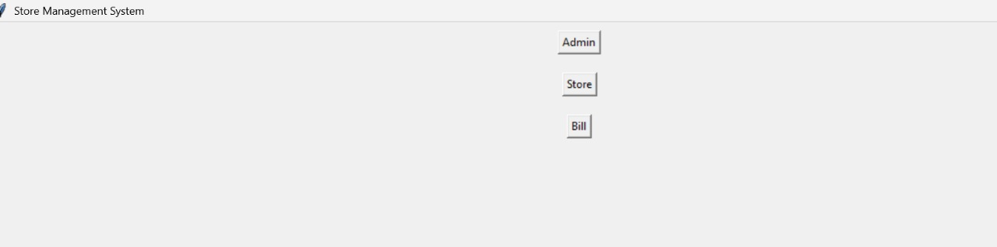

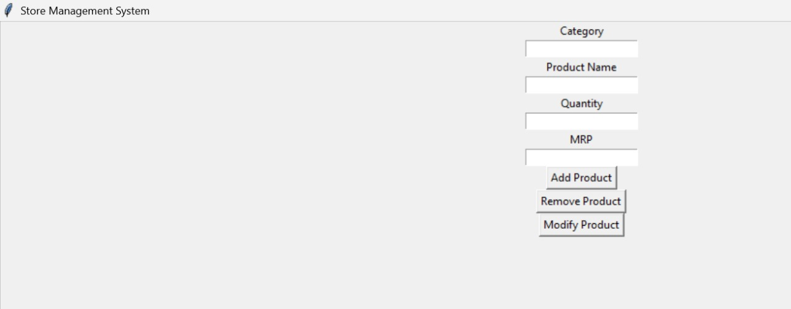

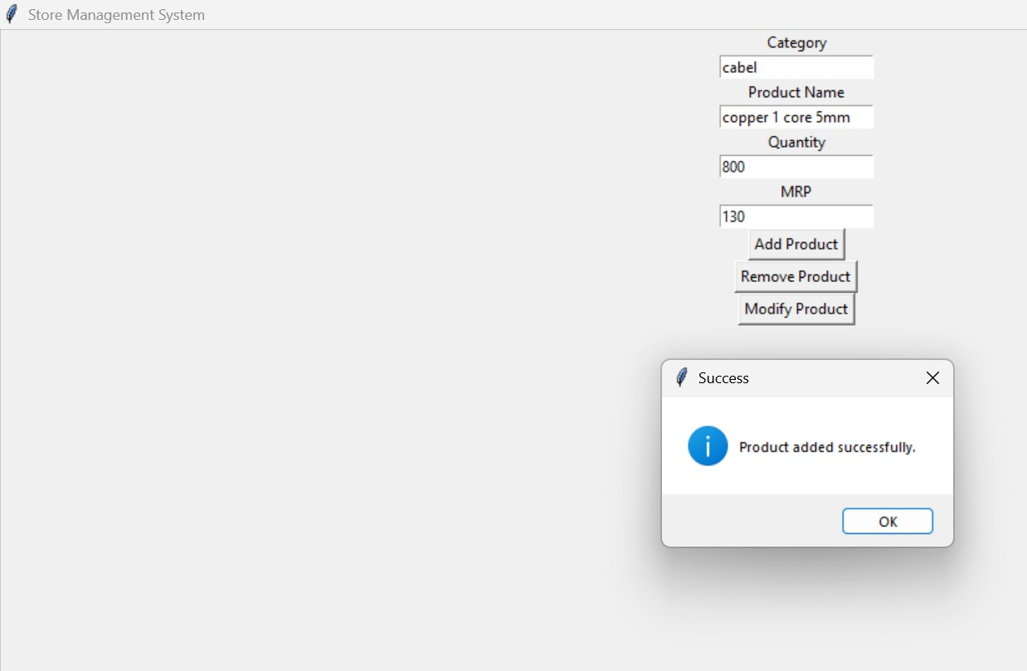

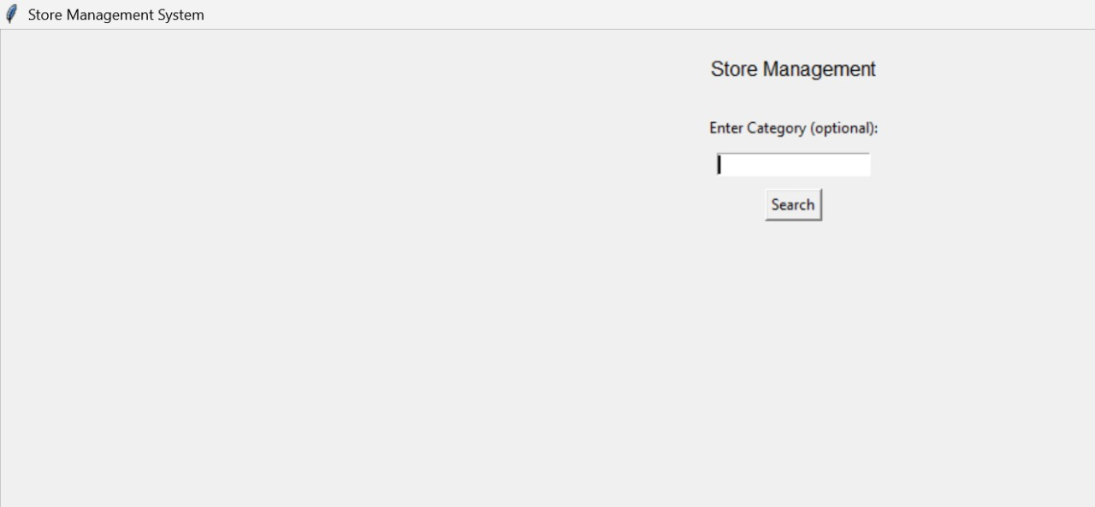

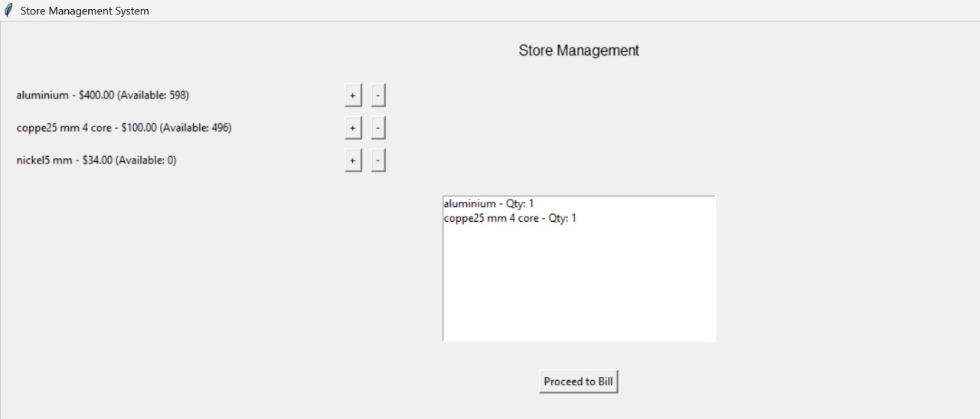

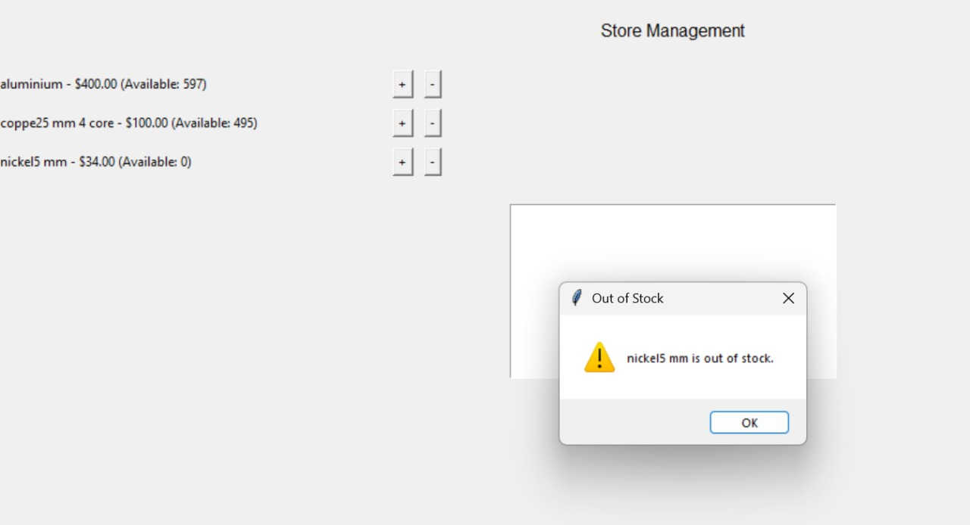
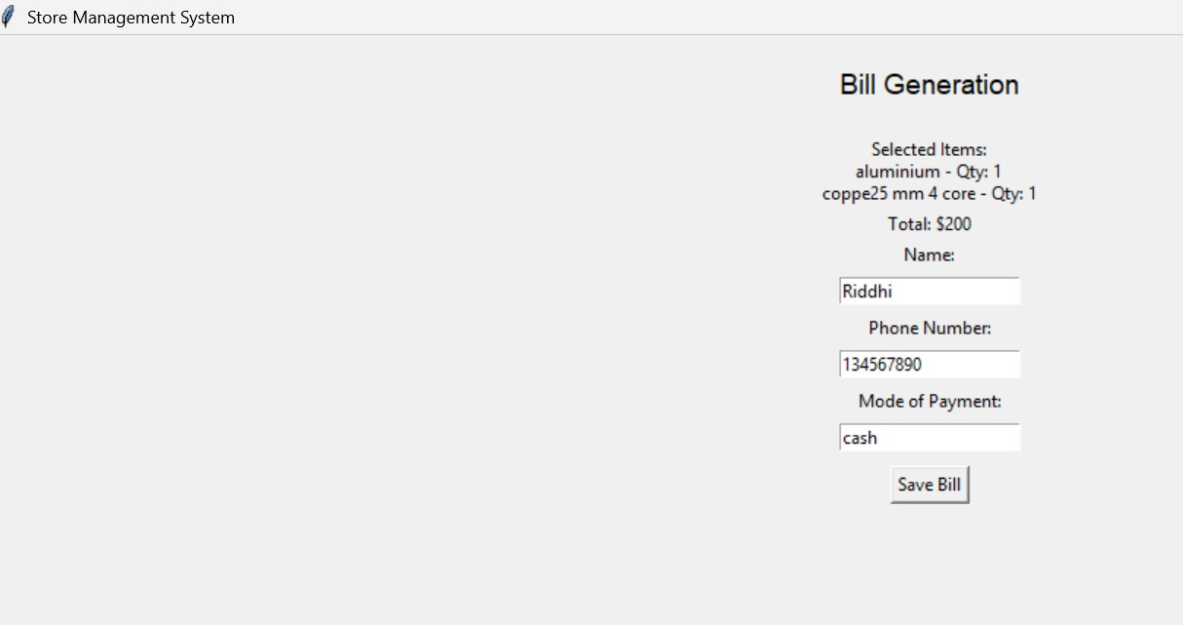

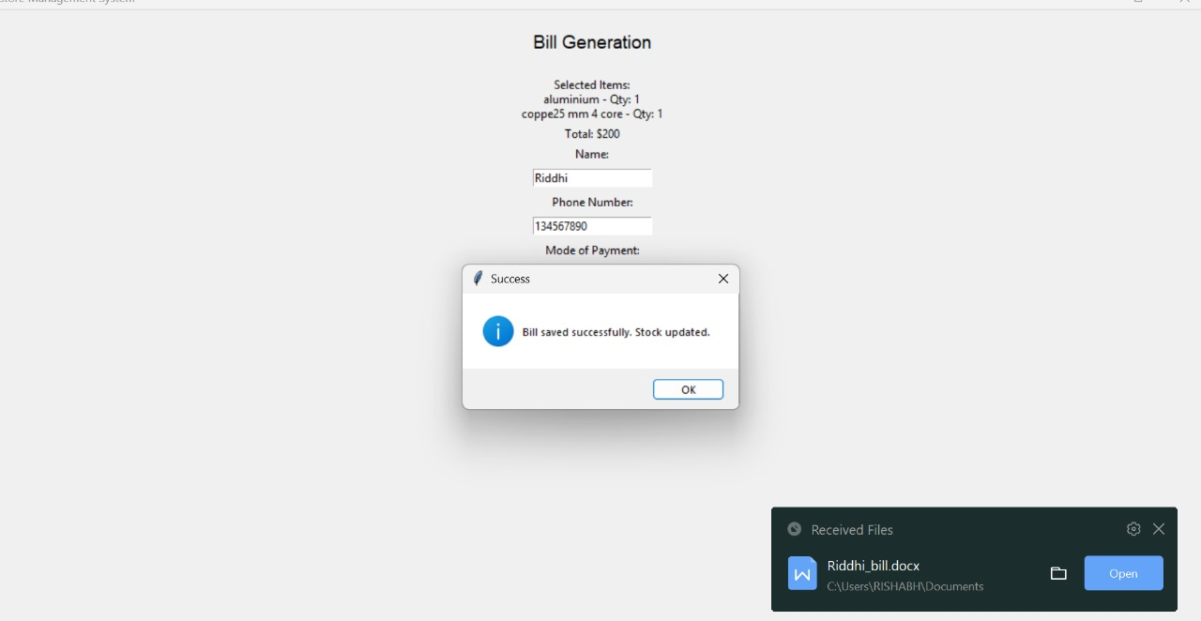

RECORDS
Program Based on Python
BASIC PYTHON PROGRAMs

1: Make a udf of prime() which takes a parameter and tell whether given number is prime or not.

def prime(a):
m=0
for i in range(1, a+1):
if a%i==0:
m=m+1
if m==2:
return True
else:
return False
n=int(input('Enter number:'))
if prime(n)==True:
print('It is PRIME.')
else:
print('It is not PRIME.')

2: Accept numbers and display the highest and the second highest.
h=0 #input 10 numbers
s=0
for c in range (1,11):
n=int(input('Enter number:'))
if c==1:
h=n
s=n
elif n>h:
s=h
h=n
elif n>s:
s=n
print(h,"is highest and",s,"is second highest.")
or
a=int(input('Enter 1st no.:')) #input 3 numbers
b=int(input('Enter 2nd no.:'))
c=int(input('Enter 3rd no.:'))
if a>b and a>c:
print(a,'is highest.')
if b>c:
print(b,'is second highest.')
else:
print(c,'is second highest.')
elif b>a and b>c:
print(b,'is highest.')
if a>c:
print(a,'is second highest.')
else:
print(c,'is second highest.')
elif c>a and c>b:
print(c,'is highest.')
if a>b:
print(a,'is second highest.')
else:
print(b,'is second highest.')

3. Accepta number and display its table.
a=int(input('Enter a number for its table:'))
for c in range(1,11):
p=c*a
print('{} x {} = {}'.format(a,c,p))
4. Accept10 numbers and display highest and lowest number.
h=0
s=0
for c in range(1,11,1):
n=int(input("Enter Number:"))
if c==1:
h=n
s=n
elif n>h:
h=n
elif n<s:
s=n
print("Highest Number:",h)
print("Lowest Number:",s)

5. Accept range from user and then accept that many numbers and display their sum.
s=0
x=int(input('Enter the range:'))
for c in range(1,x,1):
n=int(input('Enter number:'))
s=s+n
print('Sum of the numbers is:',s)

6. Accept range from user and display the sum upto range(range included).
n=int(input('Enter the range you want:'))
s=0
for c in range(1,n+1,1):
s=s+c
print (s)

7. Accept 3 numbers and display sum of even and odd numbers.
a=int(input('Enter 1st number:'))
b=int(input('Enter 2nd number:'))
c=int(input('Enter 3rd number:'))
so=0
se=0
if a%2==0:
se=se+a
else:
so=so+a
if b%2==0:
se=se+b
else:
so=so+b
if c%2==0:
se=se+c
else:
so=so+c
print('Sum of even numbers:',se)
print('Sum of odd is numbers:',so)

8. Accept 20 numbers and display their sum.
CODE:
s=0
for c in range(1,21):
n=int(input('Enter number:'))
s=s+n
print('Sum of numbers is:',s)

9. Accept range from user and. Accept the numbers and display sum of even and odd numbers up to given range.
se=0
so=0
x=int(input('Enter range:'))
for c in range(1,x):
n=int(input('Enter number:'))
if n%2==0:
se=se+n
else:
so=so+n
print('Sum of even is:',se,'\nSum of odd is:',so)

10. Accept a number and display reverse of it.
n=int(input('Enter number:'))
rev=0
while n>0:
r=n%10
n=n//10
rev=10*rev+r
print(rev)

11. Accept a number from user and display sum of digits of that number.
n=int(input('Enter number:'))
s=0
while n>0:
r=n%10
n=n//10
s=s+r
print (s)

12. Accept a number and print the sum of digits in one digit form.
n=int(input('Enter number:'))
while n>9:
s=0
while n>0:
r=n%10
n=n//10
s=s+r
n=s
print(n)

13. Accept a number from user and display whether it is prime or not.
n=int(input('Enter number:'))
s=0
for i in range (1,n+1):
if n%i==0:
s=s+1
if s==2:
print(n,'is prime number')
else:
print(n,'is not a prime number')
14. Accept range from user and display sum of squares of numbers upto range(range included).
s=0
n=int(input("Enter range:"))
for r in range(1,n+1):
s=s+(r**2)
print(s)

15. Accept range from user and display sum of reciprocal of numbers upto range(range included).
s=0
n=int(input("Enter range:"))
for i in range(1,n+1):
s=float(s+(1/i))
print(s)

16. Accept a number from user and display whether it is palindrome.
s=0
r=0
rev=0
n=int(input('Enter number:'))
while n>0:
r=n%10
n=int(n/10)
rev=(rev*10)+r
if n==rev:
print('Number is palindrome.')
else:
print('Number is not palindrome.')

17. Accept a number and display whether the number is Armstrong or not.
n=int(input('Enter number:'))
c=n
s=0
while n>0:
r=n%10
n=n//10
s=r**3+s
if s==c:
print('It is an Armstrong')
else:
print('It is not anArmstrong')

18. AcceptName,Roll number and marks of any three subjects and display his/her result.
r=int(input("Enter the roll no.: "))
n=input("Enter the name:")
sub1=int(input("Enter the marks:"))
sub2=int(input("Enter the marks:"))
sub3=int(input("Enter the marks:"))
t=sub1+sub2+sub3
per=(t)/300*100
print ("Total= {} \nPercentage = {}".format(t,per))
if per>=90:
print("Grade=A")
elif per>=75 and per<90:
print("Grade=B")
elif per>=50 and per<75:
print("Grade=C")
else:
print("Fail")

LIST & STRING BASED PROGRAMs

19. Accept a list and display sum of elements of list.
l=eval(input('Enter list:'))
n=0
for i in l:
n=n+i
print(n)
20. Accept insert elements in list as per users' choice.
l=[]
while True:
p=input('Enter element:')
l.append(p)
a=input('Do you want to enter morevalues?Y or N?')
if a!='y':
break
print('Your list is:',l)

21. To print in ascending order.
l=eval(input('Enter list:'))
l.sort()
print(l)

23. Accept a list and replace all odd values as zero and print.
l=eval(input('Enter list:'))
for i in range(0,len(l)):
if l[i]%2!=0:
l[i]=0
print(l)

24. Accept a list, append the list to empty list and display sorted list.
l=eval(input('Enter list:'))
L=[]
for i in l:
L.append(i)
L.sort()
print('Your list is:',l,'and sorted list is:',L)

25. To say if the given element exist in list or not.
l=eval(input('Enter list:'))
p=int(input('Enter element you want to check:'))
c=0
for i in l:
if i==p:
c+=1
if c==0:
print(p,"doesn't exist in the list.")
else:
print(p,'element exists.')

26. Accept 2 double dimension lists and display both in matrix form.
L=eval(input('Enter list:'))
M=eval(input('Enter list:'))
p=[]
print('Matrix of 1st list:')
for i in range(0,len(L)):
for j in range(0,len(L[i])):
print(L[i][j],end=" ")
print()
print('\nMatrix is 2nd list:')
for i in range(0,len(M)):
for j in range(0,len(M[i])):
print(M[i][j],end=" ")
print()

27. Accept a String/Paragraph and a character and find how many times this character exists in the String/Paragraph.
S=input(Enter String”)
c=input(“Enter Charecter to check”)
cou=0
for ch in S:
if ch==c:
co+= 1
print(cou)

28.Accept a String/Paragraph and a character and remove that character int he String/Paragraph.
S=input(Enter String:”)
c=input(“Enter Character to Remove from the String”)
SSS=None
for ch in S:
if ch!=c:
SSS+=ch
print(SSS)

29. Accept a String/Paragraph and a word and find how many times this word exist in the String/Paragraph.
S = input(Enter String: ”)
c = input(“Enter Word to check: ”)
cou=0
for ch in S:
if ch==c:
cou+=1
print(cou)
30. Accept a String/Paragraph and print each word in new line in Title case.
S=input(Enter String”)
wod=None
for ch in S:
if ch=='':
print(wod)
wod=''
else:
wod+=ch

31. Accept a String/Paragraph and print each word along with its length.
S =input(Enter String”)
wod=''
for ch in S:
if ch=='':
print(wod,'-',len(wod))
wod=''
else:
wod+=ch

32. Accept a String/Paragraph and print length of the longest word in the sentence.
S = input(Enter String”)
Hg=0
HgWord=''
wod=''
c=1
for ch in S:
if ch=='':
if c==1:
Hg=len(wod)
HgWord=wod
c+=1

eliflen(wod)>Hg:
Hg=len(wod)
HgWord=wod
wod=''
else:
wod+=ch
print(''Longest Word = '', HgWord, '' and its Length = '', Hg)
33. Accept a String/Paragraph and print in reverse order (without slicing algorithm).
S = input("Enter String :")
fori in range(len(S),-1,-1):
print(S[i],end='' )

34. Accept an email and check whether input email is the valid email (valid email means it contains @ and .com)
S=input("Enter String :")
if "@" in S and ".com" in S:
print("Email is Valid")
else:
print("Email is not Valid")

35. Accept a string and check whether its palindrome or not.
S=input("Enter String :")
if S==S[::-1]:
print("Palindrome")
else:
print("Not Palindrome")
36. Accept a list and display 3x3 matrix.
l=eval(input('Enter nine elements aslist:'))
i=0
for r in range(1,4):
for c in range(1,4):
print(l[i],end=" ")
i=i+1
print()

37. String Handling & Menu Driven Programming
import os
S=input('Enter Sentence or Paragraph\n>')
while True:
os.system('cls')
print('1: Upper Case')
print('2: Lower Case')
print('3: Title Case')
print('4: Sentance Case')
print('5: Toggle Case')
print('6: Count Vowels &Consonent')
print('7: Count Upper, Lower, Digit & Special Character')
print('8: Exit')
x = int(input('Enter Your Choice: '))
if x==1:
s=S.upper()
print(s)
elif x==2:
s=S.lower()
print(s)
elif x==3:
s=S[0].upper()
I=1
while i<len(S):
if S[i]==' ':
s+=S[i]+S[i+1].upper()
I+=1
else:
s+=S[i].lower()
I+=1
print(s)
elif x==4:
s=S[0].upper()
i=1
while i<len(S):
if S[i]=='.':
s+=S[i]+S[i+1]+S[i+2].upper()
i+=2
else:
s+=S[i].lower()
i+=1
print(s)
elif x==5:
s=''
for ch in S:
if ch.isupper():
s+=ch.lower()
elifch.islower():
s+=ch.upper()
else:
s+=ch
print(s)
elif x==6:
con=0
wov=0
for ch in S: #for i in range(0,len(S)):
if ch.isalpha(): #if S[i].isalpha():
if ch.lower() in['a','e','i','o','u']:
wov+=1
else:
con+=1
print('Vowel =', wov)
print('Consonent =', con)
elif x==7:
cap=0
low=0
num=0
spc=0
spch=0
for ch in S: #for i in range(0,len(S)):
if ch.isupper(): #if S[i].isupper():
cap+=1
elifch.islower():
low+=1
elifch.isdigit():
num+=1
elifch.isspace():
spc+=1
else:
spch+=1
print('Total Character =', len(S))
print('Upper Character =', cap)
print('Lower Character =', low)
print('Number =', num)
print('Spaces =', spc)
print('Special Character = ',spch)
elif x==8:
exit()
else:
ch=input('Its a Wrong Choice..\nPress Any Key to Continue.....\n>')

UDf & RECURSION BASED PROGRAMs

1. Accept Name, Roll number, class, Father and Mother name, Address and Marks in [english, maths, chemistry, physics, cs] and display the reportcard in formatted style.
import os
nam = input("Enter your Name:")
rol = int(input("Enter your Roll no.:"))
clas= input("Enter your class:")
fan = input("Enter your Father's name:")
mot = input("Enter your Mother's name:")
adr = input("Enter your Address:")
eng = float(input("Enter your marks in English:"))
mat = float(input("Enter your marks in Maths:"))
chm = float(input("Enter your marks in Chemistry:"))
phy = float(input("Enter your marks in Physics:"))
cs = float(input("Enter your marks in CS:"))
fp=''
hy='-'
total=eng + cs + phy + chm + mat
prcnt=total/5
def per(a):
p=(a/100)*100
return p

def grade(c):
if c>=95:
return "A+"
elif c>=85 and c<95:
return "A"
elif c>=75 and c<85:
return "B"
elif c>=65 and c<75:
return "C"
elif c>=45 and c<65:
return "D"
elif c>=33 and c<45:
return "E"
else:
return "F"

def table(a, b, c, d):
if a==b==c==d=='-':
l1=("\t\t\t|{:15s}|{:15s}|{:15s}|{:15s}|".format(str(a)*15,str(b)*15,str(c)*15,str(d)*15))
return l1
else:
l2=("\t\t\t|{:^15s}|{:^15s}|{:^15s}|{:^15s}|".format(str(a),str(b),str(c)+'%',str(d)))
return l2

def table2(a, b, c):
if a==b==c=='-':
l1=("\t\t\t|{:15s}|{:15s}|{:24s}|".format(str(c)*15,str(c)*15,str(c)*24))
return l1
else:
l2=("\t\t\t|{:^15s}|{:^15s}|{:^24s}|".format(str(a)+'%',str(b),str(c)))
return l2

#percents of each subject
pe=per(eng)
pp=per(phy)
pc=per(chm)
pm=per(mat)
ps=per(cs)

#Grades of each subject
ge=grade(pe)
gp=grade(pp)
gc=grade(pc)
gm=grade(pm)
gs=grade(ps)
gper=grade(prcnt)
os.system("clear")

#Information of student
index=119
print('\n>>>The following is your reportcard:\n')
print("~"*index)
print("\t\tName: {:20s} Roll No.: {:8s} Class: {:11s}".format(nam,str(rol),clas))
print("~"*index)
print("\t\tFather's name: {:30s} Mother's name: {:20s}".format(fan,mot))
print("~"*index)
print('\t\tAddress: {:50s}'.format(adr))
print("~"*index)
#All subject Table
print("\n")
print(table(hy,hy,hy,hy))
print(table('Subject','Marks','Percent','Grade'))
print(table(hy,hy,hy,hy))
print(table('English',eng,pe,ge))
print(table('Maths',mat,pm,gm))
print(table('Chemistry',chm,pc,gc))
print(table('Physics',phy,pp,gp))
print(table('C.S.',cs,ps,gs))
print(table(hy,hy,hy,hy))

#Overall result table
if prcnt>=33 and prcnt<95:
fp='Pass'
elifprcnt>=95:
fp='Passed with Excellence'
else:
fp='Fail'
print("\n>>>The following is your overall result:\n")
print(table2(hy,hy,hy))
print(table2('Overall','OverallGrade','Overall Result'))
print(table2(hy,hy,hy))
print(table2(prcnt,gper,fp))
print(table2(hy,hy,hy))
2. Program based in Menu Driven
def chkEvenOdd():
n=int(input("Enter number.."))
if n%2==0:
print("Number is Even")
else:
print("Number is Odd")

def Mytable():
n = int(input("Enter Number:"))
for c in range(1,11):
print(n,"x",c,"=",n*c)

def Palin():
n=int(input("Enter Number:"))
n1=n
rev=0
while n>0:
r=n%10
n=n//10
rev=10*rev+r
if rev==n1:
print("Number is Palindrome")
else:
print("Number is not Palindrome")
def Arm():
n=int(input("Enter Number:"))
n1=n
ss=0
while n>0:
r=n%10
n=n//10
ss=ss+r**3
if ss==n1:
print("Number is Armstrong")
else:
print("Number is Not Armstrong")
while True:
print("1: Test for Even or Odd")
print("2: Generate Table")
print("3: Palindrome Number")
print("4: Armstrong Number")
print("5: Exit From the Program")
ch=int(input("Enter Your Choice"))
if ch==1:
chkEvenOdd()
elifch==2:
Mytable()
elifch==3:
Palin()
elifch==4:
Arm()

elifch==5:
exit()
else:
print("You have entered Wrong Choice")

3. Program based on Recursion to find GCD.
def gcd(a,b):
if b==0:
return a
return gcd(b,a%b)
print(gcd(12,18))

4. Program based on UDF for Binary Search.
def BinarySearch(ar,key,low,high):
while low<=high:
mid=(low+high)/2
if ar[mid]==key:
return mid
elif key<ar[mid]:
high=mid–1
else:
low=mid+1

5. Program based on Recursion for Binary Search.
def BinarySearch(ar,key,low,high):
if low>high:
return False
mid=(low+high)/2
if ar[mid]==key:
return mid
elif key<ar[mid]:
high=mid-1
return BinarySearch(ar,key,low,high)

else:
low=mid+1
return BinarySearch(ar,key,low,high)

FILE HANDLING PROGRAMs

1. Count total number of words available in Test.dat file?
f=open(“test.dat”,“r”)
S=f.read()
words=S.split()
print(len(words))
f.close()

2. Count Number of Alphabets, Vowels, Upper Case, Lower Case, Number and Special character available in the file.
nA=nV=nU=nL=nN=nS=0
f=open("ABC.dat", 'r')
S=f.read()
for c in S:
if c.lower() in ['a', 'e', 'i', 'o', 'u']:
nV+=1
if c.isalpha():
nA+=1
elifc.isdigit():
nN+=1
else:
nS+=1
if c.isupper():
nU+=1
elifc.islower():
nL+=1
f.close()

print("Number of Alphabet(s): {}\nNumber of Digit(s): {}\nNumber of Special Charecter(s): {}\n Number of Vowvel(s):{}\n Number of Upper Case: {} and Lower Case: {}".format(nA, nN, nS, nV, nU, nL)) "

3. Create a file with writing mode Like copy con command in DOS style saved with ^Z and then display the contents from that file.
f=open("ABC.dat", 'w')
while True:
try: #Because when^Zpressed it raise error
a=input(">")+'\n'
f.write(a)
except:
f.close()
break
f = open("ABC.dat","r")
print(f.read())
f.close()

4. Create a file with Append mode and saved with ^Z then displays the contents.
f=open("ABC.dat","a+")
while True:
try: #Because when ^Z pressed it raises error
a=input(">")+'\n'
f.write(a)
except:
break
#To Read the content first Move the cursor from EOF to BOF
f.seek(0) #Cursor Movement
print(f.read())
f.close()

5. Copy from one existing file to another file. (ie Multiple File Handling).
f=open("ABC.dat","r")
f1=open("ABC.txt","w")
f1.write(f.read())
f.close()
f1.close()

6. Accept a word and remove that word from the file.
w=input("Enter word: ")
f=open("ABC.dat",'r')
lines=f.readlines()
f.close()
f=open("ABC.dat",'w')
for line in lines:
Words=line.split()
for word in Words:
if word!=w:
f.write(word+' ')
f.write('\n')
f.close()

7. Accept Roll, Name and Phone from User and stored into file as Record(s) style.
f=open("ABC.txt","w")
while True:
rl=input("Enter Roll: ")
nm=input("Enter Name: " )
ph=input("Enter Phone Number: ")
f.write(rl+","+nm+","+ph+"\n")
ch=input("Add More....?y/n")
if ch.lower()!="y":
break
f.close()

8. Interesting Tricks And Technique (Read the above file and display inHTML Table structure.)
fl=open("ABC.txt","r")
fh=open("ABC.htm","w")
fh.write("<html><body><table><thead><tr><th>Roll</th><th>Name</th>\<th>Phone</th></thead><tbody>")
for line in fl:
words=line.split(",")
fh.write("<tr><td>"+words[0]+"</td><td>"+words[1]+"</td><td>"+words[2]+"</td></tr>")
fh.write("</tbody></table></body></html>")
fl.close()
fh.close()

9. Explanation of Reading and Writing File in the form of UDF:
def writeInFile():
f=open("Stu.dat","a")
while True:
nm=input("Enter Name")
m1=float(input("Enter Eng "))
m2=float(input("Enter Maths "))
m3=float(input("Enter CS "))
#f.write(nm,m1,m2,m3)
# if we use in this form it shows an error
# Because only One string parameter will accepted by write function
# So, it can be written as
# Method 1:
f.write(nm+','+m1+','+m2+','+m3+'\n')
# Store one record per line so \n
# Here we use ', ' separator to split the data easily at the time of reading

# Or Method 2: By using python template
f.write("{},{},{},{}{}".format(nm, m1, m2, m3, '\n'))
#Or Method3: By using List form
L = []
L.append(nm)
L.append(m1)
L.append(m2)
L.append(m3+'\n')
f.writelines(L)
# Any One Method can be implemented
ch=input("Want to add more..")
# Condition for exit from the infinite loop
if ch!='y':
break
f.close()

def readFromFile():
f=open("Stu.dat","r")
#Method 1: Whole contents as a String form
S=f.read()
print(S)
#Method 2: Whole contents in a form of List
L = f.readlines()
for rec in L: #stores One String Element
print(rec) #Whole one line
#Or To Print in Formatted Way
#Since at the time of writing data it uses ', ' separator
data=rec.split(',')
print('Name: ',data[0])
print('Marks1: ',data[1]) #and so on

#Method3: Technique for without using read()/readline()/
# readlines() and read the records till EOF
#reading records line by line and stored it in rec variable as string
for rec in f:
print(rec) #Whole one line
# Or To Print in Formatted Way
#Since at the time of writing data it uses ', ' separator
data=rec.split(',')
print('Name: ',data[0])
print('Marks1: ',data[1]) #and so on
f.close()

11. Explanation of Above Example with the help of "with"keyword:
def writeInFile():
# Instead of f=open("Stu.dat","a")it can be use as
# By using withkeyword file can be open but no need to close() with open("Stu.dat", "a") as f:
while True:
nm=input("Enter Name")
m1=float(input("Enter Eng "))
m2=float(input("Enter Maths "))
m3=float(input("Enter CS "))
#Method 1:
f.write(nm+','+m1+','+m2+','+ m3+'\n')
# Store one record per line so \n
# Or Method 2: By using python template
f.write("{},{},{},{}{}".format(nm, m1, m2, m3, '\n'))
ch = input("Want to add more..")
# Condition for exit from the infinite loop
if ch!='y':
break
#f.close()
# No need to close the file. It will automatically close.

def readFromFile():
with open("Stu.dat","r") as f:
S=f.read()
print(S) # and so on

12. Explanation of above UDF in the form of Class and object.
class FileHandling: #Name of the Class
def writeInFile(self):
f=open("Stu.dat","a")
while True:
nm=input("Enter Name:")
m1=float(input("Enter English:"))
m2=float(input("Enter Maths:"))
m3=float(input("Enter CS:"))
f.write("{},{},{},{}{}".format(nm,m1,m2,m3,'\n'))
ch=input("Want to add more..")
if ch!='y':
break
f.close()

def readFromFile(self):
f=open("Stu.dat","r")
for rec in f:
print(rec)
f.close()
ob=FileHandling()
ob.writeInFile()
ob.readFromFile()

13. Explanation of Function Overloading by using the above Class:
class FileHandling: # Name of the Class
def writeInFile(self):
f=open("Stu.dat","a")
while True:
nm=input("Enter Name:")
m1=float(input("Enter English:"))
m2=float(input("Enter Maths:"))
m3=float(input("Enter CS;"))
f.write("{},{},{},{}{}".format(nm,m1,m2,m3, '\n'))
ch=input("Want to add more..")
if ch!='y':
break
f.close()
# Like other languages (like method overloading in C++) do, \ #python does not supports method overloading.
# It can be performed by the following method
defwriteInFile(self,nm=None,m1=None,m2=None,m3=None):

f=open("Stu.dat""a")
# Check for values available in formal parameter ornot
if nm is not None and m1 is not None and m2 is not None and m3 is not None:
f.write("{},{},{},{}{}".format(nm,m1,m2,m3, '\n'))
else:
while True:
nm=input("Enter Name:")
m1=float(input("Enter English:"))
m2=float(input("Enter Maths:"))
m3=float(input("Enter CS:"))
f.write("{},{},{},{}{}".format(nm, m1, m2, m3, '\n'))
ch=input("Want to add more..")
if ch!='y':
break
f.close()

def readFromFile(self):
f = open("Stu.dat", "r")
for rec in f:
print(rec)
f.close()
ob=FileHandling()
ob.writeInFile() # Function Overloading
ob.writeInFile('Harsh Patel', 80, 97, 100) #FunctionOverloading
ob.readFromFile()

14. Explanation of Reading and writing from CSV files:
import csv
def writeInFile():
fieldHeadingsList=["Name","Eng","Maths","CS"]
with open("Stu.csv","a",newline='') as f:
csvwriterObj=csv.writer(f)
csvwriterObj.writerow(fieldHeadingsList) #Data as a Headings
while True:
nm=input("Enter Name:")
m1=float(input("Enter English: "))
m2=float(input("Enter Maths:"))
m3=float(input("Enter CS:"))
rowData=list(nm, m1, m2, m3) #Data Value
csvwriterObj.writerow(rowData)
ch=input("Want to add more..")
if ch!='y':
break
def readFromFile():
fieldHeadingList=[]
rowData=[]
with open("Stu.dat","r") as f:
csvreaderObj=csv.reader(f)
#Extracting first row and move the cursor to next row
fieldHeadingList=next(csvReaderObj)
for row in csvreaderObj: #Read all data and stored in rowData listrowData.append(row)
print(fieldHeadingList)
for rec in rowData:
print(rec)

15. Explanation of Reading and writing from binary files:
import pickle
class StuRecord:
def ReadData(self):
self.nm=input("Enter Name:")
self.m1=float(input("Enter English: "))
self.m2=float(input("Enter Maths:"))
self.m3=float(input("Enter CS:"))
def DispData(self):
print("Name: ",self.nm)
print("Eng Marks: ",self.m1,"Maths Marks: ",
self.m2,"CS marks: ",self.m3)
if name=="__main__":
Obj=StuRecord() # Object of Class StuRecord
f=open("Stu.dat","wb")
# File Open in Writing mode with Binary
while True:
Obj.ReadData()
pickle.dump(Obj, f) # Writing Data
ch=input("Want to add more... y/n")
if ch.lower()!="y":
break
f.close()
#Now Read the Content(s) from the binary file
f=open("Stu.dat","rb")
#File Open in Reading mode with Binary try:
#It raise Error when Record pointer goes at EOF so to trap Runtime error
while True:
Obj=pickle.load(f) # Reading Data
Obj.DispData())

except EOFError:
f.close()

16. Explanation of Complete Program For Simple Text File Menu Driven:
import os
def addRec():
with open("StuSimple.txt","a") as f:
rl=input("Enter Roll : ")
nm=input("Enter Name : ")
f.write("{},{}".format(rl,nm+'\n'))
def dispRec():
with open("StuSimple.txt","r") as f:
for rec in f:
print(rec,end='')
rr=rec.split(",")
print("Roll = ",rec[0])
print("Name: ", rec[1])
def delRec():
f1=open("tmp.txt","w")
rl1=input("Enter Roll to Delete:")
with open("StuSimple.txt","r") as f:
for rec in f:
rec=rec.split(',')
if rec[0]!=rl1:
f1.write("{},{}".format(rec[0],rec[1]))
f1.close()
os.system("del StuSimple.txt") # OR os.remove("StuSimple.txt")
os.system("ren tmp.txt StuSimple.txt") # OR os.rename(tmp.txt StuSimple.txt")

def modRec():
f1=open("tmp.txt","w")
rl1=input("Enter Roll to Modify:")
with open("StuSimple.txt","r") as f:
for rec in f:
rec=rec.split(',')
if rec[0]==rl1:
nm=input("Enter New Name")
rec[1]=nm+'\n'
f1.write("{},{}".format(rec[0],rec[1]))
else:
f1.write("{},{}".format(rec[0],rec[1]))
f1.close()
os.system("del StuSimple.txt") # OR os.remove("StuSimple.txt")
os.system("ren tmp.txt StuSimple.txt") # OR os.rename(tmp.txt StuSimple.txt") print("Normal Text File Handling")
while True:
print("1: Add Record")
print("2: Display Record")
print("3: Delete Record")
print("4: Modify Record")
print("5: Exit")
ch=input("Enter Your Choice ... ")
if ch=='1':
addRec()
elifch=='2':
dispRec()
elifch=='3':
delRec()

elifch=='4':
modRec()
elifch=='5':
exit()
17. Explanation of Complete Program For CSV File Menu Driven:
import csv
def addRec():
with open("StuSimple.csv","a",newline='' ) as f:
fo=csv.writer(f,delimiter=",")
rl=int(input("Enter Roll : "))
nm=input("Enter Name : ")
data=[rl,nm]
fo.writerow(data)
def dispRec():
with open("StuSimple.csv","r") as f:
records=csv.reader(f)
for rec in records:
print(rec)
def delRec():
afterRecDel=[]
rl1=int(input("Enter Roll to delete"))
with open("StuSimple.csv","r") as f:
records=csv.reader(f)
for rec in records:
if int(rec[0])!=rl1:
afterRecDel.append(rec)
with open("StuSimple.csv","w",newline='') as f:
fo=csv.writer(f,delimiter=",")
for data in afterRecDel:
fo.writerow(data)

def modRec():
afterRecModi=[ ]
rl1=int(input("Enter Roll to Modify: "))
with open("StuSimple.csv","r") as f:
records=csv.reader(f)
for rec in records:
if int(rec[0])==rl1:
print("Old Name is",rec[1])
rec[1]=input("Enter New name: ")
afterRecModi.append(rec)
else:
afterRecModi.append(rec)
with open("StuSimple.csv","w",newline='') as f:
fo=csv.writer(f,delimiter=",")
for data in afterRecModi:
fo.writerow(data)

print("CSV File Handling")
while True:
print("1: Add Record")
print("2: Display Record")
print("3: Delete Record")
print("4: Modify Record")
print("5: Exit")
ch=input("Enter Your Choice ... ")
if ch=='1':
addRec()
elifch=='2':
dispRec()
elifch=='3':
delRec()

elifch=='4':
modRec()
elifch=='5':
exit()

18. Explanation of Complete Program For Binary File Menu Driven:
import pickle
def addRec():
with open("StuBinary.txt","ab") as f:
rl=input("Enter Roll : ")
nm=input("Enter Name : ")
stu={'Roll':rl,'Name':nm}
pickle.dump(stu,f)
def dispRec():
stu={}
with open("StuBinary.txt","rb") as f:
while True:
try:
stu=pickle.load(f)
print(stu)
except EOFError:
break
def delRec():
f1=open("tmp.txt","wb")
rl1=input("Enter Roll to Delete")
with open("StuSimple.txt","rb") as f:
for rec in f:
rec=rec.split(',')
if rec[0]!=rl1:
f1.write("{},{}".format(rec[0],rec[1]))
f1.close()

os.system("del StuSimple.txt") # OR os.remove("StuSimple.txt")
os.system("ren tmp.txt StuSimple.txt") # OR os.rename(tmp.txt “StuSimple.txt")

def modRec():
found=False
stu={}
rl=input("Enter Roll to Modify:")
with open("StuBinary.txt","rb+") as f:
try:
while True:
pos=f.tell()
stu=pickle.load(f)
if stu['Roll']==rl:
print("Old Name :",stu['Name'])
stu['Name']=input("Enter New name:")
f.seek(pos)
pickle.dump(stu,f)
found = True
except EOFError:
if found==False:
print("No Data Found")
else:
print("Data Modified")

print("Binary File Handling")
while True:
print("1: Add Record")
print("2: Display Record")
print("3: Delete Record")
print("4: Modify Record")
print("5: Exit")

ch=input("Enter Your Choice ... ")
if ch=='1':
addRec()
elifch=='2':
dispRec()
elifch=='3':
delRec()
elifch=='4':
modRec()
elifch=='5':
exit()

Q. Write a Program to print Line, Bar, Multiple Bar and Pie Chart.
import numpy as np
import matplotlib.pyplot as plt
#Multiple Line Chart
dataY=[[5.,25.,45.,20.],[8.,13.,29.,27.],9.,29.,27.,39.]]
x=np.arange(4)
plt.plot(x, dataY[0], color='r', label='range1')
plt.plot(x, dataY[1], color='g', label='range2')
plt.plot(x, dataY[2], color='b', label='range3')
plt.legend(loc="upper left")
plt.title("MultiRange Line Chart")
plt.xlabel("X Value")
plt.ylabel("Y Value")
plt.show()

#Bar Chart
cities=['Delhi','Mumbai','Bangalore','Hyderabad']
population=[234567,200812,121212,114916]
plt.bar(cities,population,color=['r','g','b','k’],width=[0.5, 0.6, 0.7, 0.8])
plt.show()
#Multiple Bar Chart
A=[2,4,6,8]
B=[2.5,3.5,4.5,6.5]
X=np.arange(len(A))
plt.bar(X, A, color = 'r', width = 0.25)
plt.bar(X+0.25, B, color = 'b', width = 0.25)
plt.show()
#Pie Chart
markP=[55,80,60,90,87]
stuN=['Raj','Mohan','Sohan','jay','Sanjay']
plt.pie(markP, labels=stuN, colors=['r','g','b','c','m'], autopct='%2.2f%%' , explode=[0,0.2,0,0.3,0])
plt.show()

STACK, QUE and SINGLE LINK LIST

1. Stack
import os
def isEmpty(stk):
if stk==[]:
return True
else:
return False

def Push(stk,itm):
stk.append(itm)
def Pop(stk):
if isEmpty(stk):
return 'Underflow'
else:
itm=stk.pop()
return itm
def Peep(stk):
if isEmpty(stk):
return 'Underflow'
else:
itm=stk[len(stk)-1]
return itm
def DisplayStack(stk):
if isEmpty(stk):
print('Stack is Empty')
else:
print(stk[::-1])
if __name__ == "__main__":
StackList=[]
while True:
os.system("cls")
print("Stack Operation")
print("1: Push")
print("2: Pop")
print("3: Peep")
print("4: Display Stack")
print("5: Exit")
ch=int(input("Enter your Choice: "))

if ch==1:
item=int(input("Enter Number: "))
Push(StackList,item)
print("Item Add in the Stack")
elifch==2:
item=Pop(StackList)
if item=='Underflow':
print('Underflow!!!,Stackis Empty')
else:
print(item,'isPopped')
elifch==3:
item=Peep(StackList)
if item=='Underflow':
print('Underflow!!!, Stack is Empty')
else:
print(item,'is the Top Most Element')
elifch==4:
DisplayStack(StackList)
elifch==5:
break
else:
print('Invalid Choice')
ch=input('Press Any Key to Continue....\n>')
2. Queue
import os
def isEmpty(stk):
if stk==[]:
return True
else:
return False

def Push(stk,itm):
stk.append(itm)
def Pop(stk):
if isEmpty(stk):
return 'Underflow'
else:
itm=stk.pop(0)
return itm
def Peep(stk):
if isEmpty(stk):
return 'Underflow'
else:
itm=stk[0]
return itm
def DisplayQueue(stk):
if isEmpty(stk):
print('Queue is Empty')
else:
print(stk[::-1])
if __name__=="__main__":
QueueList=[]
while True:
os.system("cls")
print("Queue Operation")

print("1: Push")
print("2: Pop")
print("3: Peep")
print("4: Display Queue")
print("5: Exit")
ch=int(input("Enter yourChoice: "))
ifch==1:
item=int(input("EnterNumber: "))
Push(QueueList,item)
print("Item Added in the Queue")
elifch==2:
item=Pop(QueueList)
if item=='Underflow':
print('Underflow!!!,Queueis Empty')
else:
print(item,'is Popped')
elifch==3:
item=Peep(QueueList)
if item=='Underflow':
print('Underflow!!!,Queue is Empty')
else:
print(item,'is the TopMost Element')
elifch==4:
DisplayQueue(QueueList)
elifch==5:
break
else:
print('Invalid Choice')
ch = input('Press Any Key to Continue....')

3. Stack with Record Based
import os
def isEmpty(stk):
if stk==[]:
return True
else:
return False
def Push(stk,itm):
stk.append(itm)
def Pop(stk):
if isEmpty(stk):
return 'Underflow'
else:
itm=stk.pop()
return itm
def DisplayStack(stk):
if isEmpty(stk):
print('Stack is Empty')
else:
for itm in range(len(stk)-1,-1 -1):
print(stk[itm]['ID'],stk[itm]['Name'], stk[itm]['Age'])
if __name__=="__main__":
StackList=[]
while True:
os.system("cls")
print("Stack Operation Record Based")
print("1: Push")
print("2: Pop")
print("3: Display Stack")
print("4: Exit")

ch=int(input("Enter your Choice: "))
if ch==1:
empid=int(input("Employee ID: "))
ename=input("Enter Name: ")
eage=int(input("Enter Age: "))
item={'ID':empid,'Name':ename,'Age':eage}
Push(StackList,item)
print("Item Add in the Stack")
elifch==2:
item=Pop(StackList)
if item=='Underflow':
print('Underflow!!!,Stack is Empty')
else:
print(item['ID'],item['Name'],item['Age'],'is Popped')
elifch==3:
DisplayStack(StackList)
elifch==4:
break
else:
print('Invalid Choice')
ch=input('Press Any Key to Continue....')

4. Dynamic Single Link List
class Node:
def __init__(self,item):
self.item=item
self.nxt=None
class SLink:
def __init__(self):
self.head=None

def addNode(self):
item=int(input("Enter Number: "))
new_node=Node(item)
if self.head is None:
self.head=new_node
else:
p=self.head
while p.nxt is not None :
p=p.nxt
p.nxt=new_node
def dispNode(self):
if self.head is None:
print("List is Empty")
else:
p=self.head
while p is not None:
print(p.item)
p=p.nxt
def serchNode(self,it2srch):
if self.head is None:
return "Empty"
else:
p self.head
flg=0
while p is not None:
if p.item==it2srch:
flg=1
break
p=p.nxt
if flg==1:
return "Exist"
else:
return "Not Exist"
defdeleteNode(self,it2del):
if self.head is None:
print("List Empty")
else:
p=p1=self.head
flg=0
while p is not None:
if p.item==it2del:
flg=1
break
p1=p
p=p.nxt
if flg==1:
if p==self.head:
self.head=self.head.nxt
elifp.nxt is None:
p1.nxt=None
else:
p1.nxt=p.nxt
print(p.item,"Deleted")
else:
print("Number Not Exist")

if __name__ == "__main__":
SNode=SLink()
while True:
print("1: Add Node")
print("2: Display Node")
print("3: Search")
print("4: Delete")
print("5: Exit")
ch=int(input("enter Your Choice:"))
if ch==1:
SNode.addNode()
elifch==2:
SNode.dispNode()
elifch==3:
print(SNode.searchNode(int(input("Enter Number to Search:"))))
elifch==4:
SNode.deleteNode(int(input("Enter Number to Delete:")))
else:
exit()

MYSQL PYTHON INTERFACE

import mysql.connector as sql
mydb=sql.connect(host="localhost",user="", passwd="", database="test")
mycur = mydb.cursor()

def insertRec():
rl=int(input("Enter Roll Number: "))
nm=input("Enter Name: ")
ag=input("Enter Age: ")
mycur.execute("insert into student values({},'{}',{})".format(rl, nm, ag)) mydb.commit()
print(mycur.rowcount,"Record(s) inserted successfully")

def dispAll():
mycur.execute("Select * from student")
for x in mycur: #Now X act as a tuple....
print("Roll Number : ", x[0])
print("Name :", x[1])
print("Age :", x[2])
print("-"*20)

def dispParti():
rl=int(input("Enter Roll: "))
mycur.execute("select * from student where id={}".format(rl))
for x in mycur:
print("Roll Number : ", x[0])
print("Name :", x[1])
print("Age :", x[2])

def delSepRec():
rl=int(input("Enter Roll to Delete"))
cf=input("Are you Confirm to Delete this Record")
if cf.lower()=='y':
mycur.execute("delete from student where id={}".format(rl)) mydb.commit()
print(mycur.rowcount,"Record(s) Deleted")

def delAllRec():
cf=input("Are you Confirm to Delete all Record?")
if cf.lower()=='y':
mycur.execute("delete from student")
mydb.commit()
print(mycur.rowcount,"Record(s) Deleted")

def modiRec():
rl=int(input("Enter Roll to Modify: "))
nm=input("Enter Name: ")
ag=input("Enter Age: ")
cf=input("Are you Confirm to Modify: ")
if cf.lower()=='y':
mycur.execute("update student set name='{}', age={} \ where id={}".format(nm,ag,rl))
mydb.commit()
print(mycur.rowcount,"Record(s) modified")

#Menu driven Program
while True:
print("1: Insert Records")
print("2: Display All Records")
print("3: Display Specific Record(s)")
print("4: Delete Specific Record(s)")
print("5: Delete All Records")
print("6: Modify Record(s)")

print("7: Exit")
ch=int(input("Enter Your Choice: "))
if ch==1:
insertRec()
elifch==2:
dispAll()
elifch==3:
dispParti()
elifch==4:
delSepRec()
elifch==5:
delAllRec()
elifch==6:
modiRec()
elifch==7:
exit()

PATTERN BASED PROGRAMs

1. Pattern 1:
#Square pattern(1).
for r in range(1,5):
for c in range(1,6):
print('*',end=" ")
print()
OUTPUT:
* * * * *
* * * * *
* * * * *
* * * * *
Pattern 2:
#Square pattern(2).
for r in range(1,5):
for c in range(1,6):
print (c,end=' ')
print()
OUTPUT:
1 2 3 4 5
1 2 3 4 5
1 2 3 4 5
1 2 3 4 5

Pattern 3:
#Square pattern(3).
for r in range (1,5):
for c in range(1,6):
print(r,end=" ")
print()
OUTPUT:
1 1 1 1 1
2 2 2 2 2
3 3 3 3 3
4 4 4 4 4

Pattern 4:
#Square pattern(4).
for r in range(5,0,-1):
for c in range(4,0,-1):
print(r,end=" ")
print()
OUTPUT:
5 5 5 5
4 4 4 4
3 3 3 3
2 2 2 2
1 1 1 1

Pattern 5:
#Square pattern(5).
for r in range(0,4):
for c in range(4,0,-1):
print(c,end=" ")
print()
OUTPUT:
4 3 2 1
4 3 2 1
4 3 2 1
4 3 2 1
Pattern 6:
#Square pattern(6).
s=0
for r in range(1,6):
for c in range (4,9):
s=s+1
print(s,end=" ")
print()
OUTPUT:
1 2 3 4 5
6 7 8 9 10
11 12 13 14 15
16 17 18 19 20
21 22 23 24 25
Pattern 7:
#Triangular pattern(1).
for r in range(1,5):
for c in range(0,r):
print("*",end=" ")
print()
OUTPUT:
*
* *
* * *
* * * *
Pattern 8:
#Triangular pattern(2).
for r in range(5,1,-1):
for c in range(1,r,1):
print("*",end=" ")
print()
OUTPUT:
* * * *
* * *
* *
*

Pattern 9:
#Triangular pattern(3).
for r in range(1,5):
for c in range(1,r+1):
print(c,end=" ")
print()
OUTPUT:

1 2
1 2 3
1 2 3 4

Pattern 10:
CODE:
#Triangular pattern(4).
for r in range(4,0,-1):
for c in range(1,r+1):
print(c,end=" ")
print()
OUTPUT:
1 2 3 4
1 2 3
1 2
1
Pattern 11:
#Triangular pattern(5).
for r in range(1,5):
for c in range(1,5-r):
print(" ",end=" ")
for b in range(1,r+1):
print("*",end=" ")
print()
OUTPUT:
*
* *
* * *
* * * *

Pattern 12:
#Double Triangle pattern.
for r in range(1,5):
for c in range(1,5-r):
print(" ",end=" ")
for b in range(1,r+1):
print(b,end=" ")
for p in range(r-1,0,-1):
print(p,end=" ")
print()
OUTPUT:
1
1 2 1
1 2 3 2 1
1 2 3 4 3 2 1

mySQL

Table:COACHING
ID | NAME | AGE | CITY | FEE | PHONE
P1 | SAMEER | 28 | DELHI | 45000 | 9811076656
P2 | ARYAN | 34 | MUMBAI | 54000 | 9911343989
P4 | RAM | 28 | CHENNAI | 45000 | 9810593578
P6 | PREMLATA | 36 | BHOPAL | 60000 | 9910139987
P7 | SHIKHA | 36 | INDORE | 34000 | 9912139456
P8 | RADHA | 32 | DELHI | 23000 | 8110668888
Write the queries for needed output:
Q1. To display NAME in descending order whose AGE is more than 23.
Select NAME from COACHING where AGE>23 order by NAME desc;
Q2. To find the average FEE grouped by AGE.
Select average(FEE) from COACHING group by AGE;
Q3. To find the total FEE in which ‘O’ character is available in CITY.
Select sum(FEE) from COACHING where CITY like ‘%o%’;
Q4. To display NAME and number of character available in NAME.
select NAME,length(NAME) from COACHING;

Q5. To increase FEE by 5000 whose AGE is more than 30.
update COACHING set FEE=FEE+5000 where AGE>30;
Q6. To show the maximum and minimum FEE of coaches.
select max(FEE),min(FEE) from COACHING;
Q7. To show NAME and PHONE of coach whose FEE is more than 50000.
select NAME,PHONE from COACHING where FEE>50000;
Q8. What will be the output of the followingqueries:
i. Select NAME,AGE from COACHING where FEE>45000;
OUTPUT:
NAME | AGE
ARYAN | 45
PREMLATA | 36

ii. Select ID,PHONE from COACHING order by NAME desc;
OUTPUT:
ID | PHONE
P2 | 9911343989
P6 | 9910139987
P8 | 8110668888
P4 | 9810593578
P1 | 9811076656
P7 | 9912139456

iii. Select ID,NAME,AGE,FEE from COACHING where (‘DELHI’ and ‘BHOPAL’) not in CITY;
OUTPUT:
ID | NAME | AGE | FEE
P2 | ARYAN | 34 | 54000
P4 | RAM | 28 | 45000
P7 | SHIKHA | 36 | 34000

JOINING
TABLE: STATIONARY
S_ID | StationaryName | Company | Price
DP01 | Dot pen | ABC | 10
PL02 | Pencil | XYZ | 6
ER05 | Erasor | XYZ | 7
PL01 | Pencil | CAM | 5
GP02 | Gel pen | ABC | 15

TABLE: CONSUMER
C_ID | ConsumerName | Address | S_ID
01 | Good learner | Delhi | PL01
06 | Write well | Mumbai | GP02
12 | Topper | Delhi | DP01
15 | Write & draw | Delhi | PL02
16 | Motivation | Bangalore | PL01

Write queries for the needed output:
Q1. To display the details of those consumer whose Address is Delhi.
select * from CONSUMER where Address=‘Delhi’;
Q2. To display the details of stationary whose price is in range of 8 to 15 (both values are included).
select * from STATIONARY where Price>=8 and Price<=15;
Q 3.To display the ConsumerName, Address, Company and Price.
select c.ConsumerName, c.Address, s.Company, s.Price from CONSUMER c,STATIONARY s where c.S_ID=s.S_ID;
Q4.To increase the price of all stationary by 2.
update STATIONARY set Price=Price+2;
Q5.To display StationaryName, ConsumerName, Address, Company, Price order by Company.
elect s.StationaryName, c.ConsumerName, c.Address, s.Company, s.Price from STATIONARY s,CONSUMER c where s.S_ID=c.S_ID order by s.Company;
What will be the output of the following queries:
i. Select Company,max(Price),count(*) from STATIONARY group by company;
OUTPUT:
Company | max(Price) | count(*)
ABC | 10 | 4
CAM | 5 | 2
XYZ | 7 | 4

2.Select c.ConsumerName, s.StationaryName, s.Price from CONSUMER c,STATIONARY s where c.S_ID=s.S_ID;
OUTPUT:
ConsumerName | StationaryName | Price
Good learner | Pencil | 5
Write well | Gel pen | 15
Topper | Dot pen | 10
Write & draw | Pencil | 6
Motivation | Pencil | 5

iii. Select c.C_ID, c.Address, s.Company from CONSUMER c,STATIONARY s where c.S_ID=s.S_ID and Company=‘ABC’;
OUTPUT:
C_ID | Address | Company
06 | Mumbai | ABC
12 | Delhi | ABC
iv. Select c.Address,s.Company from CONSUMER c,STATIONARY s where c.S_ID=s.S_ID and Price<=6;
OUTPUT:
Address | Company
Mumbai | ABC
Delhi | ABC
Delhi | XYZ

v. Select s.StationaryName, c.ConsumerName, s.Company, c.Address from STATIONARY s,CONSUMER c where s.S_ID=c.S_ID and Address<>’Delhi’;
OUTPUT:
StationaryName | Company | ConsumerName | Address
Pencil | CAM | Motivation | Bangalore
Gel pen | ABC | Write well | Mumbai
Future scope

