**The Evolution of Metabolisms that Shaped Life on Earth**

**Supervisors:**

Dr. Patricia Sánchez-Baracaldo (Geographical Sciences, University of Bristol) – Main contact Email: [p.sanchez-baracaldo@bristol.ac.uk](mailto:p.sanchez-baracaldo@bristol.ac.uk); Tel: +44 (0) 117 954 6858

Prof. John Huelsenbeck (Dept. of Integrative Biology, University of California, Berkeley

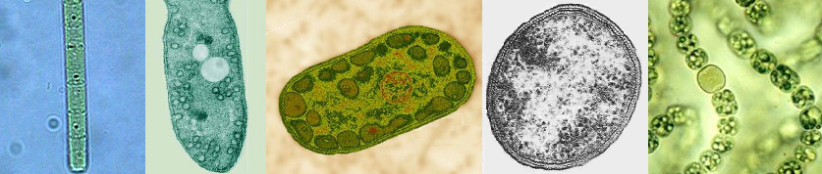

The bacterial metabolisms of photosynthesis and nitrogen fixation have shaped life on our planet by contributing to the cycling of carbon and nitrogen in the Earth’s biosphere. While photosynthesis fixes carbon dioxide using different electron donors (*e.g.*, H20, H2S) into carbohydrates, nitrogen fixation transforms atmospheric nitrogen (N2) into a bioavailable source such as ammonium (NH4). Geochemical and biological evidence suggests that photosynthesis 1-3 and nitrogen fixation 4,5 evolved shortly after life originated on our planet. Understanding how these metabolisms evolved through the bacterial domain will give insights into how these processes have shaped biogeochemical cycles. How can we study the evolution of photosynthesis and nitrogen fixation given that they evolved billions of years ago? The evolution of these processes must be studied indirectly, through the phylogenetic comparison of a wide diversity of bacterial lineages. Such an analysis can help elucidate the details of how these processes evolved and when they evolved. Lateral gene transfer — the transmission of genes between different bacterial lineages — has been used to explain the current distribution of these metabolisms on the bacterial tree of life. Alternative explanations might also be possible, such as the differential loss of genes involved in these metabolisms as bacterial lineages diversified.

Using the bacterial tree of life, this project aims to study how and when these fundamental metabolisms evolve. We will use large genomic data sets to study: (1) the evolution of the bacterial linages and (2) the evolutionary patterns for photosynthesis and nitrogen fixation (both vertical and horizontal) across bacterial groups. The Ph.D. student funded by this grant will also have the unique opportunity to not only collect the appropriate data but also to develop new phylogenetic methods.

This student would be co-advised by Dr. Patricia Sánchez-Baracaldo (University of Bristol) who is an expert in the biological/geological data and Prof. John Huelsenbeck (University of California, Berkeley) who is an expert in the development of phylogenetic methods. This is a great opportunity for students interested in evolutionary biology, phylogenetic methods, bioinformatics, and the origin of life.

This is a four-year project funded by the University of Bristol (Host institution). Please follow this link to apply to this project. **How to apply**

**Applications deadline: Friday 10th of February 2017. Interviews will be held during the 24th or/and 25th of February.**

References:

1. Bell, E. A., Boehnke, P., Harrison, T. M. & Mao, W. L. Potentially biogenic carbon preserved in a 4.1 billion-year-old zircon. *P Natl Acad Sci USA* **112**, 14518-14521, (2015).

2. Tice, M. M. & Lowe, D. R. Photosynthetic microbial mats in the 3,416-Myr-old ocean. *Nature* **431**, 549-552, (2004).

3. Blankenship, R. E. Early evolution of photosynthesis. *Plant Physiol* **154**, 434-438, (2010).

4. Thomazo, C., Ader, M. & Philippot, P. Extreme 15N-enrichments in 2.72-Gyr-old sediments: evidence for a turning point in the nitrogen cycle. *Geobiology* **9**, 107-120, (2011).

5. Weiss, M. C. *et al.* The physiology and habitat of the last universal common ancestor. *Nat Microbiol* **1**, 16116, (2016).