Project Number: ADP-EBD1001

Electronic Map Management System
Project Explanation
Version：Ver1.0

Total Pages | 12 | Content | 11 | Appendix | 0 | Date | 2010-1-5
Maker：Neusoft Traiaing Center |  |  |  | Approved by：

Revision History

Revision No. | Date | Modifier | Version | Modified Content
1 | 2010-1-5 | Y.B | 1.0 | Create
2
3

Content

1. Project Summary 2
1.1 Project Name 2
1.2 Project Objectives 3
1.3 Sofeware Summary 3
1.4 Function Description 3
1.5 Developement Environment 4
1.6 Key Technologies 4
1.7 Development System 5
1.8 Devlopment Phases 6
2. Detailed Requirement of the Project 6
2.1 Overall 6
2.2 Read File 7
2.3 Sort 8
2.3 Search 8
2.4 Update 10
2.5 Exit 11

1. Project Summary

1.1 Project Name
Electronic Map Management System(EMMS)

1.2 Project Objectives
- Experience software development process as a whole, from requirement understanding to primary design, detailed design, coding, test and product release.
- To better understanding the process-oriented analysis and design thought.
- Be familiar with Visual Studio development environment, thus, to design software with Windows Application.
- Able to consult related SDK of MSDN, and develop software by using the SDK.
- Culture and learn new knowledge, and ability to use in your project.

1.3 Software Summary
Design a E_map system to manage data information including in the map. The original data formatting in accordance with the map data, are stored in a binary file.(Each road including in the E_map has a unique number called LinkID.)Details about the road conditions are described in the file, and disorderly stored (with LinkID disorder).You should recognize, analyze, query, and sort the road conditions data contained in the file.
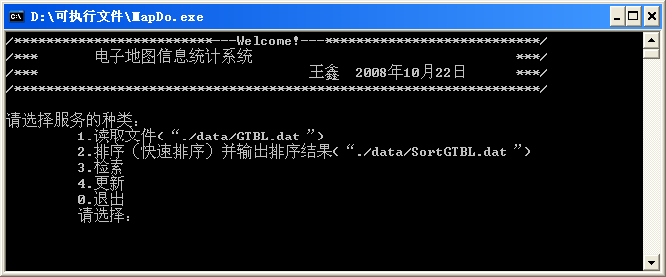
图1-1

1.4 Function Description
- Master the binary data structure of E_map.
- Be able to read the raw map data from a binary file.
- Recognize, analyze, query, and sort the road conditions information contained in the file.
- Using bubble sort, quick sort, insertion sort, or other sort methods to handle the raw map data, and give out the performance comparison between different methods。
- Using sequential search, binary search, block search or other search methods to handle the raw map data, and give out the performance comparison between different methods。

1.5 Development Environment
OS：Microsoft Windows XP SP2
Complier：Microsoft Visual C++ 6.0/2005
MSDN：Library

1.6 Key Technologies
- Process Oriented Design Thought
- Data Structure
- Application of C/C++ Console
- File Operation
- Usage of Link list
- Search and Sort Algorithm
- Bit Computing

1.7 Development System
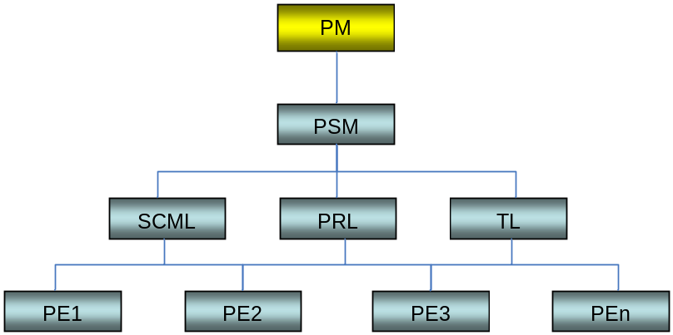

NO. | Project Roles | Responsibility | Comment
1 | PM | Trainer, the person should have experience of development and management. He should track the project process and check the progress and goal before each process of the project | Part-time
2 | TL | Team leader, the person should be skillful at management. The main responsibility is to lead the team to accomplish the train program and report the progress of the project to PM.  Should also take charge of the project module. | Full-time
3 | PRL | Peer Review Leader, the person should have strong technical skill. The main responsibility is to organize the review and check the review result.  Should also take charge of the project module. | Full-time
4 | SCML | Configuration Management Leader, the person should be dedicated and good at handle details. The main responsibility is to track the development process and result based on the rules, and manages the process result. Learn how to use the template of next process before the process start, and explain to the other leaders.  Should also take charge of the project module. | Full-time
5 | PE1 | Project module 1 leader. | Full-time
6 | PE2 | Project module 2 leader. | Full-time
7 | PE3 | Project module 3 leader. | Full-time

1.8 Development Phases
Expected development time of the project is 10 days.

Time  （Days） | Phase | Outcomes | Comment
2 | Requirement Analysis  + Technical Investigation | RTM(100 items) | Investigate related technology using in the project.
1 | Primary Design | Primary Design  Documentation | Including Module Relationship diagram, and motion sequence diagram.
1 | Detail Design | Detail Design  Documentation | Including the mainly function flow diagram.
2 | Coding | Code in Ver.0.5 | Feather Fix version release
2 | Coding | Code in Ver1.0 | Final Version release  Complete the Code review reports
1 | Test | Test Result | Test Case
0.5 | Product Release | Make Instillation Package of the product | Also need a user manual about the product
0.5 | Project Summary | Project Summary Report

2、Detailed Requirement of the Project

2.1 Overall
The system interface of the project is just as bellows:
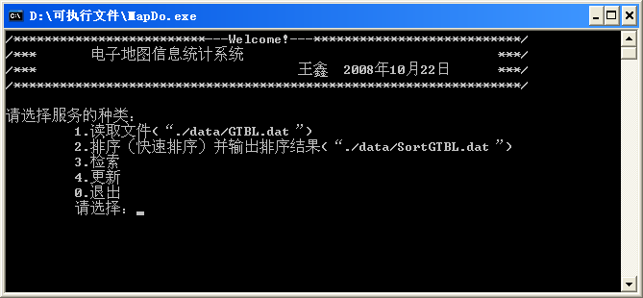
图2-1
1. The interface displays the main screen of the project, including the project name and creation time and creator information for the project, you can design it just as the Windows help menu.
2. Lists all of the system's functionality in the form of a sequence number, including read file, sort, search, update, exit and other functions.

2.2 Read File
When the entered number of the "Please select" is equal to “1”, read the binary file, and if the file is read successfully, there will be a message prompt, and then repeat the types of services.
It is just looks as below。

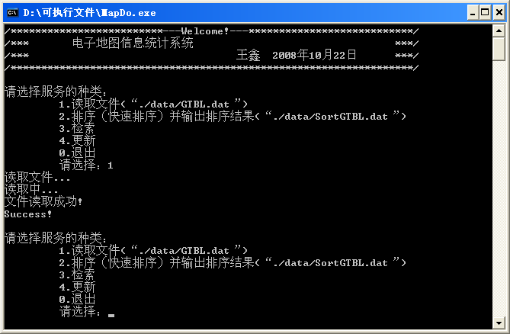
图2-2

NOTES：
- If the source file does not exist must be prompt, or manually enter the file path. After the successfully load of the file, the system must return to the project interface for all types of services.
- Location of output file generated should have clear instructions, which can be used as the application source file of other functions。
- Previous operating records retained in the form of rolling reserved。

2.3 Sort
This function is used to sort the binary file loaded successfully. You can given a variety of sort algorithms, and record the sort time of each algorithm. Then, you should given the performance comparison between different sort algorithms。
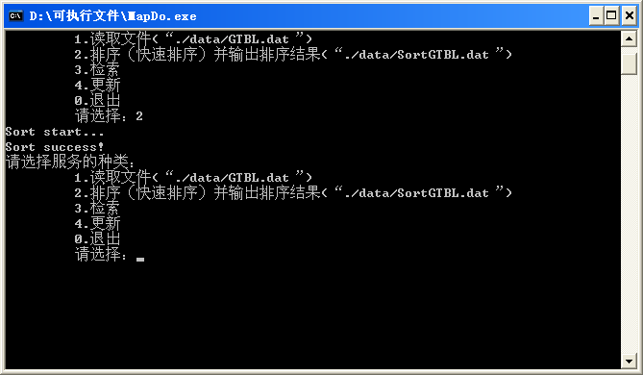
图2-3

The sort results should be outputted to the specified location. And the interface should back to main menu.

2.3 Search
When the entered number of the "Please select" is equal to “3”, you should load the search function, which is designed to search specific information from the file. This function is on the basis of a sorted file.
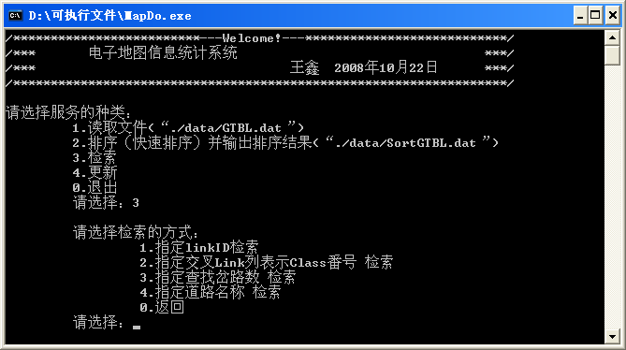图2-4
This section lists the different search keywords which are part of the binary file map format。It also is able to use different search algorithm to search for one keyword, and you should given the performance comparison between different methods.
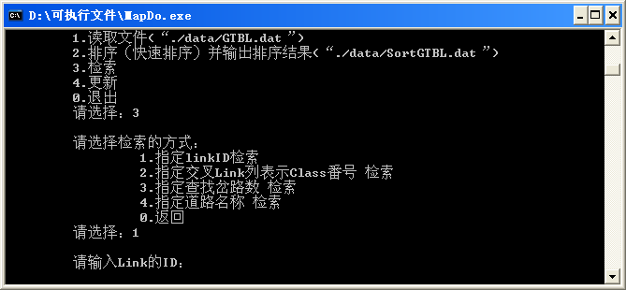
图2-5
NOTES:
If the input keywords search failed, it should be prompted. And return to the search screen。
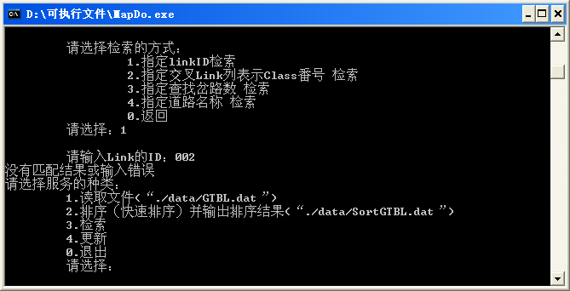
图2-6
The searched information can be handled in two ways, if the information is less than 5 items, they can be display in the screen; but if the items if larger, you can store the search result to another text file for convenient read and double check.
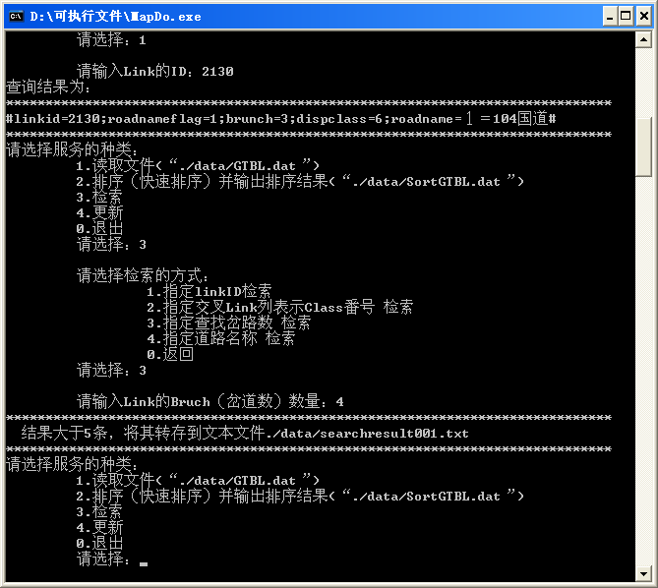
图2-6
这部分中的“退出”是退出本检索层次的部分。

2.4 Update
This feature is the use of sorted binary file to replace the original file, if an error occurs during the update process, the system will make prompt. And if it is successful, the source file can be a new file。It is a update error as below.
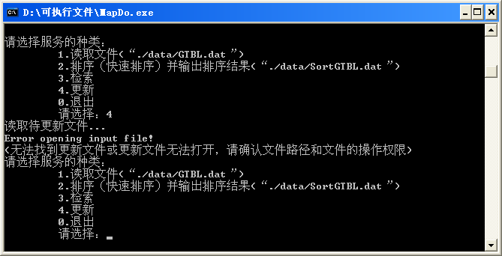
图2-7

2.5 Exit
The last item in the main menu is the exit, to exit the system, you just need to enter the number "0" in the "Please select"menu.

