Do superiority-violating multiple singular which-questions have pair-list readings?
Andreea C. Nicolae¹, Patrick D. Elliott², and Yasutada Sudo²
ZAS¹ and University College London²

Sentences like (1) with multiple singular which-phrases give rise to a pair-list (PL) and single-pair (SP) reading.

(1) Which boy likes which girl?

A complete answer to the PL reading of (1) determines for each boy which girl he likes. A complete answer to the SP reading is about a single boy-girl pair.

Kayne (1983) and Pesetsky (1987), among many others, point out that multiple wh-questions with which-phrases tolerate superiority violations, as in (2).

(2) Which girl does which boy like?

While the grammaticality of (2) is unquestionable, there is disagreement among scholars as to whether questions like (2) have PL readings. Specifically, Barss (2000) and Bošković (2001) claim that they only have SP readings, while Pesetsky (2000) and Kotek (2014) assume that they also allow PL readings, just like their superiority-obeying counterparts.

We conducted an online experiment to investigate which hypothesis is correct. The task of our experiment was to judge the felicity of question-answer pairs on a scale of 1 (very unnatural)–5 (very natural). There were 12 critical items, 6 of which involved superiority-obeying questions like (1) and 6 of which involved superiority-violating questions like (2). All of them were paired with a PL answer. They were presented with 6 filler items and 24 items from a separate experiment. The order of presentation was randomized for each participant, except that the first two items were always filler items.

34 self-claimed native speakers of English were recruited on Amazon Mechanical Turk and paid $0.40 for their participation. The data from six of them were excluded from the analysis, as they did not provide correct answers to more than two filler items (where the correct answers are those that fall into the interquartile range calculated with all the subjects). For three of the fillers, the median rating was 5, and for two, it was 2 and for one, it was 1.

The results are summarized in Figure 1. The median rating (indicated by a thick horizontal bar) is 5 for both conditions, suggesting that PL readings are possible for both superiority-obeying and superiority-violating multiple singular which-questions. This runs counter to Barss’s and Bošković’s view.

However, we also observe a significant difference between the conditions such that superiority-violating questions are judged as less natural with PL answers than superiority-obeying ones (Wilcoxson signed-rank test: W=1033, Z=–4.463, p < 0.001). Furthermore, a by-subject breakdown of the data indicates that this difference is driven by a subset of the subjects, suggesting inter-speaker variation. Specifically, as shown in Figure 2, a number of subjects judged the superiority-violating questions with PL answers worse than the superiority-obeying questions, while others judged them more or less equally good. If such inter-speaker variation exists, a theory of PL readings needs to be able to explain the existence of speakers for whom superiority-violating questions do not have PL readings.
(471 words)

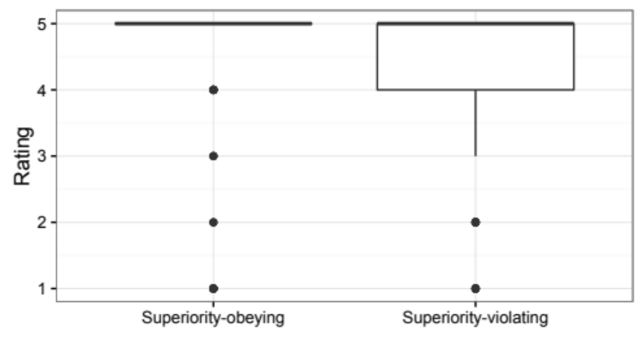
Figure 1: The ratings for the two conditions of the experiment.

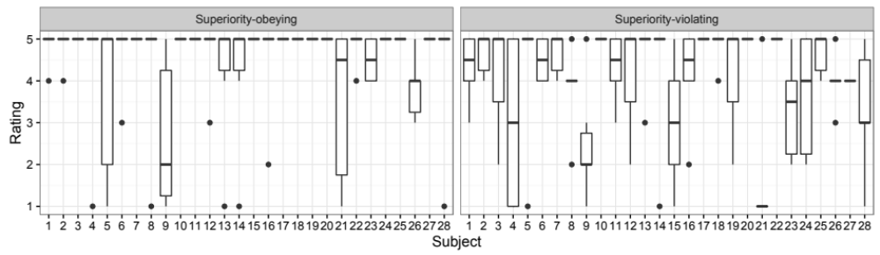
Figure 2: A by-subject breakdown of the data in the two conditions. Each subject is identified by a number on the x-axis.

The results are available on https://github.com/patrl/superiorityExperiment.

References
Barss, Andrew (2000) Minimalism and asymmetric wh-interpretation. In Roger Martin, David Michaels, and Juan Uriagereka (eds.), Step by Step: Essays on Minimalism in Honor of Howard Lasnik. pp. 31–52. Cambridge, MA: MIT Press.
Bošković, Željko (2001) On the interpretation of multiple questions. Linguistic Variation Yearbook, 1(1): 1–15.
Kayne, Richard (1983) Connectedness. Linguistic Inquiry, 14(2): 223–249.
Kotek, Hadas (2014) Composing Questions. Ph.D. dissertation, MIT.
Pesetsky, David (1987) Wh-in-situ: Movement and unselective binding. In Eric Reuland and Alice ter Meulen (eds.), The Representation of (In)definiteness. pp. 98–129. Cambridge, MA: MIT Press.
Pesetsky, David (2000) Phrasal Movement and Its Kin. Cambridge, MA: MIT Press.

