SCHOOL OF TECHNOLOGY | 
DATABASE MANAGEMENT SYSTEMS
(Course Code: 25TU01MLM2)
PROJECT-BASED LEARNING (PBL) REPORT
Small Database Application Development using Python
PROJECT TITLE
LABORATORY EQUIPMENT BOOKING & MAINTENANCE SYSTEM: DESIGN AND IMPLEMENTATION OF A DATABASE MANAGEMENT SYSTEM
Program | B.Tech Computer Science and Engineering
Section | CSE Panthers
Faculty | Prof. Sahithi Chennamadhavuni
Date of Submission | 16 October 2026
Academic Year | 2026 – 27
Submitted by
Roll Number | Student Name | Mobile | Email ID
25WU0104005 | A Khushi Patro | 9668814783 | khushi.patro_2029@woxsen.edu.in
© School of Technology, Woxsen University, 2026. All rights reserved

ACKNOWLEDGEMENT
I would like to place on record my sincere gratitude to Woxsen University, School of Technology, and its Department of Computer Science and Engineering for giving me the platform and the academic infrastructure to take up this Project-Based Learning (PBL) activity as part of the Database Management Systems (DBMS) course.
I am especially thankful to my course faculty, Prof. Sahithi Chennamadhavuni, for the guidance, feedback and steady support I received while designing and building the “Laboratory Equipment Booking and Maintenance System”. Her suggestions helped me turn ideas I had only read about, such as entity-relationship modelling, 3NF normalisation, integrity constraints, conflict-checking triggers, transactions and analytical SQL queries, into a working database application.
Working on this project strengthened my understanding of DBMS concepts and showed me how they apply to a real-world problem.
A Khushi Patro

UNDERTAKING
I hereby declare that the project entitled “Laboratory Equipment Booking and Maintenance System”, submitted as part of the Project-Based Learning activity for the Database Management Systems (DBMS) course, is my individual work carried out under the guidance of the course faculty.
I undertake that the project report, database design, SQL scripts, application source code, results, and supporting materials submitted by me have been prepared for academic purposes. Wherever information, ideas, tools, datasets, or other resources have been referred to, appropriate acknowledgement has been provided.
I further undertake that I am responsible for the correctness and authenticity of the work submitted and that I have followed the academic and project guidelines prescribed by the University.
Date | Place | Name: | Roll Number: | Program: | Signature
16/10/2026 | Woxsen University | A Khushi Patro | 25WU0104005 | B.Tech CSE | [Sign here]

TABLE OF CONTENTS
Contents Page No.
LIST OF TABLES 5
LIST OF FIGURES 6
LIST OF ACRONYMS 7
Abstract 8
1. PROBLEM STATEMENT, SOLUTION STRATEGY AND ER DIAGRAM 9
1.1 Problem Statement 9
1.2 Existing Systems 10
1.3 Proposed Solution 10
1.4 Distinguishing Features 11
1.5 System Requirements 11
1.6 System Workflow and Business Rules 12
1.7 Entity-Relationship Diagram (ERD) 13
1.8 Entity and Relationship Summary 14
1.9 Objectives 14
1.10 Scope and Assumptions 15
2. LOGICAL DATABASE DESIGN 16
2.1 Initial Relational Schema 16
2.2 Keys and Integrity Constraints 17
2.3 Functional Dependencies 18
2.4 Normalization up to Third Normal Form (3NF) 19
2.5 Data Dictionary 20
2.6 Implementation of Logical Design: DDL and Sample Data 22
3. PROJECT PLAN 24
3.1 Three-Phase Roadmap 24
3.2 Progress Against the Roadmap 24
4. APPLICATION DEVELOPMENT USING LOGICAL DATABASE DESIGN 25
4.1 Application Overview 25
4.2 Development Environment and Database Connectivity 26
4.3 Application Modules and Database Mapping 26
4.4 CRUD Operations 27
4.5 Business Rules, Validation and Error Handling 27
4.6 Reports and Database Operations 28
4.7 Application Screens 31
4.8 Testing and Results 35
5. CONCLUSION 37
5.1 Limitations and Future Enhancements 37
6. REFERENCES 38
7. APPENDICES 39

LIST OF TABLES
Table No. | Table Title | Page No.
Table 1 | Existing Systems | 10
Table 2 | Distinguishing Features | 11
Table 3 | System Requirements | 11
Table 4 | Functional Requirements | 12
Table 5 | Key Business Rules | 13
Table 6 | Entity and Relationship Summary | 14
Table 7 | Scope and Assumptions | 15
Table 8 | Initial Relational Schema | 16
Table 9 | Keys and Integrity Constraints | 17
Table 10 | Normalization Status up to 3NF | 19
Table 11 | Data Dictionary | 20
Table 12 | Database Implementation Environment | 22
Table 13 | Project Plan | 24
Table 14 | Roadmap Activities and Where They Are Documented | 24
Table 15 | Application Development Environment | 26
Table 16 | Application Module-to-Database Mapping | 26
Table 17 | CRUD Operations | 27
Table 18 | Business Rules, Validation and Error Handling | 28
Table 19 | Reports and Database Operations | 28
Table 20 | Test Cases | 35

LIST OF FIGURES
Figure No. | Figure Title | Page No.
Figure 1 | Entity-Relationship Diagram of the Laboratory Equipment Booking and Maintenance System | 13
Figure 2 | Initial Relational Schema | 16
Figure 3 | Three-tier System Architecture | 25
Figure 4 | Flowchart of Booking Request and Approval | 30
Figure 5 | Flowchart of Breakdown Reporting and Maintenance Completion | 31
Figure 6 | LabTrack Home Page | 32
Figure 7 | Proposed Solution: Register, Search, Check and Book | 32
Figure 8 | Distinguishing Features Page | 33
Figure 9 | Live Demo: Conflict-aware Equipment Booking | 33
Figure 10 | Database Schema Page: Twelve Tables with Primary and Foreign Keys | 34
Figure 11 | Three-phase Project Roadmap Page | 34
Figure 12 | Laboratory Floor in 3D: Equipment Status (angle 1) | 35
Figure 13 | Laboratory Floor in 3D: Equipment Status (angle 2) | 35

LIST OF ACRONYMS
Acronym | Expansion
3NF | Third Normal Form
ACID | Atomicity, Consistency, Isolation, Durability
API | Application Programming Interface
BCNF | Boyce–Codd Normal Form
CRUD | Create, Read, Update, Delete
DBMS | Database Management System
DDL | Data Definition Language
DML | Data Manipulation Language
ER | Entity-Relationship
ERD | Entity-Relationship Diagram
FD | Functional Dependency
FK | Foreign Key
FR | Functional Requirement
HTTP | HyperText Transfer Protocol
JSON | JavaScript Object Notation
PBL | Project-Based Learning
PK | Primary Key
REST | Representational State Transfer
SQL | Structured Query Language
TC | Test Case
UI | User Interface
UNF | Unnormalised Form

ABSTRACT
Laboratories depend on expensive shared instruments such as oscilloscopes, spectrometers, routers, 3D printers and CNC machines, yet in most institutions the booking, usage, calibration and repair of this equipment is recorded in handwritten registers and separate spreadsheets. The result is predictable: two groups arrive for the same instrument, nobody can see whether an instrument is due for calibration at the time it is booked, breakdowns are noted in one log while consumable stock is noted in another, and the history of who used what and when cannot be reconstructed for an audit. The objective of this project is to design and implement a centralised relational database for a Laboratory Equipment Booking and Maintenance System that connects the complete equipment lifecycle: equipment, booking, usage, calibration or breakdown, maintenance and reports.
I designed an Entity-Relationship model with twelve entities, converted it into a Third Normal Form schema and implemented it in SQL with primary, foreign, unique, check, default and not-null constraints, six indexes, a reporting view and five triggers. The triggers enforce the most important business rules inside the database itself: no overlapping approved bookings for the same equipment, only active equipment can be reserved, calibration dates must be valid, consumable stock cannot go negative, and maintenance status and completion are recorded consistently. A Python/Flask REST layer and the LabTrack website connect users to the database, and every multi-step operation runs as a single transaction. Analytical SQL queries produce availability, utilisation, calibration-due, downtime, breakdown and vendor-service reports. Seventeen automated test cases were run against the implementation and all of them passed, showing that the key laboratory rules are guaranteed by the database and not only by application code.
KEYWORDS
Keywords: Laboratory Equipment, Booking Management, Relational Database, ER Diagram, Normalization, SQL Triggers, Python Flask

CHAPTER 1
PROBLEM STATEMENT, SOLUTION STRATEGY AND ER DIAGRAM

1.1 Problem Statement
Manual, disconnected tools lead to double bookings, missing history, and unclear equipment status at booking time.
- Double bookings in busy weeks
- Incomplete history (who, when, why) makes tracking hard
- Calibration and maintenance status isn’t shown when booking
- Separate logs for breakdowns and consumables cause delays and stockouts
Processes converge to a centralized laboratory database to eliminate fragmentation.
A university laboratory is a shared resource. Faculty teach practical sessions in it, students book instruments for project work, lab technicians calibrate and repair the equipment, and administrators answer audit questions about utilisation and downtime. Each of these people normally keeps a different record: a booking register at the laboratory door, a spreadsheet of equipment, a separate calibration sheet, a breakdown notebook and a stock list for consumables. Because these records are not connected, no one can answer simple questions quickly, such as whether a particular oscilloscope is free on Thursday at 10:00, when it was last calibrated, or how many days a milling machine has been out of service this semester.
The domain is also a good vehicle for the main topics of a database course: relational design, normalisation, integrity constraints, triggers, indexing and transaction management. Five domain-specific challenges had to be solved:
- Conflict-free scheduling. Two approved bookings for the same instrument must never overlap in time, even when they are partially overlapping (for example 09:00–11:00 and 10:00–11:00), and the rule must hold even if a record is inserted directly with SQL.
- Equipment status at booking time. Only equipment in ACTIVE status can be reserved; equipment that is under maintenance or retired must be blocked automatically.
- Calibration provenance. Every calibration must carry a valid next-due date so that overdue instruments are visible before they are used for measurements.
- Breakdown-to-repair tracking. A reported fault should change the equipment status, link to a maintenance job and vendor, and restore the equipment only when the job is completed.
- Consumable stock limits. Consumables such as filament, cuvettes and buffer solutions must never go below zero, and low stock must be visible before it causes a stockout.

1.2 Existing Systems
Disparate tools handle parts of the workflow but lack a single source of truth or dependable availability checks. Table 1 summarises the existing approaches.
Table 1. Existing Systems
Existing Approach | Main Use | Observation
Manual Registers | Equipment bookings and records | Handwritten or incomplete entries hinder traceability and often cause double bookings or missing history.
Spreadsheets and separate maintenance logs | Equipment and booking data, and maintenance tracking | Version drift and siloed logs lead to outdated availability, duplicate bookings, and missed calibration or repair status.

Neither approach can enforce a rule. A spreadsheet will accept two overlapping bookings without complaint, and a register cannot warn that an instrument is overdue for calibration. What is needed is a system in which the rules are part of the data store.

1.3 Proposed Solution
A centralized relational database system for managing laboratory equipment from booking and usage to calibration, breakdown and maintenance.
The solution follows four steps: Register, Search, Check and Book. The overall lifecycle covered by the system is:
EQUIPMENT → BOOKING → USAGE → CALIBRATION / BREAKDOWN → MAINTENANCE → REPORTS
In practice the four steps work as follows:
- Register. Laboratories, categories, equipment, users, time slots and vendors are recorded once in master tables.
- Search. A user searches equipment by name, laboratory or category and sees its current status and next calibration date.
- Check. The system checks availability for the chosen date and time slot against approved bookings and verifies that the equipment is ACTIVE.
- Book. A booking request is created as PENDING and becomes APPROVED only when no overlapping approved booking exists. Usage, calibration, breakdown and maintenance then attach to the same equipment record, so a single history is kept.

1.4 Distinguishing Features
Table 2 lists the features that distinguish the proposed system.
Table 2. Distinguishing Features
Feature | Description
Conflict-Aware Equipment Booking | Prevents overlapping approved bookings for the same equipment.
Equipment Lifecycle Tracking | Connects booking, usage, calibration, breakdowns, and maintenance into one history.
Calibration and Maintenance Tracking | Maintains calibration records and maintenance logs for full provenance.
Availability and Utilization Reporting | Reports on availability, utilization, calibration due dates, and downtime for planning and audits.

Together these features change the role of the database from a passive store into an active guard: a booking that breaks a rule is refused at the moment it is attempted, and the reason is returned to the user.

1.5 System Requirements
Core capabilities required for the Laboratory Equipment Booking and Maintenance System are listed in Table 3.
Table 3. System Requirements
Requirement Area | Capabilities
1. Equipment Management | Manage laboratories  Manage equipment categories  Manage equipment  Track equipment status
2. Booking Management | Search equipment  Check equipment availability  Create bookings  Approve bookings  Prevent overlapping approved bookings
3. Usage & Calibration | Record equipment usage  Maintain usage logs  Record calibration information  Track calibration due dates
4. Maintenance & Inventory | Report equipment breakdowns  Manage maintenance jobs  Manage consumables  Track stock limits  Maintain vendor information
5. Reporting | Equipment availability  Equipment utilization  Calibration due  Downtime  Breakdown information  Vendor service

Table 4 refines these capabilities into numbered functional requirements with their priority, so that each one can be traced to a table, a rule and a test case later in the report.
Table 4. Functional Requirements
Req. ID | Functional Requirement | Priority
FR-01 | Register laboratories and equipment categories | High
FR-02 | Register equipment against a laboratory and a category | High
FR-03 | Maintain equipment status (ACTIVE, UNDER_MAINTENANCE, RETIRED) | High
FR-04 | Maintain users with roles (student, faculty, lab technician, admin) | Medium
FR-05 | Maintain a catalogue of bookable time slots | High
FR-06 | Search equipment by name, laboratory, category and status | High
FR-07 | Show slot-wise availability of equipment for a chosen date | High
FR-08 | Create a booking request as PENDING | High
FR-09 | Approve, reject or cancel a booking | High
FR-10 | Refuse overlapping approved bookings for the same equipment | High
FR-11 | Refuse bookings for equipment that is not ACTIVE | High
FR-12 | Record usage against an approved booking and mark it COMPLETED | Medium
FR-13 | Record calibration with a valid next-due date | High
FR-14 | List calibration due and overdue equipment | Medium
FR-15 | Report a breakdown and move equipment to UNDER_MAINTENANCE | High
FR-16 | Create and complete maintenance jobs with vendor and dates | High
FR-17 | Maintain consumables and refuse negative stock | Medium
FR-18 | Maintain vendor details | Low
FR-19 | Report availability, utilisation, downtime and vendor service | Medium

1.6 System Workflow and Business Rules
The system workflow proceeds through the following steps: Register Equipment, Search Equipment, Check Availability and Create Booking. The key business rules are given in Table 5.
Table 5. Key Business Rules
Rule No. | Business Rule
1 | No overlapping approved bookings
2 | Only active equipment can be reserved
3 | Calibration dates must be valid
4 | Consumables must respect stock limits
5 | Record maintenance status and completion

Availability checks and status tracking preserve traceability.
Each rule is enforced by a named database mechanism rather than by convention. Rule 1 is enforced by two triggers on the Booking table (one for INSERT and one for UPDATE, because approval is an update). Rule 2 is enforced by a trigger that checks the Equipment status before a booking is inserted. Rule 3 is a CHECK constraint on the Calibration table (next_due_date must be later than calibration_date). Rule 4 is a CHECK constraint on Consumable.stock_quantity combined with a guarded stock-adjustment routine. Rule 5 is enforced by a CHECK constraint on Maintenance_Job together with a trigger that resolves the linked breakdown and re-activates the equipment when a job is completed.

1.7 Entity-Relationship Diagram (ERD)
Figure 1 shows the Entity-Relationship Diagram of the Laboratory Equipment Booking and Maintenance System.
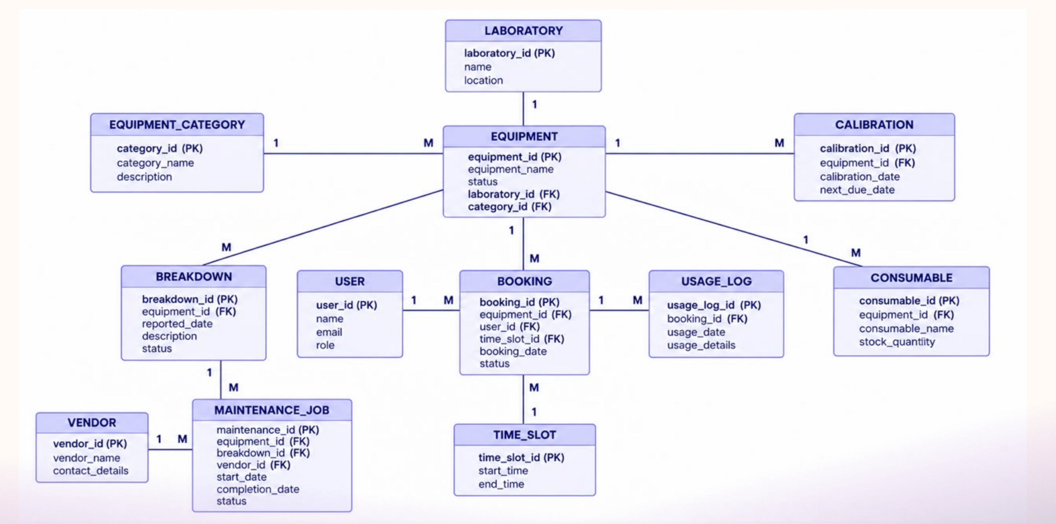
Figure 1. Entity-Relationship Diagram of the Laboratory Equipment Booking and Maintenance System
The database contains twelve entities. Equipment is the central entity: it belongs to one Laboratory and one Equipment_Category, and it is the parent of Booking, Calibration, Breakdown, Consumable and Maintenance_Job records. Booking joins Equipment, User and Time_Slot, and each Usage_Log record belongs to exactly one booking. Maintenance_Job links an equipment item to the Breakdown that caused it and to the Vendor who repairs it.

1.8 Entity and Relationship Summary
Table 6 summarises each entity, its key attributes and the relationships in which it takes part.
Table 6. Entity and Relationship Summary
Entity | Key Attributes | Relationships / Cardinality
Laboratory | laboratory_id (PK), name, location | 1 Laboratory – N Equipment
Equipment_Category | category_id (PK), category_name, description | 1 Category – N Equipment
Equipment | equipment_id (PK), laboratory_id (FK), category_id (FK), equipment_name, status | Parent of Booking, Calibration, Breakdown, Consumable and Maintenance_Job (1 – N each)
User | user_id (PK), name, email, role | 1 User – N Booking
Time_Slot | time_slot_id (PK), start_time, end_time | 1 Time_Slot – N Booking
Booking | booking_id (PK), equipment_id (FK), user_id (FK), time_slot_id (FK), booking_date, status | N Booking – 1 Equipment, 1 User, 1 Time_Slot; 1 Booking – N Usage_Log
Usage_Log | usage_log_id (PK), booking_id (FK), usage_date, usage_details | N Usage_Log – 1 Booking
Consumable | consumable_id (PK), equipment_id (FK), consumable_name, stock_quantity | N Consumable – 1 Equipment
Calibration | calibration_id (PK), equipment_id (FK), calibration_date, next_due_date | N Calibration – 1 Equipment
Breakdown | breakdown_id (PK), equipment_id (FK), reported_date, description, status | N Breakdown – 1 Equipment; 1 Breakdown – N Maintenance_Job
Maintenance_Job | maintenance_id (PK), equipment_id (FK), breakdown_id (FK), vendor_id (FK), start_date, completion_date, status | N Maintenance_Job – 1 Equipment, 1 Breakdown, 1 Vendor
Vendor | vendor_id (PK), vendor_name, contact_details | 1 Vendor – N Maintenance_Job

1.9 Objectives
- Model laboratories, categories, equipment, users, time slots, bookings, usage logs, consumables, calibrations, breakdowns, maintenance jobs and vendors in a normalised relational schema (3NF).
- Enforce data integrity and business rules at the database level using constraints and triggers, and not only in application code.
- Provide a working front end and a Python backend that perform equipment search, availability checking, booking and approval, usage and calibration entry, breakdown and maintenance handling, stock control and reporting against a live database.
- Demonstrate indexing, transaction handling, input validation and error handling as visible features of the system.
- Validate the behaviour of the system through systematic automated tests.

1.10 Scope and Assumptions
Table 7 summarises what the system covers, what it leaves out and what has been assumed.
Table 7. Scope and Assumptions
Item | Description
In Scope | Laboratory office operations: equipment registration, search and availability, booking and approval, usage logging, calibration tracking, breakdown reporting, maintenance jobs, consumable stock and vendor records. Reporting: availability, utilisation, calibration due, downtime, breakdowns and vendor service.
Out of Scope / Exclusions | Barcode or RFID scanning, email or SMS reminders, online payment for external users, role-based login and integration with the university ERP are outside the scope of this version.
Assumptions | Bookings are made for whole time slots on a single date. Each equipment item has one laboratory and one category. A weekly bookable capacity of 40 hours per equipment item is assumed when computing utilisation. Dates are stored in ISO format (YYYY-MM-DD) and times as HH:MM.
Data | The sample data represents four laboratories, fourteen equipment items and seventeen bookings and is used only for demonstration and testing.

CHAPTER 2
LOGICAL DATABASE DESIGN
This chapter explains how the ER model was converted into a relational design, how the relations were checked up to Third Normal Form, and how the design was implemented in SQL.

2.1 Initial Relational Schema
Figure 2 shows the initial relational schema for the Laboratory Equipment Booking and Maintenance System, with primary keys (PK) and foreign keys (FK) marked. Table 8 lists the attributes of each relation.
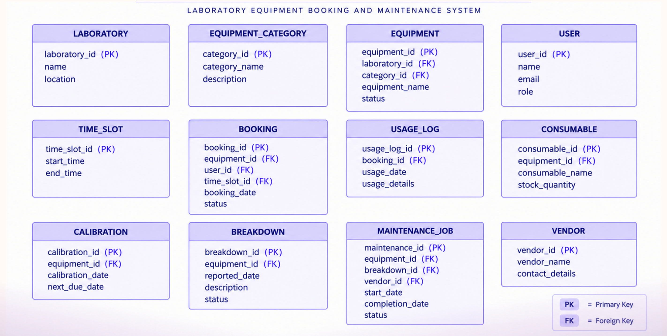
Figure 2. Initial Relational Schema
Table 8. Initial Relational Schema
S.No. | Table Name | Attributes
1 | LABORATORY | laboratory_id (PK), name, location
2 | EQUIPMENT_CATEGORY | category_id (PK), category_name, description
3 | EQUIPMENT | equipment_id (PK), laboratory_id (FK), category_id (FK), equipment_name, status
4 | USER | user_id (PK), name, email, role
5 | TIME_SLOT | time_slot_id (PK), start_time, end_time
6 | BOOKING | booking_id (PK), equipment_id (FK), user_id (FK), time_slot_id (FK), booking_date, status
7 | USAGE_LOG | usage_log_id (PK), booking_id (FK), usage_date, usage_details
8 | CONSUMABLE | consumable_id (PK), equipment_id (FK), consumable_name, stock_quantity
9 | CALIBRATION | calibration_id (PK), equipment_id (FK), calibration_date, next_due_date
10 | BREAKDOWN | breakdown_id (PK), equipment_id (FK), reported_date, description, status
11 | MAINTENANCE_JOB | maintenance_id (PK), equipment_id (FK), breakdown_id (FK), vendor_id (FK), start_date, completion_date, status
12 | VENDOR | vendor_id (PK), vendor_name, contact_details

Every many-to-many situation in the ER model has been resolved through a relation of its own. For example, Booking resolves the many-to-many relationship between Equipment and User over time, and Maintenance_Job resolves the relationship between Breakdown and Vendor.

2.2 Keys and Integrity Constraints
Table 9 lists the keys and constraints that the database enforces. Referential actions are RESTRICT unless stated otherwise, so a record with dependants cannot be deleted by mistake.
Table 9. Keys and Integrity Constraints
Table | Key / Constraint | Attribute(s) | Rule Enforced
Laboratory | Primary Key / Unique | laboratory_id / name | Each laboratory is identified once; names are not repeated.
Equipment_Category | Primary Key / Unique | category_id / category_name | One row per category.
Equipment | Primary Key | equipment_id | Each equipment item is identified uniquely.
Equipment | Foreign Key | laboratory_id, category_id | Equipment must belong to an existing laboratory and category.
Equipment | Check, Default | status | ACTIVE, UNDER_MAINTENANCE or RETIRED; default ACTIVE.
User | Primary Key / Unique | user_id / email | One account per email address.
User | Check | role | STUDENT, FACULTY, LAB_TECHNICIAN or ADMIN.
Time_Slot | Primary Key / Unique | time_slot_id / (start_time, end_time) | A slot is defined once.
Time_Slot | Check | end_time > start_time | A slot must end after it starts.
Booking | Primary Key | booking_id | Each booking is identified uniquely.
Booking | Foreign Key | equipment_id, user_id, time_slot_id | Bookings refer to existing equipment, user and slot.
Booking | Check, Default | status | PENDING, APPROVED, REJECTED, CANCELLED or COMPLETED; default PENDING.
Booking | Trigger | trg_booking_no_overlap_ins / _upd | Rule 1: no overlapping approved bookings.
Booking | Trigger | trg_booking_active_equipment | Rule 2: only ACTIVE equipment can be reserved.
Usage_Log | Primary Key, Foreign Key | usage_log_id, booking_id | A usage entry belongs to an existing booking.
Consumable | Check, Default | stock_quantity >= 0 | Rule 4: stock can never be negative; default 0.
Calibration | Check | next_due_date > calibration_date | Rule 3: calibration dates must be valid.
Breakdown | Check, Default | status | OPEN, IN_PROGRESS or RESOLVED; default OPEN.
Breakdown | Trigger | trg_breakdown_status | Reported breakdown moves ACTIVE equipment to UNDER_MAINTENANCE.
Vendor | Primary Key / Unique | vendor_id / vendor_name | One row per vendor.
Maintenance_Job | Foreign Key | equipment_id, breakdown_id, vendor_id | A job refers to existing equipment, breakdown and vendor.
Maintenance_Job | Check, Default | status; completion_date >= start_date | Rule 5: valid status (default SCHEDULED) and valid completion date.
Maintenance_Job | Trigger | trg_maintenance_complete | Completion resolves the breakdown and re-activates the equipment.

2.3 Functional Dependencies
The important functional dependencies of the design are listed below. In every case the determinant is the primary key (or a candidate key) of its relation.
- Laboratory: laboratory_id → name, location
- Equipment_Category: category_id → category_name, description
- Equipment: equipment_id → laboratory_id, category_id, equipment_name, status
- User: user_id → name, email, role; email → user_id (candidate key)
- Time_Slot: time_slot_id → start_time, end_time
- Booking: booking_id → equipment_id, user_id, time_slot_id, booking_date, status
- Usage_Log: usage_log_id → booking_id, usage_date, usage_details
- Consumable: consumable_id → equipment_id, consumable_name, stock_quantity
- Calibration: calibration_id → equipment_id, calibration_date, next_due_date
- Breakdown: breakdown_id → equipment_id, reported_date, description, status
- Maintenance_Job: maintenance_id → equipment_id, breakdown_id, vendor_id, start_date, completion_date, status
- Vendor: vendor_id → vendor_name, contact_details

2.4 Normalization up to Third Normal Form (3NF)
I started from the way the laboratory records exist today: one wide register row that repeats the equipment name, laboratory, location, user, slot, calibration dates, fault description and vendor contact on every line. This unnormalised form (UNF) was normalised in three steps.
First Normal Form (1NF). Repeating groups such as several calibrations, several faults and several consumables for the same equipment were moved into rows of their own, and every attribute was made atomic (a date is stored as a single value, and a time slot is a start and an end time).
Second Normal Form (2NF). In the register row the key is a combination such as (equipment, date, slot). Attributes such as equipment_name, laboratory and category depend on the equipment alone, and user details depend on the user alone. These partial dependencies were removed by creating the Equipment, User and Time_Slot relations, so that every non-key attribute depends on the whole key of its relation.
Third Normal Form (3NF). Transitive dependencies were removed: the laboratory name and location depend on laboratory_id, not on equipment_id; the category description depends on category_id; and the vendor name and contact details depend on vendor_id, not on a maintenance job. Each fact is now stored in exactly one place. Table 10 shows the normalisation status of every relation.
Table 10. Normalization Status up to 3NF
Relation | 1NF | 2NF | 3NF | BCNF | Remark
Laboratory | ✓ | ✓ | ✓ | ✓ | Name and location depend only on laboratory_id.
Equipment_Category | ✓ | ✓ | ✓ | ✓ | Description depends only on category_id.
Equipment | ✓ | ✓ | ✓ | ✓ | Laboratory and category details held by FK only.
User | ✓ | ✓ | ✓ | ✓ | email is a candidate key.
Time_Slot | ✓ | ✓ | ✓ | ✓ | Start and end time depend on the slot.
Booking | ✓ | ✓ | ✓ | ✓ | Equipment, user and slot details held by FK only.
Usage_Log | ✓ | ✓ | ✓ | ✓ | Depends only on the booking.
Consumable | ✓ | ✓ | ✓ | ✓ | Stock depends on the consumable row.
Calibration | ✓ | ✓ | ✓ | ✓ | Dates depend on the calibration record.
Breakdown | ✓ | ✓ | ✓ | ✓ | Fault details depend on breakdown_id.
Maintenance_Job | ✓ | ✓ | ✓ | ✓ | Vendor details held by FK only.
Vendor | ✓ | ✓ | ✓ | ✓ | Contact details depend only on vendor_id.

The initial schema of Section 2.1 was therefore already in 3NF and no relation had to be split further. Because every determinant is a candidate key, the relations also satisfy Boyce–Codd Normal Form. The implementation adds constraints, defaults, indexes and triggers to this design but does not change its structure.

2.5 Data Dictionary
Table 11 describes the attributes of all twelve tables. Data types are those of the SQLite implementation; the equivalent MySQL types are INT, VARCHAR, DATE, TIME and ENUM.
Table 11. Data Dictionary
Table | Attribute | Data Type | Key / Constraint | Description
Laboratory | laboratory_id | INTEGER | PK, AUTOINCREMENT | Unique id of the laboratory.
 | name | TEXT | NOT NULL, UNIQUE | Laboratory name.
 | location | TEXT | NOT NULL | Block and room.
Equipment_Category | category_id | INTEGER | PK, AUTOINCREMENT | Unique id of the category.
 | category_name | TEXT | NOT NULL, UNIQUE | Category name.
 | description | TEXT | NULL allowed | Short description.
Equipment | equipment_id | INTEGER | PK, AUTOINCREMENT | Unique id of the equipment item.
 | laboratory_id | INTEGER | FK, NOT NULL | Laboratory where it is kept.
 | category_id | INTEGER | FK, NOT NULL | Category of the item.
 | equipment_name | TEXT | NOT NULL | Display name, for example DSO-1.
 | status | TEXT | CHECK, DEFAULT ACTIVE | ACTIVE, UNDER_MAINTENANCE or RETIRED.
User | user_id | INTEGER | PK, AUTOINCREMENT | Unique id of the user.
 | name | TEXT | NOT NULL | Full name.
 | email | TEXT | NOT NULL, UNIQUE | Institutional email.
 | role | TEXT | CHECK | STUDENT, FACULTY, LAB_TECHNICIAN, ADMIN.
Time_Slot | time_slot_id | INTEGER | PK, AUTOINCREMENT | Unique id of the slot.
 | start_time | TEXT | NOT NULL | Start time (HH:MM).
 | end_time | TEXT | NOT NULL, CHECK | End time; later than start.
Booking | booking_id | INTEGER | PK, AUTOINCREMENT | Unique id of the booking.
 | equipment_id | INTEGER | FK, NOT NULL | Equipment reserved.
 | user_id | INTEGER | FK, NOT NULL | User who booked.
 | time_slot_id | INTEGER | FK, NOT NULL | Slot reserved.
 | booking_date | TEXT | NOT NULL | Date of use (YYYY-MM-DD).
 | status | TEXT | CHECK, DEFAULT PENDING | Booking life-cycle status.
Usage_Log | usage_log_id | INTEGER | PK, AUTOINCREMENT | Unique id of the usage entry.
 | booking_id | INTEGER | FK, NOT NULL | Booking that was used.
 | usage_date | TEXT | NOT NULL | Date of actual use.
 | usage_details | TEXT | NULL allowed | What was done.
Consumable | consumable_id | INTEGER | PK, AUTOINCREMENT | Unique id of the consumable.
 | equipment_id | INTEGER | FK, NOT NULL | Equipment that uses it.
 | consumable_name | TEXT | NOT NULL | Name of the consumable.
 | stock_quantity | INTEGER | CHECK >= 0, DEFAULT 0 | Units in stock.
Calibration | calibration_id | INTEGER | PK, AUTOINCREMENT | Unique id of the calibration.
 | equipment_id | INTEGER | FK, NOT NULL | Equipment calibrated.
 | calibration_date | TEXT | NOT NULL | Date calibrated.
 | next_due_date | TEXT | NOT NULL, CHECK | Must be after calibration_date.
Breakdown | breakdown_id | INTEGER | PK, AUTOINCREMENT | Unique id of the breakdown.
 | equipment_id | INTEGER | FK, NOT NULL | Equipment affected.
 | reported_date | TEXT | NOT NULL | Date the fault was reported.
 | description | TEXT | NOT NULL | Description of the fault.
 | status | TEXT | CHECK, DEFAULT OPEN | OPEN, IN_PROGRESS or RESOLVED.
Vendor | vendor_id | INTEGER | PK, AUTOINCREMENT | Unique id of the vendor.
 | vendor_name | TEXT | NOT NULL, UNIQUE | Vendor name.
 | contact_details | TEXT | NULL allowed | Email and phone.
Maintenance_Job | maintenance_id | INTEGER | PK, AUTOINCREMENT | Unique id of the job.
 | equipment_id | INTEGER | FK, NOT NULL | Equipment serviced.
 | breakdown_id | INTEGER | FK, NULL allowed | Breakdown that caused it (preventive jobs have none).
 | vendor_id | INTEGER | FK, NULL allowed | Vendor doing the work.
 | start_date | TEXT | NOT NULL | Job start date.
 | completion_date | TEXT | CHECK >= start_date | Date completed; NULL while open.
 | status | TEXT | CHECK, DEFAULT SCHEDULED | SCHEDULED, IN_PROGRESS or COMPLETED.

2.6 Implementation of Logical Design: DDL and Sample Data
The design was implemented as a SQL script (schema.sql) and loaded with a seed-data script (seed.py). Table 12 describes the environment used. The complete DDL, the indexes, the triggers and the reporting view are listed in Appendix A.
Table 12. Database Implementation Environment
Item | Details
DBMS | SQLite 3 (relational engine with foreign keys, CHECK constraints, triggers and views); the schema is written in standard SQL and ports to MySQL 8.0
Database name | LabEquipmentDB
Number of tables | 12 tables, 6 indexes, 5 triggers, 1 view
Sample data | Seed script loading 4 laboratories, 5 categories, 14 equipment items, 7 users, 8 time slots, 17 bookings, 5 usage logs, 11 calibrations, 3 breakdowns, 3 vendors, 3 maintenance jobs and 8 consumables
Programming language | Python 3 for the seed script, the REST API and the tests

Representative DDL
CREATE TABLE EQUIPMENT (
equipment_id INTEGER PRIMARY KEY AUTOINCREMENT,
laboratory_id INTEGER NOT NULL REFERENCES LABORATORY(laboratory_id),
category_id INTEGER NOT NULL REFERENCES EQUIPMENT_CATEGORY(category_id),
equipment_name TEXT NOT NULL,
status TEXT NOT NULL DEFAULT 'ACTIVE'
CHECK (status IN ('ACTIVE','UNDER_MAINTENANCE','RETIRED'))
);

CREATE TABLE BOOKING (
booking_id INTEGER PRIMARY KEY AUTOINCREMENT,
equipment_id INTEGER NOT NULL REFERENCES EQUIPMENT(equipment_id),
user_id INTEGER NOT NULL REFERENCES USER(user_id),
time_slot_id INTEGER NOT NULL REFERENCES TIME_SLOT(time_slot_id),
booking_date TEXT NOT NULL,
status TEXT NOT NULL DEFAULT 'PENDING'
CHECK (status IN ('PENDING','APPROVED','REJECTED','CANCELLED','COMPLETED'))
);

CREATE TABLE CALIBRATION (
calibration_id INTEGER PRIMARY KEY AUTOINCREMENT,
equipment_id INTEGER NOT NULL REFERENCES EQUIPMENT(equipment_id),
calibration_date TEXT NOT NULL,
next_due_date TEXT NOT NULL,
CHECK (next_due_date > calibration_date)
);

Rule 1 trigger: no overlapping approved bookings
CREATE TRIGGER trg_booking_no_overlap_upd
BEFORE UPDATE ON BOOKING
WHEN NEW.status = 'APPROVED' AND EXISTS (
SELECT 1 FROM BOOKING b
JOIN TIME_SLOT o ON o.time_slot_id = b.time_slot_id
JOIN TIME_SLOT n ON n.time_slot_id = NEW.time_slot_id
WHERE b.equipment_id = NEW.equipment_id AND b.booking_date = NEW.booking_date
AND b.status = 'APPROVED' AND b.booking_id <> NEW.booking_id
AND o.start_time < n.end_time AND n.start_time < o.end_time)
BEGIN
SELECT RAISE(ABORT, 'Overlapping approved booking exists for this equipment');
END;

Two time intervals overlap exactly when each one starts before the other ends. The condition o.start_time < n.end_time AND n.start_time < o.end_time therefore catches identical slots as well as partial overlaps, while allowing back-to-back slots such as 09:00–10:00 and 10:00–11:00.
Indexes and views
Six indexes support the most frequent searches: bookings by (equipment_id, booking_date) for the availability check and the overlap triggers, bookings by user_id, equipment by laboratory_id, calibrations by (equipment_id, next_due_date), breakdowns by (equipment_id, status) and maintenance jobs by status. The view vw_calibration_due returns the last calibration date and the latest next-due date for every equipment item and is used by the calibration report and the dashboard.

CHAPTER 3
PROJECT PLAN

3.1 Three-Phase Roadmap
The project follows a three-phase roadmap aligned to review milestones and final delivery, as shown in Table 13.
Table 13. Project Plan
Phase 1 – Review 1 | Phase 2 – Review 2 | Phase 3 – Review 3
1. Requirements gathering  2. Use cases and constraints  3. ER schema draft | 1. Normalize the design  2. Define tables and keys  3. Implement SQL schema | 1. Prototype build  2. Sample data and workflows  3. Testing and final handoff

3.2 Progress Against the Roadmap
Table 14 maps every planned activity to the section of this report that documents it, so that the final report can be checked against the plan.
Table 14. Roadmap Activities and Where They Are Documented
Phase | Activity | Deliverable | Section
Phase 1 | Requirements gathering | Problem statement, requirements and objectives | 1.1, 1.5, 1.9
Phase 1 | Use cases and constraints | Business rules and workflow | 1.6
Phase 1 | ER schema draft | Entity-Relationship diagram and summary | 1.7, 1.8
Phase 2 | Normalize the design | Functional dependencies and 3NF analysis | 2.3, 2.4
Phase 2 | Define tables and keys | Relational schema, constraints and data dictionary | 2.1, 2.2, 2.5
Phase 2 | Implement SQL schema | DDL, indexes, triggers and view | 2.6, Appendix A
Phase 3 | Prototype build | REST API and LabTrack website | 4.1 – 4.3, 4.7
Phase 3 | Sample data and workflows | Seed data, flowcharts, reports | 2.6, 4.6
Phase 3 | Testing and final handoff | Test cases and results; conclusion | 4.8, Chapter 5

All three phases are complete. The deliverables of Phases 1 and 2 are the logical design in Chapters 1 and 2, and the Phase 3 deliverables are the application, reports and tests in Chapter 4.

CHAPTER 4
APPLICATION DEVELOPMENT USING LOGICAL DATABASE DESIGN

4.1 Application Overview
The application lets laboratory users search equipment, check availability, request and approve bookings, log usage, record calibration, report breakdowns, manage maintenance jobs and consumables, and view reports. It follows a three-tier architecture: a browser-based front end (the LabTrack website), a Python/Flask REST layer that validates input and holds the business logic, and the relational database that stores and protects the data. Figure 3 shows the architecture.
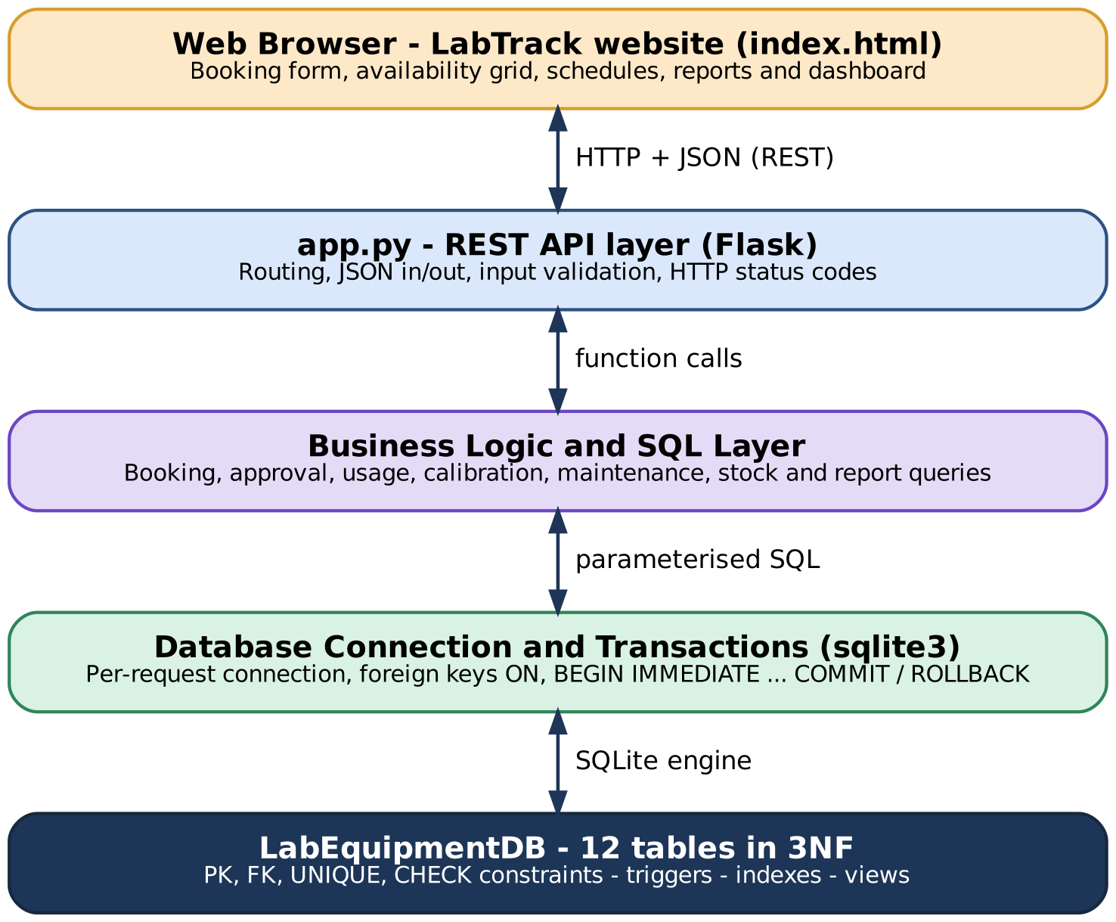
Figure 3. Three-tier System Architecture
Presentation tier: LabTrack website
The front end is a browser-based website, LabTrack, that presents the project and includes a live booking demo. Its pages (shown in Section 4.7) cover the home page, the proposed solution, the distinguishing features, the conflict-aware booking demo, the 12-table schema and the project plan. The booking demo shows equipment against time slots and reports a conflict when a slot is already taken.
Application tier: app.py (REST API layer)
The API exposes the operations of the system as JSON endpoints: equipment search and registration, slot availability, booking creation, approval, rejection and cancellation, usage logging, calibration, breakdown and maintenance handling, consumable adjustment and the report endpoints. Each endpoint validates its input first and returns a precise HTTP status code: 400 for invalid input, 404 for a missing record, 409 for a conflict such as an overlapping booking, and 422 for a violated business rule.
Data tier: LabEquipmentDB
All persistent data lives in the relational database. Every request opens its own connection with foreign-key enforcement switched on. Operations that change more than one row, such as approving a booking or completing a maintenance job, run inside a single transaction that is committed when all steps succeed and rolled back on any error.

4.2 Development Environment and Database Connectivity
Table 15. Application Development Environment
Item | Details
Programming language | Python 3
DBMS | SQLite 3, database LabEquipmentDB
Web framework | Flask (REST endpoints, JSON responses)
Front end | LabTrack website: HTML, CSS and JavaScript, calling the REST API
Database connectivity | Python sqlite3 module (DB-API 2.0, PEP 249) with parameterised queries and per-request connections
Testing tools | Flask test client and a Python test script (test_api.py) run against a fresh seeded database
Visual output | Chromium (Playwright) used to capture the 3D view of the laboratory floor

Connectivity uses parameterised SQL everywhere, so user input is never concatenated into a query. This both prevents SQL injection and lets the database reuse query plans. Each request opens one connection, enables PRAGMA foreign_keys, and closes the connection when the request ends.

4.3 Application Modules and Database Mapping
Table 16 shows how every module of the application is tied to the tables it reads and writes.
Table 16. Application Module-to-Database Mapping
Module | Purpose | Tables Used | Main Operations
Equipment Register | Register, search and update equipment status | Equipment, Laboratory, Equipment_Category | INSERT, SELECT with filters, UPDATE status, guarded DELETE
Availability and Booking | Show free slots and create booking requests | Booking, Time_Slot, Equipment, User | SELECT with overlap test, INSERT (PENDING)
Approvals | Approve, reject or cancel a request | Booking | UPDATE inside a transaction; overlap trigger
Usage Log | Record actual use of a booked slot | Usage_Log, Booking | INSERT, UPDATE booking to COMPLETED
Calibration | Record calibration and track due dates | Calibration, vw_calibration_due | INSERT, SELECT on view
Breakdown and Maintenance | Report faults and manage repair jobs | Breakdown, Maintenance_Job, Vendor, Equipment | INSERT, UPDATE; status triggers
Consumables | Track stock and issue consumables | Consumable | UPDATE with stock check
Reports | Dashboards and analytical reports | All tables through joins and the view | SELECT with JOIN, GROUP BY, aggregates

4.4 CRUD Operations
Table 17 lists the Create, Read, Update and Delete operations provided by the application and the tables they affect.
Table 17. CRUD Operations
Operation | Application Feature / Screen | Tables Affected | Evidence
Create | Register equipment; create a booking request; log usage; add calibration, breakdown, maintenance job | Equipment, Booking, Usage_Log, Calibration, Breakdown, Maintenance_Job | TC-03, TC-12, TC-16
Read / Search | Equipment search; slot availability; booking lists; calibration due; reports | All tables through joins and views | TC-01, TC-02
Update | Change equipment status; approve or reject a booking; complete a maintenance job; adjust stock | Equipment, Booking, Maintenance_Job, Consumable | TC-07, TC-13
Delete | Remove equipment that has no history; cancel a booking (status change, not deletion) | Equipment, Booking | TC-15

Deletion is deliberately restricted. Equipment that has booking history cannot be deleted; it can only be retired, so that past bookings and usage logs keep their meaning.

4.5 Business Rules, Validation and Error Handling
Every endpoint validates its input before touching the database: required fields must be present, dates must be valid and not in the past for new bookings, and numeric values must be integers. Problems the application cannot see in advance are caught from the database itself: trigger and constraint failures are translated into a structured JSON message with a suitable status code. Table 18 gives the main rules.
Table 18. Business Rules, Validation and Error Handling
Rule / Validation | How Implemented | Evidence / Message
Required fields missing | API check before INSERT | HTTP 400, "user_id is required"
Booking date in the past | API date check | HTTP 400, "Booking date cannot be in the past"
Equipment not ACTIVE | Trigger trg_booking_active_equipment | HTTP 422, "Equipment is not ACTIVE and cannot be reserved"
Overlapping approved booking | Triggers trg_booking_no_overlap_ins / _upd | HTTP 409, "Overlapping approved booking exists"; booking stays PENDING
Approving a booking that is not PENDING | Status check inside a transaction | HTTP 409, "Booking is APPROVED; cannot move to APPROVED"
Invalid calibration dates | CHECK constraint and API check | HTTP 400, "next due date must be after calibration date"
Stock below zero | CHECK stock_quantity >= 0 and API check | HTTP 422, "Stock limit: quantity cannot go below zero"
Duplicate email or name | UNIQUE constraints | HTTP 409, "duplicate value"
Deleting equipment with history | API check; foreign keys | HTTP 409, "Cannot delete equipment with booking history"
Unexpected database error | Error handler with ROLLBACK | HTTP 500, readable message; no partial data saved

4.6 Reports and Database Operations
The reports of the system are produced by SQL queries over the normalised tables. Table 19 lists them with the SQL concept each one demonstrates.
Table 19. Reports and Database Operations
Report / Operation | SQL Concept Used | Application Output
Slot availability | Correlated EXISTS with interval-overlap test | FREE or BOOKED for every slot of a date
Equipment utilisation | LEFT JOIN, SUM over slot hours, GROUP BY | Booked hours and percentage of a 40-hour week
Calibration due | View with MAX, date arithmetic, CASE | OK, DUE SOON (30 days) or OVERDUE
Downtime and breakdowns | JOIN, julianday difference, COALESCE | Days out of service per breakdown
Vendor service | LEFT JOIN, COUNT, SUM, AVG | Jobs, completed jobs and average repair days
Consumable stock | CASE on stock_quantity | LOW, WATCH or OK for every consumable
Dashboard counts | Scalar sub-queries and COUNT | Active equipment, pending bookings, open breakdowns

Representative report queries
-- Slot availability for one equipment item on one date
SELECT t.time_slot_id, t.start_time, t.end_time,
CASE WHEN EXISTS (SELECT 1 FROM BOOKING b JOIN TIME_SLOT o ON o.time_slot_id = b.time_slot_id
WHERE b.equipment_id = ? AND b.booking_date = ? AND b.status = 'APPROVED'
AND o.start_time < t.end_time AND t.start_time < o.end_time)
THEN 'BOOKED' ELSE 'FREE' END AS state
FROM TIME_SLOT t ORDER BY t.start_time;

-- Calibration due, overdue and due soon
SELECT equipment_name, laboratory, next_due_date,
CASE WHEN next_due_date < :today THEN 'OVERDUE'
WHEN julianday(next_due_date) - julianday(:today) <= 30 THEN 'DUE SOON'
ELSE 'OK' END AS state
FROM vw_calibration_due ORDER BY next_due_date;

-- Vendor service
SELECT v.vendor_name, COUNT(m.maintenance_id) AS jobs, SUM(m.status = 'COMPLETED') AS completed,
ROUND(AVG(julianday(m.completion_date) - julianday(m.start_date)), 1) AS avg_days
FROM VENDOR v LEFT JOIN MAINTENANCE_JOB m USING (vendor_id) GROUP BY v.vendor_id;

Booking and approval
A user selects equipment, a date and a slot. The inputs are validated and the equipment status is checked by the trigger, and a PENDING booking is inserted. When the request is approved, the application starts a transaction, re-reads the booking, checks that it is still PENDING and updates it to APPROVED. If an overlapping approved booking exists, the trigger aborts the update, the transaction is rolled back and the user receives a 409 message. Figure 4 shows the flow.
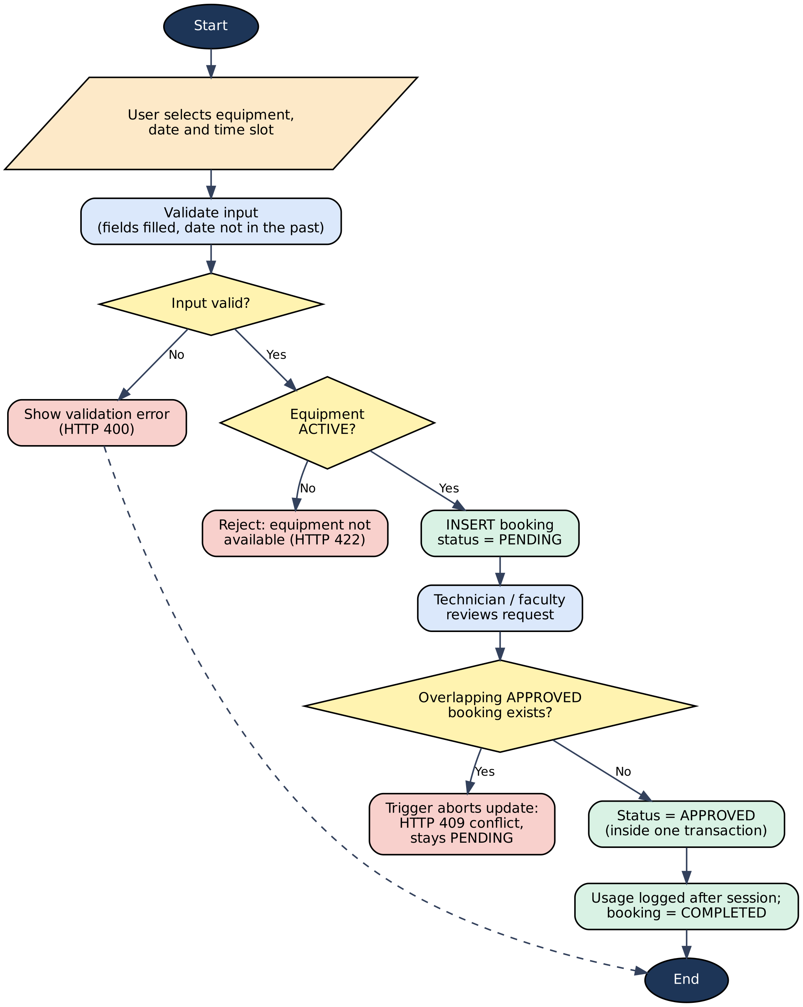
Figure 4. Flowchart of Booking Request and Approval
Breakdown and maintenance
When a fault is reported, a Breakdown row is inserted and a trigger moves the equipment from ACTIVE to UNDER_MAINTENANCE, which blocks further bookings. A maintenance job records the vendor and the start date. When the job is completed, another trigger marks the breakdown RESOLVED and sets the equipment back to ACTIVE, but only if no other unresolved breakdown exists for the same equipment. Figure 5 shows the flow.
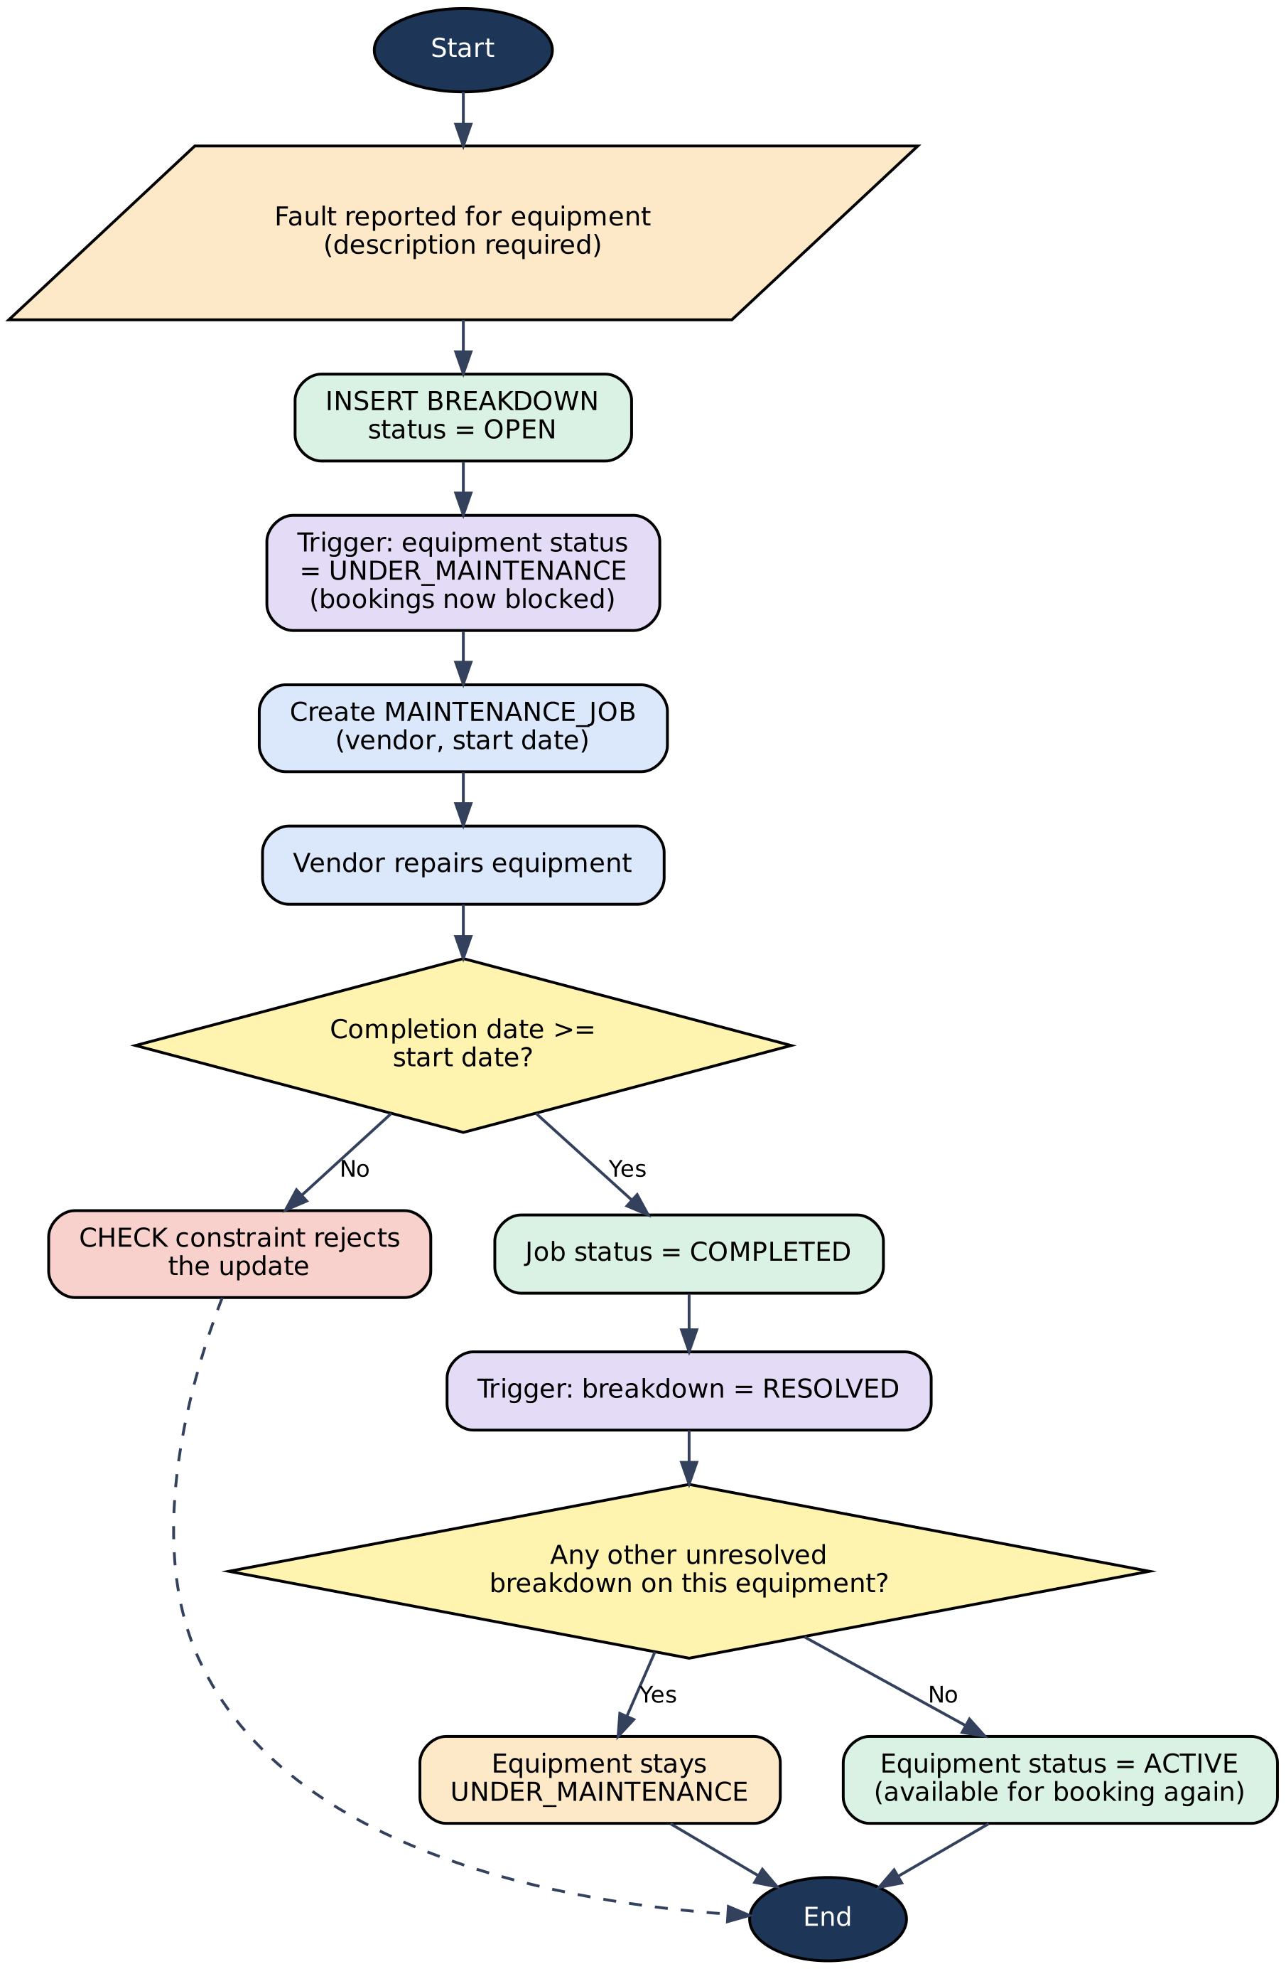
Figure 5. Flowchart of Breakdown Reporting and Maintenance Completion

4.7 Application Screens
The screens below show the LabTrack website. They cover the home page, the proposed solution, the distinguishing features, the live conflict-aware booking demo, the database schema and the project plan, followed by a 3D view of the laboratory floor.
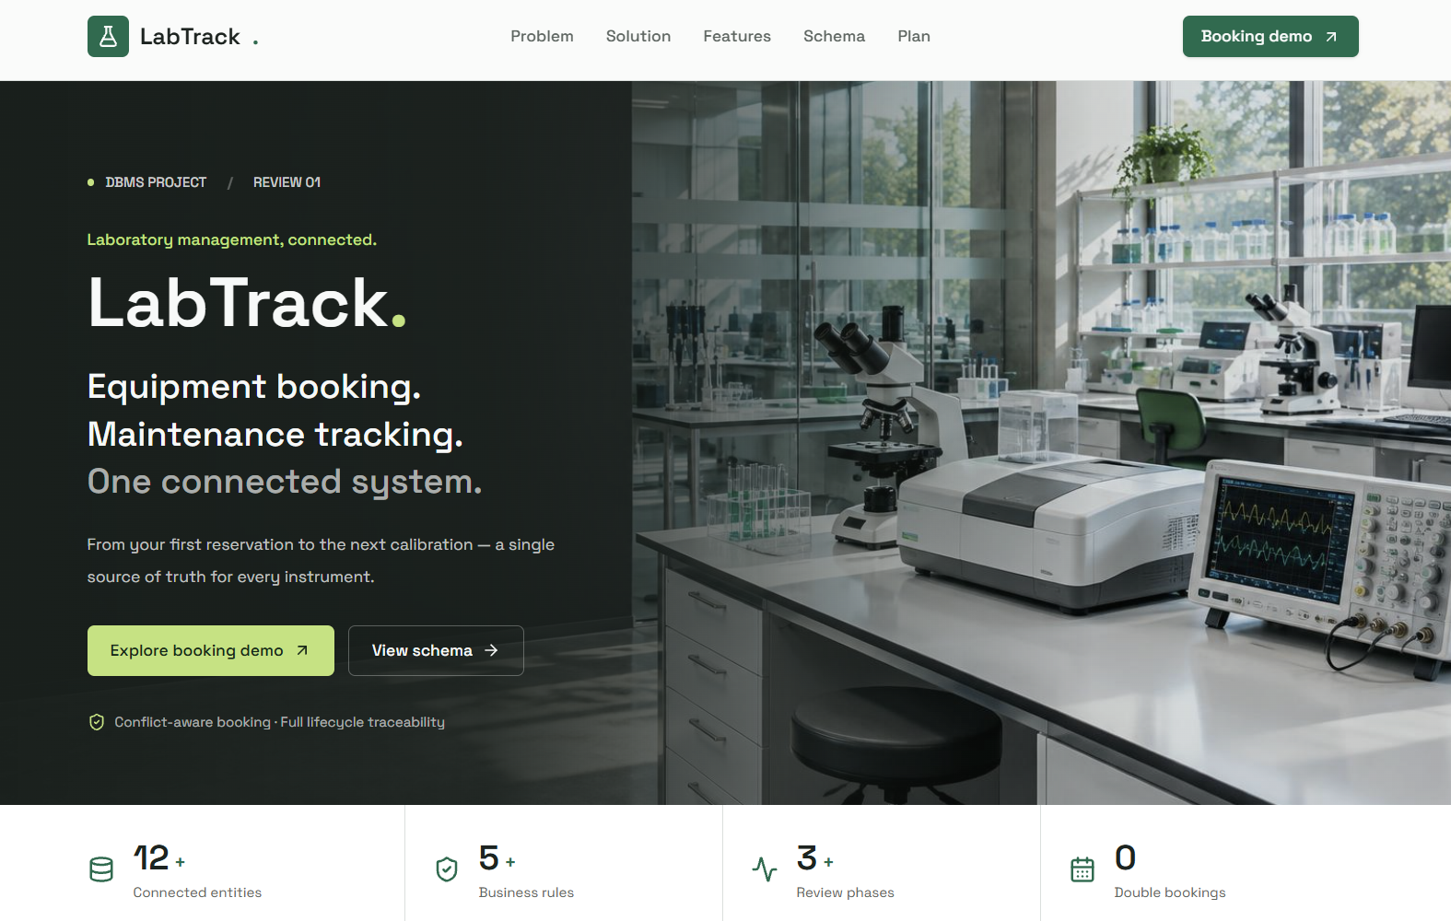
Figure 6. LabTrack Home Page
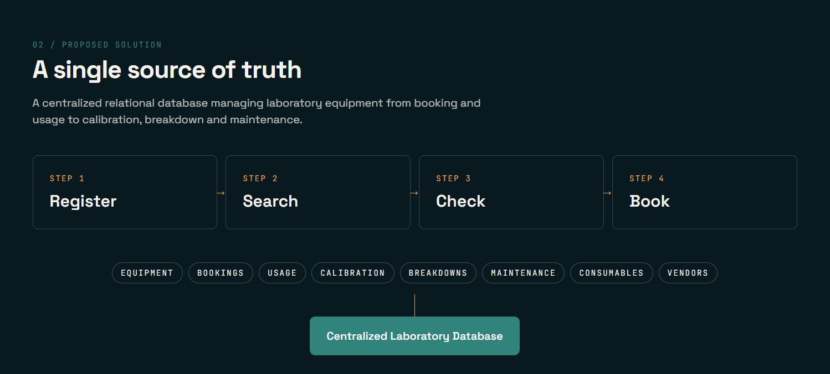
Figure 7. Proposed Solution: Register, Search, Check and Book
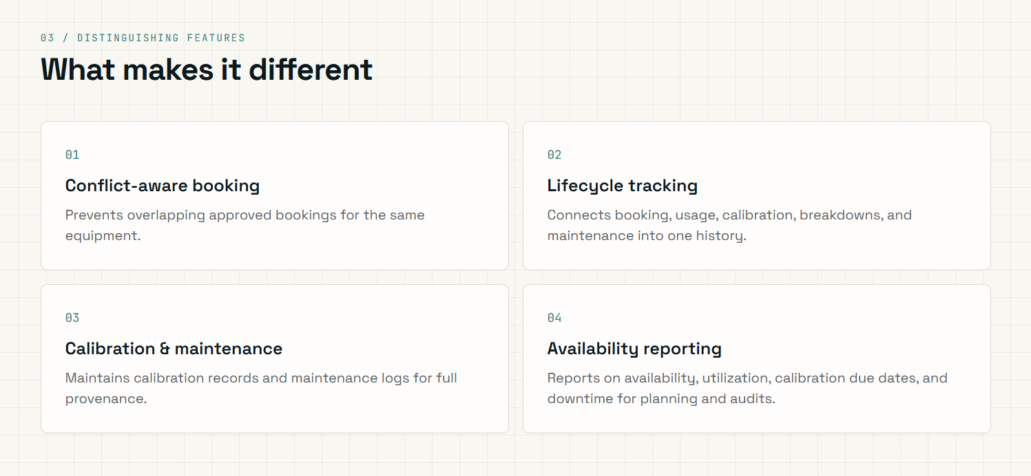
Figure 8. Distinguishing Features Page
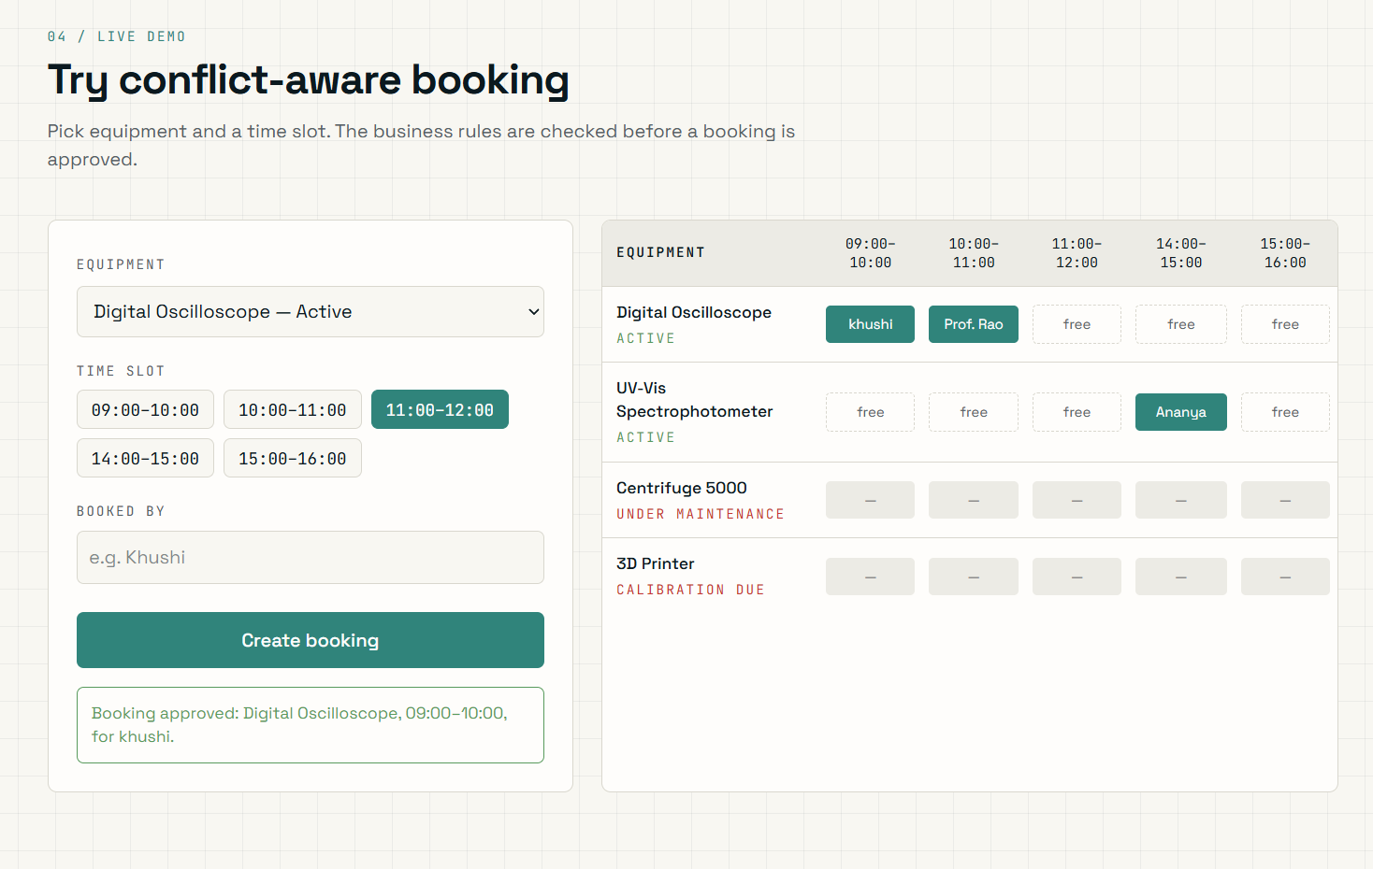
Figure 9. Live Demo: Conflict-aware Equipment Booking
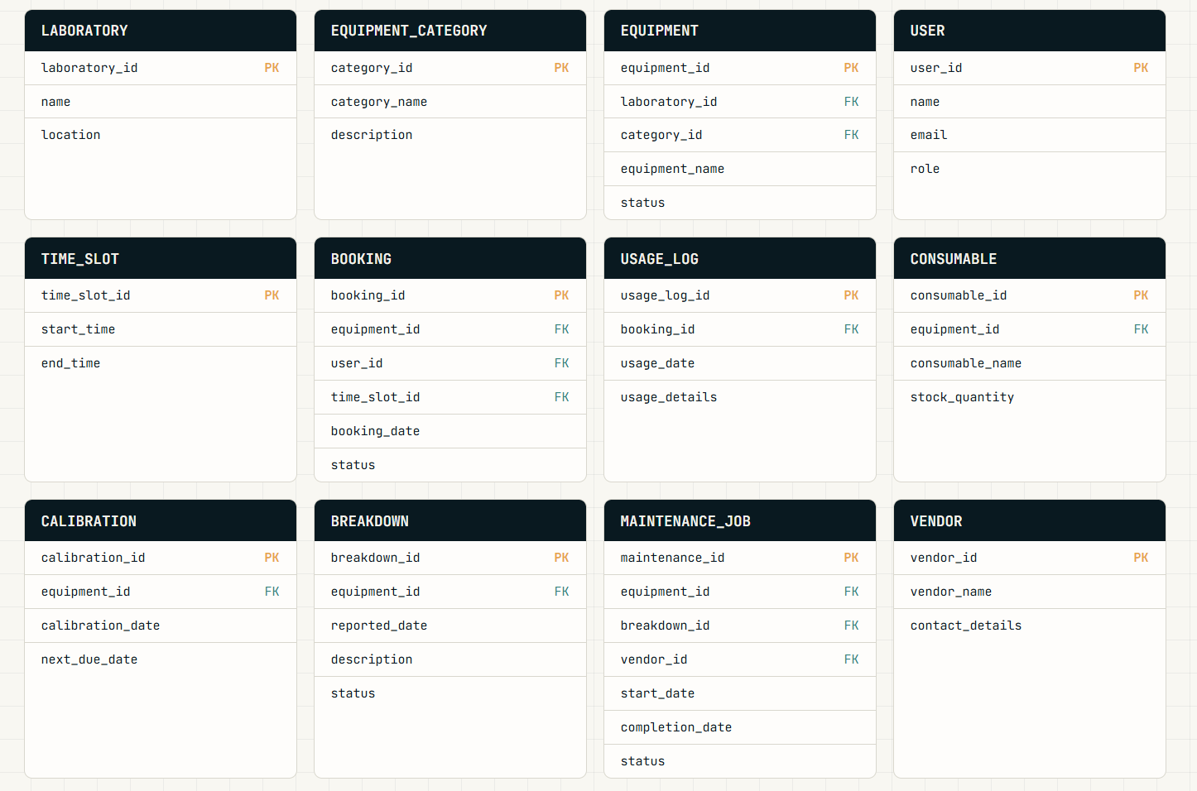
Figure 10. Database Schema Page: Twelve Tables with Primary and Foreign Keys
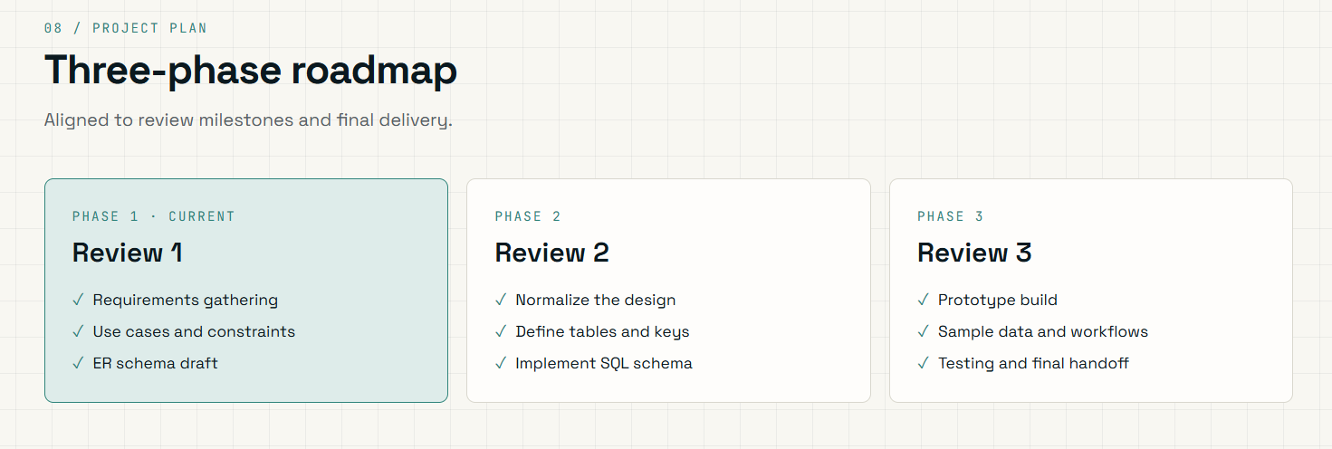
Figure 11. Three-phase Project Roadmap Page
The booking demo in Figure 9 shows the idea behind Rule 1 for the user: each equipment item is shown against the time slots, booked slots carry the name of the person who holds them, and equipment that is under maintenance or due for calibration is blocked. The schema page in Figure 10 repeats the twelve tables of Chapter 2 with their key columns marked.
3D view of the laboratory floor
To make equipment status easier to grasp, the prototype also renders the four laboratories as a 3D floor plan. Every equipment item is a block coloured by its live status in the database: green for active, amber for booked today and red for under maintenance. The view can be rotated with the mouse; Figures 12 and 13 show two angles.
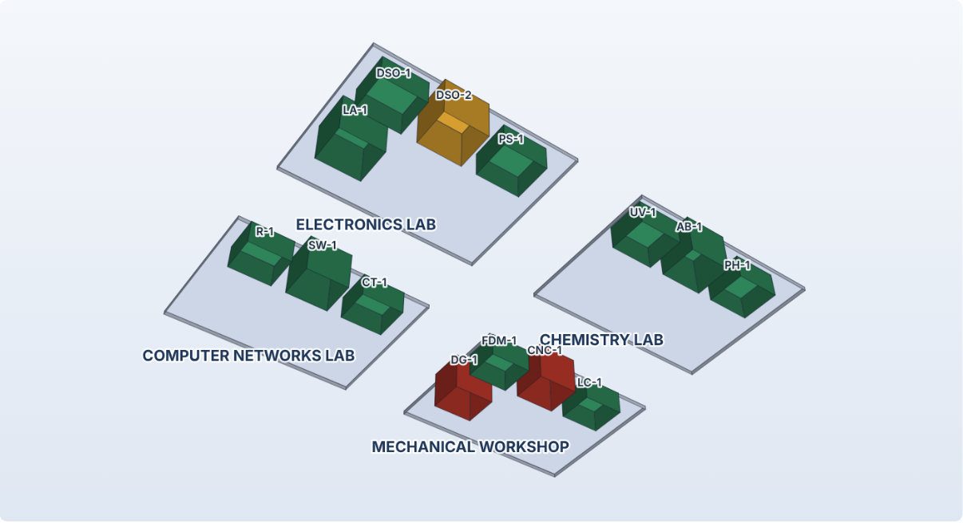
Figure 12. Laboratory Floor in 3D: Equipment Status (angle 1)
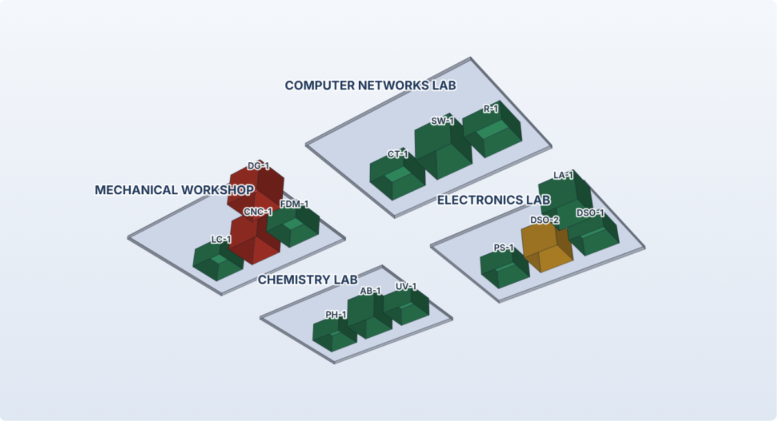
Figure 13. Laboratory Floor in 3D: Equipment Status (angle 2)

4.8 Testing and Results
The application was tested by calling the REST API and the database directly against a freshly seeded database, using both positive and negative cases. Table 20 lists the 17 test cases with the result actually recorded. All 17 passed.
Table 20. Test Cases
Test ID | Feature | Input / Action | Expected Result | Actual Result | Status
TC-01 | Equipment search | GET /api/equipment?q=oscilloscope | HTTP 200, two oscilloscopes | HTTP 200, 2 rows returned | Pass
TC-02 | Availability | GET availability for DSO-1 on 15 Oct | Booked slots shown as BOOKED, others FREE | HTTP 200, 09:00-12:00 BOOKED, afternoon FREE | Pass
TC-03 | Valid booking | POST booking for an ACTIVE item | HTTP 201, status PENDING | HTTP 201, booking 18 PENDING | Pass
TC-04 | Missing field | POST booking without user_id | HTTP 400 | HTTP 400, user_id is required | Pass
TC-05 | Past date | POST booking dated 1 Oct | HTTP 400 | HTTP 400, Booking date cannot be in the past | Pass
TC-06 | Non-ACTIVE equipment | POST booking for CNC under maintenance | HTTP 422 | HTTP 422, Equipment is not ACTIVE and cannot be reserved | Pass
TC-07 | Approve booking | POST approve on a PENDING booking | HTTP 200, APPROVED | HTTP 200, Booking 18 set to APPROVED | Pass
TC-08 | Overlap on approval | Approve second request for DSO-1, 09:00–10:00 | HTTP 409, stays PENDING | HTTP 409, booking stays PENDING | Pass
TC-09 | Overlap by direct SQL | INSERT APPROVED booking into a taken slot | Trigger aborts | Trigger: Overlapping approved booking exists for this equipment | Pass
TC-10 | Partial overlap | INSERT APPROVED 09:00–11:00 over an approved 10:00–11:00 | Trigger aborts | Trigger: Overlapping approved booking exists for this equipment | Pass
TC-11 | Calibration dates | POST next due before calibration date | HTTP 400 | HTTP 400, Calibration dates must be valid: next due date must be after calibration date | Pass
TC-12 | Breakdown effect | POST breakdown for PS-1 | Equipment becomes UNDER_MAINTENANCE | HTTP 201, equipment status UNDER_MAINTENANCE | Pass
TC-13 | Complete maintenance | POST complete on open CNC job | Breakdown RESOLVED, equipment ACTIVE | HTTP 200, equipment ACTIVE, breakdown RESOLVED | Pass
TC-14 | Stock limit | Issue 3 units when stock is 1 | HTTP 422 | HTTP 422, Stock limit: quantity cannot go below zero | Pass
TC-15 | Delete with history | DELETE equipment having bookings | HTTP 409 | HTTP 409, Cannot delete equipment with booking history; retire it instead | Pass
TC-16 | Usage logging | POST usage for PENDING and for APPROVED booking | 422 for PENDING; 201 and COMPLETED for APPROVED | HTTP 422 for PENDING booking; HTTP 201 for APPROVED, booking now COMPLETED | Pass
TC-17 | Unique email | INSERT user with existing email | UNIQUE constraint failure | SQLite: UNIQUE constraint failed: USER.email | Pass

The tests show that the key business rules are enforced by the database and not only by the application: TC-09 and TC-10 insert directly with SQL, bypassing the Flask layer, and are still rejected by the trigger.

CHAPTER 5
CONCLUSION
This project took a Laboratory Equipment Booking and Maintenance System from a conceptual ER model to a working, database-driven application over three reviews. The twelve-entity schema was normalised to Third Normal Form and implemented with keys, constraints, indexes, a view and triggers. The five business rules of the laboratory are enforced inside the database, a Flask REST layer and the LabTrack website connect users to it, and analytical SQL queries provide the reports needed for planning and audits.
The final system shows that overlapping bookings, bookings of unavailable equipment, invalid calibration dates, negative stock and inconsistent maintenance status can all be prevented at the level of the data. Seventeen automated test cases passed, including two that bypass the application layer. The project also deepened my understanding of normalisation, integrity constraints, triggers, transactions and indexing, and of how they combine to solve a practical problem.

5.1 Limitations and Future Enhancements
- Overlap detection works on a single date and whole time slots; recurring bookings and bookings that cross midnight are not supported yet.
- Role-based login and approval rights are not implemented; any user of the prototype can approve a booking.
- Calibration, maintenance and low-stock alerts are shown on screen but are not sent by email or SMS.
- Barcode or QR-code scanning could identify equipment and users at the laboratory door.
- The same schema can be moved to a multi-user server such as MySQL or PostgreSQL, with row-level locking, for a campus-wide deployment.
- Predictive maintenance could use the usage and breakdown history already stored to suggest service intervals.

REFERENCES
[1] R. Elmasri and S. B. Navathe, Fundamentals of Database Systems, 7th ed. Pearson, 2016.
[2] A. Silberschatz, H. F. Korth and S. Sudarshan, Database System Concepts, 7th ed. McGraw-Hill, 2019.
[3] C. J. Date, An Introduction to Database Systems, 8th ed. Pearson, 2003.
[4] SQLite Consortium, SQLite Documentation: CREATE TRIGGER, Foreign Key Support and Date and Time Functions. [Online]. Available: https://www.sqlite.org/docs.html
[5] Pallets, Flask Documentation. [Online]. Available: https://flask.palletsprojects.com/
[6] Python Software Foundation, “PEP 249 – Python Database API Specification v2.0”. [Online]. Available: https://peps.python.org/pep-0249/
[7] ISO/IEC 17025:2017, General requirements for the competence of testing and calibration laboratories. International Organization for Standardization, 2017.

APPENDICES
APPENDIX A - COMPLETE DATABASE SCRIPT
The complete database script (schema.sql) is submitted with this report. It contains the DDL for all twelve tables with their constraints, the six indexes, the five triggers (trg_booking_active_equipment, trg_booking_no_overlap_ins, trg_booking_no_overlap_upd, trg_breakdown_status and trg_maintenance_complete) and the view vw_calibration_due, together with the seed-data script seed.py, which rebuilds the database and loads the sample data.
Trigger: breakdown puts equipment under maintenance, completion restores it
CREATE TRIGGER trg_breakdown_status
AFTER INSERT ON BREAKDOWN
BEGIN
UPDATE EQUIPMENT SET status = 'UNDER_MAINTENANCE'
WHERE equipment_id = NEW.equipment_id AND status = 'ACTIVE';
END;

CREATE TRIGGER trg_maintenance_complete
AFTER UPDATE OF status ON MAINTENANCE_JOB
WHEN NEW.status = 'COMPLETED'
BEGIN
UPDATE BREAKDOWN SET status = 'RESOLVED' WHERE breakdown_id = NEW.breakdown_id;
UPDATE EQUIPMENT SET status = 'ACTIVE'
WHERE equipment_id = NEW.equipment_id AND status = 'UNDER_MAINTENANCE'
AND NOT EXISTS (SELECT 1 FROM BREAKDOWN
WHERE equipment_id = NEW.equipment_id AND status <> 'RESOLVED');
END;

APPENDIX B - APPLICATION SOURCE CODE
The source code is submitted with this report. The files are: app.py (Flask routes, validation and error handling), schema.sql (DDL, indexes, triggers, view), seed.py (seed-data generator), test_api.py (automated tests and test_results.json), and static/index.html (single-page interface and the 3D floor view).
APPENDIX C - ADDITIONAL TEST DATA AND OUTPUTS
Worked example of the overlap rule. DSO-1 has an approved booking on 15 October for 10:00–11:00. A request for the 09:00–11:00 slot on the same date is created as PENDING. When it is approved, the interval test finds that the existing booking starts (10:00) before the new one ends (11:00) and that the new one starts (09:00) before the existing one ends (11:00); the trigger aborts the update and the request stays PENDING. A request for 11:00–12:00, which only touches the end of the existing slot, passes the test and is approved.
Worked example of the maintenance rule. The CNC milling machine is reported with a spindle fault; the trigger sets its status to UNDER_MAINTENANCE and a booking request for it is refused with HTTP 422. When the vendor’s job is completed (test case TC-13), the breakdown becomes RESOLVED and, because no other unresolved breakdown exists, the machine returns to ACTIVE and can be booked again.
Worked example of the calibration report. With 14 October 2026 as the reference date, the CNC milling machine (next due 5 October) is OVERDUE, the logic analyser (20 October) and the second oscilloscope (25 October) are DUE SOON because they fall within 30 days, and all other equipment is OK.

