**DATA ANALYTICS WITH TABLEAU** 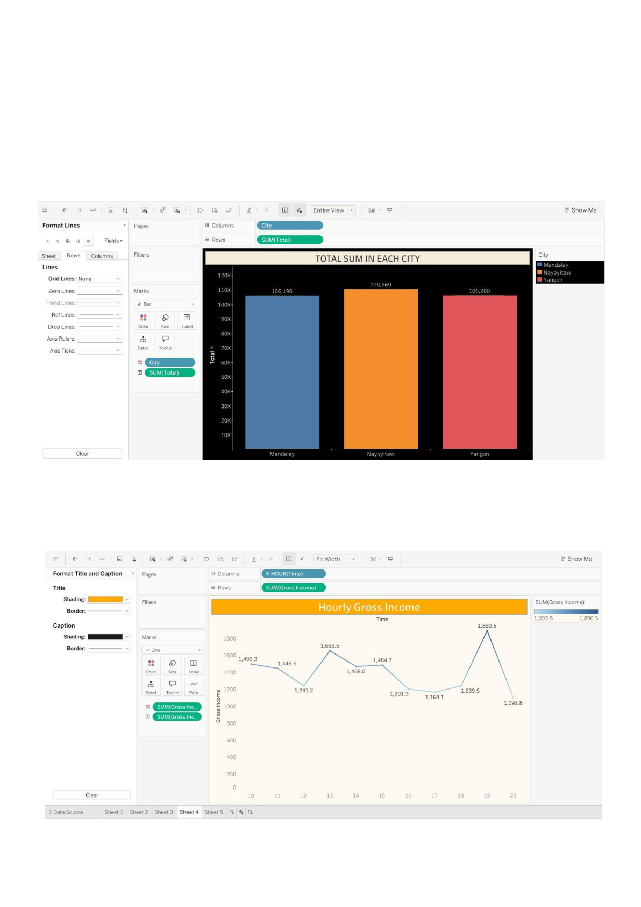

**SUPERMARKET SALES ANALYTICS REPORT**

**ASSIGNMENT-1**

**1. Total Sum in Each City**

**2. Hourly Gross Income**

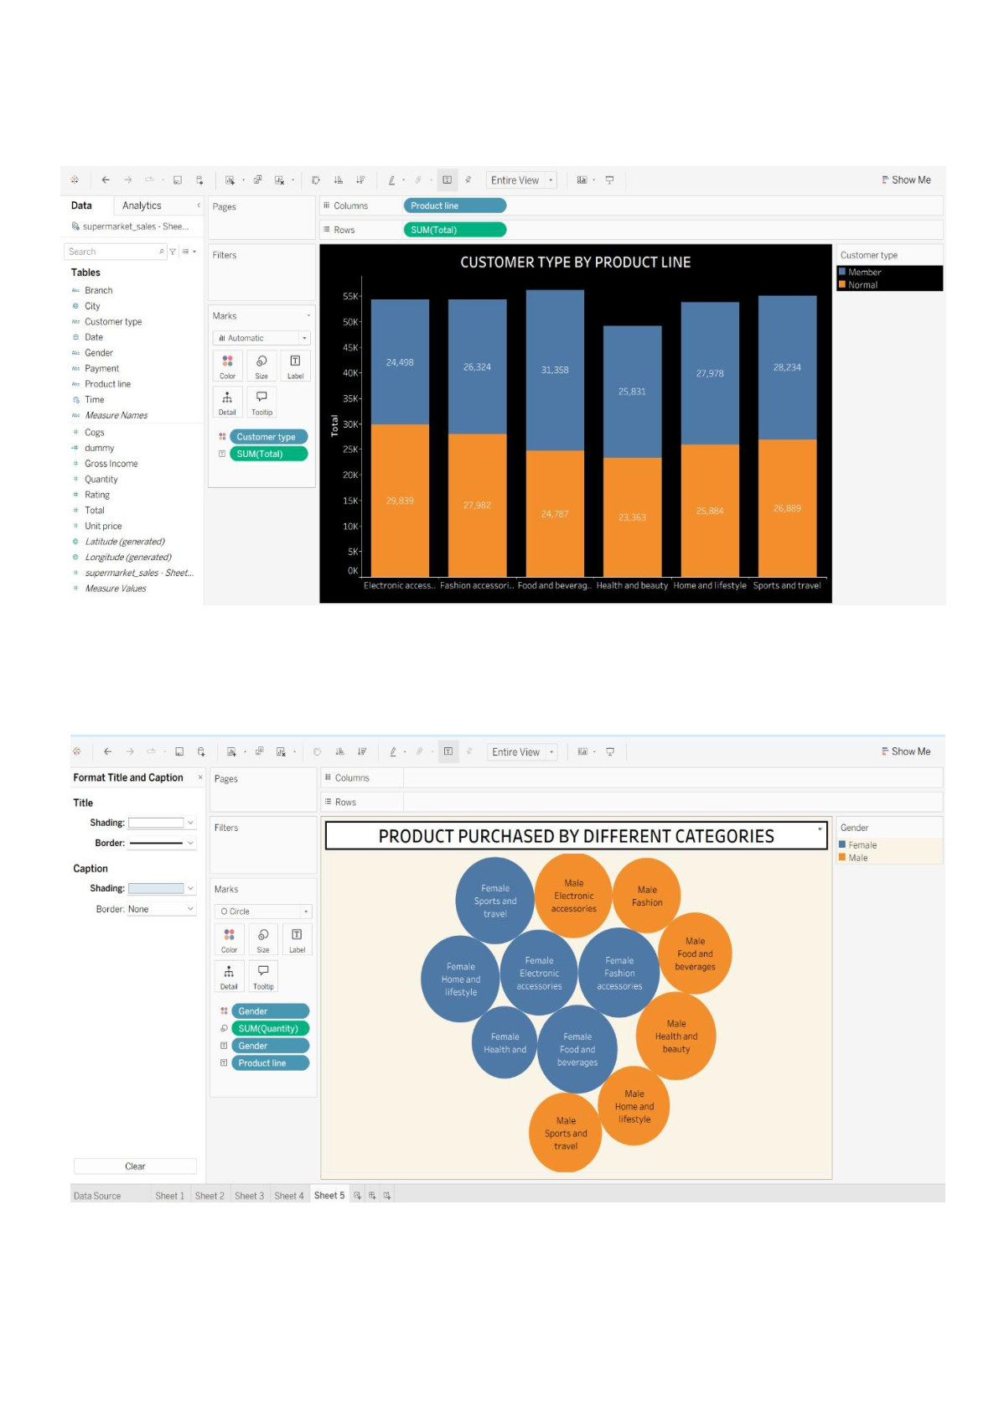

**3. Customer Type byProduct Line**

**4. Product Purchased by Different Categories**

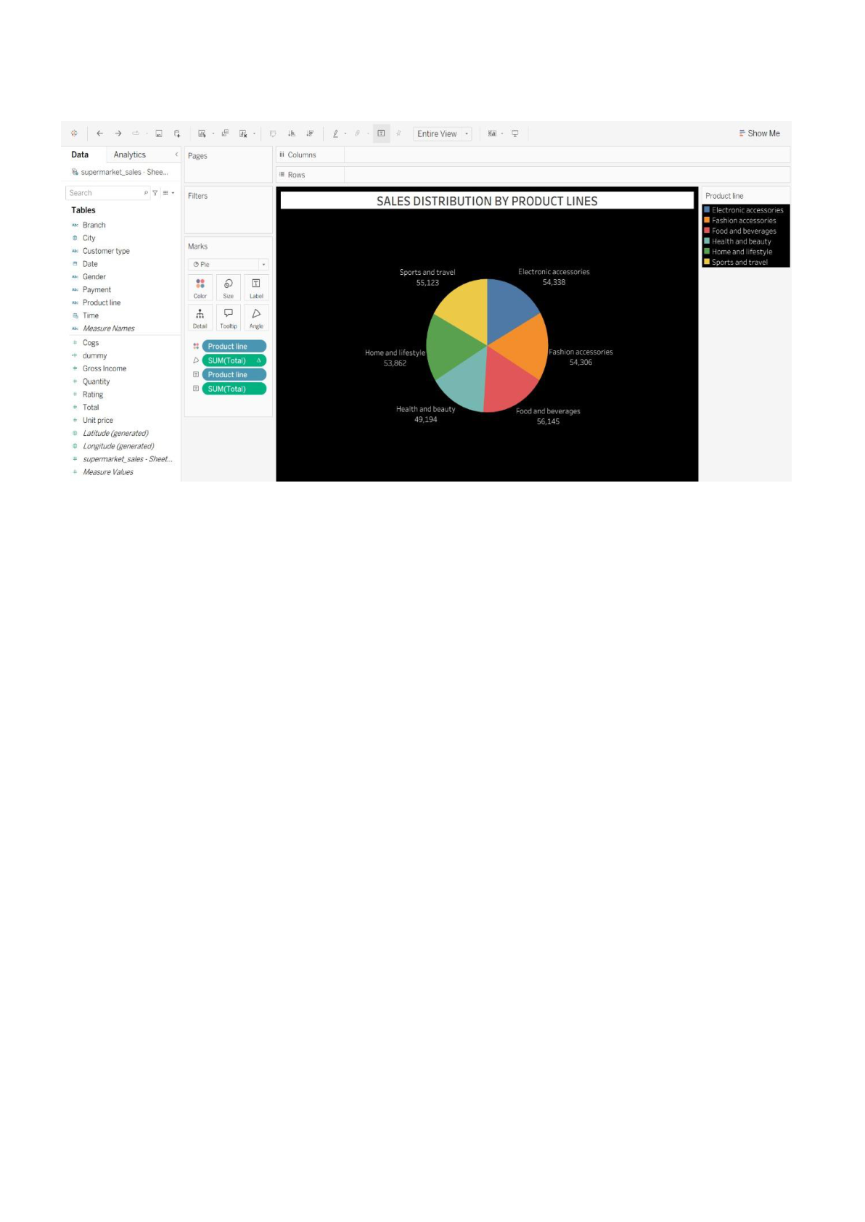

**5. Sales Distribution by Product Lines**

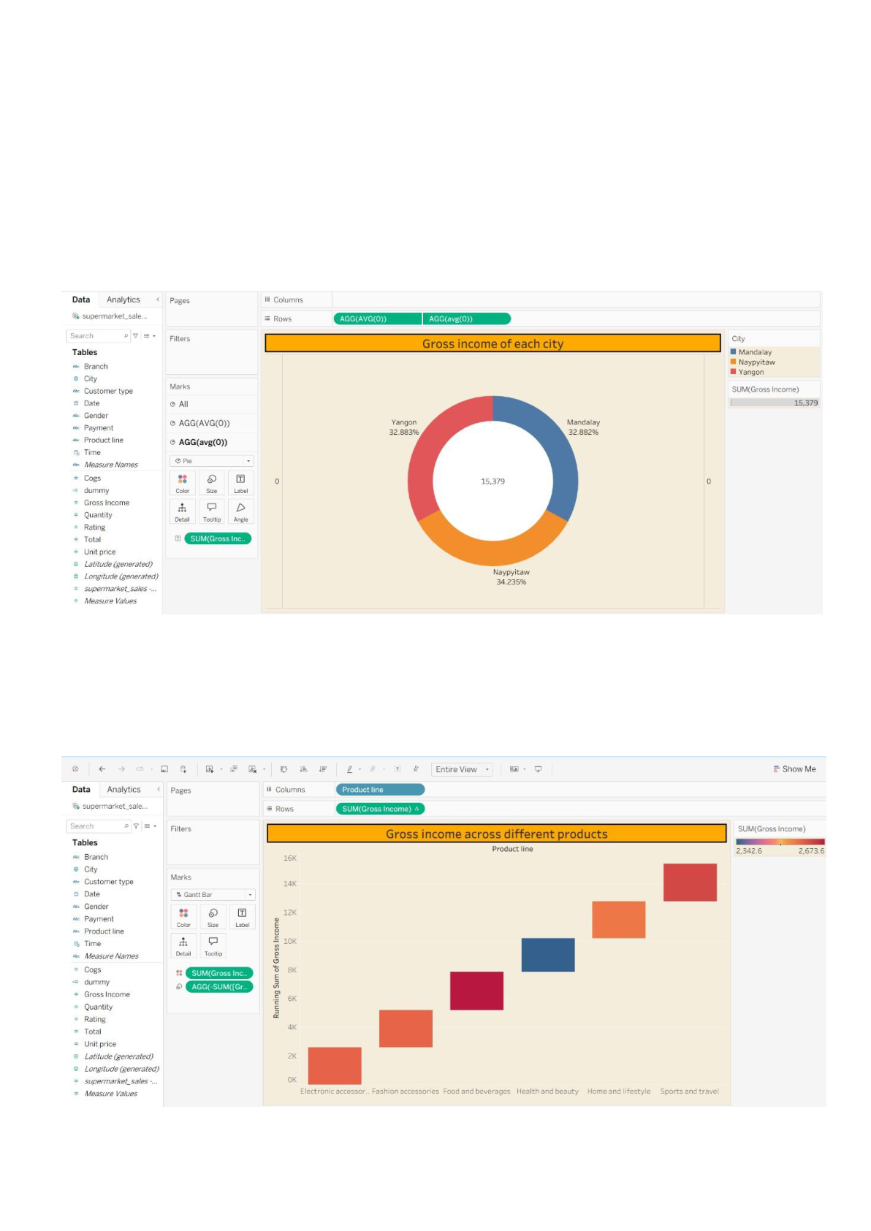

**DATA ANALYTICS WITH TABLEAU**

**SUPERMARKET SALES ANALYTICS REPORT**

**ASSIGNMENT-2**

**1. Gross Income of Each City**

**2. Gross Income Across Different Products**

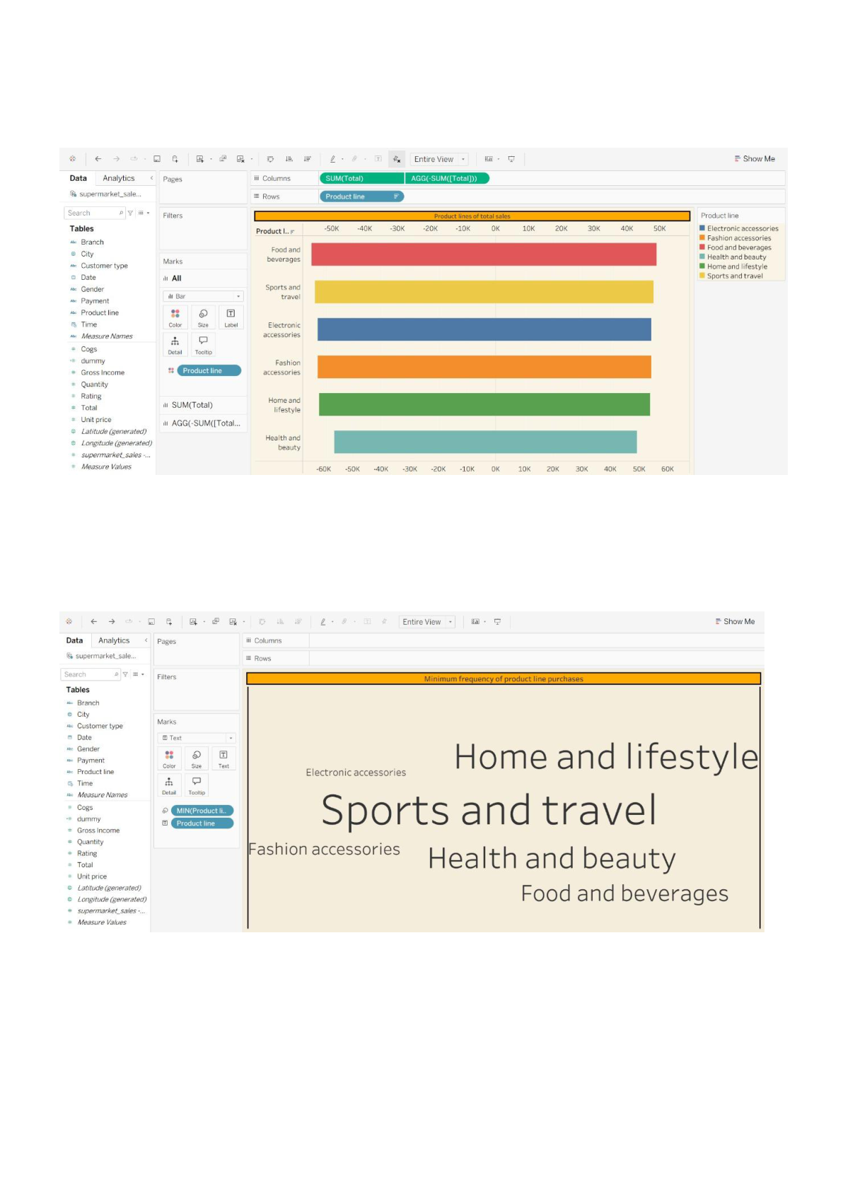

**3. Product Lines of Total Sales**

**4. Minimum Frequency of Product Line Purchases**

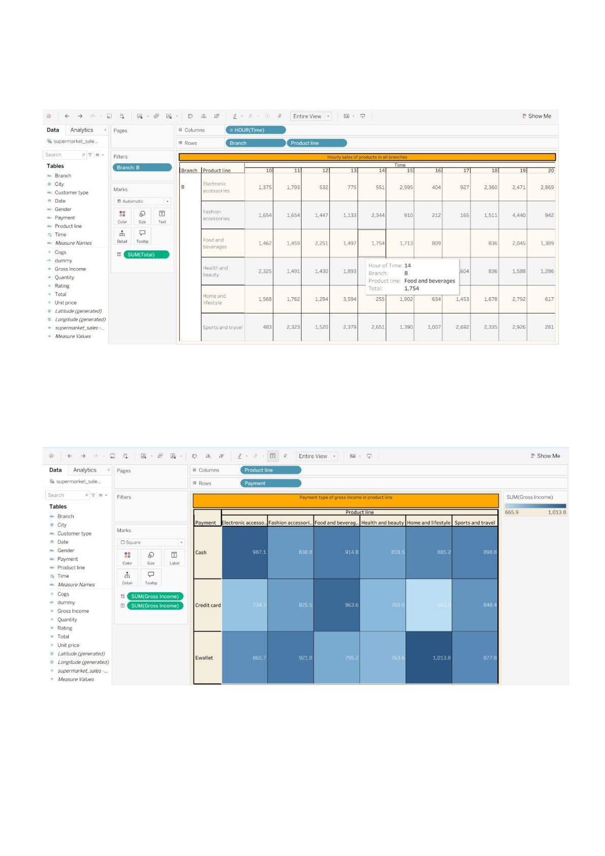

**5. Hourly Sales of Products in all Branches**

**6. Payment Types of Gross Income in Product Line**

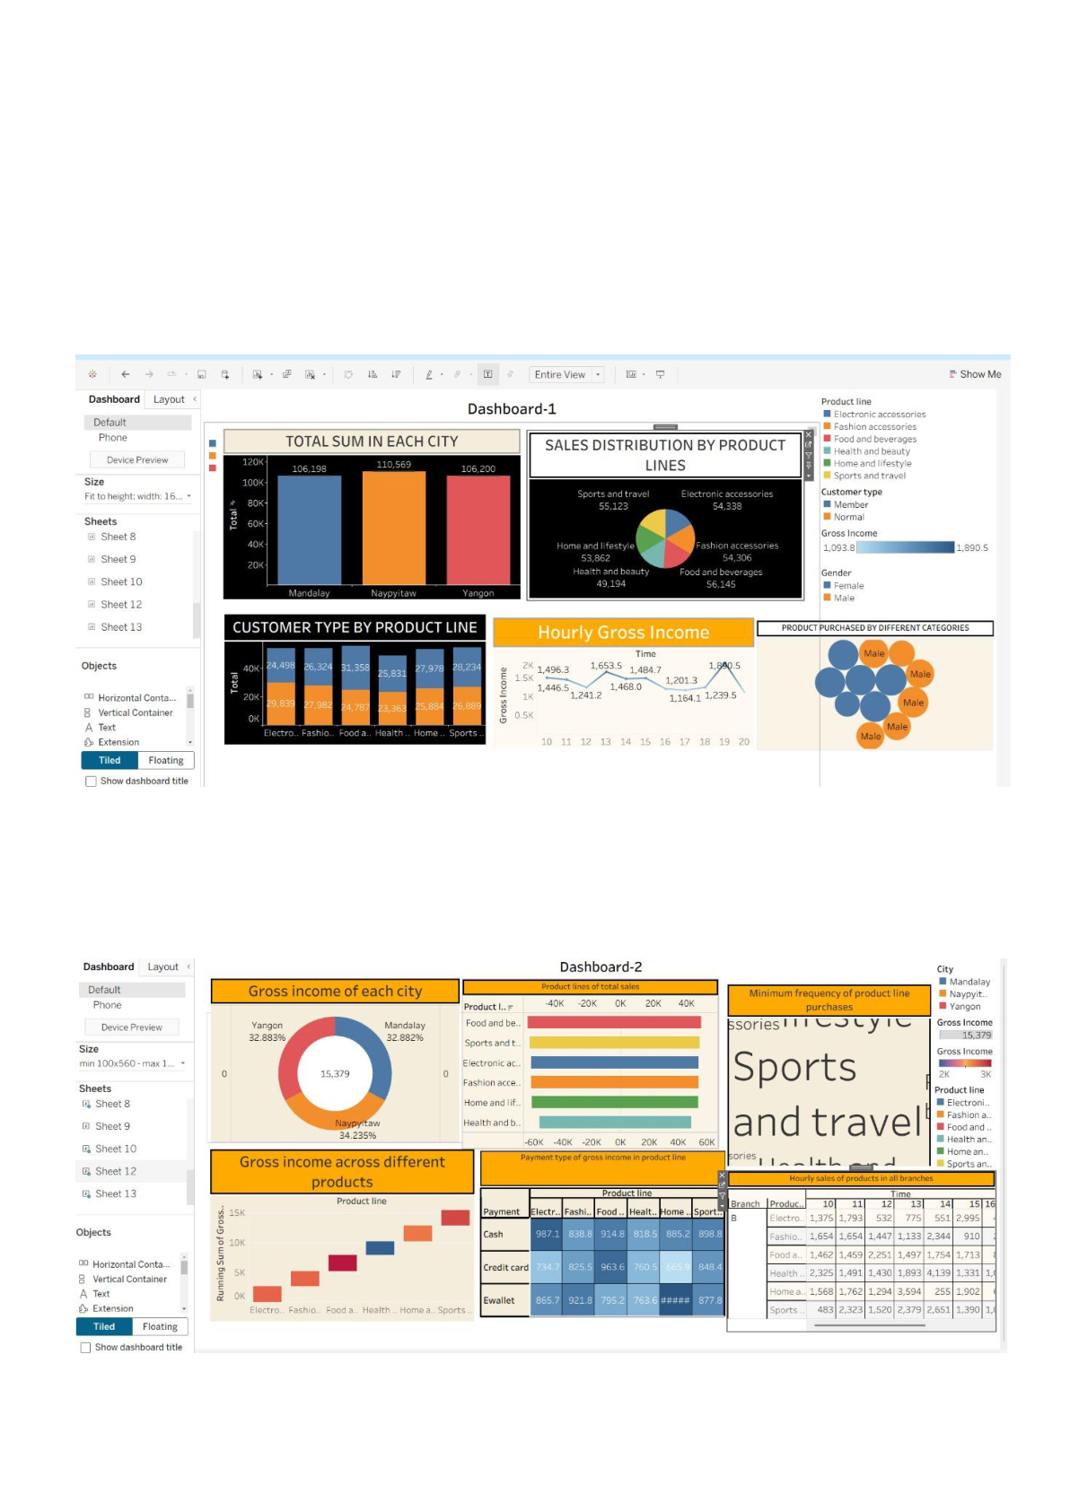

**DATA ANALYTICS WITH TABLEAU**

**SUPERMARKET SALES ANALYTICS REPORT**

**ASSIGNMENT-3**

**1. Dashboard for Assignment -1**

**2. Dashboard for Assignment - 2**