**FeeDumpAnalyzer Tool ---------------------------------------------------------🡪**

This tool has been integrated into the project

Topic/project: Tools

1. **About**

* The tool shall be used to analyze the DataFlash dumps on every project that uses **Infineon** Fee module.
* The tool shall have a database with all the Fee configurations for each R-step on SP2021, and the user shall be able to select a block from the configuration and see what was written in the DataFlash for that specific block, because the main purpose is to be used inside ------ project team, but it shall have the option to be used also on other projects by uploading the Fee configuration or only by knowing the block number.
* Inputs: DataFlash dumps (*.hex or *.txt), FEE configuration files (*.xdm) or directly the FEE block number for which the user is interested to find its data.
* Output:
  + User shall have access at information like:
    - Block user data.
    - Block cycle counter.
    - Fee state page (erased/valid, state counter)

1. **Block Structure**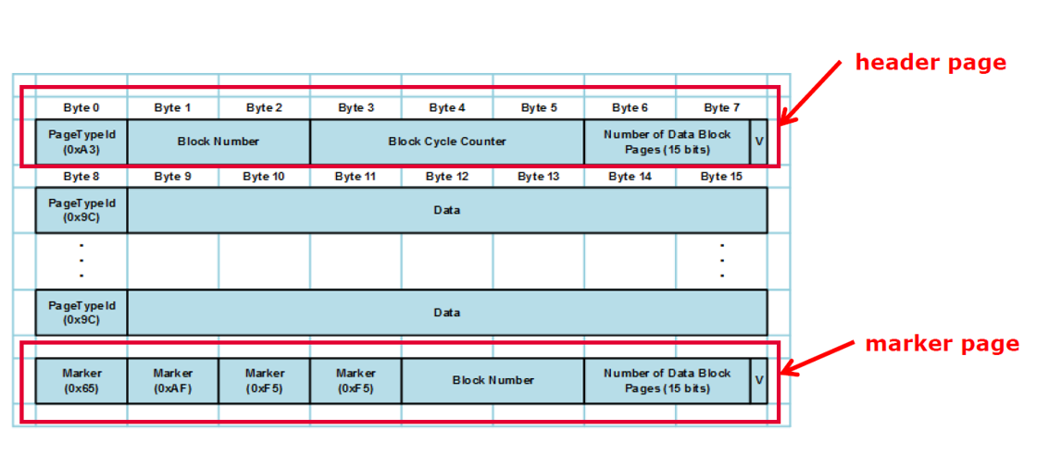

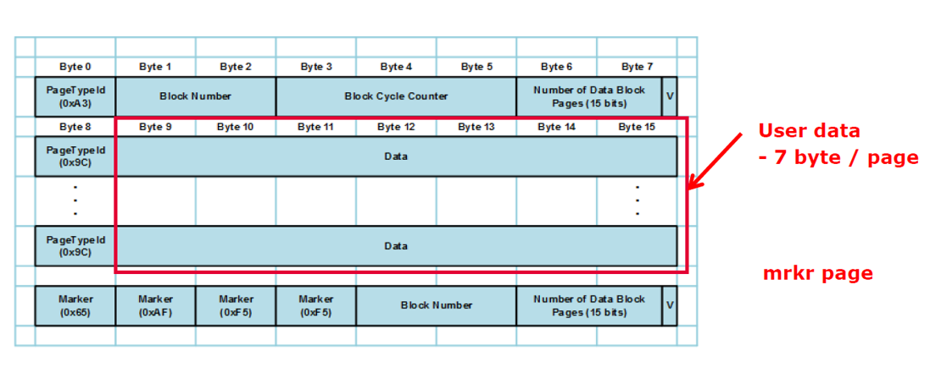

**+Fee State Page Format**

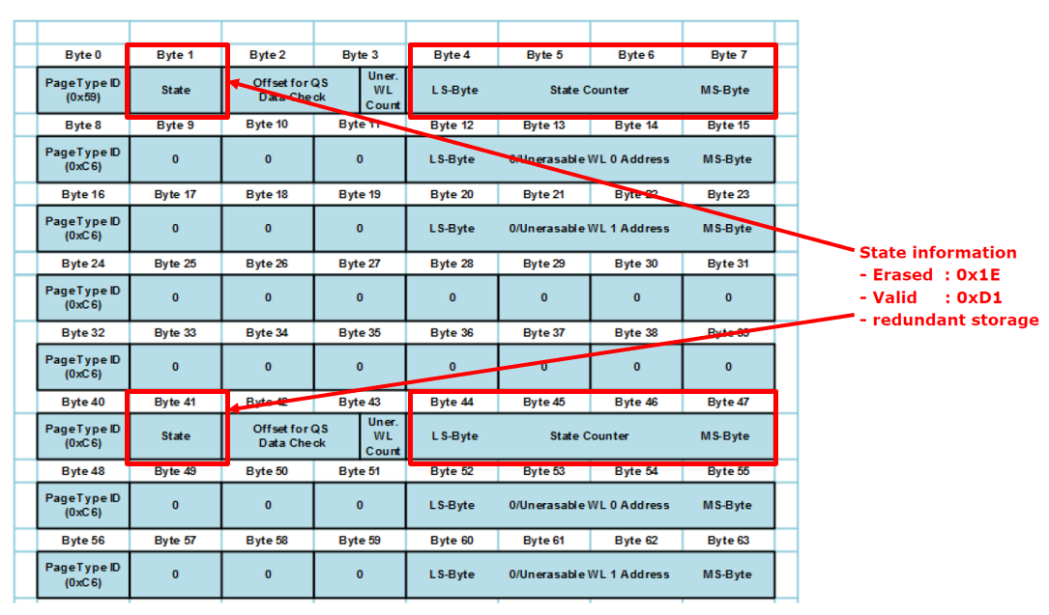

1. **Design**



**Icon:**

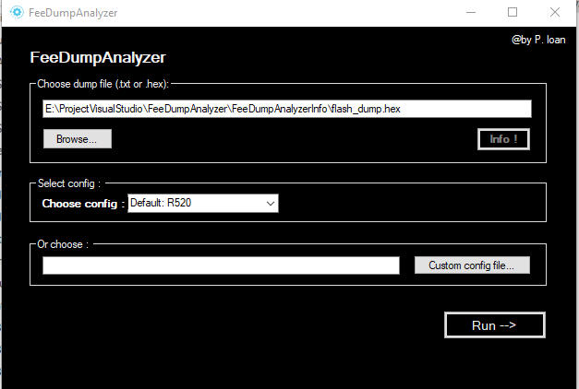

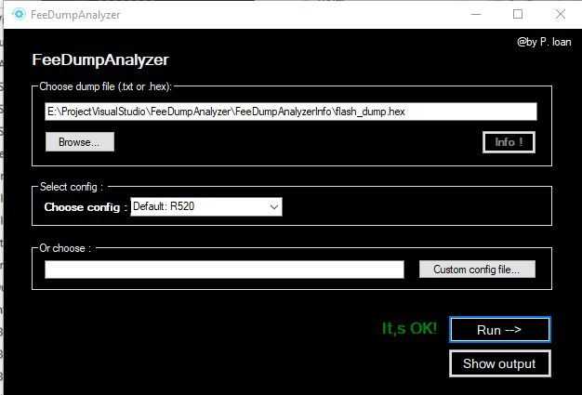

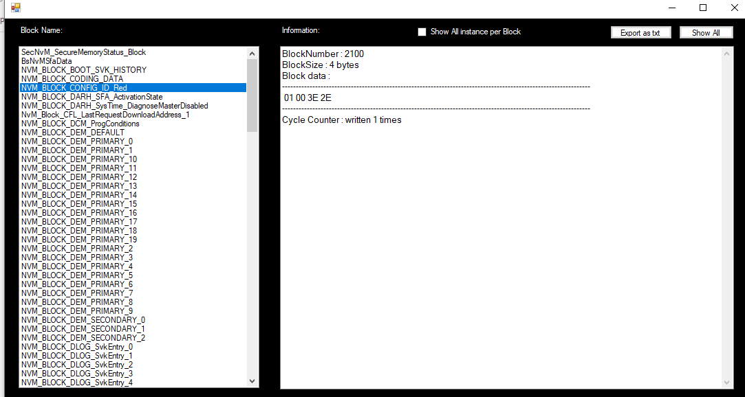

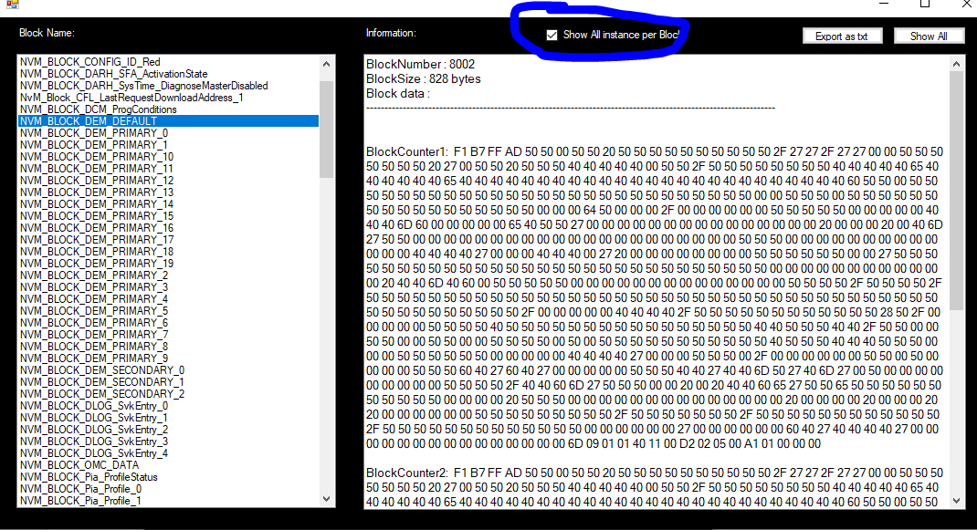

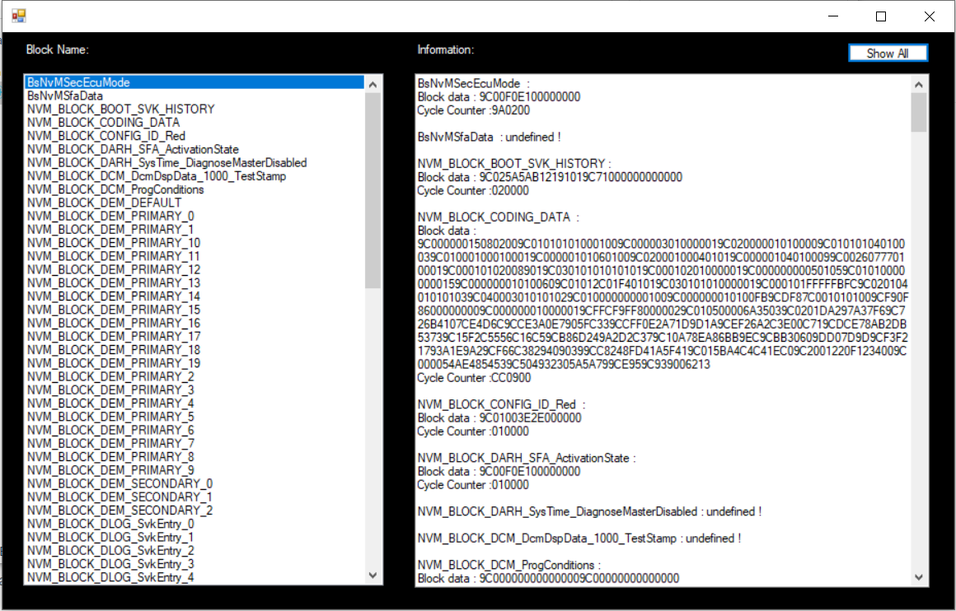

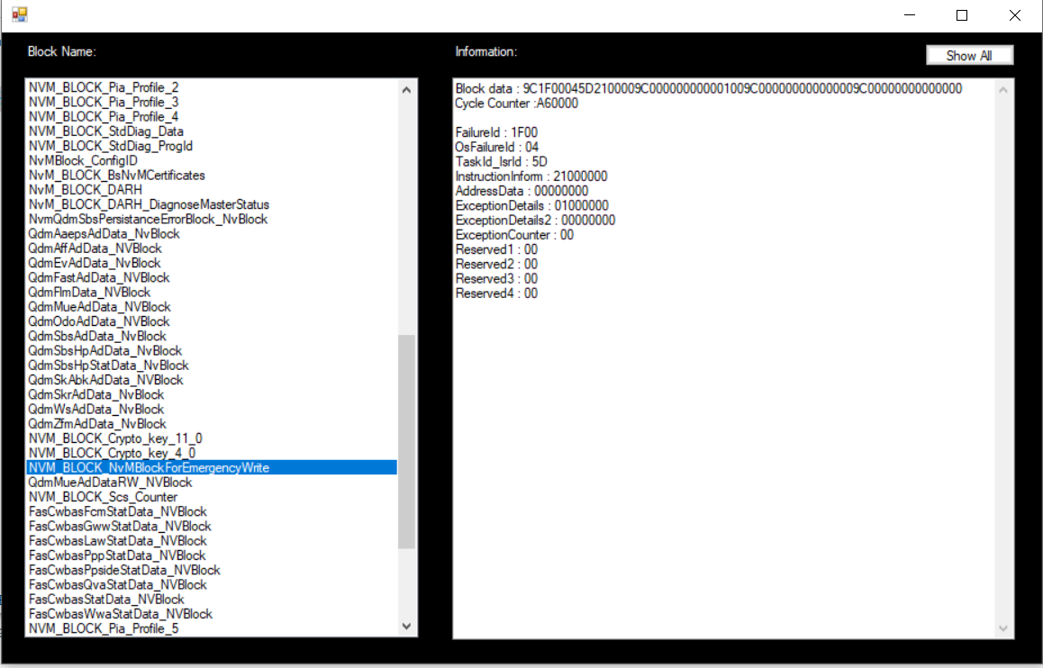

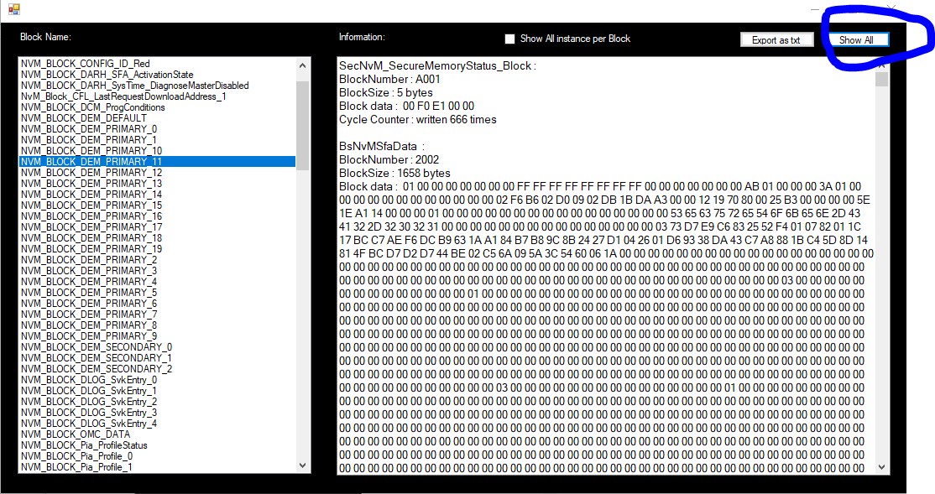

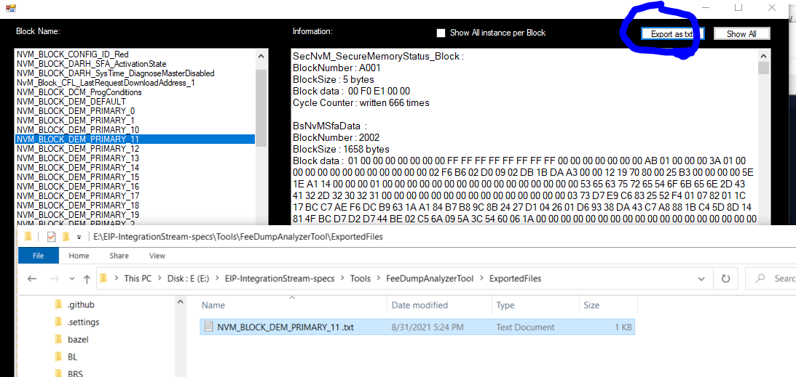

1. **Instructions**

**Hex file/Txt file**

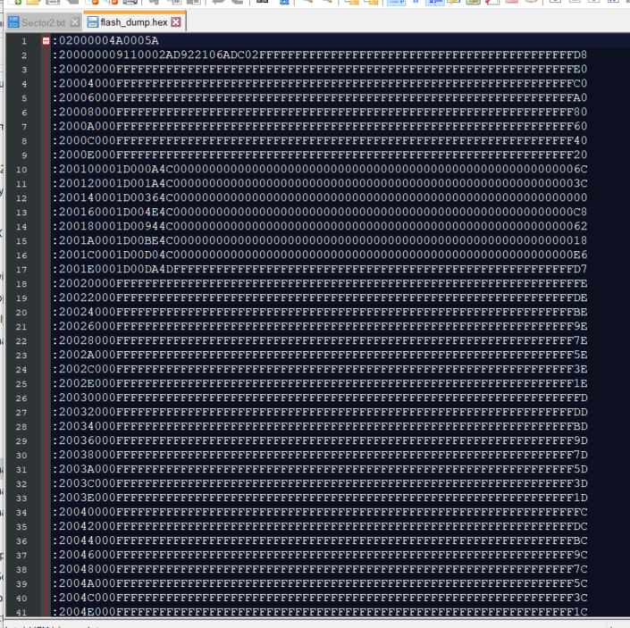



1. Open FeeDumpAnalyzer.exe
2. Choose .txt or .hex file

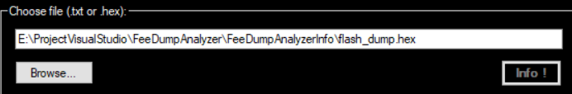

1. Select configuration or choose custom config file

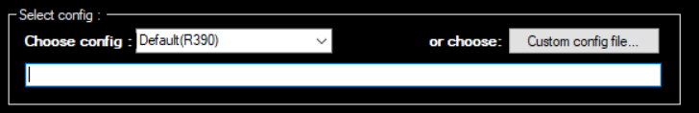

1. Check Run , and wait…

 

1. If this message appears  , press Show output
2. This is result :
3. 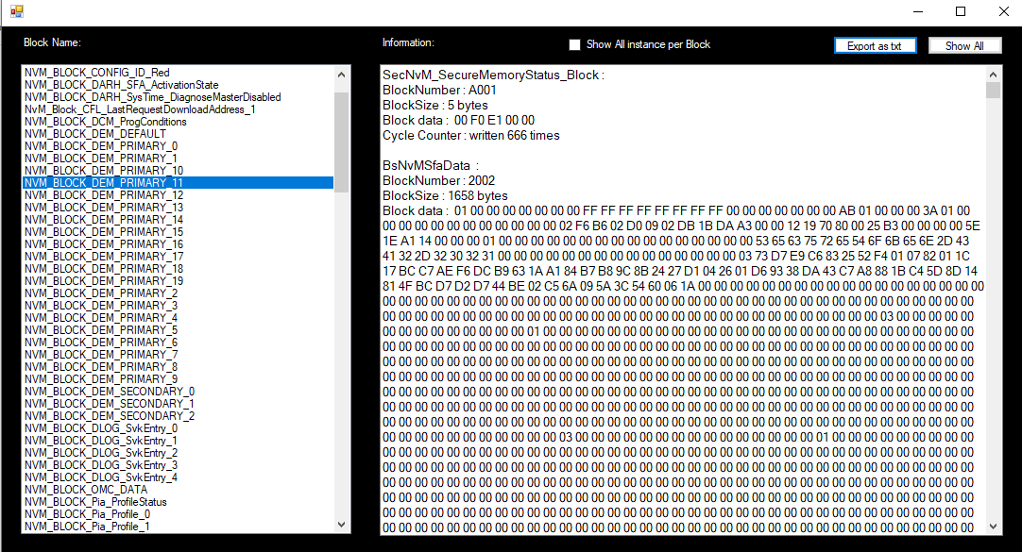

-You can select one at the time or all , just press Show All button

1. **Important**

!!!Application structure:

Must be:

 - - >

- - >

Config - - >

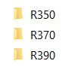

R390 - - >

 ( all config folder must have .xdm file)