- States with the Highest Profit

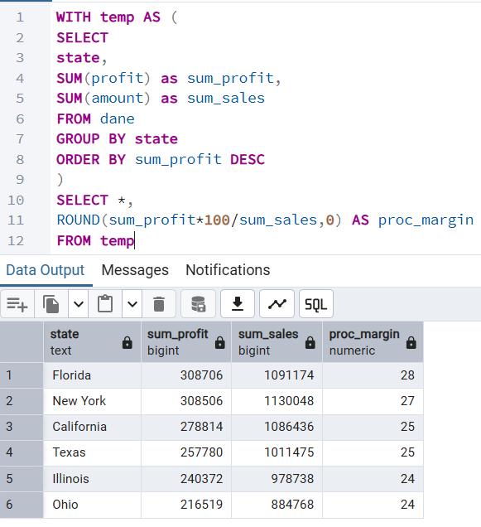

- Florida generates the highest total profit despite not recording the highest total sales. This suggests a higher profit margin and stronger overall profitability compared to other states
- Observed positive relation between total sales and profit margin. States with higher sales tend to achieve slightly higher margins
- Profit margins remain relatively consistant across states (24–28%)

- Most Profitable Category in Each State
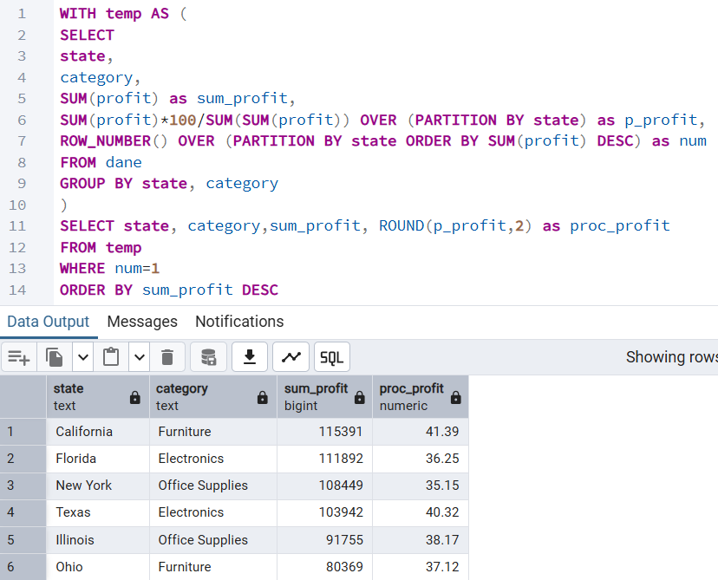
- The most profitable product category varies across states, indicating differences in local demand and market structure
- A particularly strong category dominance is visible in California (Furniture) and in Texas (Electronics), where over 40% of total profit is generated by the leading category

- Sales vs Profitability Analysis (for sub-categories with sales >= 300k)
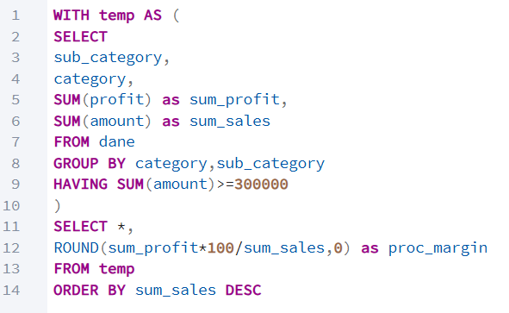
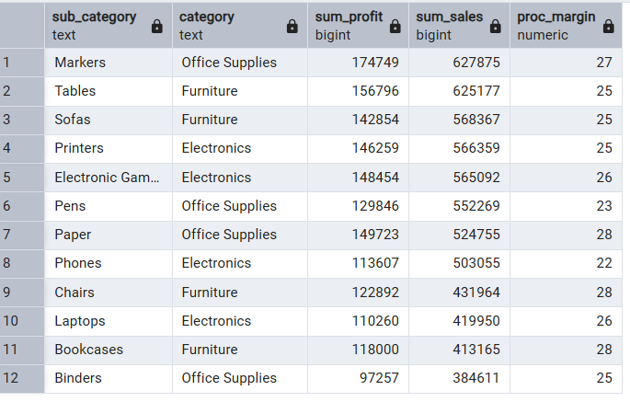
- High sales volume at the sub-category level does not necessarily correlate with higher profit margins
- The highest sales and total profit are generated by Markers and Tablets. However, the highest profit margins are achieved by Paper, Chairs and Bookcases (28%), followed by Markers (27%)
- The lowest profit margins are observed for Phones (22%) and Pens (23%)

- Year-Over-Year Perfomance Analysis
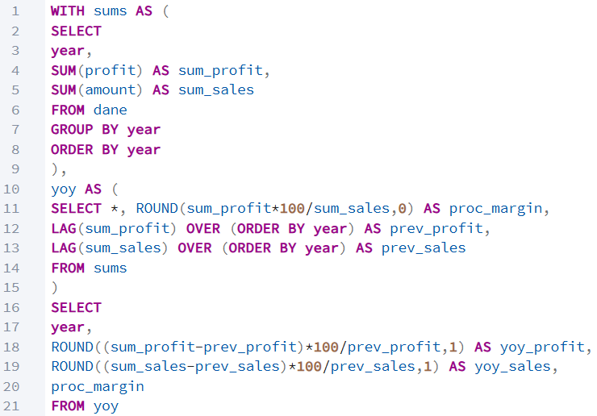

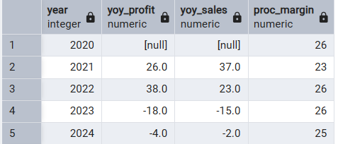
- 2021: Strong growth in both profit and sales
- 2022: Continued growth in profit and sales, with an improvement in margin. These two years represent a period of strong performance for the company
- 2023: A noticeable decline in both profit and sales, while the margin remained stable at 26%. This suggests the end of the growth phase and the beginning of a slowdown.
- 2024: A slight further decrease in profit and sales, indicating that the decline is slowing down and the company may be stabilizing

- Sales Trends by Months
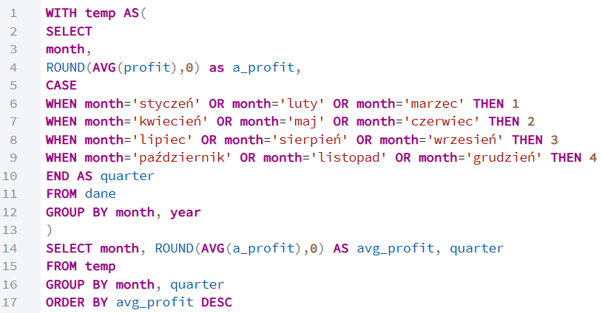
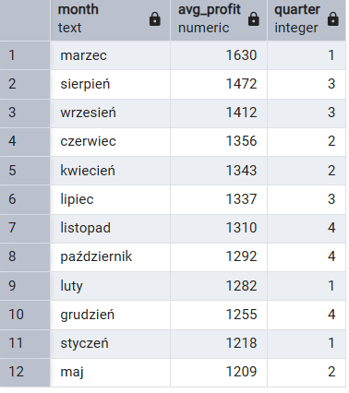
- The highest average profit is observed in March (1630), while the lowest is recorded in May (1209)
- The difference between the most and least profitable months is around 25%, which suggests seasonality in sales
- Higher profits are generally observed in the 2nd and 3rd quarters than in 1st and 4th quarters

