Basic Databases – Report02
Wroclaw University of Technology, Date: October 26, 2018
Student: | Email: ---------------------------------------------------- | Grade
Identifier | 242363
First name | Patryk
Last name | Szwed
This task consists of 2 problems. If you cannot solve a problem, try to give at least a partial answer or partial solution. Remember to write your name, and identifier.

Problem 1
Based on the developed conceptual data model "Books" in previous lab classes:
- Define the structure of the database (tables, constraints: PRIMARY KEY, FOREIGN KEYS, CHECK - domain constraints
- Introduce sample records to check the correctness of defined constraints

Solution:

- Structure of the database:

CREATE TABLE Publisher(
NIP VARCHAR(11) CONSTRAINT pk_Publisher PRIMARY KEY,
"name" VARCHAR(30)
);

CREATE TABLE Author(
PESEL VARCHAR(15) CONSTRAINT pk_Author PRIMARY KEY,
firstName VARCHAR(20),
lastName VARCHAR(20)
);

CREATE TABLE Reader(
PESEL VARCHAR(15) CONSTRAINT pk_Reader PRIMARY KEY,
firstName VARCHAR(20),
lastName VARCHAR(20),
booksRead INT,
CONSTRAINT chk_booksRead CHECK(booksRead >= 0)
);

CREATE TABLE Book(
ISBN VARCHAR(14) CONSTRAINT pk_Book PRIMARY KEY,
title VARCHAR(100),
category VARCHAR(30),
rating FLOAT,
formats VARCHAR(50),
pages INT,
NIP VARCHAR(11) CONSTRAINT fk_Publisher REFERENCES Publisher(NIP),
PESEL_author VARCHAR(15) CONSTRAINT fk_Author REFERENCES Author(PESEL),
PESEL_reader VARCHAR(15) CONSTRAINT fk_Reader REFERENCES Reader,
CONSTRAINT chk_rating CHECK(rating >= 0 AND rating <= 6),
CONSTRAINT chk_pages CHECK(pages > 0)
);

2.
INSERT INTO Publisher VALUES(
5731006793,
'Pwr Publishing'
);

INSERT INTO Publisher VALUES(
5731006793,
'Second Publisher'
);

INSERT INTO Publisher VALUES(
5212319312,
'Oxford'
);

Is invalid as two inputs have the same value of primary key. The error says:

Msg 2627, Level 14, State 1, Line 1
Violation of PRIMARY KEY constraint 'pk_Publisher'. Cannot insert duplicate key in object 'dbo.Publisher'. The duplicate key value is (5731006793).
The statement has been terminated.

I have also tried putting too big VARCHAR into table, but the error says:

Arithmetic overflow error converting numeric to data type varchar.

Publisher table obtained by query SELECT * FROM Publisher:

NIP | name
5212319312 | Oxford
5731006793 | Pwr Publishing

In the Author table I wanted to add too long VARCHAR, using this code:

INSERT INTO Author VALUES(
81323491236,
'Janerqreqrwqewerrewrqqeweqweqewq',
'Nowak'
);

but an error occurred:

String or binary data would be truncated.

One took place as I set the maximum value for firstName VARCHAR to 20.

I added new entries using those queries:

INSERT INTO Author VALUES(
98023491237,
'Jan',
'Kowalski'
);

INSERT INTO Author VALUES(
81323491236,
'Piotr',
'Nowak'
);

INSERT INTO Author VALUES(
7627481221,
'James',
'Bond'
);

The output for query:

SELECT *
FROM Author;

is following:

PESEL | firstName | lastName
7627481221 | James | Bond
81323491236 | Piotr | Nowak
98023491237 | Jan | Kowalski

I wanted to add new entry into Reader table, but with incorrect booksRead amount. I check this using CHECK constraint (booksRead >= 0). Following was code and error:

INSERT INTO Reader VALUES(
4367823912,
'Andrzej',
'Kowalczyk',
-1
);

The INSERT statement conflicted with the CHECK constraint "chk_booksRead". The conflict occurred in database "242363", table "dbo.Reader", column 'booksRead'.

I inserted three entries by this query:

INSERT INTO Reader VALUES(
4367823912,
'Andrzej',
'Kowalczyk',
2
);

INSERT INTO Reader VALUES(
5512734912,
'Anna',
'Dąb',
44
);

INSERT INTO Reader VALUES(
9063813991,
'Michael',
'Jordan',
23
);

Using query:

SELECT *
FROM Reader;

I obtained following result:

PESEL | firstName | lastName | booksRead
4367823912 | Andrzej | Kowalczyk | 2
5512734912 | Anna | Dab | 44
9063813991 | Michael | Jordan | 23

Finally, I started to create entries into Book table. Firstly, I decided to add entry with invalid foreign key. I created that query:

INSERT INTO Book VALUES(
978-1-60309,
'Java - Tutorial',
'Computer Science',
4.3,
'PDF/TXT',
452,
5731006794,
7627481221,
9063813991
);

Foreign key for NIP is invalid as it doesn’t exist. Fortunately, the error occurred:

The INSERT statement conflicted with the FOREIGN KEY constraint "fk_Publisher". The conflict occurred in database "242363", table "dbo.Publisher", column 'NIP'.

Next I tried to insert data with invalid pages(CHECK constraint pages > 0) and rating(CHECK constraint rating [0.0, 6.0]). Validation system works as the errors say:

The INSERT statement conflicted with the CHECK constraint "chk_rating". The conflict occurred in database "242363", table "dbo.Book", column 'rating'.

The INSERT statement conflicted with the CHECK constraint "chk_pages". The conflict occurred in database "242363", table "dbo.Book", column 'pages'.

I obtained these results by this query:

INSERT INTO Book VALUES(
978-1-60309,
'Java - Tutorial',
'Computer Science',
6.3,
'PDF/TXT',
0,
5731006793,
7627481221,
9063813991
);

I added some correct entries using following query:

INSERT INTO Book VALUES(
'978-1-60309',
'Java - Tutorial',
'Computer Science',
4.3,
'PDF/TXT',
427,
5731006793,
7627481221,
9063813991
);

INSERT INTO Book VALUES(
'978-1-60308',
'PHP IS not that EASY',
'Computer Science',
5.1,
'PDF',
315,
5212319312,
81323491236,
4367823912
);

INSERT INTO Book VALUES(
'978-1-60315',
'Beach Safari',
'Science Fiction',
4.9,
'PDF/Hard Cover',
539,
5731006793,
98023491237,
5512734912
);

INSERT INTO Book VALUES(
'978-1-60241',
'Any Empire',
'Adventure',
3.7,
'TXT',
994,
5212319312,
7627481221,
5512734912
);

INSERT INTO Book VALUES(
'978-1-51912',
'Second Thoughts',
'Romantic',
4.9,
'PDF/TXT/Hard Cover',
207,
5212319312,
98023491237,
5512734912
);

INSERT INTO Book VALUES(
'978-1-914501',
'Red Panda and Moon Bear',
'Short story',
5.0,
'Hard Cover/TXT',
51,
5731006793,
81323491236,
9063813991
);

And by query:

SELECT *
FROM Book;

I got this result:

ISBN | title | category | rating | formats | pages | NIP | PESEL_author | PESEL_reader
978-1-51912 | Second Thoughts | Romantic | 4.9 | PDF/TXT/Hard Cover | 207 | 5212319312 | 98023491237 | 5512734912
978-1-60241 | Any Empire | Adventure | 3.7 | TXT | 994 | 5212319312 | 7627481221 | 5512734912
978-1-60308 | PHP IS not that EASY | Computer Science | 5.1 | PDF | 315 | 5212319312 | 81323491236 | 4367823912
978-1-60309 | Java - Tutorial | Computer Science | 4.3 | PDF/TXT | 427 | 5731006793 | 7627481221 | 9063813991
978-1-60315 | Beach Safari | Science Fiction | 4.9 | PDF/Hard Cover | 539 | 5731006793 | 98023491237 | 5512734912
978-1-914501 | Red Panda and Moon Bear | Short story | 5 | Hard Cover/TXT | 51 | 5731006793 | 81323491236 | 9063813991

Each book has its publisher, author, reader(s) and its unique primary key, which is ISBN.

Problem 2
- Define conceptual data model based on the following relational database schema (Company relational data model) using UML
- Implement the Company relational database in MS SQL 2017

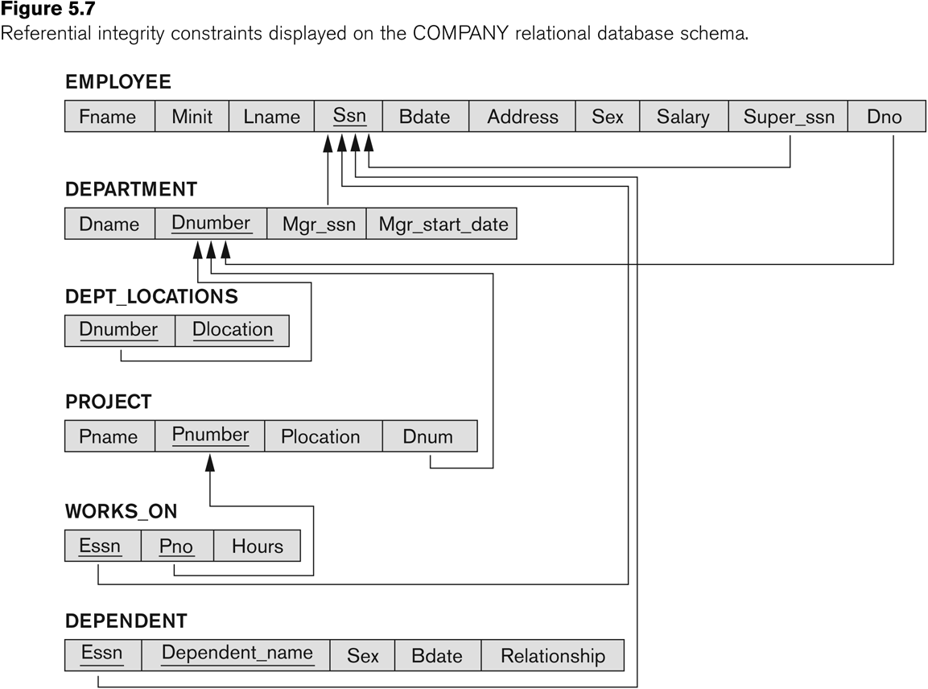

Solution:

Database schema in UML:

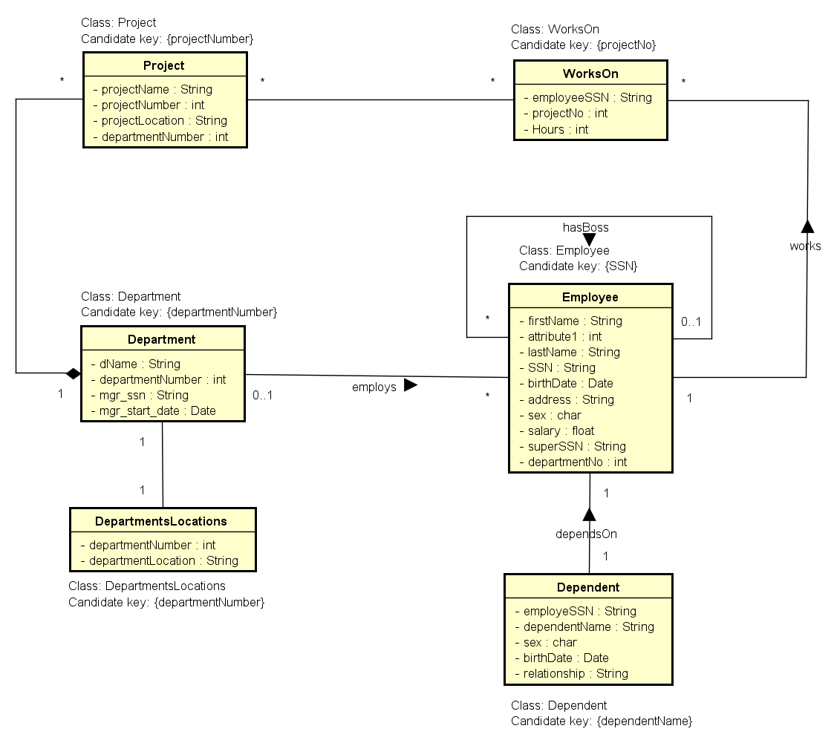

Conclusions
?

----------------------------------------------------------------------------------------------------------------------------
Please do not forget about the conclusions being a summary of considered problems and proposed solutions!
Remarks:
- Students' reports (as one package) should be sent by the leader of the group via e-mail before the next lab
- The rule of naming student’s file report is defined below

Name of the file: Rep01-StudId-Last name.pdf | Example: Rep01-1951355-Turan.pdf

