HR Attrition Analysis — IBM Employee Dataset
This report analyzes the IBM HR Employee Attrition dataset, which contains data on 1,470 employees. The goal of this analysis was to identify key patterns and reasons behind employee attrition, in order to provide actionable recommendations for reducing turnover.

Key Findings
After analyzing the data, I found that the highest number of attritions occurs in the Research & Development department. As this is the largest department in the company, I decided to focus on it, as key findings will have a significant impact on a large group of employees.
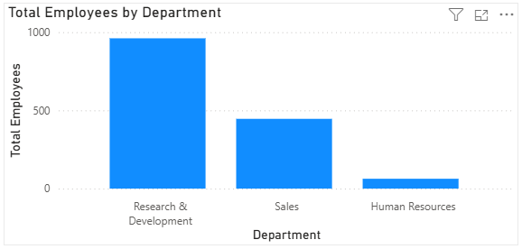
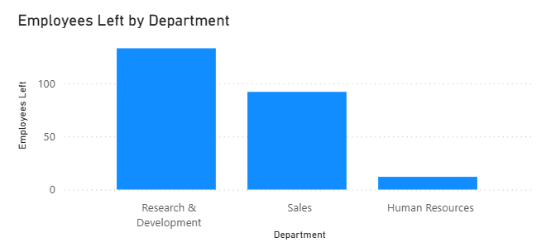
Furthermore, I found that the highest number of attritions occurs within the first two years of employment. After the first year, 38 employees left from Research & Development, 17 from Sales, and 4 from Human Resources. This suggests that the company struggles with employee retention during the onboarding and early career phase.
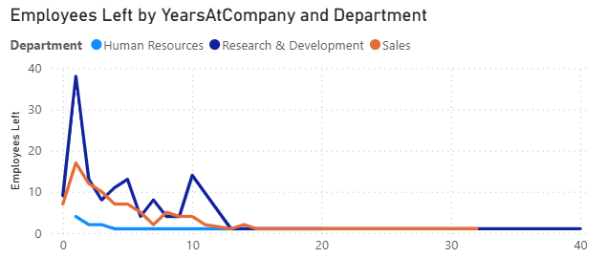

After deeper analysis, I identified that the highest attrition rate occurs among Laboratory Technicians. Out of all employees who left the Research & Development department (133), 62 were Laboratory Technicians, 47 were Research Scientists, 10 were Manufacturing Directors, 9 were Healthcare Representatives, 3 were Managers, and 2 were Research Directors.
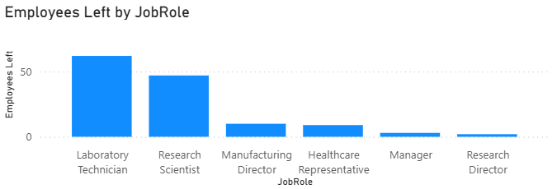
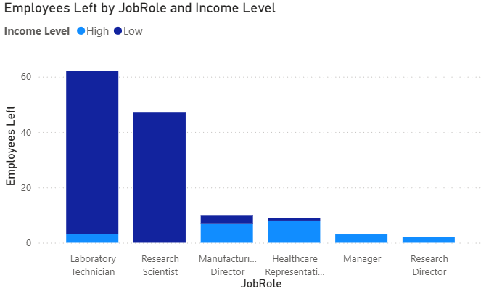

The job role with the highest attrition is Laboratory Technician, which also has one of the lowest average monthly incomes in the department, at approximately $3,128 per month. Further analysis revealed a clear income gap between employees who left and those who stayed — employees who left earned an average of $2,920 per month, compared to $3,340 for those who remained. This suggests that below-average compensation is a key driver of attrition among Laboratory Technicians.
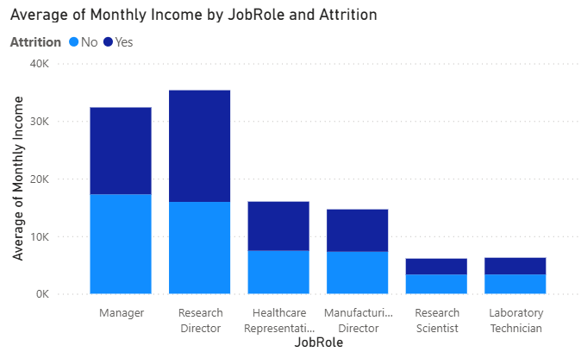
Recommendations
I recommend raising the lower bracket of the salary range for the Laboratory Technician role, combined with a moderate increase in qualification requirements. This approach would result in a more skilled workforce while simultaneously reducing the attrition rate. Based on the data, aligning the average salary of departing employees ($2,920) closer to that of retained employees ($3,340) could significantly improve retention. It is worth noting that the cost of recruiting and onboarding a new employee typically exceeds the cost of a salary increase, making this recommendation financially justified

