9533321 Software Requirement   
Group Project

Fit and Rich Requirement Document

Team member

|  |  |
| --- | --- |
| 642115002 | Krittayoch Jongchisittikul |
| 642115003 | Kan Katpark |
| 642115017 | Dusit Chunviset |
| 642115024 | Thaiphat Sukhumpraisan |
| 642215037 | Poopa Somthawil |

**BACHELOR OF SCIENCE**

**SOFTWARE ENGINEERING PROGRAM**

**COLLEGE OF ARTS, MEDIA, AND TECHNOLOGY**

**CHIANG MAI UNIVERSITY**

Contents

Inception 0

Project Description 0

Problems of the User 0

Goal and Objective 0

Goals 0

Objectives 0

Benefit 1

Target Users 1

Persona 2

Persona 3

Fish Bone Diagram 4

Elicitation 5

Software Progress Plan 5

Project Prioritization 6

Business Review 6

SWOT analysis 7

Risk analysis 9

Cost and time estimation 12

Technology Review 13

External Service 13

Library / Framework / Database 13

Development Tools 14

Interview 14

Software Requirement Specification 15

User journey 15

User Requirement Specification 15

**URS-01: Exercise Category Selection** 15

**URS-02: Start/Resume Exercise Tracking** 15

**URS-03: Real-time Exercise Tracking** 15

**URS-04: Stop/Pause Exercise Tracking** 16

**URS-05: Post-exercise summary** 16

**URS-06: Claim rewards** 16

**URS-07: Alert if unexpected event occurs.** 16

System Requirement Specification 16

Use Case Diagram 17

Use Case Description 18

Activity Diagram 21

Wireframe 22

Non-functional Requirement 25

Traceability matrix 25

URS-SRS 25

URS-UI 26

SRS-UI 26

URS-UCD 26

UCD-AD 26

# Inception

## Project Description

**“Fit and Rich”** is a **mobile application** which aims to create an innovative insurance platform that integrates fitness and wellness into the insurance experience. Users will be able to exercise to earn discount points and reduce their insurance premiums. The platform will offer personalized fitness plans, tracking of exercise progress, and opportunities to participate in challenges and competitions. Additionally, partnerships with local gyms and fitness centers will enhance user engagement.

## Problems of the User

* Many young adults and middle-aged adults (20 - 40 years old) face a range of challenges in their daily lives, including:
* Balancing work and personal responsibilities often leave little time for fitness and health.
* Finding insurance to be a financial burden rather than an integrated part of their lifestyle.
* Struggling to maintain a consistent exercise routine due to lack of motivation or rewards.

## Goal and Objective

### Goals

The primary goal of this project is to redefine insurance for young adults and middle-aged adults (20 - 40 years old), making it more engaging, relevant, and rewarding.

### Objectives

**Promote Health:** Encourage users to adopt a healthier lifestyle by incorporating regular exercise into their routines.

**Financial Incentives:** Reward users for exercising with discounts on insurance premiums, making insurance more affordable and appealing.

**Personalized Fitness:** Provide users with personalized fitness plans to help them achieve their health and wellness goals.

**Motivation and Engagement:** Keep users motivated and engaged through progress tracking, challenges, and competitions.

**Community Building:** Foster a supportive community of users with similar fitness goals and interests.

## Benefit

**Health and Wellness:** Users will lead healthier lives by incorporating regular exercise, potentially reducing the risk of health issues.

**Financial Savings:** By earning discounts on insurance premiums, users will enjoy financial benefits, making insurance more affordable.

**Motivation and Engagement:** The project will motivate users to stay active and engaged in their fitness journey through rewards, challenges, and tracking.

## Target Users

The primary target users for this project are young adults and middle-aged adults (20 - 40 years old), typically individuals in their early to mid-career stages who have no work-life balance. And also, users, who are seeking affordable insurance options and opportunities to improve their fitness and well-being.

## Free photo fashion young businessman black suit casual poses at studioPersona

Name: Poopha

* + CTO of KrataiBin.
  + 21 years old.
  + Live in Chiang Mai.
  + Work very hard.
  + Love to exercise.
  + LGBTQ++

Goals:

* + Want to have a special discount for his insurance and be healthy.

Gains:

* + Always wake up at 05:00 and do exercise every day.
  + Love to share his exercise summary on Instagram.
  + Want to participate in virtual exercise events.

Pains:

* + His insurance premium is very expensive.
  + His salary has been reduced 80%
  + Want to exercise and get more benefits.
  + Nobody wants to exercise with him.

## Persona

Name: Kong

* + CTO of CU.
  + 69 years old.
  + Live in Chiang Mai.
  + Work very chill
  + Don’t like to exercise.
  + LGBTQ++

Goals:

* + Want to have a special discount for his insurance and adopt exercise habit.

Gains:

* + Be able to exercise every day.
  + Love to share his journey on Instagram.
  + Want to have big muscles.

Pains:

* + His insurance premium is very expensive.
  + His salary has been reduced 30%
  + Want to exercise and get more benefits.

## Fish Bone Diagram

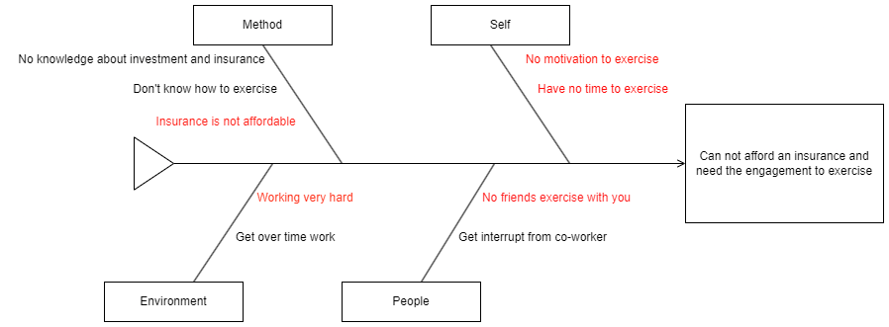

Note: Red text is the problem which we aim to solve.

# Elicitation

## Software Progress Plan

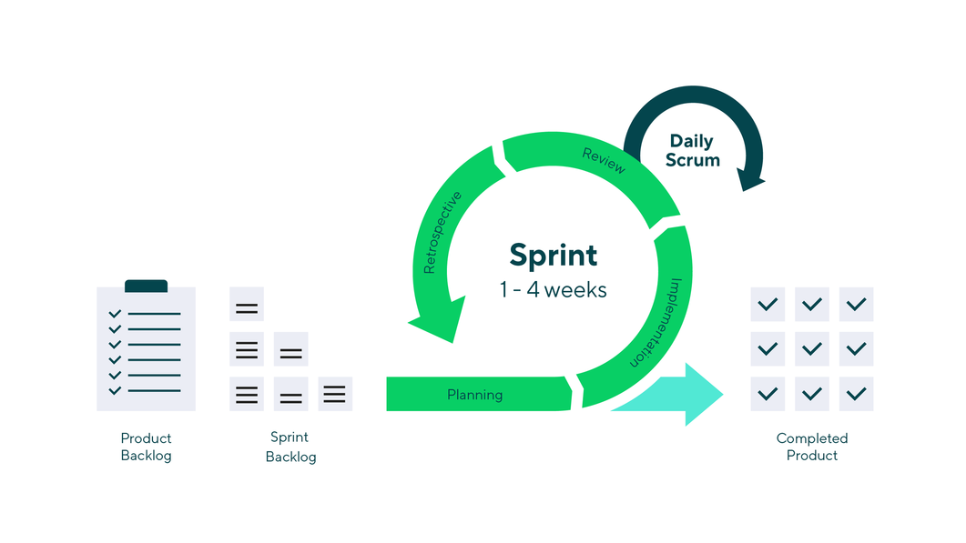

The Scrum framework is a widely used approach in software development that emphasizes iterative and incremental processes. It divides the project into small, manageable units called sprints, typically lasting two to four weeks. During each sprint, a cross-functional team works to complete a set of predefined tasks or user stories, resulting in a potentially shippable product increment. Scrum promotes regular communication and collaboration within the team and with stakeholders through daily stand-up meetings, sprint planning, sprint review, and sprint retrospective sessions. This framework offers flexibility by allowing adjustments and improvements in subsequent sprints based on feedback and changing requirements, making it a valuable methodology for complex and evolving projects.

|  |  |
| --- | --- |
| Sprint | Checkpoint |
| 1 | * Gather requirement. * Raise funds. * Create Prototype. |
| 2 | * Exercise tracking feature |
| 3 | * Insurance subscription feature |
| 4 | * Point Spending Feature |
| 5 | * Virtual Event Feature |

## Project Prioritization

The criteria of selecting the feature to be implemented first. We consider the criteria based on effort, impact and risk. We would select the feature which has high impact, effort and low risk. And we can summarize the prioritization as a table:

|  |  |  |  |
| --- | --- | --- | --- |
| **Feature** | **Impact** | **Effort** | **Risk** |
| Exercise Tracking | High | Medium | Low |
| Reward Redemption | Medium | Medium | High |
| Insurance subscription feature | High | High | High |
| Virtual Event and Competition | Medium | Low | Low |

So, this table provides the prioritization based on effort, impact and risk. The feature that should be done first is the **Exercise Tracking feature** because this feature has medium effort, high impact, and low risk.

## Business Review

From our interview, the interviewee said they paid very huge amount of money on an insurance premium and the price is not reasonable. Plus, they wanted to get a discount which encourages them to exercise or stay healthy.

Nowadays applications that encourage the user and give the user benefit from the insurance discount. Therefore, insurance technology like RooJai and some mobile banking applications provide the users insurance, however the premium price can not be discounted. And those applications can not help encouraging their users to exercise.

So, we saw the opportunity to capture the insurance and health tech markets by create the “Fit and Rich” mobile application which increases the user access the insurance and also provide the activity to engage user to exercise more.

## Competitive Advantage Audit

We have researched the applications which can provide insurance and the exercise helper application.

|  |  |  |  |
| --- | --- | --- | --- |
| **Competitor Name** | Provides Insurance | Help user to exercise | Have virtual event |
| RooJai | ✔️ |  |  |
| TipInsure | ✔️ |  |  |
| FitOn |  | ✔️ |  |
| viRace |  |  | ✔️ |
| Fit and Rich | ✔️ | ✔️ | ✔️ |

To sum up, the comparation of sample competitors in health and insurance market. “Fit and Rich” offers a unique combination of services. It provides insurance coverage, exercise motivation for users and also provides the virtual event to increase the user engagement.

## SWOT analysis

**Strengths:**

* "Fit and Rich" offers a unique concept that combines insurance incentives with fitness and wellness.
* We already have an existing customer base in insurance that can boost the number of users at the program release.
* We have a team of experienced developers.

**Weaknesses:**

* The insurance and fitness industries are competitive.
* Handling sensitive health and exercise data may require robust data security measures to protect user privacy and comply with regulations.
* Partnering with local gyms and fitness centers may involve significant initial costs.

**Opportunities:**

* The increasing focus on health and wellness in modern trends presents an opportunity for "Fit and Rich"
* Collaborations with local gyms and fitness centers can expand the user base and encourage healthy attitudes for existing users.
* Additional health-related services such as nutritional guidance and mental health support can expand the project offering further.
* "Fit and Rich" targets young and middle-aged adults (20 - 40 years old), which are health-conscious and cost-aware.

**Threats:**

* Complying with health and insurance regulations can pose a challenge to non-functional aspects.
* Insurance and fitness companies may be fast to adapt similar models.

## Risk analysis

Market Risk

|  |  |  |  |  |  |  |
| --- | --- | --- | --- | --- | --- | --- |
| Risk ID | Headline | Description | Priority Level | Impact | Likelihood of Event | Mitigation Strategy |
| 1 | A product similar to “Fit and Rich” appears. | A product that resembles the “Fit and Rich” concept is released during the development. | H | A competitive environment between the products is created. | Somewhat likely | Schedule project meeting and discuss potential requirement changes. |
| 2 | Wellness or Insurance trends decrease. | Wellness or Insurance trends fall off. | N | Potential number of target users decrease. | Very unlikely | Have Marketing department motivate the trend. |

Technology Failure

|  |  |  |  |  |  |  |
| --- | --- | --- | --- | --- | --- | --- |
| Risk ID | Headline | Description | Priority Level | Impact | Likelihood of Event | Mitigation Strategy |
| 3 | Server fail | Some factors lead to the situation where the server cannot provide accurate data. | N | Users may not be satisfied with the application | Certainty | Exception Handling.  Displaying proper messages for the users. |
| 4 | Any technology used in the project faces security risk. | Security risks are found in any technology stack/tools/libraries used in the project.  Example: log4j vulnerability | H | The security vulnerability of the program can be exploited. | Very unlikely | Schedule project meeting and discuss the change in technology stack. |

People Risk

|  |  |  |  |  |  |  |
| --- | --- | --- | --- | --- | --- | --- |
| Risk ID | Headline | Description | Priority Level | Impact | Likelihood of Event | Mitigation Strategy |
| 5 | Not enough members to divide work to | Low number of members such as programmer leading to overworking the rest | H | Could lead to longer development time | Somewhat likely | Hire and train more worker into the team |
| 6 | Lack of responsibility of team’s member | A member of team cannot finish their task on time or cannot meet the requirement of the project | H | The project cannot be delivered on time | Somewhat likely | Report every team member’s work at project meeting, and discuss what should be done. |
| 7 | A team member gets sick or has an accident | A team member may get sick or has an accident and cannot work on the project | L | It may lead to the situation where the project cannot finish in time | Somewhat likely | Adjust the plans and schedules.  The absent member should assign works to the other members who can continue work on the project. |

Process failure

|  |  |  |  |  |  |  |
| --- | --- | --- | --- | --- | --- | --- |
| Risk ID | Headline | Description | Priority Level | Impact | Likelihood of Event | Mitigation Strategy |
| 8 | Project schedule changes. | Some factors may force the project schedule to change | H | Influence progress | Certainty | Create comprehensive project timeline and adjust the project schedule according to the requirements. |
| 9 | The system faces reliability or stability | Users cannot use the application or cannot get complete information because of unexpected external factors | N | Users may not be satisfied with the application. | Somewhat likely | Manage the application and maintain the system timely. |
| 10 | Requirement might change | New ideas from stakeholders make the project requirements. | H | Affect the process of the application development | Certainty | Before developing each function, understand the needs as much as possible.  Meet and discuss with other stakeholders. |
| 11 | Tasks are not completed in time. | Some factors may lead to the situation where the team members cannot finish their work in time | N | Influence progress and affect the delivery time | Somewhat likely | In project planning, team members should reserve buffer time.  Meet with the team members and find solutions. |
| 12 | Work cannot be traced. | The change of the requirement may lead us to change our previous work | H | Spend a lot of time to trace back the changes | Somewhat likely | Create the traceability record. |
| 13 | Works do not meet the requirement | Team members did not understand the requirement clearly | L | Spend a lot of time to change. Cannot deliver the project in time | Somewhat likely | Have a frequent meeting and share members’ understanding of the requirements. |
| 14 | The project conflicts with other ongoing projects in the organization. | There are ongoing projects that conflicts with this project’s technicality/interest | H | Conflicts can cause mismanagement during development | Somewhat unlikely | Have meeting of project to determine the priority and change the requirement accordingly. |

## Cost and time estimation

Cost estimation

The total cost of this project is 1M THB. The employee salary would be allocated 44% of all budget. 28% for utility, 17% for marketing, and 11% for research and development.

Time estimation

Estimate time is around 7 months or 28 weeks. This project has 5 sprints. Each sprint takes 3 weeks. The total week spent on the scrum sprint is 15 weeks. And the rest of the time would be the project preparation and requirement gathering.

## Technology Review

### Tools

|  |  |  |
| --- | --- | --- |
| External Service | | |
| Name | Description | Alternative |
| GitHub | Online version control platform that use to develop the software with a team | GitLab, BitBucket |
| AWS | The PaaS that allows users to rent their service for hosting their software | Microsoft Azure, Google cloud |
| Docker | Container software allows users to create a virtual environment for sharing the software without any hardware issues | - |
| GitHub Action | CI/CD tool to do an automated task | Jenkin, Travis |

|  |  |  |
| --- | --- | --- |
| Library / Framework / Database | | |
| Name | Description | Alternative |
| NodeJS | Server-side JavaScript runtime | Bun, Deno |
| VueJS 3 | JavaScript framework for building user interfaces | React,Svelte |
| Flutter | Cross-platform app development framework | React Native, Xamarin |
| CosmosDB | Globally distributed, multi-model database | - |
| ExpressJS | Web application framework for Node.js | honoJS, elysiaJS |

|  |  |  |
| --- | --- | --- |
| Development Tools | | |
| Name | Description | Alternative |
| Visual studio code | Code editor with a focus on simplicity and performance | Sublime text |
| Webstorm | JavaScript IDE with intelligent coding assistance | - |
| Android Studio | Integrated development environment for Android apps | - |

### Smart devices

Our application also integrates with smart devices like Xiaomi Smart Band, Apple Watch, Huawei watch and more.

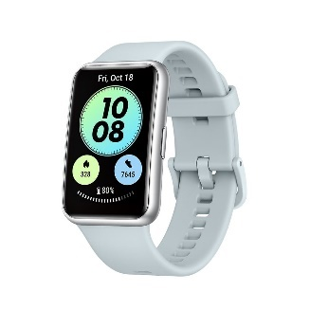

## Interview

Interview Questions:

1. Do you have any insurance?
2. What is your current insurance plan?
3. Do you think your current insurance premium is too expensive or not?
4. Do you often do exercise and if you do, what exercises do you perform?
5. Do you need any engagement to force yourself to exercise?
6. Do you think your current work interrupts you from maintaining good health?

# Software Requirement Specification

## User journey

Step 1: Open Fit-And-Rich Application

Step 2: Open the exercise tracking section.

Step 3 (URS-01): Select exercise category.

Step 4 (URS-02): Hit start tracking exercise button.

Step 5 (URS-03): Application provides the tracking.

Step 6 (URS-04): User hits end the tracking.

Exception (URS-07): Alert if unexpected event occurs.

Step 7 (URS-05): Application shows post-exercise summary.

Step 8 (URS-06): Claim rewards.

## User Requirement Specification

### **URS-01: Exercise Category Selection**

Users can choose an exercise category from a selection of exercise categories.

### **URS-02: Start/Resume Exercise Tracking**

Users can start or resume tracking the exercise progress from the exercise category chosen by the user in URS-01.

### **URS-03: Real-time Exercise Tracking**

Users can see the progress of their exercise tracking in real time. The information to display:

|  |  |  |
| --- | --- | --- |
| Name | Unit | Format |
| Heart rate | BPM | Text |
| Distance | km | Text |
| Burned calories | cal | Text |
| Duration | minute | Text |

### **URS-04: Stop/Pause Exercise Tracking**

Users can stop or pause the exercise progress tracking. The information to display:

|  |  |  |
| --- | --- | --- |
| Name | Unit | Format |
| Total Distance | km | Text |
| Burned calories | cal | Text |
| Duration | minute | Text |
| Average heart rate | BPM | Text |
| Date and Time | - | dd/mm/yyyy |
| Running route | - | Map or Infographic |

### **URS-05: Post-exercise summary**

Users can see the summary of the exercise progress after URS-04.

### **URS-06: Claim rewards**

Users can claim their exercise reward in terms of points.

### **URS-07: Alert if unexpected event occurs.**

## System Requirement Specification

**SRS-01: Exercise Category Selection**

System can show all available exercise categories on the screen with the exercise icon. [UI-01]

**SRS-02: Start/Resume Tracking**

System can start tracking the exercise and resume exercise tracking with the huge button at the screen. [UI-02]

**SRS-03: Real-time Exercise Tracking**

System should be able to know what exercise the users are doing and how long they are doing it for in real-time. [UI-03]

**SRS-04: Stop/Pause Exercise Tracking**

System can stop or pause the exercise progress tracking when the user press stop or pause button respectively. [UI-03]

**SRS-05: Post-exercise Summary**

The system can summarize all information from the exercise and show it to the user. The information include: [UI-04]

**SRS-06: Claim Reward button**

System displays the total gained points of user in 1 exercise and also has the button for the users to claim their exercise reword point. [UI-04]

**SRS-07: Notification**

System has the notification for the users if any unexpected situations occur.   
[UI-05]

## Use Case Diagram

## Use Case Description

|  |  |  |  |
| --- | --- | --- | --- |
| Use Case ID | UC-1 | | |
| Use Case Name | Record exercise journey | | |
| Created By | Kan Katpark | Last Update By | Kant Katpark |
| Date Created | 18 Sep 2023 | Last Revision Date | 18 Sep 2023 |
| Actors | User | | |
| Description | User wants to track and record his/her exercise journey for gathering points and rewards. | | |
| Trigger | User opens the exercise tracking section. | | |
| Preconditions | * Users have good health condition. * Users are ready to exercise. | | |
| Use Case Input Specification | | | |
| Input | type | Constraint | Example |
| Exercise category | String | The categories are set and supported by the system. | “running”, “walking” |
| Exercise data | Object | The object must contain heart rate, and others. | { hearth_rate: ‘..’, speed: 0, distance: 0, … } |

|  |  |  |
| --- | --- | --- |
| Post conditions | Users can claim his/her exercise rewards after finishing exercise. | |
| Normal Flows | User | System |
| 1 | Select exercise category [UI-01] |  |
| 2 | Hit start exercise tracking button [UI-02] |  |
| 3 |  | Record the exercise data [E1: Application stops working] [E2: Lost GPS signal] [E3: No internet connection] [E4: Disconnect to smart device] |
| 4 | [A1: Heart beat is too high/low] [UI-05] | Provide tracking information |
| 5 | View real time exercise information [A2: Pause exercise] [UI-03] |  |
| 6 | Stop exercise [UI-03] |  |
| 7 |  | Summarize the exercise record and display the summary to the user. |
| 8 | View exercise summary. [E3: No internet connection] [UI-04] |  |

|  |  |
| --- | --- |
| Alternative Flow | A1: Heart beat is too high/low   * Warn users to stop or rest by showing a message “Please pause your exercise momentarily. Your heart rate appears to be outside the optimal range for safe exercise.” [UI-05] * Users select whether to stop or pause the exercise. * User hits continue button * Go to normal flow   A2: Pause exercise   * Showing the message: “Your exercise session has been temporarily paused. You are welcome to resume when you feel prepared.” [UI-05] * User hits continue button * Go to normal flow |
| Exception Flow | E1: Application stops working   * Application stopped successfully and stopped recording.   E2: Lost GPS signal   * Notify the user that the application can not get the user GPS signal. * Application continues to record the exercise but not record the distance. * Go to the normal flow.   E3: No internet connection   * Notify the user that the application can not connect to the internet. * Application continues to record the exercise but not record the distance. * Some information will be not shown on the tracking screen * Go to the normal flow.   E4: Disconnect with smart device   * Notify the user that the application can not connect to the smart device. * Application stopped recording the exercise. |
| Assumption | * Users must be registered and authorized to the system. * Users must install the fit and rich mobile application. * Users must wear a smartwatch or tracking device. |

## Activity Diagram

Activity Diagram ID: AD-1

## Wireframe

|  |  |
| --- | --- |
| UI-01: Category selection screen  1  User can select the exercise category | UI-02: Real Time Exercise dashboard (paused)  A screenshot of a phone  Description automatically generated  The application waits for the user to activate the exercise button, then the application records the exercise data and displays the summary in real time. |

|  |  |
| --- | --- |
| UI-03: Real Time Exercise dashboard  A screenshot of a phone  Description automatically generated  The application starts the exercise record. And the users are able to stop or pause with the button. | UI-04: Post-exercise summary    The application displays the post exercise summary and the running route to the user.  User also can view the total gained points and claim them. |

|  |  |
| --- | --- |
| **UI-05: Exception Notification** |  |

## Non-functional Requirement

Usability:

* 90% of a panel that is representative of the public shall successfully start and stop tracking their exercise within 1 minute of handling the program.

Performance Operational:

* The application responds within 1 second in every step of features.

Maintainability & Support Security:

* Customer support should respond to the user within 15 minutes.
* The average cyclomatic complexity of the application should not be more than 14.

Reliability and Availability:

* Application and server downtime should be no longer than 6 hours.

Security:

* Data encryption following AES-256 encryption for sensitive data.

## Traceability matrix

## URS-SRS

|  |  |  |  |  |  |  |  |  |
| --- | --- | --- | --- | --- | --- | --- | --- | --- |
| NO | URS | SRS-01 | SRS-02 | SRS-03 | SRS-04 | SRS-05 | SRS-06 | SRS-07 |
| 1 | URS-01 | ✔️ |  |  |  |  |  |  |
| 2 | URS-02 |  | ✔️ |  |  |  |  |  |
| 3 | URS-03 |  |  | ✔️ |  |  |  |  |
| 4 | URS-04 |  |  |  | ✔️ |  |  |  |
| 5 | URS-05 |  |  |  |  | ✔️ |  |  |
| 6 | URS-06 |  |  |  |  |  | ✔️ |  |
| 7 | URS-07 |  |  |  |  |  |  | ✔️ |

## URS-UI

|  |  |  |  |  |  |  |
| --- | --- | --- | --- | --- | --- | --- |
| NO | URS | UI-01 | UI-02 | UI-03 | UI-04 | UI-05 |
| 1 | URS-01 | ✔️ |  |  |  |  |
| 2 | URS-02 |  | ✔️ |  |  |  |
| 3 | URS-03 |  |  | ✔️ |  |  |
| 4 | URS-04 |  | ✔️ | ✔️ |  |  |
| 5 | URS-05 |  |  |  | ✔️ |  |
| 6 | URS-06 |  |  |  | ✔️ |  |
| 7 | URS-07 |  |  |  |  | ✔️ |

## SRS-UI

|  |  |  |  |  |  |  |
| --- | --- | --- | --- | --- | --- | --- |
| NO | SRS | UI-01 | UI-02 | UI-03 | UI-04 | UI-05 |
| 1 | SRS-01 | ✔️ |  |  |  |  |
| 2 | SRS-02 |  | ✔️ |  |  |  |
| 3 | SRS-03 |  |  | ✔️ |  |  |
| 4 | SRS-04 |  | ✔️ | ✔️ |  |  |
| 5 | SRS-05 |  |  |  | ✔️ |  |
| 6 | SRS-06 |  |  |  | ✔️ |  |
| 7 | SRS-07 |  |  |  |  | ✔️ |

## URS-UCD

|  |  |  |
| --- | --- | --- |
| NO | URS | UC-01 |
| 1 | URS-01 | ✔️ |
| 2 | URS-02 | ✔️ |
| 3 | URS-03 | ✔️ |
| 4 | URS-04 | ✔️ |
| 5 | URS-05 | ✔️ |
| 6 | URS-06 | ✔️ |
| 7 | URS-07 | ✔️ |

## UCD-AD

|  |  |  |
| --- | --- | --- |
| NO | URS | AD-01 |
| 1 | UCD-01 | ✔️ |