**PrisonerGO**

## Employees

| **Employee ID** | **Employee Name** |
| --- | --- |
| 642115004 | Kitdanai Palee |
| 642115006 | Jakkaphat Ploylake |
| 642115023 | Thanyatorn Noenpoempisut |
| 642115040 | Ratchaporn Nuchrungruang |
| 642115046 | Sarin Patanompee |

## Product Request

### Problem of the user

* Users may have limited access to healthcare services, and medical issues can be a significant concern.
* There are safety concerns for the users, both from other inmates and prison staff.
* Prison is very uncertain, risky situations can occur at every moment.
* There is no insurance for inmates in the Thailand market.
* Our users may be maltreated by prison staff.
* Users may not have a future after serving their sentence.

### Goal and Objective

#### Goal

Increase insurance coverage for all types of demographics, bring attention to safety of inmates, and support their successful reintegration into society.

#### Objectives

1. Provide users with compensation for health-related problems concerning life in prison, this includes, violence from fellow inmates, or from prison staff.
2. Offer insurance products and services that support the successful reintegration of inmates into society upon release.
3. Cater specific needs and circumstances, policies should address their potential health, legal, and financial needs both inside and outside of prison.
4. Helps inmates in making their time serving a sentence go smoothly.

### Project Description

PrisonerGO is an insurance plan that caters to inmates that are serving a sentence. Inmates or inmates-to-be can apply for our insurance. They may be accepted or denied based on their background, and offense.

This insurance plan covers: (1) Inmate’s health-related problems in prison, (2) Inmate’s rehabilitation, (3) Inmate’s integration back to society.

### Benefits

1. Users can get better healthcare access.
2. Users can integrate back to society after serving their sentence.
3. Users can be compensated for health-related problems concerning life in prison.

### Target Users

The main target users are inmates.

### Fishbone diagram

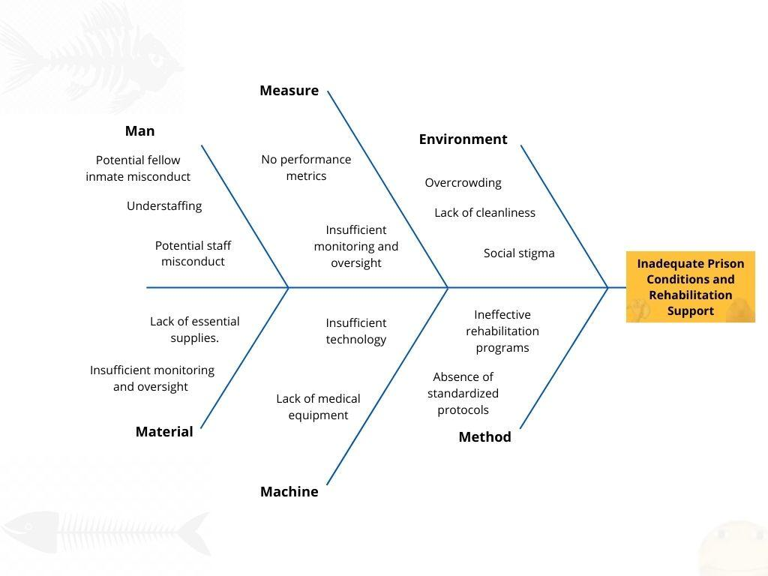

## Interview

### Questions(Diamond structure)

Q1) Have you ever had a health-related problem while in prison? (CLOSED QUESTION)

Q2) Can you describe your experience with healthcare services in prison? (OPEN QUESTION)

Q3) Could you share more about any safety concerns you have had in prison? (OPEN QUESTION)

Q4) Can you elaborate on any instances where you felt maltreated by prison staff? (OPEN QUESTION)

Q5) How do you feel about your future after serving your sentence? (OPEN QUESTION)

Q6) Do you believe an insurance plan like PrisonerGO would be beneficial for inmates? (CLOSE QUESTION)

Q7) Would you consider applying for our insurance plan, PrisonerGO? (CLOSED QUESTION)

### 

### Interviewee #1

### Mr.Rohin; 38 years old, currently serving a 13 months sentence for DUI (2nd Offense).

Q1) Yes, during my time in prison, I did experience a health-related issue. About six months into my sentence, I developed a persistent cough that wouldn't go away. I was eventually diagnosed with bronchitis. It was a challenging experience, and getting access to medical care in prison was not as straightforward as it should have been.

Q2) My experience with healthcare services in prison was mixed. While there were medical staff available, it often took a long time to get an appointment, and the quality of care varied. In some cases, I felt that my concerns were not taken seriously, and there was a lack of transparency about the treatment options available. The overcrowded conditions in the medical facility also made it challenging to maintain social distancing during the COVID-19 pandemic, which added another layer of stress.

Q3) Safety concerns were a constant worry in prison. While I did my best to keep a low profile and avoid trouble, there were still instances of violence and altercations among inmates. Security measures were in place, but they couldn't prevent every incident. It's difficult to feel completely safe when you're confined with a diverse group of people, some of whom may have a history of violence.

Q4) Thankfully, I didn't personally experience severe maltreatment by prison staff. However, I did witness instances where some inmates felt unfairly treated. There were times when staff members seemed dismissive of inmates' concerns or were overly authoritative in their interactions. It's essential for prison staff to treat all inmates with respect and fairness to maintain a safe and humane environment.

Q5) I have mixed feelings about my future after serving my sentence. On one hand, I'm determined to turn my life around and make better choices. However, I'm also aware that reintegration into society can be challenging, especially when you have a criminal record. Finding employment and reestablishing relationships will be difficult, but I'm committed to doing my best to become a productive member of society.

Q6) Yes, I believe an insurance plan like PrisonerGO could be highly beneficial for inmates. It covers essential aspects like healthcare, rehabilitation, and reintegration into society, which are crucial for an inmate's well-being and successful reintegration into society. Many inmates face significant challenges during and after their sentences, and having access to such support can make a meaningful difference in their lives.

Q7) Absolutely, I would consider applying for PrisonerGO insurance. Given the difficulties I've encountered during my sentence and the uncertainties I face upon release, having access to comprehensive support for healthcare, rehabilitation, and reintegration would provide me with a sense of security and a better chance at rebuilding my life. It's reassuring to know that there are programs like this that genuinely care about the well-being of inmates.

### 

### Interviewee #2

### Ms.James; 30 years old, serving a 3 years sentence for Non-violent Drug Possession.

Q1) Yes, I have. During my time in prison, I experienced a few health-related issues, mainly minor illnesses like colds and occasional headaches. Access to medical care has been crucial for addressing these problems, especially considering the crowded conditions.

Q2) Healthcare services in prison have been decent for the most part. The medical staff generally provided the necessary treatment when I needed it. However, there have been times when the healthcare system felt overwhelmed due to the number of inmates seeking medical attention, leading to some delays.

Q3) Safety remains a significant concern in prison, especially given the nature of my non-violent offense. While I haven't experienced direct threats or violence personally, it's still challenging to feel completely secure in this environment, as tensions can escalate quickly among other inmates.

Q4) Fortunately, I haven't personally experienced maltreatment by prison staff. Most of them have treated me fairly and professionally. However, I am aware that such issues can occur in correctional facilities, and it's essential to have mechanisms in place to address them.

Q5) I'm optimistic about my future after serving my shorter sentence. I've been actively working on my rehabilitation, particularly addressing my substance abuse issues. I've also been participating in educational programs that I believe will help me reintegrate into society more smoothly. I'm committed to breaking free from the cycle of addiction and making better choices moving forward.

Q6) Yes, I do believe an insurance plan like PrisonerGO could be beneficial, even for inmates with shorter sentences. It could provide additional support for our healthcare needs and rehabilitation efforts. In my case, it's about preparing for a successful reintegration into society, and any assistance in that regard would be appreciated.

Q7) Absolutely, I would consider applying for PrisonerGO. Given the potential benefits it offers to inmates like myself, it seems like a valuable resource that could help improve our overall well-being and increase our chances of successful reintegration into society, even with a shorter sentence.

### 

### Interviewee #3

### Anonymous Prisoner; 27 years old, currently serving a 25 years sentence for Murder.

Q1) Yes, I have experienced some health-related issues during my time in prison. One of the most significant health challenges I faced was a recurring toothache that became unbearable. It took quite some time to get the dental care I needed, and the pain was extremely distressing.

Q2) Healthcare services in prison have been a source of frustration for me. As I mentioned, it took a long time to receive dental care, and the overall quality of medical attention can vary widely. It's not uncommon to wait for hours or even days to see a healthcare professional, and the conditions in the medical facilities are far from ideal. The focus often seems to be on treating the most severe cases, leaving less urgent medical issues unresolved for extended periods.

Q3) Safety concerns are a constant presence in prison, and I've had my share of worries. Given the nature of my offense and the long sentence, I've had to be vigilant to avoid conflicts with other inmates. It's an environment where tensions can escalate quickly, and security measures don't always prevent violence. It's challenging to feel safe when you're surrounded by individuals with various backgrounds and histories.

Q4) While I can't deny that I've had my disagreements with prison staff, I wouldn't say that I've been subjected to severe maltreatment. However, I have observed instances where staff members could be unnecessarily harsh or dismissive toward inmates. It's crucial for the prison system to prioritize respectful and fair treatment to maintain a sense of justice within the facility.

Q5) My future after serving my sentence looks bleak, to be honest. A 25-year sentence for murder is a significant burden to carry, and I know that reintegration into society will be extremely challenging. Finding employment, building relationships, and regaining trust will be formidable hurdles to overcome. I'm apprehensive about the road ahead, but I'm committed to working on personal growth and rehabilitation during my time in prison.

Q6) Yes, I do think an insurance plan like PrisonerGO could provide essential support for inmates. While my circumstances are different from others, I recognize that many inmates face a range of challenges, including healthcare needs, rehabilitation, and reintegration into society. Such a comprehensive support system could be beneficial in addressing these issues and giving inmates a better chance at a successful post-prison life.

Q7) Given my long sentence and the nature of my offense, I'm uncertain if I would be eligible for PrisonerGO insurance. However, if I were eligible, I would consider applying. The prospect of having access to healthcare, rehabilitation, and reintegration support could potentially help improve my quality of life during my time in prison and offer a glimmer of hope for a better future upon release.

## 

## 

## Features

### Life in prison benefits:

**Mental Health Support:** Recognize the importance of mental health in the inmate population and provide access to mental health professionals and services, including counseling and therapy.

**Preventative Care:** Include preventative healthcare measures, such as regular health check-ups and vaccinations, to address health issues proactively.

**Substance Abuse Treatment:** Implement substance abuse treatment programs and counseling to address addiction issues among inmates.

**Family Support:** Extend support services to inmates' families, as their well-being and stability can significantly impact an inmate's chances of successful reintegration into society.

### Rehabilitation benefits:

**Community Engagement:** Encourage inmates' involvement in community service or volunteer programs within correctional facilities to foster a sense of responsibility and give back to society.

**Education Opportunities:** Provide access to educational programs, including GED preparation and vocational training, to enhance inmates' skills and employability.

### Life after prison benefits:

**Reentry Coordinators:** Appoint reentry coordinators who can work closely with inmates to create individualized reintegration plans, addressing their unique needs and challenges.

**Employment Assistance:** Offer job training programs and assistance with job placement to facilitate inmates' transition to the workforce upon release.

**Family Reunification Support:** Facilitate family reunification efforts by providing resources and counseling to strengthen familial bonds, which can be crucial for an inmate's rehabilitation.

**Peer Mentorship:** Establish peer mentorship programs where former inmates who have successfully reintegrated into society can guide and support those still in prison.

### Convenience benefits:

**Website:** Our insurance plan can be registered through our website.

## 

## Cost ($) and Time (months) analysis

| Name | Round 1 | | Round 2 | | Round 3 | |
| --- | --- | --- | --- | --- | --- | --- |
| Cost | Time | Cost | Time | Cost | Time |
| Kitdanai | 300,000 | 6 | 0 | 0 | 0 | 0 |
| Jakkaphat | 550,000 | 6 | 80,000 | 4 | 0 | 0 |
| Thanyatorn | 500,000 | 6 | 330,000 | 6 | 150,000 | 4 |
| Ratchaporn | 0 | 0 | 250,000 | 6 | 130,000 | 4 |
| Sarin | 0 | 0 | 0 | 0 | 180,000 | 4 |

## Risk identification and Solutions

### Market risk

| **Risk ID** | **Header** | **Decription** | **Priority Level** | **Impact** | **Likelihood od Event** | **Mitigation Strategy** |
| --- | --- | --- | --- | --- | --- | --- |
| M-1 | Increased Costs for Inmate Insurance | Providing comprehensive healthcare, rehabilitation, and reintegration support can lead to increased costs for the insurance plan, potentially affecting pricing and market competitiveness. | H | Higher premiums may deter potential users, reducing the insurance plan's market penetration. | Moderate | Conduct a thorough cost-benefit analysis to strike a balance between offering comprehensive services and maintaining affordability. Seek partnerships or grants to supplement funding. |
| M-2 | Competitive Market for Inmate Insurance | The market for inmate insurance may be competitive, with other insurance providers or programs offering similar services to inmates. | N | High competition could result in pricing pressures, making it challenging for PrisonerGO to maintain affordability while providing comprehensive services. | High | Conduct a thorough competitive analysis to identify unique value propositions and pricing strategies. Continuously monitor the market and adapt offerings to remain competitive. Explore partnerships with correctional facilities for exclusive agreements. |

### Financial risk

| **Risk ID** | **Header** | **Decription** | **Priority Level** | **Impact** | **Likelihood od Event** | **Mitigation Strategy** |
| --- | --- | --- | --- | --- | --- | --- |
| F-1 | Resource Constraints in Correctional Facilities | Correctional facilities may face resource constraints in implementing rehabilitation and support programs, including staff shortages, facility limitations, and budget constraints. | H | Limited resources could hinder the effective delivery of rehabilitation services, potentially reducing their impact | High | Advocate for increased funding for correctional facilities to support the implementation of rehabilitation programs. Explore cost-effective program delivery methods. |

### Technology risk

| **Risk ID** | **Header** | **Decription** | **Priority Level** | **Impact** | **Likelihood od Event** | **Mitigation Strategy** |
| --- | --- | --- | --- | --- | --- | --- |
| T-1 | Data Privacy and Security | Managing inmates' personal information and ensuring data privacy within a prison environment can be challenging, potentially leading to breaches of confidentiality. | H | Data breaches could expose sensitive inmate information, eroding trust in the insurance plan. | Moderate | Implement robust data encryption and access controls. Train staff on data privacy best practices and conduct regular security audits. |

### People risk

| **Risk ID** | **Header** | **Decription** | **Priority Level** | **Impact** | **Likelihood od Event** | **Mitigation Strategy** |
| --- | --- | --- | --- | --- | --- | --- |
| P-1 | Public Resistance to Reentry Programs | Some communities may resist the placement of reentry programs and supportive housing for released inmates, potentially creating friction with local residents. | N | Community resistance could hinder the successful implementation of reentry initiatives. | Moderate | Engage with local communities through public awareness campaigns, community meetings, and collaboration with local leaders to address concerns and build support. |

### Structure/Process risk

| **Risk ID** | **Header** | **Decription** | **Priority Level** | **Impact** | **Likelihood od Event** | **Mitigation Strategy** |
| --- | --- | --- | --- | --- | --- | --- |
| S-1 | Bureaucratic Hurdles in Program Implementation | Complex application and approval processes for support services can create bureaucratic hurdles and delays in inmates receiving necessary assistance. | N | Bureaucratic hurdles may frustrate inmates, potentially affecting their motivation to participate in rehabilitation programs. | High | Streamline and simplify application processes, reduce paperwork, and provide support staff to assist inmates in navigating the system. |

## 

## User Journey - Registration



## URS

1. Users should be able to enter forms.
2. Users should be able to view the insurance quote.
3. Users should be able to sign legal documents.
4. Users should be able to apply for the insurance plan.

## SRS

1. System should provide user status whether they are able to use the insurance.
2. System should give preliminary information on whether the user is applicable.
3. System should keep user information for background checks.
4. System can display insurance quotes.
5. System can send email notifications.
6. System can receive uploads from users.

## Use case diagram

## 

## Use case description

| Use Case ID | UC-01 | | | |
| --- | --- | --- | --- | --- |
| Use Case Name | User can apply for insurance | | | |
| Created By | PrisonerGO Collective | | Last Update By | 18/09/2023 |
| Date Created | 18/09/2023 | | Last Revision Date | 18/09/2023 |
| Actors | User, System, Admin | | | |
| Description | This system will allow user to access our website and click the apply button to start the process to make an insurance contract, system will ask user to input their preliminary information and tell them whether they are able to apply according to the information the user has input, user must hit the submit button to proceed, the system will ask the user to input their detailed information, the system will then take the users background information for further inspection, user must hit the submit button to proceed, the system will tell users what type of personal documents the user must mail to the institution for inspection, documents will be inspected by employees, results will be returned to user within a week, digital documents are emailed to the user to sign whether they agree to legal terms of our insurance company, user must agree to the terms and sign the contract (digitally), once all the process has finished the user will then be applied to using our insurance plan | | | |
| Trigger | User enters the Apply page | | | |
| Preconditions | All systems are working properly, User can send mail, User is not the person being incarcerated. | | | |
| Use Case Input Specification | | | | |
| Input | type | Constraint | | Example |
| Offense | String | From given choices | | DUI - 1st offense |
| Age | Integer | Age > 0 | | 28 |
| Previous Conditions. | String[] | From given choices | | [Asthma, Arthritis] |
| Smoke | Boolean |  | | False |
| Post conditions |  | | | |
| Normal Flows | User | | System | |
| N-1 | User inputs preliminary information | |  | |
| N-2 | User submits the information | | Show preliminary evaluation  (A-1) | |
| N-3 | User inputs personal/detailed information | |  | |
| N-4 | User submits the information | | Calculate and display the insurance quote  (A-2) | |
| N-5 |  | | Show shipping information for hard-copy of personal documents | |
| N-6 | User mails hard-copy of personal documents to our company | | Admin evaluates the result | |
| N-7 | User views the insurance contract | | Email the result to the user  (A-3) | |
| N-8 | User signs the insurance contract and uploads  (A-4) | | Store the signed contract and add the user to insuree database | |
| Alternative Flow | A-1: Rejected   * System shows rejected screen   A-2: Rejected   * System shows rejected screen   A-3: Rejected   * System shows rejected page * System deletes all stored information from the user   A-4: User hasn’t signed the contract after 14 days   * System deletes all stored information from the user | | | |
| Exception Flow |  | | | |
| Assumption | User offenses are at acceptable degree | | | |
|  |  |  |  |  |

## 

## Activity diagram

## 

## Source: [PrisonerGo-Activuty-Diagram.jpg](https://drive.google.com/file/d/1mHNi6-g3w4PPoD_n9g_fxmj4yn5wlY8Z/view?usp=sharing)

## 

## Non-functional requirement with fit criteria

## Feeling of the UI: Maintains a modern design, easy to navigate through and visually appealing for users

## Usability: Every user must be able to access the system, the system must provide clear instructions and must be user-friendly to improve the experience for the user

## Performance: The system must be able to handle a high volume of data, data must be processed quickly with the least amount of downtime, even during peak hours of use

## Support and Maintainability: The documents and other private documents must be secure and well-documented, easy to maintain, security check-ups should be conducted regularly for safeguarding user data and privacy of user data

## Monitoring and Maintenance: The system will be monitored and have alerting systems to track the system’s compliance in real-time. Procedures, ongoing maintenance and updates will be established for best server performance

## Reliability: System must specify systems uptime or availability requirements, system must be able to handle failures and errors without data loss, after failure system must be quick to recover

## UI (wireframe or prototype)

1. Home page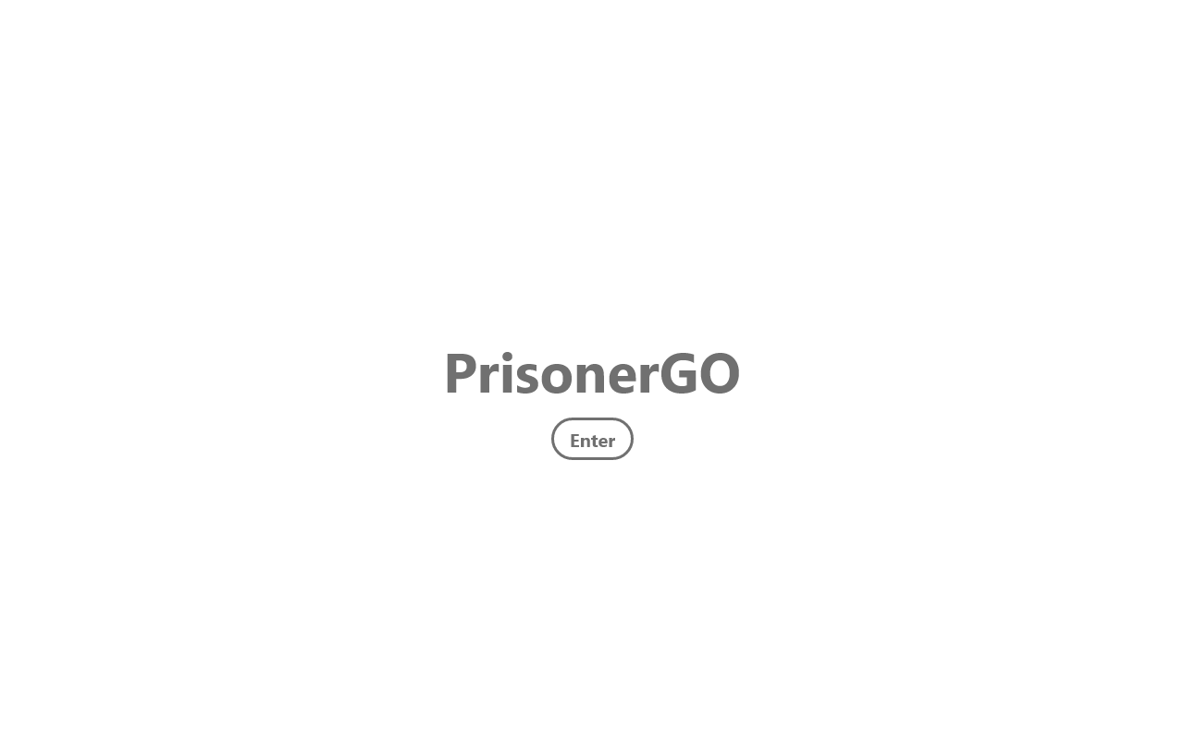
2. Preliminary Information form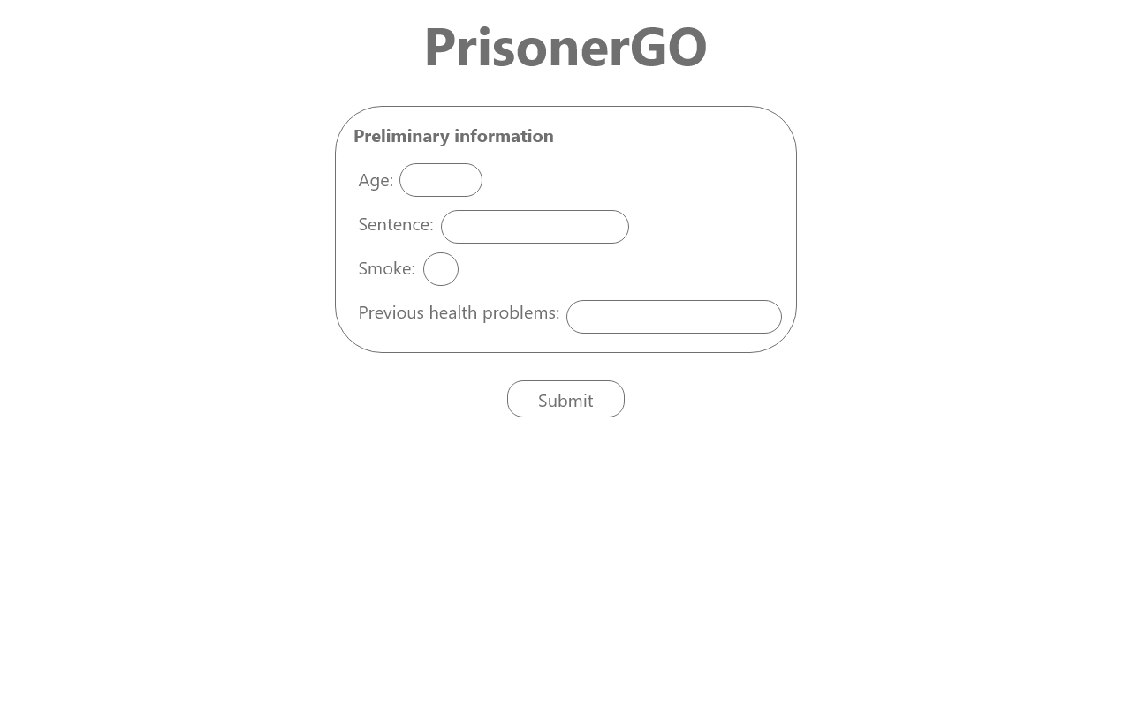
3. Detailed information form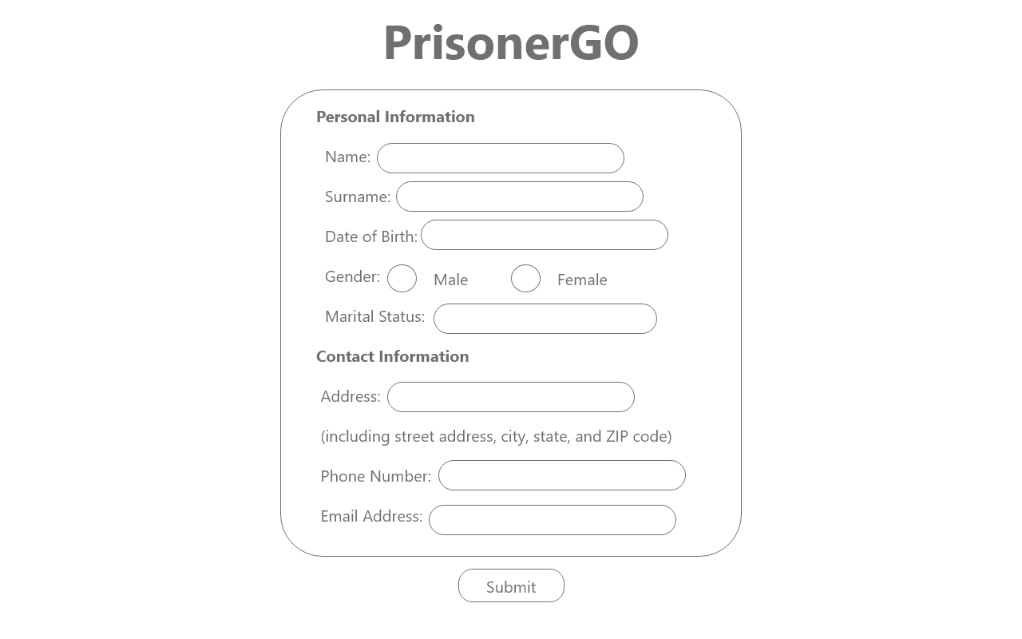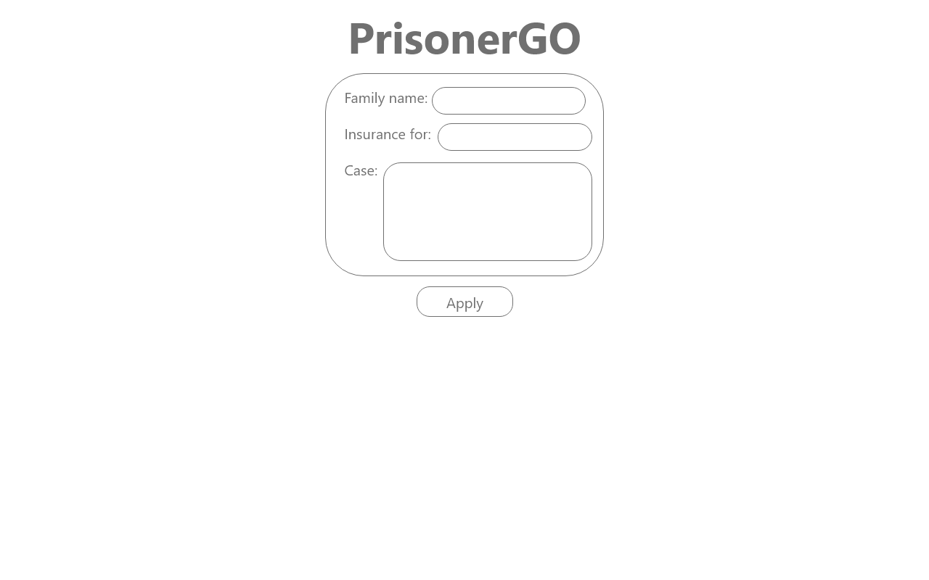
4. Quote display page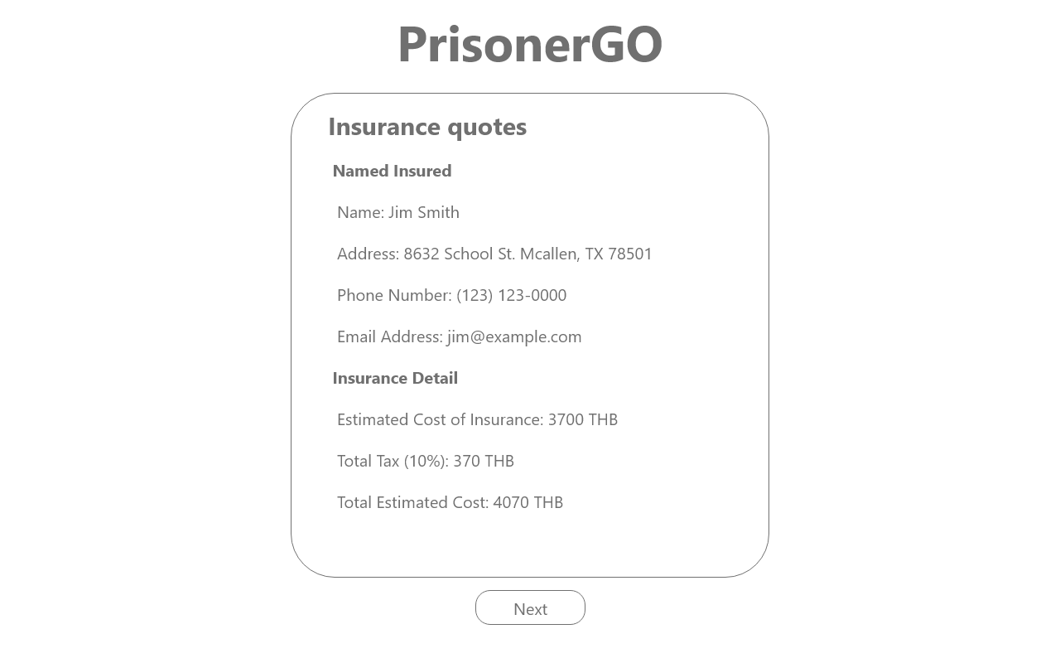
5. Insurance Contract page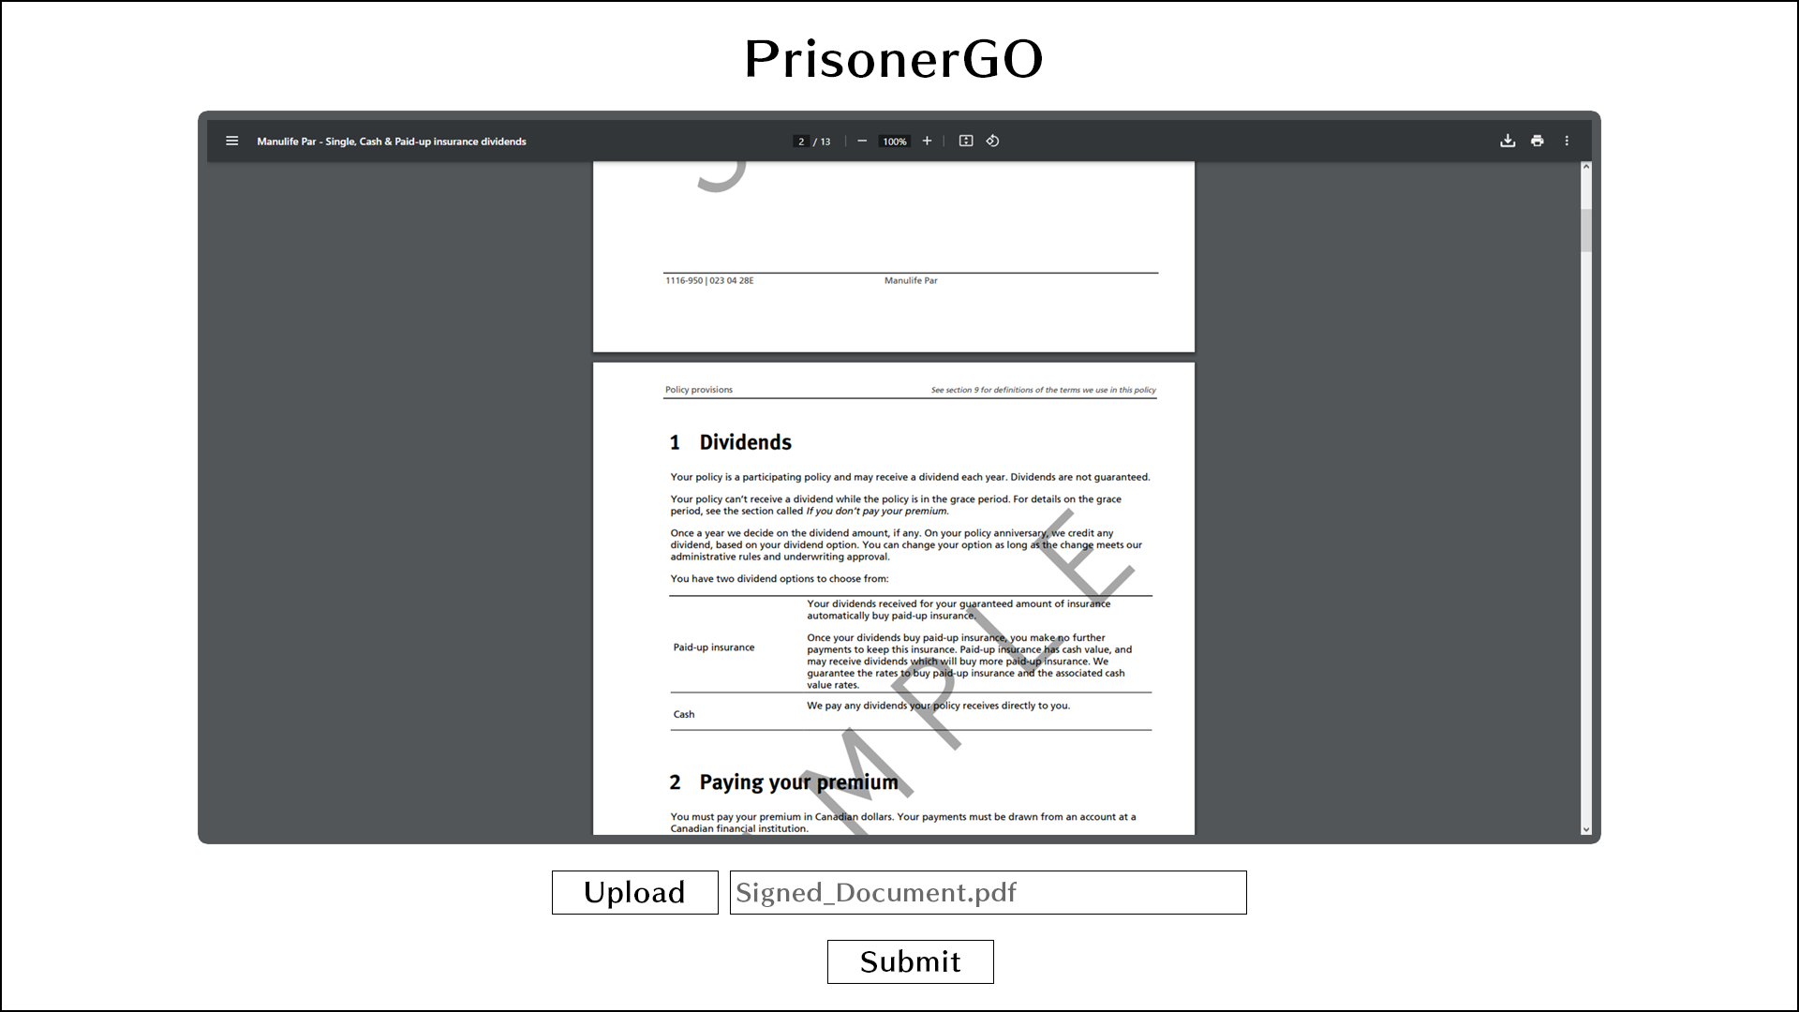
6. Rejected page

