**ชื่อ-สกุล** นางสาวปัทมาพร ถาเป็นบุญ  **รหัสนักศึกษา** 640510668 **ตอนเรียน** 001

**การบ้านปฏิบัติการ1**

**Computational Thinking**

**1) The Artist: Green Glasses**

for (var count = 0; count < 4; count++) {

turnRight(90);

moveForward(100);

}

turnLeft(90);

moveForward(150);

for (var count2 = 0; count2 < 3; count2++) {

turnLeft(90);

moveForward(100);

}

**2) The Artist: Add "Turn By 90 Degree"**

penColour(colour_random());

for (var count = 0; count < 3; count++) {

moveForward(100);

turnRight(120);

}

turnLeft(270);

penColour(colour_random());

for (var count2 = 0; count2 < 3; count2++) {

moveForward(100);

turnRight(120);

}

**3) The Artist: Pretty Flower**

for (var count2 = 0; count2 < 4; count2++) {

penColour(colour_random());

for (var count = 0; count < 3; count++) {

moveForward(100);

turnRight(120);

}

turnRight(90);

}

**4) The Farmer: Fence**

function _E0_B8_A7_E0_B8_B2_E0_B8_94_E0_B8_AA_E0_B8_B5_E0_B9_88_E0_B9_80_E0_B8_AB_E0_B8_A5_E0_B8_B5_E0_B9_88_E0_B8_A2_E0_B8_A1_E0_B8_88_E0_B8_95_E0_B8_B8_E0_B8_A3_E0_B8_B1_E0_B8_AA() {

for (var count = 0; count < 4; count++) {

moveForward(100);

turnRight(90);

}

}

function _E0_B8_A7_E0_B8_B2_E0_B8_94_E0_B8_AA_E0_B8_B2_E0_B8_A1_E0_B9_80_E0_B8_AB_E0_B8_A5_E0_B8_B5_E0_B9_88_E0_B8_A2_E0_B8_A1() {

for (var count2 = 0; count2 < 3; count2++) {

moveForward(100);

turnRight(120);

}

}

_E0_B8_A7_E0_B8_B2_E0_B8_94_E0_B8_AA_E0_B8_B2_E0_B8_A1_E0_B9_80_E0_B8_AB_E0_B8_A5_E0_B8_B5_E0_B9_88_E0_B8_A2_E0_B8_A1();

moveForward(100);

_E0_B8_A7_E0_B8_B2_E0_B8_94_E0_B8_AA_E0_B8_B5_E0_B9_88_E0_B9_80_E0_B8_AB_E0_B8_A5_E0_B8_B5_E0_B9_88_E0_B8_A2_E0_B8_A1_E0_B8_88_E0_B8_95_E0_B8_B8_E0_B8_A3_E0_B8_B1_E0_B8_AA();

moveForward(100);

_E0_B8_A7_E0_B8_B2_E0_B8_94_E0_B8_AA_E0_B8_B2_E0_B8_A1_E0_B9_80_E0_B8_AB_E0_B8_A5_E0_B8_B5_E0_B9_88_E0_B8_A2_E0_B8_A1();

**5) The Farmer: Fill the Holes**

for (var count = 0; count < 7; count++) {

moveForward();

if (pilePresent()) {

dig();

}

if (holePresent()) {

fill();

}

turnLeft();

moveForward();

turnRight();

**6) ให้นศ.เล่นเกม hour of code**

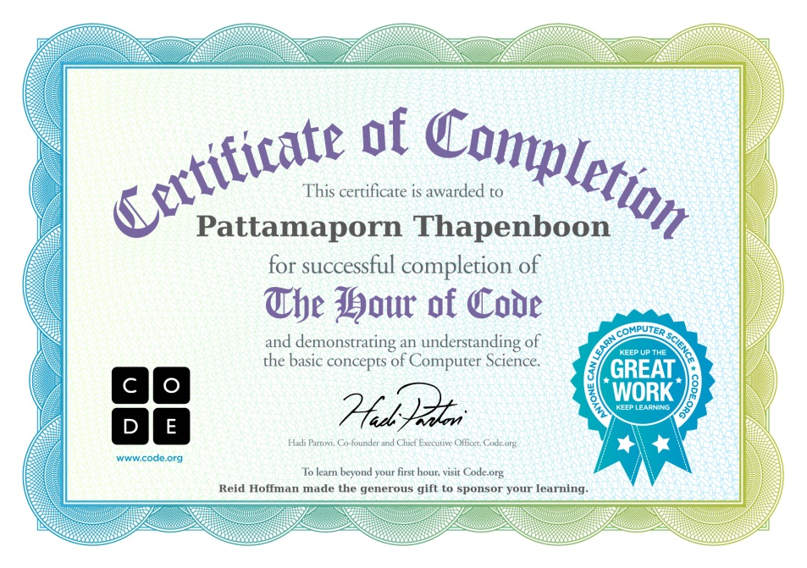

**ด่านที่ 1**

moveForward();

moveForward();

**ด่านที่ 2**

moveForward();

moveForward();

moveForward();

**ด่านที่ 3**

moveForward();

moveForward();

turnRight();

moveForward();

**ด่านที่ 4**

moveForward();

turnLeft();

moveForward();

turnRight();

moveForward();

**ด่านที่ 5**

turnRight();

moveForward();

turnLeft();

moveForward();

moveForward();

moveForward();

turnLeft();

moveForward();

**ด่านที่ 6**

for (var count = 0; count < 5; count++) {

moveForward();

}

**ด่านที่ 7**

turnRight();

for (var count = 0; count < 5; count++) {

moveForward();

}

**ด่านที่ 8**

for (var count = 0; count < 4; count++) {

moveForward();

}

turnLeft();

for (var count2 = 0; count2 < 5; count2++) {

moveForward();

}

**ด่านที่ 9**

for (var count = 0; count < 3; count++) {

moveForward();

moveForward();

turnRight();

}

**ด่านที่ 10**

while (notFinished()) {

moveForward();

}

**ด่านที่ 11**

while (notFinished()) {

moveForward();

moveForward();

turnLeft();

}

**ด่านที่ 12**

while (notFinished()) {

moveForward();

turnLeft();

moveForward();

turnRight();

}

**ด่านที่ 13**

while (notFinished()) {

turnRight();

moveForward();

turnLeft();

moveForward();

}

**ด่านที่ 14**

while (notFinished()) {

moveForward();

if (isPathLeft()) {

turnLeft();

}

}

**ด่านที่ 15**

while (notFinished()) {

moveForward();

if (isPathRight()) {

turnRight();

}

}

**ด่านที่ 16**

while (notFinished()) {

moveForward();

if (isPathLeft()) {

turnLeft();

}

}

**ด่านที่ 17**

while (notFinished()) {

moveForward();

if (isPathRight()) {

turnRight();

}

}

**ด่านที่ 18**

while (notFinished()) {

if (isPathForward()) {

moveForward();

} else {

turnLeft();

}

}

**ด่านที่ 19**

while (notFinished()) {

if (isPathForward()) {

moveForward();

} else {

turnRight();

}

}

**ด่านที่ 20**

while (notFinished()) {

if (isPathForward()) {

moveForward();

} else {

if (isPathRight()) {

turnRight();

} else {

turnLeft();

}

}

}