**RUN BOOK FOR SRE_DEMO Challenge:**

Pre -Requisite:

1)Docker Hub Account

2)Kuberetes Instance details like KUBECONFIG ,AWS KEY and AWS KEY ID ( As here we are using EKS cluster)

Tools used for automation:

1. Helm charts – For deployment to Kubernetes
2. For CI/CD git actions
3. Infra-AWS EKS Service
4. Kubectl ,aws cli ,docker desktop ,git bash should be present in your local system

Steps :

The code is present in the git hub : <<Git hub Link>>

Download the code in the local or else fork the code to another repo

2) Go to the settings and create the below secrets:

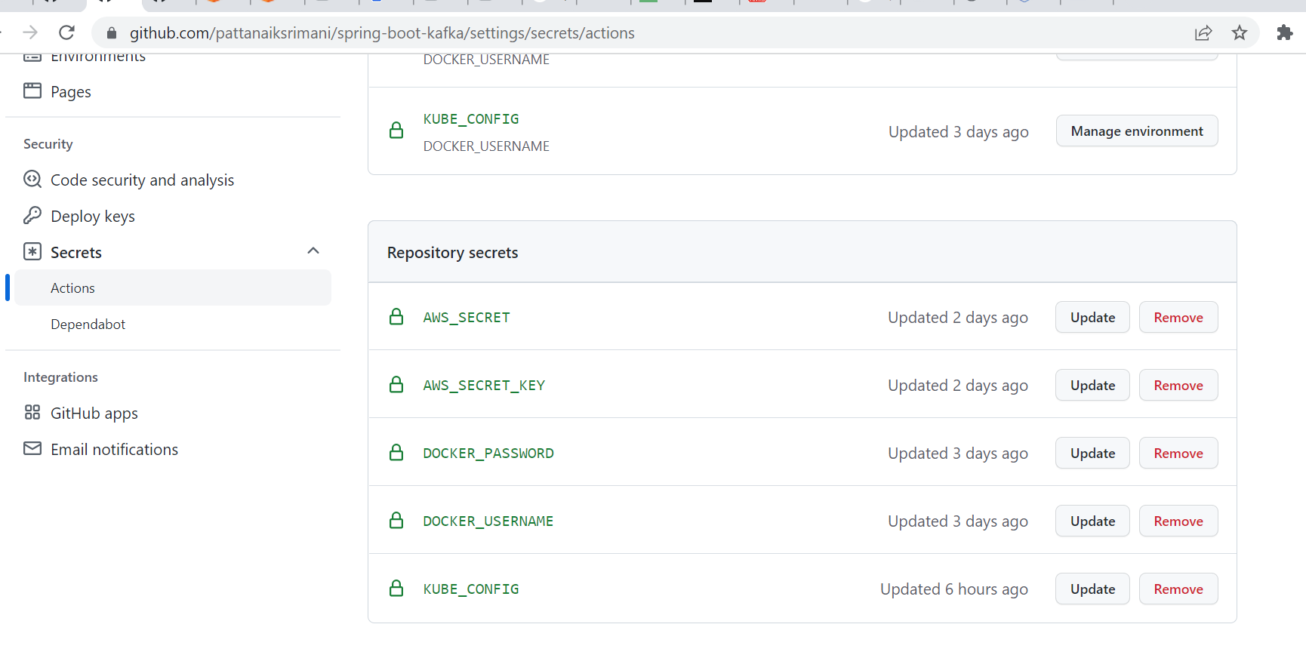

For kube_config get the value by running the below command :

PS C:\Users\srpattan> aws eks update-kubeconfig --region <region name> --name <eks cluster name >

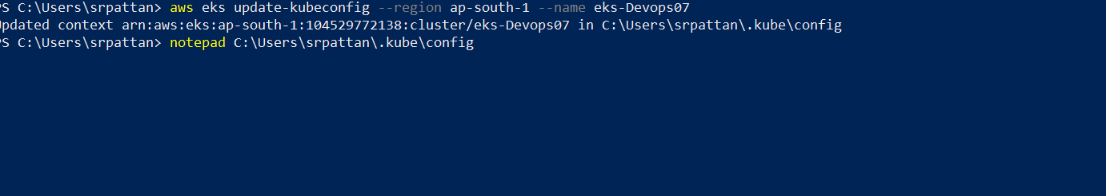

Open the content notepad to KUBE_CONFIG secret

2) We are assuming here the EKS cluster is present and node is also created :

3)Go to git hub do the changes in the below file : <https://github.com/pattanaiksrimani/sre-demo/blob/main/.github/workflows/deploy.yaml>

Change the EKS values for 3 apps (front,back and reader ):

aws-region: ap-south-1

cluster-name: ekd-Devops07

chart-path: springboot/

config-files: front-values.yaml

name: front

namespace: 'default'

1. Then commit it then goto action to check the steps and console output :

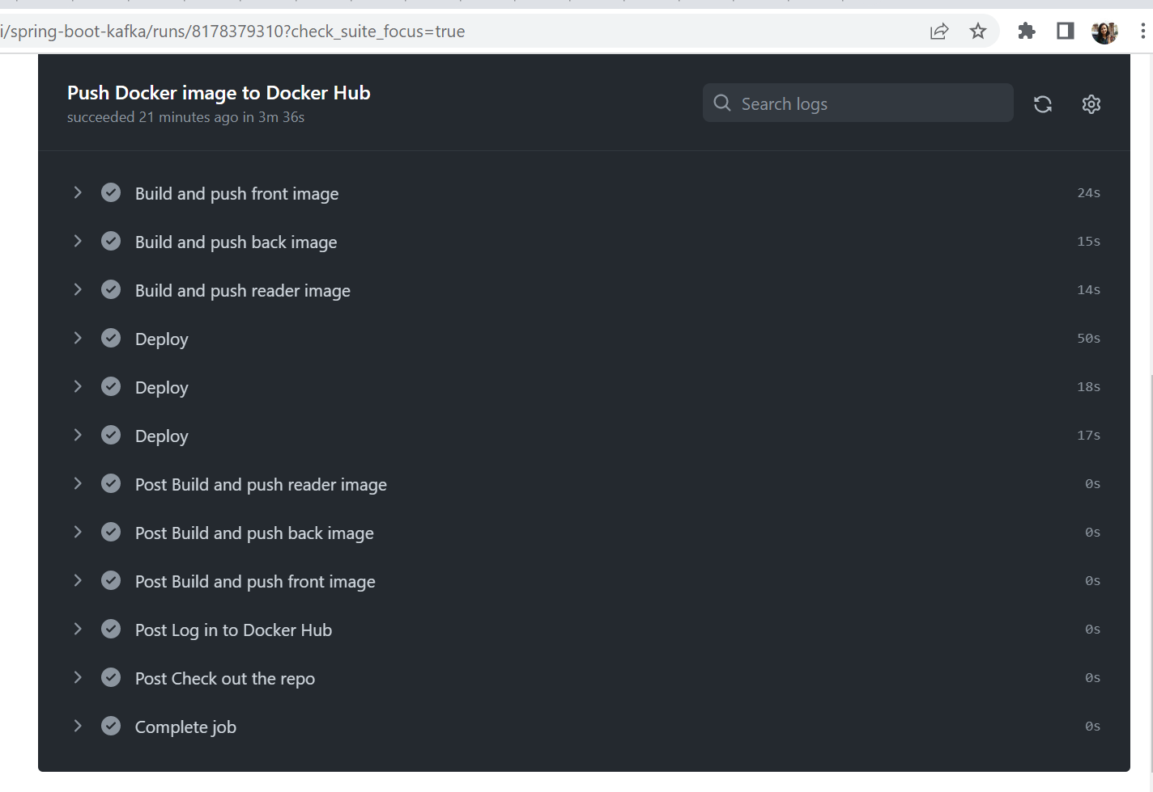

1. Once its success go to EKS cluster and check if all the pods are created 6 pods should run and required services and pvc also should created

Issue :

Now I am facing some issue with the 3 app pods so checking that but as time is already over I am submitting the assignment

3 pods are running that is zoo keeper ,postgres and kafka ,but 3 app pods are in same error going crashloop error :

Logs :

:: Spring Boot :: (v2.4.3)

2022-09-04 19:35:09.027 INFO 1 --- [ main] db.demo.back.BackApp$Companion : Starting BackApp.Companion using Java 11.0.16 on back-springboot-db6f6d995-87d6g with PID 1 (/app.jar started by root in /)

2022-09-04 19:35:09.031 INFO 1 --- [ main] db.demo.back.BackApp$Companion : No active profile set, falling back to default profiles: default

2022-09-04 19:35:10.786 INFO 1 --- [ main] .s.d.r.c.RepositoryConfigurationDelegate : Bootstrapping Spring Data JPA repositories in DEFAULT mode.

2022-09-04 19:35:10.867 INFO 1 --- [ main] .s.d.r.c.RepositoryConfigurationDelegate : Finished Spring Data repository scanning in 70 ms. Found 1 JPA repository interfaces.

2022-09-04 19:35:12.070 INFO 1 --- [ main] o.s.b.w.embedded.tomcat.TomcatWebServer : Tomcat initialized with port(s): 8080 (http)

2022-09-04 19:35:12.087 INFO 1 --- [ main] o.apache.catalina.core.StandardService : Starting service [Tomcat]

2022-09-04 19:35:12.088 INFO 1 --- [ main] org.apache.catalina.core.StandardEngine : Starting Servlet engine: [Apache Tomcat/9.0.43]

2022-09-04 19:35:12.195 INFO 1 --- [ main] o.a.c.c.C.[Tomcat].[localhost].[/] : Initializing Spring embedded WebApplicationContext

2022-09-04 19:35:12.196 INFO 1 --- [ main] w.s.c.ServletWebServerApplicationContext : Root WebApplicationContext: initialization completed in 3028 ms

2022-09-04 19:35:13.548 WARN 1 --- [ main] ConfigServletWebServerApplicationContext : Exception encountered during context initialization - cancelling refresh attempt: org.springframework.beans.factory.UnsatisfiedDependencyException: Error creating bean with name 'org.springframework.boot.autoconfigure.orm.jpa.HibernateJpaConfiguration': Unsatisfied dependency expressed through constructor parameter 0; nested exception is org.springframework.beans.factory.BeanCreationException: Error creating bean with name 'dataSource' defined in class path resource [org/springframework/boot/autoconfigure/jdbc/DataSourceConfiguration$Hikari.class]: Bean instantiation via factory method failed; nested exception is org.springframework.beans.BeanInstantiationException: Failed to instantiate [com.zaxxer.hikari.HikariDataSource]: Factory method 'dataSource' threw exception; nested exception is org.springframework.boot.autoconfigure.jdbc.DataSourceProperties$DataSourceBeanCreationException: Failed to determine a suitable driver class

2022-09-04 19:35:13.552 INFO 1 --- [ main] o.apache.catalina.core.StandardService : Stopping service [Tomcat]

2022-09-04 19:35:13.587 INFO 1 --- [ main] ConditionEvaluationReportLoggingListener :

Error starting ApplicationContext. To display the conditions report re-run your application with 'debug' enabled.

2022-09-04 19:35:13.615 ERROR 1 --- [ main] o.s.b.d.LoggingFailureAnalysisReporter :

***************************

APPLICATION FAILED TO START

***************************

Description:

Failed to configure a DataSource: 'url' attribute is not specified and no embedded datasource could be configured.

Reason: Failed to determine a suitable driver class

Action:

Consider the following:

If you want an embedded database (H2, HSQL or Derby), please put it on the classpath.

If you have database settings to be loaded from a particular profile you may need to activate it (no profiles are currently active).

PS C:\Users\srpattan>

I am checking that but as time given is over this is my work so far

|  |
| --- |
|  |
|  |  |
|  |  |
|  |  |
|  |  |
|  |  |