# Home Automation using Packet Tracer

**A Project Work**

Submitted in the partial fulfillment for the award of the degree of

**BACHELOR OF ENGINEERING**

**IN**

**CSE IBM IS-1**

**Submitted by:**

**Ashutosh Pattanayak**

**17BCS3545**

**Under the Supervision of:**

**Mr. Aman Kaushik**



**APEX INSITUTE OF TECHNOLOGY**

**CHANDIGARH UNIVERSITY, GHARUAN, MOHALI**

**140413, PUNJAB**

**DECLARATION**

I, **‘Ashutosh Pattanayak’**, student of **‘Bachelor of Engineering in BE CSE IS’**, **session: 2019 - 2020**, Apex Institute of Technology, Chandigarh University, Punjab, hereby declare that the work presented in this Project Work entitled **‘**[**Home Automation Using Cisco Packet Tracer**](https://circuitdigest.com/microcontroller-projects/arduino-medicine-reminder)’ is the outcome of our own bona fide work and is correct to the best of our knowledge and this work has been undertaken taking care of Engineering Ethics. It contains no material previously published or written by another person nor material which has been accepted for the award of any other degree or diploma of the university or other institute of higher learning, except where due acknowledgment has been made in the text.

**Ashutosh Pattanayak**

**17BCS3545**

**Date: 01/06/20**

**Place: Chandigarh University**

**CERTIFICATE**

This is to certify that the work embodies in this dissertation entitled **‘**[**Home Automation Using Cisco Packet Tracer**](https://circuitdigest.com/microcontroller-projects/arduino-medicine-reminder)**’** being submitted by **‘Ashutosh Pattanayak’** **17BCS3545** for partial fulfillment of the requirement for the award of **‘Bachelor of Engineering in BE CSE IS’** discipline to Apex Institute of Technology, Chandigarh University, Punjab during the academic year 2019 - 2020 is a record of bonafide piece of work, undertaken by him/her the supervision of the undersigned.

**Approved and Supervised by**

Signature of Supervisor

**(Supervisor's Name)**

**Designation, Department**

**Forwarded by**

**Professor & Head of Department**

**EXTERNAL EXAMINER**

**Signature of External Examiner**

**(External Examiner's Name)**

# Table of Contents

|  |  |  |
| --- | --- | --- |
|  | Title Page | i |
|  | Declaration of the Student | ii |
|  | Certificate of the Guide | iii |
|  | Abstract | iv |
|  | Acknowledgement | v |
|  |  |  |
|  |  |  |
|  |  |  |
| **1.** | **INTRODUCTION\*** | **1** |
|  | * 1. Problem Definition   2. Project Overview/Specifications   3. Hardware Specification   4. Software Specification | 1  2  3  4  4 |
| **2.** | **LITERATURE SURVEY** | **5** |
|  | * 1. Existing System   2. Proposed System | 5  6  7 |
| **3.** | **SYSTEM ANALYSIS & DESIGN** |  |
|  | * 1. Requirement Specification   2. Flowcharts / DFDs / ERDs   3. Design and Test Steps / Criteria   4. Algorithms and Pseudo Code   5. Testing Process   … | 9  10  12  16  18  19  22  27 |
| **4.** | **RESULTS / OUTPUTS** | **40** |
| **5.** | **CONCLUSIONS / RECOMMENDATIONS** | **47** |
| **6.** | **REFERENCES** | **49** |

**ABSRTRACT**

In the era of technological development today, without realizing that the technology has become a need that is often used for the life of today's society. Where almost all areas have been able to feel from the development of such technology, as in the field of computer network electronics. In this case, the need for home technology is increasingly required to make a smart home, where during this time in the control of electronic devices at home is done through the switch on or off switch. Previously some smart home development has been done in monitoring or controlling electronic devices that are in the household but can only monitor or control on one electronic device only and the transmission media is done still using SMS gateway and Bluetooth, so we can not maximize in creating or building a smart home system is good in monitoring or controlling electronic devices that are in the household. Smart Home is an application of a combination of technology and services devoted to the home environment with specific functions aimed at improving the safety, efficiency, and comfort of its inhabitants. In the smart home system usually consists of monitoring tools, control devices and automatic there are several devices that can be accessed using a computer or smartphone connected to the Internet network.

**1.INTRODUCTION**

**1.1 Problem Definition**

Many of us are away from our homes throughout the day whether be it for work purpose or running errands. Some of us usually spend a day out or even leave our house unaccounted for a couple of days leaving our electronic appliances without any monitoring or control. And due to human errors we sometimes leave devices plugged into the power sockets and some devices need to work automatically depending on the environment. All devices need individual attention time to time to operate. If some devices not operated properly could consume electricity causing higher bills or damage/ harm the room environment. So, I propose to design an internet based home automation system that will enable us to remotely manage our appliances from anywhere around the world.

**1.2 Project Overview**

The Home Automation is a wireless home automation system that is supposed to be implemented in existing home environments, without any changes in the infrastructure. Home Automation let the user to control the home from his or her computer and assignations that should happen depending on time or other sensor readings such as light, temperature or sound from any device in the Home Automation network

Home automation can help us :-

* by remotely monitoring and controlling our appliances.
* by improving home safety
* by alerting any emergency
* by saving and utilizing proper electricity according to the requirement.

**1.3 Hardware specification**

a) To simulate the program using packet tracer

* CPU: Intel Pentium 4, 2.53 GHz or equivalent.
* OS: Microsoft Windows 7, 8.1, 10, Linux Ubuntu 18.04. 3 LTS (Ubuntu 16.04 oand 14.04 LTS are no longer supported)
* RAM: 2 GB

b) To deploy smart home using IoT devices

* Home Gateway device
* Ethernet Cable
* Coaxial Cable
* Siren
* Gas & fire detector
* Smartphone
* Cable Modem

**1.4 SOFTWARE SPECIFICATION**

1. Cisco Packet Tracer

Packet Tracer is a cross-platform visual simulation tool designed by Cisco Systems that allows users to create network topologies and imitate modern computer networks. The software allows users to simulate the configuration of Cisco routers and switches using a simulated command line interface. Currently cisco released new version of packet tracer that includes:-

1. Offers a realistic simulation and visualization of IOT device
2. Permits users to design, build, configure smart home, smart city by providing different smart object used for them.
3. Provide board to control smart object
4. Allows students to explore concepts IOE
5. Provide detector for sensor

**2.LITERATURE SURVEY:**

**2.1 Existing System: -** Earlier home automation were used to be powered using supply and an Arduino chip, various sensors and relay module by creating a circuit that’d be autonomous to the change in the environment. Arduino is an open-source platformused for building electronics projects. ... Unlike most previous programmable circuit boards, the Arduino does not need a separate piece of hardware (called a programmer) in order to load new code onto the board.

**2.2 Proposed System**

In Project done using software and hardware that is designed its performance and done testing to make the application by configuring and testing of network systems by designing the concept of smart home using the IoT home gateway as the media path that connects multiple wireless devices wirelessly and provides automatic addressing to devices connected to the home gateway, where all devices connect to the smartphone as an interface medium for controlling and monitoring electronic devices. Based on the development of smartphones today already has the presentation of advanced features and also has the ability to support the development of computer networking devices that make it a necessity in humans. For that purpose, efforts are made to increase the needs of households to facilitate the use and control of all electronic devices by using remote or remote control, where devices that can be controlled using smart home technology such as lighting devices, access door, fan and various electronic devices others that can be activated or not activated using a smartphone through the home gateway computer network.

In recent years, wireless systems like Wi-Fi have become more and more common in-home networking. Also, in home and building automation systems, the use of wireless technologies gives several advantages that could not be achieved using a wired network only. We can get:-

1) Reduced installation costs: First and foremost, installation costs are significantly reduced since no cabling is necessary. Wired solutions require cabling, where material as well as the professional laying of cables (e.g. into walls) is expensive.

2) System scalability and easy extension: Deploying a wireless network is especially advantageous when, due to new or changed requirements, extension of the network is necessary. In contrast to wired installations, in which cabling extension is tedious. This makes wireless installations a seminal investment.

3) Aesthetical benefits: Apart from covering a larger area, this attribute helps to full aesthetical requirements as well. Examples include representative buildings with all-glass architecture and historical buildings where design or conservatory reasons do not allow laying of cables.

4) Integration of mobile devices: With wireless networks, associating mobile devices such as PDAs and Smartphones with the automation system becomes possible everywhere and at any time, as a device's exact physical location is no longer crucial for a connection (as long as the device is in reach of the network).

For all these reasons, wireless technology is not only an attractive choice in renovation and refurbishment, but also for new installations.

**3. SYSTEM ANALYSIS AND DESIGN:-**

**3.1 Requirements Specification**

* Intel Pentium 4, 2.53 GHz or above
* Microsoft Windows 7 and above
* 2 GB RAM
* 1.4 GB of free disk space.

**3.2 Design**

To implement smart home using cisco packet tracer I used different sensor, smart device and detector to make smarter. The following figure represent the home architecture that connected each other using wireless and wired medium.

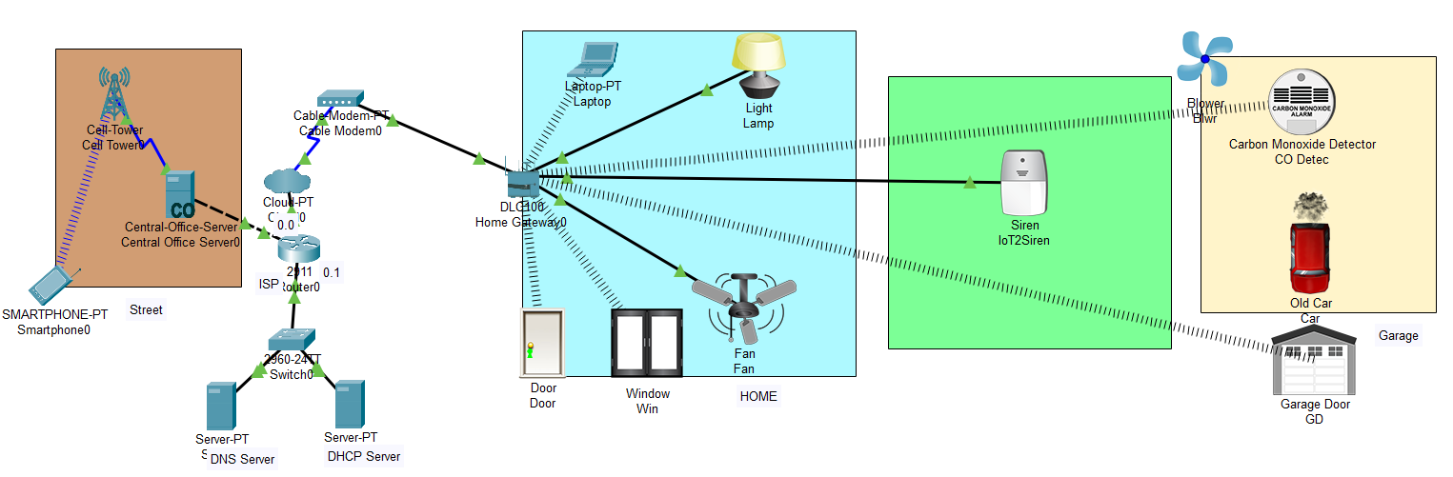

Fig 3.2 Home Network on CPT

**Devices Used**

* Internet of Things
* Internet of Everything
* 3G/4G Network Client
* Cable Modem Client
* Internet Service Provider
* Smart phone
* Server Devices
* Routers
* Modem
* Ethernet Cables
* Home Gateway
* Webcam
* Fan
* Lights
* Garage door
* CO detecter
* Blower
* Car
* Sire

**3.2.1 Home Gateway**

Home Gateway have 4 Ethernet ports in addition to a wireless access point configured with the "Home Gateway" SSID (see fig 2).To secure wireless connection WEP / WPA-PSK / WPA2

enterprise can be configured on home gateway. The figure 2 shows seven internet of Things device connected to a Home Gateway by using Ethernet cable and wireless. To connect the Home Gateway to the Internet its Internet WAN Ethernet port available on home getaway. The IoE device can be remotely managed through a web interface hosted by the Home Gateway. The Home Gateway internal (LAN) IP address is 192.168.25.1 but it can also be accessed through its Internet facing IP address.

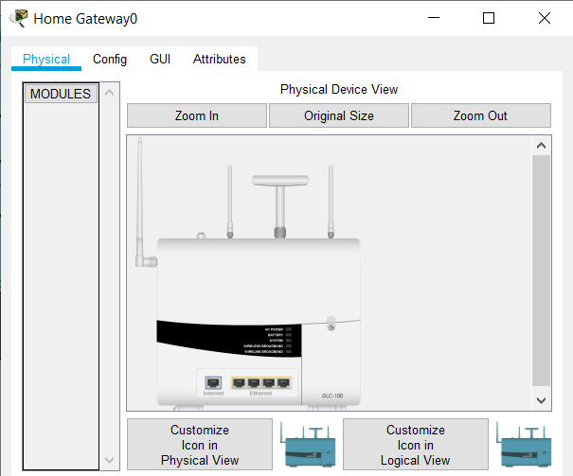

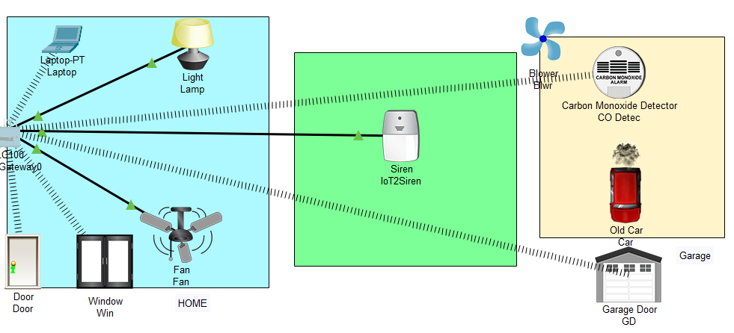

The smart object is connected to the home Gateway using Ethernet cable and wireless medium to manage smart device local and remotely. Home gateway also works as

DHCP server by assigning IP address to each smart device that connected to it.

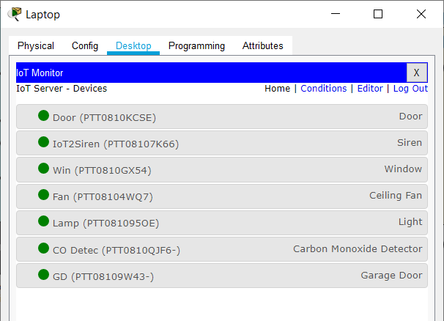

The figure shows six internet of Things device connected to a Home Gateway by using Ethernet cable and wireless. To connect the Home Gateway to the Internet its Internet WAN Ethernet port available on home getaway. The IoE device can be remotely managed through a web interface hosted by the Home Gateway. The Home Gateway internal (LAN) IP address is 192.168.25.1 but it can also be accessed through its Internet facing IP address.

The above figure shows after registering smart device to home gateway all devices are accessed through web by legitimate user. There are six IOE device registered to Home gateway those all are controlled through web by legitimate person.

* 1. **Algorithm and Pseudo Code**

**Device Configuration and Setup:**

**ISP Router Configuration**

**Assigning hostname and Ip address for ISP router**

Router>

Router>enable

Router#conf terminal

Router(config)#hostname ISP

ISP(config)#intgigabitEthernet 0/2

ISP(config-if)#ip address 10.10.220.1 255.255.255.0

ISP(config-if)#no shutdown

ISP(config)#intgigabitEthernet 0/0

ISP(config-if)#ip address 209.165.200.225 255.255.255.224

ISP(config-if)#no shutdown

ISP(config)#intgigabitEthernet 0/1

ISP(config-if)#ip address 209.165.201.225 255.255.255.224

ISP(config-if)#no shutdown

Configurating dhcp server for cell and IOE device

ISP(config)#ipdhcp excluded-address 209.165.201.225 209.165.201.230

ISP(config)#ipdhcp pool cell

ISP(dhcp-config)#network 209.165.201.225 255.255.255.224

ISP(dhcp-config)#default-router 209.165.201.225

ISP(dhcp-config)#dns-server 10.10.220.10

ISP(config)#ipdhcp excluded-address 209.165.200.225 209.165.200.230

ISP(config)#ipdhcp pool ioe

ISP(dhcp-config)#network 209.165.200.224 255.255.255.224

ISP(dhcp-config)#default-router 209.165.200.225

ISP(dhcp-config)#dns-server 10.10.220.10

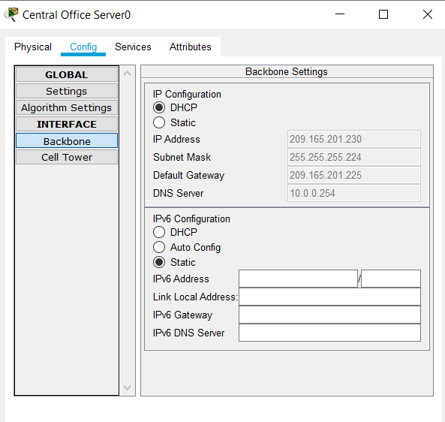

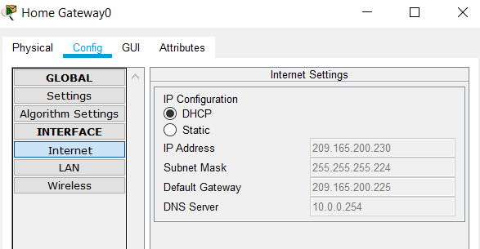

* 1. **Testing Process**

1. Use IoT monitor on smartphone to use all appliances.
2. Login to the IoT remote server.

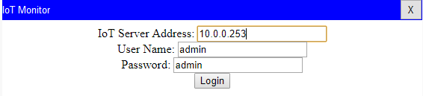

1. Monitor it

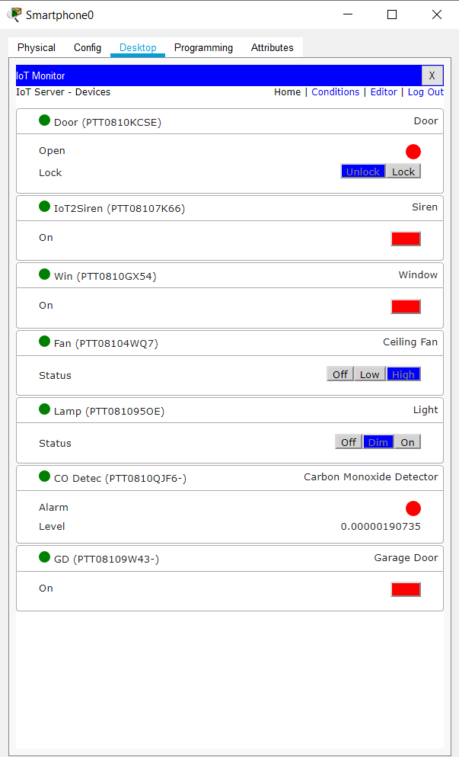

1. Home

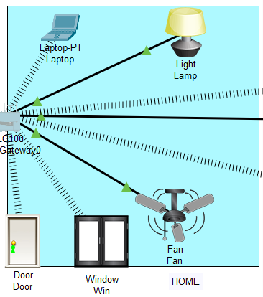

* Door opened and closed remotely
* When enter through door light switches on automatically.
* Window opened and closed remotely
* When window is opened fan turns on low mode automatically.
* Fan can be controlled remotely
* Light brightness can be controlled.
* Laptop can also be used to monitor and control all IOT devices

1. Garage

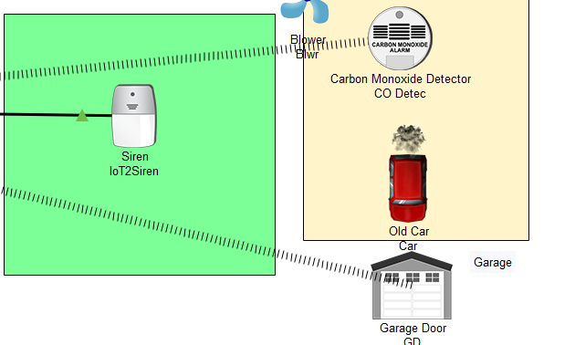

* Garage can be opened and closed remotely.
* Car if produces smoke CO detector can monitor it.
* If CO level rises more than 0.05 then Siren is alerted
* Also blower starts running

1. Street

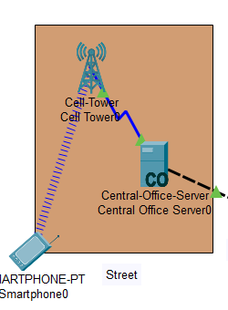

* Can use smartphone to control and monitor appliances
* Can use smartphone to lock the doors and windows

**4.RESULTS/OUTPUT:**

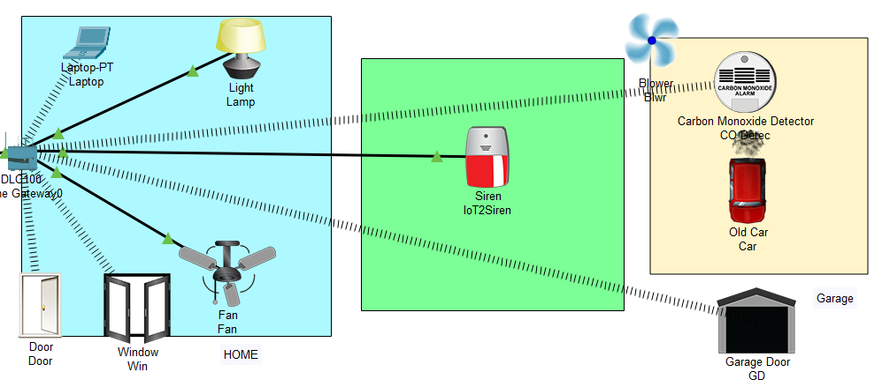

The figure above shows the light is on , the fan is moving at high speed , the door is unlocked , the siren is on , the window is open, blower is on, garage door is open and car is in garage releasing gas. This is based on the conditions made on the Home Gateway that the legitimate user is able to control the brightness of light (off , dim , on) , control fan speed (off , medium , high) , control door (lock , unlock) , control window (open , close) and blower speed (high, low, off) , Garage door ( unlocked, locked) , Carbon Mono Detector ( on, off) .

After the successful connection to the server, the data of sensor are sent to the web server for monitoring of the system. the web server page which will allow us to monitor and control the system. By entering the assigned IP address in the web browser this web server page will appear. The web server gives the information about the temperature in different places of the house and motion state in the house. It also gives the status of the various electrical appliances like light, fan etc which we can control remotely

**5.CONCLUSIONS / RECOMMENDATIONS**:

In building a smart home automated network we can simulate it using a Cisco package tracker and learn or know how to configure the network and connect multiple electronic devices to connect to each other over the wireless network, in addition, to set up some electronic devices based on their condition. set on smartphones With this simulation, design and implementation planning can be done in building smart home network using IoT home gate and there is a possibility that this simulation can be applied in real world based on current technology development, thus making it a necessity for community life which potency can improve energy efficiency , reducing energy use costs, controlling electronic devices and changing the role of occupants. we conclude that IoT has a great future and in the next five years, it is going to revolutionize the world. IoT is like clay that can be moulded in any way we wish, if provided with enough skills and expertise.

The home automation using Internet of Things has been experimentally proven to work satisfactorily by connecting simple appliances to it and the appliances were successfully controlled remotely through internet. The designed system not only monitors the sensor data, like temperature, gas, light, motion sensors, but also actuates a process according to the requirement, for example switching on the light when it gets dark. It also stores the sensor parameters in the webpage (database) in a timely manner. This will help the user to analyse the condition of various parameters in the home anytime anywhere

**6. References**

[1] Chattoraj, Subhankar. "Smart Home Automation based on different sensors and Arduino as the master controller." International Journal of Scientific and Research Publications5.10 (2015): 1-4.

[2] Soliman, Moataz, et al. "Smart home: Integrating internet of things with web services and cloud computing." Cloud Computing Technology and Science (CloudCom), 2013 IEEE 5th International Conference on. Vol. 2. IEEE, 2013

[3] S. Haller S. Karnouskos and C. Schroth "The Internet of Things in an Enterprise Context " in Future Internet-FIS 2008 Lecture Notes in Computer Science Vol. 5468 2009 pp 14-28.

[4] Jie, Yin, et al. "Smart home system based on iot technologies." Computational and Information Sciences (ICCIS), 2013 Fifth International Conference on. IEEE, 2013

[5] <http://www.packettracernetwork.com/>

[6] Qin, X. U. E. "Simulation Experimental Teaching of Computer Network Based on Packet Tracer [J]." Research and Exploration in Laboratory 2 (2010): 57-59.

[7] <http://www.packettracernetwork.com/internet-ofthings/pt7-iot-devicesconfiguration.htm>

[8] Sun, Liangxu, et al. "Comparison between physical devices and simulator software for Cisco network technology teaching." Computer Science & Education (ICCSE), 2013 8th International Conference on. IEEE, 2013.