AI Agent

Document Control
Property | Value
ABB ID | AB-130
ABB Name | AI Agent
Version | 1.0.0
Status | Preliminary
Category | Agentic

1. ABB Overview

1.1 Definition
ABB Name: AI Agent
Short Name: AGT
Category: Agentic
Description:
A platform-agnostic, autonomous AI agent that executes tasks using LLM-based reasoning, tool invocation, memory access, and structured workflows. Represents the deployable unit of agentic AI functionality, independent of the underlying hosting platform or development framework.

1.2 Purpose and Rationale
Business Purpose:
Enable the creation and deployment of specialized AI agents that can autonomously perform domain-specific tasks, reducing manual effort and accelerating business processes. Each agent encapsulates business logic, tool access, and reasoning capabilities for a specific use case or domain, regardless of the underlying technology platform.
Technical Purpose:
Provide a standardized, vendor-agnostic specification for individual AI agents that can be implemented across multiple hosting platforms and development frameworks. This ABB defines the logical agent capabilities independent of:
- Hosting Platforms: AWS AgentCore, Microsoft Azure AI Agent Service, Microsoft Copilot Studio, Google Vertex AI Agent Builder, or self-hosted solutions.
- Development Frameworks: LangGraph, Strands, AutoGen, Semantic Kernel, CrewAI, or proprietary frameworks.
- Runtime Languages: Python, TypeScript/JavaScript, C#/.NET, Java, or others.
Key Responsibilities:
- Execute autonomous reasoning loops using LLM-based inference.
- Invoke tools from the Tool Registry to perform actions.
- Persist and retrieve context from the Agent Memory System.
- Manage conversation state and task progress.
- Report execution status, metrics, and audit events.
- Handle errors, retries, and graceful degradation.

1.3 Scope
In Scope:
- Agent runtime execution and lifecycle.
- LLM prompt construction and response parsing.
- Tool invocation and result handling.
- Memory read/write operations (short-term and long-term).
- State management within agent execution.
- Error handling and retry logic.
- Metrics and telemetry emission.
- Support for ReAct (Reasoning + Acting), Plan-and-Execute, and custom reasoning patterns.
Out of Scope:
- Agent orchestration across multiple agents (handled by Agent Orchestrator AB-001).
- Tool implementation and registration (handled by Tool Registry AB-002).
- Memory storage infrastructure (handled by Agent Memory System AB-003).
- LLM model hosting and inference (handled by LLM Service AB-050).
- Human approval workflows (handled by Human-in-the-Loop Gateway AB-008).
- Agent versioning and deployment (handled by Agent Versioning Manager AB-010).

2. Functional Specification

2.1 Core Capabilities
Capability ID | Capability Name | Description | Priority
CP-105 | Agent Orchestration | Coordinate agent execution. | Must Have
CP-107 | Agent Memory | Short and long-term agent memory. | Must Have
CP-109 | Tool Use | Agents invoke external tools and APIs. | Must Have
CP-111 | Multi-Step Reasoning | Logical inference across steps. | Must Have
CP-115 | Agent Specialization | Domain-specific expert agents. | Should Have
CP-117 | Guardrails | Safety boundaries for agent actions. | Must Have
CP-119 | State Management | Maintain execution state. | Must Have

2.2 Functional Requirements
Primary Functions:
Requirement ID | Requirement | Description | Acceptance Criteria
FR-001 | LLM Reasoning Loop | Execute iterative reasoning using LLM inference. | Agent successfully completes multi-turn reasoning to achieve goal.
FR-002 | Tool Invocation | Call registered tools with proper parameters. | Tools invoked correctly with validated inputs and outputs parsed.
FR-003 | Memory Integration | Read/write to short-term and long-term memory. | Context persisted and retrieved correctly across interactions.
FR-004 | State Persistence | Maintain agent state across execution steps. | State recoverable after interruption or failure.
FR-005 | Error Handling | Handle tool failures, LLM errors, and timeouts. | Graceful degradation with appropriate error responses.
FR-006 | Guardrail Enforcement | Enforce safety boundaries on actions and outputs. | Blocked actions logged, user notified of guardrail triggers.
FR-007 | Telemetry Emission | Emit metrics, traces, and audit logs. | All execution steps traceable in observability platform.
FR-008 | Framework Compatibility | Support multiple agent frameworks. | Agents deployable using LangGraph, Strands, AutoGen, Semantic Kernel, CrewAI, or platform-native frameworks.
FR-009 | Platform Portability | Deploy across multiple hosting platforms. | Agent logic portable between AWS AgentCore, Azure AI Agent Service, Copilot Studio, and self-hosted environments.

2.3 Non-Functional Requirements
Category | Requirement | Target | Rationale
Performance | Single step latency | <2s p95 (excluding LLM inference) | Responsive agent execution
Performance | End-to-end task completion | <30s for simple tasks, <5min for complex | User experience
Scalability | Concurrent executions | 1000+ per agent type | Handle peak load
Availability | Uptime SLA | 99.9% | Business continuity
Security | Data encryption | TLS 1.3 in transit, AES-256 at rest | Compliance
Compliance | Data residency | Australia/New Zealand only | Regulatory requirement
Reliability | Task completion rate | >95% for well-defined tasks | Quality of service
Maintainability | Deployment frequency | Multiple daily deployments | CI/CD agility

3. Integration Specification

3.1 Dependencies
Upstream Dependencies (ABBs this building block depends on):
ABB ID | ABB Name | Dependency Type | Description
AB-050 | Large Language Model Service | Required | LLM inference for agent reasoning
AB-002 | Tool Registry | Required | Discovery and invocation of available tools
AB-003 | Agent Memory System | Required | Short-term and long-term memory storage
AB-004 | Planning Module | Optional | Strategic planning for complex tasks
AB-006 | Reflection Module | Optional | Self-critique and learning
AB-080 | Knowledge Base | Optional | Domain knowledge retrieval
AB-051 | Vector Database | Optional | Semantic search for RAG patterns
Downstream Consumers (ABBs that depend on this building block):
ABB ID | ABB Name | Dependency Type | Description
AB-001 | Agent Orchestrator | Required | Orchestrates multiple AI Agents
AB-007 | Multi Agent Communication Bus | Optional | Inter-agent messaging
AB-008 | Human in the Loop Gateway | Optional | Human approval integration
AB-009 | Agent Cost Monitor | Required | Cost tracking per agent
AB-096 | Observability Platform | Required | Monitoring and tracing
AB-065 | Audit Trail and Logging | Required | Audit logging for compliance

3.2 Interfaces
Input Interfaces:
Interface ID | Interface Name | Protocol | Data Format | Description
IF-IN-001 | Agent Invocation API | REST/gRPC | JSON | Receives task requests with goal, context, and constraints
IF-IN-002 | Streaming Input | WebSocket | JSON | Receives streaming input for interactive sessions
IF-IN-003 | Event Trigger | Kafka/EventBridge | Avro/JSON | Receives event-driven invocation triggers
IF-IN-004 | Orchestrator Callback | gRPC | Protobuf | Receives instructions from Agent Orchestrator
Output Interfaces:
Interface ID | Interface Name | Protocol | Data Format | Description
IF-OUT-001 | Task Response API | REST/gRPC | JSON | Returns task results, status, and artifacts
IF-OUT-002 | Streaming Output | WebSocket/SSE | JSON | Streams intermediate results and reasoning steps
IF-OUT-003 | Agent Events | Kafka | Avro | Publishes execution events for observability
IF-OUT-004 | Tool Invocation | REST/gRPC | JSON | Calls tools via Tool Registry
IF-OUT-005 | Memory Operations | REST/gRPC | JSON | Read/write to Agent Memory System

3.3 Data Contracts
Input Data:
# Agent invocation request schema
agent_invocation_request:
type: object
properties:
invocation_id:
type: string
format: uuid
description: "Unique identifier for this invocation"
agent_id:
type: string
description: "Identifier of the agent to invoke"
agent_version:
type: string
description: "Semantic version of the agent"
goal:
type: string
description: "Natural language description of the task goal"
context:
type: object
properties:
conversation_id:
type: string
description: "ID for conversation continuity"
user_id:
type: string
description: "Requesting user identifier"
session_context:
type: object
description: "Session-specific context data"
domain_context:
type: object
description: "Domain-specific input data"
constraints:
type: object
properties:
max_steps:
type: integer
description: "Maximum reasoning steps allowed"
max_tokens:
type: integer
description: "Maximum tokens to consume"
timeout_seconds:
type: integer
description: "Maximum execution time"
allowed_tools:
type: array
items:
type: string
description: "Whitelist of permitted tools"
require_human_approval:
type: array
items:
type: string
description: "Actions requiring human approval"
required:
- invocation_id
- agent_id
- goal
Output Data:
# Agent invocation response schema
agent_invocation_response:
type: object
properties:
invocation_id:
type: string
description: "Matching invocation identifier"
status:
type: string
enum: [completed, failed, pending_approval, timeout, cancelled]
description: "Execution status"
result:
type: object
properties:
output:
type: string
description: "Final output/answer from the agent"
artifacts:
type: array
items:
type: object
description: "Generated artifacts (files, data, etc.)"
confidence:
type: number
description: "Agent's confidence in the result (0-1)"
execution_trace:
type: array
items:
type: object
properties:
step_number:
type: integer
action:
type: string
enum: [think, tool_call, memory_read, memory_write, respond]
details:
type: object
timestamp:
type: string
format: date-time
duration_ms:
type: integer
metrics:
type: object
properties:
total_duration_ms:
type: integer
llm_calls:
type: integer
tokens_consumed:
type: integer
tools_invoked:
type: integer
memory_operations:
type: integer
estimated_cost_usd:
type: number
error:
type: object
properties:
code:
type: string
message:
type: string
recoverable:
type: boolean

4. Quality Attributes

4.1 Performance Characteristics
Metric | Target | Measurement Method
Latency (p50) | <500ms per step | APM tracing
Latency (p95) | <2s per step | APM tracing
Throughput | 100 req/s per agent instance | Load testing
Error Rate | <1% | Error monitoring

4.2 Reliability Requirements
Attribute | Requirement | Recovery Strategy
Availability | 99.9% | Multi-AZ deployment, auto-scaling
Durability | State persisted | Checkpoint to Agent Memory System
Recovery Time (RTO) | < 5 minutes | Automatic restart, state recovery
Recovery Point (RPO) | < 30 seconds | Frequent state checkpointing

4.3 Security Requirements
Security Control | Requirement | Implementation Guidance
Authentication | mTLS + API keys | Service mesh with certificate rotation
Authorization | RBAC per agent/tool | Policy engine integration
Encryption at Rest | AES-256 | KMS-managed keys
Encryption in Transit | TLS 1.3 | Certificate pinning
Audit Logging | All actions logged | Integration with AB-065
Input Validation | Strict schema validation | JSON Schema validation
Output Sanitization | PII detection and masking | Integration with AB-114

5. Governance

5.1 Ownership and Accountability
Role | Responsibility | Contact
Architecture Owner | Strategic direction, design decisions | AI Platform Architecture Team
Technical Owner | Implementation, maintenance | AI Engineering Team
Operations Owner | Day-to-day operations, monitoring | Platform Operations Team

5.2 Lifecycle Management
Phase | Activities | Exit Criteria
Design | Agent specification, capability mapping | Design approved
Build | Framework selection, agent code development | Testing complete
Deploy | Container packaging, platform deployment | Production validated
Operate | Monitoring, tuning, incident response | Ongoing
Retire | Migration, deprecation notice | Replacement deployed

5.3 Change Management
Change Categories:
- Minor: Prompt tuning, configuration changes (no approval required)
- Standard: New tool integrations, capability additions (team approval)
- Major: Framework changes, security model updates (architecture board approval)

6. Solution Building Block Options

6.1 Agent Hosting Platforms
Note: This ABB can be implemented on multiple hosting platforms. The choice depends on existing cloud strategy, integration requirements, and organizational preferences.
Platform | Vendor | Deployment Model | Key Strengths | Considerations
AWS AgentCore | AWS | PaaS | Native AWS integration, Strands framework support, built-in memory and tools | AWS-centric, newer service
Azure AI Agent Service | Microsoft | PaaS | Enterprise integration, Azure OpenAI, .NET ecosystem | Azure-centric
Microsoft Copilot Studio | Microsoft | SaaS/Low-Code | Rapid development, M365 integration, business user friendly | Less flexibility for custom logic
Google Vertex AI Agent Builder | Google | PaaS | Gemini models, GCP integration | Google-centric
Amazon Bedrock Agents | AWS | SaaS | Fully managed, quick setup, Bedrock model access | Limited customization
Self-Hosted (Kubernetes) | Open Source | Self-Managed | Full control, multi-cloud, no vendor lock-in | Operational overhead

6.2 Agent Development Frameworks
Framework | Vendor/Project | Primary Language | Platform Compatibility | Maturity | Best For
LangGraph | LangChain | Python, TypeScript | AgentCore, Azure, Self-hosted | Mature | Complex stateful workflows, graph-based agents
Strands | AWS | Python | AgentCore (native) | Emerging | AWS-native agents, AgentCore optimization
AutoGen | Microsoft | Python | Azure, Self-hosted, AgentCore | Emerging | Multi-agent conversations, research
Semantic Kernel | Microsoft | C#, Python, Java | Azure (native), Self-hosted | Mature | .NET enterprise, Copilot extensions
CrewAI | CrewAI | Python | Self-hosted, AgentCore | Emerging | Role-based multi-agent teams
Copilot Studio | Microsoft | Low-Code | Copilot Studio (native) | Mature | Business users, M365 integration
Bedrock Agents | AWS | Config/SDK | Bedrock (native) | Mature | Quick deployment, managed service

6.3 Language and Runtime Support
Language | Supported Frameworks | Platform Support | Notes
Python 3.11+ | LangGraph, Strands, AutoGen, CrewAI, Semantic Kernel | All platforms | Primary recommendation, richest ecosystem
TypeScript/Node.js | LangGraph.js, Vercel AI SDK | AgentCore, Azure, Self-hosted | Web-native, streaming-focused
C#/.NET 8+ | Semantic Kernel | Azure (native), Self-hosted | Enterprise .NET, Copilot extensions
Java 17+ | Semantic Kernel (Java) | Self-hosted | Enterprise Java ecosystem
Low-Code | Copilot Studio, Power Automate | Copilot Studio | Business user development

6.4 Candidate SBBs
SBB ID | SBB Name | Platform | Framework | Recommendation
SBB-130-001 | LangGraph on AgentCore | AWS AgentCore | LangGraph | Recommended (AWS)
SBB-130-002 | Strands on AgentCore | AWS AgentCore | Strands | Recommended (AWS-native)
SBB-130-003 | Semantic Kernel on Azure | Azure AI Agent Service | Semantic Kernel | Recommended (Azure/.NET)
SBB-130-004 | AutoGen on Azure | Azure AI Agent Service | AutoGen | Alternative (Multi-agent)
SBB-130-005 | Copilot Studio Agent | Microsoft Copilot Studio | Low-Code | Recommended (Low-code/M365)
SBB-130-006 | LangGraph Self-Hosted | Kubernetes | LangGraph | Alternative (Multi-cloud)
SBB-130-007 | Bedrock Agent | AWS Bedrock | Bedrock Native | Alternative (Managed)
SBB-130-008 | CrewAI on AgentCore | AWS AgentCore | CrewAI | Alternative (Team agents)

6.5 Platform Selection Criteria
Criterion | Weight | AWS AgentCore | Azure AI Agent | Copilot Studio | Self-Hosted
Functionality | 25% | 5 | 5 | 3 | 5
Enterprise Integration | 20% | 4 | 5 | 5 | 3
Flexibility | 20% | 4 | 4 | 2 | 5
Operational Overhead | 15% | 4 | 4 | 5 | 2
Cost Efficiency | 10% | 4 | 4 | 4 | 3
Security/Compliance | 10% | 5 | 5 | 5 | 4
Weighted Total | 100% | 4.3 | 4.4 | 3.7 | 3.8

7. Traceability

7.1 Capability Mapping
Capability ID | Capability Name | Description | Level | How This ABB Supports
CP-105 | Agent Orchestration | Coordinate agent execution | L2 | Provides the executable agent unit that orchestrators coordinate
CP-107 | Agent Memory | Short and long-term agent memory | L2 | Integrates with memory system for context persistence
CP-109 | Tool Use | Agents invoke external tools and APIs | L2 | Executes tool invocations as part of reasoning
CP-111 | Multi-Step Reasoning | Logical inference across steps | L2 | Implements reasoning loops (ReAct, Plan-Execute)
CP-115 | Agent Specialization | Domain-specific expert agents | L2 | Enables domain-specific agent implementations
CP-117 | Guardrails | Safety boundaries for agent actions | L2 | Enforces guardrails during execution
CP-119 | State Management | Maintain execution state | L2 | Manages internal state throughout task execution

7.2 Pattern Usage
Pattern ID | Pattern Name | Description | Role in Pattern
PT-007 | Agentic AI Pattern | Enable autonomous AI agents for complex tasks | Primary - The core executable agent
PT-008 | Multi-Agent Orchestration | Coordinate multiple specialized agents | Component - Individual agent within multi-agent system
PT-021 | Autonomous Operations | Self-managing AI operations | Component - Autonomous task executor

7.3 Use Case Support
Use Case ID | Use Case Name | Description | How This ABB Supports
UC-001 | FrontLine - Partnership Banking | GenAI-driven relationship management | RM Copilot agent for meeting prep and client insights
UC-002 | Finance | Financial report generation | Finance automation agent for report creation
UC-007 | Contact Centre | Customer service automation | Customer service agent for query resolution
UC-010 | SDLC | Developer productivity | Code assistant agent for development tasks
UC-016 | IT Ops | IT operations automation | IT support agent for ticket routing and resolution
UC-018 | Procurement | Procurement automation | Procurement agent for vendor and contract management
UC-019 | Payment Disputes | Dispute processing | Dispute resolution agent for case handling

8. Implementation Guidance

8.1 Agent Development Lifecycle
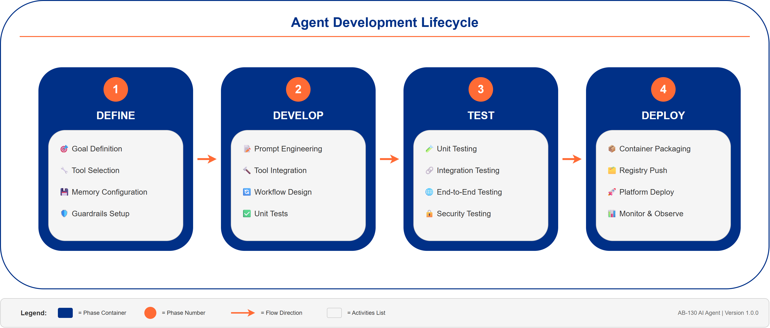
Figure 8.1: Agent Development Lifecycle showing the four phases from Definition to Deployment

8.2 Agent Structure Examples
The following examples illustrate agent implementation patterns across different frameworks. All examples are illustrative and should be adapted to specific requirements.

8.2.1 Python/LangGraph (AWS AgentCore, Azure, Self-Hosted)
# LangGraph agent structure - illustrative only
from langgraph.graph import StateGraph, END
from typing import TypedDict
class AgentState(TypedDict):
messages: list
context: dict
tools_called: list
memory: dict
class BNZAgent:
"""Base class for BNZ AI Agents using LangGraph"""
def __init__(self, agent_id: str, config: AgentConfig):
self.agent_id = agent_id
self.config = config
self.llm = self._init_llm()
self.tools = self._load_tools()
self.memory = self._init_memory()
self.graph = self._build_graph()
def _build_graph(self) -> StateGraph:
"""Build the agent execution graph"""
graph = StateGraph(AgentState)
graph.add_node("reason", self.reason)
graph.add_node("act", self.act)
graph.add_node("reflect", self.reflect)
graph.add_conditional_edges(...)
return graph.compile()
async def invoke(self, goal: str, context: dict) -> AgentResult:
"""Execute the agent with given goal and context"""
state = AgentState(
messages=[{"role": "user", "content": goal}],
context=context,
tools_called=[],
memory=await self.memory.load(context.get("session_id"))
)
result = await self.graph.ainvoke(state)
return self._format_result(result)

8.2.2 C#/Semantic Kernel (Azure AI Agent Service)
// Semantic Kernel agent structure - illustrative only
using Microsoft.SemanticKernel;
using Microsoft.SemanticKernel.Agents;
public class BNZAgent
{
private readonly Kernel _kernel;
private readonly ChatCompletionAgent _agent;
public BNZAgent(string agentId, AgentConfig config)
{
_kernel = Kernel.CreateBuilder()
.AddAzureOpenAIChatCompletion(config.ModelId, config.Endpoint, config.ApiKey)
.Build();
_agent = new ChatCompletionAgent
{
Name = agentId,
Instructions = config.SystemPrompt,
Kernel = _kernel,
Arguments = new KernelArguments(new PromptExecutionSettings { })
};
// Register tools as kernel functions
_kernel.ImportPluginFromType<ToolRegistry>();
}
public async Task<AgentResult> InvokeAsync(string goal, AgentContext context)
{
var chat = new AgentGroupChat(_agent);
chat.AddChatMessage(new ChatMessageContent(AuthorRole.User, goal));
await foreach (var response in chat.InvokeAsync())
{
// Process streaming response
}
return FormatResult(chat);
}
}

8.2.3 Python/Strands (AWS AgentCore Native)
# Strands agent structure - illustrative only
from strands import Agent, tool
from strands.models import BedrockModel
@tool
def search_knowledge_base(query: str) -> str:
"""Search the knowledge base for relevant information"""
# Tool implementation
pass
class BNZStrandsAgent(Agent):
"""BNZ Agent using AWS Strands framework"""
def __init__(self, agent_id: str, config: AgentConfig):
model = BedrockModel(model_id=config.model_id)
super().__init__(
model=model,
system_prompt=config.system_prompt,
tools=[search_knowledge_base],
memory=config.memory_config
)
async def execute(self, goal: str) -> AgentResult:
response = await self(goal)
return self._format_result(response)

8.2.4 Low-Code (Microsoft Copilot Studio)
For Copilot Studio agents, configuration is done through the visual designer:
- Topics: Define conversation flows and triggers
- Actions: Connect to Power Automate flows, APIs, or custom connectors
- Knowledge Sources: Link SharePoint, Dataverse, or custom knowledge bases
- Generative AI: Enable orchestrated responses with GPT models

8.3 Deployment Models

8.3.1 Platform-Agnostic Architecture
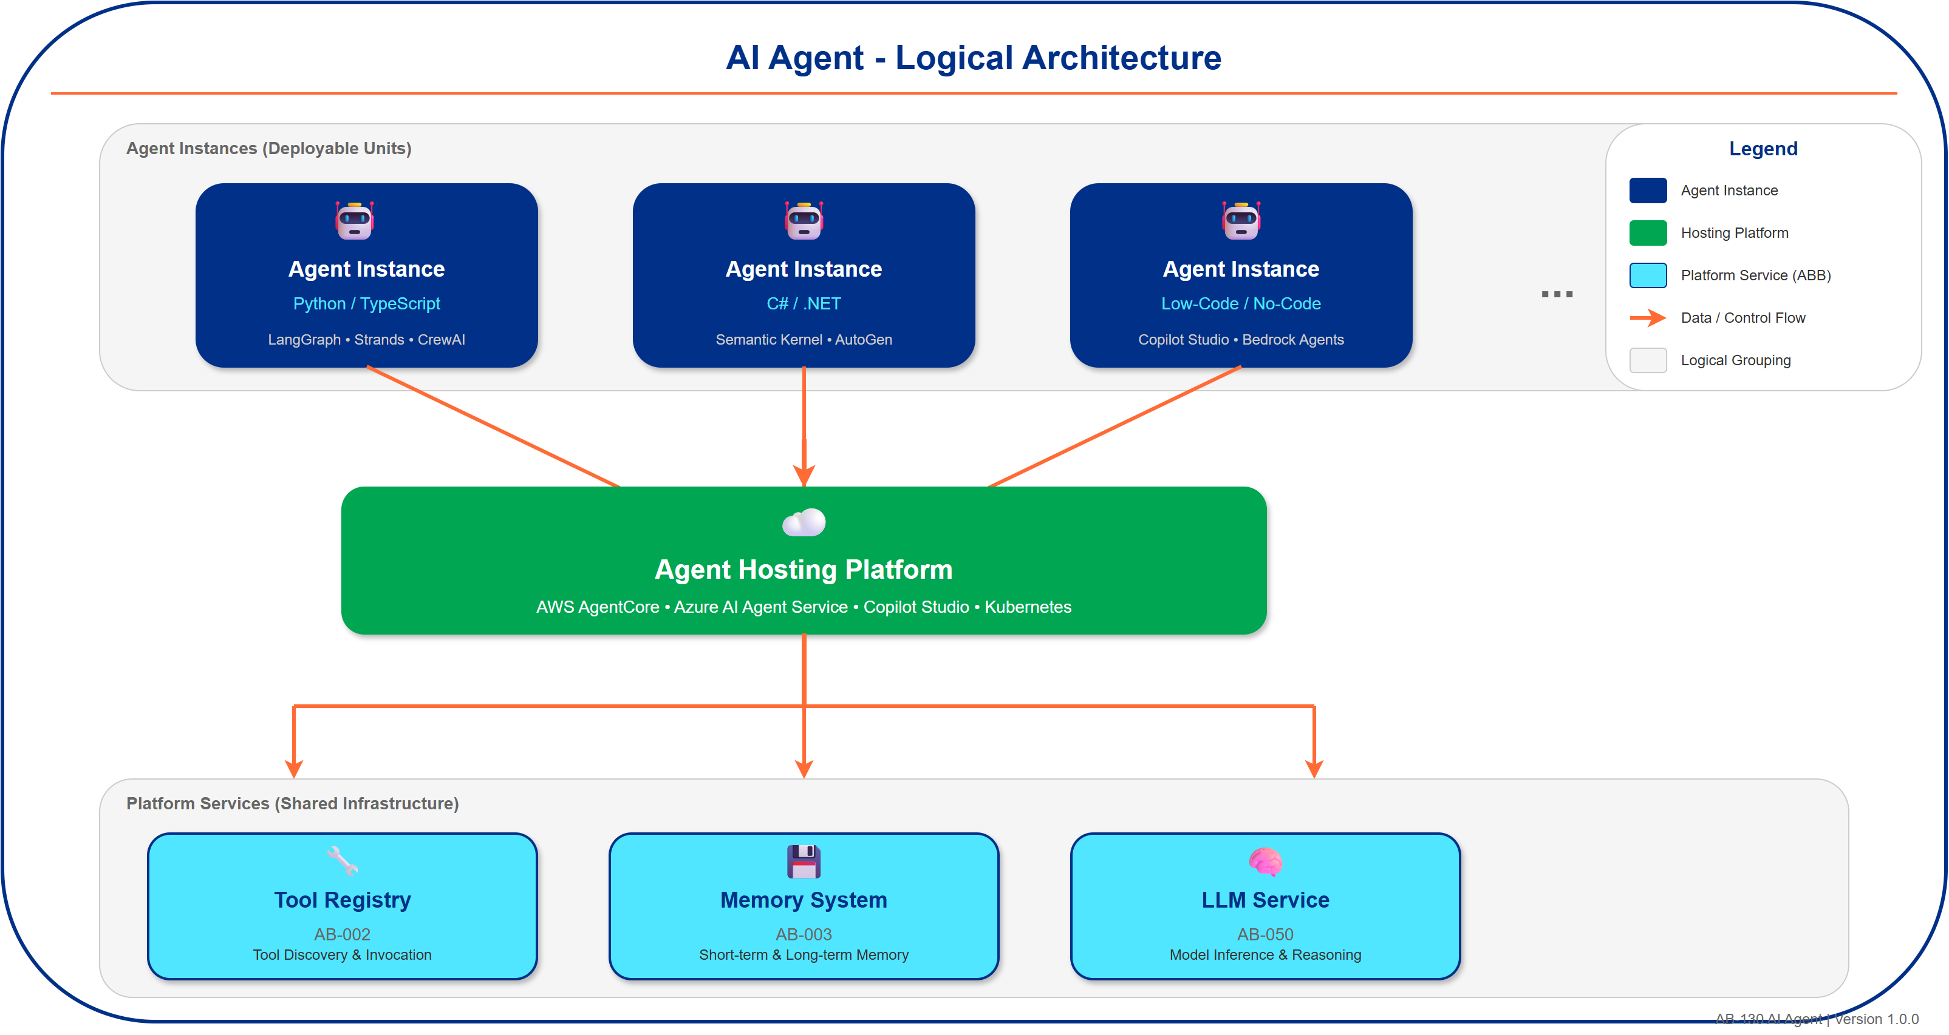
Figure 8.2: AI Agent Logical Architecture showing agent instances, hosting platform, and platform services

8.3.2 Platform-Specific Deployments
Platform | Compute | Memory | Tools | LLM
AWS AgentCore | ECS Fargate/Lambda | DynamoDB/Redis | MCP Servers | Bedrock
Azure AI Agent | Azure Functions/AKS | Cosmos DB/Redis | Azure Functions | Azure OpenAI
Copilot Studio | Microsoft Managed | Dataverse | Power Automate | Azure OpenAI
Self-Hosted | Kubernetes | PostgreSQL/Redis | REST APIs | Any LLM

9. References

9.1 Related Documents
- AB-001 Agent Orchestrator - Orchestrates multiple AI Agents
- AB-002 Tool Registry - Tool discovery and invocation
- AB-003 Agent Memory System - Memory persistence
- AB-050 Large Language Model Service - LLM inference
- PT-007 Agentic AI Pattern - Agentic design pattern

9.2 External References
Hosting Platforms:
- AWS AgentCore Documentation
- Azure AI Agent Service
- Microsoft Copilot Studio
- Google Vertex AI Agent Builder
- Amazon Bedrock Agents
Development Frameworks:
- LangGraph Documentation
- AWS Strands Agents SDK
- Microsoft Semantic Kernel
- Microsoft AutoGen
- CrewAI Documentation
Research & Best Practices:
- Anthropic Agent Patterns
- ReAct Paper - Reasoning and Acting in Language Models
- Microsoft AI Agents Overview

Appendix A: Glossary
Term | Definition
ABB | Architecture Building Block - a vendor-agnostic logical component that defines required capabilities.
Agent | An autonomous AI system that perceives its environment, reasons about goals, and takes actions.
AgentCore | AWS service for hosting and managing AI agents with built-in memory, tools, and observability.
AutoGen | Microsoft framework for building multi-agent conversational AI systems.
Azure AI Agent Service | Microsoft Azure platform for deploying and managing AI agents.
Copilot Studio | Microsoft low-code platform for building conversational AI agents with M365 integration.
Guardrail | Safety boundary that constrains agent actions to prevent harmful or unauthorized behavior.
LangGraph | Framework for building stateful, multi-step agent applications using graph-based workflows.
ReAct | Reasoning and Acting pattern where agents alternate between thinking and taking actions.
SBB | Solution Building Block - a specific technology implementation of an ABB.
Semantic Kernel | Microsoft SDK for integrating LLMs into applications with support for agents, memory, and plugins.
Strands | AWS-native agent framework optimized for AgentCore deployment.
Tool | A function or API that an agent can invoke to perform actions or retrieve information.

Appendix B: Revision History
Version | Date | Author | Changes
1.0.0 | 2025-12-12 | AI Platform Architecture | Initial version

