Data Mesh Pattern

Document Control
Property | Value
Pattern ID | PT-012
Pattern Name | Data Mesh Pattern
Version | 1.0.0
Status | Approved
Created Date | 2025-12-05
Last Modified | 2025-12-07
Owner | BNZ Enterprise Architecture
Pattern Category | Data
Maturity Level | Emerging

1. Pattern Overview

1.1 Pattern Name and Classification
Pattern Name: Data Mesh Pattern
Short Name: Data Mesh
Pattern Category: Data
Pattern Type: Data Architecture, Organizational

1.2 Intent and Context
Intent Statement:
Enable domain-oriented decentralized data ownership with federated governance, treating data as a product to improve discoverability, quality, and accessibility across the enterprise.
Problem Statement:
Traditional centralized data architectures (data lakes, data warehouses) create bottlenecks where a central data team becomes overwhelmed with requests from multiple business domains. This results in:
- Long lead times for data access (weeks to months)
- Data quality issues (central team lacks domain context)
- Data silos (domains can't access each other's data)
- Scaling challenges (central team can't keep up with demand)
- Limited domain autonomy (domains dependent on central team)
Context:
Large enterprises with multiple business domains (Retail Banking, Corporate Banking, Wealth Management) face challenges when attempting to centralize all data responsibilities. The Data Mesh pattern shifts from a centralized model to a decentralized approach where domain teams own and publish their data as products, while a platform team provides self-serve infrastructure and federated governance ensures consistency.
Forces:
- Domain Autonomy vs. Governance: Domains need freedom to move quickly, but enterprise needs consistent standards
- Speed vs. Quality: Fast data access vs. ensuring high data quality and compliance
- Centralization vs. Decentralization: Central control provides consistency, but creates bottlenecks
- Technical Complexity vs. Usability: Sophisticated platforms vs. easy-to-use tools for domain teams
- Cost vs. Scalability: Infrastructure costs increase with decentralization, but scalability improves

1.3 Pattern Maturity and Industry Adoption
Maturity Level: Emerging
Industry Adoption:
- Adoption Rate: Approximately 30-40% of large enterprises in financial services have begun data mesh initiatives as of 2025
- Reference Implementations:
  - JPMorgan Chase (enterprise data mesh implementation across banking divisions)
  - ING Bank (domain-oriented data products for retail and corporate banking)
  - Zalando (e-commerce data mesh with 100+ data products)
- Timeframe: Evolved from concept (2019) to experimental implementations (2022-2024) to production pattern (2025)
Standards Alignment:
- TOGAF 10: Domain-oriented architecture
- SAFe: Decentralized decision-making with centralized alignment
- DAMA-DMBOK: Data governance and data quality frameworks
- ISO 8000 Data Quality Standard
- GDPR and data privacy regulations (data ownership accountability)

2. Architecture Specification

2.1 Architecture Building Blocks (ABBs)
Primary ABBs (Core components required):
ABB ID | ABB Name | Purpose in Pattern | Criticality
AB-043 | Data Product Catalog | Centralized discovery of all data products with SLAs, schemas, and metadata | Critical
AB-044 | Domain Data Platform | Self-serve tools and infrastructure enabling domains to build and publish data products | Critical
AB-011 | API Gateway | Unified access layer for consuming data products via REST, GraphQL, SQL, Kafka | Critical
AB-018 | Data Quality Validator | Automated batch data quality checks and validation | High
AB-070 | Data Lineage Tracker | Track data origin, transformations, and dependencies | High
AB-104 | Data Quality Monitor | Real-time data quality monitoring, health, uptime, and latency tracking | High
Supporting ABBs (Optional or scenario-specific):
ABB ID | ABB Name | Purpose in Pattern | When Required
AB-045 | Data Contract Registry | Formal agreements between data producers and consumers | When multiple consumers depend on same data product
AB-038 | Data Lake | Scalable storage for domain-owned structured and unstructured data | For large-scale data storage
AB-039 | Data Versioning Service | Version management and history for data products | When data versioning is required
Cross-Cutting ABBs (Always required):
ABB ID | ABB Name | Purpose
AB-060 | AI Governance Platform | Compliance, risk management, audit for data products
AB-112 | Security & Identity | Authentication, authorization, encryption for data access
AB-096 | Observability Platform | Monitoring, logging, alerting for data product health

2.2 Pattern Structure
Architectural Diagram:
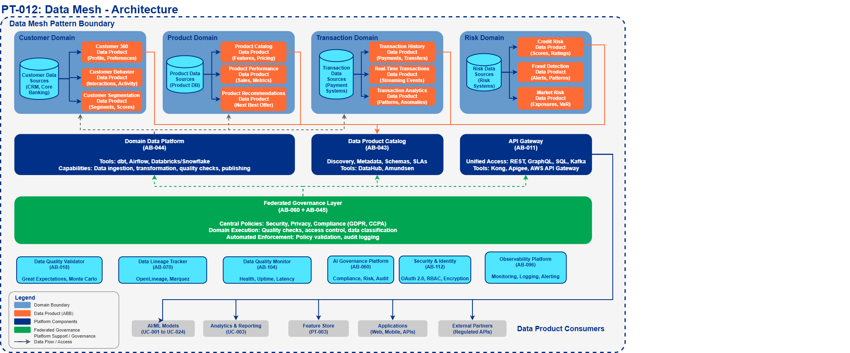
Component Interaction Flow:
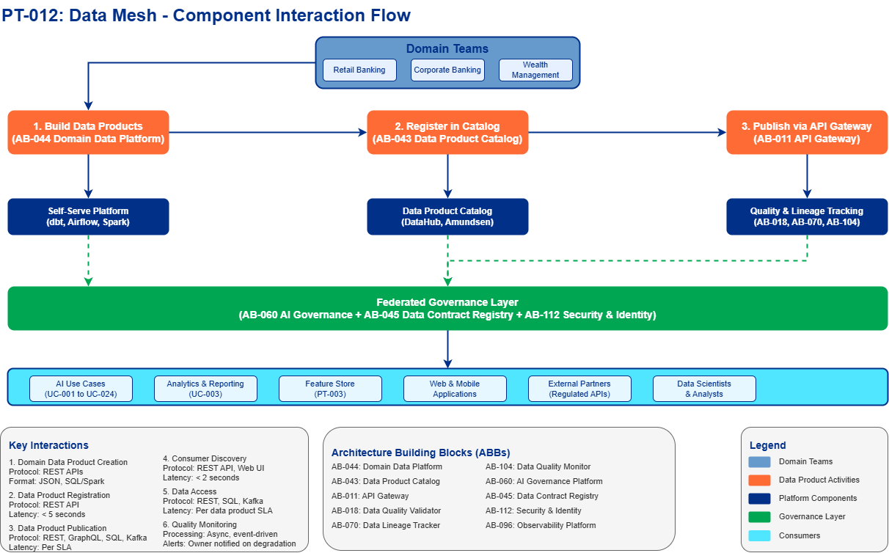
Key Interactions:
- Domain Data Product Creation: Domain team builds data product using self-serve platform
  - Protocol: Internal platform APIs (REST)
  - Data Format: JSON configuration, SQL/Spark transformations
  - Latency Target: N/A (asynchronous process)
- Data Product Registration: Data product registered in catalog with metadata
  - Protocol: REST API to Data Product Registry
  - Data Format: JSON (schema, SLA, ownership, lineage)
  - Latency Target: < 5 seconds
- Data Product Publication: Data product exposed via API Gateway for consumption
  - Protocol: REST, GraphQL, SQL, or Kafka (based on data product type)
  - Data Format: JSON, Parquet, Avro, CSV (domain-defined)
  - Latency Target: Based on SLA (batch: hours, streaming: seconds)
- Consumer Discovery: Consumers search catalog and subscribe to data products
  - Protocol: REST API, Web UI
  - Data Format: JSON metadata
  - Latency Target: < 2 seconds for search results
- Data Access: Consumers query/subscribe to data products
  - Protocol: REST API, SQL, Kafka streams
  - Data Format: JSON, Parquet, Avro (per data product spec)
  - Latency Target: Per data product SLA (e.g., < 100ms for API, < 1 hour for batch)
- Quality Monitoring: Automated checks validate data quality continuously
  - Processing Type: Asynchronous, event-driven
  - Error Handling: Alert data product owner, mark product as degraded in catalog

2.3 Data Flow
Data Sources:
- Domain Operational Systems: Customer databases, transaction systems, CRM (owned by domain)
- External Data Feeds: Market data, credit bureau data, third-party APIs
- Enterprise Data Lakes: Historical data repositories (transitioned to domain ownership)
Data Transformations:
- Domain Data Ingestion: Raw data → Domain staging area (Extract)
  - Performed by domain team using self-serve platform tools (Airflow, dbt, Spark)
- Data Product Curation: Staging data → Clean, validated, documented data product (Transform)
  - Data quality checks applied (completeness, accuracy, timeliness)
  - Business logic applied (calculations, aggregations, joins)
  - Schema standardization and documentation
- Data Product Publishing: Curated data → Published interface (Load)
  - Exposed via API Gateway or streaming platform
  - Metadata registered in catalog
Data Sinks:
- Data Product API: REST/GraphQL endpoints for synchronous access
- Data Product Stream: Kafka topics for real-time consumption
- Data Product Database: SQL interface for analytical queries
- Data Product Files: S3/ADLS files for batch processing
Data Governance:
- Classification: Defined by domain team (Public / Internal / Confidential / Restricted)
- Retention: Per data product policy (e.g., 7 years for financial transactions)
- Lineage: Tracked from source system → transformations → data product → consumers
- Quality: Automated checks defined in data product specification (99% completeness, < 1 hour latency, etc.)
- Ownership: Clear accountability (domain team owns data product lifecycle)
- Access Control: Role-based access control (RBAC) enforced at API Gateway

2.4 Interface Specifications
Inbound Interfaces (Inputs to pattern):
Interface ID | Interface Name | Type | Protocol | Data Format | SLA
IF-IN-001 | Domain Data Source | Database Connection | JDBC/ODBC | SQL | Per domain system
IF-IN-002 | External Data Feed | API / File Transfer | REST / SFTP | JSON / CSV | Per vendor SLA
IF-IN-003 | Data Product Configuration | API | REST | JSON | < 5s registration
Outbound Interfaces (Outputs from pattern):
Interface ID | Interface Name | Type | Protocol | Data Format | SLA
IF-OUT-001 | Data Product API | REST API | HTTPS | JSON | Per data product SLA (e.g., < 100ms, 99.9% uptime)
IF-OUT-002 | Data Product Stream | Event Stream | Kafka | Avro / JSON | < 1s latency, 99.9% availability
IF-OUT-003 | Data Product SQL Interface | SQL Query | TLS | Parquet / ORC | < 5s for queries, 99% uptime
IF-OUT-004 | Data Product Metadata | Catalog API | REST | JSON | < 2s search, 99.9% uptime
Internal Interfaces (Between ABBs within pattern):
Interface ID | Source ABB | Target ABB | Protocol | Purpose
IF-INT-001 | AB-044 Domain Data Platform | AB-043 Data Product Catalog | REST | Register new data product
IF-INT-002 | AB-018 Data Quality Validator | AB-043 Data Product Catalog | REST | Update quality metrics
IF-INT-003 | AB-070 Data Lineage Tracker | AB-043 Data Product Catalog | REST | Publish lineage metadata
IF-INT-004 | AB-011 API Gateway | AB-038 Data Lake | JDBC / REST | Proxy data access requests
IF-INT-005 | AB-104 Data Quality Monitor | AB-043 Data Product Catalog | REST | Update health status

3. Pattern Variants and Options

3.1 Pattern Variations
Variant 1: Centralized Data Mesh (Hybrid)
- When to Use: Transitioning from centralized data warehouse to data mesh
- Key Differences: Central platform team also acts as a domain for shared/enterprise data products (e.g., customer golden record)
- Trade-offs:
  - Gain: Easier migration path, leverages existing central team expertise
  - Lose: Still creates some central team bottleneck, less pure decentralization
Variant 2: Federated Data Mesh
- When to Use: Mature organizations with strong domain teams and clear boundaries
- Key Differences: Fully decentralized with minimal central platform team (infrastructure-only)
- Trade-offs:
  - Gain: Maximum domain autonomy, fastest time-to-market for data products
  - Lose: Risk of inconsistency without strong governance, higher learning curve for domains
Variant 3: Event-Driven Data Mesh
- When to Use: Real-time data products are primary use case (streaming analytics, fraud detection)
- Key Differences: Data products primarily exposed as Kafka streams rather than APIs/databases
- Trade-offs:
  - Gain: Low latency (milliseconds), event-driven architecture alignment
  - Lose: More complex for batch consumers, requires stream processing expertise

3.2 Composition with Other Patterns
Commonly Combined With:
Pattern | Integration Point | Combined Benefit
PT-003 Feature Store | Data products feed feature store as high-quality, curated data sources | Enables ML teams to discover and consume domain data products as features
PT-001 Enterprise AI Governance | Governance policies applied to data products via federated governance layer | Ensures data products meet compliance, privacy, and risk requirements
PT-007 Real-Time Streaming | Streaming data products published via Kafka, consumed by real-time ML models | Enables low-latency AI use cases (fraud detection, personalization)
PT-005 MLOps Pipeline | ML models consume data products for training/inference; model predictions published as data products | Creates closed-loop ML system with traceable data lineage
Anti-Patterns (What NOT to do):
- Anti-Pattern 1: Data Mesh Without Governance
  - Why Problematic: Leads to ungoverned data chaos, compliance violations, inconsistent quality
  - Better Approach: Implement federated governance from day one with clear policies
- Anti-Pattern 2: Central Team Building All Data Products
  - Why Problematic: Defeats the purpose of data mesh; recreates central bottleneck
  - Better Approach: Central team builds platform and standards; domains build data products
- Anti-Pattern 3: No Self-Serve Platform
  - Why Problematic: Domains struggle with infrastructure complexity, slow adoption
  - Better Approach: Invest in self-serve tools (dbt, Airflow, data quality frameworks) first
- Anti-Pattern 4: Over-Engineering Data Products
  - Why Problematic: Domains spend months building perfect data products that never ship
  - Better Approach: Start with "good enough" data products, iterate based on consumer feedback

4. Implementation Guidance

4.1 Key Principles
1. Domain-Oriented Ownership
- Each business domain (Retail Banking, Corporate Banking, Wealth Management) owns its data
- Domain teams are accountable for data product quality, SLAs, and consumer support
- Organizational alignment: Data product owners embedded in domain teams
2. Data as a Product
- Treat data with product thinking: discoverability, usability, quality, SLAs
- Data products have clear ownership, documentation, versioning, and deprecation policies
- Consumer-centric design: APIs, schemas, and documentation designed for ease of use
3. Self-Serve Infrastructure
- Platform team provides tools and infrastructure for domains to build data products independently
- Low barrier to entry: templates, automation, guided workflows
- Example tools: dbt for transformations, Airflow for orchestration, Great Expectations for quality
4. Federated Governance
- Decentralized execution (domains build and own data products)
- Centralized standards (enterprise-wide policies for security, privacy, quality)
- Automated policy enforcement via platform (e.g., data classification tags required)

4.2 Data Product Components
Every data product MUST include the following components:
Component | Description | Example
Data | The actual data (batch or streaming) | Customer transactions for last 24 months
SLA | Quality guarantees and commitments | 99.9% uptime, < 1 hour refresh latency, 99% completeness
API | Access mechanism(s) for consumers | REST API (JSON), SQL interface (Snowflake), Kafka stream (Avro)
Metadata | Documentation, schema, lineage, ownership | Schema: customer_id (UUID), transaction_amount (DECIMAL), Lineage: CRM DB → ETL → Data Product
Quality | Automated validation and monitoring | Great Expectations tests: no nulls in customer_id, amount > 0
Ownership | Accountable team and contact | Owner: Retail Banking Data Team, Contact: retail-data@bnz.co.nz
Access Policy | Who can consume and how | Role-based: All authenticated BNZ employees (read), Retail domain (read/write)

4.3 When to Use
Ideal Scenarios:
- Large enterprises with multiple business domains (Retail, Corporate, Wealth)
- Data silos problem: domains cannot easily access each other's data
- Centralized data warehouse/lake failing to scale (long lead times, bottlenecks)
- Need for domain autonomy with governance (regulated industries)
- High data quality requirements with domain expertise needed
Not Recommended For:
- Small organizations with single domain (< 50 people)
- Simple analytics use cases (basic reporting from single source)
- Greenfield projects with no existing data infrastructure
- Organizations without clear domain boundaries

4.4 BNZ Use Cases
Foundational Data Product (Enables all use cases):
- UC-009: Data Products - Core implementation of data mesh pattern
Primary Consumers (Direct dependency):
- UC-003: Analytics and Reporting - Consumes data products for business intelligence
- UC-006: Hyper-Personalization - Consumes customer behavior data products
- UC-010: SDLC - Consumes code quality and deployment data products
- UC-015: Risk Functions - Consumes risk data products (credit, operational, market)
Indirect Consumers (All 24 use cases):
- All AI use cases should consume data via data products, not direct database access
- Ensures consistent governance, quality, and lineage tracking
- Example: UC-001 (Partnership Banking) consumes "Customer 360" data product instead of querying 10 different databases

4.5 Implementation Components
Technology Stack (2025 Recommendations):
Data Product Catalog:
- DataHub (LinkedIn open-source) - Modern metadata platform with data lineage
- Amundsen (Lyft open-source) - User-friendly data discovery
- Alation (Commercial) - Enterprise data catalog with AI-powered search
- AWS Glue Catalog (AWS-native) - Serverless metadata repository
API Gateway:
- Kong - Open-source API gateway with plugin ecosystem
- Apigee (Google Cloud) - Enterprise API management
- AWS API Gateway - Serverless, scalable API management
Self-Serve Data Platform:
- Databricks - Unified analytics platform (Spark, Delta Lake, MLflow)
- Snowflake - Cloud data warehouse with data sharing
- AWS Lake Formation - Managed data lake with governance
- dbt - SQL-based transformation tool (infrastructure-as-code)
Data Quality:
- Great Expectations - Python-based data validation framework
- Monte Carlo - Data observability and anomaly detection
- Datafold - Data diff and quality monitoring
- Soda - Data quality testing and monitoring
Data Lineage:
- OpenLineage - Open standard for data lineage
- Marquez (open-source) - Metadata service for lineage collection
- DataHub - Includes built-in lineage tracking

4.6 Best Practices (2025)
Start Small, Expand Incrementally:
- Begin with 1-2 pilot domains (e.g., Retail Banking, Corporate Banking)
- Build 3-5 high-value data products in each domain
- Learn, refine platform and governance, then expand to more domains
Define Data Product Standards:
- SLA Template: Define minimum SLAs (uptime, latency, quality thresholds)
- Quality Checks: Standardize data quality tests (Great Expectations templates)
- API Patterns: REST API standards (versioning, pagination, error handling)
- Documentation: Required metadata (schema, lineage, examples, changelog)
Implement Federated Governance:
- Central Policies: Data classification, retention, privacy (GDPR, CCPA)
- Domain Execution: Domains apply policies to their data products
- Automated Enforcement: Platform validates compliance (e.g., PII detection, encryption)
Use Data Contracts:
- Formal agreement between data producer (domain) and consumers
- Specifies: schema, SLA, breaking change policy, support model
- Example: "Customer 360" data product guarantees schema stability for 6 months
Monitor Data Product Health:
- Track SLA compliance: uptime (99.9%), latency (< 1 hour), quality (99% completeness)
- Alert on degradation: data product owner notified within 5 minutes
- Publish health dashboard: consumers can see real-time data product status
Incentivize Data Product Ownership:
- Make data product quality part of domain team OKRs/KPIs
- Recognize high-quality data products (e.g., "Data Product of the Quarter")
- Chargeback model: Consumers pay for data product usage (aligns incentives)

4.7 Migration Strategy
Phase 1: Foundation (Months 1-3)
- Select 1-2 pilot domains
- Deploy self-serve platform (dbt, Airflow, Snowflake/Databricks)
- Deploy data product catalog (DataHub or Amundsen)
- Define data product standards and templates
Phase 2: Pilot (Months 4-6)
- Build 3-5 data products per pilot domain
- Onboard 5-10 consumers (AI use cases, analytics teams)
- Implement federated governance policies
- Deploy data quality and lineage tracking
Phase 3: Scale (Months 7-12)
- Expand to 3-5 additional domains
- Build 20-30 total data products
- Transition existing centralized data pipelines to data mesh
- Establish data product support model (domain-owned)
Phase 4: Optimize (Months 13+)
- Continuous improvement based on consumer feedback
- Advanced features: data marketplace, monetization, cross-domain data products
- Automated data product generation (AI-assisted)

5. Quality Attributes and NFRs

5.1 Performance
Metric | Target | Measurement
API Latency | < 100ms (p95) | Per data product SLA
Batch Refresh | < 1 hour | Time from source update to data product availability
Catalog Search | < 2 seconds | Time to search and retrieve data product metadata
Stream Latency | < 1 second | End-to-end latency for streaming data products

5.2 Availability
Metric | Target | Measurement
Data Product Uptime | 99.9% | Per data product SLA (measured monthly)
Catalog Availability | 99.95% | Catalog search and metadata APIs available
Platform Availability | 99.9% | Self-serve platform tools and infrastructure

5.3 Scalability
Dimension | Target | Approach
Number of Data Products | 100+ | Horizontal scaling of catalog and API gateway
Number of Consumers | 1000+ | API gateway auto-scaling, caching layer
Data Volume | 100TB+ per domain | Distributed storage (S3, ADLS), partitioning
Query Throughput | 10,000 queries/sec | Load balancing, read replicas, caching

5.4 Security
Requirement | Implementation | Standard
Authentication | OAuth 2.0, JWT tokens | Industry standard
Authorization | RBAC via API Gateway | Least privilege principle
Encryption at Rest | AES-256 | FIPS 140-2 compliant
Encryption in Transit | TLS 1.3 | Industry standard
Data Classification | Automated PII/sensitive data detection | GDPR, CCPA compliance

5.5 Data Quality
Metric | Target | Enforcement
Completeness | 99% (no missing critical fields) | Automated Great Expectations tests
Accuracy | 99% (validated against source) | Sample-based validation, anomaly detection
Timeliness | < 1 hour lag from source | SLA monitoring, alerting
Consistency | 100% (referential integrity) | Cross-domain data validation

6. Risks and Mitigations

6.1 Key Risks
Risk | Impact | Likelihood | Mitigation
Domain teams lack data engineering skills | High | High | Provide training, templates, and platform team support
Governance inconsistency across domains | High | Medium | Automated policy enforcement via platform
Data product duplication | Medium | Medium | Catalog search, discovery workshops, governance reviews
SLA violations | High | Medium | Automated monitoring, alerting, escalation process
Platform complexity | Medium | High | Simplify with low-code tools, guided workflows, templates
Cross-domain data products | Medium | Low | Clear ownership model, shared responsibility agreements

6.2 Change Management
Organizational Change:
- Shift from centralized to decentralized mindset (biggest challenge)
- Domain teams now accountable for data product quality and support
- Central team transitions from "doers" to "enablers"
Training Requirements:
- Domain teams: Data product thinking, dbt, Airflow, data quality (2-week training)
- Platform team: Infrastructure-as-code, Kubernetes, API gateway (4-week training)
- Consumers: Catalog search, API consumption, data contracts (1-day training)
Communication Plan:
- Executive sponsorship: Secure buy-in from domain leaders
- Quarterly showcases: Highlight successful data products
- Monthly community of practice: Domain teams share lessons learned

7. Success Metrics

7.1 Leading Indicators
Metric | Target | Measurement Frequency
Number of Data Products | 50 by Year 1 | Monthly
Data Product Adoption Rate | 80% of AI use cases consuming data products | Quarterly
Time to Publish Data Product | < 2 weeks (from idea to production) | Per data product
Domain Team Satisfaction | 4.0/5.0 (self-serve platform ease of use) | Quarterly survey

7.2 Lagging Indicators
Metric | Target | Measurement Frequency
Time to Data Access | Reduced from 4 weeks to < 1 week | Quarterly
Data Quality Incidents | < 5 per month across all data products | Monthly
Data Product SLA Compliance | 95% of data products meet SLA | Monthly
Consumer Satisfaction | 4.2/5.0 (data product quality and usability) | Quarterly survey

7.3 Business Outcomes
Outcome | Target | Timeframe
Reduced Time to Insights | 50% reduction in time from data request to insight | Year 1
Increased Data Reuse | 3x increase in data reuse across domains | Year 2
Cost Savings | 30% reduction in data engineering costs (via self-serve) | Year 2
AI Use Case Velocity | 2x increase in AI use cases deployed (via faster data access) | Year 1

8. References and Resources

8.1 Related Patterns
Pattern ID | Pattern Name | Relationship | Reference
PT-001 | Enterprise AI Governance | Federated governance applied to data products | PT-001-Enterprise-AI-Governance-v1.0.0.md
PT-003 | Feature Store | Data products feed feature store as curated data sources | PT-003-Feature-Store-v1.0.0.md
PT-005 | MLOps Pipeline | ML models consume data products for training/inference | TBD
PT-007 | Real-Time Streaming | Streaming data products enable real-time AI use cases | TBD

8.2 Related ABBs
ABB ID | ABB Name | Document Link
AB-043 | Data Product Catalog | AB-043-Data-Product-Catalog-v1.0.0.md
AB-044 | Domain Data Platform | AB-044-Domain-Data-Platform-v1.0.0.md
AB-011 | API Gateway | AB-011-API-Gateway-v1.0.0.md
AB-018 | Data Quality Validator | AB-018-Data-Quality-Validator-v1.0.0.md
AB-070 | Data Lineage Tracker | AB-070-Data-Lineage-Tracker-v1.0.0.md
AB-104 | Data Quality Monitor | AB-104-Data-Quality-Monitor-v1.0.0.md
AB-045 | Data Contract Registry | AB-045-Data-Contract-Registry-v1.0.0.md
AB-038 | Data Lake | AB-038-Data-Lake-v1.0.0.md
AB-060 | AI Governance Platform | AB-060-AI-Model-Registry-v1.0.0.md
AB-112 | Security & Identity | AB-112-Data-Encryption-Service-v1.0.0.md
AB-096 | Observability Platform | AB-096-Observability-Platform-v1.0.0.md

8.3 Standards and Guidelines
Internal BNZ Standards:
- BNZ Data Governance Standard (TBD)
- BNZ API Design Standard (TBD)
- BNZ Data Classification Policy (TBD)
- BNZ Visual Design Standard: 05-governance/standards/visual-design/visual-design-standard.md
Industry Standards:
- ISO 8000: Data Quality Standard
- DAMA-DMBOK: Data Management Body of Knowledge
- TOGAF 10: Enterprise Architecture Framework
- OpenLineage: Open Standard for Data Lineage
Regulatory Compliance:
- GDPR: General Data Protection Regulation
- CCPA: California Consumer Privacy Act
- RBNZ: Reserve Bank of New Zealand Data Governance Requirements

8.4 External References
Industry Research:
- Zhamak Dehghani: "Data Mesh Principles and Logical Architecture" (2024-2025 evolution) - https://martinfowler.com/articles/data-mesh-principles.html
- ThoughtWorks: "Data Mesh in Practice" Technology Radar (2025) - https://www.thoughtworks.com/radar
- Gartner: "Market Guide for Data Catalogs" (2025) - https://www.gartner.com
Technology Documentation:
- DataHub: https://datahubproject.io/
- Amundsen: https://www.amundsen.io/
- dbt: https://docs.getdbt.com/
- Great Expectations: https://greatexpectations.io/
Vendor Resources:
- Databricks: "Data Mesh Architecture on Databricks" - https://www.databricks.com/solutions/data-mesh
- Snowflake: "Building a Data Mesh with Snowflake" - https://www.snowflake.com/guides/data-mesh
- AWS: "Implementing Data Mesh on AWS" - https://aws.amazon.com/big-data/datalakes-and-analytics/data-mesh/
Books:
- "Data Mesh: Delivering Data-Driven Value at Scale" by Zhamak Dehghani (O'Reilly, 2022)
- "Fundamentals of Data Engineering" by Joe Reis and Matt Housley (O'Reilly, 2022)

Appendix A: Glossary
Term | Definition
Data Mesh | Decentralized data architecture paradigm where domain teams own and publish data as products with federated governance
Data Product | A self-contained, discoverable data asset with clear ownership, SLAs, and quality guarantees
Domain | Business capability area with clear boundaries (e.g., Retail Banking, Corporate Banking)
Federated Governance | Governance model combining centralized policies with decentralized execution
Self-Serve Platform | Infrastructure and tools enabling domain teams to build data products independently
Data Contract | Formal agreement between data producer and consumers specifying schema, SLA, and support model
SLA | Service Level Agreement: Commitment on data product quality, latency, and availability
Data Lineage | Tracking of data origin, transformations, and consumption across systems
Data Catalog | Centralized repository for discovering and understanding data products
Data Quality | Measure of data's fitness for purpose (completeness, accuracy, timeliness, consistency)

Appendix B: Change History
Version | Date | Author | Changes
1.0.0 | 2025-12-05 | BNZ Enterprise Architecture | Initial version - comprehensive Data Mesh pattern based on 2025 best practices
1.0.0 | 2025-12-07 | BNZ Enterprise Architecture | Updated ABB references from legacy ABB-DATA-### format to standard AB-### format to align with diagram

Appendix C: Review and Approval
Role | Name | Signature | Date
Pattern Author | BNZ Enterprise Architecture |  | 2025-12-05
Enterprise Architect | TBD
Security Architect | TBD
TAF | TBD

Appendix D: Implementation Checklist
Use this checklist when implementing Data Mesh pattern at BNZ:
Phase 1: Foundation
- Select 1-2 pilot domains (recommend: Retail Banking, Corporate Banking)
- Deploy self-serve data platform (Databricks or Snowflake)
- Deploy data product catalog (DataHub or Amundsen)
- Deploy data quality framework (Great Expectations)
- Define data product standards (SLA template, quality checks, API patterns)
- Define federated governance policies (classification, retention, privacy)
- Train domain teams on data product thinking and platform tools
Phase 2: Pilot
- Build 3-5 high-value data products per pilot domain
- Register data products in catalog with full metadata
- Implement automated data quality checks
- Implement data lineage tracking
- Deploy API Gateway for data product access
- Onboard 5-10 consumer use cases
- Collect feedback and iterate on platform/standards
Phase 3: Scale
- Expand to 3-5 additional domains
- Transition existing centralized pipelines to data mesh model
- Build 20-30 total data products
- Implement data product SLA monitoring and alerting
- Establish data product support model (domain-owned)
- Deploy data marketplace (optional - for discovery and billing)
Phase 4: Optimize
- Implement advanced data quality (anomaly detection, profiling)
- Implement data contracts for critical data products
- Enable cross-domain data products (shared ownership)
- Optimize costs (usage-based chargeback, resource optimization)
- Continuous improvement based on consumer satisfaction surveys
- Explore AI-assisted data product generation
Ongoing Governance
- Monthly data product health reviews
- Quarterly governance policy reviews
- Quarterly domain team community of practice
- Annual data mesh maturity assessment

