Architecture document

2024-10-08

Last modified: 2024-10-09 12:01:52 +0200

Model version : *<*[*commit id*](https://github.com/bflorat/modele-da/commits/master)*, ex: b523b6a>*

**Status**: …​

This document is made up of:

* an [application view](view-application.adoc) presenting the general context and the application architecture;
* a [development view](view-development.adoc) presenting the software architecture and its environment;
* a [sizing view](view-sizing.adoc) presenting aspects related to the performance and sizing of the infrastructure;
* an [infrastructure view](view-infrastructure.adoc) presenting the servers, middleware, operations, etc.;
* a [security view](view-security.adoc).

Each section sets out the constraints, requirements and then solutions implemented.

To be read first according to your role:

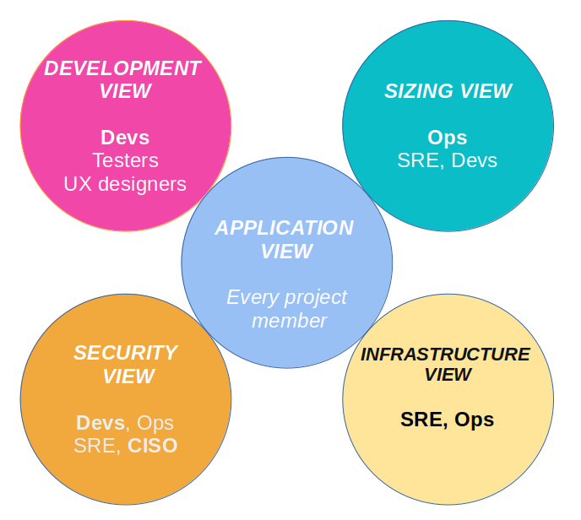

# Architectural subjects remaining

* …​