# Dogstagram

Lets take this opportunity to build something useful from the knowledge we have gained. Coding is a creative process hence this document will only guide you with the project setup and steps based on the requirements of the application. However, a sample implementation of this can be found under Dogstagram/dogstagram.

Let’s get started with Dogstagram - An Instagram for Dogs

## Project Set Up

Set up a new React Native project using the command

expo init <name-of-app>

To start tht application, navigate to the directory and run one of the following commands.

cd <name-of-app>

* yarn start will give ys the option to start ios android or web.

Or else, we can directly run

* yarn android
* yarn ios
* yarn web

Thereafter, the app can be run on an Android/ios simulator, emulator, or even on the device using the expo go app.

## Sign Up Form

1. The first step is to create a reusable custom component that gives our input field a label, and also a space for the user to provide their input. This component will be made up of some of React Native’s core components: View, Text, and TextInput. Your custom component should accept props for:
   * a label to identify what this particular component is for
   * a placeholder value to show before the input is provided
   * the actual value the component accepts & stores
   * a callback function to be called whenever the content of the TextInput is changed
2. Import the custom component in the <App> component, and create inputs for each of the following using the custom component you built in Step 1:
   * email
   * password
   * confirm password
   * pet’s name
   * pet’s date of birth
   * breed
   * favorite toy
3. Using the useState() hook from React, tie up all the custom input components to the state of the parent component i.e. <App>. Transform each of the components created into a controlled component by accordingly setting the value to state and calling the appropriate setState() in the onChangeText prop.
4. BONUS: Try to implement validation for password mismatch from the confirm password. When true, a small message indicating passwords do not match. should be visible.

The sample output of the application should roughly resemble the image below.

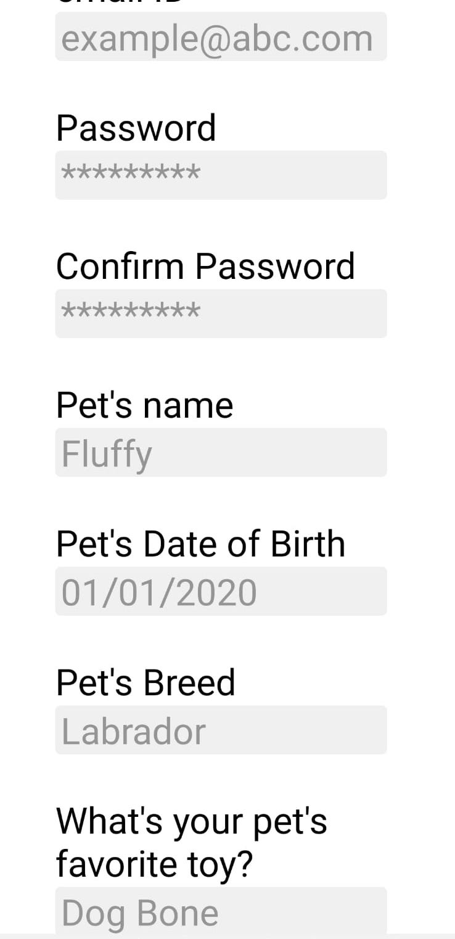

title

This tutorial should help you get comfortable with the basics of mobile application development with React Native. Hope you enjoyed it :)