

**Academic Year: 2024-2025**

**ICT DEPARTMENT**

**Program: B-Tech IT Class**

**Module Name: DEVELOPMENT OPERATIONS**

**Module code: ITLDO801**

**On 6th February, 2025**

**REPORT OF CONTINUOUS ASSESSMENT PRACTICAL PARTS**

Submitted By: IRADUKUNDA Patrick 24RP15513

1. Project initialization and index page Creation

**Folder Creation**

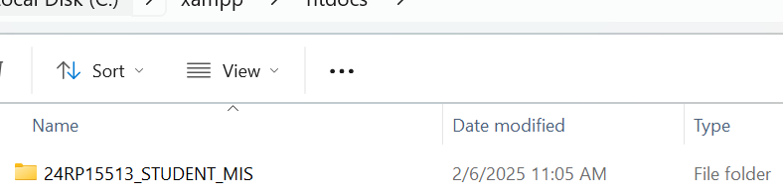

**Code of index page**

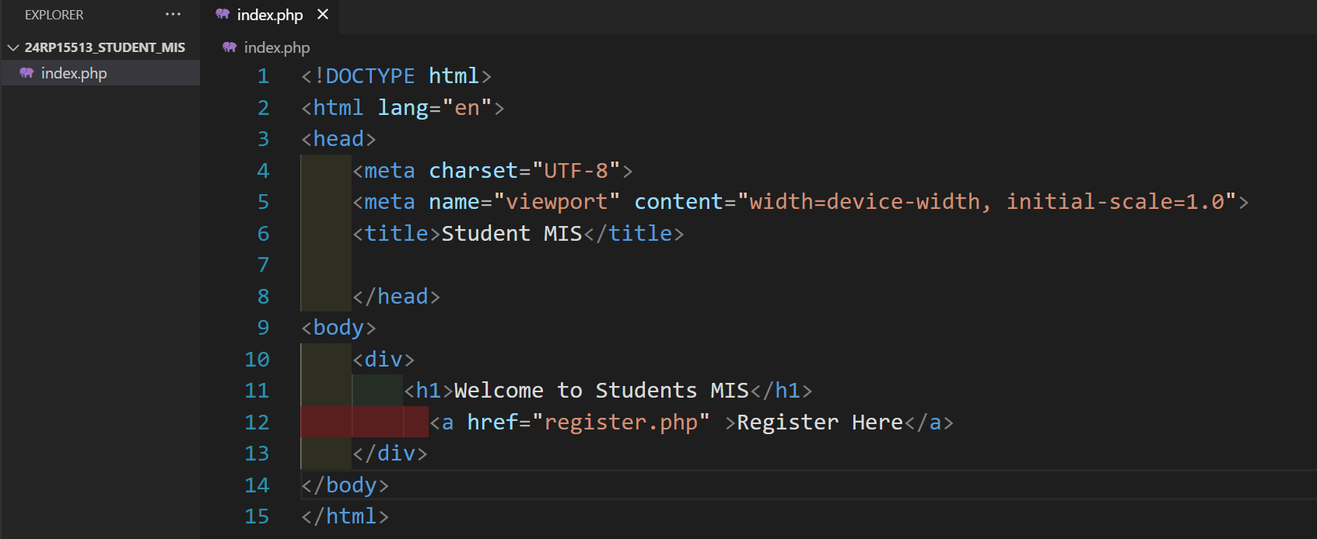

**Testing page or accessing page in browser**

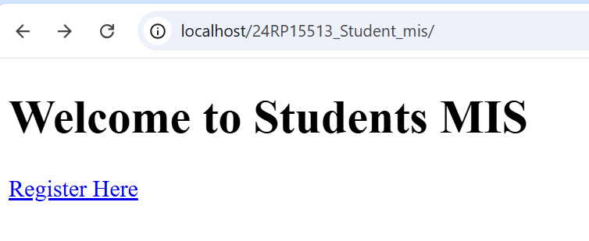

1. Commit index page creation

**Init part for initializing the git repository**

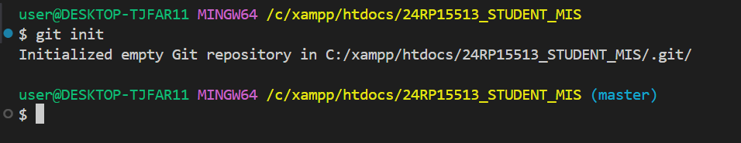

**Git status to the staging environment**

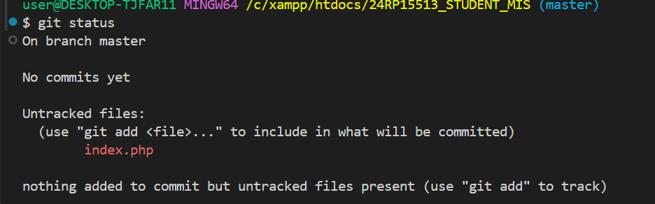

**index file addition to staging environment**

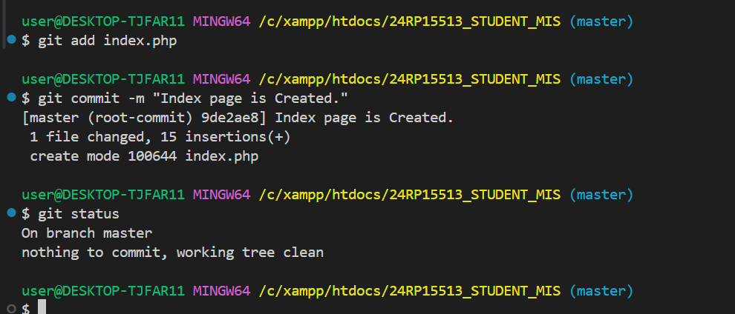

1. Registration page creation

**checking branch I have before creating another one add another one**

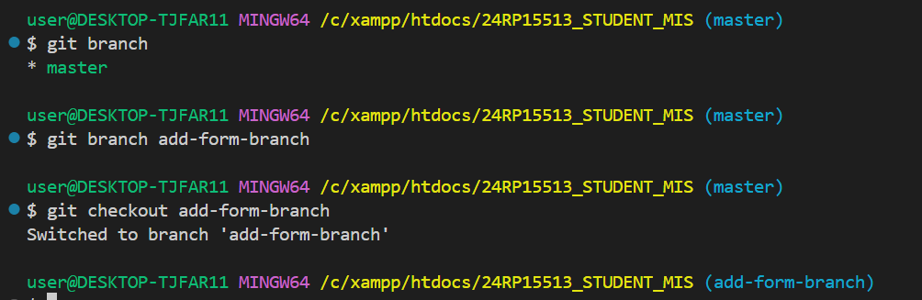

**registration source code**

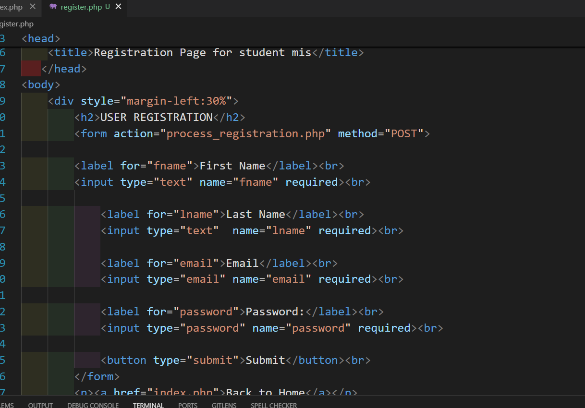

**registration page visualization on browser**

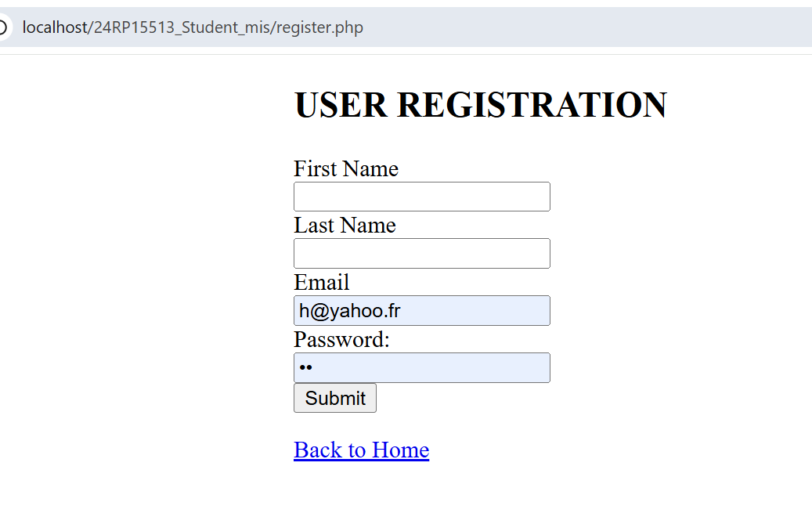

1. Commit registration page creation

**checking the status of branch**

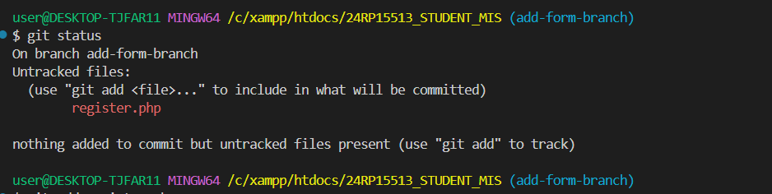

**git page addition in staging environment and commiting**

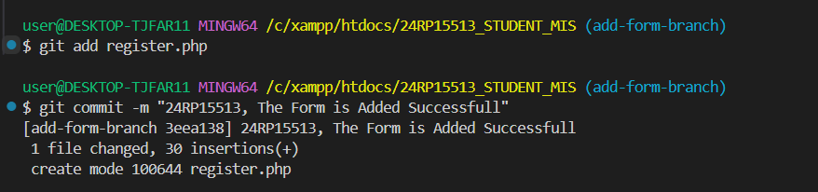

1. Merge Registration Form Page to man/master Branch

**. branch merging**

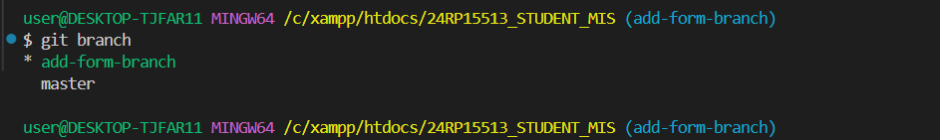

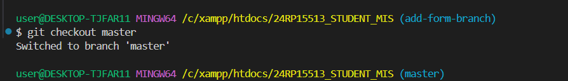

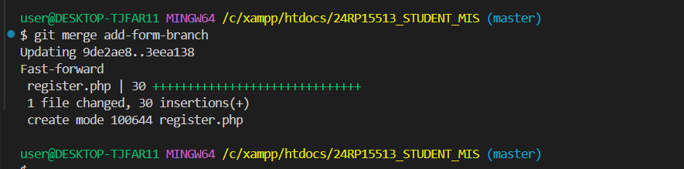

1. Bootstrap Integration

**. bootstrap integration in code under bootstrap branch**

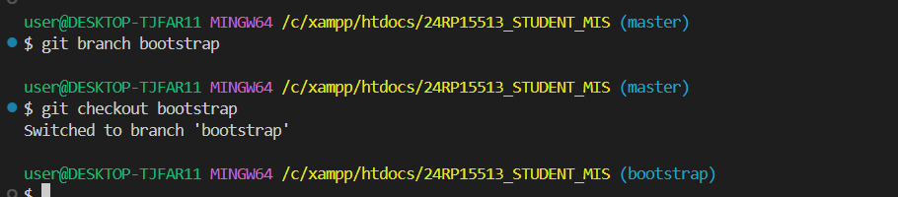



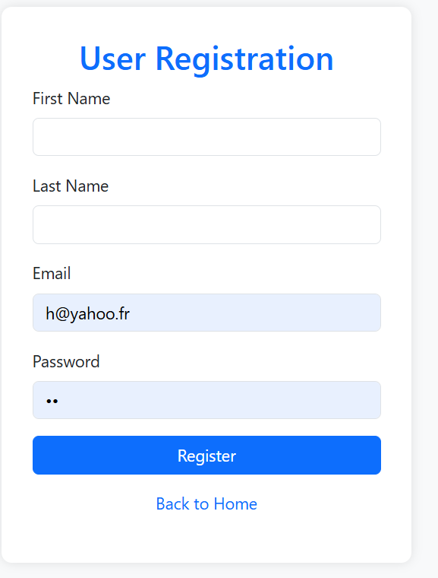

1. Commit Bootstrap Integration

**. committing for the bootstrap added**

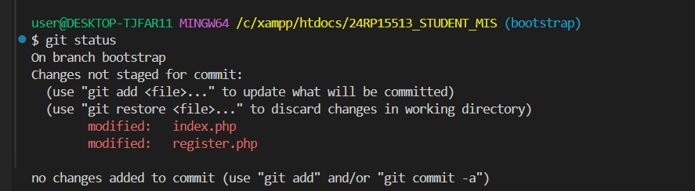

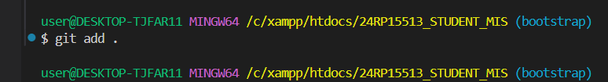

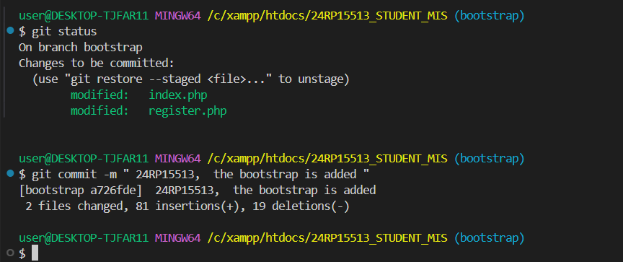

1. Merge Bootstrap Branch Integration to main/master Branch

**. merging the branches**

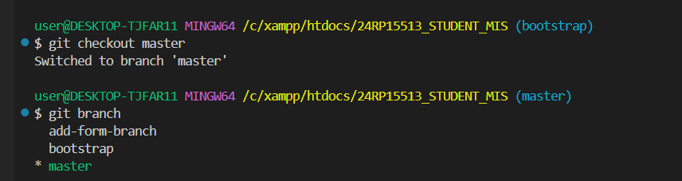

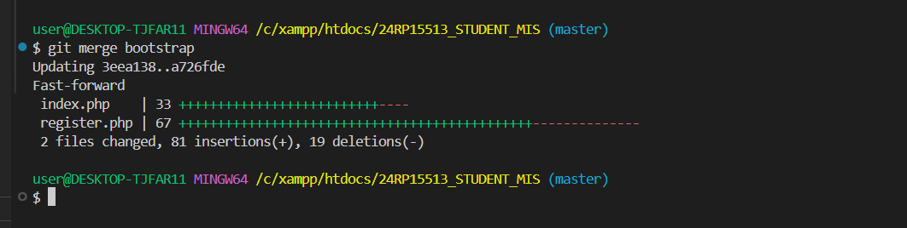

1. Remote Repository Creation

**. repository creation on github platform**

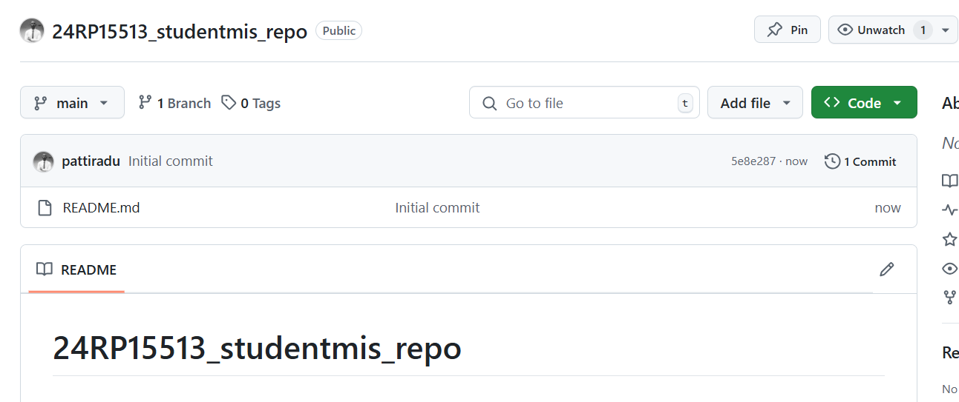

1. Dockerization.

**. dockerization done**

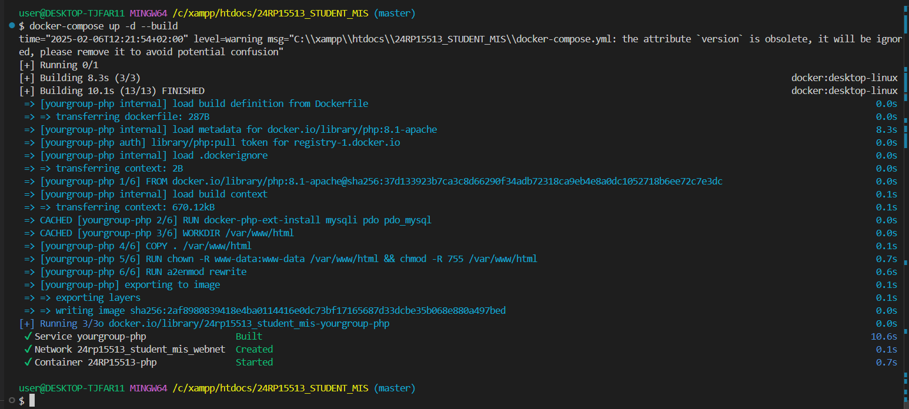

1. Testing.

**. checking the accessibility of after dockerization**

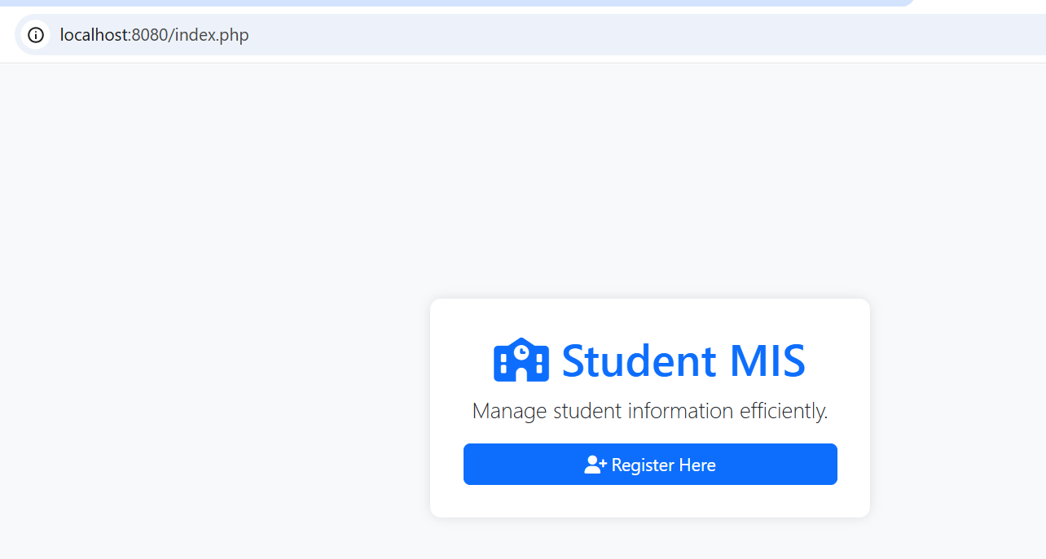

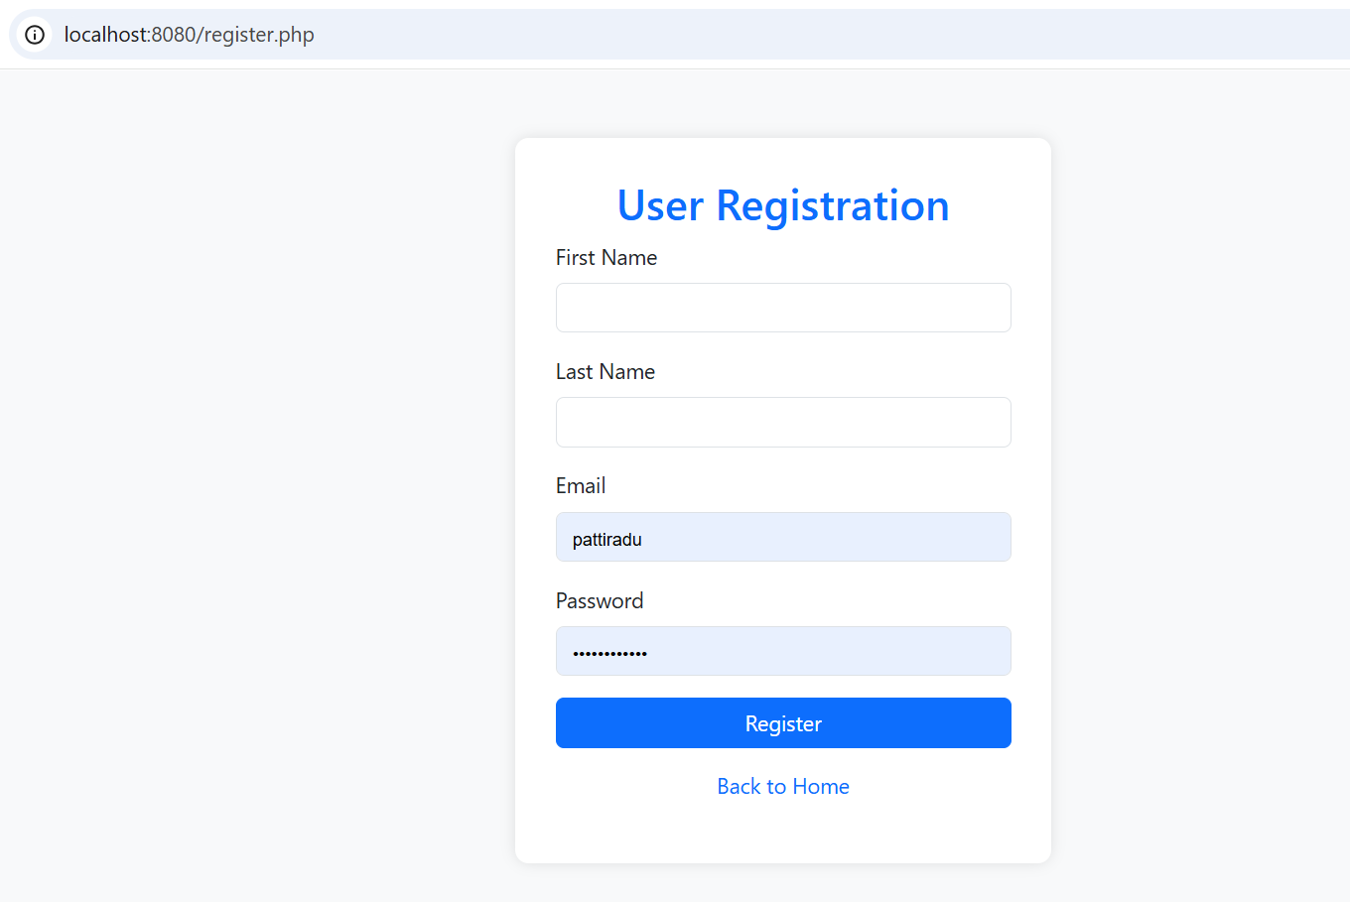

1. Pushing to Github.

**. addition to github repository**

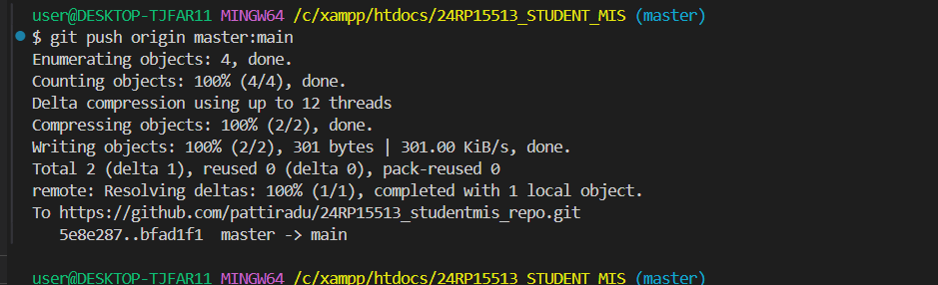

1. Collaboration Invitation.

**. github invitation**

