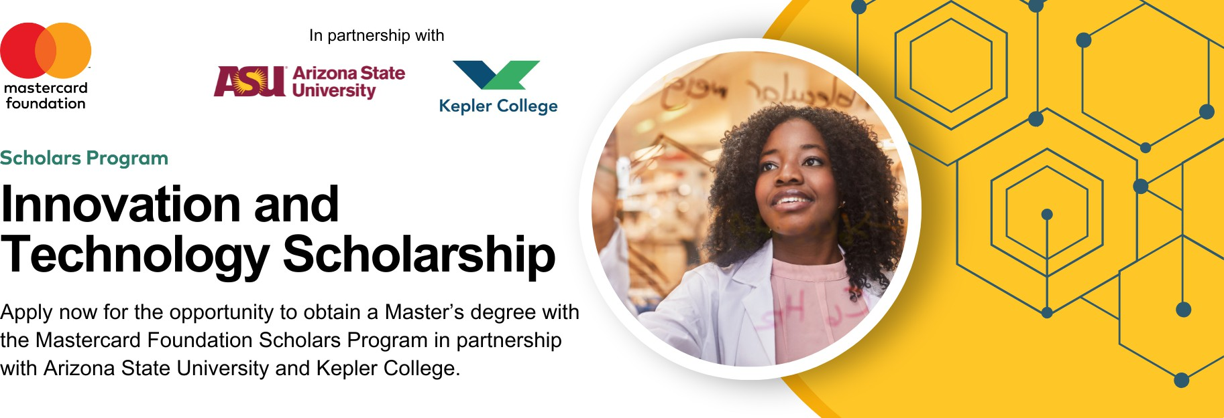

2025 Innovation and Technology Scholarship Application Frequently Asked Questions

🌐 [***Access Scholarship Application***](https://asu.co1.qualtrics.com/jfe/form/SV_9Z8p6mwu91xxVuC)

🌐 [***Informational Flyer***](https://drive.google.com/file/d/1YBR0-i_QZr1stDWQc0uUGT3A64nedVZK/view?usp=sharing)

# What makes a good scholarship essay?

**Answer:** A successful scholarship essay provides a detailed and well-constructed answer strongly conveying how your personal and professional experiences align with the requirements and expectations of graduate studies at ASU, and as a candidate for the specific graduate program you’d like to apply for.

## Review and Proofread:

* + Ask a friend or mentor to review your essays for errors, grammar, and spelling.
  + Request feedback on the flow and clarity of your writing to ensure your message is well-articulated.

## Leverage AI Thoughtfully:

* + If you choose to use AI/Chat GPT for support, ensure your responses remain authentic.
  + Remember, AI generates generic outputs, so showcasing your unique voice is critical.
  + Take time to personalize your essay responses to reflect your individual experiences and perspective.

## Make Your Essay Memorable:

* + Keep in mind you’re applying alongside individuals with similar experiences.
  + **Ask yourself:** What makes you unique? How have your experiences shaped your interests and passion for transforming Africa?
  + Ensure your essay conveys who you are and what distinguishes you from others.

## Demonstrate Understanding of the Program:

* + Show a strong understanding of the academic program and its potential impact on Africa.
  + Spend time researching and learning about these topics.
  + **Tip:** Thoroughly review the academic program page for your degree of choice to highlight its relevance in your essay.

# Do I need to apply for admission before applying for the scholarship?

**Answer:** No. You need to apply for the scholarship first, then you will be guided to apply for admission to Arizona State University if you are selected to interview for the scholarship.

# Deadlines are approaching…do I need to apply to ASU before applying for the scholarship? Can I have financial assistance for the grad application fee now?

**Answer:** No, you should not apply to ASU before applying for the scholarship. Your application will be reviewed prior to admission to the academic program and is not required for scholarship eligibility.

We advise you to submit the scholarship application first. If you are selected as a scholarship finalist, you will be prompted to apply to the academic program. **Do not pay for the application fee.**

**Please note, getting the scholarship does not guarantee admission to the graduate program.**

# I will graduate with my bachelors (undergraduate) degree in 2025. Am I eligible to apply for the scholarship?

**Answer:** Your bachelors (undergraduate) degree will need to be conferred before July 2025 to be considered eligible.

# Does getting the scholarship admission guarantee getting admission into the desired graduate program?

**Answer:** No. But graduate program admission is required in order to be selected for the scholarship.

# Could you elaborate on the recommendation letter requirements?

**Answer:** Scholarship application requires one letter, which should speak to your leadership, academic success, etc. Most academic admission applications require more than one letter, and you might be

able to re-use the letter of recommendation submitted for this scholarship. Academic or professional

letters of recommendation are accepted. We suggest letters of recommendation that are addressed to the Scholarship committee. We also recommend more recent letters of recommendation.

# Can my recommender submit a letter of recommendation directly? To whom should my letter of recommendation be addressed to?

**Answer:** Our preference would be to have your recommender send the letter directly to you, and you can upload it when you submit the rest of your application materials.

However, if your recommender would like to send your letter directly to us, advise them to include your name, and send it to our email address: [keplerasuscholars@asu.edu](mailto:keplerasuscholars@asu.edu)

# Does submitting a non-academic recommendation letter reduce your chances of being accepted?

**Answer:** A non-academic recommendation letter is fine for the scholarship application, but the academic program will require recommendation letters that speak to your academic abilities/experience.

# Do I need to submit an official translation if my transcript is in French?

**Answer:** Please submit the responses to the online scholarship application form in English.

# For the additional materials, including letters of recommendation, resumes, and transcripts, those can be submitted in French. Our Francophone staff will be able to review your application materials in full.

An official transcript translation will only be needed if you are selected as a scholarship finalist. At that point, you may be asked to produce an official translation to apply to the academic program. However, for the purposes of this scholarship application, a transcript translation is not required.

# Do you have specific numbers for how many students will be accepted per country or the minimum?

**Answer:** There are no minimums or maximums for country representation in the scholarship program.

# Do I need to summit both an online application & a printable application?

**Answer:** No, please only submit one application. The PDF version of the application is available for applicants with limited internet access who are unable to submit the application online.

Click [here](https://drive.google.com/file/d/1ZWZW1TbKOO0kDEMrS5EZ02dyvD7FHrHG/view?usp=sharing) to download the printable application form and email it along with required attachments to [keplerasuscholars@asu.edu](mailto:keplerasuscholars@asu.edu).

Please note, submitting your application directly via the online application form is preferable. To access the direct link to submit your scholarship application, click [HERE](https://asu.co1.qualtrics.com/jfe/form/SV_9Z8p6mwu91xxVuC).

# Can I get Edit access to the PDF version of the application?

**Answer:** No, please do not request edit access.

To access the downloadable form, click [HERE](https://drive.google.com/file/d/1ZWZW1TbKOO0kDEMrS5EZ02dyvD7FHrHG/view?usp=sharing). This will take you to a link containing a PDF document. Download the application directly to your device. To submit the completed PDF form, email it to [mastercardfndscholars@asu.edu](mailto:mastercardfndscholars@asu.edu) along with all required attachments.

# I completed a 3 year undergraduate degree, am I eligible for the scholarship?:

**Answer:** The eligibility criteria depends on the program of study for this particular scholarship. All applications will be reviewed to determine eligibility.

# I am over 33 years of age or under 18, am I eligible for the scholarship?

**Answer:** No, current age eligibility criteria limit applications to individuals who are between the ages of 18 and 33 at the time of application. This is a scholarship requirement with no exceptions.

# Can I select or apply for more than one academic program?

**Answer:** No, we encourage applicants to select only one program they feel a strong interest in.

# Can you provide funding for an academic program of my choosing?

**Answer:** No, the current scholarship opportunity is only available for the specific programs listed in the application page. These opportunities have been pre-arranged with the Mastercard Foundation in

partnership with Kepler College.

# I received an error message,“You have either already completed the survey or your session has expired”? Was my application submitted?

**Answer:** Your application is likely timed out. You can resubmit your application along with the required documentation for review, or kindly email us to ask if your application has been submitted at

[keplerasuscholars@asu.edu](mailto:keplerasuscholars@asu.edu).

# After submitting an application, I didn’t get an email confirming the application has been received.

**Answer:** You will not automatically receive a confirmation email. Once you submit the online application, you will see a message saying,

*“End of Survey. Thank you for submitting your application. We are pleased to confirm that your application has been successfully received.”*

Please consider this message as your submission confirmation. If you would like further confirmation your application was received, please email us at [keplerasuscholars@asu.edu](mailto:keplerasuscholars@asu.edu).