The less command allows users to browse the txt file on the UI.

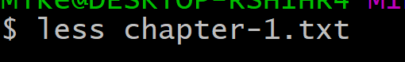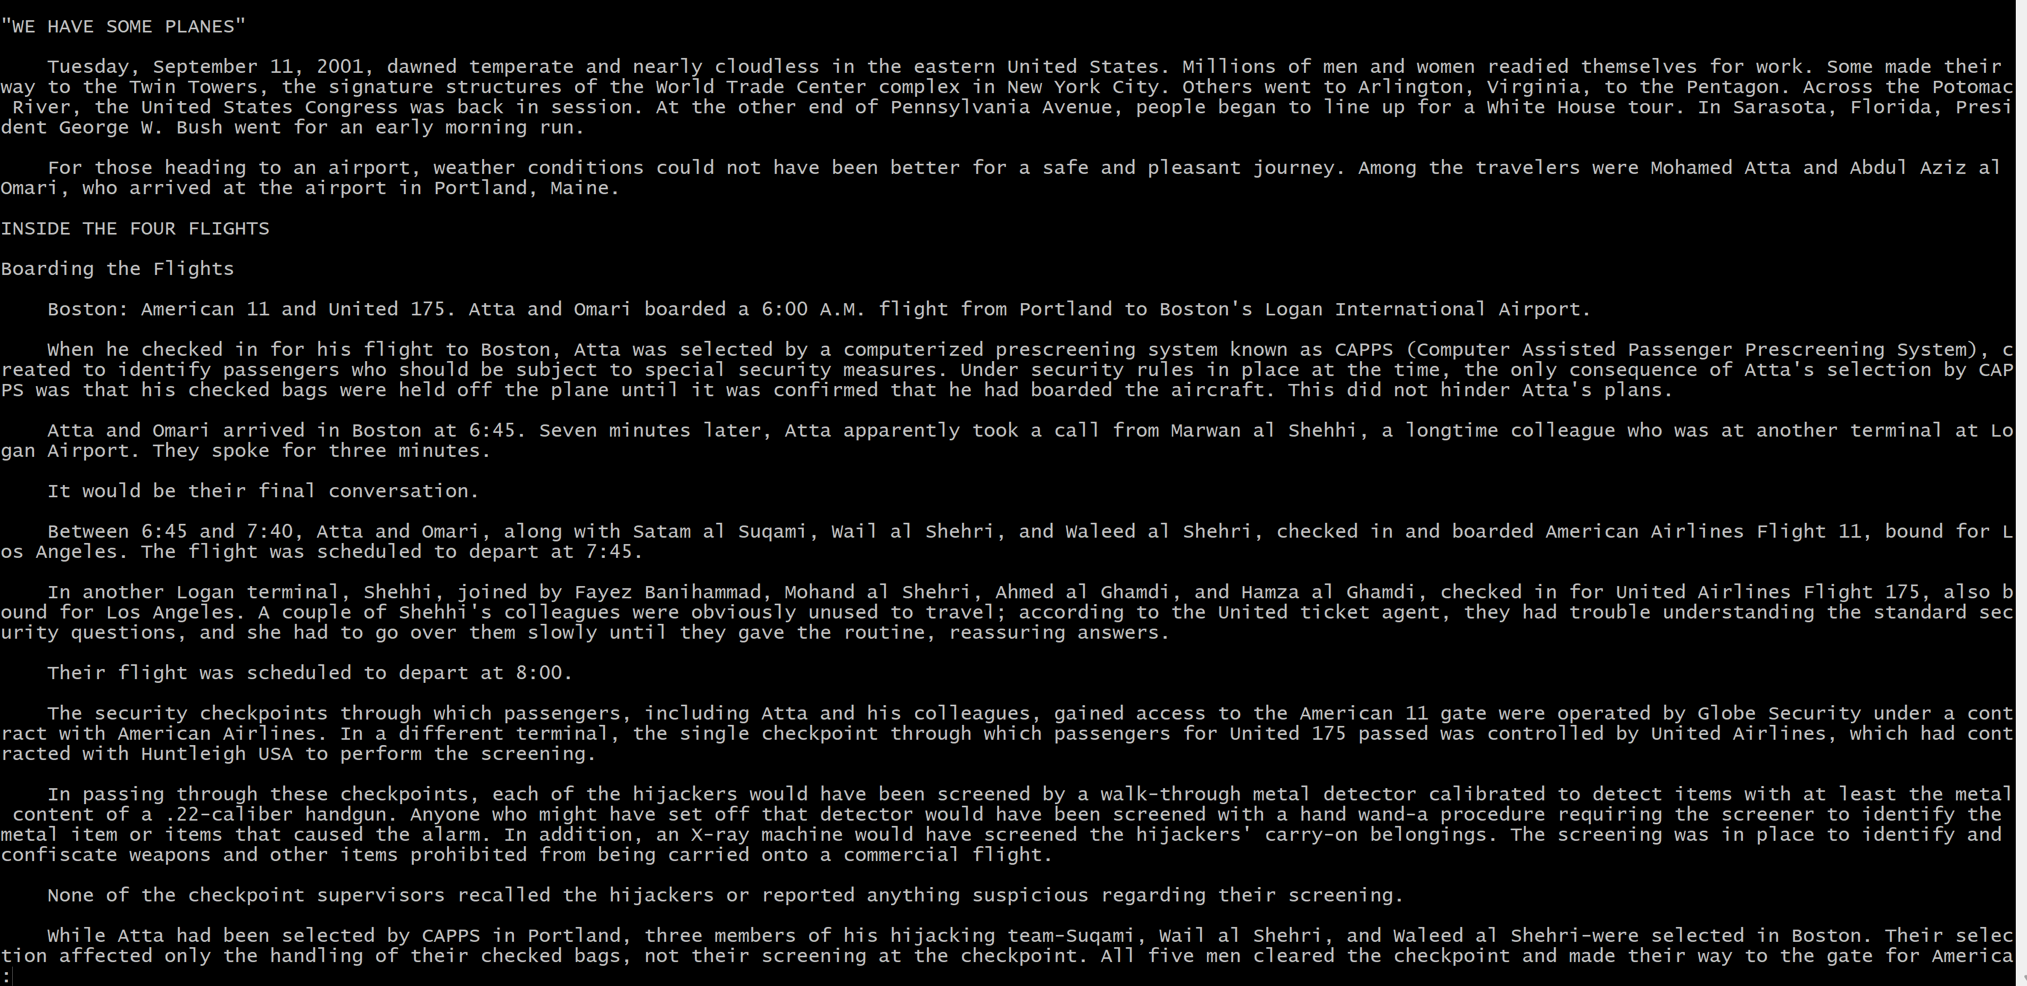





-E option automatically exits upon reaching the end of file.



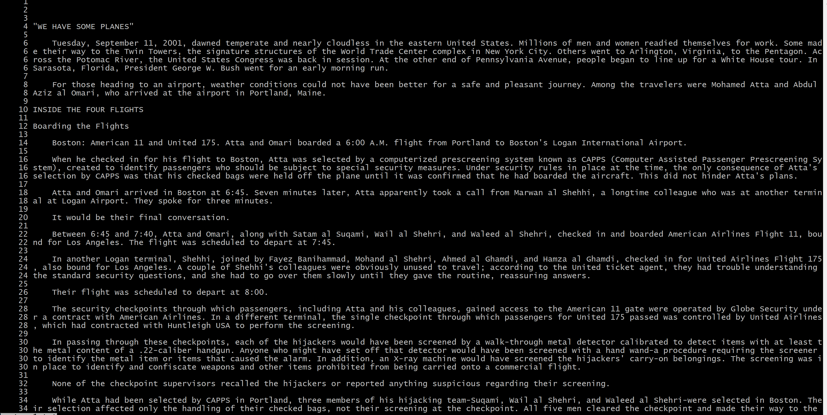

-N Displays line numbers at the beginning of each line.





-s Merges consecutive blank lines into a single blank line.

The find command walks a file hierarchy.

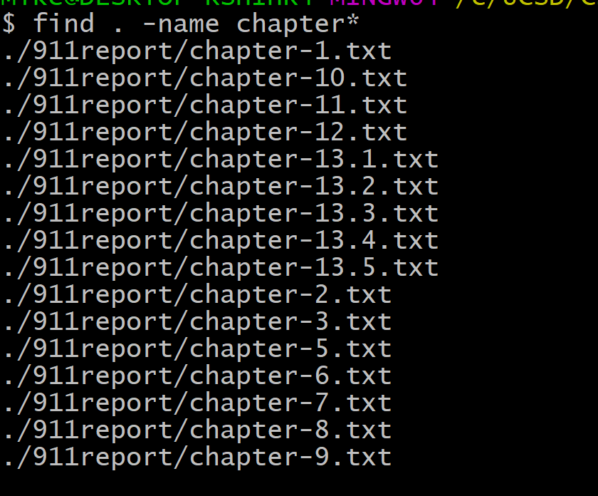

-name option will find all files that match the regex

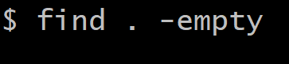

-empty searches for empty files and directories.

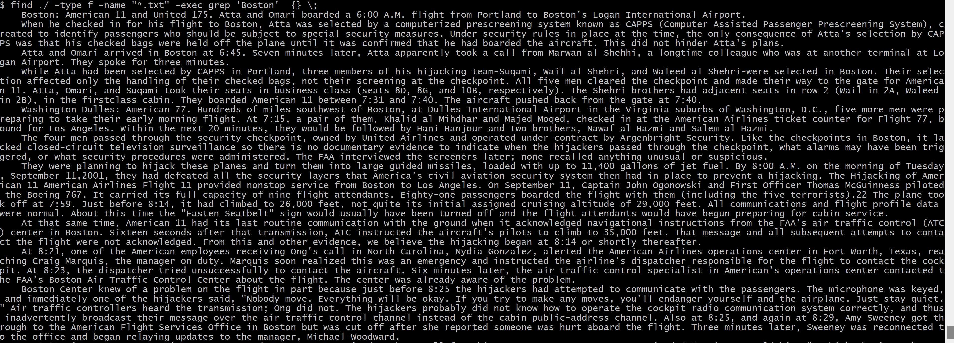

-exec execute another command

In my case ‘grep’ finds all the lines have ‘Boston’

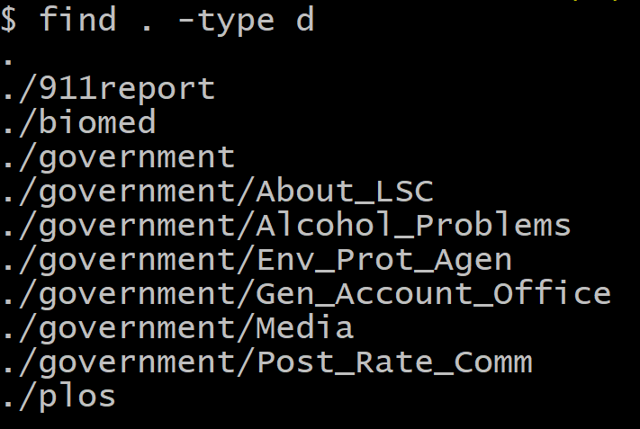

-type specifies the type of search ‘d’ means directory ‘f’ means file

grep is used to search text and strings in a given file.

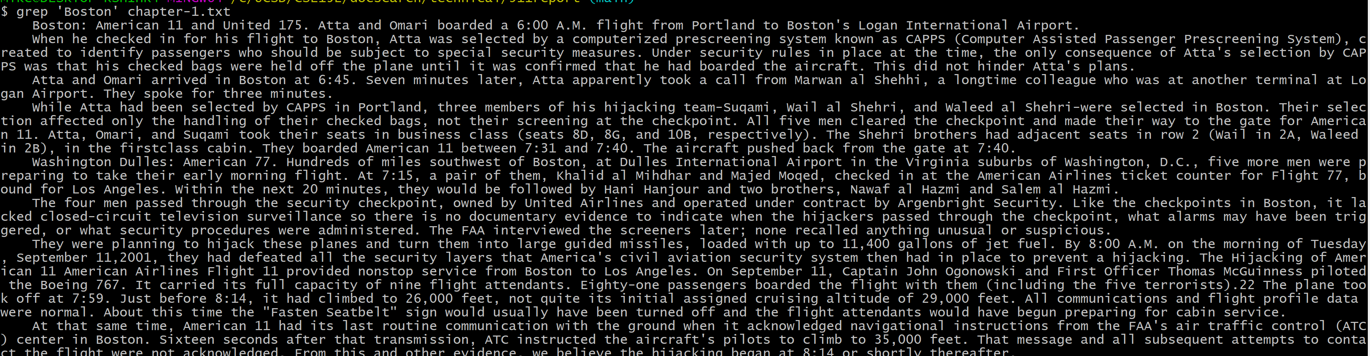

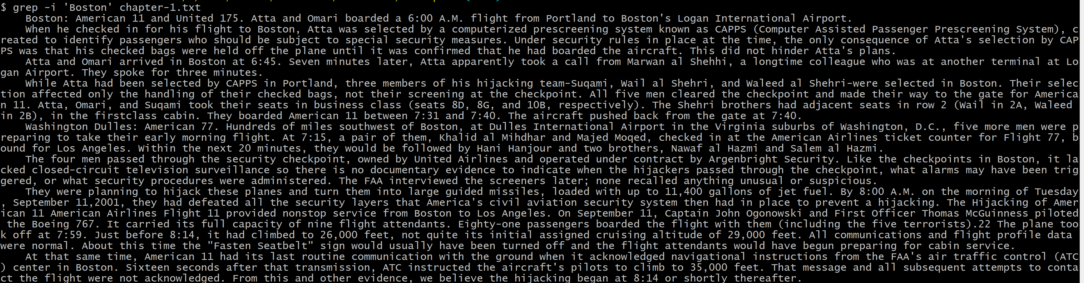

-i performs search in the case-insensitive style.

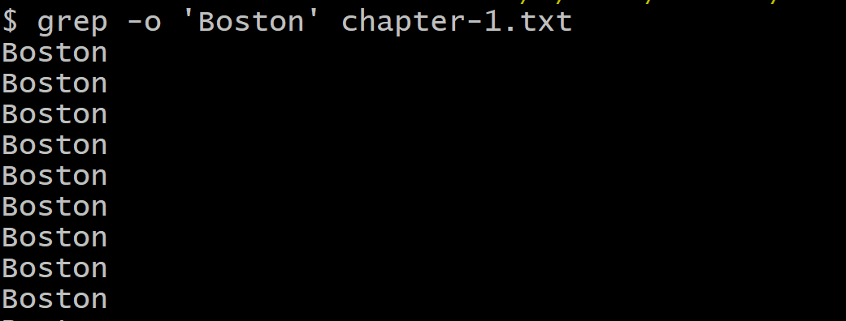-o prints only the matched parts of a matching line

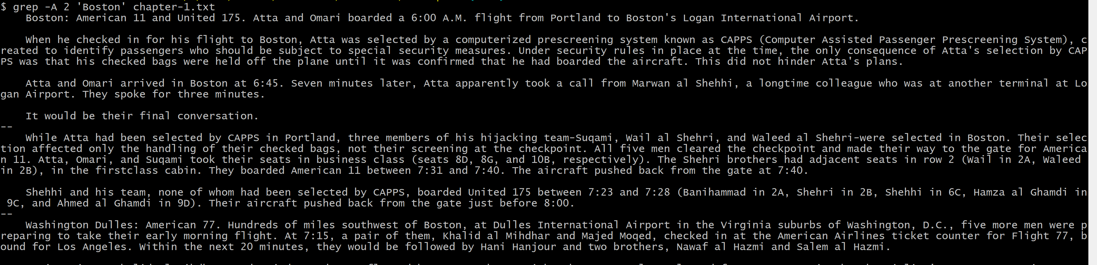

-A n prints searched line and nlines after the result.