**Car rent**

**Desk test**

In the next screen, the user should enter the data, for calculate the price to rent a car:

First the user must choose the model and the car type:

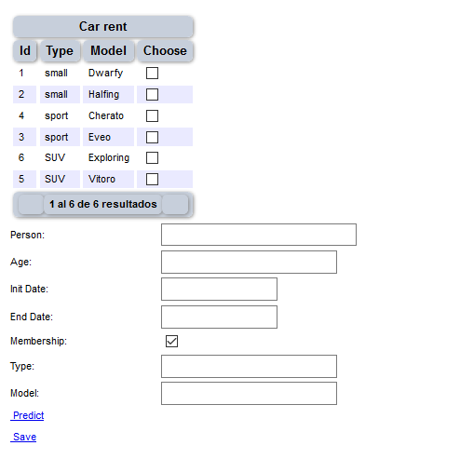

The name of the person is mandatory:

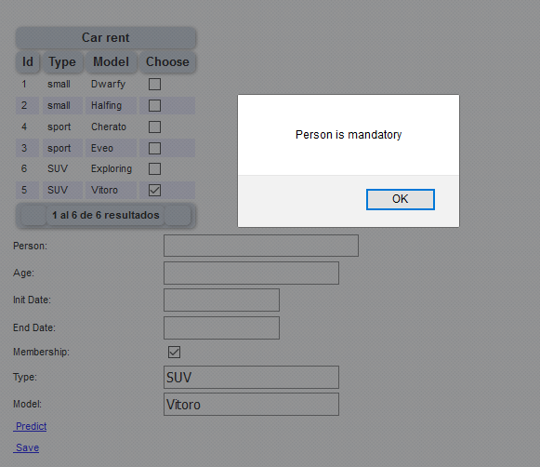

The person should be older than 18 years old:

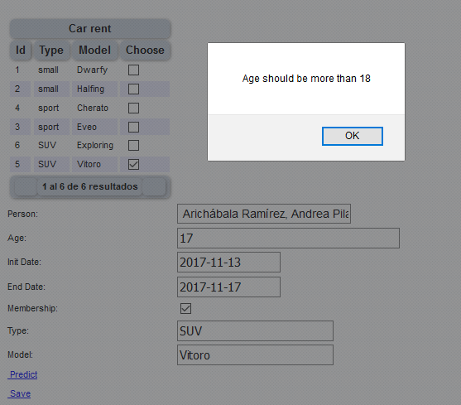

When the fields are complete, the user should click in the bottom “Predict”. Then the price is going to display in a report below. If the client agrees then the user should click in the bottom “Save”, for save the data.

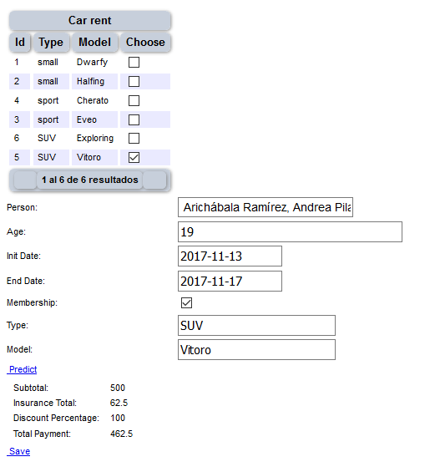

If the days are in the week, there is a discount.

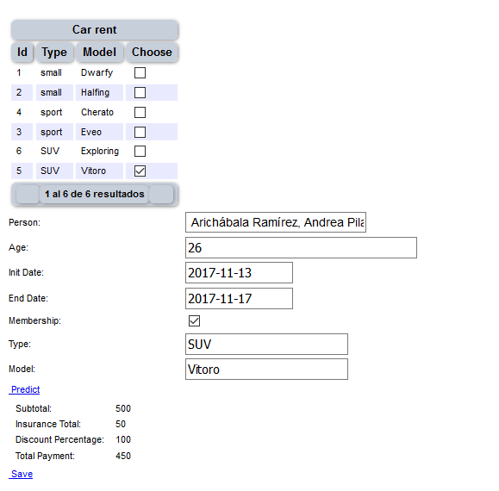

If the client doesn’t have the membership, then the discount is lower:

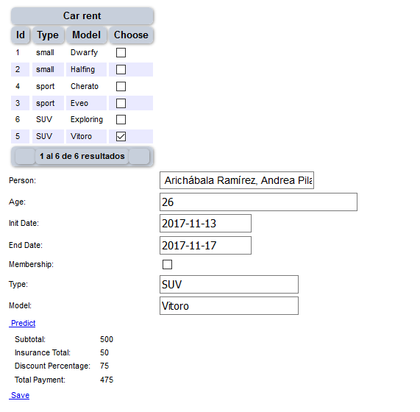

If the car is cheaper, then the total price is lower.

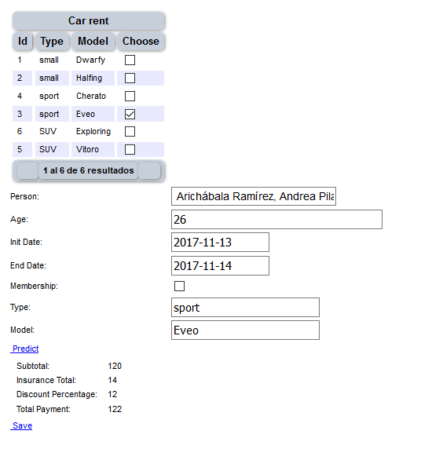

If the days are weekend, there isn’t a discount.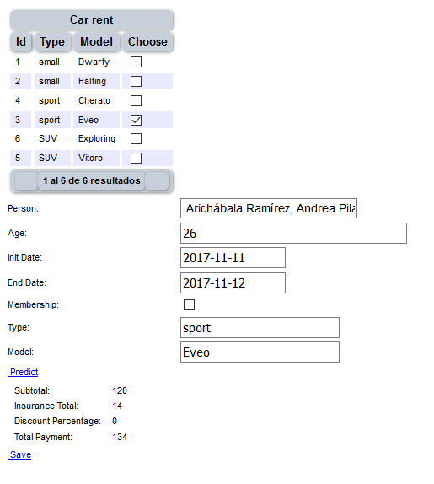

If the days are weekend, but the client has a membership, there is a discount.

