**Automation challenge**

Perform a test automation using the java language and the BDD serenity framework has embedded the selenium web driver library which allows you to enter the official Sophos Solutions portal and then navigate to the work with us tab, from the work with us page, capture all the job offers that are available and then print the captured values ​​to the console.

Remember that it is an advantage to use other technologies such as a serenity, cucumber, gherkin, maven or gradle and you could adapt or edit some steps as the last one, for example you can receive a list and do a validation through the assertion and don’t print in the console.

Delivery requirements:

The code must be uploaded to a repository on Github, public.

The test must be written in Java

Recommendations

Try to use best practices, there are some patterns you can use to create the test

**Functional steps of the challenge.**

**Step 1.**

Open the web browser (Opciones: Google Chrome, Firefox, internet explore)

**Step 2.**

Navigate to Url <https://www.sophossolutions.com/>

**Step 3**

Click and navigate to the session “*trabaje con nosotros”. Or “Work with us”*



*The automation navigates to the next page.*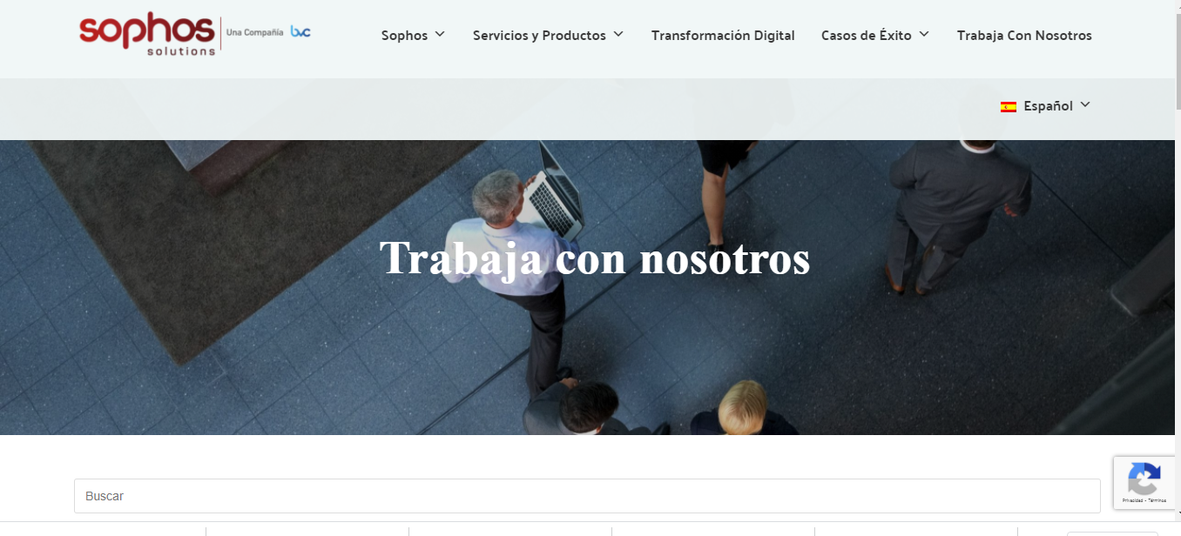

*Or*

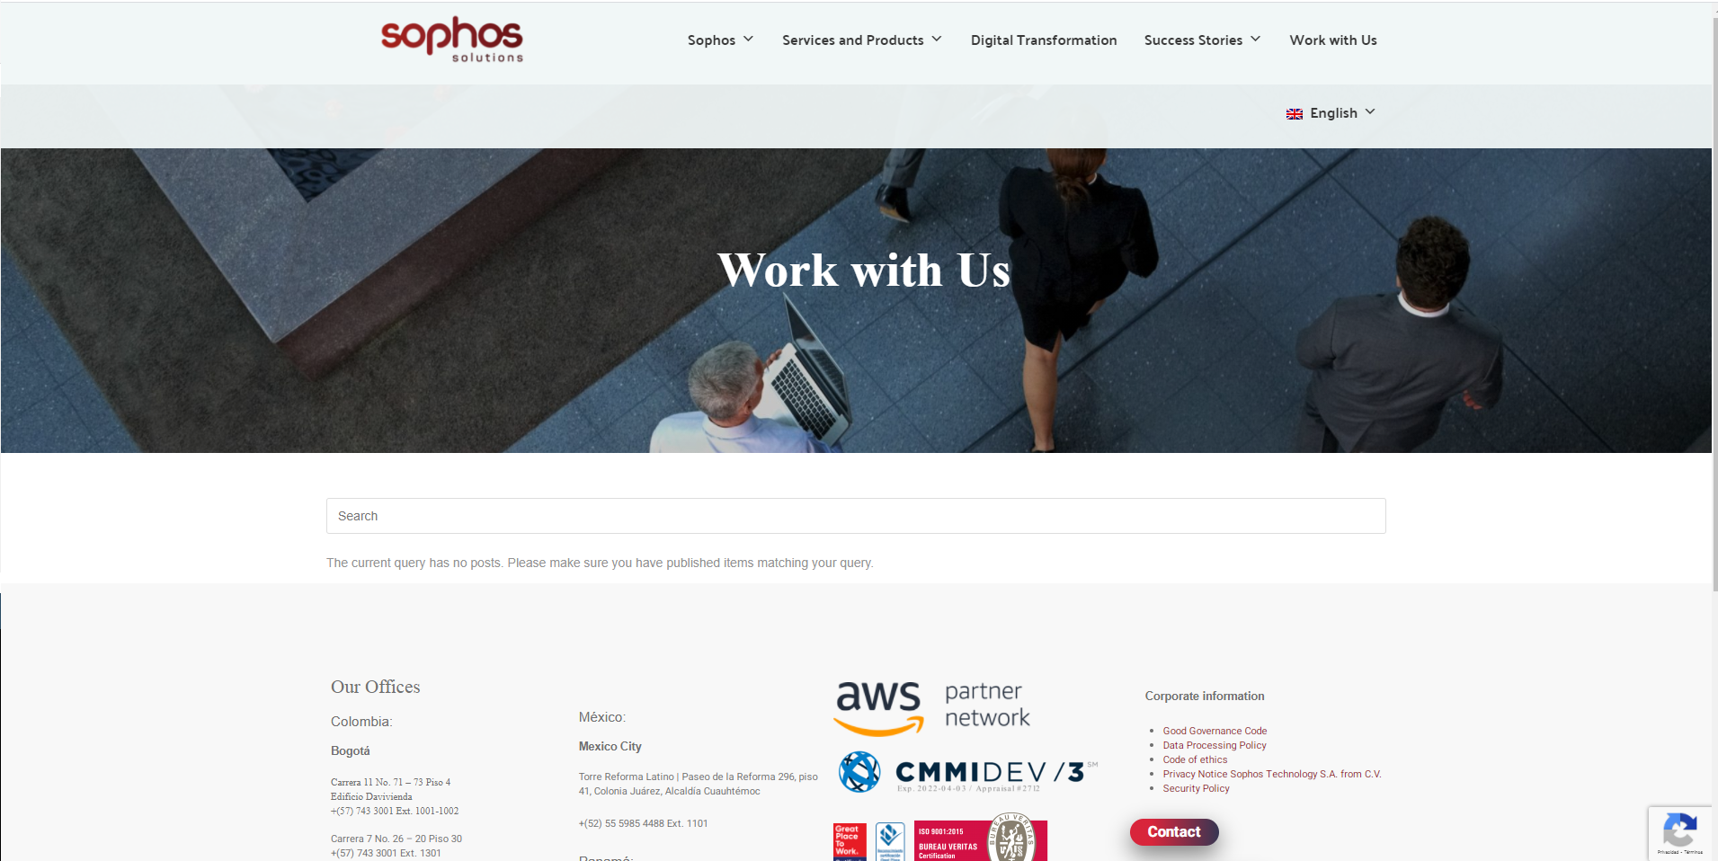

**Step 4**

Capture the text of all job offers displayed on the current page. If there is no offer enter a keyword for example "Java" this will give you related results.

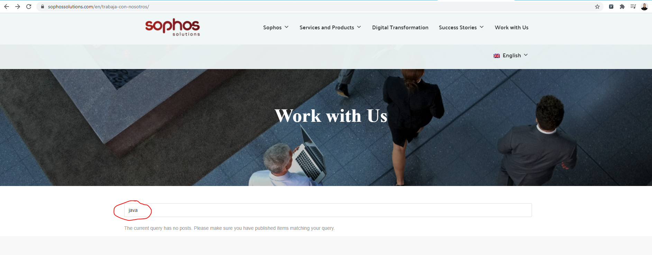

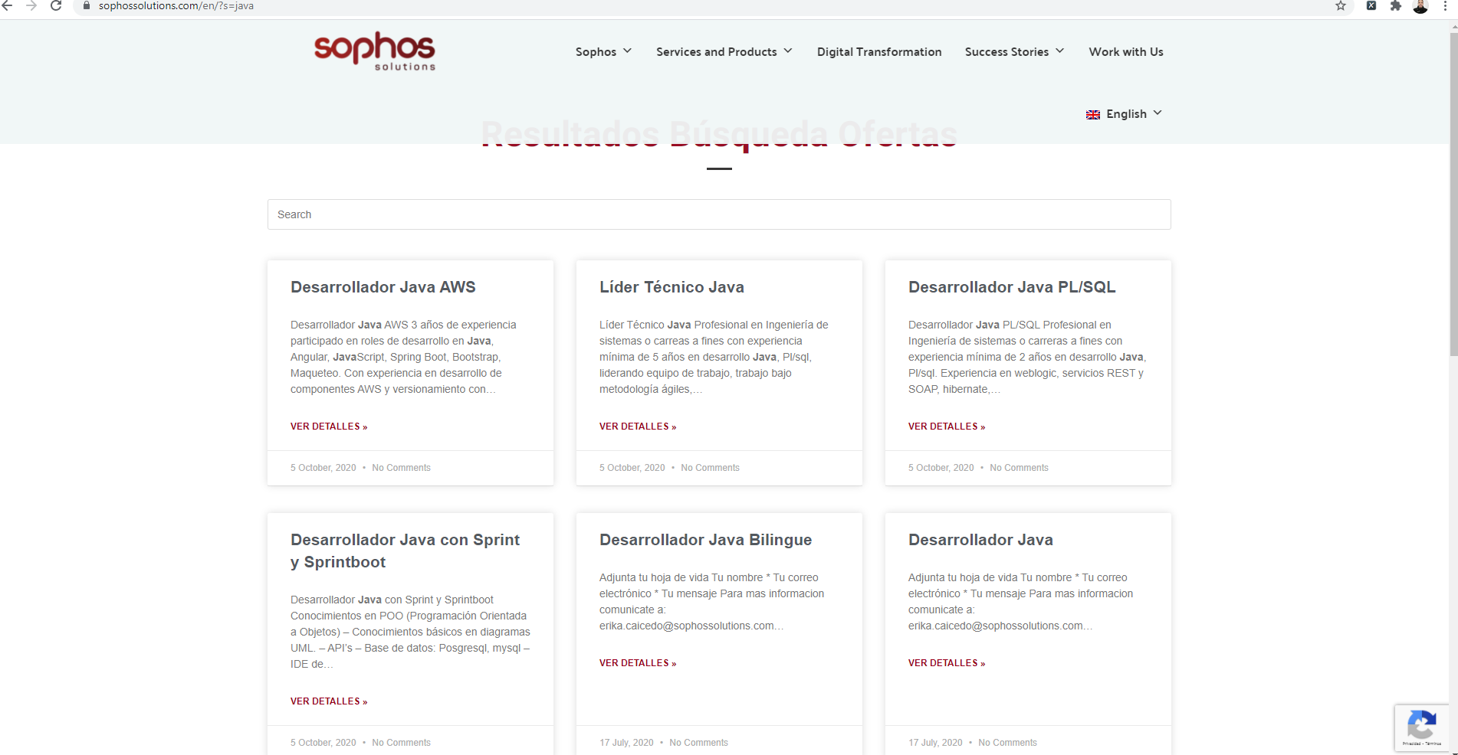

**Step 5**

Print the console.

• Name of the offer:

• Publication date

• Description

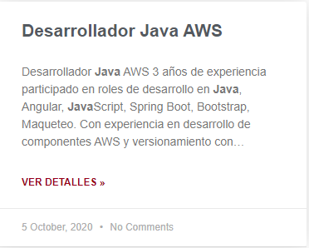

Console printing example.