DOCUMENTATION FOR THE Buzzvel 2024 Test
To test the endpoints of your HolidayPlanController, you can use tools like Postman, Insomnia, or even cURL. Below are examples of how to test each of your endpoints:

1. Create a new holiday plan (POST):
Endpoint: POST /api/holiday-plans
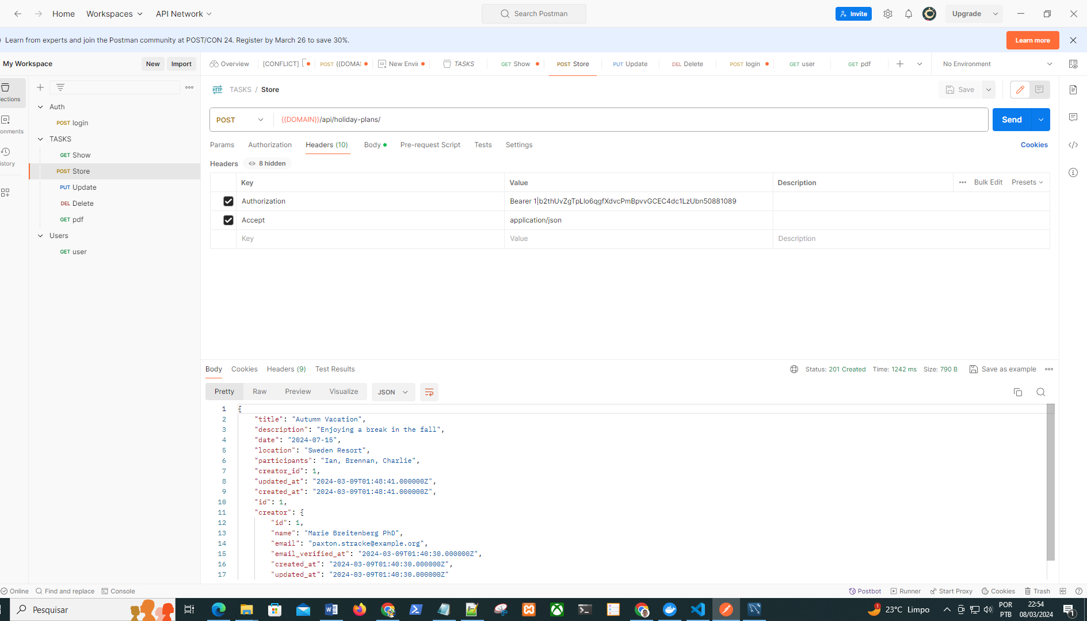
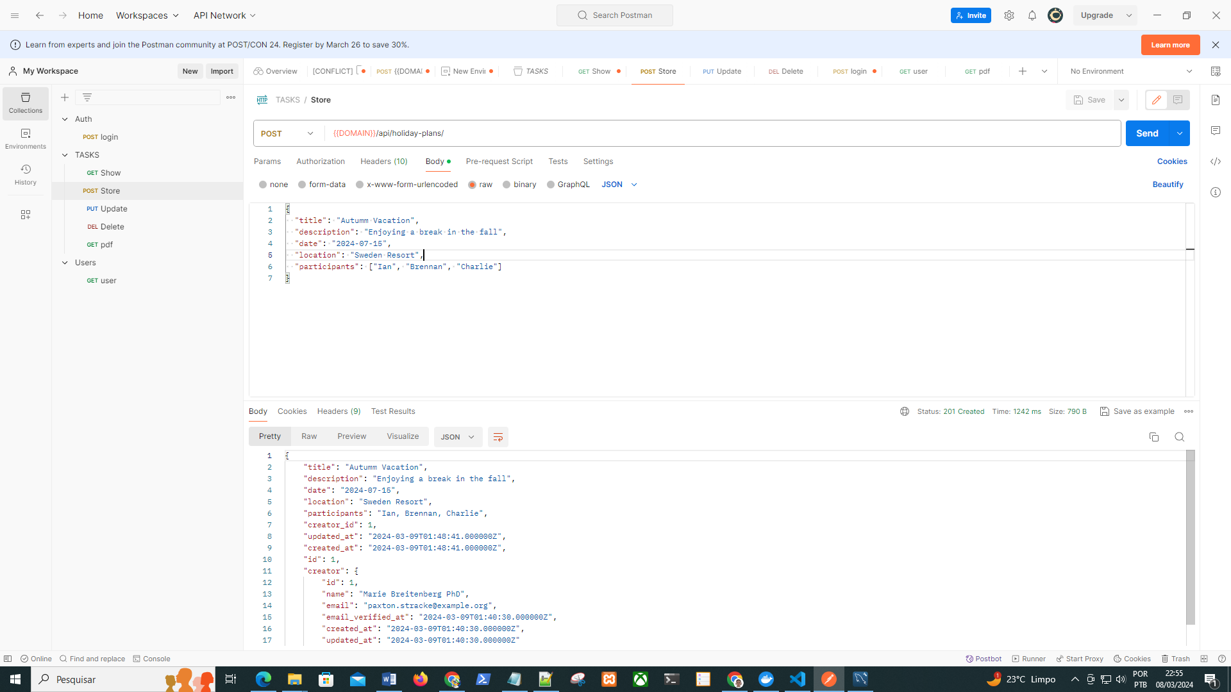

2. Retrieve all holiday plans (GET):
Endpoint: GET /api/holiday-plans
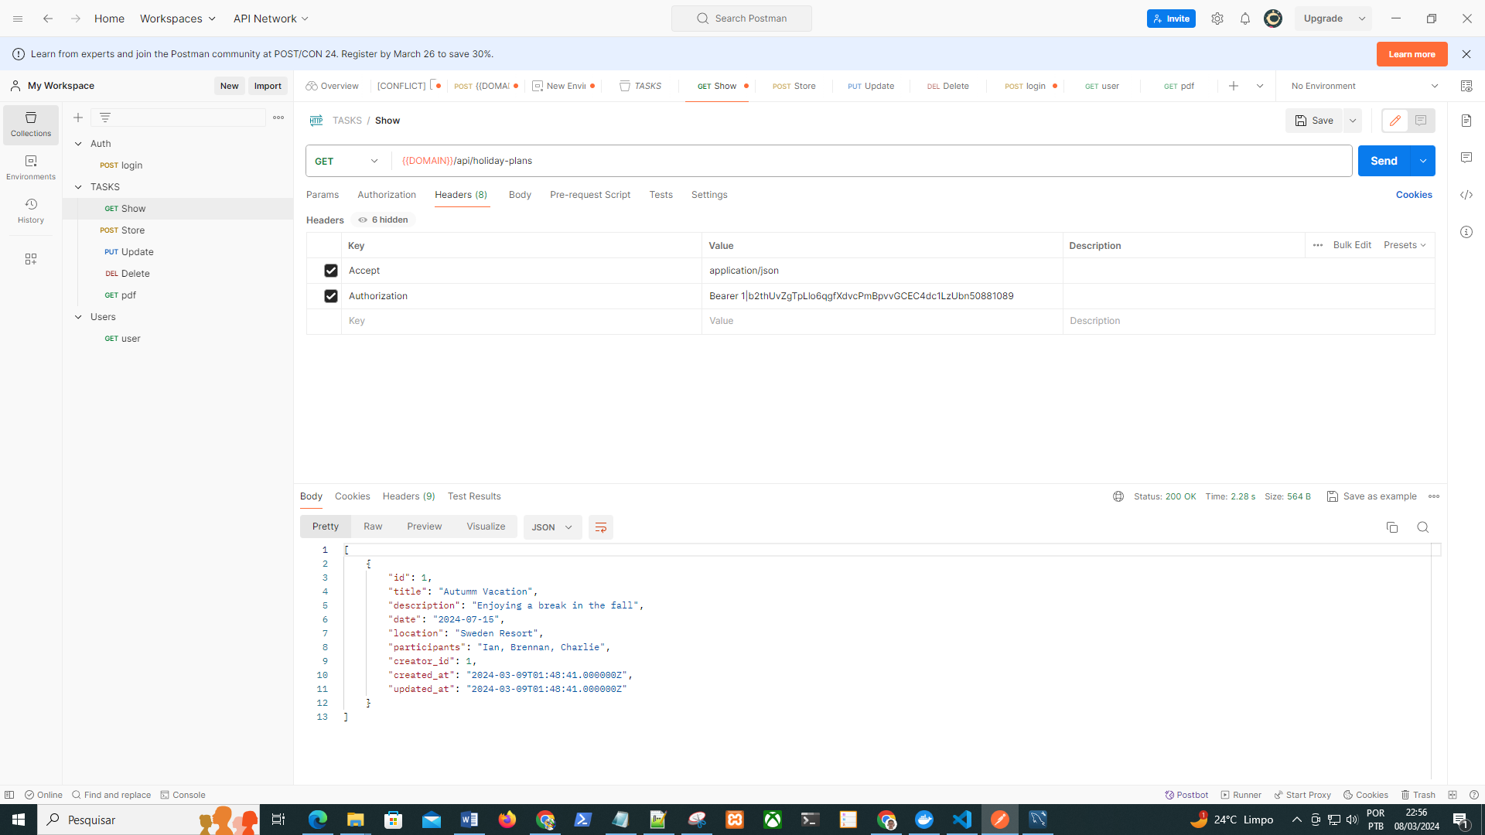

3. Retrieve a specific holiday plan by ID (GET):
Endpoint: GET /api/holiday-plans/{id}
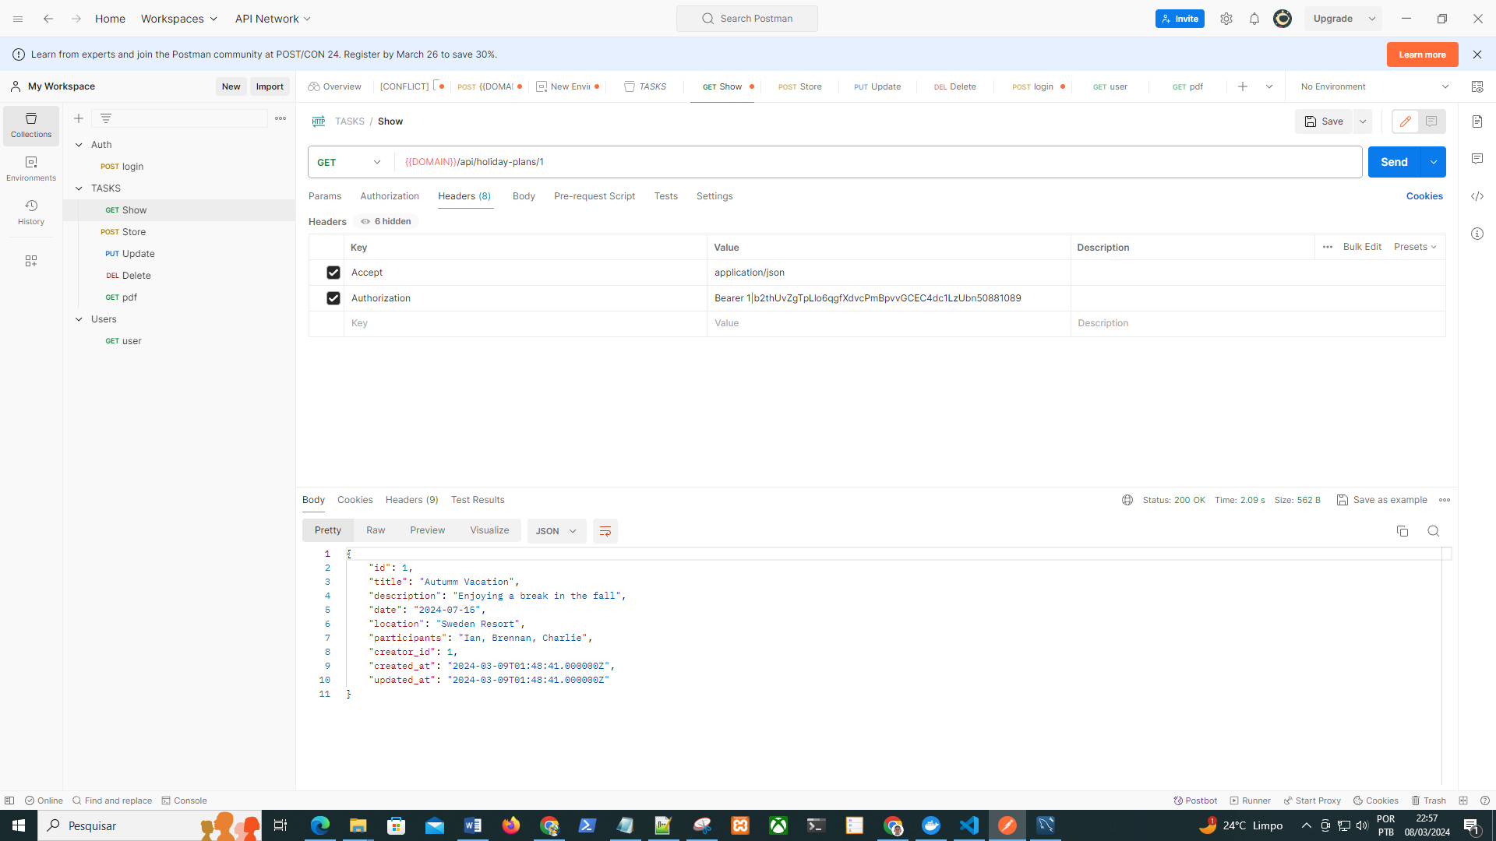

4. Update an existing holiday plan (PUT or PATCH):
Endpoint: PUT /api/holiday-plans/{id} or PATCH /api/holiday-plans/{id}
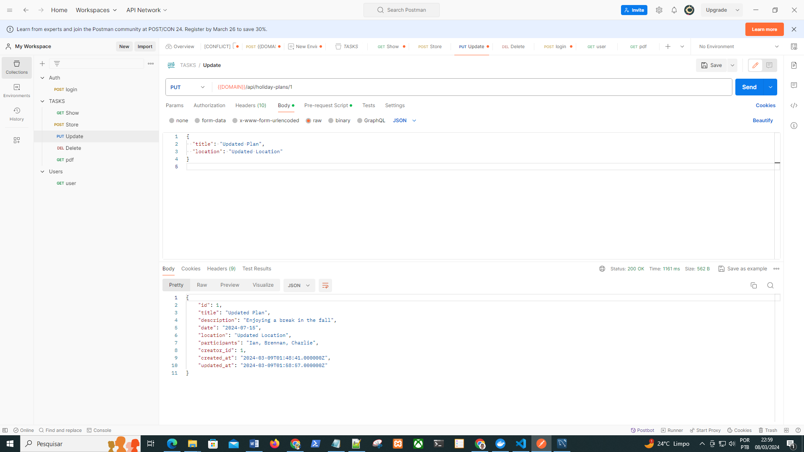

5. Delete a holiday plan (DELETE):
Endpoint: DELETE /api/holiday-plans/{id}
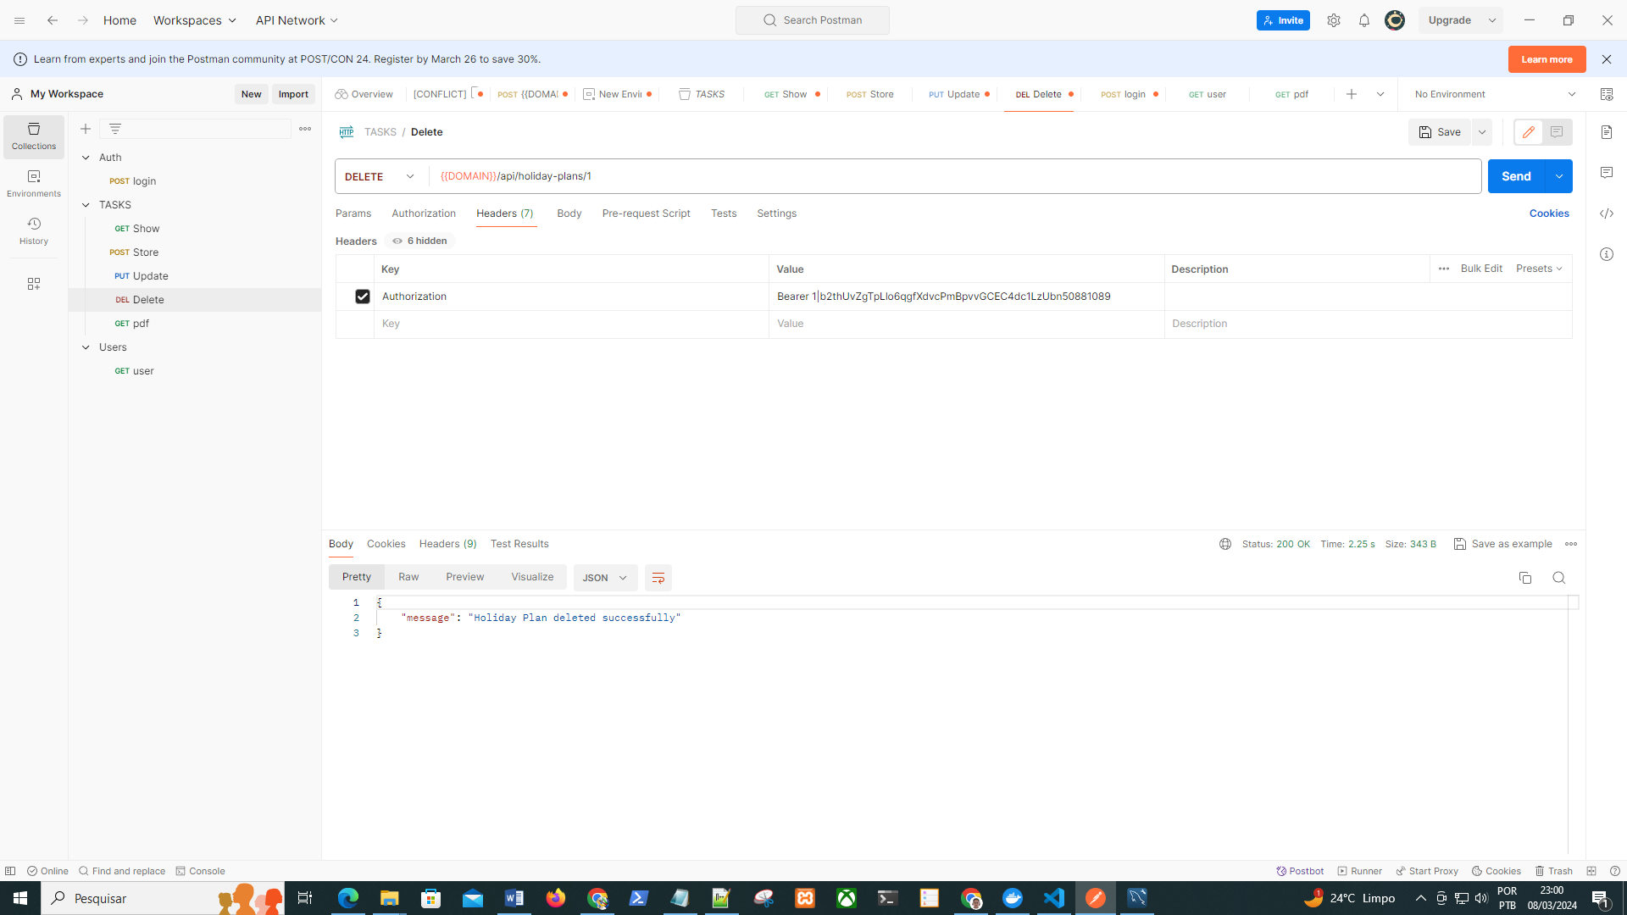

6. Generate PDF for a specific holiday plan (GET):
Endpoint: GET /api/holiday-plans/{id}/generate-pdf
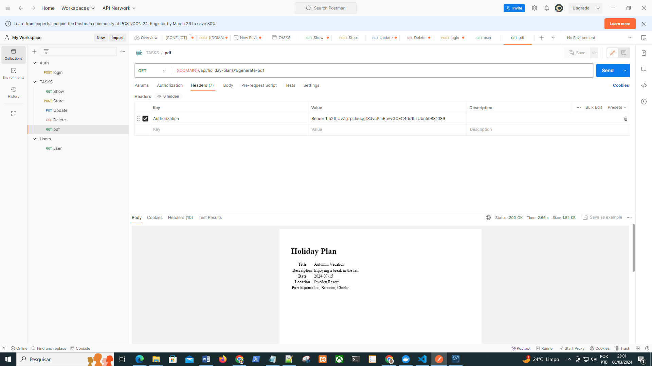

The endpoints for the authentication:
POST /api/login
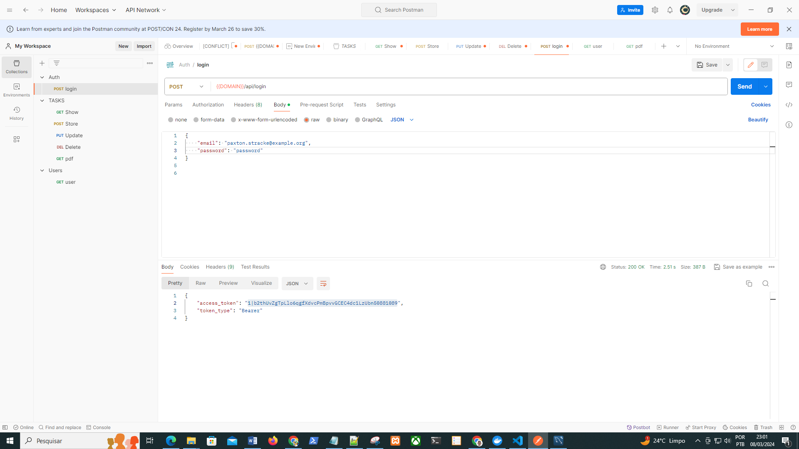

For the user:
GET /api/user
