1. Customized cloning requires the Blitz Actions plugin. This will probably also bring in the Kepler, JJupin, and katl-commons plugins.
2. The Clone script creates a button on the View screen of the issue. This is what the user sees. This should be the first thing under the toolbar on the main screen of the CCXSW default issue screen.

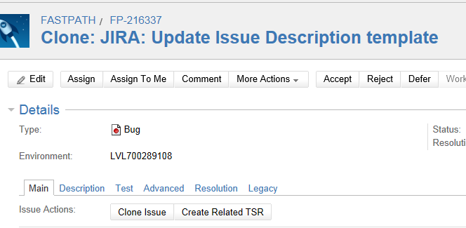

1. The background administration looks something like this:
   1. Custom fields



* 1. When you configure the field value, add the “Clone Issue” button.
     1. 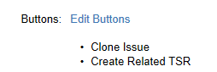

1. The Kepler Plugins will be added to the administration panel.



* 1. There is apparently nothing to do here.

1. The SIL scripts will need to be installed as directed.
   1. The configuration of the scripts are probably completely handled by the SIL scripts. These will have to be loaded in the designated place on the server. Ask Jacob Adelmann what the location of the latest copy of the
      1. EditCondition.txt
      2. EditScreen.txt
      3. EditScript.txt.
         1. This script really causes select fields to be copied.
   2. Follow the guidelines from the Kepler web pages
2. Minimally, we need to copy all fields that are required for opening an issue.
3. We may need a special plugin for the nfeed support. This package contains an outdated plugin. Do not load it unless the latest versions of JIRA work
   1. Kepler SIL Support for nFeed 1.0-SNAPSHOT