2520030151---------P. MADHULIKA

Trigger Example – AFTER INSERT

Create an employees table:

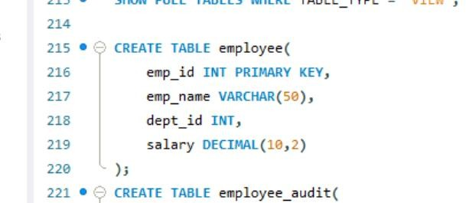

Create an audit table:
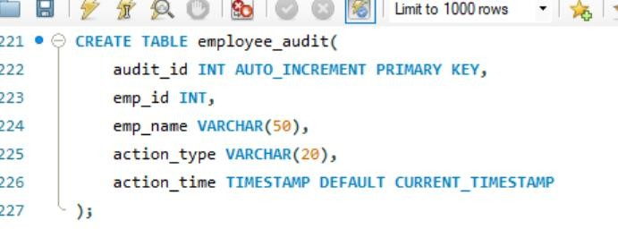
Now create the trigger:
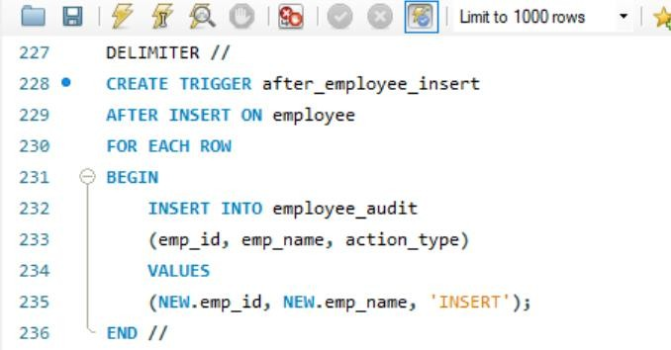

Now insert an employee:

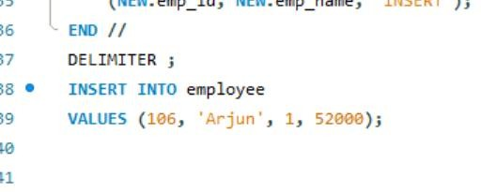

- You didn't call the trigger. It automatically executes.
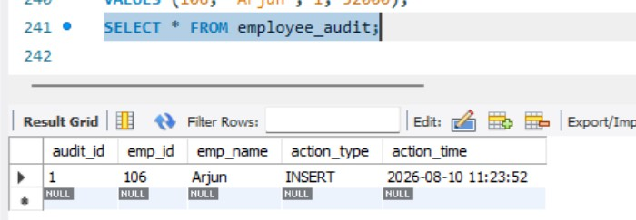

Second Trigger Example – AFTER DELETE Suppose Employee deleted:
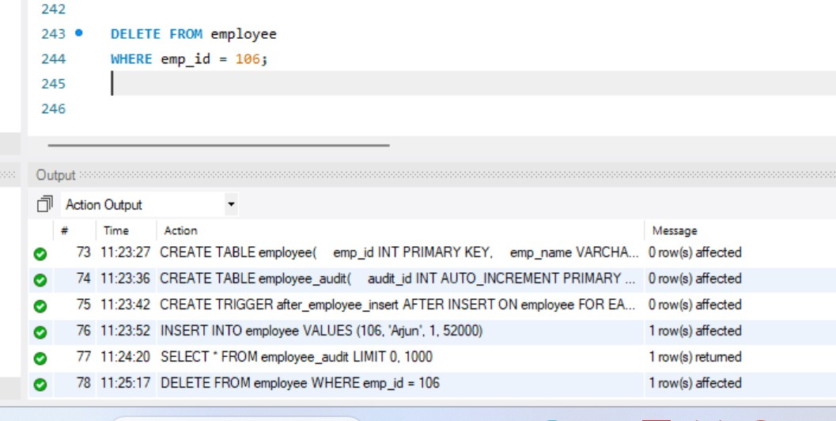

We can automatically record that deletion.

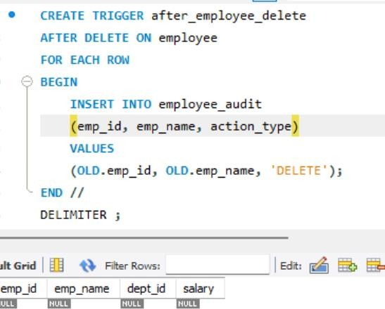

Third Trigger Example--AFTER UPDATE Trigger: We can record the update.

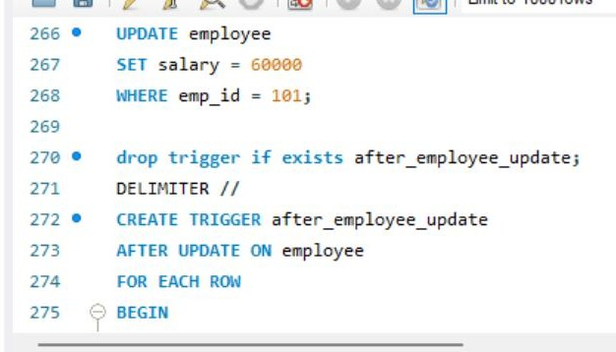

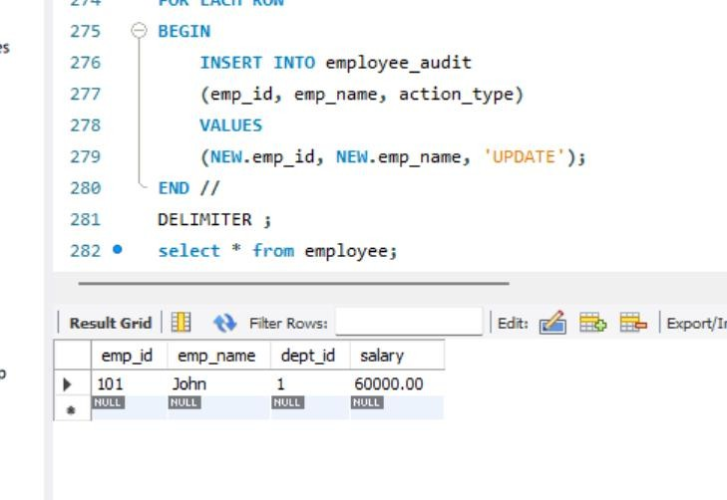

Fourth Trigger Example--BEFORE INSERT Trigger:

Employee salary cannot be less than ₹20,000.
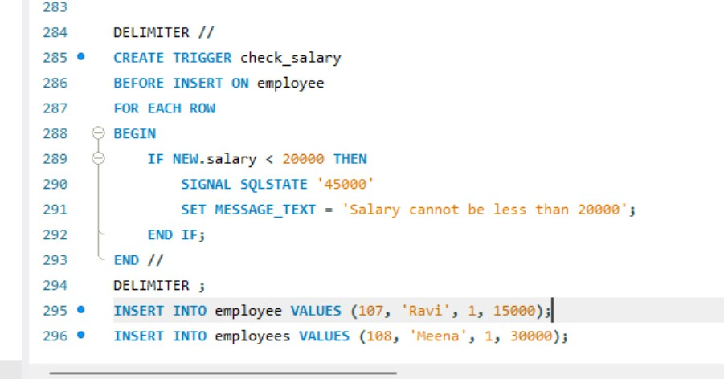

Now, run this Query

INSERT INTO employees VALUES (107, 'Ravi', 1, 15000);

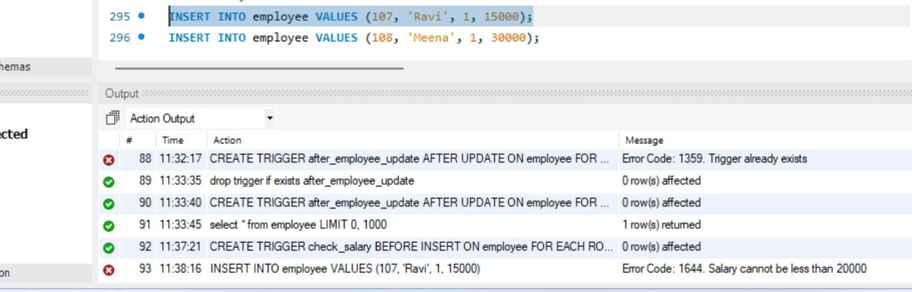

MySQL will reject it and display:

Salary cannot be less than 20000

But, If you run this Query it will succeed as salary is greater than 20000
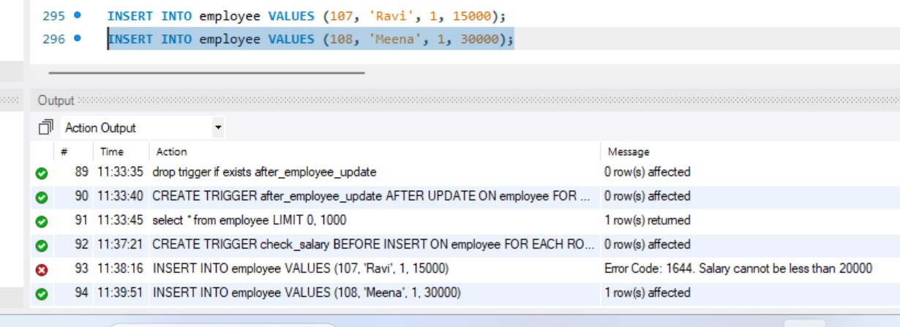

Fifth Trigger Example--BEFORE UPDATE Trigger:

Suppose the company does not allow salary reduction.

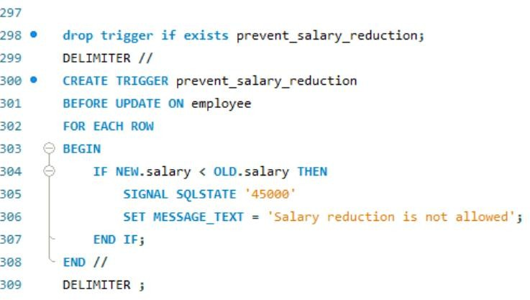

Now, run this Update Query

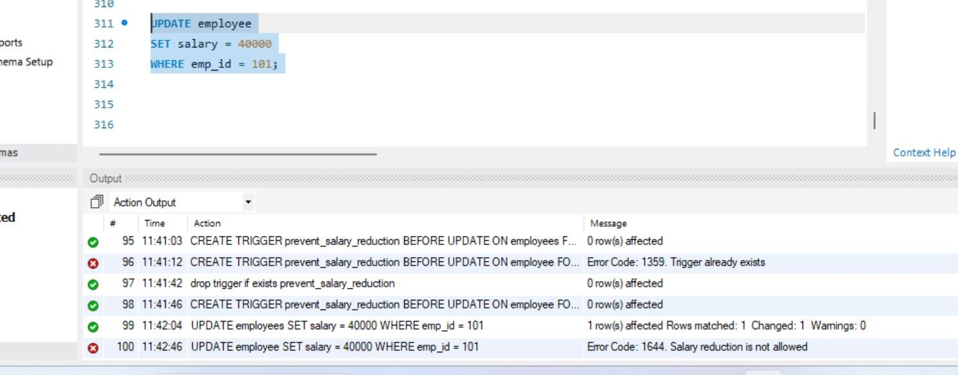

If the old salary was ₹50,000, the trigger rejects the update.

But, if you run the below update query, it succeeds as you are not reducing salary

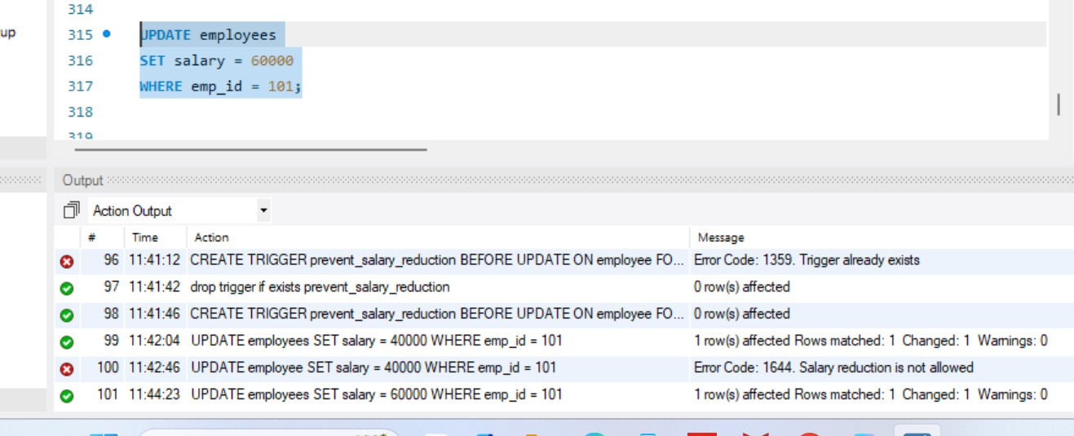

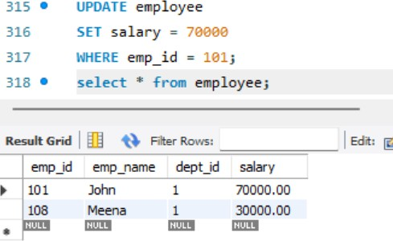

Here, after salary update

OLD.salary → 60000

NEW.salary → 70000

