DATABASE MANAGEMENT SYSTEM LAB exercise

Week 1: Creating Database, Tables and Applying Constraints
Name: PATURU MADHULIKA
Roll No: 2520030151
Branch: CSE
Section: 5
Experiment No: 1
Title
Creation of Database and Tables with Constraints using MySQL Workbench
Procedure
Step 1: Create Database
Query
CREATE DATABASE IF NOT EXISTS bookflow_db;
output:
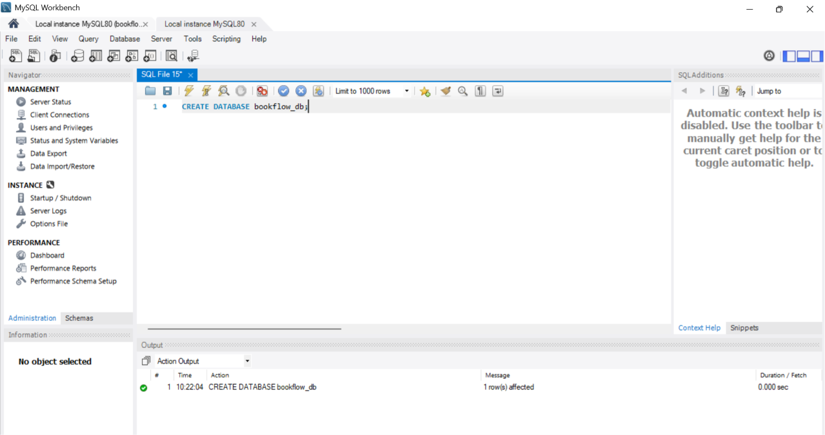
Step 2: Select the Database
Query
USE bookflow_db;
OUTPUT:
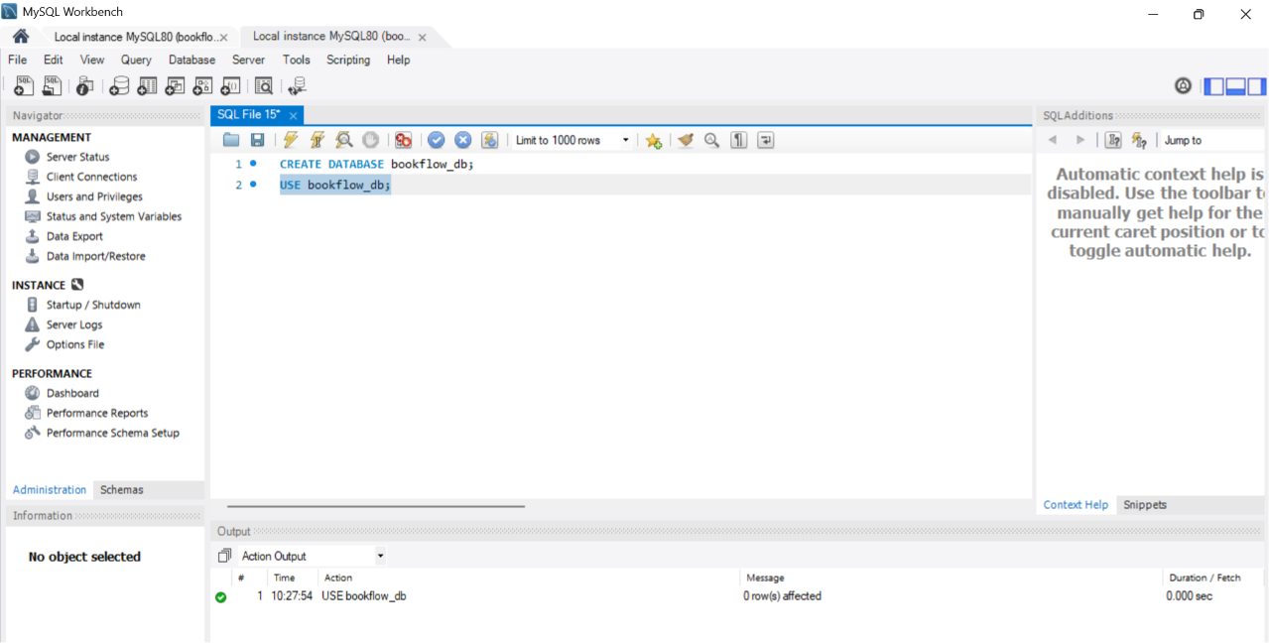

Step 3: Create Books Table
Query
CREATE TABLE books (
book_id INT AUTO_INCREMENT PRIMARY KEY,
title VARCHAR(255) NOT NULL,
isbn VARCHAR(13) NOT NULL UNIQUE,
published_year INT,
CONSTRAINT chk_published_year
CHECK (published_year < 2027)
);

OUTPUT:

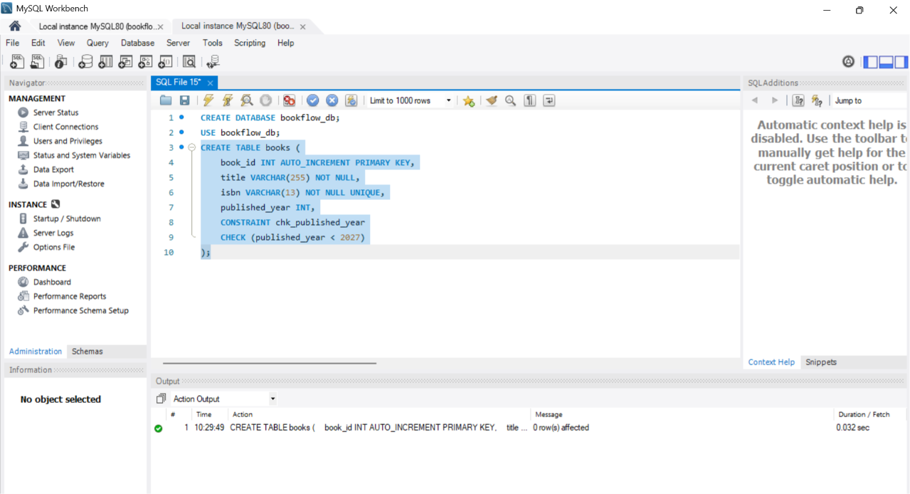
Step 4: Create Members Table
Query
CREATE TABLE members (
member_id INT AUTO_INCREMENT PRIMARY KEY,
full_name VARCHAR(100) NOT NULL,
email VARCHAR(150) NOT NULL UNIQUE
);

OUTPUT:
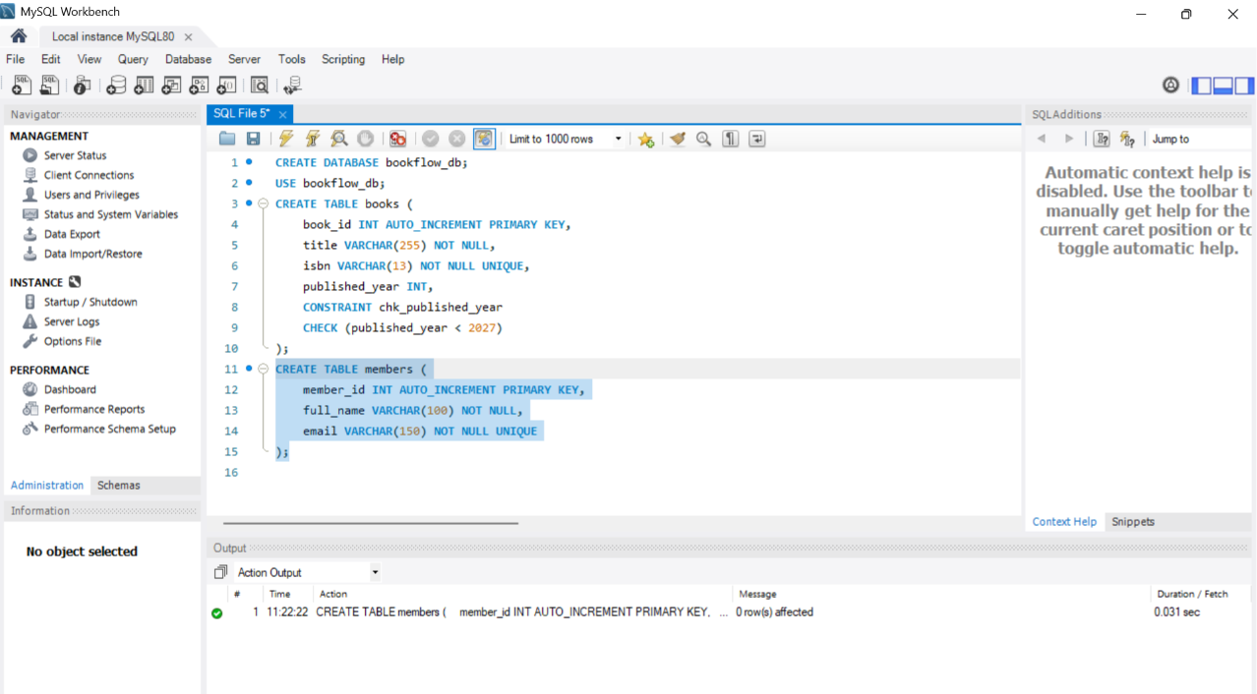
Step 5: Display Tables
Query
SHOW TABLES;
OUTPUT:
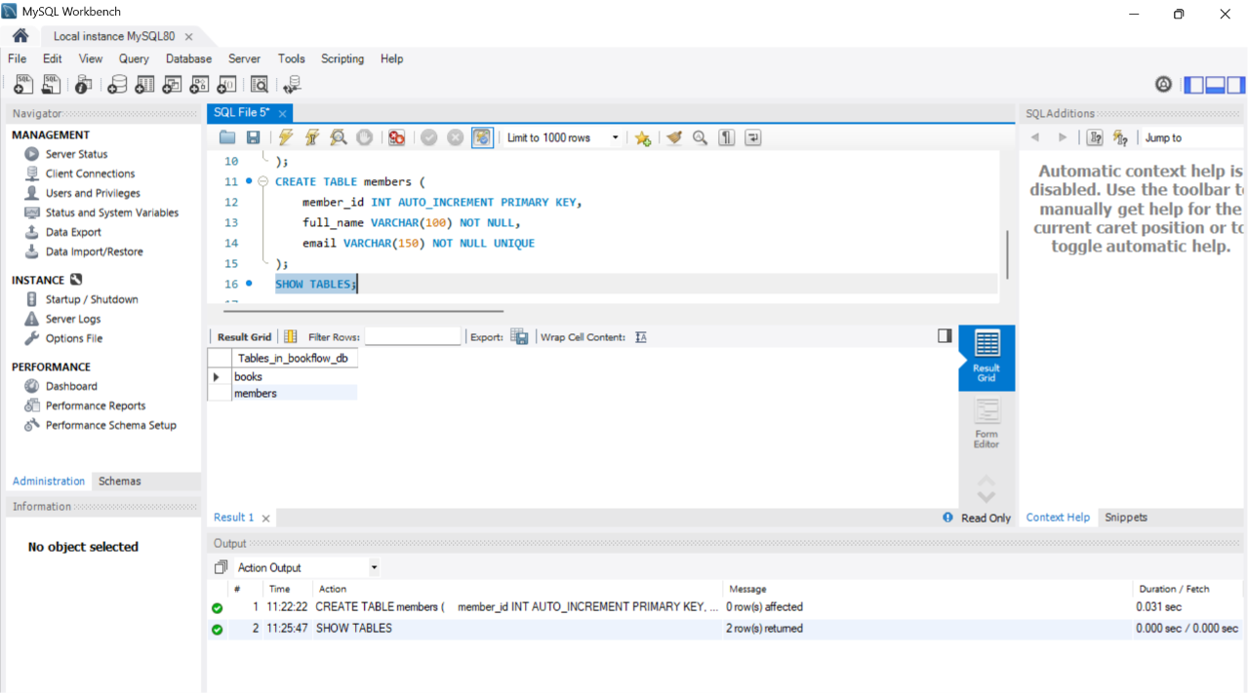

Step 6: Insert Records into Books Table
Query
INSERT INTO books (title, isbn, published_year)
VALUES
('The Alchemist', '9780061122415', 1988),
('Clean Code', '9780132350884', 2008),
('Atomic Habits', '9780735211292', 2018);
OUTPUT:
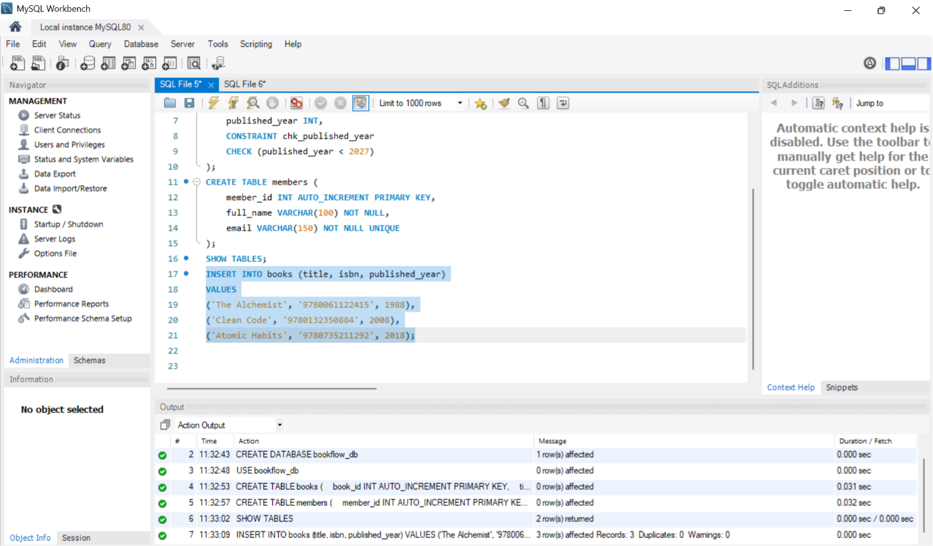

Step 7: Insert Records into Members Table
Query
INSERT INTO members (full_name, email)
VALUES
('Anil Kumar', 'anil.kumar@example.com'),
('Priya Sharma', 'priya.sharma@example.com'),
('Ravi Verma', 'ravi.verma@example.com');
OUTPUT:
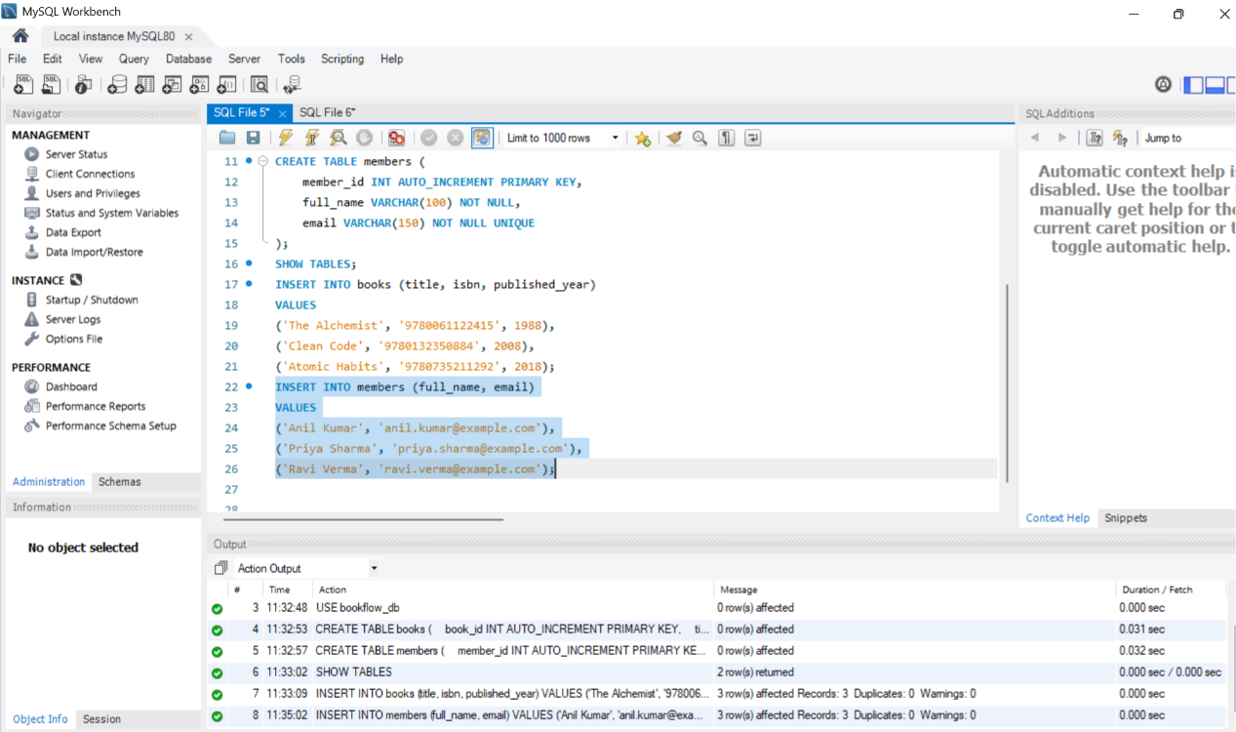
Step 8: Display Books Table
Query
SELECT * FROM books;
OUTPUT:
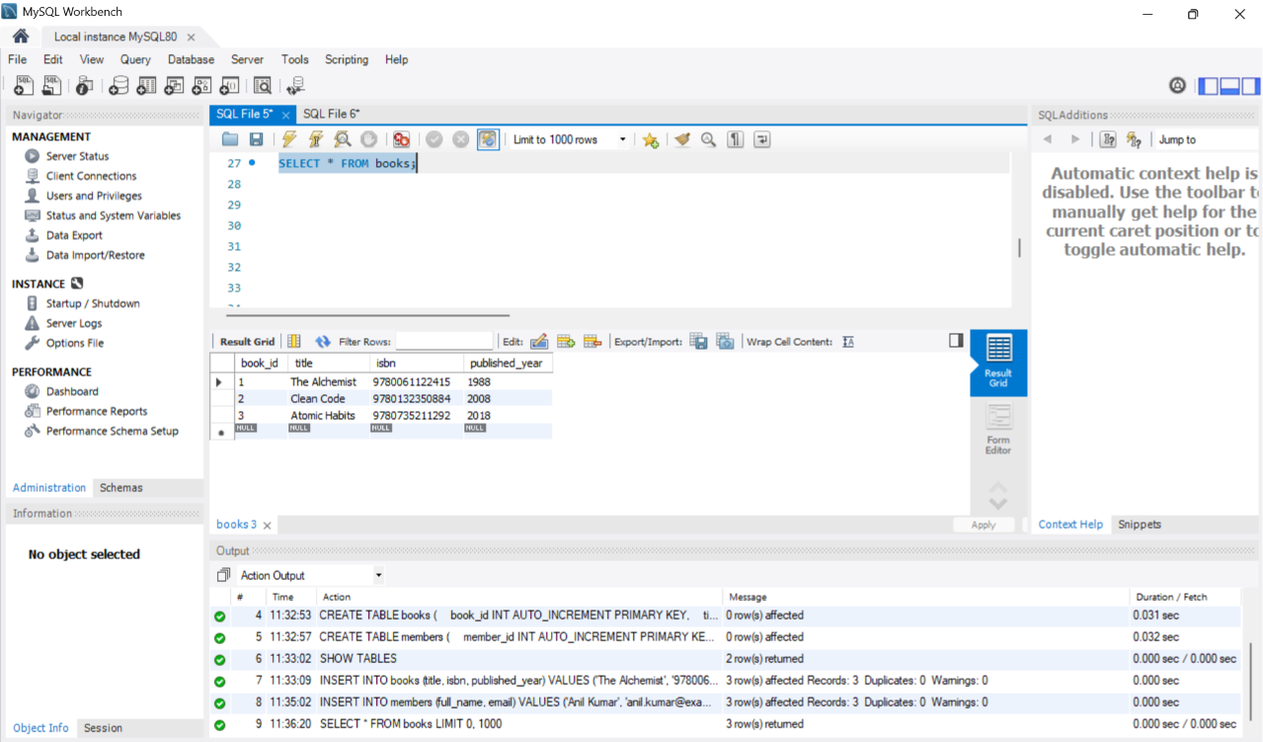
Step 9: Display Members Table
Query
SELECT * FROM members;
OUTPUT:
