PAR Laboratory Assignment

Lab 2: OpenMP programming model and analysis of overheads

Deliverable

Optional: execution time for the multiple versions of Pi
As an optional part for this laboratory assignment, we ask to ll in a table (or draw a graph) with the execution time of the different versions of Pi explored in section 1.2 and the achieved speed-up S₄ with respect to the sequential version pi-v0. Which are the most relevant conclusions you extract?

Part I: OpenMP questionnaire
When answering to the questions in this questionnaire, please DO NOT simply answer with yes, no or a number; try to minimally justify all your answers. Sometimes you may need to execute several times in order to see the effect of data races in the parallel execution.

- Basics
1.hello.c
  - How many times will you see the "Hello world!" message if the program is executed with "./1.hello"?

We will see 24 “Hello world!” messages because we have 24 availables CPUs to execute the program, and OpenMP uses the maximum number of CPUs available in the parallel part if we don't define the number of threads.

  - Without changing the program, how to make it to print 4 times the "Hello World!" message?

We can achieve this by adding the directive OMP_NUM_THREADS=8 before the execution of 1.hello as shown in the following image.
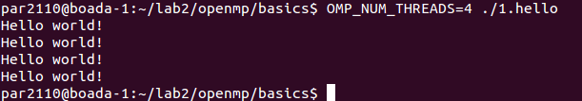

2.hello.c: Assuming the OMP_NUM_THREADS variable is set to 8 with "export OMP_NUM_THREADS=8"
- Is the execution of the program correct? (i.e., prints a sequence of "(Third) Hello (Third) world!" being Third the thread identifier) Which data sharing clause should be added to make it correct?.
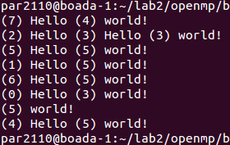
As we can see in the image, the program is not correct, and it prints values that should not be printed.To correct the program we should add the clause private(id) at the OMP line (the resulting line is #pragma omp parallel private(id))
so that the threads do not override the id parameter of the others and are allowed to do the prints correctly.
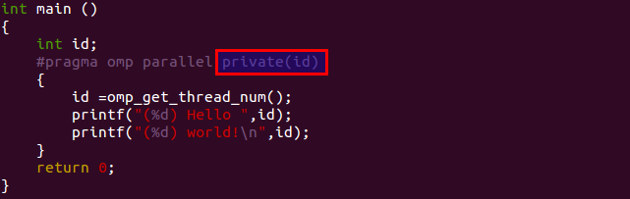
Figure 1: Code of 2.hello.c correct

- Are the lines always printed in the same order? Could the messages appear intermixed?

The lines are not printed in the same order always. This is a problem that appears because each thread has to print 2 times separately, and then so there is the possibility that one or more threads print between those two.
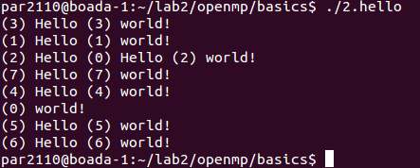
Figure 2: execution of 2.hello with correct code but mixed messages

3.how_many.c: Assuming the OMP_NUM_THREADS variable is set to 8 with "export OMP_NUM_THREADS=8"
- How many "Hello world ..." lines are printed on the screen?

We can see that it prints always 16 “Hello world ...” messages. In the 1st parallel region the variable OMP_NUM_THREADS is set to 8, so it shows 8 messages, one from each thread that executes. Then OMP_NUM_THREADS is setted to 2 with the function omp_set_num_threads(2) and the 2nd parallel region shows 2 messages because it's executed in two threads. The third parallel region, as is launched to 3 threads will ignore the variable OMP_NUM_THREADS and will be executed in the 3 threads defined by the line #pragma omp parallel num_threads(3). The fourth parallel region shows 2 messages like the 2nd region because the global variable OMP_NUM_THREADS is setted to 2 from before the 2nd region. Finally, the fourth region shows only one message because the if(0) after the pragma clause defines that if the result of the if is false then it will be executed only in one thread.

- If the if(0) clause is commented in the last parallel directive, how many "Hello world ..." lines are printed on the screen?

The regions one, two and three will continue to show 8, 2 and 3 messages respectively, but the fourth region will now show between 1 and 4 messages (the number will be determinated by the operation rand%4+1), because now we do not have the if(0) forcing us to use only one thread.

4.data_sharing.c
- Which is the value of variable x after the execution of each parallel region with different data-sharing attribute (shared, private and firstprivate)?

We can ensure that after the execution of the parallel region with private and firstprivate data-sharing attributes, x will have the value 0, because the variable x that each thread uses is a copy of the original x, so they do not change it's value (which is 0). Then we have the shared region, which will usually set the value of x to 8 after the execution, but sometimes it can give us lower results because it can happen that while one thread is incrementing the value of x, another one reads it's value before the other thread has setted the new value and then when he increases it, the incrementation of the other thread is overwritten and it is like if it has not been executed.
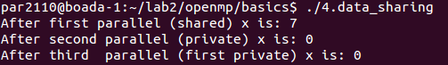

- What needs to be changed/added/removed in the 1st directive to ensure that the value after the 1st parallel is always 8?.

We need to change the directive shared(x) for reduction(+:x). This will ensure that only one thread can be incrementing the value of x at the same time.

5.parallel.c
- How many messages the program prints? Which iterations is each thread executing?
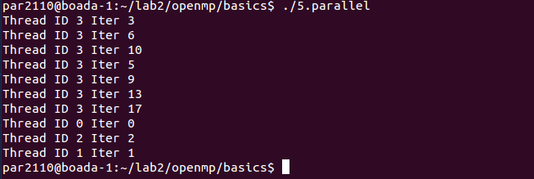
In this image we can see that thread 3 is executing the iterations 3, 6, 10, 5, 9, 13 and 17. The thread 0 executes the iteration 0, the thread 2 executes the iteration 2 and the thread 1 executes the iteration 1. This is one of the different results that we've obtained when executing the program 5.parallel, which shows 10 messages, but obviously its not working correctly due to problems with the data-sharing. It should show 20 messages with 4 threads executing iterations by steps of 4.

- What needs to be changed in the directive to ensure that each thread executes the appropriate iterations?.

To solve the problem mentioned in the las point and ensure that each thread excutes the apropiate iterations we must add private(i) to the directive.

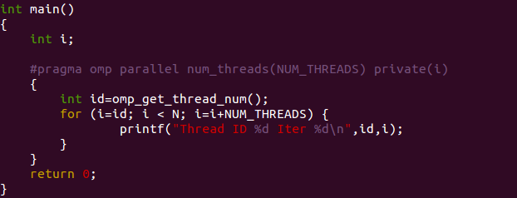
6.datarace.c (execute several times before answering the questions)

- Is the program always executing correctly?

After executing several times we can see that the execution of 6.datarace sometimes fails and shows the message “Sorry, something went wrong, value of x = $value”.
- Add two alternative directives to make it correct. Which are these directives?

To make this program correct we have two options:
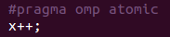
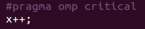
- atomic
- critical
This directives provide a region of exclusion where only one thread can work at the same time. The difference is that while critical only lets one thread to work at any given time, atomic is protecting a storage location avoiding the possibility of being read and written by multiple threads.

7.barrier.c
  - Can you predict the sequence of messages in this program? Do threads exit from the barrier in any specific order?

Let's analyze the following code corresponding to the main of 7.barrier.c.
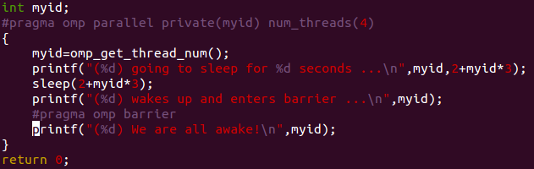
From this code we can see that in the parallel region we have 3 different printf, so lets see each one of them separately:
- The first printf only prints the id of the thread, but we cannot predict the sequence of the messages because they're all being executed at the same time and there is no way to predict the order in which they will do the printf.
- Before this printf the threads have been put to sleep for a time of 2+$threadID*3 seconds, so in this case the messages will be printed in order (0 → 1 → 2 → 3).
- At this point, all threads come from the barrier. They will be through that barrier when all threads have finished their work, then they'll be allowed to continue their execution and do the printf, so as the execution is simultaneously, we have no way to predict the order of the messages.
After several executions, I've observed that the first thread to exit from the barrier is the last one who finishes the work, but we cannot specify the order in which the rest of threads exit from it.

- Worksharing
1.for.c
- How many iterations from the 1st loop are executed by each thread?

In this 1st loop each thread executes 2 iterations of the loop.

- How many iterations from the 2nd loop are executed by each thread?

In this 2nd loop, the first 3 threads execute 3 iterations each one, meanwhile the other threads execute just 2 threads.

- Which directive should be added so that the 1st printf is executed only once by the 1st thread that finds it?.

Adding the directive “#pragma omp single” we can make that only the 1st thread to reach the printf executes it.

2.schedule.c
1. Which iterations of the loops are executed by each thread for each schedule kind?

In the table we 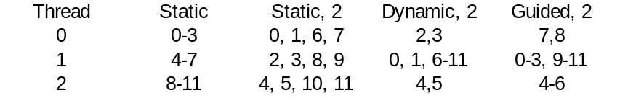can see the data resulting from the execution of 2.schelude.c

3.nowait.c
- How does the sequence of printf change if the nowait clause is removed from the 1st for directive?

The printf of the 1st loop are printed all before printing the 2nd ones because there is an implicit barrier at the end of the loop.

- If the nowait clause is removed in the second for directive, will you observe any difference?

We will not observe any difference because its the last loop and theres nothing else to execute after it.

4.collapse.c
- Which iterations of the loop are executed by each thread when the collapse clause is used?

Each thread executes N²/num_threads which are distributed between them in packs so that the 1st thread executes the iterations 0-0, 0-1, 0-2, 0-3 (it executes one more iteration than the other ones), the 2nd thread executes the iterations 0-4, 1-0, 1-1 and so on with the rest of threads.

- Is the execution correct if the collapse clause is removed? Which clause (different than collapse) should be added to make it correct?.
The execution is not correct if we remove the collapse clause. To make it correct we have to privatize the variables i and j with the private(i,j) clause, so that each threat will have its own values of them and will not be shared with the other threads, allowing a correct execution of the loop.

5.ordered.c
- How can you avoid the intermixing of printf messages from the two loops?
We can avoid the intermixing of printf removing the nowait clause of the 1st loop, with this change we're placing an implicit barrier at the end of the 1st loop so that the 2nd loop does not start until the 1st one finishes.

- How can you ensure that a thread always executes two consecutive iterations in order during the execution of the 1st loop?
We can ensure that changing the schedule clause for schedule(static,2). We can also change it for schedule(dynamic,2), but this second version will ensure that a thread executes a “multiple of two” consecutive iterations in order as the iterations are assigned dynamically in packs of two.

6.doacross.c

- In which order are the "Outside" and "Inside" messages printed?
The “Outsite” messages are printed before the “Inside” ones.

- In which order are the iterations in the second loop nest executed?
When both of the dependences are completed, the iteration can be executed, but if more than one has to be executed we cannot ensure their order.

- Tasks

1.serial.c

  - Is the code printing what you expect? Is it executing in parallel?
The code is printing what we expect, the execution of the computation of the Fibonacci sequence, but it is not being executed in parallel.
2.parallel.c

- Is the code printing what you expect? What is wrong with it?

Its not printing what I expect because the execution of the program is not correct.
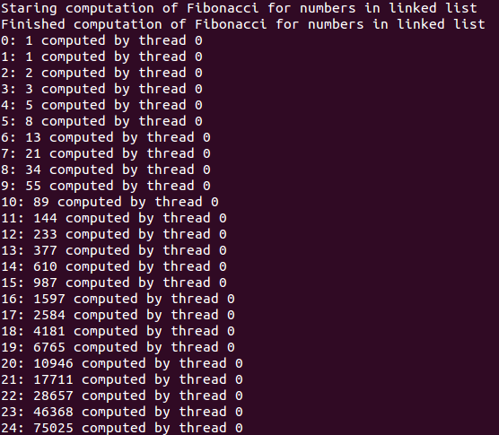
- Which directive should be added to make it's execution correct?.
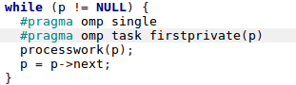
To achieve a correct execution we need to add a clause #pragma omp single before the #pragma omp task so that only one thread executes the task clause.

- What would happen if the firstprivate clause is removed from the task directive? And if the firstprivate clause is ALSO removed from the parallel directive? Why are they redundant?

Removing the firstprivate clause of the task directive has no effect on the execution of the program, but removing the one from the parallel directive makes the program fail from a segmentation fault or either entering a wait mode that never ends.
It is redundant in the task clause because the variables are by default firstprivate in tasks.

- Why the program breaks when variable p is not firstprivate to the task?

Because then the p variable is shared with the other threads and then doing a simultaneous access to the variable p will make a Segmentation Fault in p=p->next.

- Why the firstprivate clause was not needed in 1.serial.c?

It was not needed because there was no parallelism there so only one thread was accessing to p.

3.taskloop.c

- Execute the program several times and make sure you are able to explain when each thread in the threads team is actually contributing to the execution of work (tasks) generated in the taskloop.

Part II: Parallelization overheads

- Which is the order of magnitude for the overhead associated with a parallel region (fork and join) in OpenMP? Is it constant? Reason the answer based on the results reported by the pi omp parallel.c code.

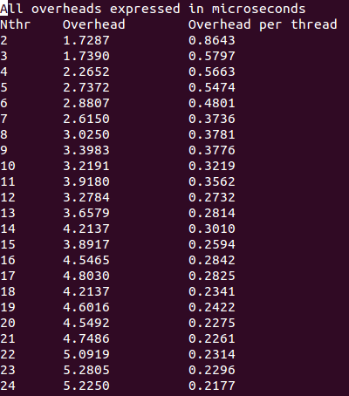
The results below were obtained with the execution queue with the argument submit-omp.sh pi_omp_parallel 1 24.
We can see that the order of the magnitude for the overhead is of microseconds. The overhead becomes smaller as the number of threads increases, and it becomes more or less constant from the 18th number of thread, where the overhead from the threads goes from 0.23 to 0.25µs from that one on.

- Which is the order of magnitude for the overhead associated with the creation of a task and it's synchronization at taskwait in OpenMP? Is it constant? Reason the answer based on the results reported by the pi omp tasks.c code.

The overhead for the creation and synchronization of a task is in the order of magnitude of tenths of microseconds per task (10⁻⁷ s), but it is not constant and depends on the number of tasks that we have, with higher number of tasks having lower values, probably being due to initialization costs which are not increased with the number of tasks. There is not much variation and seems to be about 0:12µs when the number of tasks increases.

The results below were obtained with the execution queue with the argument submit-omp.sh pi omp tasks 10 1.
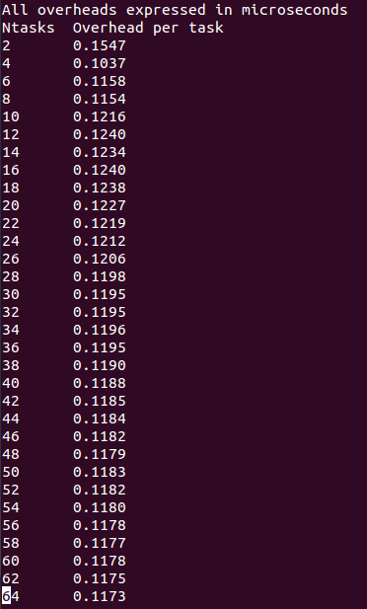
- Which is the order of magnitude for the overhead associated with the execution of critical regions in OpenMP? How is this overhead decomposed? How and why does the overhead associated with critical increase with the number of processors? Identify at least three reasons that justify the observed performance degradation. Base your answers on the execution times reported by the pi omp.c and pi omp critical.c programs and their Paraver execution traces.

Table 3.4 on page 15 lists the measured execution times for pi omp critical, which will be used for the calculations below.
The overhead per iteration for 1 processor can be calculated by the di erence in execution time for 1 processor between pi omp and pi omp critical, divided by the number of iterations. This is:

1:794 312 s 0:793 466 s _{= 10:008 46 ns}

100 10⁶

When the number of processors is increased to 8, a similar calculation can be performed to see the overhead. This will similarly be compared to pi omp for 8 processor and will also be divided by the same number of iterations (as this is unchanged). This will give us the estimated overhead per iteration for pi omp critical with 8 processors:

20:996 068 s 0:109 428 s _{= 208:871 78 ns}

100 10⁶
With 1 processor, it can be seen that the order of magnitude of the overhead is 10 ns (10⁻⁸ s), but with 8 processors there is a 20-fold increase, so the overhead is in the order of 100 ns (10⁻⁷ s).
This can be visualized by using Paraver, as seen in the figure below. In this trace:

Red: represents synchronization

Dark blue: represents execution

Light blue: represents idle

Figure 3.1: Paraver Trace for pi omp critical
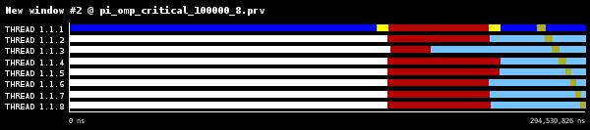

Looking at the results it can be seen that pi omp critical takes a much longer time with 8 threads than with 1. This is due to the fact that the critical directive is within each iteration of the for loop, restricting the access of the shared variable sum, but in pi omp this is only restricted outside of the for loop. From the Paraver trace in 3.1 it can be seen that once the threads are created, they spend the most of their time in the synchronization state. This can also be seen in the two Paraver-generated Figures 3.2 and 3.3 below, where it is clear that a large portion of the time spent is wasted on synchronization due to the critical region, but also due to I/O and scheduling.

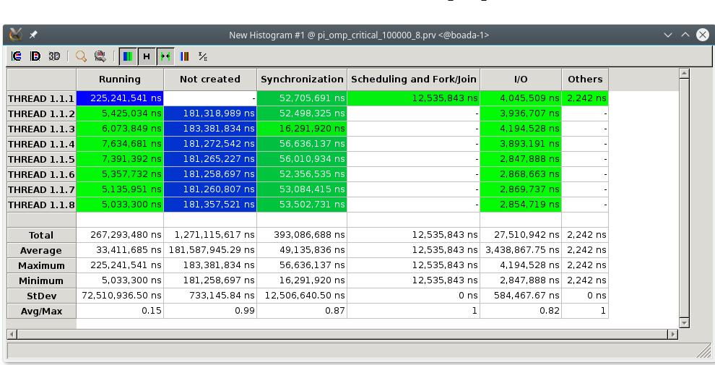
Figure 3.2: Time spent in state for pi omp critical

Figure 3.3: Percentage time spent in state for pi omp critical
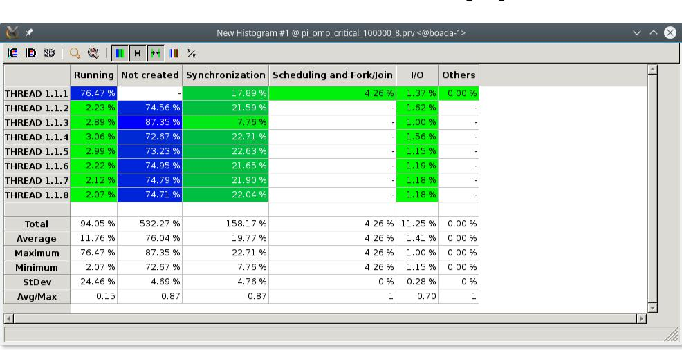

- Which is the order of magnitude for the overhead associated with the execution of atomic memory accesses in OpenMP? How and why does the overhead associated with atomic increase with the number of processors? Reason the answers based on the execution times reported by the pi omp.c and pi omp atomic.c programs.

Table 3.4 on page 15 lists the measured execution times for pi omp atomic, which will be used for the calculations below.
As in the case with the critical clause, the overhead per iteration for 1 processor can be calculated by comparing the execution time for 1 processor between pi omp and pi omp critical:

1:469 002 s 0:793 466 s _{= 6:755 36 ns}

100 10⁶

When the number of processors is increased to 8, a similar calculation can be performed to see the overhead in this case:
6:247 624 s 0:109 428 s _{= 61:381 96 ns}

100 10⁶

As can be seen, the overhead for each iteration in this case is in the order of 10 ns (10⁻⁷ s), but it increases more than tenfold when the number of processors is increased. This is not surprising, given that the 8 threads will have to compete for access to the same atomic operation, but with 1 processor the overhead will be only due to setting and unsetting of locks, but not due to actual synchronization (as there is only one thread).

- In the presence of false sharing (as it happens in pi omp sumvector.c), which is the additional average time for each individual access to memory that you observe? What is causing this in-crease in the memory access time? Reason the answers based on the execution times reported by the pi omp sumvector.c and pi omp padding.c programs. Explain how padding is done in pi omp padding.c.

Table 3.4 on page 15 lists the measured execution times for pi omp padding and pi omp sumvector, which will be used for the calculations below.
In order to measure the overhead due to false sharing, we will compare the execution times of pi omp padding, which has been designed to avoid false sharing, and pi omp sumvector, where false sharing is present. As in other cases, the overhead per iteration for 1 processor can be given by:
0:791 440 s 0:788 964 s _{= 24:76 ps}

100 10⁶

This number is small enough to be considered within the margin of error, as is expected with 1 thread. Here there will not be any false sharing between threads because there is only one. For 8 threads the result is different:
0:631 446 s 0:117 247 s _{= 5:141 99 ns}

100 10⁶

Here we see there is a noticeable per iteration. This is still a smaller impact than that due to the atomic or critical clauses, but it is still enough to signi cantly slow down the program (it is almost 5 times as slow), and is in the order of 1 ns (10⁻⁹ s) per iteration.

The table below summarizes the execution times with 1 and 8 threads for the different versions of the program. Each execution was performed 3 times for 100000000 iterations, and the median value was taken.
The speed-up column was calculated by dividing the execution time for pi seq.c by the time with 8 pro-cessors for each row.
- Write down a table (or draw a plot) showing the execution times for the different versions of the Pi computation that we provide to you in this laboratory assignment (session 3) when executed with 100:000:000 iterations. and the speed{up achieved with respect to the execution of the serial version pi seq.c. For each version and number of threads, how many executions have you performed?
The table below summarizes the execution times with 1 and 8 threads for the different versions of the program. Each execution was performed 3 times for 100000000 iterations, and the median value was taken.
The speed-up column was calculated by dividing the execution time for pi seq.c by the time with 8 pro-cessors for each row.

Table 3.4: Execution times (s) for different versions of pi xxxxx.c

version |  | 1 processor | 8 processors | speed-up
pi seq.c |  | 0.794029 | - | 1
pi omp.c (sumlocal) |  | 0.793466 | 0.109428 | 7.256
pi omp critical.c |  | 1.794312 | 20.996068 | 0.0378
pi omp atomic.c |  | 1.469002 | 6.247624 | 0.127
pi omp sumvector.c |  | 0.791440 | 0.631446 | 1.257
pi omp padding.c |  | 0.788964 | 0.117247 | 6.772

