


Faculty of Electrical engineering & Informatics
Budapest university of technology and economics

Document of
Book Bank

By
Bikash Kumar Mahanti
O8F1L9

Class Diagram:
- Library
- Admin Login
- AdminMenu
- Enterlibraryuserdata
- viewLibrarian
- RemoveLibraryUser
- LibraryUserManager
- Librarian
- libraryUserlogin
- LibraryUsermenu
- enterBookData
- CheckBook
- IssuedBookForm
- CheckIssuedBook
- Returnbook
- BookManager
- returnBookManager
- issuedBookManager
- BookManager
- Book
- IssuedBook
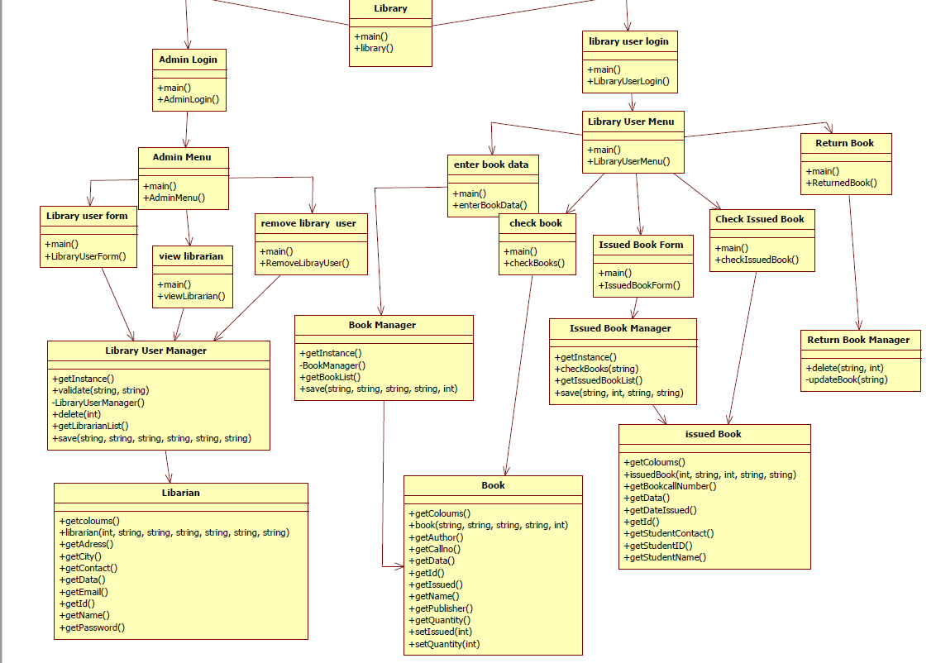

Sequence diagram:

Admin login
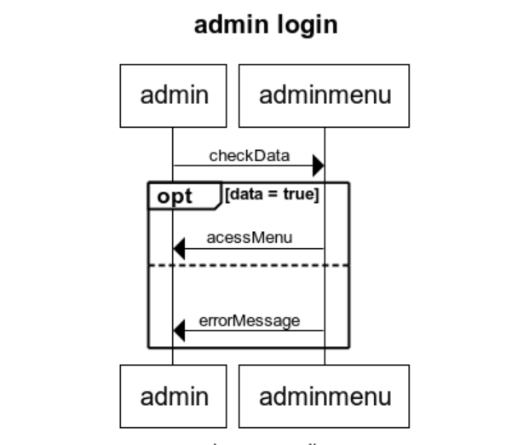

Library user login
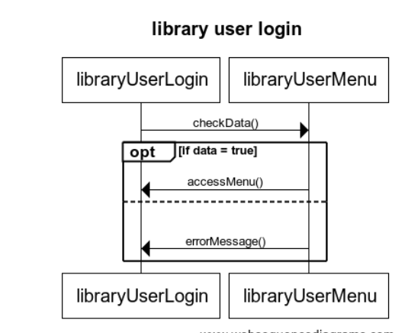

Remove librarian
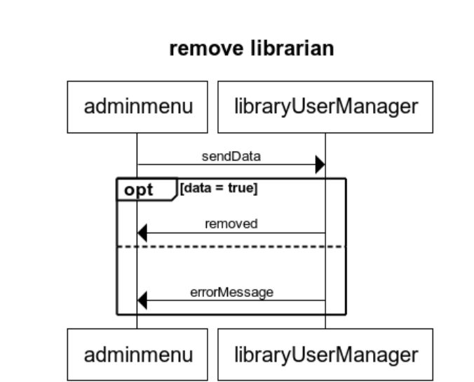

View librarian

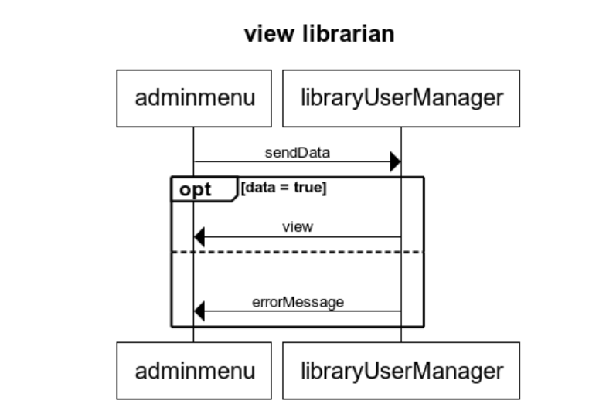

Enter Book Data
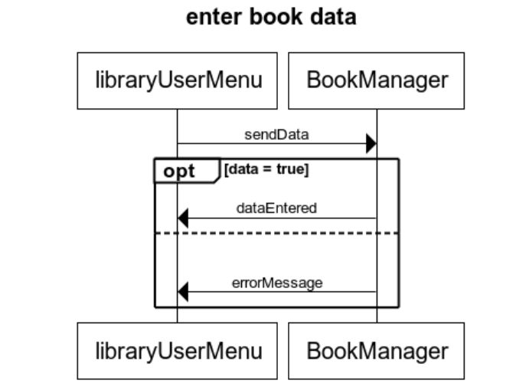

Check Book
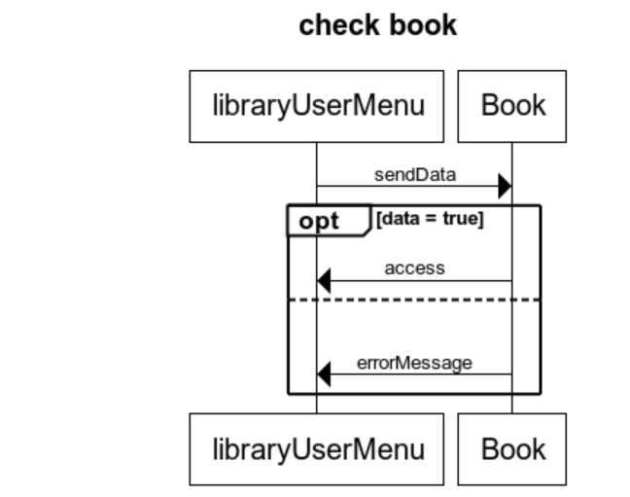

Issued Book Form
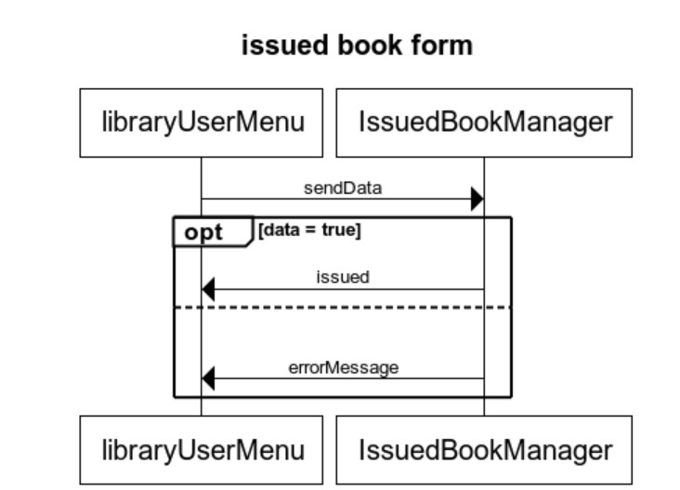

Checked issued book
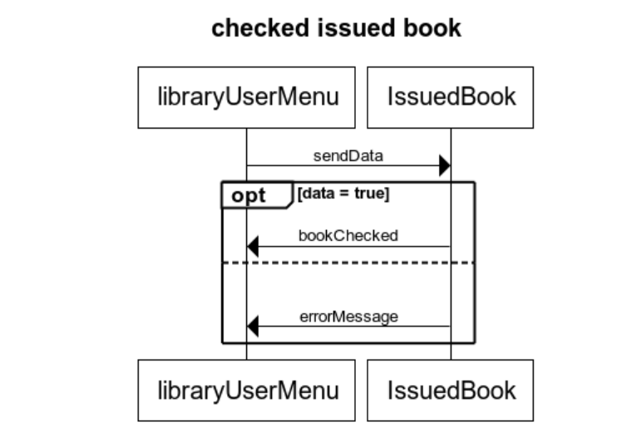

Return Book
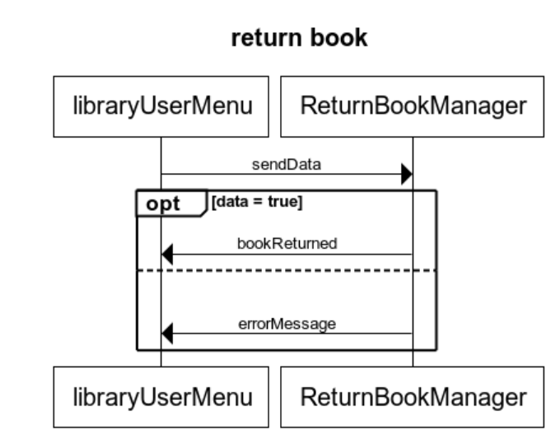

Test cases:

addBook():void
given are the test values for add book.
- String name = "testName";
- String pass = "testPw";
- String email = "testEmail";
- String addr = "testAddr";
- String city = "testCity";
- String contact = "testContact";

addLibrarian():void
given are the test values for addLibrarian.
- String name = "testName";
- String pass = "testPw";
- String email = "testEmail";
- String addr = "testAddr";
- String city = "testCity";
- String contact = "testContact";

deleteLibrarian():void
given are the values for the delete librarian,
- String name = "testName";
- String pass = "testPw";
- String email = "testEmail";
- String addr = "testAddr";
- String city = "testCity";
- String contact = "testContact";

issueBook():void
given are the values for the issue book,
- String callno = "testNo";
- String name = "testName";
- String author = "testEmail";
- String publisher = "testAddr";
- int quantity = 9999;

returnBook():void
given are the values to test return Book,
- String bookCallNo = "test";
- int studentId = 9999;
- String studentName = "testName";
- String studentContact = "testContact";

