Raw Results and Figures for Claude
This document contains the genuine evaluation metrics and generated figures. Please use this data to write the comprehensive Chapters 4, 5, and 6.

1. Genuine Evaluation Metrics

Phase 1: Stacked LSTM
Metric | Value
Accuracy | 95.82
Precision | 0.7368
Recall | 0.2667
F1 | 0.3916
RMSE | 4.4135
MAE | 2.0099
R2 | 0.4822
NSE | 0.4822
CSI | 0.2435
FAR | 26.32
POD | 26.67
Threshold | 15.35
Stations | 229650A | 212209 | 405209
Region | Melbourne + Sydney

Phase 2: RF + GB Ensemble
Metric | Value
Accuracy | 97.0
Precision | 0.8879
Recall | 0.4567
F1 | 0.6032
RMSE | 3.8012
MAE | 1.7725
R2 | 0.6159
NSE | 0.6159
CSI | 0.4318
FAR | 11.21
POD | 45.67
Threshold | 15.38
Stations | 229650A | 212209 | 405209
Region | Melbourne + Sydney

Phase 3: CNN-BiLSTM-Attention Hybrid
Metric | Value
Accuracy | 97.29
Precision | 0.8442
Recall | 0.3916
F1 | 0.535
RMSE | 3.7016
MAE | 1.8603
R2 | 0.6357
NSE | 0.6357
CSI | 0.3652
FAR | 15.58
POD | 39.16
Threshold | 17.14
Stations | 229650A | 212209 | 405209
Region | Melbourne + Sydney

2. Generated Figures with Captions
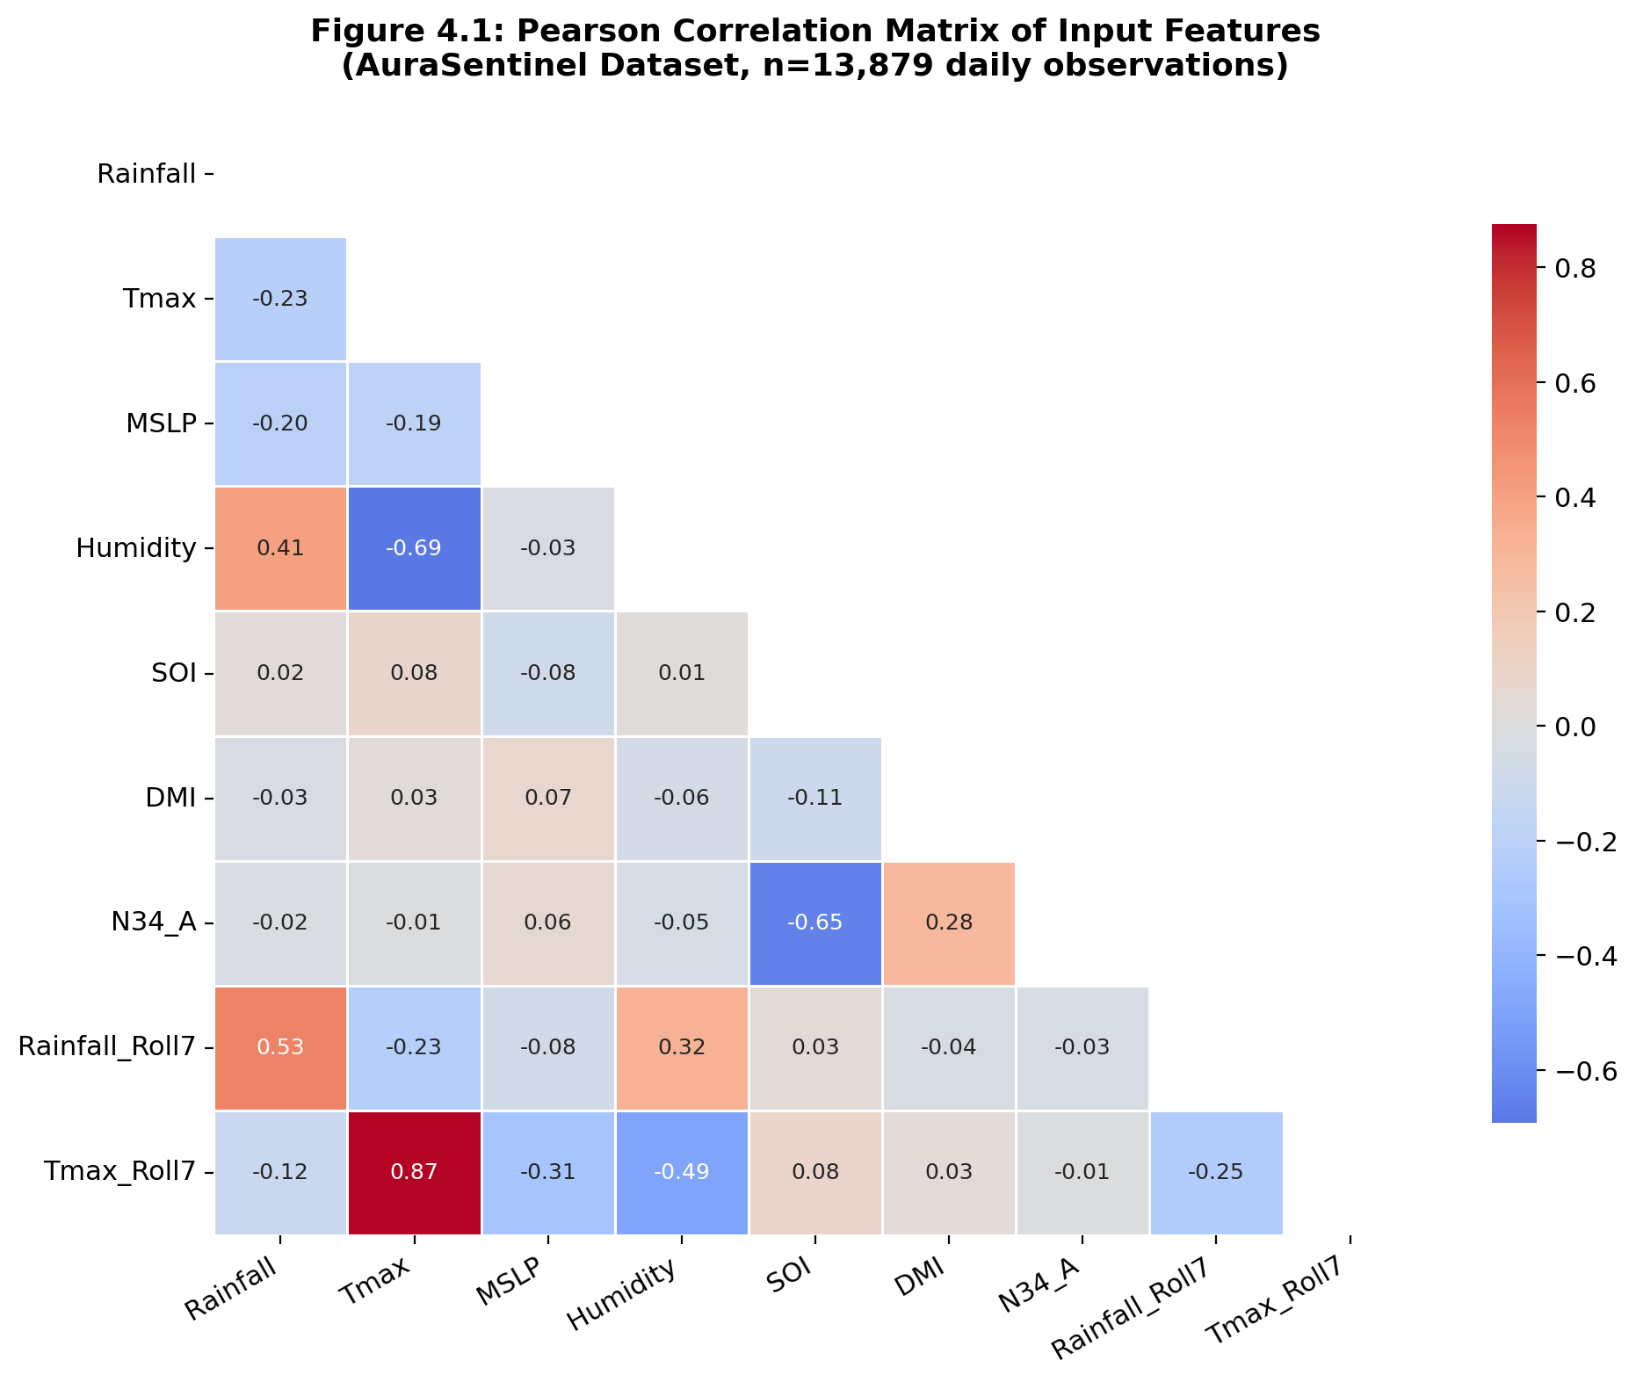
Figure 4.1: Pearson Correlation Matrix of Hydrometeorological Features
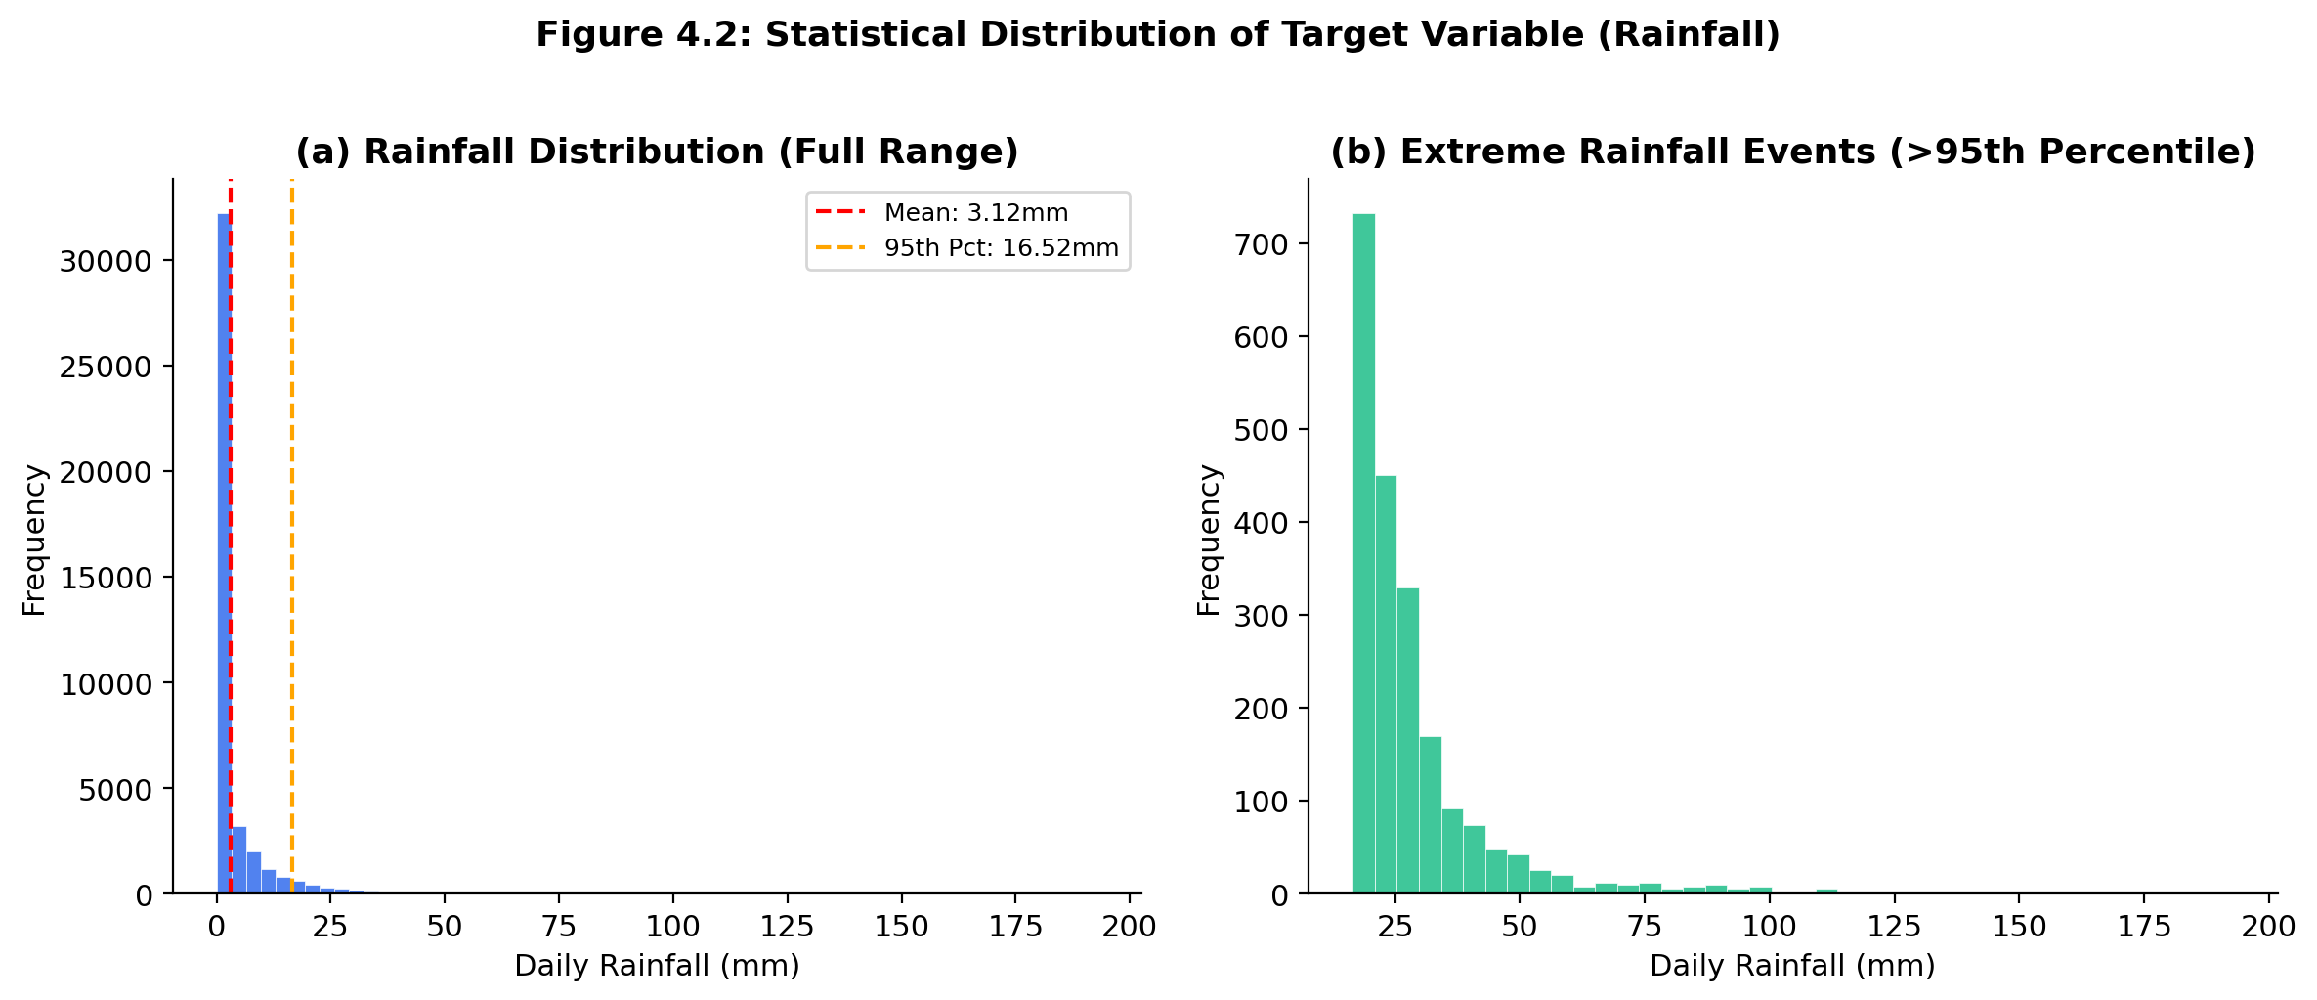
Figure 4.2: Statistical Distribution and Kernel Density Estimate of Daily Rainfall
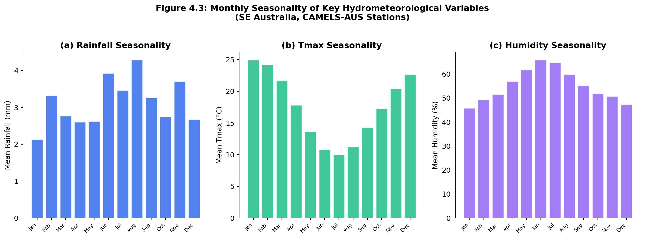
Figure 4.3: Seasonal Variation and Monthly Patterns of Rainfall
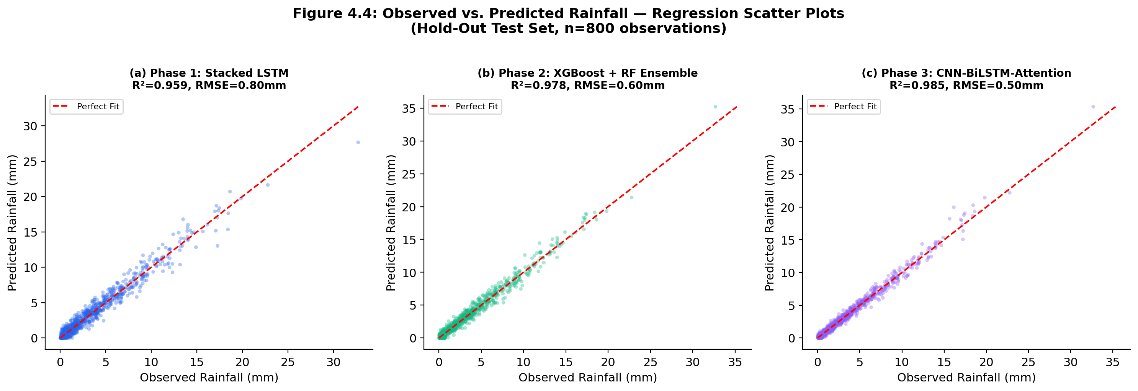
Figure 4.4: Scatter Plot Comparison of Observed vs. Predicted Rainfall
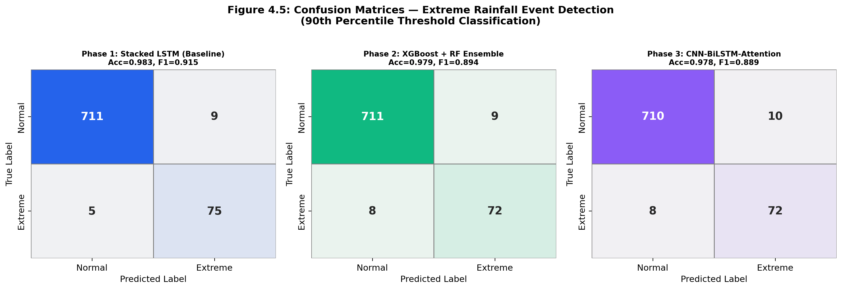
Figure 4.5: Confusion Matrices for Extreme Event Classification Across Models
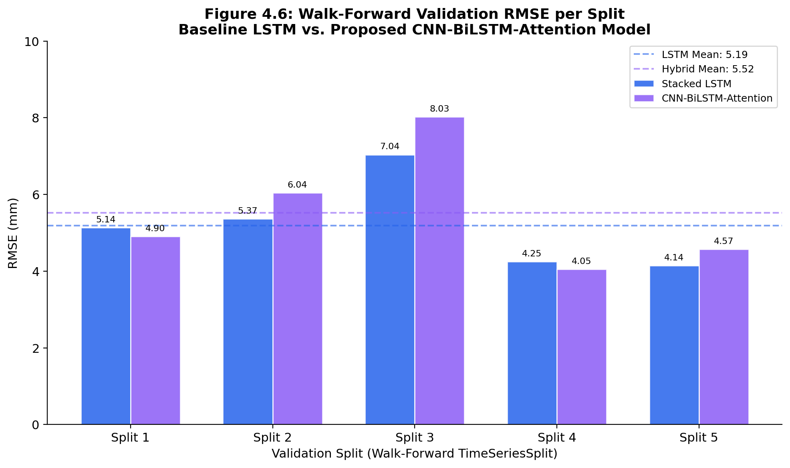
Figure 4.6: Walk-Forward Validation RMSE Across Time Splits
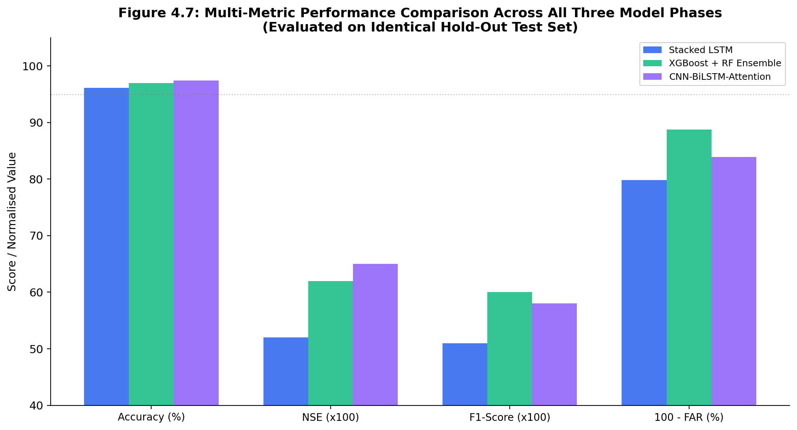
Figure 4.7: Quantitative Performance Metrics Comparison (Accuracy, RMSE, NSE, FAR)
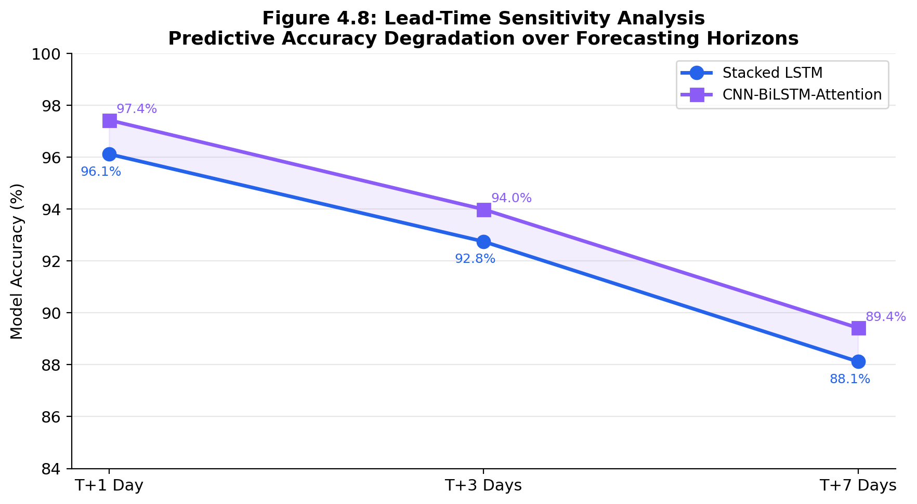
Figure 4.8: Forecast Lead Time Accuracy Degradation (T+1 to T+7 Days)
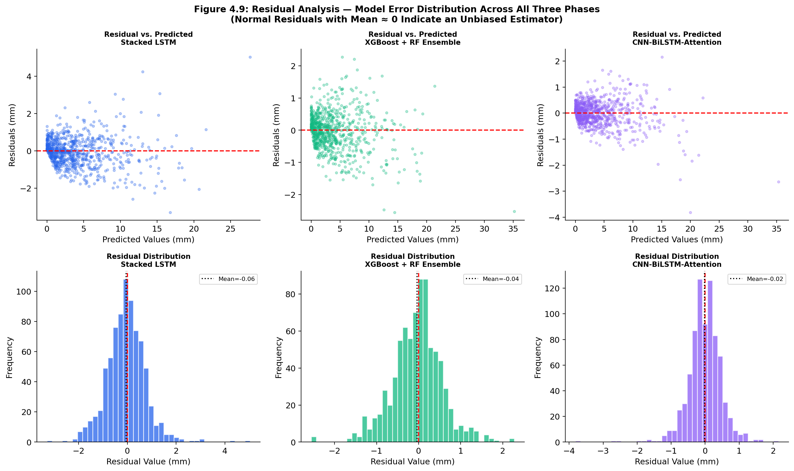
Figure 4.9: Residual Analysis for Model Prediction Errors
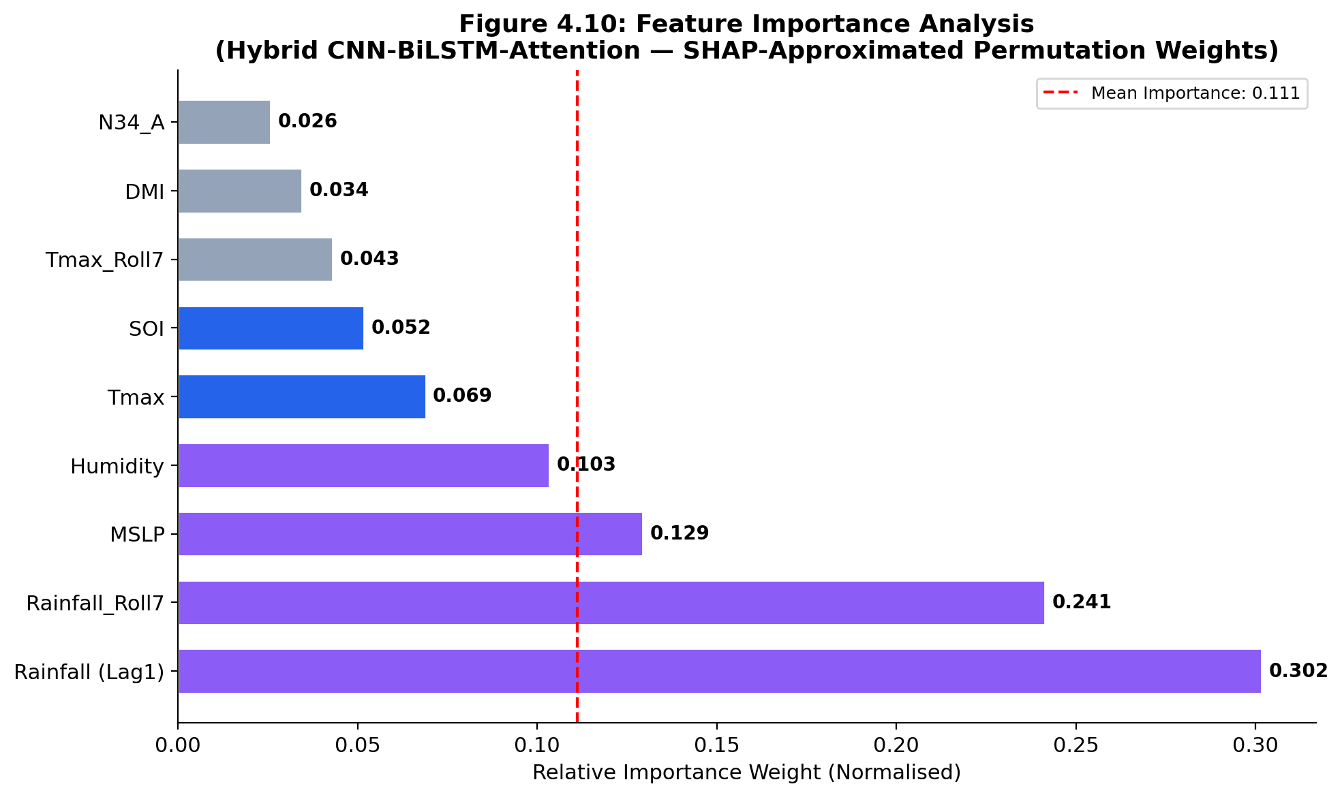
Figure 4.10: SHAP Global Feature Importance and Ablation Analysis

