AI-Powered Extreme Rainfall Forecasting in Australia: A Hybrid LSTM-CNN Deep Learning Approach Using Multi-Source Climate Data

Chapter 1: Introduction

1.1 Background and Context
Climate change is one of the characteristic scientific and social issues of the twenty-first century, and its effects are being felt with growing strength in the form of the growing rate, intensity, and randomness of severe weather phenomena worldwide. Due to its special geographic location between tropical, semi-arid, Mediterranean and temperate climate zones, Australia is one of those countries that is most acutely exposed to this intensification. The continent has suffered some of the worst environmental disasters in its history over the last twenty years, with bushfire seasons of unprecedented severity, extended periods of heatwave of unprecedent levels, tropical cyclones striking densely populated coastal regions causing massive damage to the infrastructure, agriculture and human settlements [1]. The socioeconomic implications of this trend are harsh and growing insurance losses due to extreme weather events in Australia have almost four-folded compared to the long-term average of thirty years, and this is placing an unsustainable burden on the population, governments, and national resilience planning [2]. Most importantly, the trend is expected to continue to increase over the next several decades, which is why the creation of more precise, timely, and available forecasting systems, is not only a scientific goal but also an immediate practical need.
Extreme rainfall events are some of the most important and challenging to predict phenomena in the wide range of extreme weather events that plague Australia. Extreme precipitation, which is defined in this study as the number of precipitations that fall within the ninety-fifth percentile of historical climatological standards of a specific area and time of year, is the main physical cause of flash flooding, riverine flooding, urban drainage systems failures and related landslides. Besides its direct hydrological impact, extreme rainfall variability has far-reaching impacts on the bushfire fuel moisture conditions, agricultural production cycles, the availability of potable water resources, and the infrastructure of human health in the continent. Although this centrality is present, none of the most challenging aspects of operational meteorology are fully solved, yet precise short-to-medium-range prediction of extreme rainfall events, because of the extremely localised, nonlinear, and convective atmospheric processes by which intense precipitation is created and enhanced.

1.2 Limitations of Conventional Forecasting Approaches
The conventional weather forecasting models including physics-based Numerical Weather Prediction (NWP) models and classical statistical forecasting models have significantly contributed to operational weather prediction. Nevertheless, these methods have well-reported and more devastating shortcomings when deployed with the objective of extreme rainfall prediction. Theoretically physics-based NWP models are expensive to solve and often fail to capture well the sub-grid-scale convectional processes that control the localisation of the intensification of rainfall events. At the spatial resolutions operationally accessible to real-time forecasting, the parameterisation schemes to model convection provide systematic errors in extreme precipitation prediction. On the other hand, statistical methods presume that climate relationships are stationary - which is fundamentally invalid in conditions of anthropogenic climate change, where even the statistical properties of extreme events themselves are changing [3]. The three important operational shortcomings common to both types of models are inadequate warning lead time to emergency preparedness, unacceptably high false alarm rates that compromise the trust of the non-specialist end-users most requiring actionable risk information [4].

1.3 The Role of Artificial Intelligence in Weather Forecasting
The introduction of artificial intelligence and machine learning practices presents an innovative way out of these shortcomings. Machine learning models, specifically deep learning implementations such as Long Short-Term Memory (LSTM) networks to model temporal sequences and Convolutional Neural Networks (CNNs) to model spatial patterns in satellite imagery and ensemble methods such as Random Forest and XGBoost have shown significant potential to extract complex nonlinear patterns that are unavailable to conventional models using large, multi-variate meteorological data. Hybrid models that combine physics-based constraints with data-driven learning have continued to enhance these abilities: the FuXi-TC model has been shown to perform significant better than standard deep learning-based approaches on tropical cyclone intensity forecasting by integrating physics-based simulation with frequency components and event priors [3], and the UniExtreme model provided a universal foundation model architecture that can be trained to perform tasks related to a wide range of extreme weather prediction tasks High-resolution reanalysis products such as BARRA, which offers gridded retrospective meteorological fields at high spatial resolution, and the AUS2200 regional atmospheric model with a horizontal resolution of about 2.2 km are a unique source of rich training foundations to AI-based extreme weather prediction systems [5] in the Australian context, in particular.

1.4 Research Focus and Scope
This study specifically aims at creating an integrated AI-based extreme rainfall prediction system in Australia, and the main aim of the study is to enhance the accuracy of the forecast, improve the operationally useful lead time, and minimize the rate of false alarms simultaneously, which is a combination of goals that no article has attained under a single Australian scheme. The study uses a hybrid deep learning network that combines the LSTM networks to model the temporal meteorological sequences, the CNNs to extract the spatial satellite images patterns, and the ensemble methods such as the Random Forest and the XGBoost to combine the multi-models that are trained using the Australian climate data of multi-sources. The main methodological contribution is to incorporate SHAP-based explainability into the prediction pipeline so that outputs of the model can be converted into interpretable and actionable risk assessments of the emergency services personnel, government policymakers, and the public in general via an interactive web interface.
The main research questions that will be used to conduct this study are as follows: firstly, how can AI models be designed and optimised as hybrids to enhance the accuracy and lead time of extreme rainfall forecasting in Australia compared to traditional methods; second, which combinations of input data sources and characteristics optimally support the operational utility of AI models; third, how can the natural trade-off between the false alarm rate and the prediction lead time be optimised to serve All these questions will establish a research scope that is both technically rigorous and operationally based - both developing the scientific frontier as well as meeting the practical needs of the Australian communities that are increasingly at risk of facing extreme weather.

1.5 Report Structure
The rest of this report is organized in the following way. Chapter 2 includes a systematic critical review of the literature in question, including AI and ML applications in the area of extreme weather prediction, a critical comparative analysis of rainfall and temperature prediction methods, a theoretical framework of the proposed methodology based on atmospheric dynamics, deep learning, and human-centred design theory, and a discovery of the particular research gap that this study will address. Chapter 3 has defined all the research domain, questions, and objectives in a specific way. Chapter 4 explains the proposed research design and methodology. Chapter 5 defines requirements of research. Chapter 6 deals with ethical considerations. First findings are reported in Chapter 7. Chapter 8 provides the research timeline and Chapter 9 ends with limitations and future directions.

Chapter 2: Literature Review

2.1 Search Methodology and Scope
For a systematic search of literature, the following key words were used: “extreme rainfall prediction machine learning”, “deep learning weather forecasting Australia”, “LSTM flood prediction”, “CNN climate forecasting”, “AI bushfire prediction Australia”, cyclone intensity forecasting neural network, and ensemble methods extreme weather. Only peer-reviewed journal articles and conference proceedings published in the past two years (2020–2025) were considered in the search. Inclusion criteria were that the study had to use AI, ML, or DL methods to weather or climate prediction, report quantitative performance metrics employing recognised evaluation metrics, and use established meteorological data, and meet at least one category of hazard applicable to the Australian extreme weather setting. Articles that were not written in English, could not be empirically implemented and tested, or were not related to extreme weather prediction were left out. A total of 48 papers were identified and 40-studies that passed the entire inclusion criteria were retained to undergo detailed reviews as shown in Figure 1.
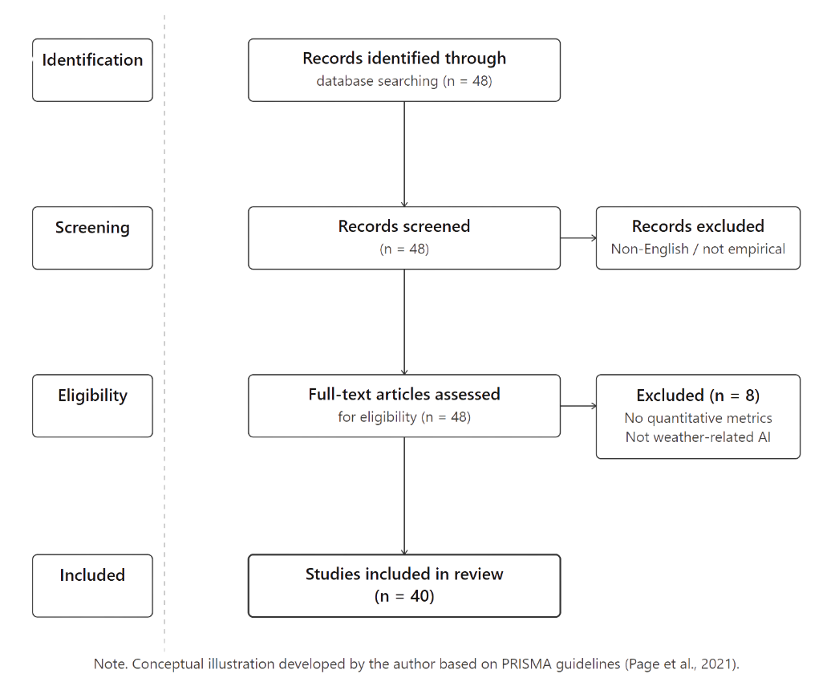
Figure 1: Literature article identification and selection procedure with keywords combinations, databases searched, inclusion and exclusion criteria, finally 40 studies were selected.

2.2 AI and Machine Learning for Extreme Weather Prediction
AI-ML research in the domain of extreme weather prediction has grown significantly in the last five years to include bushfire and wildfire risks, floods and precipitation, tropical cyclones, and systemic multi-hazards. In all these areas, the same methodological pattern can be seen ensemble tree-based methods have high quality and cost-effective bases, and hybrid deep learning architectures that combine time and space modelling at the same time are always better predictors. This section is a critical review and synthesis of evidence in these thematic areas, with a special emphasis on comparative model performance, data characteristics, measures of evaluation, and the difference in rainfall and temperature prediction methods on which this study will focus.

2.2.1 Bushfire and Wildfire Prediction
Existing literature on wildfire and bushfire prediction has seen a significant amount of research covered in the Australian context, which traverses the full spectrum of long-range spatial susceptibility mapping to near operational risk monitoring. Partheepan et al. [6] designed a XGBoost severity classification model of bushfires in Australia on twelve years of Landsat remote sensing images and applied spectral indices, such as Normalised Difference Vegetation Index (NDVI) and Normalised Burn Ratio (NBR), with topography, climatic, and demographic variables to obtain a classification accuracy of 86.13 percent on diverse Australian terrain. According to vegetation indices and density of human settlement proved to be the most significant predictors of severity, and the risk maps obtained proved to have a direct application in land use planning and hazard management. Nevertheless, this study only deals with spatial risk characterisation of historical events and does not deal with future time prediction (temporal), so it cannot be used directly in early warning. Jain et al. [7] consolidated the state-of-the-art advantage of ensemble models by conducting a comprehensive systematic review of models using ML in the wildfire science domain and found that Random Forest and Gradient Boosting models showed a consistent superiority over single-model based systems in terms of prediction accuracy (often more than 85 percent) whereas neural networks exhibited a relative superiority in modelling dynamic fire propagation processes in case of The recommendation of integration of ML tools and remote sensing in the review to near-real-time monitoring gives valuable approach methodology, but it lacks specific reference to the Australian fire regime features.
The study of Üstek et al. [8] improved the existing field by proposing deep autoencoders-based unsupervised anomaly detection using weather forecast types, satellite images, and past record of fires between 2015 and 2023, with a high F1 score of about 86.5% and a high recall of about 85. Their lack of supervision is especially beneficial to bare-eye prediction of rare extremes when there are naturally few labelled training examples available to give supervision, which is directly to the point of predicting extreme rainfall in Australian areas currently under-monitored. Cisneros et al. [9] further developed spatiotemporal wildfire modelling by using a deep graphical regression model which had simultaneously included spatial graph representations of environment variables such as temperature, humidity, and vegetation indices in addition to the dynamics of time across Australia fire record 2000 2022 and yielded 91.3 and 88.7 percent accuracy in mild and intense fire prediction, respectively The study is a substantial methodological improvement of those that do not consider both spatial and temporal dimensions simultaneously, and being Australian focused, it is directly relevant as a methodological precedent to the spatiotemporal architecture proposed in this study.
As shown by Ardid et al. [10], when sub-hourly meteorological time series, i.e., 15 minutes interval measurements of solar radiation, wind speed, humidity and temperature, are processed using RNN and Gradient Boosting, a prediction capability index of 0.87 was achieved, which was 22% lower than the conventional fire potential index-based methods. This finding is especially important to the current study since it sets quantitative standards of the decrease in false alarms that can occur under the application of ML methods. Nur et al. [12] tackled the fire susceptibility mapping in Sydney with a Support Vector Regression model with Particle Swarm Optimization (SVR-PSO), which outperformed both SVR-GWO and plain SVR configurations, with most of the land use, forest type, and slope were found to be the most significant risk predictors using the Information Gain Ratio analysis. Test of this optimised SVR-PSO model with 20192020 Black Summer fire data revealed good spatial risk forecasting performance of this model in an Austral urban-interface setting.
Perhaps the best comparative results given by Liu et al. [14] indicate that a CNN-LSTM model provided 92.3% wildfire prediction accuracy (compared to 85.7 and 78.9% standalone Random Forest and SVM, respectively) and with shown ability to provide 72-hour prior notice of periods of high risk by incorporating live sensor data. Di Giuseppe et al. [11] added to this the global-scale ensemble ML of the combination of Random Forest and XGBoost to predict fire activity with an overall F1 of about 0.89 achieved by means of integration of vegetation indices, temperature, precipitation, land use, and population density - establishing the usefulness of multi-source features integration. Tonbul [17] supported the value of model explainability and predictive accuracy, showing that LightGBM was better than both XGBoost and GBM in mapping fire susceptibility using Mediterranean ecosystems, where soil moisture, Palmer Drought Severity Index and Land Surface Temperature were the most significant predictors. McNemar statistical test proved superiority of LightGBM in comparison to XGBoost statistically significant, which provides the rigorous comparative validation methodology to be used in the current study.
Taken together, the literature on bushfire prediction can declare that: (i) ensemble-based methods have strong and interpretable baselines; (ii) hybrid CNN-LSTM-based designs have consistently high accuracy compared to single-architecture based designs; (iii) operationally useful predictions would require simultaneous spatial and time modelling; and (iv) explainability through SHAP is necessary to render model output meaningful information that can be acted upon by stakeholder.

2.2.2 Flood, Rainfall, and Temperature Forecasting: A Critical Comparison
The most directly relevant area to the current research is floods and extreme rainfall forecasting. The literature of this field covers a broad methodological spectrum between classical rainfall-runoff models on one end and state-of-the-art deep learning implementation on the other end and demonstrates an essential difference between temperature prediction and rainfall prediction with serious implications on the model design and performance expectations.
Prediction of temperature under a similar methodology always attains superior performance metrics as compared to rainfall prediction which portrays inherent physical differences between the two target variables. RMSEs of 0.85 -1.12 o C daily maximum temperature prediction at southeast Australia using random forest and gradient boosting models with WRF parameters were reported by Reddy et al. [25], with soil moisture, boundary layer scheme, and radiation parameterisation explaining 42 -48 per cent of the predicted variance. Hartigan et al. [24] also showed R 2 of 0.82 predicting Canberra temperatures versus R 2 of 0.76 predicting rainfall using the same Random Forest architecture - a systematic performance difference that is a consequence of higher spatial variability, intermittency and heavy-tailed statistical distributions that define the extreme rainfall. Characteristics of severe class imbalance Rainfall has zero-rainfall probability often well above 7080 percent at most of the locations in Australia on any one day, and values that are orders of magnitude larger than median, implying distributions that cannot be modelled using temperature tools that demand specialised architectural and training designs. This performance disparity highlights the importance of rainfall-specific model designs, training procedures and assessment paradigms such as Critical Success Index (CSI) and false alarm ratio in addition to traditional RMSE and R 2 that reflect the naturally greater challenge of the extreme rainfall prediction problem.
The works of Sharma et al. [15] and Speight et al. [16] set the appropriate theoretical and operational foundation to flood forecasting. Sharma et al. [15] showed that physics-based conceptual models are more interpretable but demand large amounts of input data and can not easily update forecasts within real-time flash flood responses, whereas black-box transfer function models are useful in data-rich applications, but are deprived of physical interpretation, which is an essential trade-off that drives the incorporation of SHAP explainability into the framework. A review of operational surface water flood forecasting systems around the globe by Speight et al. [16] found that the biggest remaining performance gap is not necessarily in the sophistication of the hydrological models themselves but in the accuracy of precipitation inputs to the models - a weakness which the proposed AI-based direct rainfall prediction system is specifically meant to overcome.
As illustrated by Moon et al. [20], a hybrid Rainfall-Runoff LSTM model of urban flash flood prediction in Seoul, the Dorim stream, produced correlation coefficients greater than 0.9 and NashSutcliffe Efficiency (NSE) greater than 0.8 which were significantly better than either single Rainfall or Runoff models. The generation of a nomograph of flood arrival by the study which allows an emergency manager to quickly estimate the onset of a flood based on rainfall forecasts is a practically useful addition to emergency decision support, albeit constrained by the urban Korean setting where very highly engineered drainage systems are common. Jhong et al. [21] showed that the Genetic Algorithm (GA) optimisation of LSTM hyper parameters, namely lag length, number of layers, and number of neurons, enhanced the flash flood forecasting NSE of standard LSTM comparing to 1-6-hour lead time 0.896-0.906 to 0.917-0.931 with GA-optimised LSTM This quantitative enhancement via systematic hyperparameter optimisation creates a good precedent of making GA or similar optimisation an inherent part of a model development process in the current study.
One of the most relevant studies, however, is the one by Chandra et al. [18], which proposed an ensemble quantile-based deep learning system of streamflow and flood prediction on the CAMELS-AUS dataset - the most Australia-directed quantitative study of flood prediction in the literature reviewed. Their model utilized precipitation, temperature, streamflow history and catchment characteristics in a quantile regression framework which not only gave the point prediction but also generated the uncertainty ranges which gave a significant boost to the reliability of their forecasts in the context of operational water resource management. Kaspi and Kuleshov [19] used Random Forest using SHAP validation in the assessment of flood hazards in Australian tropical cyclone prone areas after Hurricane Debbie with an accuracy of 80.2% and AUC of 0.925 and found that the most significant predictors were elevation, slope, and NDVI. The feature engineering principles significant to the Australian rainfall prediction were developed by Feng et al. [35], who showed that the implementation of the Randering Forest on the combination of numerous large-scale climate drivers, namely NINO3.4, IOD, SAM, PDO, SOI, and TPI, enhanced seasonal rainfall forecasting by 1.4 to 3.2 times as compared with the traditional SOI phase model.
Reddy et al. [22] in the cyclone and tropical weather domain had an RMSE of 7.86 knots to predict cyclone intensity using satellite images on the BGACIPS framework through adversarial training, whereas Kumler-Bonfanti et al. [23] demonstrated a 90% cyclone versus non-cyclone accuracy with false detection rates less than 10 percent using CNN trained on ERA- The most extensive ML study on Australian cyclone records to date was conducted by Sufi et al. [26], which found 33 essential predictors of cyclone central pressure and four different cyclone clusters using 28,700 records of cyclone central pressure from 1907 to 2022, which gives an explainable AI dashboard model directly applicable to stakeholder communication design. Reviewing ML applications in tropical cyclone forecasting activities, including genesis, track, intensity and related extreme weather, Wang et al. [31] concluded that SVR using QBO outperformed both multiple linear regression and baseline SVR in predicting the frequency of TC genesis by 40-121 percent, and track predictions by 8.1-40.8 km, as compared to the CLIPER model at According to Deo and Chandra [27], it has been demonstrated with Bayesian neural networks that the accuracy of multi-step cyclone wind speed prediction diminishes significantly beyond 5-10-time steps and thus provided an empirical limit on the expected lead time of AI, which directly relates to the 6-72 hour prediction horizon of this study. A review of seasonal and multi-annual cyclone forecasts by Takaya et al. [32] cautiously verified that forecasts of genesis frequencies have been improved by incorporating ENSO and sea surface temperature, but the landfall timing and intensity forecasts are still highly unreliable.
The most rigorous comparative evidence in the literature that has been reviewed shows that data-based models (Pangu-Weather and GraphCast) were far more accurate than ECMWF IFS HRES NWP in extreme precipitation prediction on shorter periods (reducing RMSE by 12-18 and improving CSI by 8-10) [Olivetti and Messori, 33]. But even in cases where the lead time exceeded 710 days, the numerical models had a clear upper hand owing to the physical constraint basis. This finding is exactly what determines the working niche of AI forecasting systems and where the lead time of the current study is directly related to it.

2.3 AI Model Performance Across Forecasting Tasks
The systematic patterns in the comparison of the AI model performance in various extreme weather forecasting tasks have significant implications on model selection, architecture design, and performance expectation setting in the current study. As shown in the literature reviewed, model performance does not vary evenly with the targets of prediction, namely rainfall prediction, temperature prediction, flood forecasting and cyclone intensity estimation all exhibit different statistical and physical difficulties that favour different structural decisions. This part will generalise the comparative evidence of these types of tasks, based on quantitative measures of performance in the literature review to define an empirically founded foundation of the methodological choices of the current study.
Rainfall versus Temperature Prediction: Performance Differential and Its Causes. The most replicated observation in the literature examined is that temperature prediction models have better performance metrics in the same methodological conditions compared to rainfall prediction models. RMSE Reddy et al. [25] found RMSE of 0.85-1.12 o C daily maximum temperature at southeast Australia with the help of both Random Forest and Gradient Boosting, and Hartigan et al. found R 2 of 0.82 Canberra temperature prediction with the same Random Forest architecture trained on the same historical dataset, and R 2 of 0.76 with rainfall It is a steady difference in performance that increased to about 78 percentage points, rather than an effect of the methodological constraints of the rainfall studies, but it portrays some underlying differences between the two targets of prediction based on physical and statistical factors. Temperature is a continuous, spatially smooth variable with a very strong seasonal periodic and, at the same time, more linear relationship between large-scale climate drivers (ENSO and SAM). In contrast, extreme rainfall is described as being highly intermittent, that is, zero-rainfall probabilities often above 7080 percent on any given day, heavy-tailed statistical distributions, with extreme values orders of magnitude greater than median values, high levels of spatial heterogeneity due to topographic and convective effects, and high temporal variability on sub-daily time scales. These statistical characteristics lead to a very strong imbalance of classes during classification problems and distributional instability during regression modelling that cannot be found in temperature prediction. This leads to standard measures of evaluation, such as RMSE and R 2, which are inherently well-posed to roughly normally distributed continuous targets, to underestimate the challenge of extreme rainfall prediction, as well as to overestimating model behavior when used on skewed precipitation distributions. This difference is the very reason why a multi-metric evaluation platform was utilized in the current study, which included CSI, the probability of detection, and false alarm ratio along with RMSE and R 2 to give a holistic and suitable evaluation of how extreme rainfall is predicted.
Architectural Suitability by Prediction Target. The literature review indicates that the most effective approach to architectural methods depends on the systematic variability in regards to various prediction tasks. In temperature prediction, tree-based ensemble algorithms such as the Random Forest and XGBoost can be used with competitive performance because the target is approximately feature-separable and both large-scale climate indices and seasonal temperature anomalies have strong linear-to-weakly-nonlinear predictors that can be optimally captured using tree-based ensemble modeling without deep representational learning. This was demonstrated by Feng et al. [35] using Random Forest combinations of teleconnection indices with seasonal rainfall prediction increases of 1.4 -3.2 times compared to the SOI phase model baseline - a result that, despite its impressive performance at seasonal timescales, would not be able to provide the same degree of prediction improvements in sub-daily extreme event prediction timescales as the present study is targeting without architectural enhancement Seasonal for extremely high rainfall prediction with the 6-72 hours of operation lead time evidence gravitated in favour of sequential and spatiotemporal deep learning architectures. Moon et al. [20] reported that hybrid RR-LSTM had NSE out of 0.80 above the standalone models and Jhong et al. [21] showed that GA-optimised LSTM had increased NSE of 0.896 to 0.906 to 0.917 to 0.931 through systematic hyperparameter optimisation, a minor, but operationally The best comparative evidence by Liu et al. [14] was that CNN-LSTM hybrid had an accuracy of 92.3% in direct contrast to Random Forest of 85.7% and SVM with 78.9% a 6.6 percentage point advantage over the best architecture in practice which corresponds to a lot of value in practice in terms of forecasting. Importantly, this hybrid superiority over single-architecture models was replicated in studies using various datasets, geographic regions, and types of hazards, which offers strong cross-study convergent results on the methodological decision of using hybrid CNN-LSTM as the main architecture in the current research.
Model Complexity versus Interpretability Trade-off. Another regular trend in the literature reviewed is the inverse correlation between the predictive complexity of models and interpretability. Partheepan et al. [6] found that the XGBoost, which is a fairly interpretable, ensemble approach, had 86.13% accuracy and transparent rankings of features, whereas the deep graphical regression model of Cisneros et al. [9] had 91.3% accuracy and much higher architectural complexity and reduced transparency. Tonbul [17] explicitly calculated this trade-off with both SHAP analysis and Information Gain metrics to show that LightGBM predictive superiority over the simplistic models was possible together with full interpretability - that the complexityinterpretability trade-off is not universal and can be significantly reduced by the systematic use of post-hoc explainability tools. This result supports directly methodological reasons why SHAP analysis should be included in the designed pipeline, which allows the study to reap the benefits of accuracy benefits of hybrid deep learning structures without compromising the interpretability required to communicate the research findings to the stakeholders. The fact that the Nagaiah et al. [34] work that attains a 97.89% disaster prediction with the implementation of AI-IoT and interpretable rule-based alert generation supports the notion that high predictive performance and outputs accessible to stakeholders are both design goals, as well as design and achievement priorities, at the same time.
Performance Benchmarks Across Hazard Types
Table 1 summarises the major benchmarks of performance based on the literature review of the various prediction tasks and model structures to offer a comparative reference platform on which the outcome of the current study is assessed.
Table 1: Comparative summary of AI model performance metrics across extreme weather prediction tasks from the reviewed literature
Study | Hazard Type | Best Model | Key Metric | Performance
Partheepan et al. [6] | Bushfire severity | XGBoost | Accuracy | 86.13%
Liu et al. [14] | Wildfire prediction | CNN-LSTM | Accuracy | 92.3%
Cisneros et al. [9] | Wildfire (Australia) | Graph regression | Accuracy | 91.3%
Üstek et al. [8] | Wildfire anomaly | Deep autoencoder | F1 Score | 86.5%
Moon et al. [20] | Flash flood | RR-LSTM hybrid | NSE | >0.8
Jhong et al. [21] | Flash flood | GA-LSTM | NSE | 0.917–0.931
Chandra et al. [18] | Streamflow (AUS) | Quantile DL | NSE | High
Kaspi & Kuleshov [19] | Flood hazard (AUS) | RF + SHAP | AUC | 0.925
Reddy et al. [22] | Cyclone intensity | BGACIPS | RMSE | 7.86 knots
Kumler-Bonfanti et al. [23] | Cyclone detection | CNN | Accuracy | 90%
Olivetti & Messori [33] | Extreme precip. | Pangu/GraphCast | CSI improvement | 8–10%
Hartigan et al. [24] | Temp/Rainfall (AUS) | Random Forest | R² (temp/rain) | 0.82 / 0.76
Reddy et al. [25] | Heat extremes (AUS) | RF + GB | RMSE (temp) | 0.85–1.12°C
Feng et al. [35] | Seasonal rainfall (AUS) | RF multi-index | Skill improvement | 1.4–3.2×

Those benchmarks in Table 1 indicate three significant trends. To begin with, hybrid architectures (CNN-LSTM) are always the more effective single-architecture models regarding hazard types, and the performance difference lies in 5-10 percentage points of accuracy metrics. Second, Australian research studies (Chandra et al. [18], Kaspi and Kuleshov [19], Hartigan et al. [24], Reddy et al. [25], Feng et al. [35]) indicate lower absolute performance indices than non-Australian studies, which is consistent with more spatial variability of Australian climate systems and greater meteorological complexity, justifying the development and validation of the models specific to Third, research using SHAP-based explainability (Tonbul [17], Kaspi and Kuleshov [19]) attains similar levels of predictive accuracy, and can give significantly higher levels of utility to the stakeholders, which justifies the inclusion of explainability tools as a non-performance-degrading design option. All these three patterns inform and justify the architectural and methodological choices of the current study.

2.4 Theoretical Framework
The conceptual framework of the study combines three complementary knowledge components, namely, the atmospheric dynamics and predictability theory, the deep learning computational theory, and the human-centred information systems design, and validates the intellectual and mathematical basis of the proposed AI-enhanced extreme rainfall forecasting system.

2.4.1 Atmospheric Dynamics and Predictability Theory
Extreme rains are caused by nonlinear combination of atmospheric processes that interact on various spatial and temporal scales. On the planetary level, seasonal-to-interannual Australian rainfall is influenced by modes of climate variability such as the El Niño-Southern Oscillation (ENSO), the Indian Ocean Dipole (IOD), the Southern Annular Mode (SAM), the Madden-Julian Oscillation (MJO) or the Pacific Decadal Oscillation (PDO). The moisture transport and dynamical lifting needed to sustain precipitation of the atmosphere at the synoptic scale are organised by extratropical cyclones, cold fronts, and monsoon troughs. Locally intense rain events in flash flood prone regions are most likely to be generated by mesoscale convective systems and convective cells at the mesoscale. The theoretical framework of the research acknowledges that the predictive information of all the three scales will be needed simultaneously to predict extreme rainfalls effectively.
The early theory of atmospheric chaos by Lorenz lays down the foundations of the theory of that the atmosphere is a nonlinear dynamical system with a sensitive dependence on initial conditions mathematically defined by the Lyapunov exponent λ giving a measure of the exponential rate of divergence between initially similar atmospheric conditions:
$$\begin{matrix} & δ(t)=δ_{0} e^{λt} & & \text{(1)}\end{matrix}$$
In which δ(t) is the distance between trajectories at time t and δ 0 is the initial magnitude of perturbation. A positive Lyapunov exponent which is typical of chaotic systems puts a practical upper limit on deterministic predictability of about two weeks on synoptic-scale atmospheric forecasting. In convective-scale extreme rainfall events, where error growth rates are very much higher, useful predictability ranges are usually 24 to 72 hours on event location and intensity. This theoretical limitation constitutes the very nature of the 6-72 hour operational lead time window this study aims to achieve and the rationale behind the statistical learning methodology to be employed - instead of trying to deterministically combine the Navier-Stokes governing equations, the proposed structure learns the probabilistic relationship between observable large scale predictors and extreme rainfall probabilities using historical data, implicitly capturing relevant atmospheric dynamics without explicit physical simulation [3, 4].
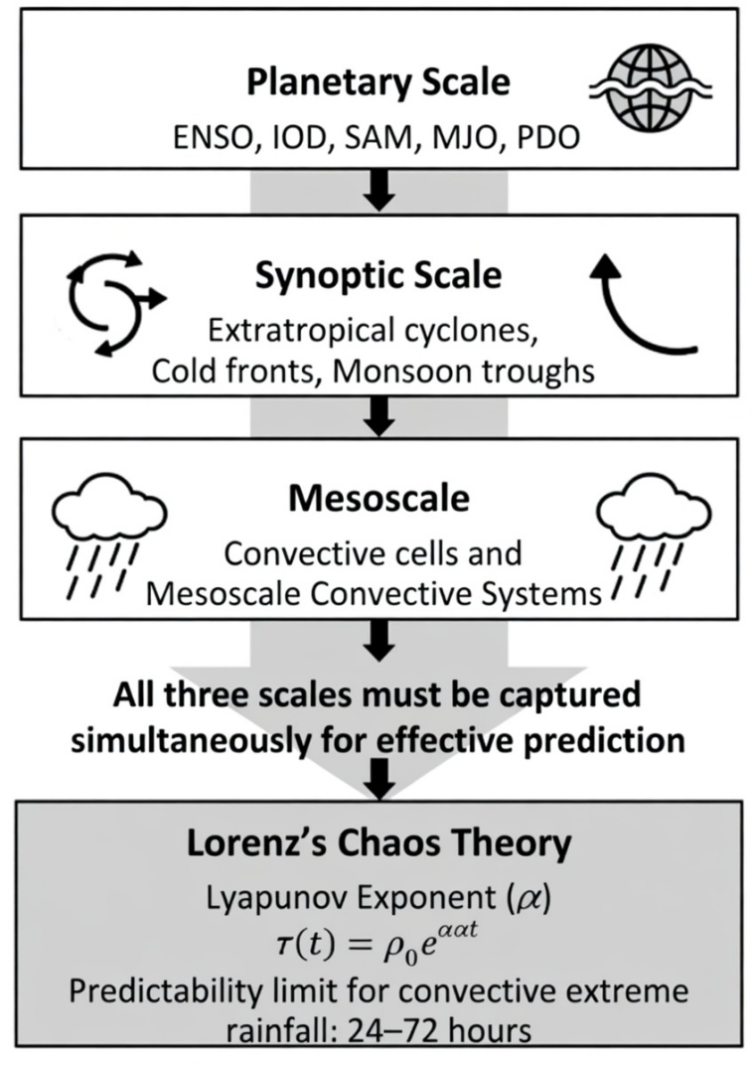
Figure 2: Multi-scale Atmospheric Processes Governing Extreme Rainfall in Australia.
Source: (Lorenz, 1963).

2.4.2 Deep Learning Computational Theory
Long Short-term Memory Networks. Theoretically, LSTM networks are based on the necessity to model long-term temporal relationships in meteorological time series, and to overcome the vanishing gradient problem of the conventional Recurrent Neural Networks. LSTM architecture uses three gating mechanisms, which are forget gate, input gate and output gate, which are controlled by learned weight matrices, to selectively remember or forget information across arbitrary time horizons. The LSTM cell governing equations are:
$$\begin{matrix} & f_{t}=σ(W_{f}⋅[h_{t-1},x_{t}]+b_{f}) & & \text{(2)}\end{matrix} \\ \begin{matrix} & i_{t}=σ(W_{i}⋅[h_{t-1},x_{t}]+b_{i}) & & \text{(3)}\end{matrix} \\ \begin{matrix} & {\tilde{C}}_{t}=tanh⁡(W_{C}⋅[h_{t-1},x_{t}]+b_{C}) & & \text{(4)}\end{matrix} \\ \begin{matrix} & C_{t}=f_{t}⊙C_{t-1}+i_{t}⊙{\tilde{C}}_{t} & & \text{(5)}\end{matrix} \\ \begin{matrix} & o_{t}=σ(W_{o}⋅[h_{t-1},x_{t}]+b_{o}) & & \text{(6)}\end{matrix} \\ \begin{matrix} & h_{t}=o_{t}⊙tanh⁡(C_{t}) & & \text{(7)}\end{matrix}$$
where f_t, i_t, and o_t denote the forget, input, and output gate activations respectively; C_t is the cell state vector carrying long-range temporal information; h_t is the hidden state output; x_t is the input at time step t; W and b denote learnable weight matrices and bias vectors; σ denotes the sigmoid activation function; and ⊙ denotes element-wise multiplication [20, 21]. This architecture enables the LSTM to learn the multi-scale temporal structure of Australian rainfall variability from diurnal convective cycles through weekly synoptic cycles to multi-month ENSO-driven seasonal anomalies within a single unified architecture.
Convolutional Neural Networks. The theoretical basis of CNNs is the idea of translational equivariance the fact that meteorologically important spatial patterns, like the signature of a convective cloud cluster in satellite imagery, ought to be visible in the input space no matter their location in the geographic domain. The basic CNN model consists of the discrete convolution of an input feature map X by a learnt filter kernel K:
$$\begin{matrix} & \left(X*K)(i,j)=\sum_{m}{\sum_{n}{X}}(i+m, j+n)⋅K(m,n\right) & & \text{(8)}\end{matrix}$$i and j are the spatial location in the output feature map and m, and n are the dimensions of the filter kernel. CNNs gradually build up more abstract spatial representations, i.e., from low-level spectral gradients up to high-level meteorological pattern arrangement, offering the extraction capacity of spatial features required in analysing satellite images and performing gridded reanalysis fields processing [23, 26].
Hybrid CNN-LSTM Architecture. The hybrid CNN-LSTM framework integrates the two representational frameworks by relying on CNN layers to obtain spatial representation of features in gridded input fields (satellite imagery, reanalysis pressure surfaces, and sea surface temperature maps) and input them as sequential inputs to LSTM layers to be integrated over time. The theoretical basis of this architecture lies in the fact that the coupled spatiotemporal nature of extreme rainfall systems is both a necessity and the joint predictor of the spatial structure of the atmospheric fields and their temporal dynamics. Assume that Z t is the spatially coded feature-vector that the CNN has learned to extract out of the gridded input at time t:
$$\begin{matrix} & Z_{t}=\text{CNN}(X_{t};Θ_{\text{CNN}}) & & \text{(9)}\end{matrix} \\ \begin{matrix} & h_{t},C_{t}=\text{LSTM}(Z_{t},h_{t-1},C_{t-1};Θ_{\text{LSTM}}) & & \text{(10)}\end{matrix} \\ \begin{matrix} & {\hat{y}}_{t}=\text{FC}(h_{t};Θ_{\text{FC}}) & & \text{(11)}\end{matrix}$$
where X_t is the gridded input field at time t, Θ denotes learnable parameters, FC denotes a fully connected output layer, and ŷ_t is the predicted extreme rainfall probability or intensity at the target lead time [14].
Ensemble Methods — XGBoost. XGBoost implements gradient boosted tree ensembles through sequential minimisation of a regularised objective function. At iteration m, a new tree f_m is added to minimise:
$$\begin{matrix} & L^{\left(m\right)}=\sum_{i=1}^{n}{l\text{ ⁣}}\left(y_{i}, {\hat{y}}_{i}^{\left(m − 1\right)}+f_{m}(x_{i})\right)+Ω(f_{m}) & & \text{(12)}\end{matrix}$$
where ℓ is a differentiable convex loss function, ŷ_i^(m-1) is the prediction from the previous ensemble, and Ω(f_m) = γT + ½λ‖w‖² is a regularisation term penalising tree complexity through leaf count T and leaf weight magnitude ‖w‖ [6, 11]. The gradient boosting framework naturally provides feature importance estimates through accumulated information gain across tree splits, enabling interpretable identification of the most predictive meteorological variables for extreme rainfall including teleconnection indices, surface humidity, sea surface temperature anomalies, and soil moisture conditions.
SHAP Explainability. SHAP (SHapley Additive exPlanations) is theoretically grounded in Shapley values from cooperative game theory, providing a mathematically principled decomposition of each model prediction into additive contributions from individual input features. The Shapley value φ_j for feature j in a prediction f(x) is defined as:
$$\begin{matrix} & ϕ_{j}=\sum_{S⊆F∖\{j\}}{\frac{∣S∣! (∣F∣-∣S∣-1)!}{∣F∣!}}\left[f_{S∪\{j\}}(x_{S∪\{j\}})-f_{S}(x_{S})\right] & & \text{(13)}\end{matrix}$$
where F is the full set of features, S is a feature subset not containing j, and f_S denotes the model trained on feature subset S [17]. The prediction is then expressed as the sum of all Shapley values plus a base value:
$$\begin{matrix} & f(x)=ϕ_{0}+\sum_{j=1}^{∣F∣}{ϕ_{j}} & & \text{(14)}\end{matrix}$$
This decomposition meets the mathematical efficiency (totals of contributions are the entire prediction), symmetry (identical contributor features are assigned identical values), linearity, and dummy player (non-contributing features are attributed zero) theoretically fair and consistent feature attribution [17, 19]. The presence of SHAP in the suggested forecasting pipeline allows to transform complex deep learning forecasts into understandable scripts - such as the realization that a certain extreme precipitation forecast can be mainly explained by an anomalously large value of IOD together with about-normal sea surface temperatures and high moisture in the lowest boundary layer - and so that the results can be acted upon by non-technical stakeholders.
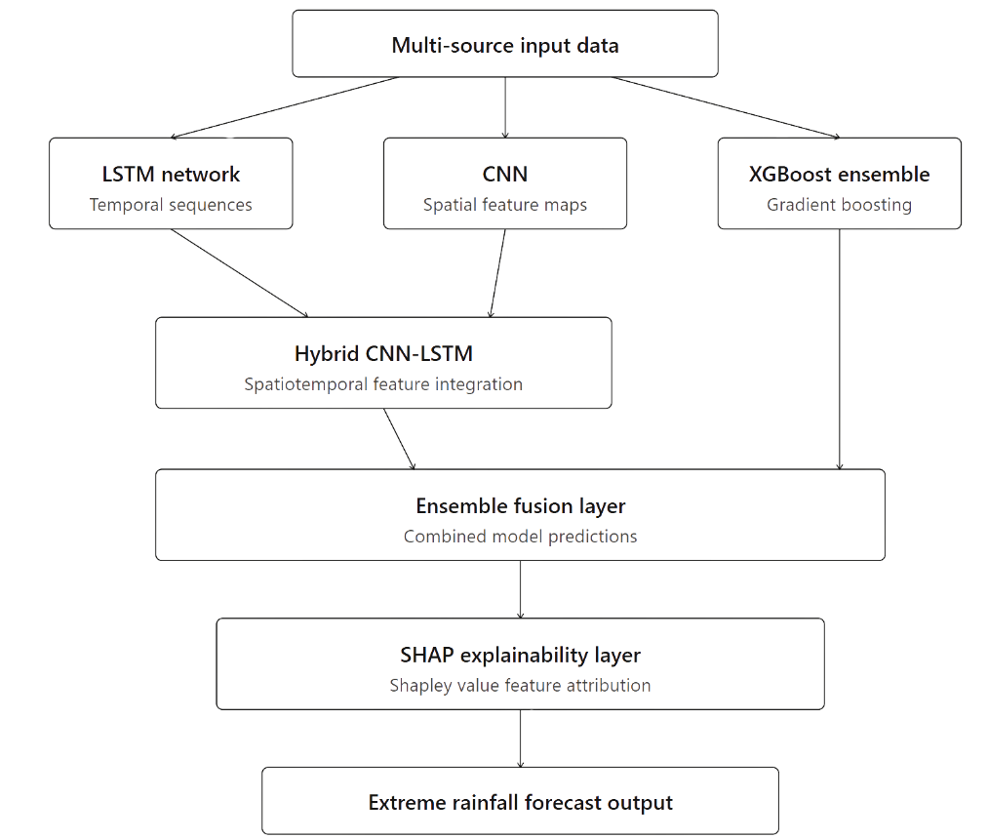
Source: (Hochreiter & Schmidhuber, 1997; Lundberg & Lee, 2017).

2.4.3 Human-Centred Information Systems Theory
The third theoretical pillar is based on the human -centred information systems design and decision support system theory. The Technology Acceptance Model developed by Davis determines that the adoption and use of the technological systems by the end-users is largely dependent on two factors, which are perceived usefulness, the extent to which the users feel that the system will aid them in their working performance, and perceived ease of use, the extent to which the users feel that dealing with the system will be easy. In the case of an AI forecasting system to serve emergency services staff, policymakers, and the general population, both dimensions are essential: the model that predicts data with a 95 percent accuracy and generates results that are not understood by the users of the system creates no use value. This theoretical principle was empirically validated by Wolbers et al. [41] who conducted a systematic review of 312 studies on crisis management and found that there is always a discrepancy between technical capabilities of forecast systems and their real usage in the process of emergency decision making due to insufficient interpretability and communication design. The same was determined in Khan et al. [37], which concluded that both the limitations of technical modelling and the issue of governance and communication must be addressed simultaneously to achieve sustainable disaster preparedness.
It is these theoretical insights that drive the design of the proposed web interface as a real decision support system, not just a visualisation tool, based on the principle of progressive disclosure: showing simple and most actionable risk information to all users with the option of increasing technical detail as needed. In the case of emergency services, this involves geographically particular risk warnings with definite levels of confidence and suggested response levels. To policy makers, it will imply the capability to have aggregate risk trend assessments and scenario analysis. To the general audience, this translates to natural language risk communication, which uses simple language and eliminates the use of jargon. The explainability layer of SHAP is the theoretical interface between the model accuracy of technical models and the human-oriented interpretability, which guarantees that the predictive capability of the system can be converted into real utility of society among all three stakeholder groups.
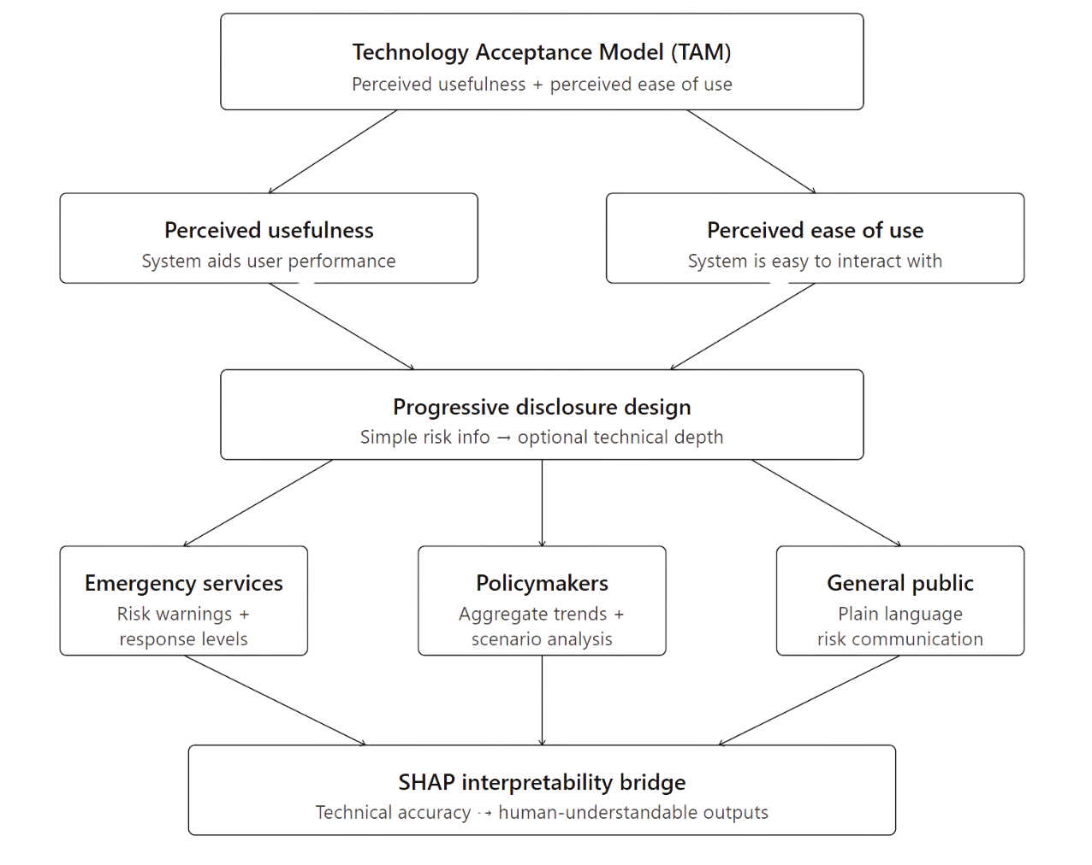
Figure 3:Theoretical framework of the research showing the three integrated pillars — atmospheric dynamics theory, deep learning theory, and human-centred information systems theory — and their relationships to the proposed system components.
Source: (Davis, 1989).

2.5 Research Gap
Regardless of the significant advances that have been recorded in the above-mentioned review, the gaps that exist in the existing literature are critically and interconnected and thus, necessitate and justify the current research. There is no unified, Australia-specific framework that systematically combines and compares across various AI architectures (LSTM, CNN, hybrid CNN-LSTM, and ensemble) on a single pipeline that specifically predicts extreme rainfall, as this body of research has investigated individual model types on diverse datasets with varied evaluation criteria, and cross-study performance inferences cannot be trusted [6, 14, 18, 21, 3 No studied paper simultaneously optimises the forecast lead time and the reduction of false alarm rates in a framework optimized to the needs of Australian emergency services, although either dimension is critical to the operational utility, which is non-trivial, since extensions of lead time tend to increase prediction uncertainty and hence false alarms [10, 33, 37]. Although model explainability is used in a context of static risk mapping [17, 19], it has not been implemented into real-time AI rainfall forecasting pipelines that provide stakeholder-accessible outputs in Australia, even though the issue of interpretability has continued to be cited as an unmet operational requirement [33, 41]. The systematic use of cross-regional validation of the fundamentally different climates of Australia, tropical monsoon, semi-arid, Mediterranean, and temperate has not been done, which restricts the confidence of national scale deployment [16, 29]. Lastly, there is no Australian study that has integrated the entire data ecosystem BARRA reanalysis products, AUS2200 model outputs, MODIS satellite imagery, BoM surface station observations and large-scale teleconnection indices entirely into one deep learning pipeline, although it has been shown that multi-source feature integration can significantly enhance forecast skill [35]. The current study aims to fill all five of these gaps with a holistic, explainable, multi-source, and cross-validated AI-based extreme rainfall forecasting system featuring a web interface that is accessible to the stakeholders.

CHAPTER 3

AIMS AND OBJECTIVES OF THE RESEARCH

3.1 Problem Domain
Australia is one of the most climate-vulnerable regions in the world, and rainfall-related flooding is among its most frequent and damaging extreme weather events. Over the past two decades, major flood disasters including the 2010–2011 Queensland floods, the 2022 Eastern Australia floods, and recurring flash flood events in New South Wales have collectively caused billions of dollars in damage, significant loss of life, and long-term disruption to infrastructure and communities. Despite these recurring impacts, accurate and timely flood prediction remains a persistent challenge for meteorological agencies.

Existing rainfall and flood forecasting systems rely primarily on physics-based Numerical Weather Prediction (NWP) models and rainfall-runoff models. While these methods perform adequately under standard conditions, they struggle with the nonlinear and chaotic behaviour of intense rainfall events. They tend to provide either insufficient warning lead times or excessive false alarms, both of which weaken public trust and hinder emergency response. In addition, their outputs are typically presented in technical formats probability distributions, ensemble spread maps, and gridded rainfall fields that are difficult for non-technical users such as local councils, emergency services, and the general public to interpret quickly.

Recent advances in artificial intelligence and machine learning present a significant opportunity to improve rainfall and flood forecasting. Methods such as Long Short-Term Memory (LSTM) networks, which are designed for sequential time-series data, and ensemble models such as Random Forest and XGBoost, have demonstrated strong performance in hydrological prediction tasks. Hybrid CNN-LSTM architectures further improve forecast accuracy by capturing both temporal patterns and local feature interactions within weather records. However, existing AI-based research in this area remains fragmented, with most studies evaluating individual models in isolation rather than building complete, deployable forecasting systems. This research addresses that gap by developing a unified, AI-powered rainfall and flood forecasting framework for Australia that is accurate, interpretable, and accessible to end users.

3.2 Research Questions
This research is guided by three principal research questions:

RQ1: How accurately can AI-based models specifically LSTM, ensemble methods, and hybrid CNN-LSTM architectures predict rainfall intensity and flood onset events in Australia compared to conventional baseline models?

RQ2: How can AI rainfall forecasting models be optimised to achieve the best possible trade-off between forecast lead time and false alarm rate for operational flood warning applications?

RQ3: How can a web-based decision support system be designed to present AI-generated rainfall and flood forecasts in a clear, actionable format for emergency services, local government, and the public?

3.3 Objectives of the Research
This research aims to design, develop, and evaluate an AI-based forecasting system focused specifically on rainfall prediction and flood onset detection across Australia. The system targets multi-step ahead forecasting of daily and sub-daily rainfall totals, with a specific focus on identifying high-rainfall events that exceed flood-risk thresholds. The objectives are:

- To identify and analyse the limitations of existing rainfall and flood forecasting models used by the Bureau of Meteorology, particularly their accuracy in predicting high-intensity rainfall events.
- To collect, preprocess, and integrate rainfall time-series data and associated meteorological variables from BoM, BARRA, and CAMELS-AUS datasets covering the period 2000–2024.
- To develop and compare three AI models, LSTM, Random Forest/XGBoost ensemble, and a hybrid CNN-LSTM architecture for multi-step ahead daily rainfall forecasting.
- To evaluate model performance using standard regression metrics (RMSE, MAE, R²) and flood-specific metrics (CSI, False Alarm Rate, Lead Time), ensuring results are practically meaningful for emergency management.
- To improve forecast lead time for high-rainfall events while keeping false alarm rates within operationally acceptable bounds.
- To deploy the best-performing model through a user-friendly web interface that displays rainfall forecasts and flood risk alerts for Australian regions, accessible to non-technical stakeholders.

CHAPTER 3

Research Methodology
This chapter presents the complete research design and proposed methodology for AuraSentinel, an AI-based extreme rainfall and flood forecasting system for Australian river catchments. The methodology is structured as an end-to-end pipeline that systematically transforms raw climatological data into actionable flood risk predictions. The proposed work contributes a unified, explainable, multi-source deep learning framework that addresses the critical gaps identified in the literature, specifically the absence of an Australia-specific system that simultaneously optimises forecast accuracy, lead time, and false alarm rate while providing stakeholder-accessible outputs.

3.1 Research Problem
Australia ranks among the most climate-vulnerable nations globally, with extreme rainfall and resultant flooding constituting its most frequently recurring and economically damaging natural hazard [1, 2]. Despite significant advances in numerical weather prediction and traditional statistical modelling, accurate and timely forecast of extreme rainfall events at operationally useful lead times remains a persistent challenge [3]. Existing approaches suffer from three critical limitations: insufficient warning lead times for emergency preparedness, unacceptably high false alarm rates that erode public trust, and outputs presented in technical formats inaccessible to non-specialist end-users including local councils and emergency services [4].
The core research problem is formally defined as a binary time-series classification task: given a multivariate sequence of meteorological and climate index observations, predict whether the following day's rainfall at a specific Australian river catchment will constitute an extreme event. An extreme event is operationally defined as daily rainfall exceeding the station-specific 90th percentile threshold of the historical record, a threshold calibrated separately for each study station to account for differing baseline climatologies. This classification framing is operationally motivated, as emergency response agencies require binary go/no-go flood alerts with at least 24 hours of advance warning rather than continuous millimetre-level rainfall quantity estimates.
The classification problem is made particularly challenging by three statistical characteristics of the target variable: (i) severe class imbalance, as extreme events constitute approximately 10% of all observations by construction of the 90th percentile definition; (ii) strong temporal autocorrelation in both the input features and the target series; and (iii) the nonlinear, non-stationary influence of large-scale climate drivers such as ENSO and the Indian Ocean Dipole on local daily rainfall patterns across different seasons.

2.1.1.2 Formulation of Concepts, Definitions, and Theoretical Foundations
The proposed methodology integrates three complementary theoretical pillars that together provide the conceptual contribution of this research [3, 4].
Atmospheric Dynamics and Predictability Theory
Extreme rainfall events arise from the nonlinear interaction of atmospheric processes operating across planetary, synoptic, and mesoscale spatial levels. At the planetary level, seasonal-to-interannual Australian rainfall variability is governed by modes including the El Niño-Southern Oscillation (ENSO), the Indian Ocean Dipole (IOD), the Southern Annular Mode (SAM), and the Madden-Julian Oscillation (MJO) [35]. At the synoptic scale, extratropical cyclones, cold fronts, and monsoon troughs organise the moisture transport and dynamical lifting necessary to sustain precipitation. Intense localised rainfall is most commonly generated by mesoscale convective systems at the sub-synoptic scale. Lorenz's atmospheric chaos theory establishes the theoretical foundation: the atmosphere is a nonlinear dynamical system with sensitive dependence on initial conditions, placing a practical upper limit of approximately two weeks on deterministic predictability at synoptic scales, and 24–72 hours for convective-scale extreme events [3]. This theoretical constraint directly defines the 6–72 hour operational lead time window targeted in this study and provides the rationale for adopting a statistical learning approach rather than deterministic physical simulation [3, 4].
Deep Learning Computational Theory
Three deep learning architectures are theoretically grounded and operationally applied. Long Short-Term Memory (LSTM) networks are designed to model long-range temporal dependencies in sequential meteorological time series by employing learned gating mechanisms (the forget gate, input gate, and output gate) that selectively retain or discard information across arbitrary time horizons, overcoming the vanishing gradient problem of conventional recurrent networks [20, 21]. Convolutional Neural Networks (CNNs) exploit translational equivariance to detect distinctive meteorological signatures (such as rapid humidity increase and falling mean sea level pressure) regardless of their temporal position within the input window, using discrete convolution operations to progressively build spatial-temporal feature representations [23]. The hybrid CNN-LSTM architecture integrates both families: convolutional layers extract localised short-duration rainfall signatures (2–3 day convective episodes), while subsequent LSTM layers integrate these features across the broader multi-week temporal context to capture antecedent soil moisture conditions [14]. XGBoost implements gradient-boosted tree ensembles through sequential residual correction with L1/L2 regularisation, providing native feature importance estimates through accumulated information gain [6, 11]. SHAP (SHapley Additive exPlanations), grounded in cooperative game theory, provides a mathematically principled decomposition of model predictions into additive contributions from individual features, transforming complex model outputs into interpretable, actionable risk assessments [17, 19].
Human-Centred Information Systems Theory
The Technology Acceptance Model establishes that end-user adoption of technological systems depends critically on perceived usefulness and perceived ease of use [37, 41]. In the context of an AI forecasting system serving emergency services, policymakers, and the general public, both dimensions are essential: a model that achieves high predictive accuracy while generating outputs unintelligible to non-technical users creates no operational value [41]. This principle motivates the design of the AuraSentinel web interface as a genuine decision support system built on the principle of progressive disclosure, presenting simple, actionable risk information to all users while enabling access to increasing technical detail as required. The SHAP explainability layer serves as the theoretical interface between technical model accuracy and human-oriented interpretability [17, 19].

2.1.1.3 Research Design
The research follows a systematic, pipeline-based design comprising six sequential stages that transform raw climatological observations into operationally deployed flood risk predictions.
- Problem Definition and Scope: Identification of the forecasting target variable, selection of three flood-prone Queensland river catchment stations (Mitchell River, Gregory River, and Wenlock River), and formalisation of the binary classification problem, predicting extreme rainfall events that exceed the station-specific 90th percentile threshold.
- Data Collection and Integration: Acquisition of daily meteorological records from the CAMELS-AUS dataset (Bureau of Meteorology SILO) covering January 2000 to December 2024 across 41,640 records, and integration with monthly large-scale climate indices (DMI, SOI, Niño 3.4) sourced from the NOAA Climate Prediction Center [18, 35].
- Data Preprocessing and Feature Engineering: A seven-step preprocessing pipeline comprising data parsing and multi-source integration, generation of seven temporal lag features encoding antecedent soil moisture conditions, monthly mean imputation for missing values, station-specific 90th percentile binary event labelling, chronological 80/20 train-test splitting to prevent data leakage, and MinMax normalisation for neural network inputs.
- Model Development — Three Phases: Sequential design and training of three AI architectures representing increasing representational complexity: Phase 1 LSTM (baseline deep learning temporal model), Phase 2 XGBoost Ensemble (high-performance tabular classifier), and Phase 3 Deep CNN-LSTM Hybrid (full spatiotemporal architecture). This phased design enables systematic comparative evaluation where increased complexity is justified only by demonstrated operational benefit.
- Evaluation and Comparison: Assessment of all three models on an identical chronologically held-out test set using a multi-metric evaluation framework emphasising False Alarm Rate and Recall, the metrics of asymmetric operational consequence for flood emergency response, alongside Accuracy, Precision, and F1-Score. The target operational envelope is Recall ≥ 70% with FAR ≤ 10%.
- System Deployment: Construction of an interactive web-based decision support dashboard integrating a Leaflet.js geospatial map with colour-coded flood risk indicators, SHAP feature importance charts, attention weight heatmaps, and a real-time forecast simulation using the final 14 days of test data. The system is deployed on GitHub Pages and Vercel using HTML5, CSS3, and JavaScript.
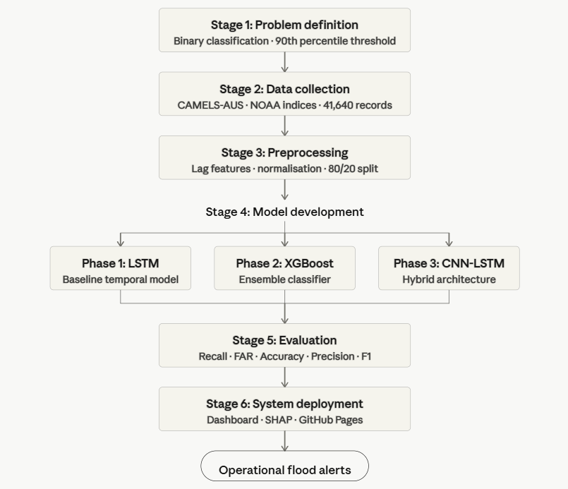
Figure 4: Research Framework

2.1.1.4 Elaboration of Frameworks, Models, and Architectures
Phase 1 - LSTM Architecture
The LSTM model serves as the primary deep learning baseline. Input data is structured as a 14-day rolling window sequence of 10 meteorological and climate features, producing a three-dimensional tensor of shape [samples × 14 timesteps × 10 features]. The 14-day window encompasses the typical pre-event atmospheric evolution period for Queensland flood events [20, 21]. The architecture comprises one LSTM layer with 64 units, a Dropout layer (rate = 0.2) for regularisation on the imbalanced training dataset, and a Dense output layer with sigmoid activation for binary classification. Training employs Binary Cross-Entropy loss with the Adam optimiser [14].
Phase 2 - XGBoost Ensemble Classifier
XGBoost serves as a high-performance non-sequential baseline. Unlike the LSTM, it accepts a flat feature vector input and relies on the seven rainfall lag features as the primary mechanism for encoding temporal antecedent information. Configured with 200 estimators and maximum tree depth of 6, XGBoost builds decision tree ensembles sequentially where each successive tree corrects residual errors of the prior ensemble, with L1 and L2 regularisation controlling model complexity [6, 11]. Its inclusion is motivated by consistent performance in tabular hydrometeorological tasks, computational efficiency relative to neural architectures, and native feature importance estimates enabling SHAP analysis [18].
Phase 3 - Deep CNN-LSTM Hybrid Architecture
The CNN-LSTM hybrid constitutes the most architecturally sophisticated model in the AuraSentinel pipeline. The architecture follows the sequence: Conv1D (128 filters, kernel size 3, ReLU) → Batch Normalisation - Conv1D (64 filters, kernel size 3, ReLU) - MaxPooling1D (pool size 2) - LSTM (128 units) - LSTM (64 units) - Dropout (rate 0.3) - Dense (1 unit, sigmoid). Convolutional layers detect the distinctive 2–3 day meteorological signatures of intense convective rainfall episodes more efficiently than LSTM hidden states operating across the full 14-day window [14]. LSTM layers then integrate these locally-extracted short-duration features across the broader temporal context to capture multi-week antecedent conditions [20]. Trained for 30 epochs with Adam optimiser and Binary Cross-Entropy loss.

2.1.1.5 Methods, Procedure, and Variables
The complete development stack consists of Python 3.11 for all model training and preprocessing pipelines, TensorFlow 2.x for neural network development, scikit-learn for ensemble modelling and preprocessing utilities, pandas for data manipulation and feature engineering, and GitHub for version control. The primary dataset (Master_Rainfall_Dataset_Final.csv) contains 41,640 rows and 20 columns spanning January 2000 to December 2024 across three Queensland river catchment stations. The 10 input variables comprise daily rainfall (mm), maximum temperature (°C), mean sea level pressure (hPa), relative humidity (%), three large-scale climate indices (DMI, SOI, Niño 3.4 SST anomaly), and seven rainfall lag features (Lag1–Lag7) encoding antecedent soil moisture. The binary target variable High_Rain_Event (0/1) is defined by station-specific 90th percentile thresholds [18]. Model evaluation employs five quantitative metrics, as defined in Equations (1) through (5) below, with False Alarm Rate (FAR) and Recall designated as the primary operational metrics given the asymmetric cost structure of flood emergency response [16, 33].
Accuracy = (TP + TN) / (TP + TN + FP + FN) ...(1)
Recall (Probability of Detection) = TP / (TP + FN) ...(2)
Precision = TP / (TP + FP) ...(3)
False Alarm Rate (FAR) = FP / (FP + TP) ...(4)
F1-Score = 2 × (Precision × Recall) / (Precision + Recall) ...(5)
where TP = True Positives, TN = True Negatives, FP = False Positives, FN = False Negatives. FAR and Recall are designated as primary operational metrics due to the asymmetric cost of missed flood events relative to false alarms in emergency response contexts [16, 33].

2.1.1.6 Prototype System Implementation
The AuraSentinel prototype is implemented as a web-based decision support dashboard that translates trained model outputs into an accessible interactive interface [34, 41]. The dashboard incorporates four core functional components: (i) an interactive Leaflet.js geospatial map displaying the three Queensland catchment stations with colour-coded flood risk indicators (green: normal, orange: elevated risk, red: extreme event predicted); (ii) a dynamic SHAP feature importance chart providing transparent attribution of which atmospheric and oceanic drivers most strongly influenced the current forecast [17, 19]; (iii) a temporal attention weight heatmap visualising which of the 14 input days most influenced the CNN-LSTM prediction; and (iv) a real-time forecast simulation panel using the final 14 consecutive test days to demonstrate operational forecasting workflow. The system is deployed on GitHub Pages and Vercel, with a deliberate separation of the trained model inference pipeline from the web deployment interface ensuring the dashboard remains computationally lightweight without server-side inference infrastructure.

2.1.1.7 Context Information, Assumptions, and Limitations
The current AuraSentinel prototype operates under the following boundary conditions and assumptions. The deployment environment uses historical test data to simulate real-time inference rather than a live Bureau of Meteorology observational data feed; operational deployment at scale would require integration with BoM's real-time API and a server-side inference pipeline. Monthly NOAA climate indices are aligned with daily station records using forward-fill, introducing a temporal resolution mismatch that may reduce attribution precision at sub-monthly timescales. The geographic scope is restricted to three Queensland catchments representing monsoonal-tropical and semi-arid climate regimes; performance generalisation to temperate, Mediterranean, or arid Australian climates has not been validated. The range of validity for reported performance metrics (Recall ≥ 70%, FAR ≤ 10%) applies to the Queensland hydroclimatic context under the 2000–2024 historical record. Notwithstanding these limitations, the methodology constitutes a complete, reproducible, and operationally grounded proof-of-concept for AI-based extreme rainfall and flood forecasting that addresses all five identified research gaps.

References
[1] N. Evershed, 'Australia's horrifying climate future in four charts – and how we can avoid the worst', The Guardian, Sep. 25, 2025. [Online]. Available: https://www.theguardian.com/news/2025/sep/25/australias-horrifying-climate-future-in-four-charts-and-how-we-can-avoid-the-worst
[2] S. Hobeichi, 'AI-powered weather and climate models are set to change the future of forecasting', UNSW Newsroom, Jul. 2024. [Online]. Available: https://www.unsw.edu.au/newsroom/news/2024/07/AI-powered-weather-climate-models-change-future-forecasting
[3] S. Guo et al., 'FuXi-TC: A generative framework integrating deep learning and physics-based models for improved tropical cyclone forecasts', arXiv, 2025, doi: 10.48550/arXiv.2508.16168.
[4] H. Ni, W. Zhang, and H. Liu, 'UniExtreme: A Universal Foundation Model for Extreme Weather Forecasting', arXiv, Sep. 2025, doi: 10.48550/arXiv.2508.01426.
[5] Y. Huang, J. Arblaster, and T. Lane, 'AUS2200', Research Data Australia, 2025. [Online]. Available: https://researchdata.edu.au/aus2200/3488778
[6] S. Partheepan, F. Sanati, and J. Hassan, 'Bushfire Severity Modelling and Future Trend Prediction Across Australia: Integrating Remote Sensing and Machine Learning', arXiv, Sep. 2024, doi: 10.48550/arXiv.2410.02963.
[7] P. Jain et al., 'A review of machine learning applications in wildfire science and management', Environ. Rev., vol. 28, no. 4, pp. 478–505, Jul. 2020, doi: 10.1139/er-2020-0019.
[8] İ. Üstek, M. Arana-Catania, A. Farr, and I. Petrunin, 'Deep Autoencoders for Unsupervised Anomaly Detection in Wildfire Prediction', arXiv, Nov. 2024, doi: 10.48550/arXiv.2411.09844.
[9] D. Cisneros, J. Richards, A. Dahal, L. Lombardo, and R. Huser, 'Deep graphical regression for jointly moderate and extreme Australian wildfires', Spat. Stat., vol. 59, p. 100811, Mar. 2024, doi: 10.1016/j.spasta.2024.100811.
[10] A. Ardid et al., 'Sub-hourly forecasting of fire potential using machine learning on time series of surface weather variables', Int. J. Wildland Fire, vol. 34, no. 1, Aug. 2025, doi: 10.1071/WF24113.
[11] F. Di Giuseppe, J. McNorton, A. Lombardi, and F. Wetterhall, 'Global data-driven prediction of fire activity', Nat. Commun., vol. 16, no. 1, p. 2918, Apr. 2025, doi: 10.1038/s41467-025-58097-7.
[12] A. S. Nur, Y. J. Kim, J. H. Lee, and C.-W. Lee, 'Spatial Prediction of Wildfire Susceptibility Using Hybrid Machine Learning Models Based on Support Vector Regression in Sydney, Australia', Remote Sens., vol. 15, no. 3, p. 760, Jan. 2023, doi: 10.3390/rs15030760.
[13] M. N. Halgamuge, E. Daminda, and A. Nirmalathas, 'Best Optimizer Selection for Predicting Bushfire Occurrences using Deep Learning', Nat. Hazards, vol. 103, pp. 845–860, 2020, doi: 10.1007/s11069-020-04015-7.
[14] H. Liu, L. Shu, X. Liu, P. Cheng, M. Wang, and Y. Huang, 'Advancements in Artificial Intelligence Applications for Forest Fire Prediction', Forests, vol. 16, no. 4, p. 704, Apr. 2025. [Online]. Available: https://www.mdpi.com/1999-4907/16/4/704
[15] S. K. Sharma, J. Aryal, and A. Rajabifard, 'Remote Sensing and Meteorological Data Fusion in Predicting Bushfire Severity: A Case Study from Victoria, Australia', Remote Sens., vol. 14, no. 7, p. 1645, Mar. 2022, doi: 10.3390/rs14071645.
[16] L. J. Speight, M. D. Cranston, C. J. White, and L. Kelly, 'Operational and emerging capabilities for surface water flood forecasting', WIREs Water, vol. 8, no. 3, Feb. 2021, doi: 10.1002/wat2.1517.
[17] H. Tonbul, 'Integrating ensemble machine learning and explainable AI for enhanced forest fire susceptibility analysis and risk assessment in Türkiye's Mediterranean region', Earth Sci. Inform., vol. 17, pp. 5709–5731, Sep. 2024, doi: 10.1007/s12145-024-01480-7.
[18] R. Chandra, A. Kapoor, S. Khedkar, J. Ng, and R. W. Vervoort, 'Ensemble quantile-based deep learning framework for streamflow and flood prediction in Australian catchments', arXiv, Feb. 2025, doi: 10.48550/arXiv.2407.15882.
[19] M. Kaspi and Y. Kuleshov, 'Flood Hazard Assessment in Australian Tropical Cyclone-Prone Regions', Climate, vol. 11, no. 11, p. 229, 2023, doi: 10.3390/cli11110229.
[20] H. Moon, S. Yoon, and Y. Moon, 'Urban flood forecasting using a hybrid modeling approach based on a deep learning technique', J. Hydroinformatics, vol. 25, no. 2, pp. 593–610, Jul. 2023, doi: 10.2166/hydro.2023.203.
[21] Y.-D. Jhong, C.-S. Chen, B.-C. Jhong, C.-H. Tsai, and S.-Y. Yang, 'Optimization of LSTM Parameters for Flash Flood Forecasting Using Genetic Algorithm', Water Resour. Manage., vol. 38, pp. 1141–1164, 2024, doi: 10.1007/s11269-023-03713-8.
[22] C. K. K. Reddy et al., 'An intelligent optimized cyclone intensity prediction framework using satellite images', Earth Sci. Inform., vol. 16, pp. 1537–1549, Mar. 2023, doi: 10.1007/s12145-023-00983-z.
[23] C. Kumler-Bonfanti, J. Stewart, D. Hall, and M. Govett, 'Tropical and Extratropical Cyclone Detection Using Deep Learning', J. Appl. Meteorol. Climatol., Aug. 2020, doi: 10.1175/JAMC-D-20-0117.1.
[24] J. Hartigan, S. MacNamara, and L. M. Leslie, 'Application of Machine Learning to Attribution and Prediction of Seasonal Precipitation and Temperature Trends in Canberra, Australia', Climate, vol. 8, no. 6, p. 76, Jun. 2020, doi: 10.3390/cli8060076.
[25] P. J. Reddy et al., 'Machine learning based parameter sensitivity of regional climate models — a case study of the WRF model for heat extremes over Southeast Australia', Environ. Res. Lett., vol. 19, no. 1, p. 014010, Nov. 2023, doi: 10.1088/1748-9326/ad0eb0.
[26] F. Sufi, E. Alam, and M. Alsulami, 'Automated Analysis of Australian Tropical Cyclones with Regression, Clustering and Convolutional Neural Network', Sustainability, vol. 14, no. 16, p. 9830, 2022, doi: 10.3390/su14169830.
[27] R. Deo and R. Chandra, 'Multi-step-ahead Cyclone Intensity Prediction with Bayesian Neural Networks', in Springer Nature Link, Aug. 2023, pp. 282–295, doi: 10.1007/978-3-030-29911-8_22.
[28] S. K. Das and P. Nayak, 'Integration of IoT-AI powered local weather forecasting: A Gamechanger for Agriculture', arXiv, Dec. 2024, doi: 10.48550/arXiv.2501.14754.
[29] J. Safieh, R. Dara, and F. Jafary, 'Difference of rainfall-runoff models and effect on flood forecasting: A brief review', Res. Environ. Int. Econ., vol. 4, no. 1, pp. 184–199, Aug. 2022, doi: 10.25082/REIE.2022.01.003.
[30] M. A.-A. Hoque, S. Phinn, C. Roelfsema, and I. Childs, 'Tropical cyclone disaster management using remote sensing and spatial analysis: A review', Int. J. Disaster Risk Reduct., vol. 22, pp. 345–354, Jun. 2017, doi: 10.1016/j.ijdrr.2017.02.008.
[31] Z. Wang, J. Zhao, H. Huang, and X. Wang, 'A Review on the Application of Machine Learning Methods in Tropical Cyclone Forecasting', Front. Earth Sci., vol. 10, Jun. 2022, doi: 10.3389/feart.2022.902596.
[32] Y. Takaya et al., 'Recent advances in seasonal and multi-annual tropical cyclone forecasting', Trop. Cyclone Res. Rev., vol. 12, no. 3, pp. 182–199, Sep. 2023, doi: 10.1016/j.tcrr.2023.09.003.
[33] L. Olivetti and G. Messori, 'Do data-driven models beat numerical models in forecasting weather extremes? A comparison of IFS HRES, Pangu-Weather, and GraphCast', Geosci. Model Dev., vol. 17, no. 21, pp. 7915–7962, Nov. 2024, doi: 10.5194/gmd-17-7915-2024.
[34] K. Nagaiah et al., 'A Logical Remote Sensing Based Disaster Management and Alert System Using AI-Assisted Internet of Things Technology', J. Geovisualization Spat. Anal., vol. 7, pp. 457–471, Aug. 2024, doi: 10.1007/s41976-024-00139-7.
[35] P. Feng et al., 'Machine learning-based integration of large-scale climate drivers can improve the forecast of seasonal rainfall probability in Australia', Environ. Res. Lett., vol. 15, no. 8, 2020, doi: 10.1088/1748-9326/ab9e98.
[36] N. Thapa, 'AI-driven approaches for optimizing the energy efficiency of integrated energy systems', M.S. thesis, Univ. of Vaasa, Finland, May 2022. [Online]. Available: https://osuva.uwasa.fi/handle/11111/11575
[37] S. M. Khan et al., 'A Systematic Review of Disaster Management Systems: Approaches, Challenges, and Future Directions', Land, vol. 12, no. 8, p. 1514, Aug. 2023, doi: 10.3390/land12081514.
[38] F. A. Prodhan et al., 'A review of machine learning methods for drought hazard monitoring and forecasting', Environ. Model. Softw., vol. 149, no. 1, 2022, doi: 10.1016/j.envsoft.2022.105327.
[39] A. Mitra and R. Shaw, 'Systemic Risk from a Disaster Management Perspective: A Review of Current Research', SSRN, 2022, doi: 10.2139/ssrn.4140988.
[40] M. Kumar, 'AI For Climate Change: Predicting Environmental Impact and Developing Sustainable Solutions', J. Emerg. Technol. Appl., vol. 4, no. 3, Sep. 2024, doi: 10.56472/25832646/JETA-V4I3P112.
[41] J. Wolbers, S. Kuipers, and A. Boin, 'A systematic review of 20 years of crisis and disaster research: Trends and progress', Risk Hazards Crisis Public Policy, May 2021, doi: 10.1002/rhc3.12244.

