**Proposal on**

**Canteen Automation System**

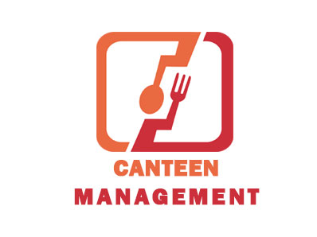

Submitted to:

Sudeep Bajimaya

Module leader: Computing Project

Softwarica College of IT and E-Commerce

Submitted by:

Sandeep Paudyal

NCCID: 00174408

Softwarica College of IT and E-Commerce

Contents

1. Introduction 1

1.1. Introduction of the project 1

1.2. Background of the project 1

1.3. Problem Statement 2

1.4. Description of the project 2

1.4.1. Features of the project 3

1.5. Overview of the project 3

2. Scope 4

2.1. Scope of the project 4

2.2. Aims 4

2.3. Objectives 4

2.4. Limitations 5

2.5. Overview of scope 5

3. Development Methodology 6

3.1. Description of methodology chosen 6

3.2. Design Pattern 6

3.3. Architecture 6

• Presentation layer 6

• Business layer 6

• Data layer 7

4. Project Planning 8

4.1. Work breakdown Structure 8

4.2. Milestone 9

4.3. Gantt chart 11

5. Risk Management 12

6. Configuration Management 14

7. Conclusion 15

8. References 16

# Table of figures/tables

Table 1: Milestone 9

Table 2: Risk Management table 13

Table 3: Backup configuration 14

Figure 1: Work breakdown structure 8

Figure 2: Gantt Chart 11

Figure 3: Spreadsheet of the project 11

Keywords

Scope, Methodology, Milestone, spreadsheet, Gantt, configuration, Laravel, credit, payment gateway, server, framework, MVC, analysis, design, testing, implementation, project, backup, GitHub, version controller.

# Introduction

## Introduction of the project

This is a proposal for the website of a canteen that I’m going to develop. This user will be able to automate the works that take place in a canteen using the web application.

## Background of the project

A canteen is a place that basically serves refreshments to people usually in a factory, schools or hospitals. In my case, I’m building this web application based on our college canteen. The current convention system of canteen takes order from students by voice and takes it to the kitchen and delivers after the food is prepared. Then the customer pays for the food by going to the counter where his order records may or may not be stored on a written form. The student can also choose not to pay for the food that day and decide to pay it up later. The credit records are kept on a copy-like ledger by the canteen owner. Many customers come to get refreshed in the canteen and order different foods at the same time. It becomes hard for the canteen owner to keep track of all the ongoing food orders as well as credit records on a manually done record keeping job. Due to that, it also becomes hard to keep exact track of expenses, profit and loss of the canteen. So, the main idea to solve this issue is by building a web application for the canteen with every possible configurations and activities. In this website, customers will be able to register their account with their credentials and login using username and password. Then, they will be able to place their order through the application. The kitchen staff will get the orders on their devices and prepare the meal accordingly and delver the food to the respective table. The user will get auto-generated bill after he finishes the ordering process. The customer can then pay online using a payment gateway or by going to the counter. Or, he can just add the bill to credit. This will help the owner to know the number of customers who paid the bill and the number of customers on credit which will help him to keep track of his profit and loss easily. The app will have a feature to notify customer if their credit exceeds 10 days.

But the canteen is currently running with a manual system and a lot of difficulties, human errors and problems.

## Problem Statement

The Challenges encountered by the manual system in canteens is efficiency and customer satisfaction. Customers have to make long queues before placing the order and when the order is placed they have to wait near the counter until the order is prepared. The major issues are given below:

• Verbal communication between cashier and customer or we can say telephonic communication: The verbal communication between two parties for placing an order and the information about bill should also result in error means error also occurs in understanding what the person want to say and especially in busy hours in canteens.

• Menu display: Today’s competition between food canteens motivates each canteen to launch new items on their menus on a more frequent basis. However, the menu in more canteens usually attached to a wall behind the counter and the customer are not aware of that new item because the menu is not up-to-date.

• Credit records: Since most of the customers choose to pay on credit for their food, the records become more important. The records on the current system are kept on a diary-like ledger which is neither automatic nor convenient. It becomes hard to calculate income and expenses.

## Description of the project

* My canteen automation system will be made solely to save time of the canteen workers and customers.
* This application will be removing complications of orders, billing as well as other management.
* This is not a product or a software that you have to pay for every copies but is an online application which makes it much cheaper with support on multiple devices.
* This application will have high security with different levels of access and customer’s data is stored on secure and protected servers.

## Features of the project

* It’ll allow users to create account.
* It’ll allow admin to provide roles to different workers in the canteen.
* Users can view menu of foods that are available and place an order.
* The application will generate a bill and send it to the customer.
* Customers can pay online or by going to the counter or using credit.
* Canteen manager can view the credits, expenses and profits through the application.
* Users will be notified if their unpaid credits exceed more than 15 days.

## Overview of the project

So, this application will be able to help customers and canteen manager by the use of order processing and bill payment management with various reports generating features.

# Scope

## Scope of the project

The vision of this project has a good promotional features for the organizations that use this application. It’ll help the customers and canteen workers to process various operations easily without any hassle.

To build this system, I am planning to use following programming languages:

* Presentation layer: HTML, CSS, JavaScript, JQuery
* Server Side: PHP
* Framework: Laravel
* Design Pattern: MVC
* Database Server: MySQL

## Aims

My aim of this proposal is to build a dynamic website for food ordering in canteen for customers and delivery and management for canteen manager and other workers.

## Objectives

Our objective is to make a platform independent application to maintain a database of all orders ordered from various sources and all the different services required by each of them.

* Registration
* Order
* Payment
* Update

The above are the modules of canteen automation system.

## Limitations

* This application will not have any mechanism to test the hygiene of the food.
* Customers will not be able to customize their food other than that is given in the menu.
* As the application is online, it will not work without active internet connection.

## Overview of scope

With a few limitations and many possibilities, the scope of this application is pretty high which will aid the organization in a great manner.

# Development Methodology

## Description of methodology chosen

For this project, I’m going to use incremental RAD model. Incremental model is advisable where requirements are clear and the development time is less. The striking feature of the incremental model is that each module can be completed and released as and when the requirement arises because of lack of time. As in our system, many of the modules are not inter-related so can be released in isolation. The user can thus get a feel of these modules and give his feedback which can be utilized for making the software more user-friendly and in line with the user requirements. Not only that the deadline set for this project is 3 months and we need a high adaptation model and again will be concentrating on parallelism because our team will be working on the different module at the same time. So looking into all these requirements we find Incremental RAD model is best suited for our system because it enables the development team to create a fully functional system within a very short period of time.

## Design Pattern

I’ll using MVC design pattern in this project. MVC stands for Model View Controller. This pattern defines different aspects of application. Model represents data that is being handled in a program. View defines the UI or the part that a user interacts with. It controls the data flow into model object and updates the view whenever data changes.

## Architecture

In this project, I’ll be using three tier architecture. It consists of following layers:

### Presentation layer

The website or windows forms application is called the presentation layer. The presentation layer is the most important layer simply because it’s the one that everyone sees and uses.

### Business layer

This layer is a class which we use to write the function which works as a mediator to transfer the data from Application or presentation layer data layer. In the three-tier architecture, we never let the data access layer to interact with the presentation layer.

### Data layer

The data layer is a separate component whose sole purpose is to serve up the data from the database and return it to the caller. This layer is also a class which we use to get or set the data to the database back and forth.

# Project Planning

## Work breakdown Structure

WBS is basically used to simplify the execution of the project. Larger tasks in a project are divided into different parts and different roles is assigned to different people working on that project. WBS can be used or applied in any kind of project.

Some benefits of WBS on a project are:

* It can be used to identify potential risks on a project.
* The project manager can also identify communication points and formulate a plan accordingly.
* A work breakdown structure indicates milestones and other project plans.

The WBS of Canteen Automation System is given below:

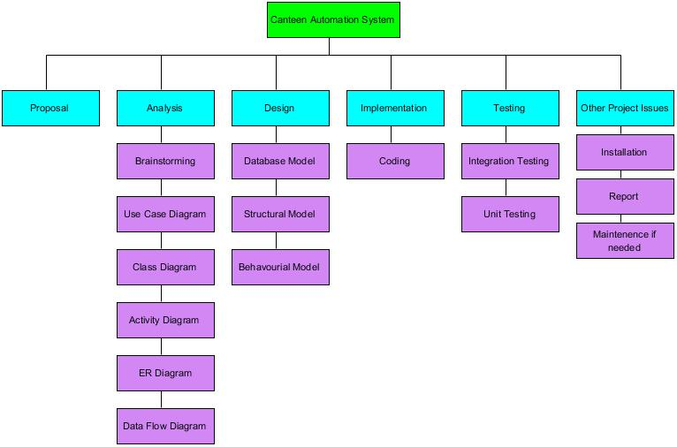

Figure 1: Work breakdown structure

## Milestone

A project milestone is a management tool that is used to delineate a point in a project schedule. These points can note the start and finish of a project, and mark the completion of a major phase –of work. Milestones can be used to symbolize anything that has started or finished, though it’s primarily used as a scheduling tool.

I’ve also produced milestone in my project which are:

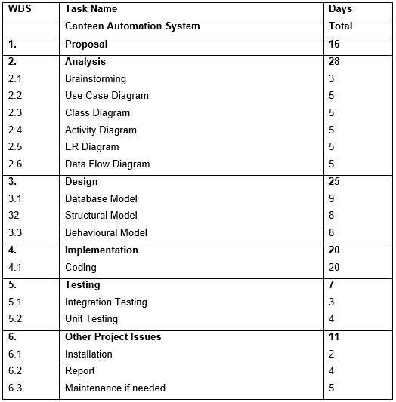

Table 1: Milestone

The six parts in milestones are described below:

* Proposal

In this stage, I’ve started the project on 25th March 2019. This period was utilized to create a proposal for the project along with choosing the topic for the project and gathering basic ideas and requirements needed for it. It was completed on 9th April 2019.

* Analysis

Analysis will take overall time of 28 days starting from 10th April 2019 to 7th May 2019. During this time, we’ll be performing analysis like brainstorming and construction of certain diagrams like class diagram and class diagram.

* Design

Design process deals with the design of different models like structural, behavioural and database model. Construction of database and UI falls under this period. This stage lasts for 25 days from 8th May to 1st June of 2019

* Implementation

The period of 20 days that deals with coding of both front end and back end is kept under implementation field. This process starts from 2nd June to 22nd June 2019.

* Testing

After the coding is complete, we need test whether different functionalities work or not. In this time, we perform two types of testing, unit testing and Integration testing. The overall time of testing is 7 days which starts from 22nd June to 28th June 2019.

* Other project Issues

After every step is completed and if we encounter some errors and issues, we can fix them during this period. This step is allocated a duration of 11 days starting from 29th June to 9th July which marks the end of our project.

## Gantt chart

I’ve used an open source software called ProjectLibre to build a Gantt chart which is given below:

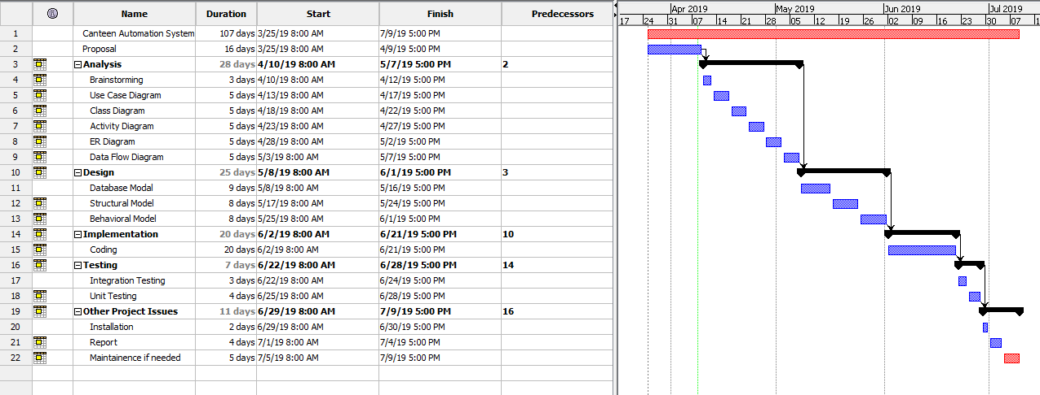

Figure 2: Gantt Chart

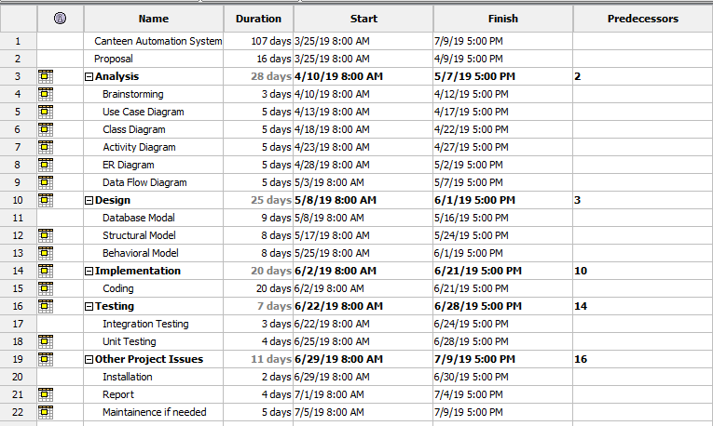

Figure 3: Spreadsheet of the project

# Risk Management

Risk is inevitable in a business organization when undertaking projects. However, the project manager needs to ensure that risks are kept to a minimal. Risks can be mainly divided between two types, negative impact risk and positive impact risk.

Risk management helps to find the impact of each risk. The impact of risk is calculated by multiplying the likelihood of the risk with its consequences.

Some of the potential risks in my project are:

* Estimation and evaluation of project scheduling can be difficult in individual software projects like this.
* Change in requirements may cause hurdle in meeting deadlines.
* The developed website might be difficult for the customer to use.
* A lot of money will be necessary which may cause some complications.
* The final product may not be as expected.
* Since the website is online, it is prone to hackers.
* Online servers where the website is hosted can be crashed.

|  |  |
| --- | --- |
| **Likelihood** | **Value** |
| Low | 1 |
| Medium | 2 |
| High | 3 |

Risk Likelihood values Dawson 2005

|  |  |
| --- | --- |
| **Consequence** | **Value** |
| Very low | 1 |
| Low | 2 |
| Medium | 3 |
| High | 4 |
| Very High | 5 |

Risk Consequence value Dawson 2005

*Impact = Likelihood * Consequences*

|  |  |  |  |  |
| --- | --- | --- | --- | --- |
| **Risk** | **Likelihood** | **Consequence** | **Impact** | **Action** |
| Analysis risks | 2 | 5 | 10 | Take enough time during analysis and prepare correct schedules. |
| Requirement changes | 3 | 4 | 12 | Confirm every requirements before implementation of the application. |
| Convenience risk | 2 | 4 | 8 | The website needs to be made understandable and usable for all types of people. |
| Budget risk | 2 | 5 | 10 | Review the progress of the project, the spend to date, and calculate your own projected total project cost. |
| Final product | 1 | 2 | 2 | Perform enough research and try to include every trends in the website and make new components ready for next update. |
| Hacking activities | 2 | 4 | 8 | Website must be hosted in a secure web hosting company. |
| Server crashing | 2 | 5 | 10 | Backup of servers must be made so that it can work when the main server is offline. |

Table 2: Risk Management table

# Configuration Management

Project baseline management or configuration management is one of the most important project disciplines that deals with tracking and controlling the changes of software development. During the project development, we need to go through different stages and our work changes from time to time. So, we need some sort of backup if anything goes wrong during the development process. For that I’m backing up all my project files to a separate backup folder. Along with that, I’m using GitHub as version controller that allows me to get back to the previous versions or steps anything goes wrong on the future.

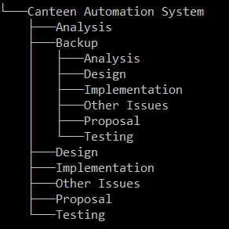

Table 3: Backup configuration

# Conclusion

Canteen automation system is a system or an application that serves the perfect job in an organization’s canteen. It’ll make the workflow in a canteen much easier and faster. In the end, a proposal for the fully automatic Canteen Automation System is created.

# References

Cms.gov. (2019). [online] Available at: https://www.cms.gov/research-statistics-data-and-systems/cms-information-technology/xlc/downloads/selectingdevelopmentapproach.pdf [Accessed 3 Apr. 2019].

The Economic Times. (2019). *Definition of Gantt Chart | What is Gantt Chart ? Gantt Chart Meaning - The Economic Times*. [online] Available at: https://economictimes.indiatimes.com/definition/gantt-chart [Accessed 2 Apr. 2019].

Gordon, A., 2014. *What is a Work Breakdown Structure?.* [Online]   
Available at: http://www.brighthubpm.com/templates-forms/2645-what-is-a-work-breakdown-structure/#imgn_1  
[Accessed 2 Apr. 2019].

Ravihansa, D., 2015. *System Development Methodologies.* [Online]   
Available at: https://www.slideshare.net/devonravihansa18/system-development-methodologies-45452837  
[Accessed 4 Apr. 2019].

Sharma, L., 2017. *Configuration Management.* [Online]   
Available at: http://toolsqa.com/software-testing/configuration-management/  
[Accessed 5 Apr. 2019].

sheffield.ac.uk, 2012. *How to: Write a Problem Statement.* [Online]   
Available at: https://www.sheffield.ac.uk/polopoly_fs/1.440722!/file/HowtoWriteaProblemStatement.pdf  
[Accessed 8 Apr. 2019].

smartsheet, 2016. *How to Write a S.M.A.R.T. Project Objective.* [Online]   
Available at: https://www.smartsheet.com/how-write-smart-project-objective  
[Accessed 29 March. 2019].