Louie Quicksell & Paul Young
CS 173- Dr. Bressoud
April 15, 2014
Homework 8 Test & Result Analysis

For this project, the new classes we wrote were: CustomerArrival, Server, Simulator, and a main driver. Additionally we modified our existing Event and OrderedSet classes, along with the test suites for either respectively. For our Event class, our modifications consisted simply of annotating each function prototype with the virtual keyword and changing the data members to protected. After re-making the file, the modifications we made were basic enough that no change in our testEvent was necessary. Next we modified the OrderedSet class to contain an array of pointers to Events, rather than copies of Event objects, and the necessary alterations to the class functions/prototypes that result from using an array of pointers. These adjustments also did not require any changes to testOrderedSet.
The first new class we created was the CustomerArrival class. For the constructor, we first tested that an empty constructor would initialize the data members to the correct default variables using the EXPECT_EQ statement. Next, we tested that the constructor parameters assigned to the correct variables, and that when necessary they were dynamically allocated correctly, again by using the EXPECT_EQ statement. We then tested the execute method, first by checking to see if the newly created Customer had the intended parameters default and otherwise, again by using the EXPECT_EQ statement. Next, we made sure that if the server was available, that service was initiated on the customer, by checking if the Server.availabe() function returned true before the service initiation and false after. We tested that if the server was busy, the customer would be placed on the shared queue by expecting that the queue length was 1 after attempting to execute the customer on the busy server. The CustomerArrival string function was easily tested by initializing a server with a specific time and id and expecting that the string function would return the desired format.
The second new class we created was the Server class. Again for the constructor we tested that the member variables for the class were initialized properly in an empty constructor and otherwise through the use of EXPECT_EQ. We then tested the available() by checking if a server was not busy when not serviced on a customer and was busy when servicing a customer through the use of the EXPECT_TRUE and EXPECT_FALSE statements. Next, we tested the startService() method by first checking the server's availability would change to busy when the method was invoked with a server on a customer again by using the EXPECT_TRUE statement. Then we checked that if a customer was passed in the startService() method on a server that was already busy, that the customer would be placed in the queue. We tested this by checking if the queue length increased by one after the second startService() invocation on the same server. Finally, we tested that the time of the server object was larger than what it was before being invoked by the startService() method with a customer. Next, we tested the execute() method and that the server it is invoked upon is changed to being not busy, and that if there is customer waiting on the queue, it calls the startService() method on it.
The last class we created was the Simulator class. First, we tested the now() method by changing the time and making sure the method returned the same time using the EXPECT_EQ statement. Second, we tested that the insert() method inserted the Event pointer into the OrderedSet by checking through each value in the OrderedSet and making sure the value inserted could be found. We then tested setup() by expecting each of the Queue, Server, and CustomerArrival parameters passed in to have the correct default values relating to each class object. We then made sure that the CustomerArrival object passed was actually passed into the OrderedSet by the method explained previously. Lastly, we tested the doAllEvents() method's correctness by that the Event pointer removed from the OrderedSet was the first in the set through the use of the EXPECT_EQ statement. Then we made certain that the time was changed to the time of the removed event using the now() method and that the correct execute() method was called relative to the Event object that was removed.
Results
To obtain the results we setup the simulation with an available server and an empty queue and allow 1000 customers to arrive with arrival time following an exponential distribution. We found that if the server's serving rate is much faster than the customer arrival rate, server utilization shoots up at the beginning of the simulation but soon levels off around a low utilization as customers continue to arrive.
Data below are shown for meanArrival rate of 0.02 and serving rate of 0.2
We confirmed that the correct rates are indeed implemented by fitting the histogram of arrival interval and service time to exponential distributions respectively.
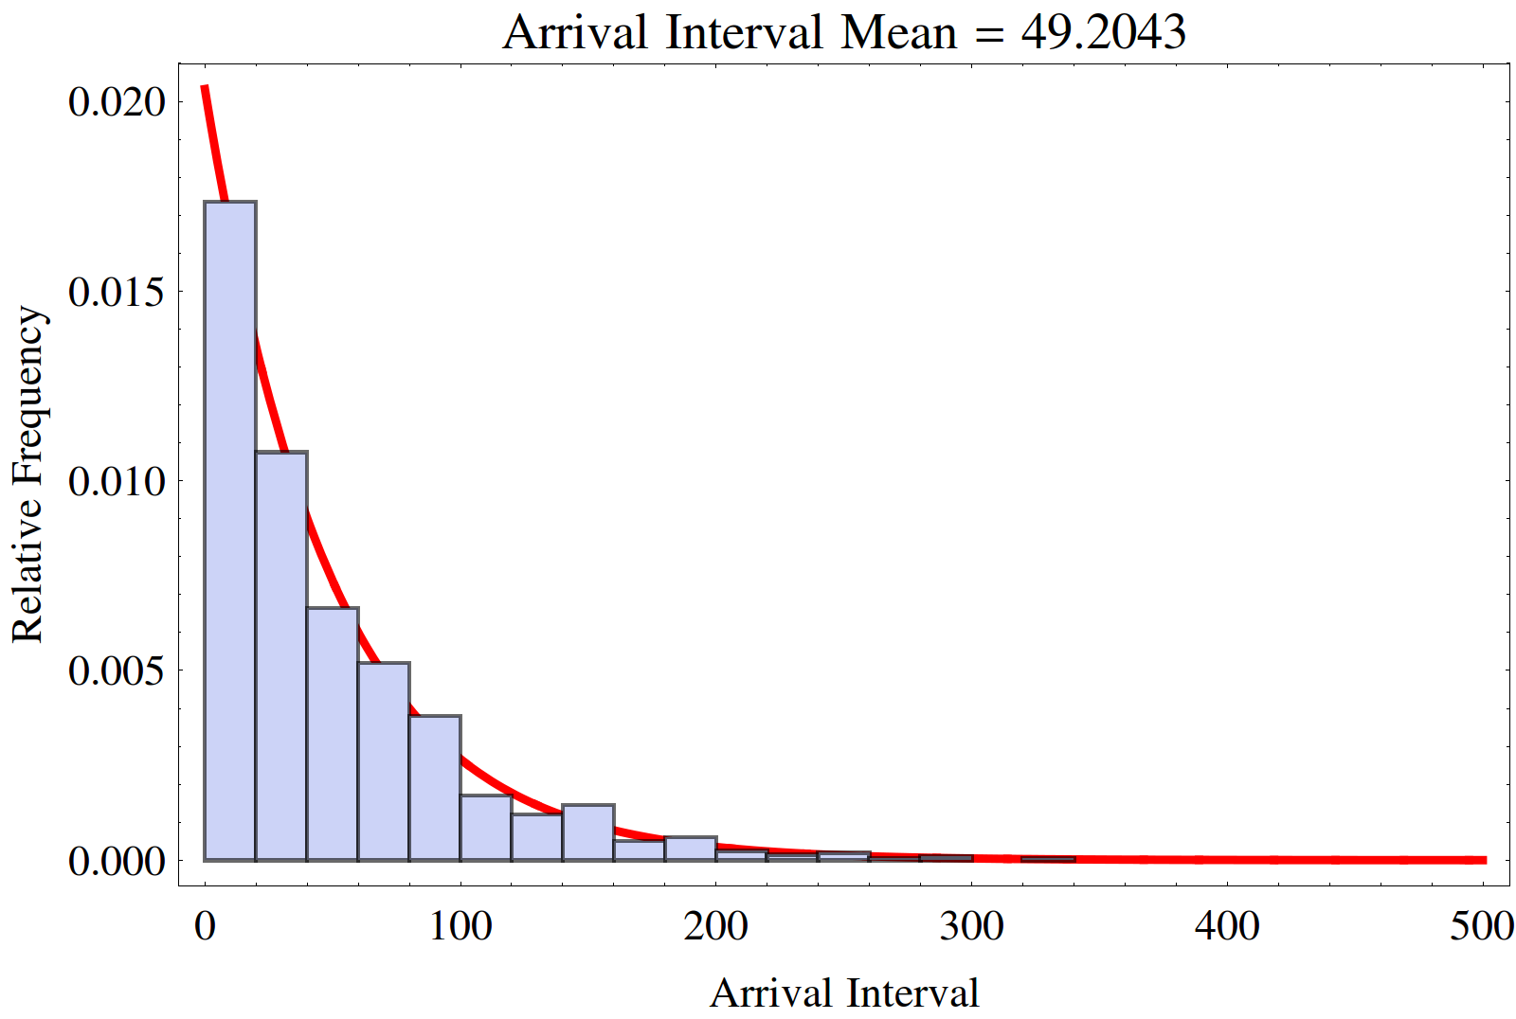
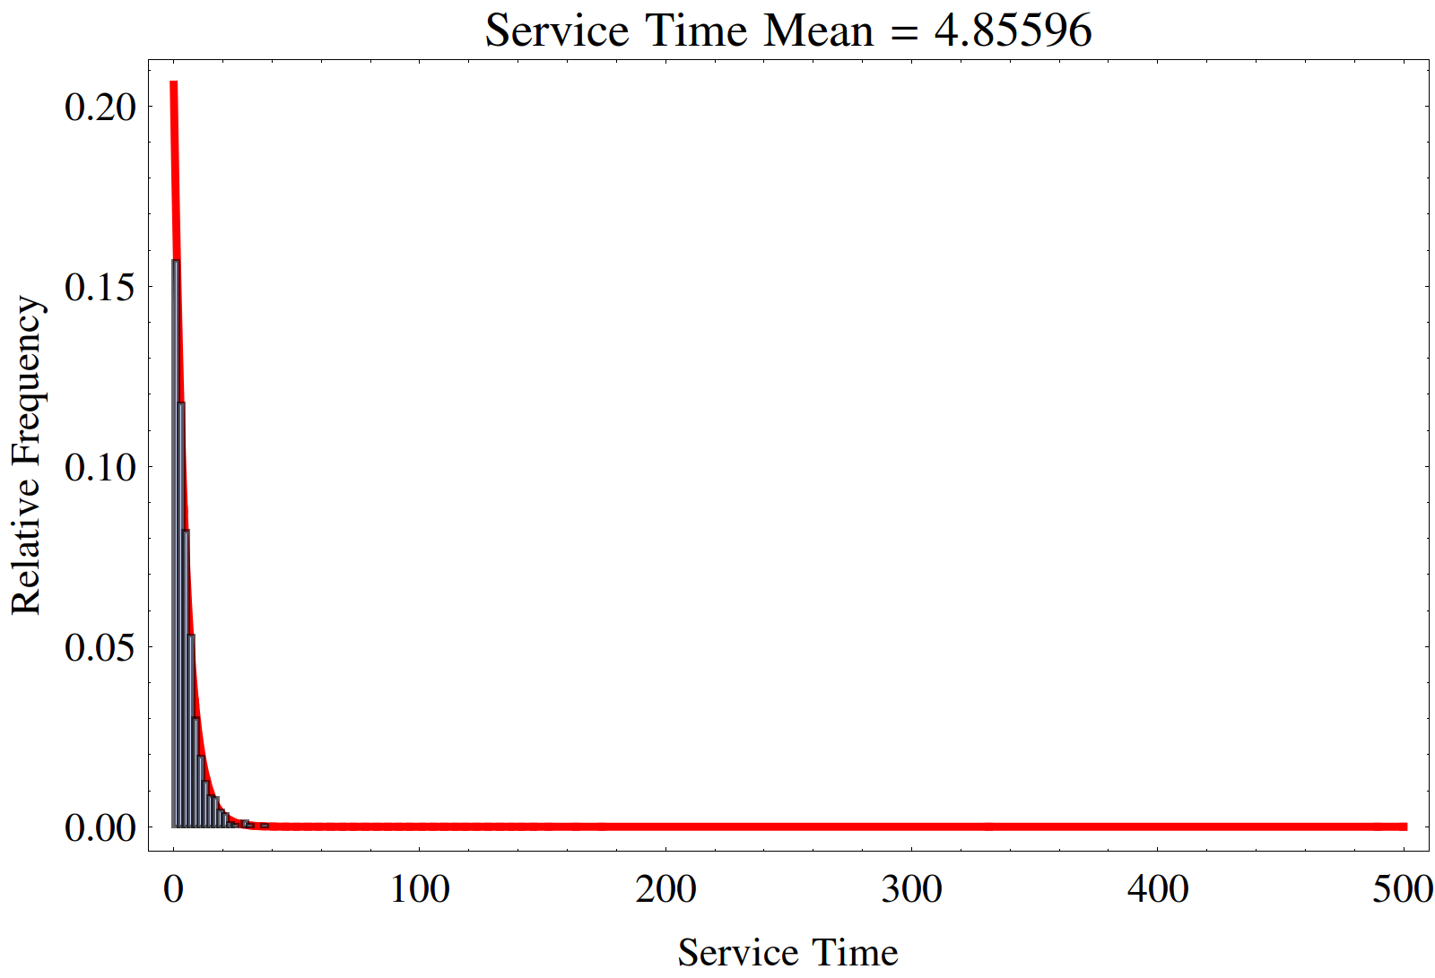

In this case the queue never gets filled up. In fact, queue length stays around 0 for the entire length of the simulation.
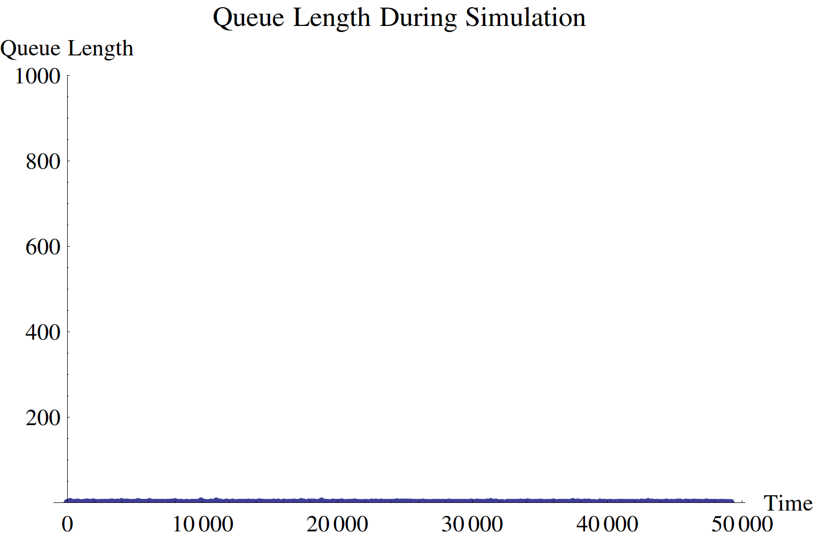

The server is only really busy for the first part of the simulation and then stays idle for 90% of the time.
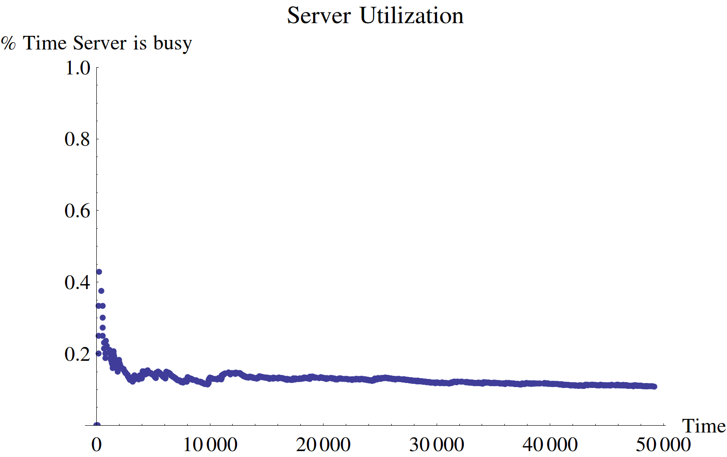

In the opposite limit, when the customer arrives much faster than the server can serve – with an arrival rate of 1 and a serving rate of 0.5

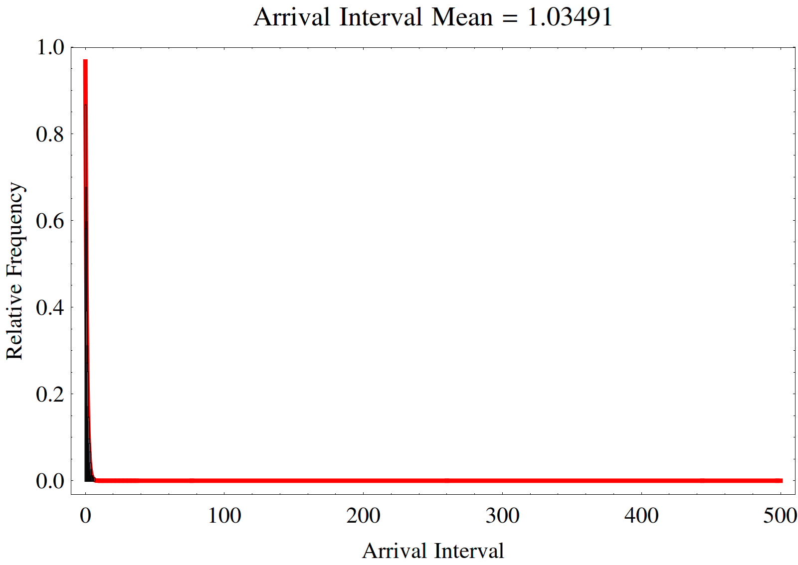

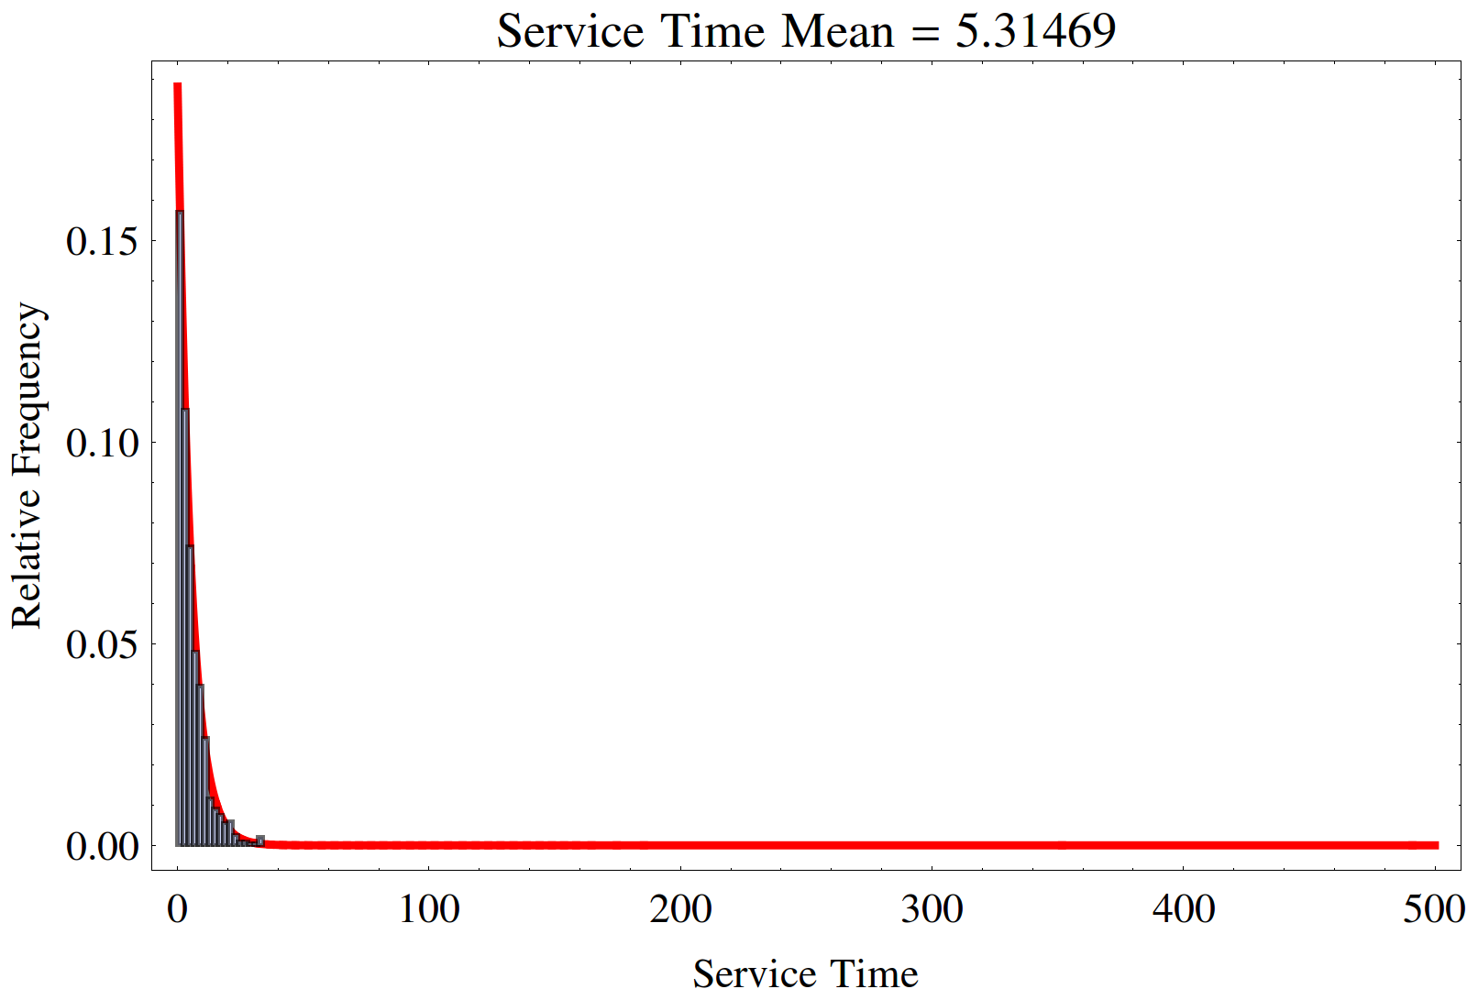

The queue quickly fills up in a linear fashion until all 1000 customers have arrived. Then the length slowly decreases linearly as the server serves the customers.
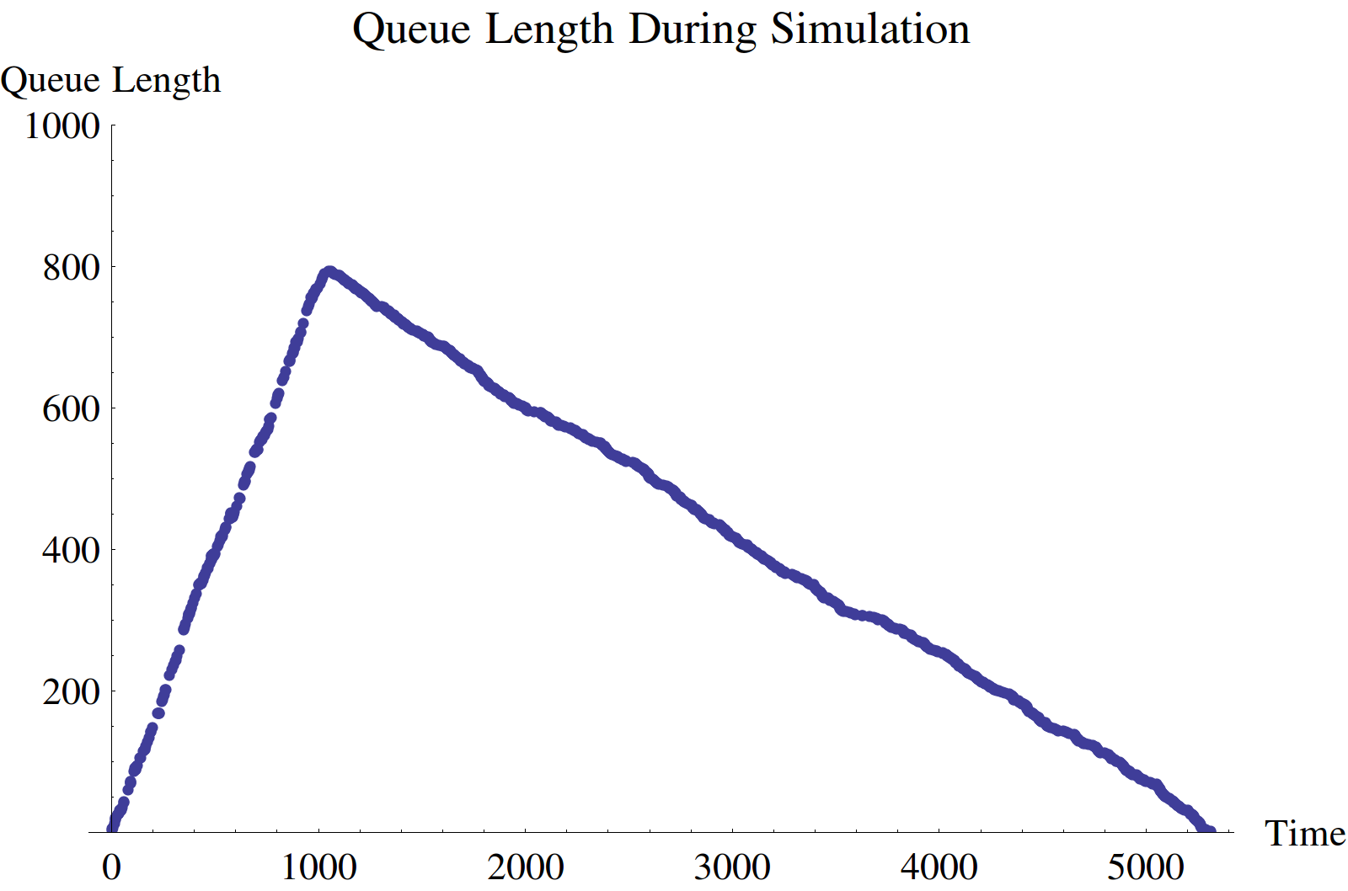

In this case, the server quickly becomes saturated with customer and stays so for the entire duration of the simulation
