Project 1: Static Foundations
Resubmission review for Hunterpedia
Student: Paul Basile Course: CSC 436, Fall 2026 First review at: 5541740 (74) This review at: d7d9785
Repo: github.com/paul-basile/static-foundations-436 Live: startling-toffee-977910.netlify.app

Grade: 84 / 100 (was 74)
Category | Points | Was | Now | What moved it
Semantic HTML | 20 | 12 | 15 | h1 everywhere, footer everywhere, script in body, button, alt fixed. New: 18 validator errors (div inside button), h1 to h3 skip
CSS layout | 25 | 22 | 23 | Typo fixed. Grid added. Six duplicate stylesheets remain, footer pasted into all six
Responsive design | 15 | 13 | 13 | Dead mobile rule now works. New grid is five columns at every width
JavaScript interaction | 15 | 12 | 13 | Real button. aria-expanded is in the HTML but the script never updates it
Repository and deployment | 15 | 8 | 11 | README has all four items. Five well-described new commits. Original due-date dump remains
Content and polish | 10 | 7 | 9 | Alt text right, footer, desktop no longer empty. Grid is five decorative squares that link nowhere
Total | 100 | 74 | 84 | Ten points, earned by fixing exactly what the first review listed. The new deductions are one-line fixes.

How this review was made
Same as the first one. Your instructor reviewed the resubmission with Claude (Anthropic's AI) as a second set of eyes. Claude pulled the five new commits, diffed every file against the graded commit, re-ran the W3C validator on all six pages, loaded the live site at phone, tablet and desktop widths, clicked the hamburger and read its aria-expanded before and after, and measured the new image grid at 375 and 1280. Every note and every point in this document was read and approved by your instructor. The original review is unchanged; this document is only about what changed.

The short version
You fixed what was on the list, and you did it in five commits with messages that say what changed. Every page has an h1. Every page has a footer, so every page now has three semantic sections, which was the brief's first requirement and the biggest deduction last time. The script is inside body. The hamburger is a button. Hisoka's alt text is Hisoka's. The README has a description, run instructions and the live link. The .nav-links a typo is gone, which also brought the dead mobile rule back to life. And there is a Grid on the home page now, which the first review suggested and did not require.
Three things came in with the fixes. The button holds three divs, which is not allowed, so every page went from one validator error to three. The aria-expanded attribute is on the button, but nothing in nav.js changes it, so it says false whether the menu is open or closed. And the grid is repeat(5, 1fr) with no media rule, so on a phone the five character portraits are 75px slivers. All three are small, and they are the difference between 84 and the high 80s.

What Claude measured
Check | First review | Now
h1 across 6 pages | 0 | 6 (one per page)
Semantic elements per page | nav, main | nav, main, footer
W3C errors across 6 pages | 6 (script after body) | 19 (div in button x18, heading skip x1)
Hamburger element | div | button with aria-expanded
aria-expanded after clicking open | n/a | still "false"
display: grid | 0 | 1 (home page, 5 columns)
Grid columns at 375 / 768 / 1280 | n/a | 5 / 5 / 5; cells are 75 px wide at 375
README items | 1 of 4 | 4 of 4
Hisoka alt text | "Locked In", "Leorio Paradinight" | "Hisoka Morow", "The formidable one."
Horizontal scroll at 375 / 768 / 1280 | None | None
Console errors | 0 | 0
Desktop home page at 1280 by 900 | Content ends at 650 px | Grid fills to 713 px, footer below
Commits | 4 | 9 (5 new on Sep 16, each with a real message)
Live vs repo | Identical | Identical apart from Netlify rewriting .html links

The home page now, at three widths

Desktop, 1280px. The new five-column portrait grid fills the fold; footer below it.
  Phone, 375px. Still five columns: each portrait is 75px wide. | 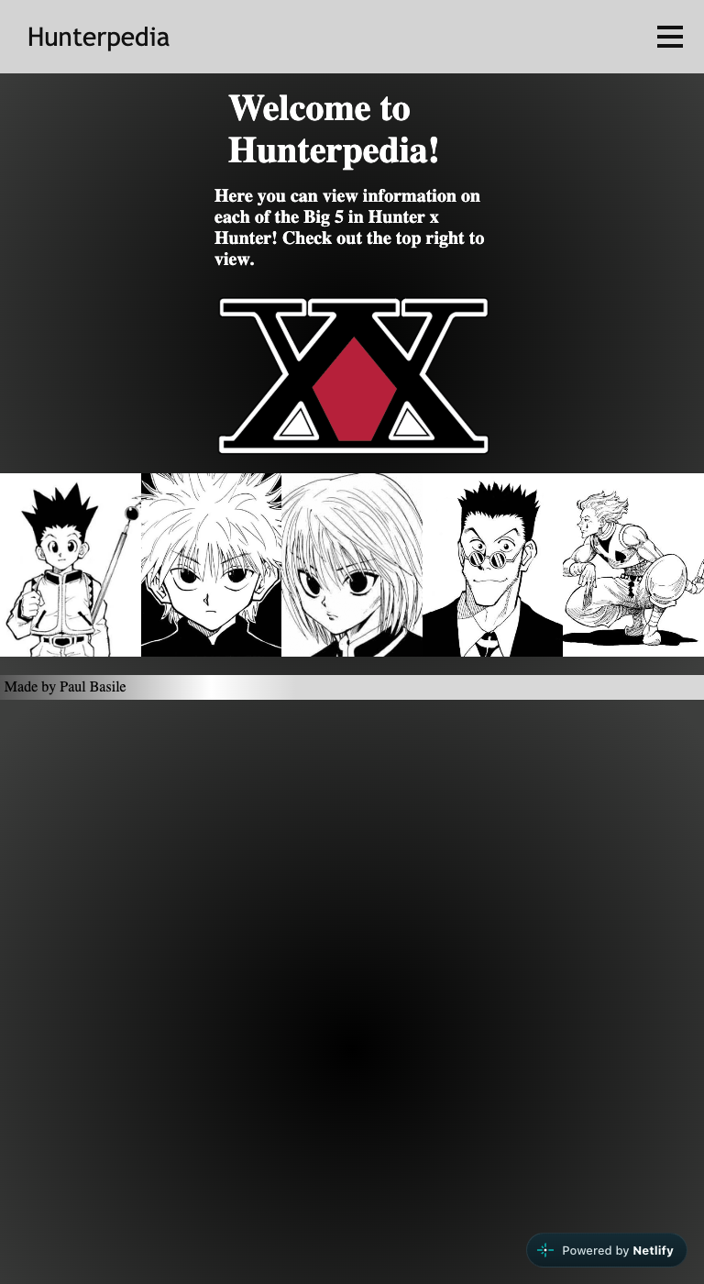  Tablet, 768px. Five columns.

What was fixed, and what it earned
- h1 on every page (index.html line 15). The logo went from h2 to h1. Every page now has exactly one. That was the single largest note in the first review.
- footer on every page (index.html lines 47 to 49, and the same on every character page). nav, main, footer: three semantic sections, which is what the brief asked for. Your reasoning about header is fine; the nav is your header. footer was the right pick.
- Script inside body (line 51). The one validator error from last time is gone from all six pages.
- The hamburger is a button (line 17). Keyboard users can reach it now. See below for the part that is not finished.
- Hisoka's alt text (page5-hisoka.html lines 32 to 33). Correct.
- README. Description, how to run, live link. All four items. The "git clone {repo url}" placeholder should be the real URL, but the item counts.
- The typo. .nav-link a is now .nav-links a inside the media query in all six files, so the phone nav rule that did nothing last time now applies.
- A Grid (home-theme.css lines 16 to 34). repeat(5, 1fr) with five background-image cells. The first review said the home page was begging for one. It looks good on a desktop.

What came in with the fixes
- Three divs inside a button (index.html lines 17 to 21). A button may only contain phrasing content, and div is not phrasing. The validator now reports three errors on every page, 18 in total, where it reported one before. The fix: change each div.bar to span.bar and add display: block to .bar in the CSS. Same look, zero errors. Also give the button aria-label="Menu", because it has no text.
- aria-expanded never changes (index.html line 17, nav.js lines 5 to 14). The attribute is there, which is the right instinct, but the script only touches style.display and menuOpen. Claude clicked the button open and read the attribute: still "false". So a screen reader announces "collapsed" while the menu is open. The fix is the same one the first review suggested for the boolean: const open = navLinks.classList.toggle("open"); dropdown.setAttribute("aria-expanded", open); with .nav-links.open { display: block } in the phone media query. No inline style, no menuOpen, and the attribute tells the truth.
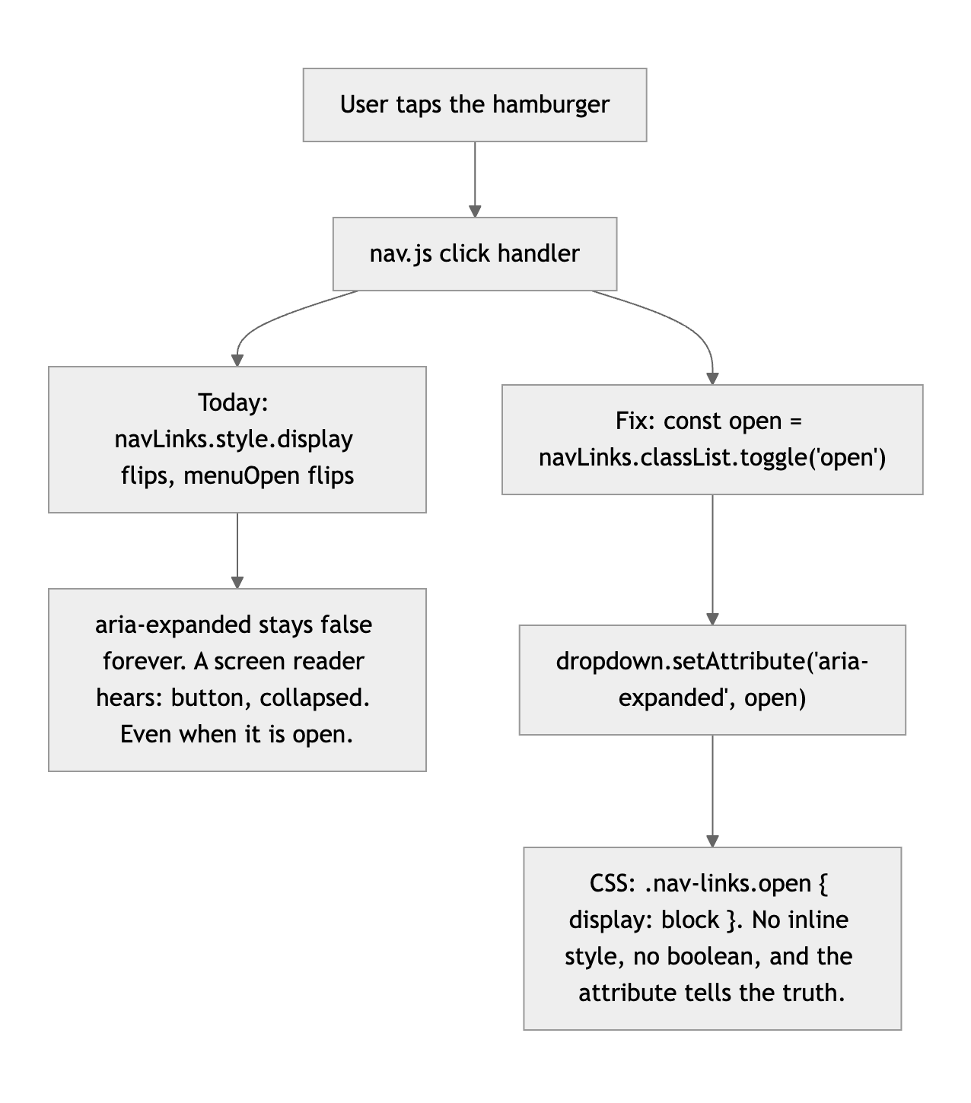
Diagram 1. What the click does today, and the four-line version that fixes the attribute, the boolean and the inline style at once.
- The grid does not adapt (home-theme.css lines 16 to 22). Five columns at 1280 is right. Five columns at 375 gives each portrait 75px, and background-size: cover crops each face to a strip. Either repeat(auto-fit, minmax(160px, 1fr)), which goes 5, 4, 2 on its own, or a two-column rule inside the existing 768px query. One line.
- The grid cells are empty divs with background images (index.html lines 39 to 45). A screen reader gets nothing, and clicking a face does nothing, which is the first thing a visitor will try. Make each cell a link to the character page with an img and alt inside, and the grid becomes navigation instead of decoration. Then add h2 headings to the character pages and change the home h3 to h2 so the outline does not skip a level (line 33).

What is still open from the first review
- Six copies of the stylesheet. The resubmission is the proof: the footer rule was added to all six files, thirteen lines times six. One base.css with the shared 140 lines, plus a 20-line theme file per character, and the next fix is one edit instead of six.
- Desktop-first, and overflow-x: hidden. Unchanged from the first review. Neither costs much, and neither is urgent.
- The history. The five new commits are what the brief asked for: "Added footer to each page with a link to my github," "Fixed .nav-links a selector typo and put script into the body." That is the habit. It arrived after the deadline, so the original single-commit deduction stays, but it is smaller than it was because the repo now shows you can do it.
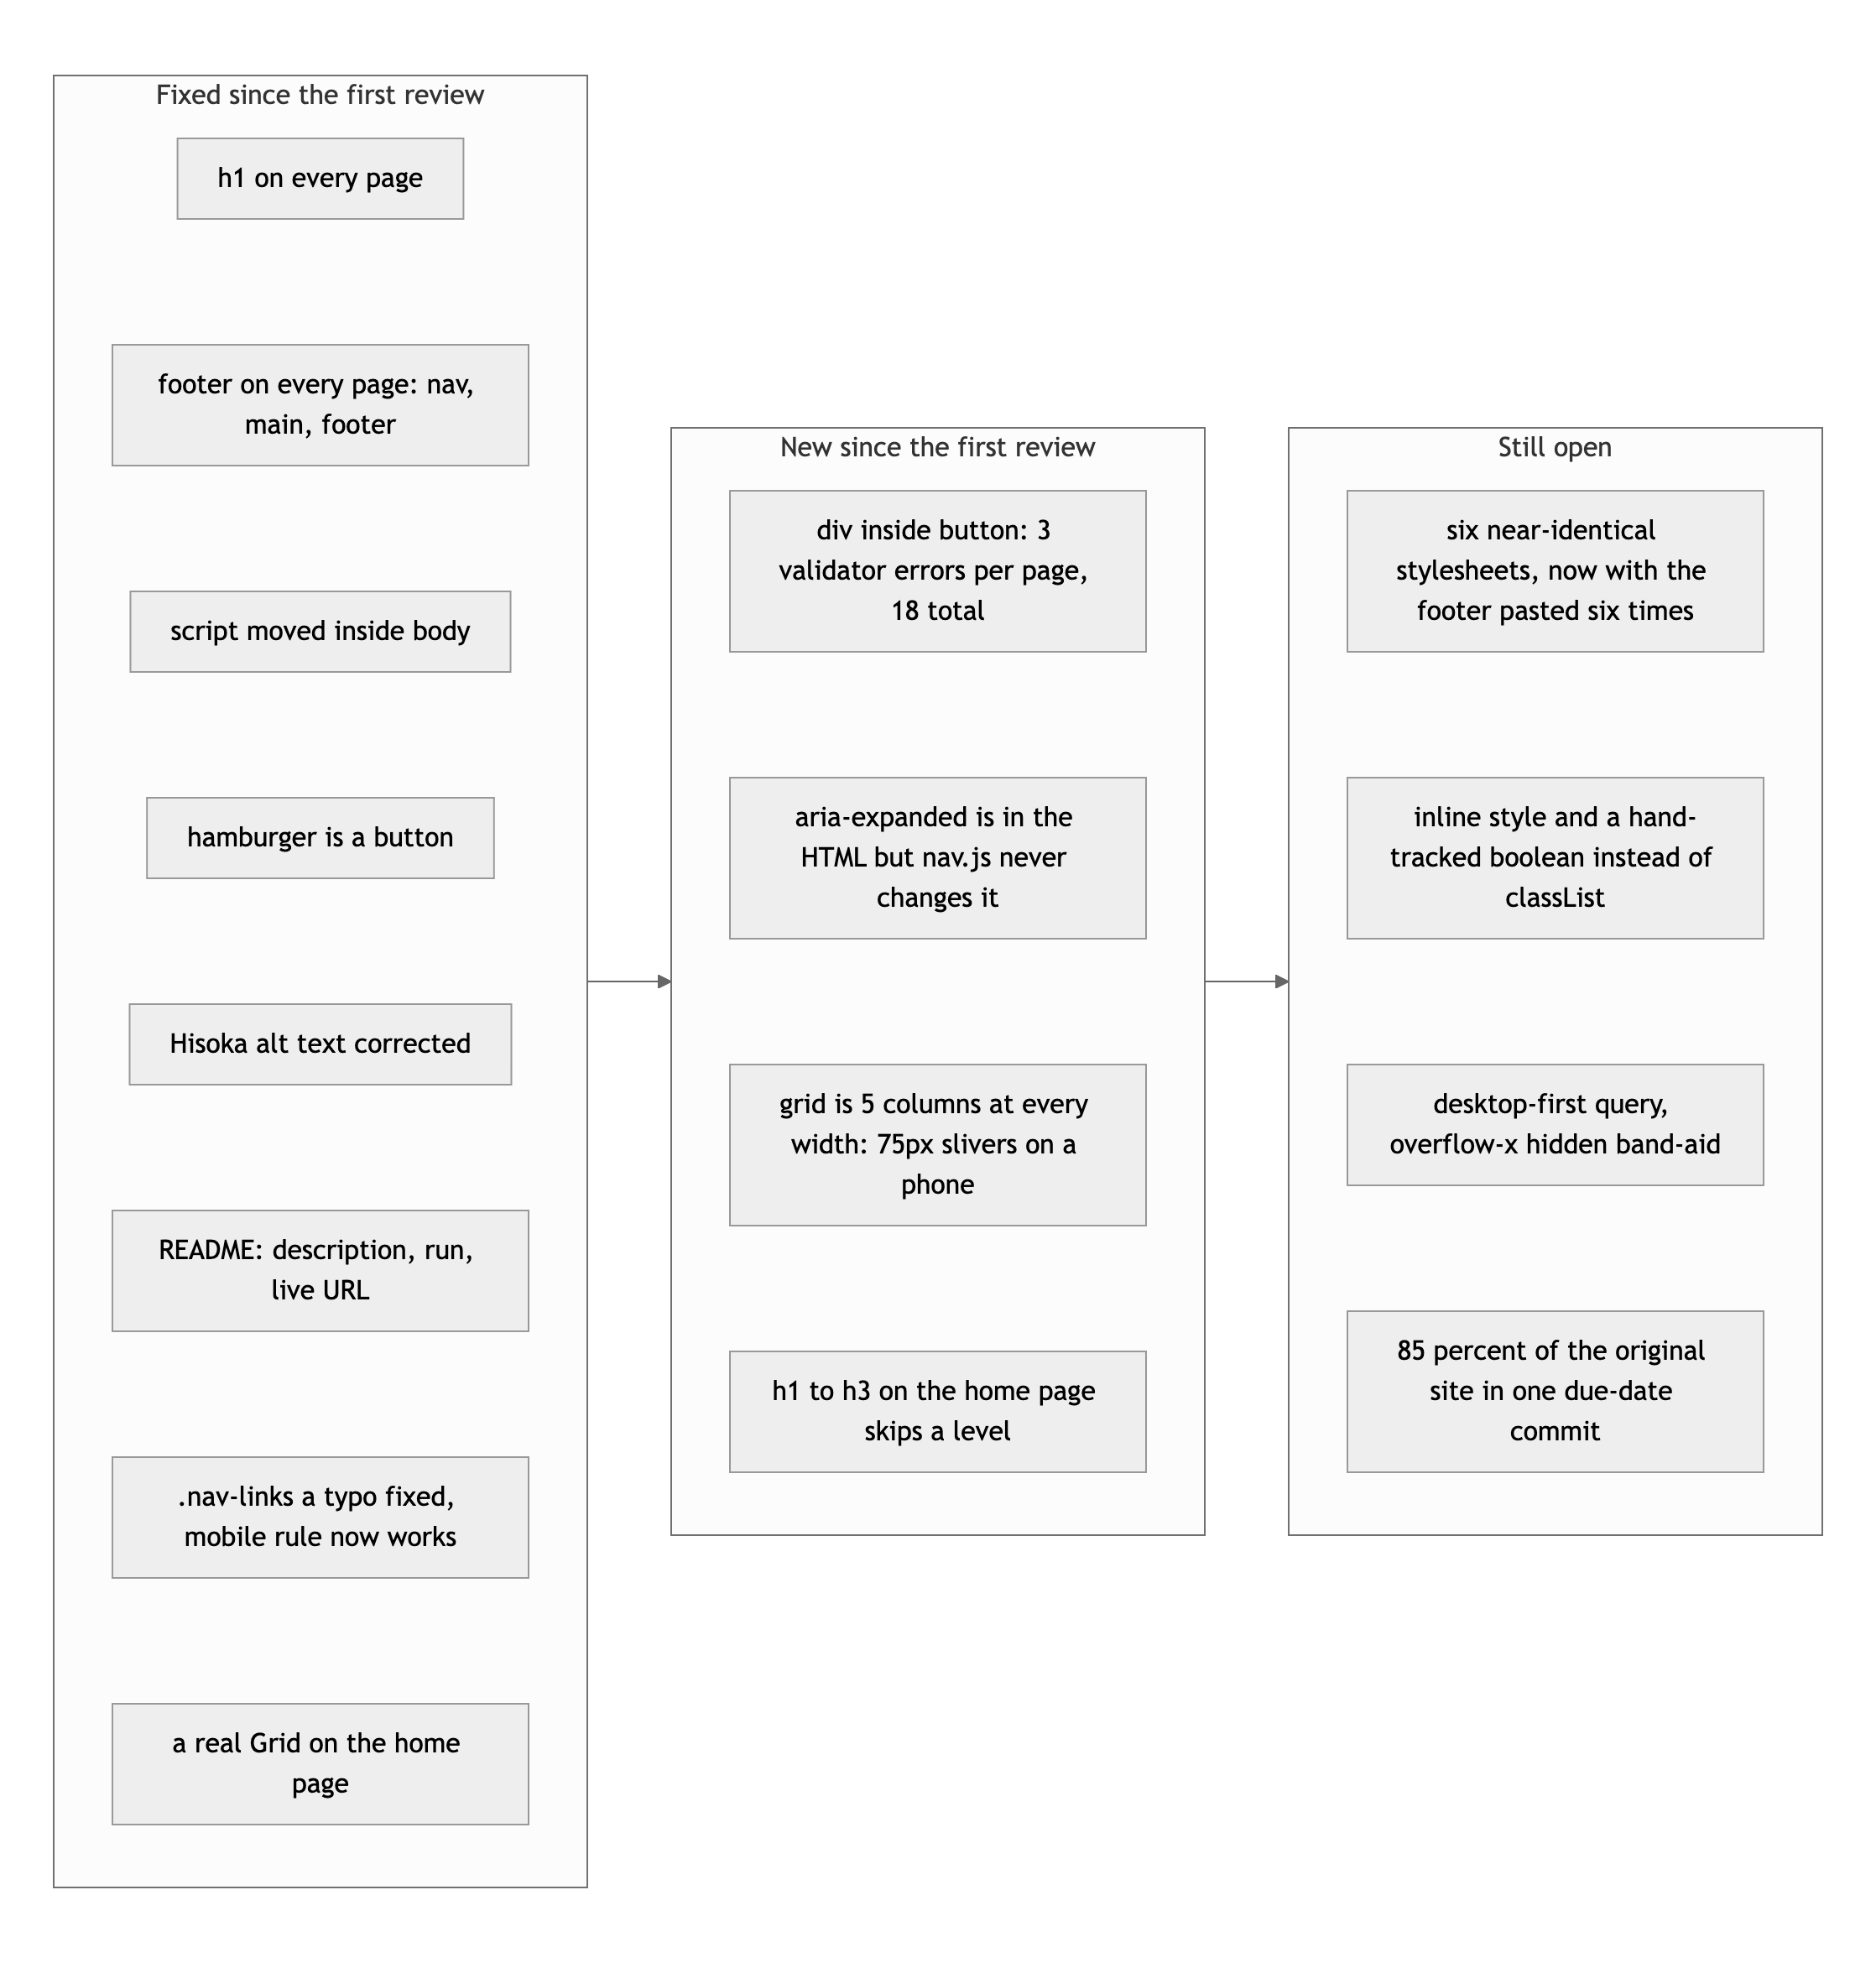
Diagram 2. Fixed, new, and still open.

If you touch it once more
- span instead of div in the button, plus aria-label="Menu". Eighteen validator errors to zero. Five minutes.
- Wire aria-expanded with classList.toggle. Four lines of JS, one line of CSS. It fixes the attribute and retires the boolean and the inline style in the same move.
- Make the grid adapt and make it clickable. auto-fit with minmax, and a link with an image in each cell.

Nice work on the turnaround, Paul. The list was long and you went through it.
This document lives alongside the original review in the same pull request. Nothing in your code is modified.

