J2EE TECHNOLOGY PERFORMANCE EVALUATION METHODOLOGY

Abstract

Internet-enabled enterprise information systems are becoming increasingly popular. They use middleware technology as the foundation. These technologies are becoming more and more complex. However, there is little understanding in the software industry on the strengths and weaknesses of competing technologies. This paper describes the approach being taken in CSIRO's Middleware Technology Evaluation (MTE) project to attempt to alleviate some of these problems. Specifically, the performance evaluation methodology of J2EE technology is presented with some evaluation results from some experiments in using different Enterprise Java Bean application architectures are presented, which clearly show how the different architectures scale and perform under various client loads.

Introduction

Web-enabled applications are becoming more and more popular. They are the front door of a business to their existing and potential customers from every corner of the world. They are often mission critical and designed to foster more self-service on the part of the customers. The Internet has forever changed the requirements for enterprise software systems. The very nature of the Internet brings to bear new pressures on applications that are not commonly experienced by traditional networked information systems. The impact of well-known non-functional requirements such as manageability, scalability, security, reliability and transactions is dramatically increased when applications are opened up to potentially limitless numbers of concurrent users.

Application Servers technologies are becoming increasingly important for enterprise systems. They provide out-of-box distributed system infrastructure for building high-performance, enterprise-scale information systems, such as transaction management, object location service, security service. J2EE-based application servers are increasingly becoming the engine rooms of Web-enabled applications, following the success and lessons learnt from CORBA, Java RMI or COM+. They provide the scalable, high-performance Java infrastructure for processing many simultaneous requests from users for Internet application services. They also offer a consistent design and deployment model, and various software components that aim to greatly ease the development of complex Internet-based applications.

There are numerous Application Server implementations based on J2EE specification in the market. They all claim to offer the J2EE support and many similar features, but varying in cost. This becomes a significant challenge for the selection of the right product for the business. The success of mission-critical applications often depends on choosing a technology which fits the specific application needs. This is a complex, time-consuming and usually expensive evaluation process that most organizations are ill equipped to perform.

In response to these challenges faced by the businesses, we have instigated the Middleware Technology Evaluation (MTE) project. One of the activities of this project is to evaluate Application Servers products and disseminate the results to industry through publications and seminars. We study and analyse each product, build applications with them and carry out rigorous performance testing on these products. We then analyse the performance testing results to gain insights of the behaviour of the product, such as how does the product scale, which features work well and what features have problems, or simply do not work. A comparison report of six Application Servers has been published [1].

The aim of this paper is to describe the evaluation approach, the test application design and design principles; the performance evaluation methodology. Section 2 introduces the relevant technologies; section 3 describes the test application design, section 4 reports performance tunning and evaluation in detail followed by section 5 which reports the performance results of a product as an example.

J2EE Technology

The Java™ 2 Platform, Enterprise Edition (J2EE) is a specification [2] from Sun Microsystems. It defines the standard for developing multi-tier enterprise applications. It extends Java technology's mission of "Write Once, Run any where" capability to the server. J2EE technology provides a component-based approach to the design, development, assembly, and deployment of enterprise applications. It defines a standard architecture that comprises of the following elements:

J2EE Application Programming Model – a standard programming model for developing multi-tier, thin-client applications.
J2EE Platform – A standard platform for hosting J2EE applications, specified as a set of required APIs and policies.
J2EE Compatibility Test Suites – A Suite of tests for verifying that a platform product is compatible with the J2EE platform standard.
J2EE Reference Implementation – A reference implementation for demonstrating the capabilities of J2EE and for providing an operational definition of the J2EE platform.
There is increasing number of product vendors licensing the Compliance Test Suite, and 16 products are now J2EE certified.

J2EE Architecture

Normally, thin-client distributed system application is very difficult to write, because it involves sophisticated algorithms and code to handle the transaction, state management, multithreading, resource pooling and management, and other complex low-level details. Middleware products such as application servers come with the ready-built infrastructure and services. They hide the complexity from the developers. J2EE is a middleware specification that offers a component-based and platform independent architecture.

J2EE architecture consists containers and services. Containers provide the interface between an application component and the low-level platform specific functionality that supports the components, such as transaction management, security service, naming service etc. Container also manage the object life cycles for EJB and servlets, database connection pooling. Containers provide the run-time environment for the application components.

There are four types of containers:

EJB container – manages the execution of the enterprise beans for an J2EE application.
Web container – manages the execution of all JSP pages and servlte components of an J2EE application.
Application client container – manages all application client components for one J2EE application.
An applet container – is the web browser and Java Plug-in combination running on the client machine.

Enterprise JavaBean Technology

Enterprise JavaBean technology is J2EE’s server side component technology. EJB technology defines a model for the development and deployment of reusable Java server components. Components are pre-developed parts of application that can be assembled into working application systems that can be deployed on any server platform that supports the EJB specification [3].

The EJB version 1.1 specification defines two main types of components (i.e. Beans): Session Beans and Entity Beans. Session Beans are typically used for containing business logic. Entity beans are typically used for representing business data objects. Figure 2 shows these different types of EJB components.

There are two types of session beans: stateless session bean and stateful session bean. A stateless session bean is not conversational with its calling process; therefore it does not keep state information on behalf of any client. A stateful session bean is conversational with its calling process; therefore it can maintain state information about the conversation.
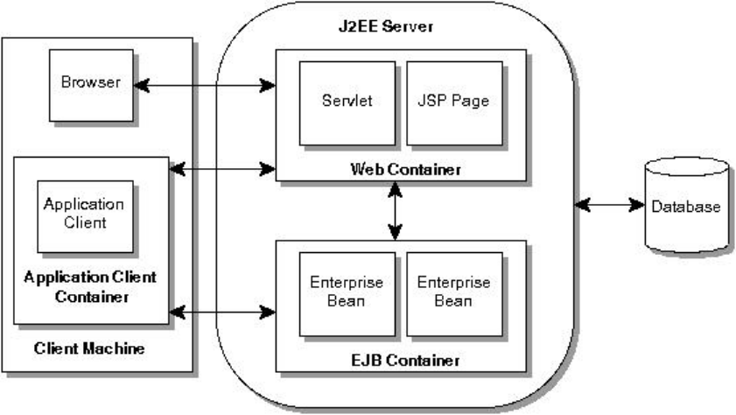

Figure 1. J2EE Architecture.

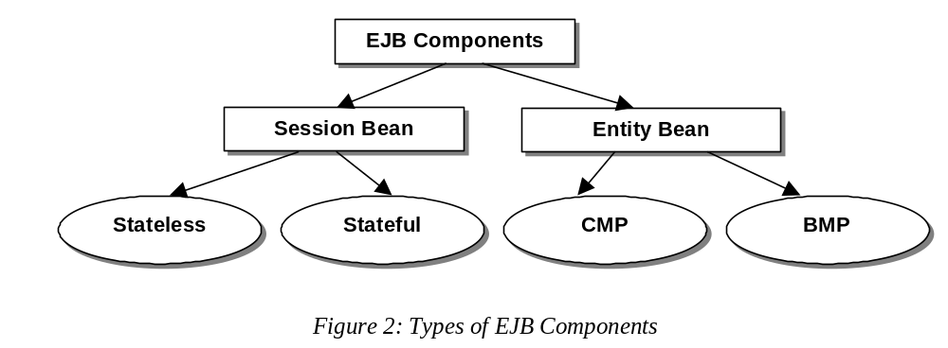

There are two types of entity beans: Container Managed Persistence (CMP) entity beans and Bean Managed Persistence (BMP) entity beans. Persistence in this context refers to the manner in which the data (usually a row in a relational database table) associated with the bean is managed. In the CMP entity bean case, the data that the bean represents is mapped automatically to the associated persistent data storage (e.g. database) by the container. The container is responsible for loading the data in to the bean instance, and writing changes back to the persistent data storage. In the case of a BMP entity bean, the bean code itself is responsible for accessing the persistent data it represents, usually using JDBC calls.

Test Application Design

Design Principle

One of the objectives in designing the test application is to have an application that is representative of enterprise system applications. Web-enabled system applications are becoming increasingly popular. They enable customers to serve themselves by doing transactions on-line. These systems generally have a business logic layer that access data from their backend data store. This type of applications correlates very well with the J2EE architecture. The Stock-OnLine application [5] that is a simulation of a simple on-line stockbroking system was chosen as the test application. Section 3.2 describes the application in detail.

Another objective in designing and implementing the test application is to test as many features of J2EE/EJB as possible. It is believed that these features all have impact to the performance. The features are:

- Underline communication protocol (eg. RMI/IIOP)
- Transaction management
- Naming service
- Clustering and scalability
- Container management
- JDBC interface
- Resource management, such as database connection pool management
- Session bean
  - object life cycle management for stateless session beans
- Entity bean
  - object life cycle management for container managed persistence entity beans
  - multi-finders for container managed persistence entity beans
  - find by primary key for container managed persistence entity beans

The test application is therefore designed to test these features. Although the application is not designed to test the features individually, but the test application and test procedure should test the overall performance of the Application Servers systems where these features have a significant impact.

Application Design

Stock-OnLine is a simulation of a simple on-line stockbroking system. It enables subscribers to buy and sell stock, inquire about the up-to-date prices of particular stocks, and get a holding statement detailing the stocks they currently own. From a subscriber’s perspective, the following services are offered:

Create Account: A person wishing to enrol with Stock-OnLine can create themselves a subscriber account with the service provider.
Update Account: A subscriber can modify their allocated credit limit.
Query Stock Value: A subscriber can query the current price for a given stock. A unique identifier code, or a mnemonic code can be used to identify the stock value to be retrieved.
Buy Stock: A subscriber can place an order to buy a given number of a specified stock. If successful, a transaction record is created for later processing.
Sell Stock: A subscriber can place a request to sell a specified number of any stock item they have purchased through the Stock-OnLine. If successful, a transaction record is created for later processing.
Get Holding Statement: A subscriber can request a statement of all the stock they have purchased through Stock-OnLine and still retain ownership of.

The Buy and Sell transactions are designed to be relatively demanding in terms of the number of database operations they perform. Both update a number of tables and will encounter lock contention in their operation. CreateAccount and Update perform database modifications, but are simple and fast. The remaining three transactions are all read-only, and will execute quickly as they only perform a single database operation and should encounter little contention for data.

Application Implementation

The test application is implemented in two versions: session bean version and container managed persistence entity bean version in order to test the features described in section 3.2.

Session Bean Version
The session bean version of the implementation uses a single session bean that provides the seven Stock-OnLine business methods. These methods are implemented by using the services of a number of local classes that essentially act as wrappers for the tables in the database and provide the necessary accessor and modifier services. These services in turn implement access to the corresponding database tables using JDBC statements.

The session bean is configured to use container-managed transactions. This means the EJB container is responsible for managing the creation of a transaction, and coordinating its outcome (i.e. commit or rollback). No application code is therefore required for transaction management. To achieve this, the bean is deployed with the EJB-defined ‘transaction required’ deployment option for all the seven business methods. This option means that each business method corresponds to a single logical transaction, which contains all the database operations performed in the bean method. In the example, the container will create a transaction context when the client calls the session bean method. When the method terminates, the container then attempts to commit the transaction.

CMP Entity Bean Version
In this version, the client applications access the interface provided by the stateless session bean. However, four entity beans are incorporated in to the application architecture. Each entity bean maps to data of an underline database tables. The session bean uses the entity beans to access the data to perform the necessary business logic. Consequently, when a session bean is created, the Home interfaces are located for each Entity bean. Every time an Entity bean is used in the business logic, the findByPrimaryKey() method is called, which returns the Remote interface of a required entity bean. The Remote interface methods are then called to get and store data from the bean. The entity bean fields that need to be persisted are mapped to the corresponding table/column names using the product-specific deployment attributes, which allow both table and column, names to be specified.

All Session and Entity bean methods were set to use container-managed transactions using the ‘transactions required’ deployment attribute. This means that each business method corresponds to a single transaction, and each transaction uses only one database connection from the connection pool.

The default CMP settings for the tests were commit mode ‘C’, and default pool size of 1000 was used for the entity beans. In addition, the container was used to generate default finder methods, including the multiple objects finder method for the GetHoldingStatement transaction.

Performance Evaluation

Performance Evaluation Principle

The evaluation tests were designed to stress the Application Server systems as much as possible. All Application Servers to be evaluated under the same conditions. Therefore, the following principles were applied for the test design and the performance evaluation.
- To use the same test application for all products.
- No sleep time between transaction method invocations at the client side is allowed.
- To configure the Application Server and the EJB deployment descriptors (including JDBC datasource and driver type) where fits to maximise the peak performance.
These principles are therefore reflected in the decisions made for the performance tunning and testing described in the following sections.

Performance Tunning

Prepared statements vs Non prepared statements

In the session bean implementation, the bean’s business methods access the underline database by issuing SQL statements to the database. This is accomplished by using
Java Data Base Connectivity (JDBC) APIs. There are two types of statement APIs: normal statements and prepared statements. The normal statements are parsed and have the associated execution plan built by the database server each time it is passed to it. The prepared statements are more efficient for repeated use. The statement is prepared (i.e. parsed and the execution plan built) once. Parameters can be passed to the statement without re-parsing the statement for subsequent uses.

Some experimentation were carried out to compare the performance of the standard SQL statement and prepared statement. Figure 3 shows the comparison results. These results show that the performance is improved by about 35% when changing non-prepared statement to prepared statement. Therefore the session bean implementation of the test application used JDBC prepared statements.

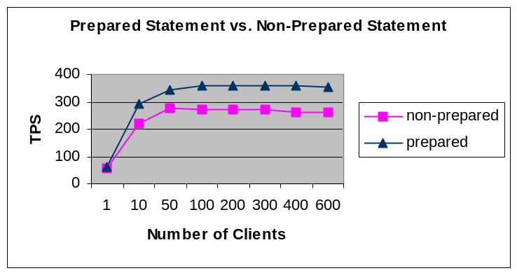

Figure 3. Performance comparison of prepared statement and non-prepared statement.

4.2.2 Basic Performance Tunning Parameters

This section only covers the basic parameters for performance tunning. Products may have product specific tunning parameters. They are not covered here.

JVM Heap Size
The Java Virtual Machine (JVM)'s heap stores all objects created by an executing Java program. Objects are created by Java's "new" operator, and memory for new objects is allocated on the heap at run time. Garbage collection (GC) is the process of automatically freeing objects that are no longer referenced by the program.

The problem with GC is during garbage collection, all application work stops. This is because modern JVMs support a single-threaded garbage collector. During GC, not only are freed objects collected, but memory is also compacted to avoid fragmentation. It is this compacting that forces Java to stop all other activity in the JVM. Figure 4 shows how GC can impact performance on a 2-way SMP computer. When GC occurs, only one processor is active doing the garbage collection, all other processors remain idle.

Heap size has significant impact on performance. If it is too small, garbage collection occurs too often. If it is too big, the garbage collection is much less often, but takes longer to complete each time (see Figure 4 for an example).

We experimented on a product-by-product basis to determine the heap size that gave best performance. Entity beans implementation often need higher heap size than the session beans, as the container has to cache the bean instances.

Max number of ORB threads
Some Application server products are implemented on top of the vendor’s Object Request Broker (ORB). ORB process is implemented as a multi-threaded process. Additional threads are created on demand. The number of threads can be limited by setting the maximum number of ORB threads. Limiting the maximum number of ORB threads is very important to avoid the application server machine overload. Some products come with the maximum unlimited as default. We experimented on a product-by-product basis varying the number of clients to determine the maximum number of ORB threads that gave the best performance.

Max Number of Database Connections
Connections are a very important resource for the database servers. Limiting the number of maximum number of database connections in the connection pool can avoid the database server overload and connection pool management overload on the application server.

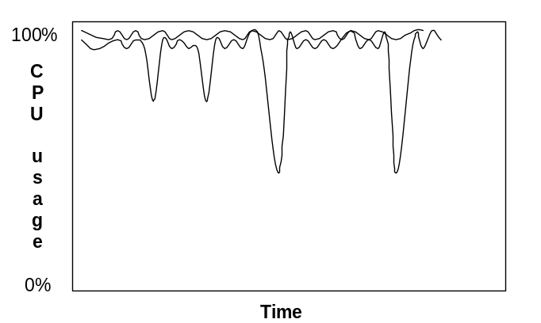

Figure 4. Java Garbage Collection.

Connection Timeout for Idle Period
Some products allow the setting of the timeout which is a parameter determining the idle time of a connection before the connection is destroyed from the connection pool. It was set to infinite to avoid the re-creation of the connection during the tests which is an expensive operation and has an impact on the performance.

Ready Pool Size setting
Some products allow setting of the maximum size of the ready pool (ie bean instance pool). The maximum can be set to the maximum number of ORB threads for the session beans. For the cmp beans, it will depend on the commit option selected.

CMP commit option
It was decided to not use commit option A, as it did not work for clustered environment. The choice between option B and C was based on experimentation on a product-by-product basis. The commit option that gave best performance was chosen. Some products show better performance using mode B. [6] compares the impact of the three commit options on performance.

Performance Evaluation

Figure 5 shows the basic test architecture. Figure 6 shows the test client behaviour during the test. Each client thread performs a number of iterations of a fixed transaction mix. The transaction mix represents the concept of one complete business cycle at the client side. It consists of a combination of different transaction types:
1 create; 3 buy; 3 sell; 1 update; 15 queryById; 15 queryByCode; 5 getHolding.

This transaction mix comprises 43 individual transactions, and is a combination of mainly read-only (81%) transactions and some update (19%) transactions. Different transaction mixes can be used to model different types of business cycle. The aim of this transaction mix is to represent a reasonably typical WWW site transaction load, where over 80% of transactions are read-only (browse) operations. Each client performs this transaction mix 10 times. The clients do not manage transactions, as this is done by the session bean methods invoked by the client. The clients also do not wait between transactions. This is to simulate the highest possible load.

Performance Evaluation Test Procedure

The following procedure was followed in preparing the performance evaluation tests:
- Turn off any debugging from the Application Server configuration and the deployed test code.
- Turn off any logging and statistical information collection options from Application server configuration.
- Turn off all the un-necessary running processes/applications from the OS system of the machines involved in the tests.
- Start Application Server.
- Run a warm up process to populate the connection pool and the ready pool for the beans.

Before running each performance test, the database is re-initialised and the warm up process is run if the Application Server has been re-started.

While running the test, the CPU usage is monitored for the database machine, Application server machine(s) and the client machines, as well as the page fault of the Application server machine(s). The Performance Monitor (of NT or win2000) was used for this purpose. The following rules were observed:
- Make sure the client machine is not a bottleneck in issuing the client requests by having the client machine CPU usage not exceeding 30%
- Application Server machine’s CPU usage should be as high as possible (>90%)
- There should be no excessive page faults on the Application server, e.g. Page fault per second on the Application server machine should be kept below 5~6%
- There should not be any disk activities on the Application server machine.

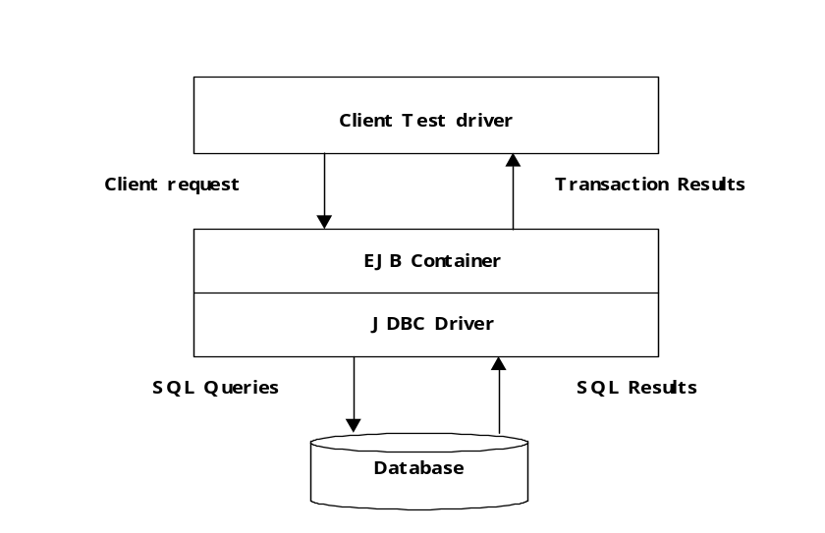
Figure 5. Basic Test Setup

Performance Evaluation Results – an example

We evaluated extensively a number of Application server products. This paper reports some results of one product. Refer to [1] for a comparison report of all the products covered by the Middleware Technology Evaluation project.

The product evaluated and reported here is IBM’s WebSphere 3.5.3. It is an EJB 1.0 complaint with some extensions, such as support for Container Managed Persistence entity beans. Figure 7 shows the best system throughput of the product after performance tunning.

Conclusion

This paper reports the foundations of the Middleware Technology Evaluation project, the test application design, performance tunning and evaluation methodologies of the J2EE application servers evaluation. The MTE project tries to address the problem that many people in the industry facing – “select a application server product from a very confusing market” by providing independent technology evaluation.

As part of the future work, the test application needs to be extended to cover new features in the EJB 2.0 specification. We also need to compare our test application with the ECperf [7} from Sun.
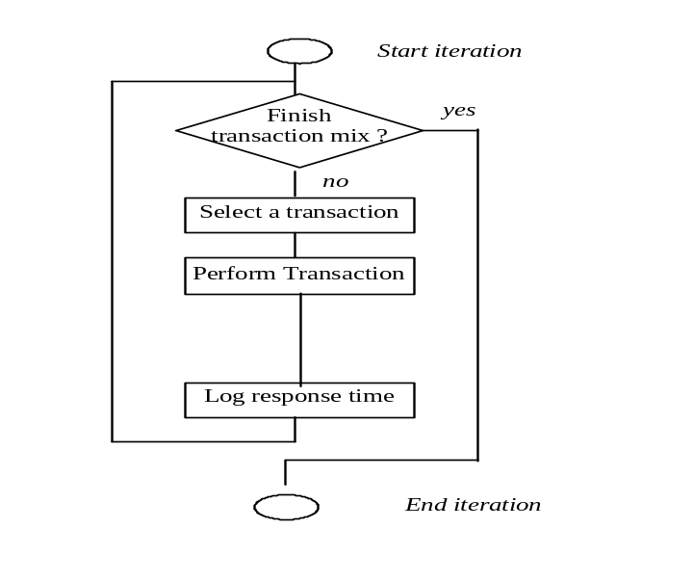
Figure 6. Client Behaviour

References

[1] CSIRO Middleware Technology Evaluation Series: Evaluating J2EE Application Servers, September 2001.
[2] Java™ 2 Platform Enterprise Edition Specification, v1.3, Sun Microsystems, July 2001.
[3] Enterprise JavaBean™ Specification v1.1, Sun Microsoft Inc, Dec 1999.
[4] Enterprise JavaBean™ Specification v2.0, Sun Microsoft Inc, May 2001
[5] Enterprise Transaction Processing Systems: Putting the CORBA OTS, Encina++ and OrbixOTM to Work, Ian Gorton, Addison-Wesley, January 2000
[6] Entity Bean A, B, C's: Enterprise Java Beans Commit Options and Caching Paul Brebner and Shuping Ran, Proceedings of IFIP/ACM International Conference on Distributed Systems Platforms p36-55, Heidelberg, Germany, November 2001.
[7] Ecperf™ Specification v1.0, Sun Microsoft Inc, June 2001.

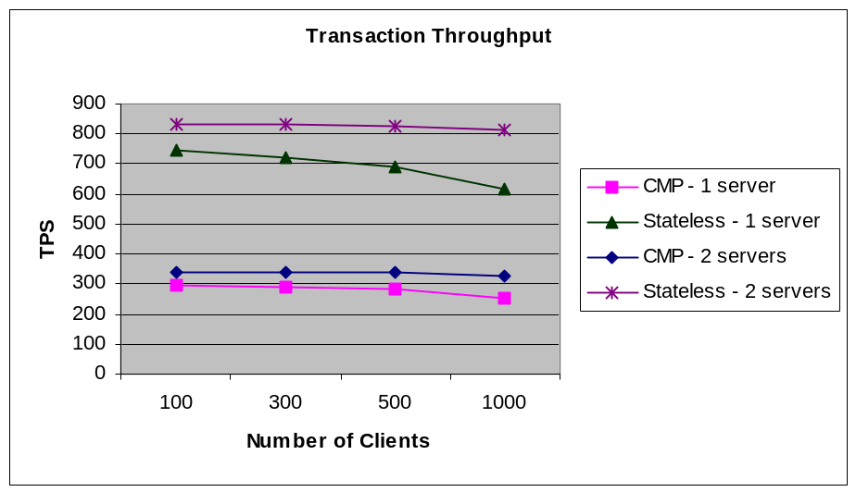
Figure 7. Performance result – an example.

Sun has since released EJB 2.0 specification in May 2001 [4]. The work presented here is based on EJB 1.1 and will be extended to EJB 2.0.
Commit option C does not cache objects or data, but only pools objects.

