Project 2 Proposal

Bryan Barrows, Monisha Jain, Issac Muck, Paul Aggarwal

Comparison of cities’ median cost to rent before and after major tech companies open an office in the area (i.e. Amazon in Long Island City). We will pull real estate data from Zillow and tying it to longitude and latitude. Serving through Flask, database TBD.

We will create a map using Leaflet with overlays showing before and after, of three different cities in the United States (Queens, San Francisco Bay, and Santa Monica).

**Data:** Zillow API

<https://www.zillow.com/howto/api/APIOverview.htm>

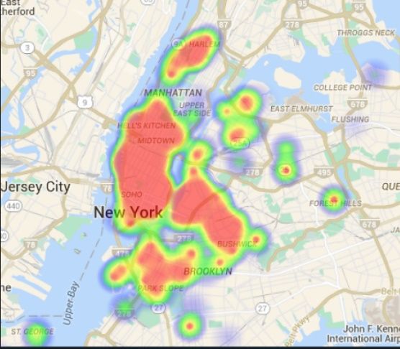

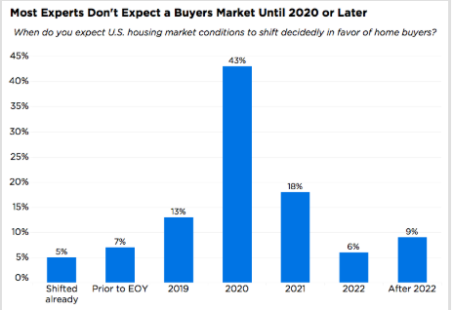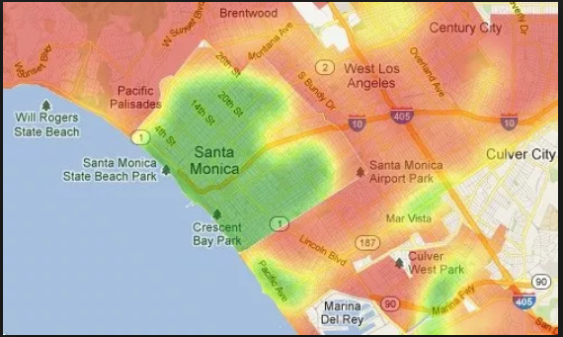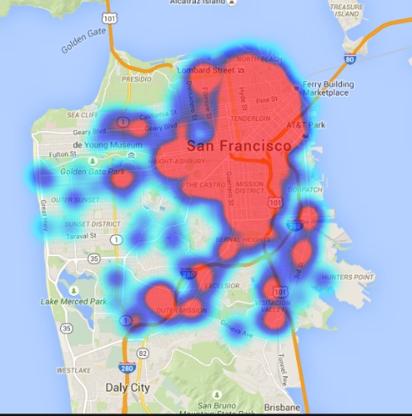

**GitHub**: https://github.com/monishacam/Project_2.git