5/2/2016

Paul Dockar, Dennis Kim, Kimi Izzo, Michael Smith, Nick Rabey

Lemongrabs

Assignment 2 Report

Mechatronics 2 - 48623



# Introduction

This report details the processes and results of programming iRobot Create to:

1. Flash a heartbeat LED at 1Hz.
2. Continuously display the IR sensor range (converted into cm) on the LCD.
3. On a button press, scan the IR sensor clockwise 360⁰ and return the sensor to face the nearest obstacle
4. On a button press, drive Create 4m whilst continually displaying total linear distance moved on the LCD screen
5. On a button press drive Create in a square shaped trajectory, whilst continuously displaying total linear distance travelled.
6. On a button press, scan for closest wall and drive parallel to that wall, maintaining a constant distance.

# Block Diagram

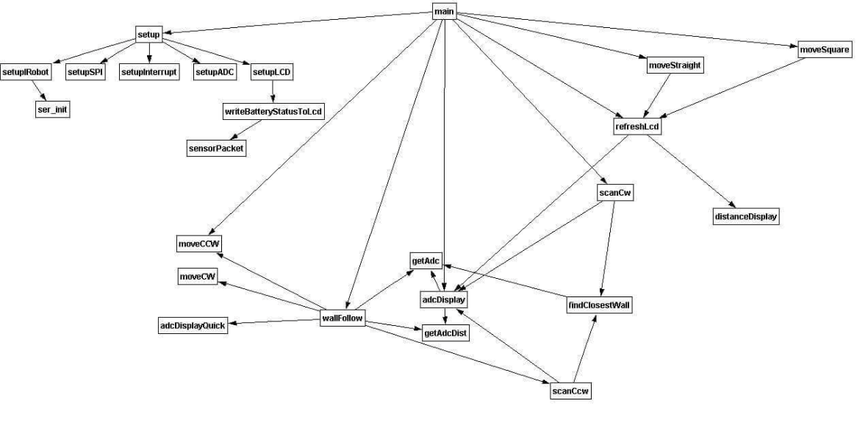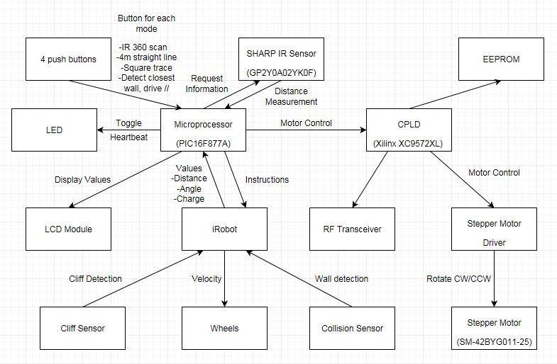**Figure 1 – Hardware Block Diagram**

**Figure 2 – Software Block Diagram**

# Code flowchart

(insert flowcharts, explanation of code + opcodes)

# Characterisation Graphs

* Straight Line Manoeuver for different speeds (actual distance for 5 attempts):

|  |  |  |
| --- | --- | --- |
| Speed(mm/s) | Distance(cm) | Command Distance(cm) |
| -100 | 404 | 400 |
| -100 | 403 | 400 |
| -100 | 401 | 400 |
| -100 | 401 | 400 |
| -100 | 403 | 400 |
| 100 | 398 | 400 |
| 100 | 404 | 400 |
| 100 | 402 | 400 |
| 100 | 403 | 400 |
| 100 | 399 | 400 |
| 200 | 398 | 400 |
| 200 | 397 | 400 |
| 200 | 403 | 400 |
| 200 | 400 | 400 |
| 200 | 401 | 400 |
| 300 | 403 | 400 |
| 300 | 395 | 400 |
| 300 | 399 | 400 |
| 300 | 404 | 400 |
| 300 | 405 | 400 |
| 400 | 430 | 400 |
| 400 | 422 | 400 |
| 400 | 427 | 400 |
| 400 | 424 | 400 |
| 400 | 432 | 400 |

From the graph and table above we can see that the slower speeds give more consistent results that remain closest to the required 4m mark. However, during our measurements iRobot Create had a tendency to drift from a straight path at slower speeds. From this observation we can conclude that 200mm/s is the optimal velocity for the purpose of this assignment.

* Straight line manoeuver for different distances:

|  |  |
| --- | --- |
| Com. Dist (m) | Actual Dist (cm) |
| 0.5 | 48 |
| 0.5 | 48 |
| 0.5 | 53 |
| 0.5 | 51 |
| 0.5 | 49 |
| 1 | 101 |
| 1 | 99 |
| 1 | 98 |
| 1 | 100 |
| 1 | 101 |
| 1.5 | 155 |
| 1.5 | 149 |
| 1.5 | 152 |
| 1.5 | 149 |
| 1.5 | 153 |
| 2 | 202 |
| 2 | 202 |
| 2 | 201 |
| 2 | 201 |
| 2 | 202 |
| 2.5 | 250 |
| 2.5 | 251 |
| 2.5 | 249 |
| 2.5 | 251 |
| 2.5 | 250 |
| 3 | 304 |
| 3 | 302 |
| 3 | 300 |
| 3 | 301 |
| 3 | 302 |