Unusual Hardware

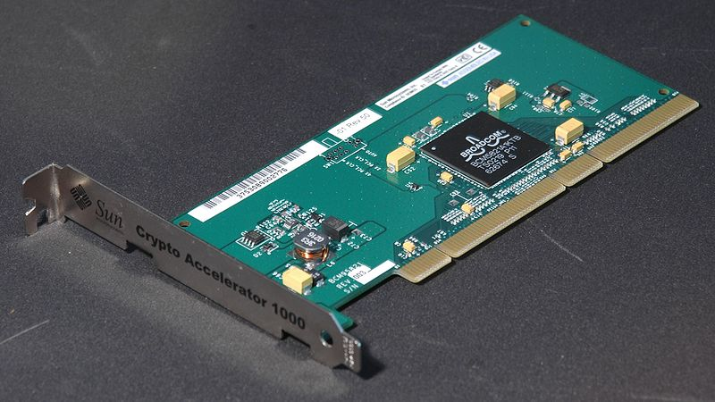

TRNG – True Random Number Generator (or Hardware Random Number Generator)

* A random number generator that relies on a physical process, rather than software (still needs software to represent the numbers).
  + Adaptor card or USB dongle
  + Relies on statistically random noise signals (a subatomic property of all matter)
    - Thermal noise (heat)
    - Photoelectric effect
    - Other quantum phenomena
  + Quantum phenomena are completely unpredictable (and thus completely random), due to the Heisenberg Uncertainty Principle.
  + Some aspect of the quantum phenomena are amplified to a measurable level, then converted into an electrical signal or pulse.
* This next TRNG is non-patented hardware offered by the Free Software Foundation. (“Free” as in “freedom”, due to the lack of a patent, and a GPL3 License – it still costs 50 bucks).

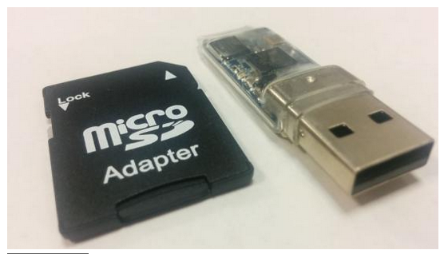

* This is considered a complete computer with a random number generating program in its firmware.