Assignment 12

I set the timeron flag by creating a timer.flag file.
With that I saw benchmark times of about 6s and that the functions psinv and resid took a lot of time.
Also I saw that mg3P.constprop.4, the optimized version of mg3p spent quite a lot of time in the children calls of those two.

Output with timeron set:

Benchmark

No input file. Using compiled defaults
Size: 256x 256x 256 (class B)
Iterations: 20

iter 1
iter 5
iter 10
iter 15
iter 20

Benchmark completed
VERIFICATION SUCCESSFUL
L2 Norm is 1.8005644013551E-06
Error is 6.6330115975290E-14

Benchmark Completed.
Class = B
Size = 256x 256x 256
Iterations = 20
Operation type = floating point
Verification = SUCCESSFUL
Version = 3.3.1
SECTION Time (secs)
benchmk : 5.307 (100.00%)
mg3P : 3.984 ( 75.07%)
psinv : 1.331 ( 25.09%)
resid : 2.649 ( 49.91%)
--> mg-resid: 1.377 ( 25.95%)
rprj3 : 0.635 ( 11.96%)
interp : 0.493 ( 9.28%)
norm2 : 0.051 ( 0.97%)
comm3 : 0.100 ( 1.88%)
Execution finished. Running gprof...
Appending gprof analysis to log file...
Flat profile:

Each sample counts as 0.01 seconds.
% cumulative self self total
time seconds seconds calls ms/call ms/call name
42.72 2.84 2.84 147 19.33 22.24 resid
20.16 4.18 1.34 168 7.98 10.49 psinv
14.44 5.14 0.96 131072 0.01 0.01 vranlc
10.83 5.86 0.72 147 4.90 7.42 rprj3
7.67 6.37 0.51 147 3.47 3.47 interp
3.91 6.63 0.26 485 0.54 2.52 norm2u3
0.00 6.63 0.00 131642 0.00 0.00 randlc
0.00 6.63 0.00 1123 0.00 0.00 timer_start
0.00 6.63 0.00 1119 0.00 0.00 timer_stop

% the percentage of the total running time of the
time program used by this function.

cumulative a running sum of the number of seconds accounted
seconds for by this function and those listed above it.

self the number of seconds accounted for by this
seconds function alone. This is the major sort for this
listing.

calls the number of times this function was invoked, if
this function is profiled, else blank.

self the average number of milliseconds spent in this
ms/call function per call, if this function is profiled,
else blank.

total the average number of milliseconds spent in this
ms/call function and its descendents per call, if this
function is profiled, else blank.

name the name of the function. This is the minor sort
for this listing. The index shows the location of
the function in the gprof listing. If the index is
in parenthesis it shows where it would appear in
the gprof listing if it were to be printed.

Call graph (explanation follows)

granularity: each sample hit covers 2 byte(s) for 0.15% of 6.63 seconds

index % time self children called name
<spontaneous>
[1] 100.0 0.00 6.63 mg3P.constprop.2 [1]
2.84 0.43 147/147 resid [2]
1.34 0.42 168/168 psinv [3]
0.72 0.37 147/147 rprj3 [5]
0.51 0.00 147/147 interp [7]
-----------------------------------------------
2.84 0.43 147/147 mg3P.constprop.2 [1]
[2] 49.3 2.84 0.43 147 resid [2]
0.09 0.34 170/485 norm2u3 [4]
0.00 0.00 340/1119 timer_stop [10]
0.00 0.00 170/1123 timer_start [9]
-----------------------------------------------
1.34 0.42 168/168 mg3P.constprop.2 [1]
[3] 26.6 1.34 0.42 168 psinv [3]
0.09 0.33 168/485 norm2u3 [4]
0.00 0.00 336/1119 timer_stop [10]
0.00 0.00 168/1123 timer_start [9]
-----------------------------------------------
8 norm2u3 [4]
0.08 0.29 147/485 rprj3 [5]
0.09 0.33 168/485 psinv [3]
0.09 0.34 170/485 resid [2]
[4] 18.4 0.26 0.96 485+8 norm2u3 [4]
0.96 0.00 131072/131072 vranlc [6]
0.00 0.00 131642/131642 randlc [8]
0.00 0.00 491/1123 timer_start [9]
0.00 0.00 2/1119 timer_stop [10]
8 norm2u3 [4]
-----------------------------------------------
0.72 0.37 147/147 mg3P.constprop.2 [1]
[5] 16.4 0.72 0.37 147 rprj3 [5]
0.08 0.29 147/485 norm2u3 [4]
0.00 0.00 294/1119 timer_stop [10]
0.00 0.00 147/1123 timer_start [9]
-----------------------------------------------
0.96 0.00 131072/131072 norm2u3 [4]
[6] 14.5 0.96 0.00 131072 vranlc [6]
-----------------------------------------------
0.51 0.00 147/147 mg3P.constprop.2 [1]
[7] 7.7 0.51 0.00 147 interp [7]
0.00 0.00 147/1119 timer_stop [10]
0.00 0.00 147/1123 timer_start [9]
-----------------------------------------------
0.00 0.00 131642/131642 norm2u3 [4]
[8] 0.0 0.00 0.00 131642 randlc [8]
-----------------------------------------------
0.00 0.00 147/1123 rprj3 [5]
0.00 0.00 147/1123 interp [7]
0.00 0.00 168/1123 psinv [3]
0.00 0.00 170/1123 resid [2]
0.00 0.00 491/1123 norm2u3 [4]
[9] 0.0 0.00 0.00 1123 timer_start [9]
-----------------------------------------------
0.00 0.00 2/1119 norm2u3 [4]
0.00 0.00 147/1119 interp [7]
0.00 0.00 294/1119 rprj3 [5]
0.00 0.00 336/1119 psinv [3]
0.00 0.00 340/1119 resid [2]
[10] 0.0 0.00 0.00 1119 timer_stop [10]
-----------------------------------------------

This table describes the call tree of the program, and was sorted by
the total amount of time spent in each function and its children.

Each entry in this table consists of several lines. The line with the
index number at the left hand margin lists the current function.
The lines above it list the functions that called this function,
and the lines below it list the functions this one called.
This line lists:
index A unique number given to each element of the table.
Index numbers are sorted numerically.
The index number is printed next to every function name so
it is easier to look up where the function is in the table.

% time This is the percentage of the `total' time that was spent
in this function and its children. Note that due to
different viewpoints, functions excluded by options, etc,
these numbers will NOT add up to 100%.

self This is the total amount of time spent in this function.

children This is the total amount of time propagated into this
function by its children.

called This is the number of times the function was called.
If the function called itself recursively, the number
only includes non-recursive calls, and is followed by
a `+' and the number of recursive calls.

name The name of the current function. The index number is
printed after it. If the function is a member of a
cycle, the cycle number is printed between the
function's name and the index number.

For the function's parents, the fields have the following meanings:

self This is the amount of time that was propagated directly
from the function into this parent.

children This is the amount of time that was propagated from
the function's children into this parent.

called This is the number of times this parent called the
function `/' the total number of times the function
was called. Recursive calls to the function are not
included in the number after the `/'.

name This is the name of the parent. The parent's index
number is printed after it. If the parent is a
member of a cycle, the cycle number is printed between
the name and the index number.

If the parents of the function cannot be determined, the word
`<spontaneous>' is printed in the `name' field, and all the other
fields are blank.

For the function's children, the fields have the following meanings:

self This is the amount of time that was propagated directly
from the child into the function.

children This is the amount of time that was propagated from the
child's children to the function.

called This is the number of times the function called
this child `/' the total number of times the child
was called. Recursive calls by the child are not
listed in the number after the `/'.

name This is the name of the child. The child's index
number is printed after it. If the child is a
member of a cycle, the cycle number is printed
between the name and the index number.

If there are any cycles (circles) in the call graph, there is an
entry for the cycle-as-a-whole. This entry shows who called the
cycle (as parents) and the members of the cycle (as children.)
The `+' recursive calls entry shows the number of function calls that
were internal to the cycle, and the calls entry for each member shows,
for that member, how many times it was called from other members of
the cycle.

Copyright (C) 2012-2018 Free Software Foundation, Inc.

Copying and distribution of this file, with or without modification,
are permitted in any medium without royalty provided the copyright
notice and this notice are preserved.
Index by function name

[7] interp (real.c) [8] randlc [9] timer_start
[4] norm2u3 (real.c) [2] resid (real.c) [10] timer_stop
[3] psinv (real.c) [5] rprj3 (real.c) [6] vranlc
Job complete.

int i3, i2, i1;
if (timeron) timer_start(T_resid);
#pragma omp parallel for private(i3, i2, i1) collapse(2) schedule(dynamic)
for (i3 = 1; i3 < n3-1; i3++) {
for (i2 = 1; i2 < n2-1; i2++) {
double u1[M], u2[M]; //chat gpt proposed this, but seemed to slow down the program a bit compared to declaration outside + private copies
for (i1 = 0; i1 < n1; i1++) {
u1[i1] = u[i3][i2-1][i1] + u[i3][i2+1][i1]
+ u[i3-1][i2][i1] + u[i3+1][i2][i1];
u2[i1] = u[i3-1][i2-1][i1] + u[i3-1][i2+1][i1]
+ u[i3+1][i2-1][i1] + u[i3+1][i2+1][i1];
}
for (i1 = 1; i1 < n1-1; i1++) {
r[i3][i2][i1] = v[i3][i2][i1]
- a[0] * u[i3][i2][i1]
//-------------------------------------------------------------------
/ / Assume a[1] = 0 (Enable 2 lines below if a[1] not= 0)
//-------------------------------------------------------------------
// - a[1] * ( u[i3][i2][i1-1] + u[i3][i2][i1+1]
// + u1[i1] )
//-------------------------------------------------------------------
- a[2] * ( u2[i1] + u1[i1-1] + u1[i1+1] )
- a[3] * ( u2[i1-1] + u2[i1+1] );
}
}
}

Finally I optimized interp and rprj3 too to get some more speedup, basically identical procedure.
The random generator vranlc also took a lot of time, but there were some dependencies and simple multithreading would have made the result non-deterministic though potentially still a valid generator.

Normal output with timeron set:

Benchmark

No input file. Using compiled defaults
Size: 256x 256x 256 (class B)
Iterations: 20

iter 1
iter 5
iter 10
iter 15
iter 20

Benchmark completed
VERIFICATION SUCCESSFUL
L2 Norm is 1.8005644013551E-06
Error is 6.6330115975290E-14

Benchmark Completed.
Class = B
Size = 256x 256x 256
Iterations = 20
Operation type = floating point
Verification = SUCCESSFUL
Version = 3.3.1
SECTION Time (secs)
benchmk : 2.712 (100.00%)
mg3P : 1.929 ( 71.12%)
psinv : 0.603 ( 22.23%)
resid : 1.415 ( 52.16%)
--> mg-resid: 0.686 ( 25.29%)
rprj3 : 0.146 ( 5.38%)
interp : 0.321 ( 11.83%)
norm2 : 0.054 ( 2.01%)
comm3 : 0.123 ( 4.54%)
Execution finished. Running gprof...
Appending gprof analysis to log file...
Flat profile:

Each sample counts as 0.01 seconds.
% cumulative self self total
time seconds seconds calls ms/call ms/call name
95.66 25.16 25.16 setup
3.65 26.12 0.96 131072 0.01 0.01 vranlc
0.72 26.31 0.19 485 0.39 2.37 norm2u3
0.00 26.31 0.00 131642 0.00 0.00 randlc
0.00 26.31 0.00 1123 0.00 0.00 timer_start
0.00 26.31 0.00 1119 0.00 0.00 timer_stop
0.00 26.31 0.00 168 0.00 2.37 psinv
0.00 26.31 0.00 147 0.00 0.00 interp
0.00 26.31 0.00 147 0.00 2.74 resid

% the percentage of the total running time of the
time program used by this function.

cumulative a running sum of the number of seconds accounted
seconds for by this function and those listed above it.

self the number of seconds accounted for by this
seconds function alone. This is the major sort for this
listing.

calls the number of times this function was invoked, if
this function is profiled, else blank.

self the average number of milliseconds spent in this
ms/call function per call, if this function is profiled,
else blank.

total the average number of milliseconds spent in this
ms/call function and its descendents per call, if this
function is profiled, else blank.

name the name of the function. This is the minor sort
for this listing. The index shows the location of
the function in the gprof listing. If the index is
in parenthesis it shows where it would appear in
the gprof listing if it were to be printed.

Call graph (explanation follows)

granularity: each sample hit covers 2 byte(s) for 0.04% of 26.31 seconds

index % time self children called name
<spontaneous>
[1] 95.6 25.16 0.00 setup [1]
-----------------------------------------------
<spontaneous>
[2] 4.4 0.00 1.15 mg3P.constprop.8 [2]
0.00 0.40 147/147 resid [5]
0.00 0.40 168/168 psinv [6]
0.06 0.29 147/485 norm2u3 [3]
0.00 0.00 294/1119 timer_stop [9]
0.00 0.00 147/1123 timer_start [8]
0.00 0.00 147/147 interp [10]
-----------------------------------------------
8 norm2u3 [3]
0.06 0.29 147/485 mg3P.constprop.8 [2]
0.07 0.33 168/485 psinv [6]
0.07 0.34 170/485 resid [5]
[3] 4.4 0.19 0.96 485+8 norm2u3 [3]
0.96 0.00 131072/131072 vranlc [4]
0.00 0.00 131642/131642 randlc [7]
0.00 0.00 491/1123 timer_start [8]
0.00 0.00 2/1119 timer_stop [9]
8 norm2u3 [3]
-----------------------------------------------
0.96 0.00 131072/131072 norm2u3 [3]
[4] 3.7 0.96 0.00 131072 vranlc [4]
-----------------------------------------------
0.00 0.40 147/147 mg3P.constprop.8 [2]
[5] 1.5 0.00 0.40 147 resid [5]
0.07 0.34 170/485 norm2u3 [3]
0.00 0.00 340/1119 timer_stop [9]
0.00 0.00 170/1123 timer_start [8]
-----------------------------------------------
0.00 0.40 168/168 mg3P.constprop.8 [2]
[6] 1.5 0.00 0.40 168 psinv [6]
0.07 0.33 168/485 norm2u3 [3]
0.00 0.00 336/1119 timer_stop [9]
0.00 0.00 168/1123 timer_start [8]
-----------------------------------------------
0.00 0.00 131642/131642 norm2u3 [3]
[7] 0.0 0.00 0.00 131642 randlc [7]
-----------------------------------------------
0.00 0.00 147/1123 interp [10]
0.00 0.00 147/1123 mg3P.constprop.8 [2]
0.00 0.00 168/1123 psinv [6]
0.00 0.00 170/1123 resid [5]
0.00 0.00 491/1123 norm2u3 [3]
[8] 0.0 0.00 0.00 1123 timer_start [8]
-----------------------------------------------
0.00 0.00 2/1119 norm2u3 [3]
0.00 0.00 147/1119 interp [10]
0.00 0.00 294/1119 mg3P.constprop.8 [2]
0.00 0.00 336/1119 psinv [6]
0.00 0.00 340/1119 resid [5]
[9] 0.0 0.00 0.00 1119 timer_stop [9]
-----------------------------------------------
0.00 0.00 147/147 mg3P.constprop.8 [2]
[10] 0.0 0.00 0.00 147 interp [10]
0.00 0.00 147/1119 timer_stop [9]
0.00 0.00 147/1123 timer_start [8]
-----------------------------------------------

This table describes the call tree of the program, and was sorted by
the total amount of time spent in each function and its children.

Each entry in this table consists of several lines. The line with the
index number at the left hand margin lists the current function.
The lines above it list the functions that called this function,
and the lines below it list the functions this one called.
This line lists:
index A unique number given to each element of the table.
Index numbers are sorted numerically.
The index number is printed next to every function name so
it is easier to look up where the function is in the table.

% time This is the percentage of the `total' time that was spent
in this function and its children. Note that due to
different viewpoints, functions excluded by options, etc,
these numbers will NOT add up to 100%.

self This is the total amount of time spent in this function.

children This is the total amount of time propagated into this
function by its children.

called This is the number of times the function was called.
If the function called itself recursively, the number
only includes non-recursive calls, and is followed by
a `+' and the number of recursive calls.

name The name of the current function. The index number is
printed after it. If the function is a member of a
cycle, the cycle number is printed between the
function's name and the index number.

For the function's parents, the fields have the following meanings:

self This is the amount of time that was propagated directly
from the function into this parent.

children This is the amount of time that was propagated from
the function's children into this parent.

called This is the number of times this parent called the
function `/' the total number of times the function
was called. Recursive calls to the function are not
included in the number after the `/'.

name This is the name of the parent. The parent's index
number is printed after it. If the parent is a
member of a cycle, the cycle number is printed between
the name and the index number.

If the parents of the function cannot be determined, the word
`<spontaneous>' is printed in the `name' field, and all the other
fields are blank.

For the function's children, the fields have the following meanings:

self This is the amount of time that was propagated directly
from the child into the function.

children This is the amount of time that was propagated from the
child's children to the function.

called This is the number of times the function called
this child `/' the total number of times the child
was called. Recursive calls by the child are not
listed in the number after the `/'.

name This is the name of the child. The child's index
number is printed after it. If the child is a
member of a cycle, the cycle number is printed
between the name and the index number.

If there are any cycles (circles) in the call graph, there is an
entry for the cycle-as-a-whole. This entry shows who called the
cycle (as parents) and the members of the cycle (as children.)
The `+' recursive calls entry shows the number of function calls that
were internal to the cycle, and the calls entry for each member shows,
for that member, how many times it was called from other members of
the cycle.

Copyright (C) 2012-2018 Free Software Foundation, Inc.

Copying and distribution of this file, with or without modification,
are permitted in any medium without royalty provided the copyright
notice and this notice are preserved.

Index by function name

[10] interp (real.c) [7] randlc [8] timer_start
[3] norm2u3 (real.c) [5] resid (real.c) [9] timer_stop
[6] psinv (real.c) [1] setup (real.c) [4] vranlc
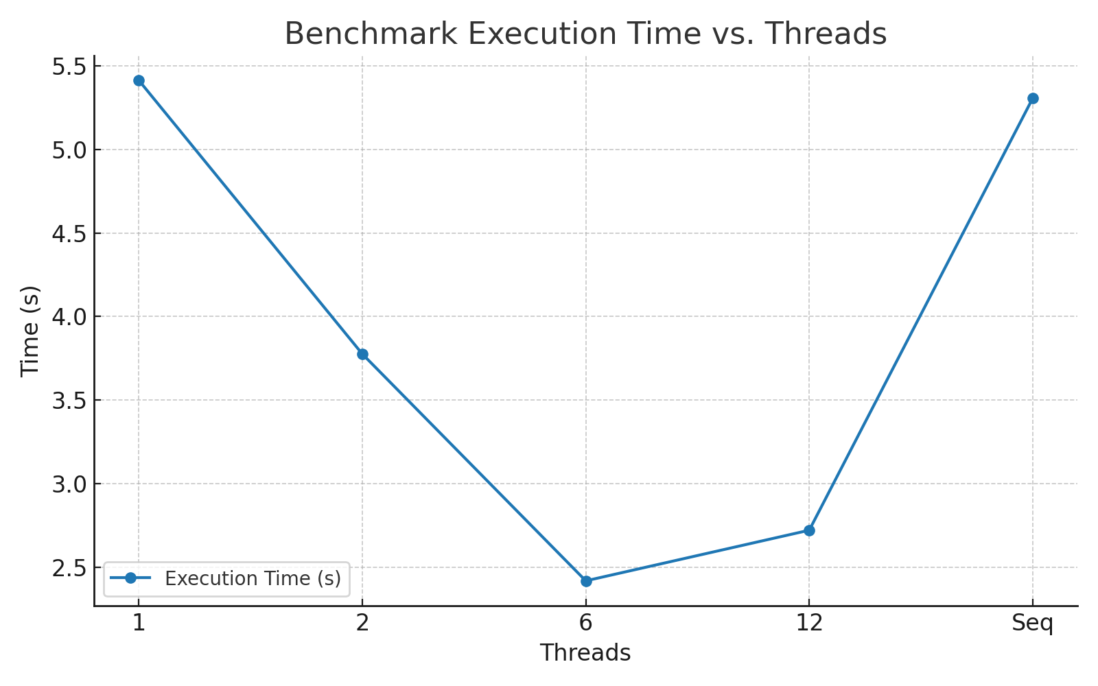
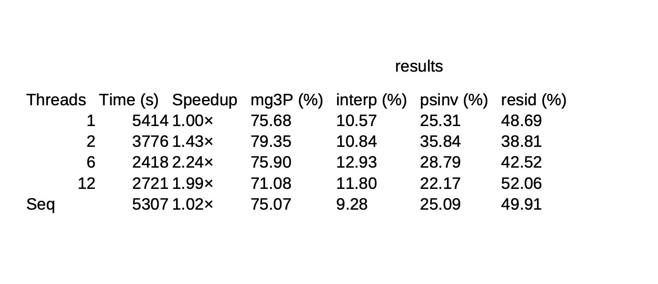
Job complete.
Benchmarks:

