BestBuy

Software Requirements Specification

**Version 1.02 approved**

**Prepared by Paul Komarnytskyy & Marta Duplina**

**Lviv Ivan Franko National University**

**04/03/2018**

**Revision History**

|  |  |  |  |
| --- | --- | --- | --- |
| **Date** | **Version** | **Description** | **Author** |
| April 03, 2018 | Draft v1.0 (v,1.00) | The first draft version of the document was created. | Marta Duplina |
| April 03, 2018 | Draft v.2.0 (v.1.01) | Updated the draft version  Added mockups  Added User classes and characteristics + permission requirements | Paul Komarnytskyy |
| April 03, 2018 | Draft v.2.0 (v.1.01) | Added overall description and system features | Marta Duplina |
| April 04, 2018 | Version 1.02 | Added system workflow and references to use case diagram, functional and non-functional requirements document. | Paul Komarnytskyy |
|  |  |  |  |
|  |  |  |  |

**Table of Contents**

**Introduction** **4**

Purpose of the document 4

**Overall Description** **4**

Product Perspective 4

System Architecture 4

User Classes and Characteristics 4

User Classes 4

User Roles 5

Permission Requirements 5

Operating Environment 6

**System Features** **6**

General Workflow 6

Actors 7

Use Case Catalog 7

For list of use cases please use Vision And Scope for reference. 7

Business Rules 7

Functional Requirements 7

For list of functional requirements please use Vision And Scope for reference. 7

Non-Functional Requirements 7

For list of non-functional requirements please use Vision And Scope for reference. 7

BestBuy Site 7

Common Functional Requirements 7

**External Interfaces** **8**

Software Interfaces 8

**Appendix** **8**

Mockups 8

# Introduction

## Purpose of the document

The purpose of this SRS document is to provide a detailed overview of our software product, its parameters and goals. This document describes the project's target audience and its user interface, hardware and software requirements. It defines how our client, team and audience see the product and its functionality.

# Overall Description

## Product Perspective

The product is a web-based system that allows the customer to shop virtually using the Internet and allow customers to buy the items of their desire from the store. It is aimed towards the vendors who want to reach out to the maximum cross-section of customer and common people who can be potential customer.

## System Architecture

The following existing Systems are to be modified\created in order to accommodate the purposes of the BestBuy Project:

* Web Api Server
* Shop’s website

For the list of outside Systems to be utilized in the scope of the BestBuy Project refer to the Software Interfaces section.

Diagram of the system’s high-level components:

**TBD**

## User Classes and Characteristics

### User Classes

The following User Classes can be defined within the scope of BestBuy project:

**Administrators:** The administrators have complete control over all the activities that can be performed.

- They verify the user after he/she registers.

- They must provide rules for the transactions.

- They must maintain the website and update the same making necessary

changes at times.

- They must take care of the security issues involved in the transactions.

- They must inform the users about their transaction status and keep them

updated about the progress through emails.

- Any failures in the system have to be detected and repaired.

**Customers:** They are the registered members of the online store website. They can view the list of products and purchase items.

### User Roles

A user role is a built-in collection of user permissions specific to a particular job. They help to optimize efficiency and reduce the risk of human error by enabling you to delegate responsibilities and permissions to certain users only.

The following User Roles can be defined within Best Buy:

* **Guest -** Unauthorized user
* **Client** - Authorized user
* **Admin -** Authorized administrator with some extra functionality

### Permission Requirements

|  |  |
| --- | --- |
| **Requirement ID** | **Requirement Description** |
| PR-AS-01 | Users of different categories and different applications should be interact with items in store in different manner   |  |  | | --- | --- | | **User Role** | **Description** | | Guest | Able to view items, search for them, view item description and compare them | | Client | Able to do everything that guest can in addition to adding items to cart | | Admin | Able to do everything that a client can | |
| PR-AS-02 | Users of different categories and different applications should see interact with carts in different manner.   |  |  | | --- | --- | | **User Role** | **Description** | | Guest | Unable to see cart | | Client | Able to see his own cart, add and remove items | | Admin | Same as client | |
| PR-AS-03 | |  |  | | --- | --- | | **User Role** | **Description** | | Guest | Unable to see “Account” window | | Client | Can enter Account window and see his order history as well as personal info | | Admin | Same as client | |
| PR-AS-04 | Only admin should be able to see full list of users and change their loyalty status.   |  |  | | --- | --- | | **User Role** | **Description** | | Guest | Unable to see “Users” window | | Client | Unable to see “Users” window | | Admin | Able to see “Users” window and change loyalty levels/statuses for users | |

## Operating Environment

Operating Environment for existing Systems should be left as it is currently. See below Operating environment for the newly created Systems.

|  |  |
| --- | --- |
| **Requirement ID** | **Requirement** |
| OE-1 | Best Buy will operate with the following browsers:   * Internet Explorer 7.0 and greater; * Firefox 3.0 and greater; * Safari 4.0 and greater; * Google Chrome; * Opera 8.0 and greater. |

# System Features

## General Workflow

Product ordering workflow starts with ordering Product by Client.

1. Client logs in into BestBuy website.
2. Client selects and adds desired goods to the cart by either entering their details screen or adding them from products screen.
3. Client enters “Cart” screen. System calculates price based on types and number of products selected as well as loyalty status discount and/or current sales.
4. Client based on the returned Price either cancels Order or proceeds with ordering the products. If he proceeds with ordering BestBuy will:
   1. In future versions: display the form to pay for the order via **e-Payment**. then go to **step 5**.
   2. In initial versions: create order and go to **step 7**
5. Client completes the form.
6. E-Payment System returns one of the following results:

* Payment is rejected (PS returned error) or declined. In this case Client will need to perform **step 4**again.
* Payment is authorized. In this case order will be sent to Home screen.

1. BestBuy logs current order into clients history. Client can check his order status in “Accounts” under history. Order statuses can be as follows:
2. Pending order. After the system creates the order but has not yet processed it, Order is assigned “Pending” status.
3. Accepted order. After the system checks storage and finds that all selected products are available, order is created.
4. On hold. If there are no products available, order is assigned “On hold” status.

### Actors

The following Actors can be defined within the scope of Best Buy project:

**Human Actors:**

For the list of human actors refer to **User Roles** section.

**Non-Human Actors:**

* BestBuy System;
* E-Payment System.

### Use Case Catalog

#### For list of use cases please use [Vision And Scope](https://docs.google.com/document/d/180YUTqV-xdK6-1jgmSpF_Tz5fHCuuUaa040zJ5nMOSs/edit?usp=sharing) for reference.

## Business Rules

|  |  |
| --- | --- |
| **Business Rule ID** | **Business Rule Description** |

## Functional Requirements

#### For list of functional requirements please use [Vision And Scope](https://docs.google.com/document/d/180YUTqV-xdK6-1jgmSpF_Tz5fHCuuUaa040zJ5nMOSs/edit?usp=sharing) for reference.

## Non-Functional Requirements

#### For list of non-functional requirements please use [Vision And Scope](https://docs.google.com/document/d/180YUTqV-xdK6-1jgmSpF_Tz5fHCuuUaa040zJ5nMOSs/edit?usp=sharing) for reference.

## BestBuy Site

TBD**™**

### Common Functional Requirements

TBD**™**

# External Interfaces

## Software Interfaces

The following outside Systems should be utilized in the Best Buy Project:

1. E-Payment (**SOME SMART LINK HERE FOR PAYPAL OR SMTH**)

# Appendix

## Mockups

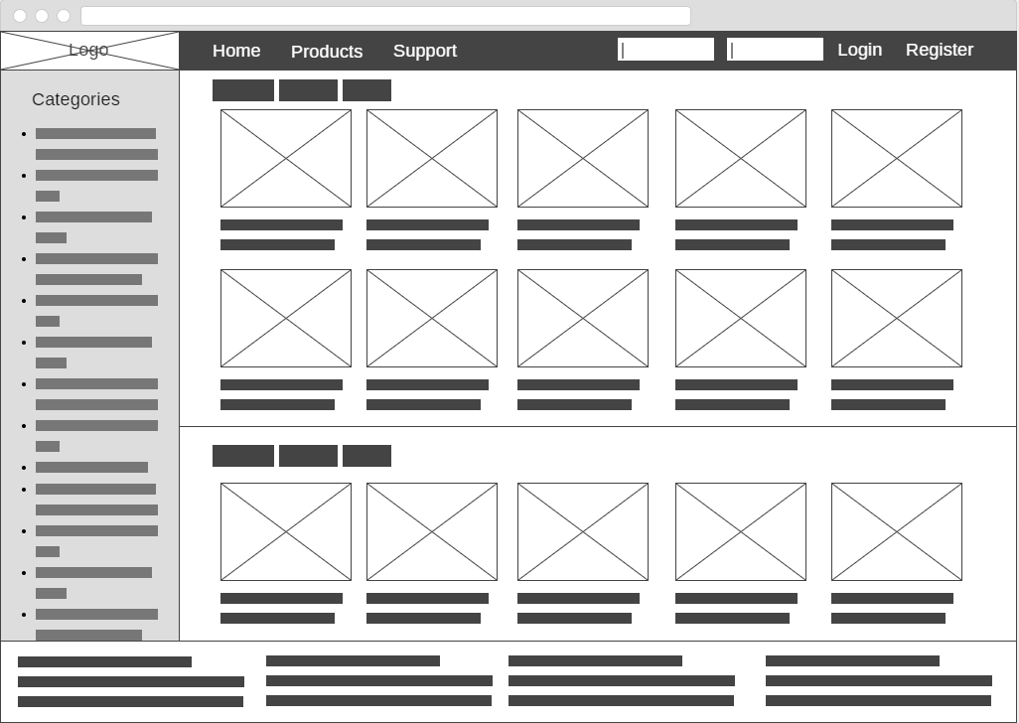

*Mockup 1 – Home page (logged out)*

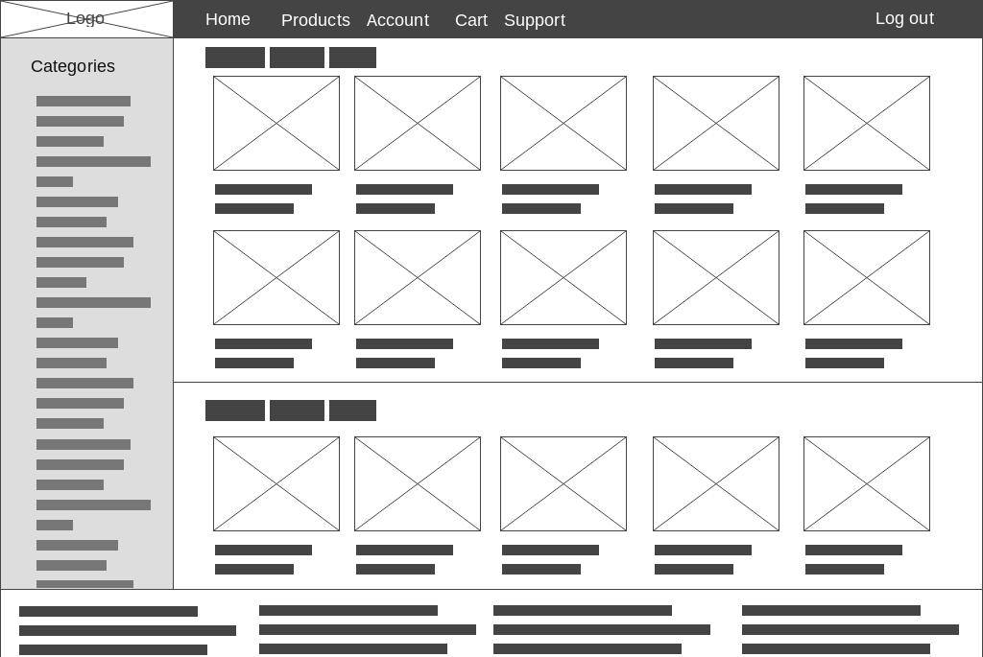

*Mockup 2 – Home page (logged in)*

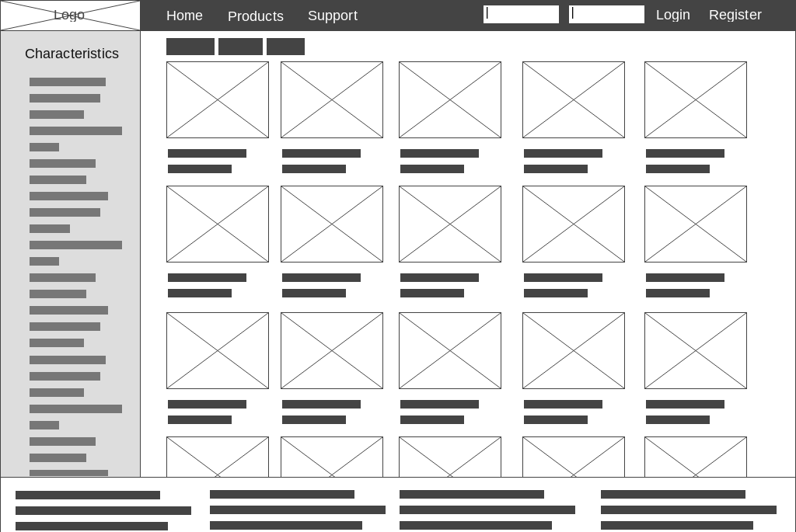

*Mockup 3 – Products page (logged out)*

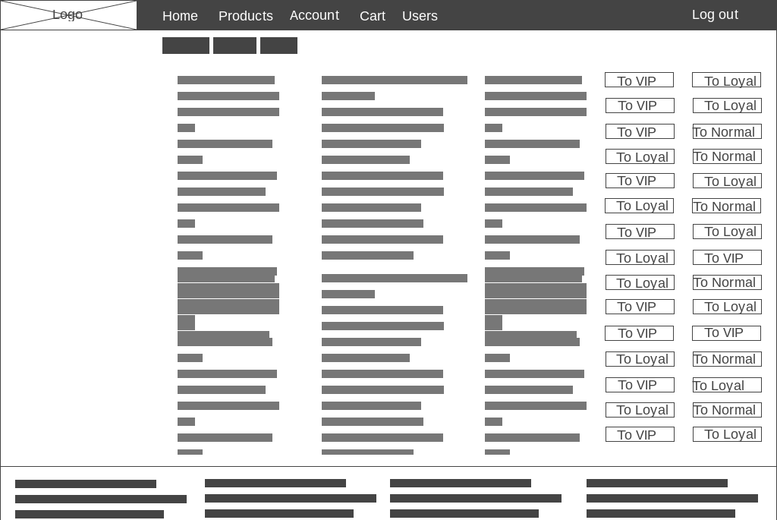

## *Mockup 4 – Users page (admin)*

## 