Practical Agile Scrum Tool
Practical Agile Scrum Tool 1
Overview 2
Some Key Features 3
Requirements 3
Quick Install (Windows only) 3
Slightly Slower Install 4
How to Update 4
Getting Started 4
Projects 4
Iterations 9
Users 10
Stories 11
Tasks and Comments 13
Tasks 13
Comments 14
Uploaded Files 14
Audit History 15
Epic/Parents 15
The ‘Epic’ or ‘Parent’ Tree  15
How the Epic or Story Tree works. 15
Velocity and Burn-up 17
Export & Import 17
Export 17
Import 18
Notes: 18
Reports 18
Searching 19
Text Search 20
Special Search 20
Releases 21
To start using the Release planning tool, 21
Hints, Tips and Tricks 21
FAQ 22
Security Model. 24
Users 24
Global Admin users: 24
Project Admin users: 25
Read Only users: 25
All Other Users 25
Some Restrictions or things to remember 25
Things to look at later 25

Overview
This was created as an exercise as I simply could not see how the majority of agile tools out there justify their pricing. On top of that I wanted something simple and easy to use that would not distract teams new to Agile and Scrum. This application is the result of that exercise.

It allows you to create and manage Projects, Iterations, Epics, Stories, Story Tasks and Comments using a tool that is simple, easy to use and only does what it needs to do.

One of the more useful features is that you can have a hierarchy of Stories or Epics, something that is normally only included in scrum tools at a substantial cost. The hierarchy is easily accessible from most places and visible for each Story that is part of a tree. This means Stories can have children (and obviously parents) to an almost infinite level.

This helps with breaking larger pieces of work down into manageable addressable chunks. Work that can then be addressed in a single Iteration while not losing track of the ultimate business value goal, and purpose of the work.

It is worth stating upfront that this is not suitable as a public facing product, but perfect for internal use. The coding standards are also not great, and I am sure a lot could be done to make it more elegant and efficient. That being said it will happily serve up multiple Projects in excess of 500 Cards each on low-end laptop spec hardware.

Some Key Features

- Free & Simple to Use
- Releases that contain Multiple Projects
- Multiple Projects
- A Story Hierarchy /Tree
- Auto calculation of Epic/parent size
- Story Tasks, Comments and Tags
- Drag and Drop Story & Epic ordering
- Users allocated per Project
- Multiple Views (List, Tree, Board)
- Burn-down/up and graph
- Customisable Story Status, Story Size
- Customisable Story text fields
- Import and Export of Stories
- A number of useful Reports
- Attach files to stories
- An audit of changes to a story card
- Easy to install

Requirements

- MySQL * (using v 5.0.67 & 5.5.?)
- PHP* (using 5.4.7) incl Gd2 & Mysqli
- Web server* (using Apache 2.2.9 & 2.4.3)
- md5⁺
- JHtml⁺
- Fancytree⁺
- JQuery⁺ & JqueryUI⁺

* included in full install
⁺ included in both full and app only install

Quick Install (Windows only)
- Download and extract the ‘PA-Full- Install’ file into a new directory ‘e.g. PracticalAgile ’ on the server you want to use (a local PC is fine for testing)
- Browse to the directory containing the extracted files
- Open and examine _Start.bat and _Stop.bat
- Run _start.bat and make sure both Apache and Mysql start up
- Navigate to http://127.0.0.1:8088
- Log in as admin : admin (Yes I know that is not an e-mail address)
- Import the default hints from the included hints,.txt file (Org. Admin menu)
- Browse the template and/or create your first Project.
- To resize your icons use ‘ _icon_resize.bat’ in the pa/images folder (Default of 24 work fine)

Slightly Slower Install
- Grab a XAMPP package that include the above requirements somewhere. (‘xampp-portable-lite-win32-1.8.1-VC9’ from PortableApps work well for me)
- Install it and makes sure that it works.
- Download and extract the ‘PA-Site-Only’ installation file somewhere.
- Drop the entire ‘pa’ folder into your document root
- Edit pa/include/dbconfig.inc.php and make sure that the server, port, user and password are correct.
- Make sure that MySQL is running
- Edit the file ‘_setupdatabase.bat’ and correct any paths, ports, usernames and passwords.
- Save and Execute the batch file (or the commands from the file)
- Stop and restart both MySQL and Apache
- Navigate to http://<yourwebserver>/pa
- Log in as admin : admin
- Change the admin password and e-mail if you wish
- Import the default hints from the included hints,.txt file (Org. Admin menu)
- Create your first Project
- To resize your icons use ‘ _icon_resize.bat’ in the pa/images folder.

How to Update
- Grab a PA-Site-Only archive
- Take a backup of both your site and database
- Stop the database and site (_stop.bat)
- Overwrite your ‘pa’ directory (do not delete the ‘/uploads’ directory)
- Start the database and site (_start.bat)
- If the database needs updating it will be updated automatically.
- Log in to the site.

Getting Started

Do not make extensive edits to the ‘Template’ Project. This forms the base for any new Projects and should contain sensible defaults for your organisation.
Items propagated to new Projects include:
- ‘Points Scale’
- ‘Story Types’
- ‘Story Status’ & ‘Status Colour’
You can amend these after the Project has been created.

Projects
A Project encapsulates all the work needed for a product. Think single product, single backlog. Where you need an overlap the use Releases to handle that. Do not mix multiple Projects onto a single backlog.
Creating your First Project (and subsequent ones for that matter)
- Log in as ‘admin’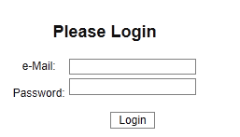

- You will be presented with the list of Projects you can access. Initially there will only be the template project in this list. 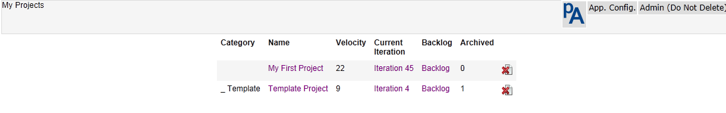

- Select ‘New Project’ from the ‘Org. Config.’ menu. 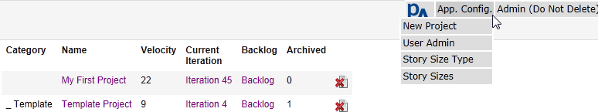

- Enter the appropriate Project details or accept the defaults (normally good enough) 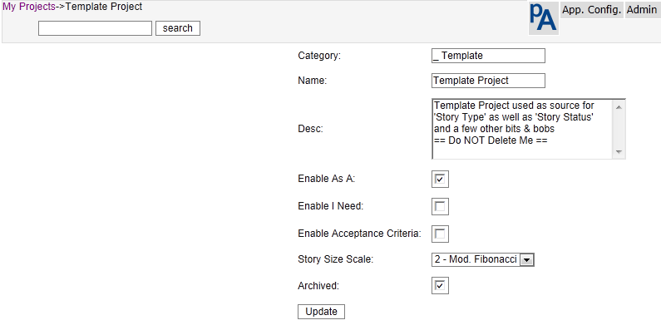
  - Category - Group Projects by category on the Project list page Use this to group related Projects. It is simply presentational
  - Name – The Project Name (presented on the Menu and in Project lists)
  - Desc – A longer description of the Project
  - Enable As A – When checked, this will enable an additional field for each Story to be used to capture the User role/Truth etc. This can be toggled off and on without losing data.
  - Enable I Need - When checked, this will enable an additional large text to be used to detail exactly what it is you need. This can be toggled off and on without losing data.
  - Enable Acceptance - When checked, this will enable an additional large text to be used to detail Story acceptance criteria. This can be toggled off and on without losing data.
  - Story Size Scale - This is the scale that will be used to size stories in this Project. To create or edit the scale navigate to ‘App Config’ and select the appropriate menu item.
  - Archived – When checked this Project will not appear in the Project list for users other than the admin user. All project information will be still be retained.
  - Hit Update and that is it! You have created a new Project.

You should now be presented with a Project list that includes your new Project. Here you can edit or delete a Project.

(When a Project is deleted, stories, comments, tasks, Story Status and Story type for that Project are also deleted.)
- Select it from the list and you will be presented with a project summary showing the basic project information as well as a history of previous iterations. Details of the most recent 200 changes are also available from this page.

Project velocity is Reported as the average of the 5 most recently completed Iterations. If you want to change this, then fiddle with the code in the function Update_Project_Points($thisProject) in the file include/common.php/
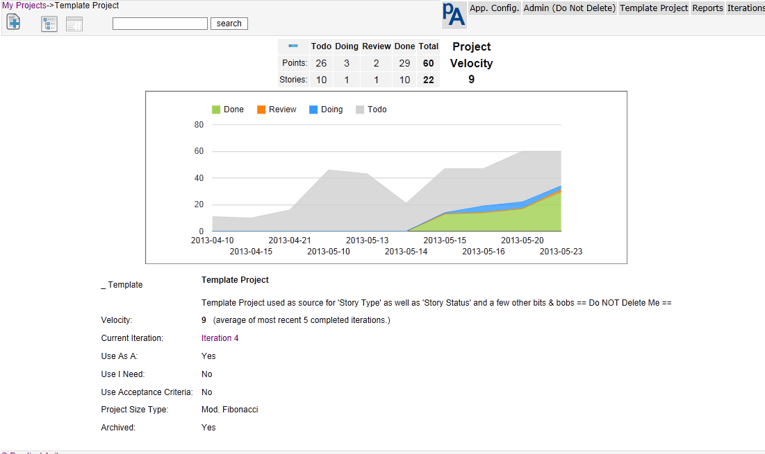
- If you want to edit the project defaults, Configure it from the <Project Name> menu as follows. 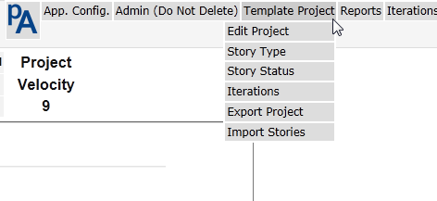
  - Check that the Project settings are what you expect to see
  - Story Type - Are the defaults suitable. It is strongly suggested that you leave these alone. If you need/want more than this, you are likely to be overcomplicating things. The default types of stories are: Features, Chores, Bugs, and Debt. 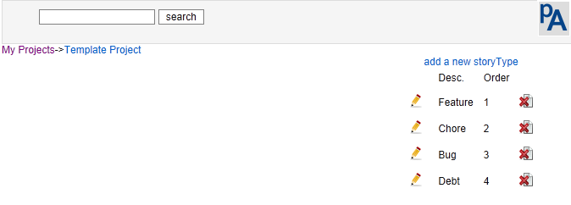
    - ‘Features’ are backlog items that provide direct visible business value to customer.
    - ‘Chores’ are backlog items where work needs to be done, but provides no direct, visible business value to the customer. Bugs represent unintended or erroneous behaviour
    - ‘Debt’ would normally be removed and addressed as a ‘Chore’. A new team is likely to initially create more debt than a mature team and this is a good way to see how much there is.

  - Story Status – Amend the descriptions and colours to suit your Project and your team, (there is a limit on the number of Status values of 10). There is no attempt to restrict the movement of a Story based on its Status, this would imply imposing a workflow that should best be decided by the team. It also help keep the product simple and easy to use. To enable a Status value, add a description remembering that a description of a single space while difficult to see is in fact a description. Remember that Less is more the more you have the smaller the chance of it being used correctly and kept up to date.
The defaults are the minimum you would expect to see and suitable for most teams 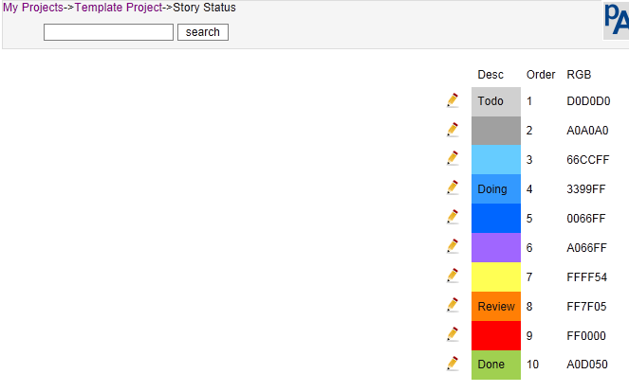

  - The table below shows some combinations I have seen. ‘List 1’ would be the absolute minimum for most teams, ‘List 2’, the recommended set for more established teams, ’List 3’ for a newer team, and ‘List 6’ is just over-kill.
 | RGB | List 1 | List 2 | List 3 | List 4 | List 5 | List 6
1 | D0D0D0 | Todo | Todo | Todo | Todo | Todo | Backlog
2 | A0A0A0 |  |  | Ready to play |  | Tasked | Estimated
3 | 66CCFF |  |  |  | Unstarted |  | Ready to play
4 | 3399FF | Doing | Doing | Doing | In Play | Started | In progress
5 | 0066FF |  |  |  |  |  | Code Reviewed
6 | A066FF |  |  |  |  |  | Tested
7 | FFFF54 |  |  |  |  |  | Checked In
8 | FF7F05 |  | To Review | Review | Review | Review | Review
9 | FF0000 |  |  |  |  |  | Rejected
10 | A0D050 | Done | Done | Done | Done | Done | Accepted

Iterations
When a Project is created, it is created with 1 Iteration/sprint, the Backlog

Add at least the current Iteration, and stubs for the next few Iterations. Iterations must have valid Start and End Dates. It is up to you to make sure this is the case.
If you are starting out, 2 week Iterations are probably most suitable. Make your Iterations start on the first working day and end on the last working day. This is especially important if you start and end your Iterations on a Monday and Friday. Wednesday to Tuesday or Thursday to Wednesday are probably better start and end days. This way you are then not disrupted as much by the weekends.

If you really must, it is possible to separate your Backlog into product work and technical debt by creating an Iteration without dates. This helps ensure that the Project is accurately sized in the backlog, and that debt and features can be separately viewed and prioritised.
If you do do this, the make sure that you have a policy of addressing at least n Points or stories worth of debt in each Iteration. Do not let it build up to unmanageable proportions
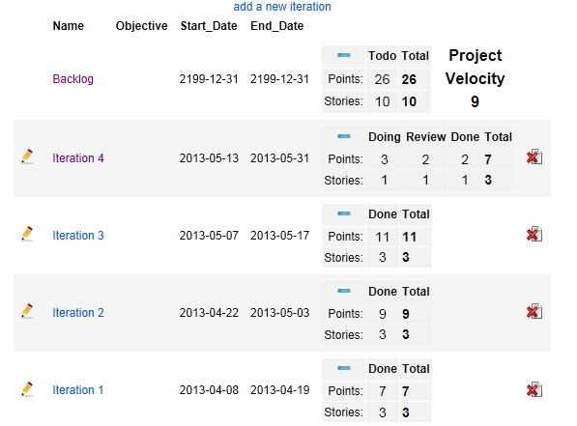
Clicking on the ‘Minus’ sign hides the Points details and the ‘Plus’ reveals them again.
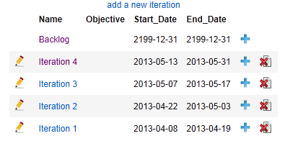

Users

- Adding users is a two pass cycle, go to the ‘Org. Config.’ Menu and
  - Add the users you expect to have access the Project, remembering that a single user can have access to many Projects.
  - Once all the users have been added, go in and edit them to allow access to their Projects.
    - Use this page disable users
    - Give them read only access to a project
    - Or make the project Administrators.
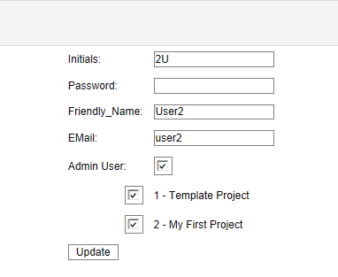

Stories

- You can now either capture your stories via add Story , or import them via a csv file. For importing stories refer to the section below.

- To add stories manually,
  - Select either the Backlog or the Iteration you want them created in. (Stories can only be created in the Backlog or an Iteration)
  - And select the Add Story button and capture the Story as detailed below.

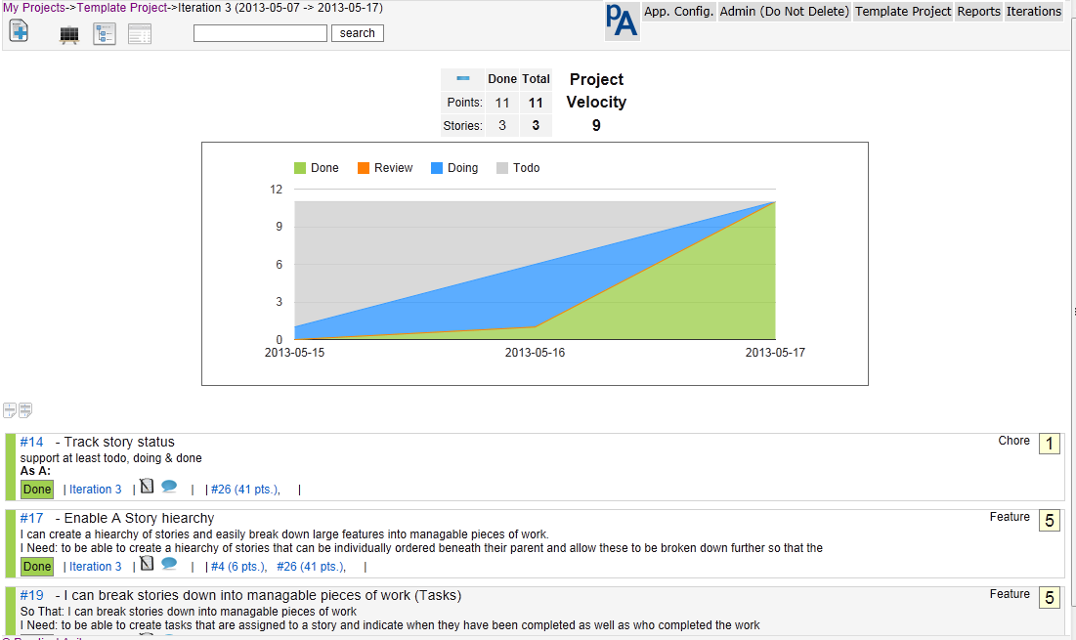

In the ‘Story List view” for the backlog or Iterations, stories that can have work executed against them, are presented in priority order. This excludes parent stories.

Drag and drop stories to re-order them, an independent order is retained for both Iteration & Epic views.
In the backlog or Iteration view drag using the vertical bar on the left of the Story (The Status indicator).

When the mouse cursor is over a Story, a small menu is presented on the right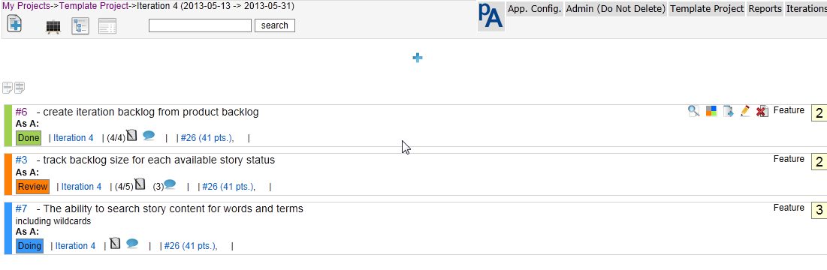 this allows a quick and easy means of viewing the full details, changing the Status, moving to a different Iteration, editing or deleting a Story.
You can also go to the Iteration by clicking the Iteration link. If this is a child Story, the Epic will be displayed after the task & comment micro menu. Hovering over the Epic with the mouse will display the Epic summary detail. Clicking on the Epic will present the Epic Tree with all its children.

Add/Edit a sory

Clicking on the Status on the left also allows you to change it, and clicking on the Story ID will put you it into Story edit mode. This is identical to the add Story view.

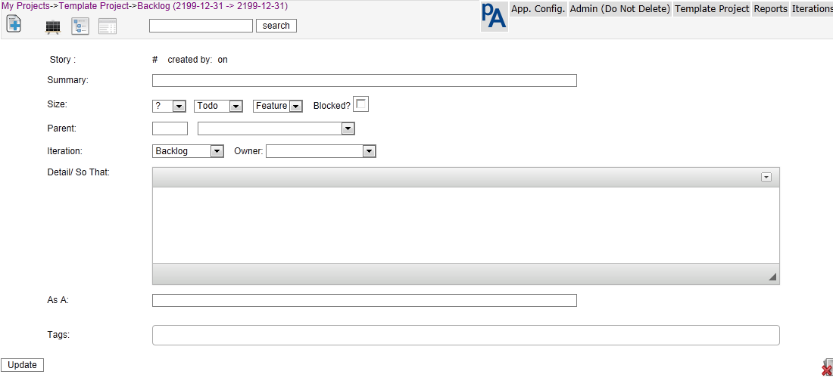
When deleting a Story, tasks & comments are also deleted.

When adding a new Story, they can be added to either the top or bottom of the current Iteration by selection the appropriate radio button (default to the bottom)
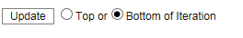

If you want to print individual stories as Cards, hit the print preview and a new tab containing a single Story will be presented in the appropriate size.
If you click in the Story summary, it will be stretched so that the Story can be printed for review with the truth. (another click will shrink it.)

If there are any existing Epic stories in the current Project, they will be presented in a dropdown for easy selection. Otherwise a parent Story number can be input in the box to the left of the dropdown.
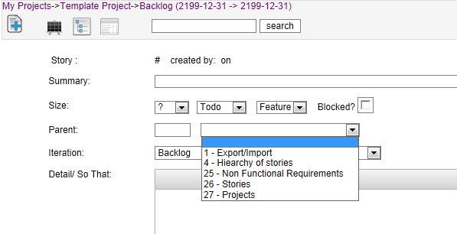
Large text fields have html editing enabled, this helps with linking, highlighting etc

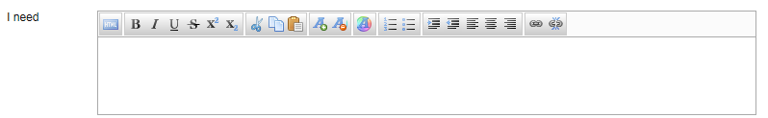

To duplicate an existing Story select the duplicate Story icon and an identical copy of the existing Story (excluding tasks and comments) will be created.
To include tasks in your duplicate select the icon.
A new Story will be created, but you will still be editing the original so take care.
Click on the link presented to edit the new Story

Tasks and Comments
Are linked to a parent Story. These can viewed or added from a Story list view, or while editing a Story. Click the appropriate icon to reveal them.

Tasks
Tasks have 3 states ‘Not Started’ , ‘Started/Doing’ , ‘Complete/Done’().
They can be re-ordered by dragging and dropping them (use either the edit or delete images as handles.)
Tasks can also be assigned to any person with access to the Project. The two columns to the right are expected and actual hours respectively. At the moment, these are not exported without accessing the database directly.

To change a task Status, simply check the box. There is no need to go into edit mode.
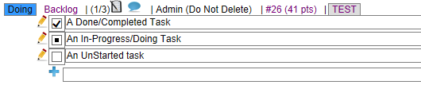
There are 3 Reports associated with tasks, namely:
- My Tasks (tasks allocated to me for this Iteration)
- Iteration tasks (all tasks for this Iteration)
- Iteration Hours (Hours against all tasks for this Iteration)

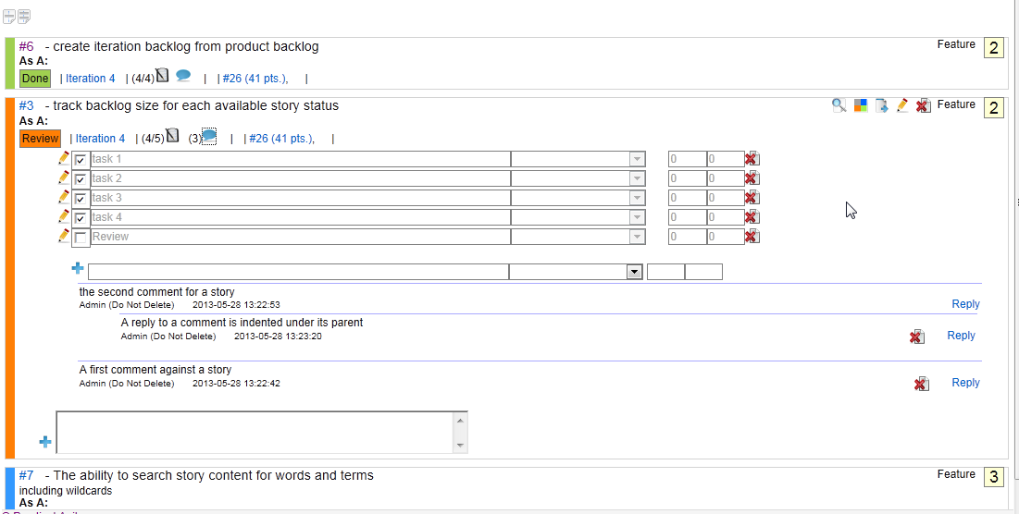

Comments
Can be replied to or deleted, not edited. Once a comment has a reply, it may not be deleted. Replies are indented under the comment they are responding to and may have replies themselves.

Uploaded Files
Files can be uploaded & attached to any Story. Uploaded Files are not stored in the database but are put into an ‘/upload’ directory. Remember to include this in your backup routines.

The list of file-types that are allowed to be uploaded are detailed in include/validfiletypes.php. and default to 'xml, txt, pdf, xls, xlsx, doc, rtf, docx, ppt, pptx, pps, ppsx, pub, png, jpg, jpeg, odt, ods, odp’. Get your sysadmin to update this as needed.

Audit History
Selecting this will present a history of changes against this card with the most recent changes at the top. There are also to reports to support namely a project audit as well as a full and complete audit for all projects.
The audit table can be truncated or shrunk via the <Org. Config> menu

Epic/Parents
Hovering the mouse over a parent Story ID or size will present a tooltip containing the parent summary.
To navigate to a parent click on the parent Story (in the last line) and you will be presented with a tree view with that Epic as the base of the tree
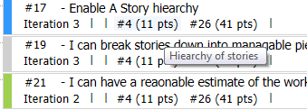

Tags
Tags can only be added when editing a Story, and the Story must be saved to update them. To create a tag that include a space enclose it in double quotes eg. “A tag with spaces”’.
Clicking on a tag in either the Story list of the Story edit will return a list of stories in the current Project that contain that tag. Essentially a case insensitive ‘tag: tagtext’ search is performed.
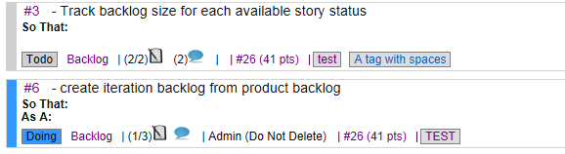

The ‘Epic’ or ‘Parent’ Tree

How the Epic or Story Tree works.
Epics, Features or themes are Top down, but work is performed bottom up.

This means that work can only be performed against the lowest level item in any Story tree. It also means that no Story that has a child Story can be moved into an Iteration or have work performed against it. Once a Story has been moved into an Iteration (work started against it) it can’t have any children.

The result of this is that the backlog only contains work that can be addressed by the team and does not show parents.

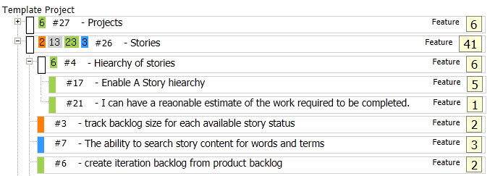

In the example above those Cards with ‘White’ handles are Epics and cannot have work performed against them. As you can see Epics can have children that are themselves Epics with children

To access the Epic view or Story/ hierarchy:
- use the Project tree view from the main menu to see the entire Project in a hierarchy
- In any list, where a Story has a parent, a link to the parent showing the parent Story number as well as the parent size is provided 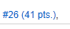 (A tooltip shows the parent summary text). When selected, this presents a tree with the Epic Story as the root of the tree.

- How the current Iteration/backlog fits into the product can be accessed from the ‘Iterations’ drop-down menu. Selecting the tree view here, presents a view showing the parents and their children, for all stories in the Iteration. Current stories are highlighted with a blue border. (Epics that this Iteration does not touch are NOT displayed)

To make a Story a child of another, either:
- Enter the Epic view for either the Project or Iteration and Drag and drop using the Project or Iteration/Backlog Epic /tree view

- Select the parent Story from the list of current parents in the dropdown on the Story edit page

- Type the parent id in the box to the left of the parent dropdown (not much validation, so take care)
You can do this to an almost unlimited level, but don’t get carried away.

Projects Epics are independently ordered and do not change the order of the work in the backlog or Iteration. The Status of the child stories are rolled up into their parent as are the Points values.
Drag and drop stories to create the hierarchy and order you need.

An Epic does not have a Status of its own, rather it accumulates the Status and size of all its children. A tooltip indicating the size for each parent Status value is presented as a reminder
eg. Epic #4 comprises 2 done stories totalling 5+1=6 Points.
Epic #26 comprises stories with a mix of Status values and size.

Velocity and Burn-up
Velocity, burn-up etc. are calculated on change of Iteration, Size or Status of any Story.
These are cascaded up through the Epics as well as to the Iteration and Project totals.
All Points and Status updates are times-tamped so progress during the Project and Iteration can be tracked.
Changes made to a Story while it is in an Iteration, will be reflected in that Iteration, even if the Iteration has ended. If the changes are made before the Iteration has started, they will appear as though they happened on the first day of the Iteration. If they change after the Iteration has ended, they will be reflected on the last day of the Iteration.

e.g. We have a Iteration-1 running from 1st to 14th of a month and Iteration-2 runs from 15th to 28th of the same month. If a Story in Iteration-1 is changed to ‘Done’ on the 15th, the Points will assigned to the 14th (the last day of the Iteration containing the Story). If the changes were made sometime in the previous month, they will appear on the 1st .

Export & Import

Export
Stories can be exported for further analysis, Reporting, or printing Cards for the radiator board.(use the included excel workbook for quick an easy printing of Story Cards.) Either the entire Project, or a single Iteration can be exported depending on where the export is selected from.
When selected from the ‘Iterations’ Menu, only the current Iterations worth of stories is exported, if selected from the ‘<Project Name>’ menu all stories for the Project are exported. If exporting the Project remember that this includes Epic Stories and if you do a simple sum() of the Points you will end up double or triple counting.
The Project export include an additional column ‘Num_Children’ that is a count of the children for that Story. This helps identify parents when printing Cards etc. The Num_Children column MUST be deleted before attempting to import the result of a Project export otherwise it will fail with an invalid column count.

Stories are written to a csv file that can easily be imported into a spread-sheet, printed etc. (The backlog is simply treated as another Iteration).

Import
To help transferring Project information a rudimentary import feature is provided. You can only import stories for a single Project. Release, Iteration and Owner columns are reference columns and must be configured for the Project before attempting an import.
The import file must be in the same format as an Iteration export file and all 17 columns must be present and in the correct order, they can however be empty (The number of Children must NOT be present). To get a sample file, simply export you smallest Iteration (It must contain at least 1 Story!!).

Import Behaviour is as follows:
- The first line of the import file will always be skipped so make sure that it does not contain data.
- When importing, if a Story ID exists, the import will issue an update to that Story, otherwise it will attempt to insert a new record.
- Both a Status and summary must be present, otherwise the import record will be skipped
- As weird as it sounds, the import routine also deletes records. To do this, a Story ID must exist, Status an summary must be present and the “Iteration” must contain the string "** Delete **"

The parent column is never updated , so any relationships will need to be manually created after the import has taken place.

Notes:
- Where an Iteration does not exist, the Story is put into the backlog.
- If there is an error when importing a record, that record will simply be skipped.
- All large text columns for a Story are limited to 32000 characters

Reports
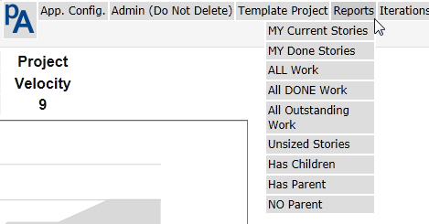

There are two types of Reports that are available:
- Type 1 has an ‘External’ value of 1 and are presented in a Story list view similar to a backlog view. These Reports are always filtered by the current Project.
- Type 2 has an ‘External’ value of 2 are not constrained other than by your imagination. These are presented in a table format with 1 line per returned row.
There are a handful of built in Reports that can be deleted or extended as you wish.
- Hitting the Report name will present the results on screen.
- Selecting the export icon to the right of the Report name will send the results to a csv file and no Report results will be presented.

ID - Dictates the order the Reports will appear in the list/menu
Desc - the Report description that appears in the list/menu

Type 1 – (External = 1)
Essentially you are building a query that returns a list of Cards for the current Project. Something along the lines of
SELECT * FROM Story where Story.Project_ID=”Current Project’" and ([Conditions]) order by [Some order].

Type 2 – (External = 2)
These are more hardcode and return pretty much anything.
The sql used to build the Report is a concatenation of the QSQL and Qorder columns (remember to have a space at the end of QSQL or the start of Qorder or you risk a syntax error and incorrect results returned.)

All Reports are available across all Projects. There is a rudimentary Report editor availe from the <Org. Admin> Menu

The QSQL & Qorder can include replaceable parameters as follows, otherwise actual column names must be used.
{Project} – Current Project
{User} – Logged on User
{Iteration} Current Iteration (remember that the backlog simply an Iteration)
{Backlog} - Current Project Backlog

The easiest way to get our head around this is to have a look at an existing Report, duplicate and amend it

Searching
Searching for Stories
In the header is a search box that accepts both words and phrases for a text search, or a special search syntax to find stories.

Text Search
Type text into the box to search for it within the Story, tasks or comments of that Story. A word search is performed and no matches are returned against partial words. It is currently performing a like search (like %text%)

Example: my search

Special Search
Special Search Criteria are #,owner, Status, size & tag (case is irrelevant)

Story number
You can find a Story by its number by using a hash (#)
Example: #10
To search for the text ‘#10’ prefix it with a space

Owner
You can find stories owned by someone by using owner:< and their initials>.
Example: owner:ppl

Status
Find stories of a particular Status by using Status: <the Status>.
Example: Status: done

Tag
Find stories of a particular Status by using tag: <tagtext>.
Example: tag: bug
or
Click on the tag when viewing a Story.

Size
Find stories of a particular Status by using size:<Size>
Example: Size:5

Type
Find stories of a particular type by using type:<type>
Example: type:bug

Special search tags can NOT be combined either by themselves or with some text (yet).
Having these tags, does mean that if you perform a search using only the tag ( incl the ‘:’ ) you will get unexpected results. Search for a Story containing the tag (including the ‘:’ ) as the start of a search term.

Search results will be presented in a Story list similar to that for an Iteration or the backlog.

Releases
Releases combine the work from multiple Projects. They can only be created by a global admin, but anybody that can edit a Story, can add it to a Release. Details of Releases are available from the Organisation Admin as well as Project admin Menus
Project admins can view Release details for those Projects that they have access to but will not see details for Projects that they do not normally have access to. In other words, you will not be able to view all the contents of a Release if you do not have rights to all the Projects in that Release,
Details for a Release are presented in a similar fashion to a Project Tree where the work in the Release, its Parent Epics and their progress are presented to each Project in the Release.
It is worth remembering that ONLY those Cards in the Release are presented in the tree, this means that the Points against an Epic (the total Points for that Epic) may not equal the work in the Release. Some may already have been Release or schedule for Release at a later date.
A summary or the Status for all Story’s for each Projects in the Release as well as for the entire Release is also presented.

To start using the Release planning tool,
- Create a Release from the Organisation Admin Menu.
- Once at least one Card has been added to the Release (Edit a Story) that Project will be included in the Release.
- At this stage, the Release will be made available on the ‘Project Admin’ Menu and the ‘Quick Edit’ features for a Release will be made available.
- These Quick Edit Features include:
  - Adding or removing
    - The entire Project
    - All ‘Done’ work
    - All work not ‘Done’
    - The contents of any ‘Epic’, but not any further Child Epics.
These features only act on Cards/Stories that are not already included in a Release. Eg if a Card is included in ‘Release 5’ it will not be moved to the current Release (Release 4) but remain where it is.
Also, when including all ‘Done’ work for a Project in a Release, any work that has bene previously Release will remain in that Release.
It would be good practice to use the ‘Not in Release’ Report to check for any ‘Done’ work, as well as checking later Releases for any ‘Done’ work that could/should be included in the current Release.

Hints, Tips and Tricks
- Use the ‘Iteration Planning’ page available from the <Project> menu to make life easier during Sprint/Iteration planning. Here you can see both the ‘Backlog’ and the ‘Sprint’ or ‘Iteration’ being planned on the same page. Along with a running total of the points in the planned iteration.
- To make a Story a child of another, either, drag and drop using the Project of Iteration tree, select the parent from the list of current parents from the dropdown on the Story edit page, or type the parent id in the box to the left of the parent dropdown
- Just about anywhere you can navigate to, can be opened in a new browser tab or window. This is really useful for Iteration planning, copy from one Project or Story to another. It does also mean that you can edit a single Story in two places. The last save counts!
- Clicking on the Story number (e.g. #11) with let you edit that Story.
- Status can be changed from either the mini menu on the Story, or by clicking on the Status on the last line of the Story.
- The order in the Project tree is independent of the Iteration order.
- Hovering over an Epic Story id will pop a tooltip containing the Story summary.
- When displaying the backlog, the numbers in brackets after the Story size will be the next empty Iteration this Story will appear in at current velocity. Worst and Best Case Iterations are presented. (w/b)
  - For Worst Case, the assumption is made that all stories can be completed in a single Iteration and if adding a story to the iteration would exceed current project velocity, the Story is moved to the next Iteration. This is probably closer to reality. It also means that Story order, especially where Story sizes are close to or larger than half the current velocity can have a big impact on the prediction. (this tends to slightly Under-load Iterations)
  - The Best case estimate loads the Iteration with stories until the Points value for the Iteration is equal to or greater than the current Project velocity. (This tends to Overload Iterations)
  - In both cases, any un-sized stories are estimated at the Projects current average Story size.
- Looking at the list of Iterations will show you your velocity trend
- The Status and Size of all child stories are rolled up to the parent.
- The graphs will only display correctly if there are 2 dates to display. This means that you will only see an update if you have changed something after day 1 of the Project/Iteration etc. You also need
- Admin users can change anybody’s password. (the is no confirmation, so get it right first time)
- Blocked work is highlighted with a RED border.
- In the Iteration Epic/tree view, work in the current Iteration has a Blue Border.
- The Reports are useful Use the ones that are already there, and create new ones to support your needs.

FAQ

Q. How do I view Project progress?
A. View the project summary page, or use the project progress report.

Q. How do I view epic progress?
A. Select the Project/Epic Tree from the header or any story list view. The status for all stories in each epic is presented to you.

Q. How do I create an Epic or convert a story to an Epic
A. View the project/Iteration backlog using the epic tree and drag the child under the appropriate parent.
A. When editing a story, select the parent from the list of existing parents in project from the dropdown
A. When editing a story, type the Parent story number in the 'manual' parent edit box.

Remember that the prospective parent must be in 'Todo' Status (No work against it) and must be in the 'Backlog' (No work Scheduled)

Q. I can’t make a story a child using the Epic tree.
A. You will find that the parent you are trying to use is already in an iteration (ie work scheduled) or not in a Todo Status. Remember, work can only be performed at the lowest level.

Q. I can't move a story in or out of a specific iteration. Why?
A. The iteration has been locked.

Q. I can't move work in or out of a specific release. Why?
A. The release has been locked.
A. Add at least 1 Story to the release via the 'Story edit' form

Q. I can't see releases, why not?
A. you need to be a project admin to view releases.

Q. Why can't I delete a comment?
A. You can only delete comments you have added and then only if there is no reply.

Q. Why can't I delete a story?
A. You only have read-only access to that project.

Q. How do I move a story from one project to another?
A. At the moment, you have to open each project in a different browser tab and copy and paste between them.
A. If you have a large number of stories, it is faster to Export them from the old and import into the new project. Remember toclear the story # and delete them from the original project.

Q. How can I delete a large number of stories from a project?
A. Export the stories you want to delete, change the iteration to "** Delete **" without the Quotes, and re-import them.

Q. Why am I directed to the login page when trying to edit a story?
A. The user you are logged in as does not have access rights to the project containing that story.

Q. I can’t get past the login page or I receive an error message.
A. You account may be disabled
A. You may be trying to use a shortcut to a project, iteration or story that does not exist anymore, check the URL you are using and change it to login.php.
A. Get your administrator to Check the username, password

Q. I can’t import anything, what is wrong.
Q. I Can't attach files to a card, what is wrong
A. Check your php.ini and make sure that file uploads are allowed and that the upload tmp directory exists, is available and writable, or use the full install that includes the following settings in php.ini.
file_uploads = On
upload_tmp_dir = /usr/local/mysql/tmp
upload_max_filesize = 2M

Q. When importing a csv file exported from a report I receive an error along the lines of "Excel has detected that the 'MyOutput.csv' is a SYLK file, .....”
A. This is a known issue with Excel, If the first column heading / value of the CSV file begins with uppercase ID, Excel will interpret the file as being in the SYLK format rather than CSV, as described here: http://support.microsoft.com/kb/323626. change the first column name to rectify this.

Q. I am having trouble with my graphs, What can I do.
A. The way to solve most of the graph issues is to update the app to ver 1.7 or greater as this uses jqplot & not google graphs
Q. When importing a csv file exported from a Report I receive an error along the lines of "Excel has detected that the 'MyOutput.csv' is a SYLK file, .....”
A. This is a known issue with Excel, If the first column heading / value of the CSV file begins with uppercase ID, Excel will interpret the file as being in the SYLK format rather than CSV, as described here: http://support.microsoft.com/kb/323626. change the first column name to rectify this.

Security Model.
The security model is fairly light, it is not there to stop a hacker it is there to prevent accidents limit Projects a user can access. The application is only meant for use inside a secure environment. And definitely not for a public facing site.
Each page is checked for valid access to a Project before presenting it to the user to go some way to mitigating URL manipulation.
User passwords are hashed both across the network and in the table of users and both individuals and a Global Admin can change a user password.

Users

Global Admin users:
- Users with the Global Admin flag set are in effect a ‘super-user’ with global rights across all Projects.
- Edit organisation attributes
- They can add/edit/delete users
- Create, archive or delete Projects
- Change user passwords
- Allow users access to Projects
- Assign Project Admin Rights
- Create & Edit new Story Point templates (numeric only)
- Create & Edit Releases

Project Admin users:
- Can Edit Project details
- Story types for a Project
- Points values for a Project
- Edit the contents of Releases
- this Setting overrides the read-only user setting

Read Only users:
- Are for when you want somebody to be able to see what is happening, but not accidentally change or move things about.
- The Project Admin setting overrides this setting.

All Other Users
- Add, Edit, Duplicate & Delete Story Cards and their contents including
  - Size
  - Status,
  - Tasks
  - Comments
- Move Cards in and out of Iterations or the Backlog
- Move individual Cards in and out of a Release
- Import & Export Cards
- Run Reports
- Edit their User details (but not access )
- View pretty much everything else related to Projects they have access to.

Some Restrictions or things to remember
- Burn-up is only calculated when something changes (a Story updated/added, a Status changed or Story moved to a different Iteration)
- Text in any field may not exceed 32000 characters (remember that if you are using formatted fields, you will suffer from html bloat!)
- A Story can only have a single owner/responsible person (create a tasks for a greater level of detail).
- Story Point templates are numeric only.
- No e-mail notifications, well not yet anyway
- Server times are used
- No Integration with other products
- Not suitable for public facing use. (security, SQL injection, ... etc)

Things to look at later
- Including an accessible audit of changes. (Who, What & When)
- When editing an Iteration start and end dates after there is work in the Iteration, the Iteration Points history are not moved to the new dates. (Toggle the Story Status or all Cards as a workaround.)
- Multiple Date & time-zone handling (for the moment edit ‘include/dbconfig.inc.php’) but still only a single time-zone

