Create a new index.html and give it styling similar (not identical) to the Twitter page, without using the Twitter logo or trademark, similar to the following page.

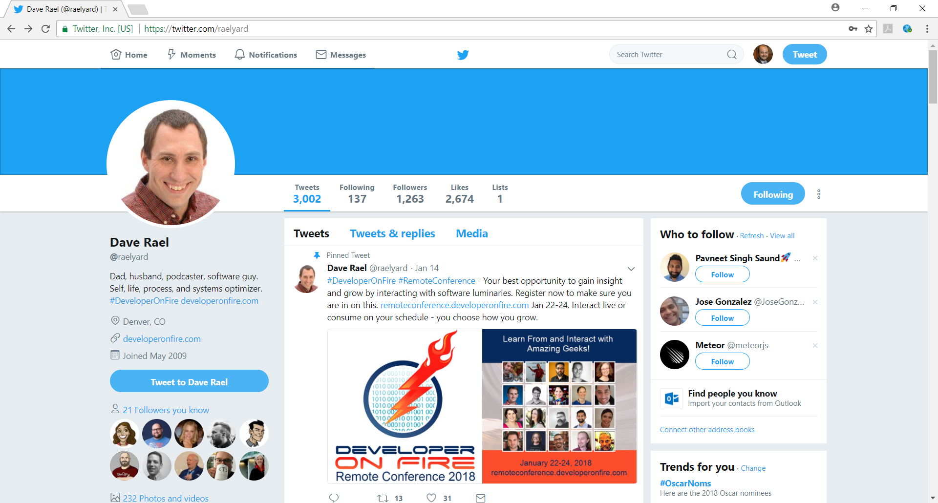

1. Have a color banner or picture at the top of the page
2. You may use the same verbiage in HW2 pages.
3. Enclose a picture in a circle
4. Have your links/menu at the top of the page
5. Select a non-white color for your background, but make it attractive and professional.
6. The body will be composed of 3 columns, each having a background color different than the color in the previous step
7. All boxes will have rounded corners, sufficient padding.
8. Have an opaque image hovering over a portion of the text.
9. Use your imagination to add additional styling to your page to better represent you.
10. Create an external style sheet using all 4 different types of selectors:
11. Universal
12. Type
13. Class
14. ID

Remove all style attributes for any elements and implement styling ONLY via CSS classes.

Classes can reflect any style you wish (i.e. changing font color, font size, family, etc.), but it must have a professional appearance. Class names must follow proper naming convention.

Due: Monday, March 18, 2019 9:00AM

Submission:

1. Create “HW3” repository in GitHub and upload all project files.
2. Deploy the final solution to *www.mydomain.com/hw3*
3. Email web site link and GitHub link to [samnasr@live.com](mailto:samnasr@live.com), with “HW3” in the subject line