

CSE 482

Internet and Web Technology

Project Proposal

**Hospital Management System**

**Section: 02**

|  |  |
| --- | --- |
| Submitted By:  **Group Members:** MD Ayat Ullah--------1331111042  Pias Paul----------------1410542042  Nazmus Sakib Adib---1420464042  Md Jahidul Hossain---1320349042 | Submitted To:  Md Naqib Imtiaz Hussain |

**1.Project Title:** Hospital Management System

2.Overview:

In this project, we are going to build a Hospital management system which will facilitate patients and as well as Hospital authority by automating the system and reducing human labor and time. We will mainly work on the sections such as online access of diagnostic records, registering a patient and keeping electronic records of patients so that doctors can check it before an appointment or any time through internet, smart appointment system, smart queue, automated billing system, a chat program so that doctors and patients can communicate easily, automated pharmacy, checking availability of rooms and beds in wards etc. All of these data will be updated frequently with our hospital management system. There will section for hospital staffs, employees, and nurses and they will be registered in the system so that they can also use the system and also for monitoring their work. Now one may ask about the security of the valuable data and information. Therefore, we will build a login system so that only right person can access the desired information through authentication.

We shall build the website using HTML, CSS, and PHP mainly. We plan to further develop the project with a framework which will be Laravel hopefully. As most of the people use smartphones now a day, therefore, we will also make an android application which will not be just a web version of the website rather more reliable and mobile-friendly application.

3.Significance of the project:

A hospital is a very busy crowded place where general to emergency patients visit frequently. Therefore, managing a hospital requires a lot of skilled manpower, paperwork and time. Often there we see large queues before the room of a doctor which is maintained by one or two people which is inefficient. If we can build a Hospital management system then patients appointments, payments, doctor allocation will be less time consuming and more convenient. Also, a smart queue can save a patient’s time significantly. For example, if the patient can learn the estimated time required to meet the doctor such as 35 minutes he or she can spend this time in other work instead of waiting in the queue. Therefore, this project will benefit both the patients and hospital authority. Also, by doing this project, we will be able to dive into the fields of internet and web technology.

4.cardinal flow:

Below We have given a Class diagram of our project:

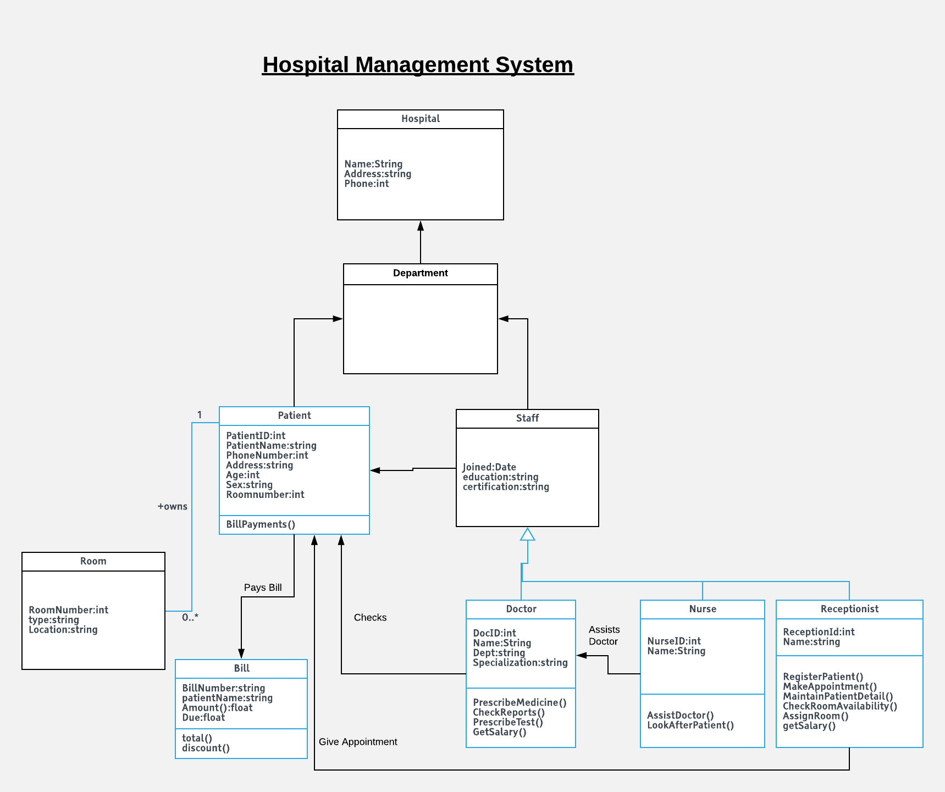

5. Feature list

We are proposing the following features for our project. We shall increment, decrement, alter more features later.

Patient Doctor online chatting

Online access facility of Diagnostic Reports

Registration system

Login System for Security

Doctors can check all of patients’ history online before appointment or anytime

Also, Patients can check their own.

Special android app for smart phone users

**Work Responsibility Distribution:**

|  |  |  |  |  |  |
| --- | --- | --- | --- | --- | --- |
|  |  | **Responsible** | | | |
| **Serial** | **Task Modules** | **Md AYAT ULLAH** | **Pias Paul** | **Nazmus Sakib Adib** | **Md Jahidul Hossain** |
| **1** | **Requirement Collection and site plan** |  |  |  |  |
| **2** | **Design** |  |  |  |  |
| **3** | **Content Developer** |  |  |  |  |
| **4** | **Database Plan** |  |  |  |  |
| **5** | **Site Development (codint)** |  |  |  |  |
| **6** | **Quality Assurance** |  |  |  |  |
| **7** | **Hosting** |  |  |  |  |