**Project Title: A preliminary survey of sword fern survival at Seward Park’s Ground Zero, on the hypothesis that proximity to large trees or logs may correlate with, and possibly facilitate survival.**

**Investigators:**

Paul Shannon GSP Forest Steward [pshannon@systemsbiology.org](mailto:pshannon@systemsbiology.org)

Leo Shannon Silviculture student at Warren Wilson College [leodshannon@gmail.com](mailto:leodshannon@gmail.com)

**Project Summary (500 words max):**

A small number of ferns have survived at Seward Park’s Ground Zero. In an area of about 1400 square meters, 80-100 dead fern crowns are easily visible; about 10 ferns have survived five years after the die-off. The survivors seem to cluster near large cedars and big-leaf maples, with some found near large douglas fir logs. We propose to quantify this clustering by locating each fern (dead or surviving), and every log and tree with respect to an anchor point, using cartesian coordinates, determining all actual by distances by subsequent calculation. Field work will be completed in one day. We will record fern health (by categorized frond count) as well as tree/log DBH and species. These data will set the stage for possible summer 2019 Reed College exploration of mechanisms of survival.

**Methods (500 words max):**

1. Layout orthogonal N/S and E/W axes in the middle of Ground Zero by compass, using tightly staked inexpensive 100-meter tape measures. Each axis will extend beyond Ground Zero by 20 meters in each direction in order to include trees or logs relatively distant from all ferns (but within Simard lab heuristics for mycorrhizal connections).
2. Place temporary numbered tags in all dead fern crowns, all surviving ferns, all area trees and logs, to be removed at the end of the survey day.
3. Classify each fern by frond count, and each frond by an estimate estimate of green/brown (living/dead) tissue.
4. Identify each tree and log by DBH and species, using the protocol described in the Forterra Protocols Guide (see references). Only large trees and logs (DBH > 16”) are present on the site. Every log will be additionally described by length, ground slope and aspect, an estimate of log-to-ground contact, and state of decay.
5. Obtain x-y coordinates of each tree and fern by tape measure and/or low-cost laser measuring device, against an easily repositioned target constructed of inexpensive retroreflective tape. Measurements will be made to the center of ferns, and the closest surface of trees and logs. Log positions will require two x-y coordinate pairs. Corrections to log or tree centers will be made via DBH during analysis. Distances from the axes to objects must be perpendicular to the axes. These distances will thus be minima, and can be easily checked to within an acceptable centimeter-scale error as we proceed. The variety of ground slopes found in the site will be recorded.

**Data Analysis (300 words max):** In addition to a simple tabular and graphical summary, and a map, we will attempt a linear model of fern survival as a function of tree/log proximity, species, and DBH. This may illuminate which factors, and/or combinations of factors, predict survival, and with what error.

**Data Management (100 words max):** Protocol-neutral data storage in tab-delimited files: one file to characterize ferns and their locations on the grid, one for trees, one for subsequently computed fern/tree distances. By using this format, the data will be available for import to excel, database, or to programming tools (R, matlab, python) for further exploration and analysis. Data and analysis scripts (in R) will be archived on a public github repository, easily transferred to Parks or academic repositories on demand.

**Project Timeline (100 words max):** 1 day of field work the week of May 13-19 (when both volunteers are available), 1 day of data cleaning and analysis, to be completed by May 31st. A draft report will be presented to the research planning group on June 3rd. A final report will be submitted to Parks by July 1st.

**Project Participants:**

Paul Shannon

Leo Shannon

Are any of the investigators volunteers?

Yes___2____ No_______

**Budget:** < $50, contributed by participants. No funds requested.

**Deliverables (100 words max):**

Tabular data, in three files (ferns, trees, proximities). Area map following the style of Dylan Mendenhall’s example (see below).

A preliminary analysis, with accompanying code and graphics, describing

all relationships discerned in the field data. A step-by-step account of our fields methods.

**Literature Cited:**

<https://forterra.org/wp-content/uploads/2015/05/Regional-Standardized-Monitoring-Protocols.pdf>

[With many thanks to Dylan Mendenhall, UBC PhD student, we offer these annotated references. We note that evidence for Douglas fir, cedar or maple facilitation of sword ferns has not yet been reported.]

Bingham, M.A., Simard, S., 2012. Networks of Pseudotsuga menziesii var. glauca Trees Facilitate Establishment of Conspecific Seedlings Under Drought. Ecosystems 15, 188–199. <https://doi.org/10.1007/s10021-011-9502-2>

*Access to mycorrhizal networks connected to mature trees increased the likelihood of Douglas fir seedling survival (Bingham and Simard, 2012). After controlling for the effects of root competition, seedlings planted closer to mature Douglas fir trees (0.5m to 2.5m) had higher growth under increasing summer drought conditions compared with seedlings planted further away from the trees (5m to 15m), suggesting that the mycorrhizal networks of mature trees facilitate seedling growth when under stress*

Brooks, J.R., Meinzer, F.C., Coulombe, R., Gregg, J., 2002. Hydraulic redistribution of soil water during summer drought in two contrasting Pacific Northwest coniferous forests. Tree Physiology 22, 1107–1117. <https://doi.org/10.1093/treephys/22.15-16.1107:>

*Mature trees in Pacific Northwest conifer forests can redistribute water horizontally through soil, giving plants with shallow root systems greater access to water during periods of drought.*

Teste, F.P., Simard, S.W., 2008. Mycorrhizal networks and distance from mature trees alter patterns of competition and facilitation in dry Douglas-fir forests. Oecologia 158, 193–203. <https://doi.org/10.1007/s00442-008-1136-5>

*The height, shoot biomass, root biomass and needle biomass of Douglas fir seedlings were lowest when planted 0.5m from mature trees and highest when planted 2.5m to 5m from mature trees (Teste and Simard, 2008), suggesting that intermediate distances to mature trees facilitate the growth of seedlings.*

**Field Work Summary: May 18-19 2019**

Leo and Paul Shannon spent 12 hours each at Ground Zero in Seward Park over two days. Using 100m tapes borrowed from Tim Billo, we established orthogonal axes intersecting at the approximate center of the study area (photo #1). The map’s positive y axis pointed 15 degrees east of due south, at 165 degrees.

A home-made retro-reflector target (two feet square, mounted on a three foot pole) and a carpenter’s laser measuring device (photo #2) contributed to a measurement process in which x and y coordinates of each of ~230 ferns, alive and dead, were obtained, at the rate of approximately one measurement per minute. Every tree and three large logs received the same treatment, with DBH and species noted. See map below.

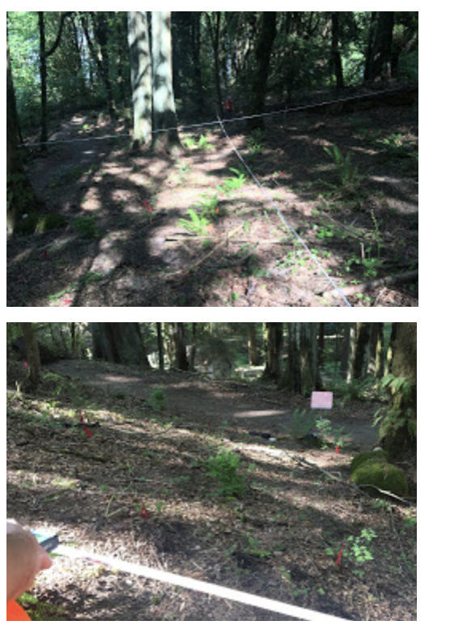

In the map below, dead ferns (recognized by vestigial brown crowns) are rendered as empty black circles of uniform size. Surviving ferns are solid green circles, also of uniform size. Downed douglas fir logs are rendered in black. DBH of trees, logs, and all locations are tabulated in attached tab-delimited files.

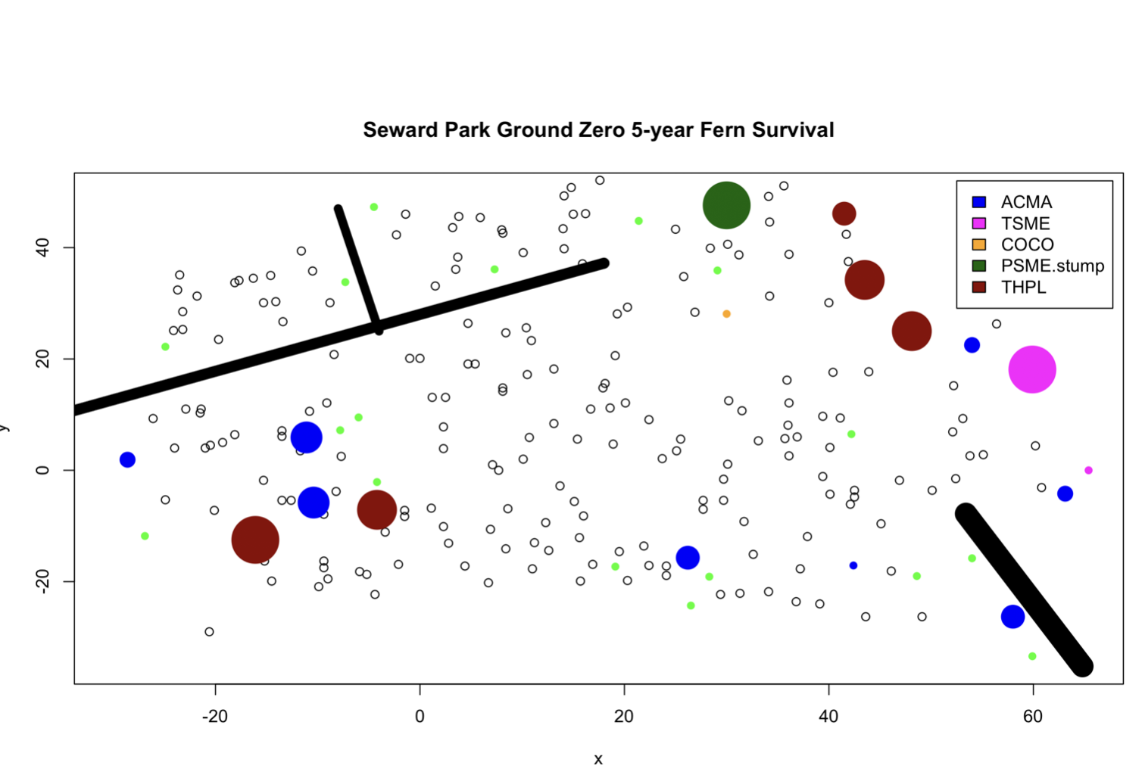

**Analysis**

UBC PhD Dylan Mendenhall analyzed the data we collected in the field, summarizing his results thus:

I did a logistic regression on the data and found that the distance between a fern and the nearest tree or log had a significant effect on survival (z =1.979, p = 0.0479). It's a weak relationship and it only stands if all the ferns are included. If the data are standardized to only include ferns within 15 ft of a tree or log, the relationship disappears. If logs are removed from the data, the relationship disappears. I think this strongly suggests that in a die-off zone, there is a distance threshold beyond which ferns are almost incapable of surviving. However, below that threshold, proximity to trees and CWD has little to no effect on survival.

The survival rate was 10.2% for sword ferns within 15 ft of a tree or log. In contrast, the survival rate was 2.3% for sword ferns further than 15 ft from a tree or log. That may not sound like a big difference but the odds of a fern surviving are 4.8 times greater if it is located within 15 ft of a tree or log.

The species and DBH of the nearest tree had no significant effect on survival. Likewise, there is no effect of DBH or minimum distance on the total number of fronds, nor the ratio of new fronds to old fronds.

All preliminary data, subsequent revisions, R scripts and figures are available at

<https://github.com/paul-shannon/swordFernData/tree/master/groundZeroSurvival>

**Acknowledgements**

We are grateful for the support from the following:

* Seattle Parks
* Lisa Cieko: for helpful comments on the research plan
* Tim Billo: research planning, field equipment
* Dylan Mendenhall: research planning, extraordinary skill and generosity in data analysis