**Problem Statement：**

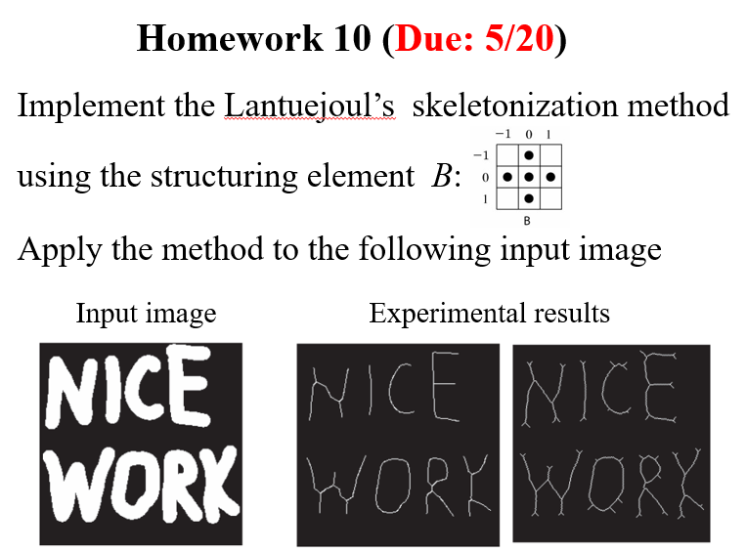

**Input:**



**output:**

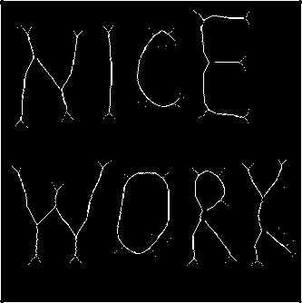

**Source Code：**

**# Import the necessary libraries**

**import cv2**

**import numpy as np**

**# Read the image as a grayscale image**

**img = cv2.imread('nicework.png', 0)**

**# Threshold the image**

**ret,img = cv2.threshold(img, 127, 255, 0)**

**# Step 1: Create an empty skeleton**

**size = np.size(img)**

**skel = np.zeros(img.shape, np.uint8)**

**# Get a Cross Shaped Kernel**

**element = cv2.getStructuringElement(cv2.MORPH_CROSS, (3,3))**

**# Repeat steps 2-4**

**while True:**

**#Step 2: Open the image**

**open = cv2.morphologyEx(img, cv2.MORPH_OPEN, element)**

**#Step 3: Substract open from the original image**

**temp = cv2.subtract(img, open)**

**#Step 4: Erode the original image and refine the skeleton**

**eroded = cv2.erode(img, element)**

**skel = cv2.bitwise_or(skel,temp)**

**img = eroded.copy()**

**# Step 5: If there are no white pixels left ie.. the image has been completely eroded, quit the loop**

**if cv2.countNonZero(img)==0:**

**break**

**# Displaying the final skeleton**

**cv2.imshow("Skeleton",skel)**

**cv2.imwrite("Skeleton.jpg",skel)**

**cv2.waitKey(0)**

**cv2.destroyAllWindows()**

**Comments：**

**這次得作業沒有太大的難度,opencv有現成的套件,並不需要手刻,所以一下就弄好了。**