**Problem Statement：**

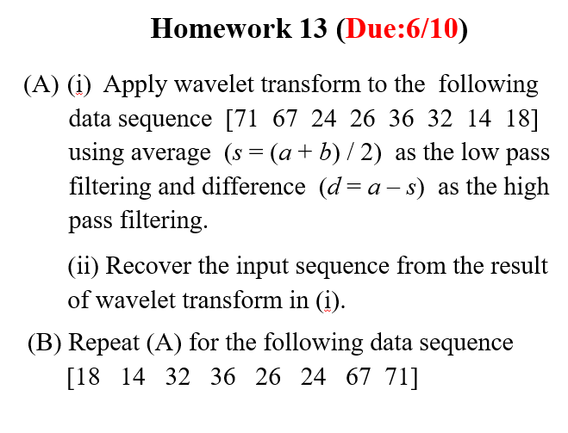

**Input:**

1. **[71 ,67,24,26,36,32,14,18]**
2. **[18,14,32,36,26,24,67,71]**

**output:**

1. **[71,44,27,25,67,46,23,29]**
2. **[18,12,35,56,14,16,33,60]**

**Result:**

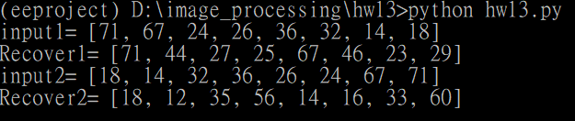

**Source Code：**

**def wavelet_trasform(w):**

**out=[]**

**cA0=[0]*4**

**cD0=[0]*4**

**cA0=lowpass(w)**

**cD0=highpass(w)**

**cA1=[0]*2**

**cD1=[0]*2**

**cA1=lowpass(cA0)**

**cD1=highpass(cA0)**

**cA2=[0]*1**

**cD2=[0]*1**

**cA2=lowpass(cA1)**

**cD2=highpass(cA1)**

**out.extend(cA2)**

**out.extend(cD2)**

**out.extend(cD1)**

**out.extend(cD0)**

**return out**

**def inverse_wavelet_trasform(t):**

**t1=t**

**r=[]**

**a=[]**

**b=[]**

**c=[]**

**d=[]**

**e=[]**

**f=[]**

**g=[]**

**h=[]**

**t[0]=t1[0]+t1[1]**

**t[1]=t1[0]-t1[1]**

**a.extend(t[:2])**

**b.extend(t[2:4])**

**c=[a[i]+b[i] for i in range(min(len(a),len(b)))]**

**d=[a[i]-b[i] for i in range(min(len(a),len(b)))]**

**t[:2]=c**

**t[2:4]=d**

**e.extend(t[:4])**

**f.extend(t[4:])**

**g=[e[i]+f[i] for i in range(min(len(e),len(f)))]**

**h=[e[i]-f[i] for i in range(min(len(e),len(f)))]**

**r.extend(g)**

**r.extend(h)**

**return r**

**def lowpass(w):**

**cA=[0]*(int(len(w)/2))**

**j=0**

**for i in range(0,len(w),2):**

**cA[j]=int((w[i]+w[i+1])/2)**

**j=j+1**

**return cA**

**def highpass(w):**

**cD=[0]*(int(len(w)/2))**

**j=0**

**s=0**

**for i in range(0,len(w),2):**

**s=int((w[i]+w[i+1])/2)**

**cD[j]=w[i]-s**

**j=j+1**

**return cD**

**w1=[71,67,24,26,36,32,14,18]**

**w2=[18,14,32,36,26,24,67,71]**

**t1=wavelet_trasform(w1)**

**t2=wavelet_trasform(w2)**

**r1=inverse_wavelet_trasform(t1)**

**r2=inverse_wavelet_trasform(t2)**

**print("input1=",w1)**

**print("Recover1=",r1)**

**print("input2=",w2)**

**print("Recover2=",r2)**

**Comments：**

**這次得作業難度普通,因為輸入固定的,可以直接一行一行用暴力解。原本想說這個題目很適合用遞迴來寫,但想了一下無法解出來,只好直接對每個情況分別處理,結果感覺與原先值雖然相近但有些落差。**